**CS301**

**PROJECT USE CASE,CLASS,SEQUENCE DIAGRAMS**

horizontal line

# Project :

A Marketplace For Renting Unique And Interesting Houses - Such As Treehouses.

# 

## 

## USE CASES :

**Use Case:** Property Owner Registration

**Primary Actor:** Property Owner

**Goal:** To create an account on the platform and list their unique and interesting property for rent.

**Preconditions:**

* The property owner has access to the platform.
* The property owner has not previously registered on the platform.

**Triggers:**

* The property owner clicks on the "Sign Up" button on the platform.

**Steps:**

* The property owner enters their personal information, such as name, email, and password.
* The property owner verifies their email address.
* The property owner creates a profile and provides information about their property, including location, description, amenities, and rental rates.
* The property owner uploads photos and videos of the property.
* The platform displays a confirmation message indicating that the account has been successfully created.

**Postconditions:**

* The property owner's information is saved in the platform's database.
* The property owner's property is listed on the platform and becomes available for rental.

**Use Case**: Property Renter Search

**Primary Actor:** Property Renter

**Goal**: To search for unique and interesting properties for rent that match their preferences and budget.

**Preconditions:**

* The property renter has access to the platform.

**Triggers:**

* The property renter clicks on the "Search" button on the platform.

**Steps:**

* The property renter enters their rental requirements, such as location, budget, and preferred amenities.
* The platform displays a list of properties that match the property renter's requirements.
* The property renter can view details about each property, including photos, videos, and descriptions.
* The property renter can send a request to rent a property by clicking on the "Request to Rent" button.

**Postconditions:**

* The property renter's request is sent to the property owner.
* The property renter's information is saved in the platform's database for future searches.

**Use Case:** Property Owner Approve Rental Request

**Primary Actor:** Property Owner

**Goal**: To approve or reject rental requests for their property.

**Preconditions:**

* The property owner has an account on the platform.
* The property renter has sent a request to rent the property.

**Triggers:**

* The property owner receives a rental request for their property.

**Steps:**

* The property owner views the rental request, including the property renter's information and rental requirements.
* The property owner decides to approve or reject the rental request.
* If the property owner approves the rental request, they provide rental terms and conditions.
* The platform displays a confirmation message indicating the rental request has been approved or rejected.

**Postconditions:**

* If the rental request is approved, the property renter and owner can finalize the rental agreement through the platform.
* If the rental request is rejected, the property renter can continue to search for other properties.

## 

## USE CASE diagram :

LEVEL-0 USE CASE:

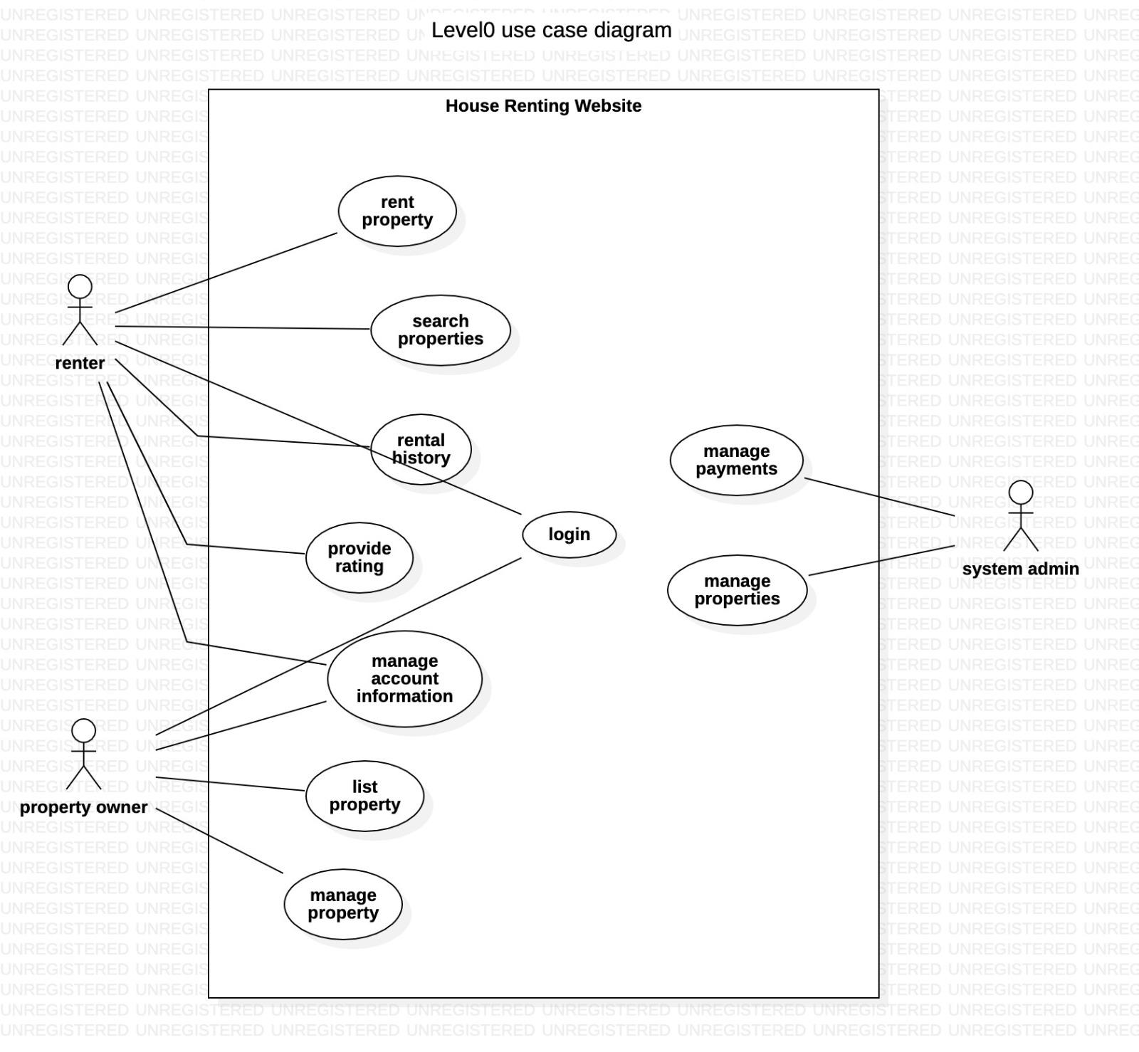

LEVEL-1 USE CASE:

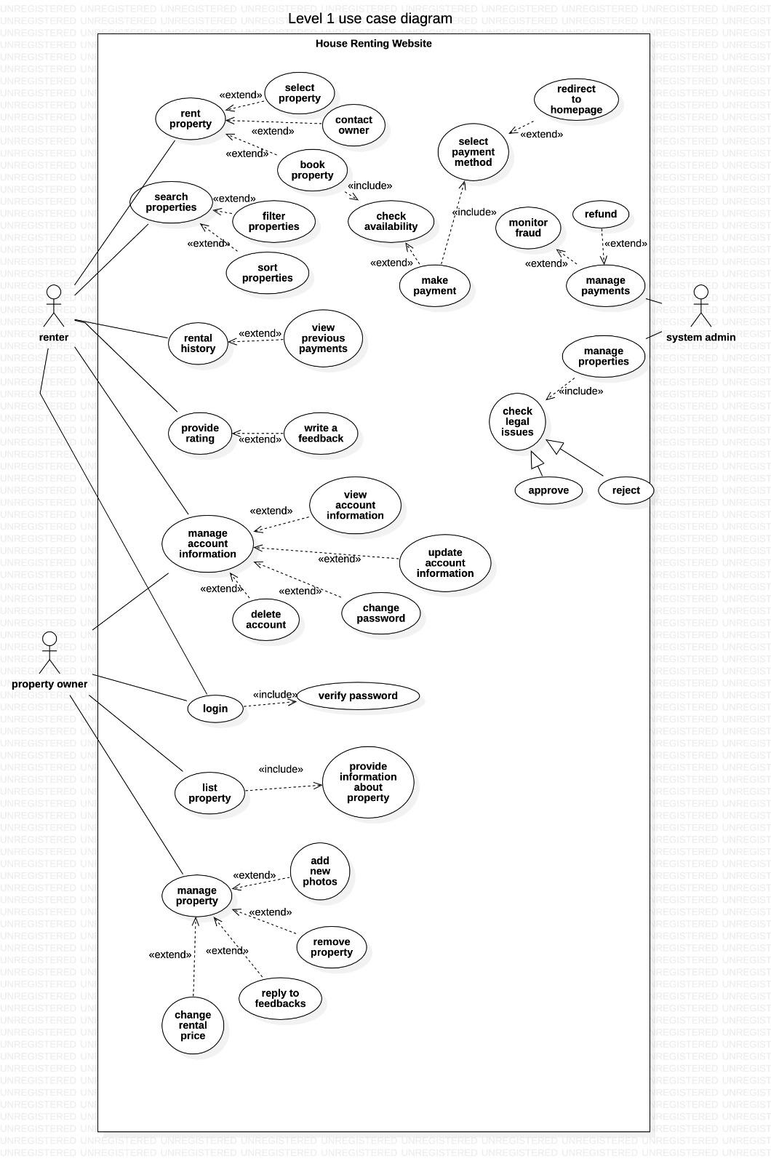

## 

## CLASS DIAGRAM :

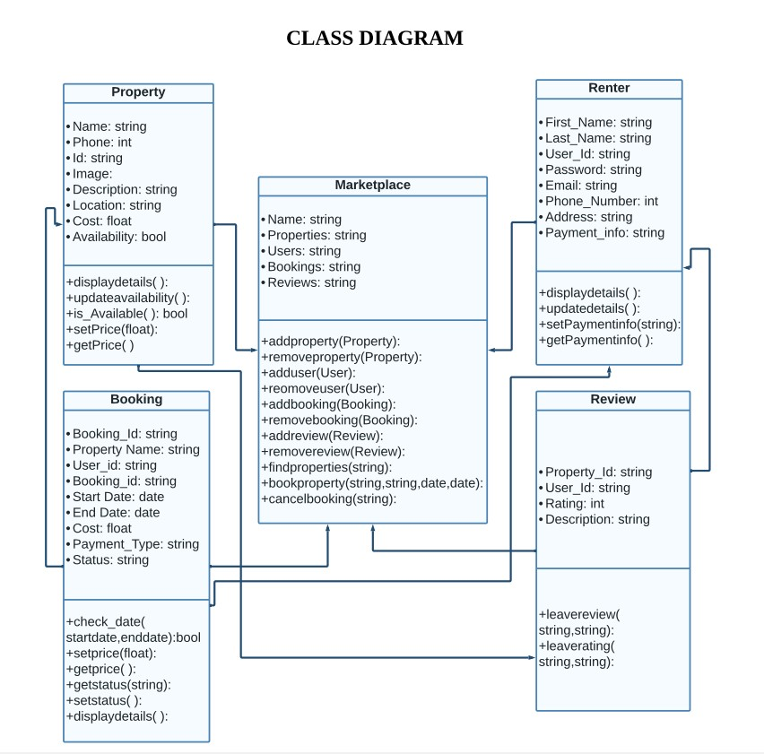

## 

## SEQUENTIAL DIAGRAM :

