A MULTI-MODEL DEEP LEARNING APPROACH FOR INTRUSION DETECTION IN VEHICULAR COMMUNICATION SYSTEMS
A PROJECT REPORT SUBMITTED IN FULFILMENT OF THE REQUIREMENTS FOR THE AWARD OF THE DEGREE OF

BACHELOR OF TECHNOLOGY IN
COMPUTER SCIENCE AND ENGINEERING


By

Batch – B4

M. Likhitha (322103210097) M. Hemalatha (322103210096)
K. Bhanupriyanka (322103210189) R. Madhurima(322103210127)

Under the esteemed guidance of Mrs. Y. Sowmya Assistant Professor
CSE Department

Department of Computer Science and Engineering

GAYATRI VIDYA PARISHAD COLLEGE OF ENGINEERING FOR WOMEN
[Approved by AICTE NEW DELHI, Affiliated to Andhra University, Visakhapatnam]
[Accredited by National Board of Accreditation (NBA) for B. Tech. CSE, ECE & IT – valid from 2019-22 and 2022-25] [Accredited by National Assessment and Accreditation Council (NAAC) with A Grade-Valid from 2022-2027]
Kommadi, Madhurwada, Visakhapatnam – 530048

2022 – 2026

GAYATRI VIDYA PARISHAD COLLEGE OF ENGINEERING FOR WOMEN

DEPARTMENT OF COMPUTER SCIENCE AND ENGINEERING



CERTIFICATE
This is to certify that the Project report titled “A Multi-Model Deep Learning Approach for Intrusion Detection in Vehicular Communication Systems” is a bonafide work of following IV B.Tech. –II Sem. students in the Department of Computer Science and Engineering, Gayatri Vidya Parishad College of Engineering for Women affiliated to Andhra University, Visakhapatnam during the academic year 2025-26, in fulfilment of the requirement for the award of the degree of Bachelor of Technology of this university.

M. Likhitha (322103210097) M. Hemalatha (322103210096)
K. Bhanupriyanka (322103210189) R. Madhurima(322103210127)

Signature of the Guide Signature of the HOD
Mrs. Y. Sowmya MTech., Ph.D., Dr. P. V. S. L. Jagadamba MTech., Ph.D.
Asst. Professor, Professor,
Dept. of CSE Dept. of CSE

External Examiner

ACKNOWLEDGEMENT

The satisfaction that accompanies the successful completion of any task would be incomplete without the mention of people who made it possible and whose constant guidance and encouragement crown all the efforts with success.
We feel elated to extend our sincere gratitude to Mrs. Y. Sowmya, Assistant Professor for encouragement all the way during analysis of the project. Her annotations, insinuations and criticisms are the key behind the successful completion of the thesis and for providing us all the required facilities.
We would like to take this opportunity to extend our gratitude to Project Coordinator, Dr. Y. Sowmya, Associate Professor of Computer Science and Engineering for making us to follow a defined path and for advising us to get better improvements in the project.
We express our deep sense of gratitude and thanks to Dr. P. V. S. Lakshmi Jagadamba, Professor and Head of the Department of Computer Science and Engineering for her guidance and for expressing her valuable and grateful opinions in the project for its development and for providing lab sessions and extra hours to complete the project.
We would like to take this opportunity to express our profound sense of gratitude to Dr.
R. K. Goswami, Principal and Dr. G. Sudheer, Vice Principal for allowing us to utilize the college resources thereby facilitating the successful completion of our thesis.
We are also thankful to both teaching and non-teaching faculty of the Department of Computer Science and Engineering for giving valuable suggestions from our project.

M. Likhitha (322103210097) M. Hemalatha (322103210096)

K. Bhanupriyanka (322103210189) Madhurima(322103210127)

TABLE OF CONTENTS
TOPICS | PAGE NO.
ABSTRACT | i
LIST OF FIGURES | ii
LIST OF TABLES | iv
LIST OF SCREENS | v
LIST OF ACRONYMS | vii
1. INTRODUCTION | 1
1.1 Motivation | 2
1.2 Problem Definition | 2
1.3 Objective of the Project | 2
1.4 Limitations of the Project | 3
1.5 Organization of the Project | 3
2. LITERATURE SURVEY | 4
2.1 Existing System | 10
2.2 Proposed System | 11
2.3 Novelty of our Project | 12
2.4 Conclusion | 12
3. REQUIREMENT ANALYSIS | 18
3.1 Introduction | 18
3.2 Software Requirement Specification | 18
3.2.1 Software Requirements | 18
3.2.2 Hardware Requirements | 20
3.3 Non-Functional Requirements | 21
3.4 Content Diagram of our Project | 21
3.5 Flowchart of our Project | 23
3.6 Algorithms | 24

TOPICS  4. DESIGN | PAGE NO.  34
4.1 Introduction | 34
4.2 UML diagrams | 35
4.2.1 Use case diagram | 35
4.2.2 Class diagram | 36
4.2.3 Sequence diagram | 37
4.3 Module Design | 39
4.3.1 System Module | 39
4.4 Conclusion | 42

- IMPLEMENTATION AND RESULTS 43
  - Introduction 43
  - Explanation of Key functions 43
  - Model building 61
    - Deep Learning models 61
      - Random Forest 61
      - Hybrid Model of CNN-LSTM 62
    - Transformer Models 64
      - AlBERT 64
      - DistilBERT 65
      - BERT-CNN 66
  - Integration of Frontend with Backend code 67
  - Results 107
    - Output Screens 107
    - Graphs 116
  - Conclusion 120
- TESTING AND VALIDATION 121
  - Introduction 121
    - Scope 121

TOPICS | PAGE NO.
6.1.2. Defects and Failures | 121
6.1.3 Compatibility | 122
6.1.4 Input Combinations and Preconditions | 122
6.1.5 Static Vs Dynamic Testing | 123
6.1.6 Software Verification and Validation | 123
6.2 Design of Test Cases and Scenario | 123
6.2.1 Validation Testing | 124
6.2.2 Unit Testing | 124
6.2.3 Black Box Testing | 124
6.2.4 White Box Testing | 125
6.2.5 Integration Testing | 125
6.2.6 System Testing | 125
6.3 Validation Testing Screens | 125
6.4 Conclusion | 125
7. CONCLUSION | 126
8. REFERENCES | 127

ABSTRACT

The Controller Area Network (CAN) bus is the primary communication method used in today's automobiles for allowing the electronic control units (ECUs) in the vehicle to exchange messages to one another. Since CAN does not natively provide security mechanisms for protecting against cyber-attacks, such as denial-of-service, fuzzing, spoofing, or replay attacks, a number of intrusion detection systems (IDS) have been proposed for CAN networks; however, most of the IDSs that have already been developed focus on only binary classification and have very limited model types and thus will not be effective in real-car environments for detecting a real-world attack.
In this paper, we propose a multi-class IDS framework for automotive CAN networks that is based on deep learning techniques. The performance of five sequence-based models (Recurrent Neural Network, Long Short-Term Memory, Gated Recurrent Unit, Bidirectional Long Short-Term Memory, Temporal Convolutional Network) is evaluated during the detection of multiple types of attacks against CAN messages. The experiments are performed on two automotive cybersecurity benchmark datasets (Car Hacking and OTIDS), in both balanced and imbalanced data conditions. Experimentation results indicate that Bidirectional Long Short-Term Memory(BiLSTM) is the best overall performer for both sets of data tested: balanced car hacking data set (98.62%) and imbalanced OTIDS data set (84.29% – Gated Recurrent Unit is also equally strong when compared to Temporal Convolutional Network). In addition, Temporal Convolutional Network performed very similarly to recurrent architectures when processing balanced datasets. Class-level evaluations of both architectures were also performed, as well as a web-based CAN-based intrusion detection system using role-based access control that allows security engineers to upload log files, automatically identify attacks, and visualize intrusions. Ultimately, the results of this research show that deep learning techniques can effectively detect intrusions in a large-scale and real-time manner in automotive environments.

LIST OF FIGURES

S. No.
Figure No. | Figure Name | Page No.
Fig.1 | Existing System | 11
Fig.2 | Proposed System | 12
Fig.3 | Content diagram of the project | 22
Fig.4 | Flowchart of the project | 24
Fig.5 | RNN architecture | 26
Fig.6 | LSTM architecture | 26
Fig.7 | BiLSTM architecture | 27
Fig.8 | GRU architecture | 29
Fig. 9 | TCN Architecture | 30
Fig.10 | Relationships in UML Diagrams | 34
Fig.11 | Use-case diagram | 36
Fig.12 | Class diagram | 37
Fig.13 | Sequence diagram | 39
Fig. 14 | Module Design of our project | 40
Fig. 17 | Architecture of Data Extraction | 40
Fig. 18 | Architecture of Data Pre-processing | 41
Fig. 19 | Architecture of Word Embedding | 42
Fig.20 | Classification of Sentiment Analysis approaches | 44
Fig. 21 | Data Extraction from Twitter | 51
Fig. 22 | Dataset extracted from Twitter | 54

1.
2.
3.
4.

5.

6.

7.

8.

9.

10.

11.

12.

13.

14.

15.
16.

17.

18.

19.

20.

21.

22.

S. No. | Figure No. | Figure Name | Page No.
23. |  |  | 59
24. | Fig. 24 | Hierarchy of our project | 67
25. | Fig. 25 | Accuracy graph for CNN-LSTM hybrid model | 116
26. | Fig. 26 | Loss graph for CNN-LSTM hybrid model | 117
27. | Fig. 27 | Accuracy graph for BERT-CNN hybrid model | 117
28. | Fig. 28 | Loss graph for BERT-CNN hybrid model | 118
29. | Fig. 29 | Comparison graph of model accuracies | 120

LIST OF TABLES

S. No. | Table No. | Table Name | Page No.
1. | Table 1 | Software Requirements | 18
2. | Table 2 | Python Packages | 19
3. | Table 3 | Frontend packages | 20
4. | Table 4 | Minimum Hardware Requirements | 21
5. | Table 5 | Class Diagram Artifacts | 36
6. | Table 6 | Twitter API credentials | 49
7. | Table 7 | Depressed keywords table | 50
8. | Table 8 | Comparison of implemented models | 119
9. | Table 9 | Black Box Testing | 123

LIST OF SCREENS

S. No.
Screen No. | Screen Name | Page No.
Screen 1 | The Developer account | 47
Screen 2 | Application response from Twitter developer account | 47
Screen 3 | Questionnaire asked by twitter team | 48
Screen 4 | Reply to Questionnaire | 48
Screen 5 | Elevated access approved by Twitter | 49
Screen 6 | The keys are used for creating the endpoint to Twitter  API | 52
Screen 7 | Extraction of keys using Cursor | 52
Screen 8 | Appending Tweets | 53
Screen 9 | Tweets posted by user | 55
Screen 10 | Removal of stop words using NLTK | 56
Screen 11 | Removal of special characters | 56
Screen 12 | Beautiful Soup implementation on Twitter | 56
Screen 13 | Vader implementation | 57
Screen 14 | Pie chart based on polarity score of VADER | 58
Screen 15 | Bar plot based on Polarity score of VADER | 58
Screen 16 | Tokenization and building Word2Vec vocabulary | 60
Screen 17 | TF-IDF | 61
Screen 18 | Random Forest | 62
Screen 19 | CNN with LSTM | 63
Screen 20 | AlBERT | 64
Screen 21 | DistilBERT | 65

1.
2.
3.
4.

5.

6.

7.

8.

9.

10.

11.

12.

13.

14.
15.

16.

17.

18.

19.

20.

21.

S. No. | Screen No. | Screen Name | Page No.
22. | Screen 22 | BERT+CNN | 66
23. | Screen 23 | Project source code directory | 68
24. | Screen 24 | Home Page | 107
25. | Screen 25 | Detection Page | 108
26. | Screen 26 | Entering the thoughts | 108
27. | Screen 27 | Alert message box | 109
28. | Screen 28 | Support message will be sent | 109
29. | Screen 29 | Email | 110
30. | Screen 30 | Alert box when email is sent | 110
31. | Screen 31 | Email will be sent to our  depressiondetectionb9@gmail.com | 111
32. | Screen 32 | About us | 111
33. | Screen 33 | Reply tweet page | 112
34. | Screen 34 | Reply to tweet | 112
35. | Screen 35 | Scanning a profile | 113
36. | Screen 36 | Tweets retrieved to host machine | 113
37. | Screen 37 | Alert message on the webpage | 113
38. | Screen 38 | Host machine status after sending message to  followers | 114
39. | Screen 39 | Follower receiving an alert message | 114
40. | Screen 40 | If profile is good | 114
41. | Screen 41 | Positive Reply | 115
42. | Screen 42 | Giving Alert Message for non-depressed user | 115
43. | Screen 43 | The dataset of our project | 116

 | LIST OF ACRONYMS
WHO | World Health Organization
API | Application Programming Interface
VADER | Valance Aware Dictionary and sEntiment Reasoner
CNN | Convolutional Neural Network
LSTM | Long Short Term Memory
BI-LSTM | Bi-Directional Long Short Term Memory
NLTK | Natural Language Tool Kit
SVM | Support Vector Machine
TF-IDF | Term Frequency-Inverse Document Frequency
UML | Unified Modeling Language
CSV | Comma Separated Values
OS | Operating System
RAM | Random Access Memory
RF | Random Forest
CBOW | Continuous Bag of Words
BOW | Bag of Words

INTRODUCTION
Modern cars use networks to connect many electronic parts. The Controller Area Network (CAN) bus is a system that helps these parts talk to each other. It is used in car systems like the engine, brakes and entertainment systems. Even though CAN is efficient and reliable it was not designed with security features like encryption or protection. This makes CAN networks easy to attack. Hackers can cause problems like stopping the car or changing how it works.
As cars become more connected to the internet and other devices, the risk of cyber attacks grows. Security problems in car networks can cause malfunctions and safety risks for people in the car and on the road. Therefore creating systems to detect intrusions has become a key research area.
Traditional methods for detecting intrusions in CAN networks use rules or statistics to identify activity. These methods look at how messages are sent, the time they are sent, or the kind of patterns they follow. However they struggle to adapt to types of attacks and can be misled by sophisticated hackers. To overcome these limitations researchers have started using machine learning and deep learning techniques. These techniques can analyze volume of data and learn to identify patterns that distinguish normal communication from malicious behavior. Some studies have used learning models like Recurrent Neural Networks (RNN) Long Short-Term Memory (LSTM) and Gated Recurrent Unit (GRU) to detect abnormal traffic patterns.
Several studies have tested machine learning models using benchmark datasets like the Car Hacking dataset and the OTIDS dataset. These datasets include CAN traffic with both messages and various attack types. Although previous studies reported accuracy, many of them focus on simple classification tasks that distinguish between normal and attack traffic.
The existing works often evaluate a limited set of models or focus on a single dataset. Another challenge is the issue of data imbalance, where normal messages outnumber attack samples.

To address these challenges this paper proposes a learning-based multi-class intrusion detection framework for automotive CAN networks. The proposed approach evaluates sequence-based neural architectures. These models are designed to capture dependencies within CAN message sequences and accurately classify different attack categories.
The proposed framework is evaluated using two available automotive cybersecurity datasets: the Car Hacking dataset and the OTIDS dataset. Experiments are conducted under both imbalanced data conditions.
The main contributions of this paper are summarized as follows:

- A multi-class learning-based intrusion detection framework for identifying multiple types of attacks in automotive CAN networks.
- A comparative evaluation of five sequence-based architectures, for CAN traffic analysis.
- Experimental validation using two benchmark datasets under both imbalanced scenarios. Development of a web-based CAN intrusion detection platform that supports log upload, automated analysis and visualization of attack detection results.
Through these contributions the proposed system aims to improve the effectiveness and practical applicability of intrusion detection solutions for securing automotive communication networks.

MOTIVATION

Modern vehicles use the Controller Area Network (CAN) for communication, but it does not have built-in security. This makes it easy for attackers to send fake or harmful messages that can affect vehicle functions. Detecting these attacks is difficult because CAN data is highly imbalanced and depends on message sequences over time. This project is motivated by the need to improve attack detection by handling data imbalance using sampling techniques and by using deep learning models to capture sequential patterns in CAN traffic. It also focuses on building a practical system that can help

monitor and detect attacks more effectively in real-world scenarios.

PROBLEM DEFINITION

The Controller Area Network (CAN) protocol, widely used in modern vehicles, does not provide built-in security mechanisms such as authentication and encryption. This makes it vulnerable to various cyberattacks, including message injection, spoofing, and denial- of-service, which can affect critical vehicle operations. A major challenge in detecting such attacks is the nature of CAN data. The datasets are highly imbalanced, where normal messages significantly outnumber attack messages, leading to biased model performance. In addition, CAN communication is sequential, and capturing temporal dependencies in message patterns is difficult using traditional approaches. Therefore, the problem is to develop an effective intrusion detection system that can handle data imbalance, learn sequential patterns, and accurately detect multiple types of attacks in CAN bus communication.

OBJECTIVE OF THE PROJECT

The main objective of this project is,to address class imbalance in CAN datasets using leverage-based sampling techniques.To apply deep learning models such as RNN, LSTM, GRU, BiLSTM, and TCN for intrusion detection. To analyze and compare the performance of different models on multiple datasets. To capture temporal patterns in CAN messages for improved detection accuracy. To detect multiple types of cyberattacks in CAN communication. To develop a web-based platform for monitoring and analyzing CAN traffic. To improve the reliability and effectiveness of intrusion detection in automotive systems.

LIMITATIONS OF THE PROJECT
The system relies on publicly available datasets rather than real-time vehicle data.Limited features (ID, DLC, payload) are used without advanced feature engineering. Sequence length selection is fixed and may not be optimal for all scenarios. No detailed evaluation of real-time performance such as latency and scalability. The system is tested in a controlled environment and may not fully represent real-world conditions.

ORGANIZATION OF THE PROJECT
Concise overview of rest of the documentation work is explained below:
Chapter 1: Introduction describes the motivation and objective of this project.

Chapter 2: Literature review of existing CAN intrusion detection techniques.

Chapter 3: Analysis deals with the detail analysis of the project. Software Requirement Specification further contains software requirements, hardware requirements.
Chapter 4: Methodology, including data preprocessing, sampling, and deep learning models.
Chapter 5: Implementation and results of the project.
Chapter 6: Conclusion and future enhancement.

Chapter 8: References.

LITERATURE SURVEY

Recent advancements in automotive systems have increased the need for secure communication in Controller Area Network (CAN) protocols. Several research works have focused on detecting cyberattacks using machine learning and deep learning techniques.
T.-T.-H. Le, Y. Hwang, J. Son, and H. Kim[1] studied the use of leverage-based sampling combined with deep neural networks to address class imbalance in CAN datasets. Their approach applied models such as RNN, LSTM, and GRU for detecting fuzzing attacks and showed improved performance after sampling. However, their work mainly focused on fuzzer attacks and did not consider a wider range of attack types or real-time deployment.
A. Yousseef and co-authors[2] proposed a hybrid threat modeling approach for autonomous vehicle security. Their study focused on identifying system-level vulnerabilities and assessing risks in vehicle architectures. However, they did not implement deep learning-based intrusion detection models, limiting practical applicability for real-time attack detection.
MDPI [3] Sensors researchers explored deep learning algorithms for detecting cyberattacks in autonomous vehicles. Their work demonstrated that neural networks can effectively identify malicious patterns in vehicle data. However, the study did not address the issue of imbalanced datasets, which can negatively impact detection performance.
A. Aloqaily, E. E. Abdallah, H. AbuZaid, A. E. Abdallah, and M. Al-hassan[4] focused on supervised machine learning techniques for real-time intrusion detection in connected and autonomous vehicles. Their study emphasized real-time processing and model efficiency but relied primarily on traditional machine learning methods, which may not effectively capture temporal dependencies in CAN data.

EXISTING SYSTEM
Existing intrusion detection systems for CAN networks mainly use rule-based, statistical, or traditional machine learning approaches. These systems detect abnormal behavior by analyzing message frequency, patterns, or predefined rules. However, they face several limitations. Most of the existing systems perform only binary classification,

identifying traffic as either normal or attack, without specifying the type of attack. They also struggle with imbalanced datasets, where normal messages are much higher than attack messages. Traditional models cannot effectively capture sequential dependencies in CAN data, leading to lower accuracy. Additionally, many systems are not designed for real-time deployment in automotive environments, limiting their practical usage.
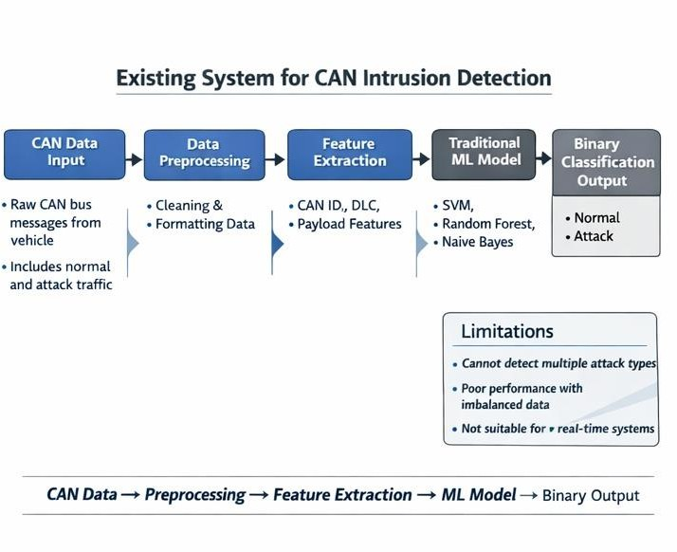
Fig. 1. Existing System

PROPOSED SYSTEM
The proposed system is a deep learning-based multi-class intrusion detection framework for CAN networks. It uses sequence-based models such as RNN, LSTM, GRU, BiLSTM, and Temporal Convolutional Network (TCN) to analyze CAN message sequences. The system is capable of detecting multiple types of attacks, including DoS, spoofing, replay, and fuzzing attacks. Data preprocessing techniques such as normalization and sequence generation are applied to improve model performance. The system is evaluated on both balanced and imbalanced datasets to ensure robustness. In addition, a web-based platform is developed for real-time intrusion detection, where users can upload CAN logs, analyze traffic, and visualize detected attacks. This makes the system practical for real-world automotive applications.

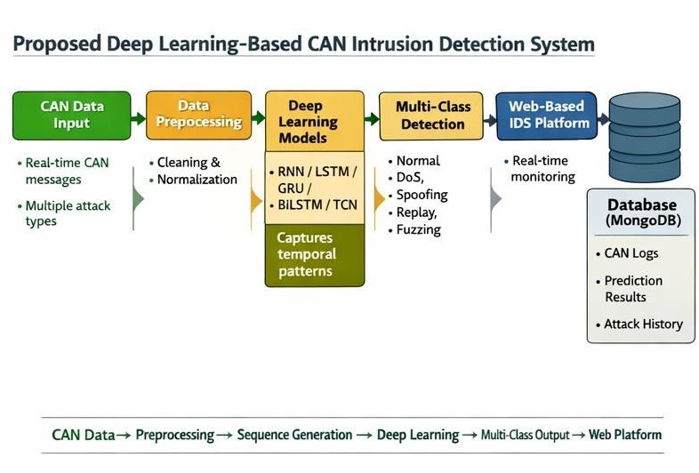
Fig. 2. Proposed System

NOVELTY OF OUR PROJECT
Multi-class attack detection instead of binary classification. Use of multiple deep learning models and comparison. Inclusion of TCN along with RNN models. Handling imbalanced data problem. Development of web-based real-time IDS platform. Combination of research and real-world implementation.

S.no | Title & Authors | Published journal and  Year | Dataset used | Approach | Outcome | Limitations
1. | “Leverage Sampling Methods and Deep Neural Networks for Fuzzer CAN Bus Message Detection”,  T.-T.-H. Le, Y. Hwang,  J. Son, H. Kim | Institute of Electrical and Electronics Engineers (IEEE) , 2025 | CAN bus dataset with normal and fuzzing attack messages. | Applied leverage-based sampling to handle class imbalance and used deep learning models such as RNN, LSTM, and GRU  for intrusion detection. | Improved detection accuracy and better handling of imbalanced CAN data. | Focused mainly on fuzzing attacks and lacks broader attack coverage and real-time implementation.
2. | “Autonomous Vehicle Security: Hybrid Threat Modeling Approach”, A. Yousseef et al. | IEEE Open Journal of Vehicular Technology, 2025 | Conceptual/syste m-level vehicle architecture data. | Proposed a hybrid threat modeling framework to identify vulnerabilities and security risks in  autonomous vehicles. | Effective identification of potential attack surfaces and system vulnerabilities. | Does not implement machine learning or deep learning models for real-time intrusion detection.
3. | “Attacks to Autonomous Vehicles: A Deep Learning Algorithm for Cybersecurity”, MDPI  Sensors | Sensors (MDPI), 2022 | Vehicle communication data with attack scenarios. | Used deep learning algorithms to detect cyberattacks in vehicle systems. | Demonstrated effectiveness of deep learning in  identifying attack patterns. | Did not address class imbalance problem in datasets.
4. | “Supervised Machine Learning for Real-Time Intrusion Detection in Connected Vehicles”,  A. Aloqaily, E. E. Abdallah, H. AbuZaid,  A. E. Abdallah, M. Al- hassan | Informatics, 2025 | Real-time vehicle network data. | Applied supervised machine learning models for intrusion detection. | Achieved efficient real-time detection performance. | Relies on traditional ML models and lacks deep learning-based temporal analysis

13

REQUIREMENT ANALYSIS

INTRODUCTION
Requirement analysis is an important step in developing any system. It helps us understand what the system should do and what resources are needed. In this project, we analyze the requirements for building a CAN bus intrusion detection system using deep learning. Modern vehicles use the Controller Area Network (CAN) for communication between different electronic components. However, CAN does not provide built-in security, which makes it vulnerable to cyber-attacks such as DoS, spoofing, replay, and fuzzing attacks. Therefore, it is necessary to design a system that can detect these attacks efficiently. This section explains the software and hardware requirements, non-functional requirements, and the overall system structure. It ensures that the system is designed properly and can work effectively in real-world conditions.

SOFTWARE REQUIREMENT SPECIFICATION

Software Requirement Specification (SRS) describes all the software tools and technologies needed to develop and run the system. It ensures that the system is implemented smoothly and performs correctly.

Software Requirements
The software requirements include the languages, libraries, packages and operating system, and different tools for developing the project. We used python for coding Refer table 1 and table 2 for software requirements.

Minimum Software Requirements
Table 1. Software Requirements

Software | Version
Google Colab | 3.7
Visual Studio Code Editor | 1.76.0
Operating System | 64-bit OS, Windows 11, 21H2
Python | 3.9.12

Python packages
Python packages we used in our project includes the following table 2.
We used the command pip install “package_name==version” to download the packages.
Table 2. Python packages

S. No. | Packages used | Description
1. | Numpy | Used for numerical computations and handling multi-dimensional arrays efficiently.
2. | Pandas | Used for data loading, preprocessing, and manipulation of CAN datasets.
3. | Scikit-learn (sklearn) | Provides tools for data preprocessing, model evaluation, and performance metrics such as accuracy, precision, recall, and F1-score.
4. | TensorFlow | Used for building and training deep learning models
5. | Keras | High-level API for designing models like RNN, LSTM, GRU, BiLSTM, and TCN.
6. | Matplotlib | Used for plotting graphs such as accuracy, loss curves, and confusion matrices.
7. | Seaborn | Used for advanced data visualization and heatmaps for model evaluation.
8. | .h5,.py | Used for saving and loading trained deep learning models.

Hardware Requirements

The below Table 4 shows the minimum hardware requirements of our project.

Minimum Hardware Requirements
Table 4. Minimum Hardware Requirements
Hardware Requirements | Configuration
Processor | Intel core with i5 configuration or equivalent processors.
RAM | 8GB
HardDisk | 256 GB or greater

NON-FUNCTIONAL REQUIREMENTS
- Compatibility: According to the definition, Compatibility is the capacity for two systems to work together without having to be altered to do so. This project is compatible to run on Windows 10,11
- Capacity: It can be stated as the capacity of a system refers to the amount of storage it utilizes. This project work i5 processor of 8GB RAM
- Environment: It can be stated as all the external and internal forces that exert on your project. This project works on python 3.9.12 environment and higher versions
- Performance: The performance of this project is analyzed based on the accuracy of model and confusion matrix.
- Reliability: It can be stated as the extent to which the software system consistently performs the specified function without failure. In this project, output is analyzed is based on the dataset which is taken in controlled environment.
- Security: User data and system data should be protected from unauthorized access.
- Usability: The system should be easy to use, with a simple and clear interface.
- Maintainability: The system should be easy to update and improve in the future.

FLOWCHARTS OF OUR PROJECT

The flowchart explains the step-by-step working of the system.
The process starts with input CAN data. The data is then preprocessed by cleaning and normalizing it. After preprocessing, the system generates sequences to capture the time- based nature of CAN messages.
Next, the processed data is given to the deep learning model. The model analyzes the data and checks whether an attack is present or not. If an attack is detected, the system classifies the type of attack and stores the result in the database. The result is then displayed on the dashboard. If no attack is detected, the system marks the data as normal, stores the result, and displays the status. Finally, the process ends after displaying the results.

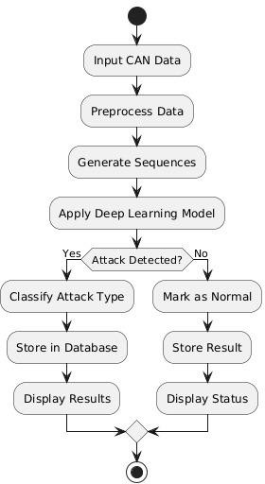

Fig. 3. Flow chart of our project

ALGORITHMS

Recurrent Neural Network (RNN):
Recurrent Neural Network (RNN) is a type of neural network designed to handle sequential data by maintaining information from previous inputs. Unlike traditional feedforward networks, RNNs have feedback connections that allow information to persist across time steps.
This makes RNN suitable for processing time-series data such as CAN bus messages, where each message depends on previous messages in the sequence.
At each time step, the RNN takes the current input and the previous hidden state to produce the current output.
ℎ_{𝑡} = tanh(𝑊_{ℎ}ℎ_{𝑡−1} + 𝑊_{𝑥}𝑥_{𝑡})

However, RNN has certain limitations, such as difficulty in capturing long-term dependencies and the vanishing gradient problem, which can reduce performance for longer sequences. This is why more advanced models like LSTM and GRU are also considered. For example, RNN can be used to detect abnormal sequences of CAN IDs over time and identify unusual message flow patterns that indicate potential attacks.
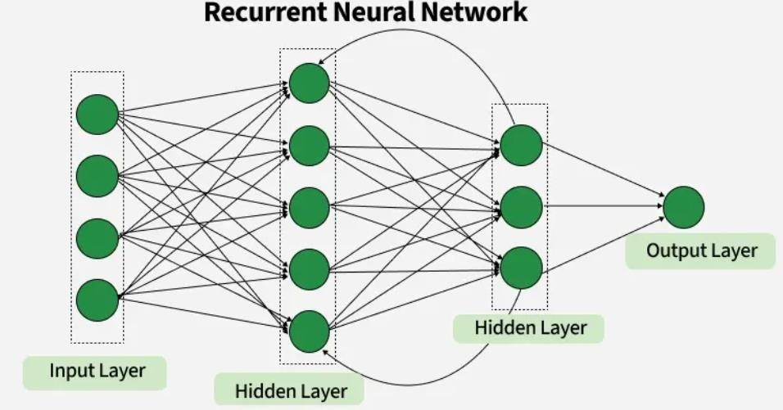

Fig. 4. RNN Architecture

Long Short-Term Memory (LSTM):
Long Short-Term Memory (LSTM) is a specialized type of recurrent neural network (RNN) designed to address the limitations of traditional RNNs. It can effectively learn long-term dependencies in sequential data, making it particularly well-suited for time-series applications such as CAN bus message analysis. Unlike feedforward neural networks, LSTM networks include feedback connections, allowing them to retain information from previous time steps. This enables the model to process sequences of CAN messages and learn patterns over time instead of treating each message independently.
At any given time step, the LSTM output depends on three key components:

- The cell state, which represents long-term memory

- The previous hidden state, which represents short-term memory

- The current input, which is the present CAN message LSTM uses three gates to control the flow of information: Forget Gate
Determines which information from the previous cell state should be discarded.

𝑓_{𝑡} = 𝜎(𝑊_{𝑓}[ℎ_{𝑡−1}, 𝑥_{𝑡}])

Input Gate

Decides which new information should be added to the cell state.

𝑖_{𝑡} = 𝜎(𝑊_{𝑖}[ℎ_{𝑡−1}, 𝑥_{𝑡}])

Output Gate
Determines the final output based on the updated cell state.
𝑜_{𝑡} = 𝜎(𝑊_{𝑜}[ℎ_{𝑡−1}, 𝑥_{𝑡}])

Working of LSTM in this Project:
• Processes sequences of CAN messages
• Retains important temporal patterns
• Filters irrelevant or redundant information

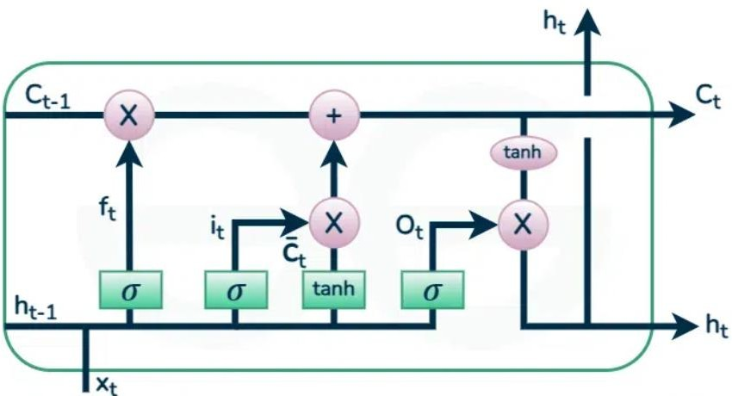

Fig. 5. LSTM Architecture

Bidirectional Long Short-Term Memory (BiLSTM):

Bidirectional Long Short-Term Memory (BiLSTM) is an advanced version of the Long Short-Term Memory (LSTM) network that processes data in both forward and backward directions. Unlike standard LSTM, which only considers past information, BiLSTM captures both past (previous states) and future (upcoming states) context in a sequence. This makes it more effective for sequential data analysis where understanding the full context is important.
BiLSTM consists of two LSTM layers: one processes the input sequence from left to right, while the other processes it from right to left. The outputs from both directions are combined to produce the final result. This dual processing helps the model learn better patterns and dependencies in the data.
In this project, BiLSTM is used to analyze CAN bus message sequences for intrusion detection. By capturing both past and future relationships in the data, the model improves the detection of complex attack patterns such as spoofing and replay attacks. However,

BiLSTM requires more computational power compared to standard LSTM, which can increase training time.
- Forward LSTM: ℎ⃗⃗⃗→ = 𝐿𝑆𝑇𝑀(𝑥 , ℎ⃗⃗⃗⃗⃗⃗⃗⃗→)
t 𝑡 𝑡−1
- Backward LSTM ℎ⃖⃗⃗⃗ = 𝐿𝑆𝑇𝑀(𝑥 , ℎ⃖⃗⃗⃗⃗⃗⃗⃗⃗)
𝑡 𝑡 𝑡+1
- Output Combination ℎ_{𝑡} = [ℎ⃗⃗⃗→; ℎ⃖⃗⃗⃗] Concatenation of forward and backward hidden

states
𝑡 𝑡

Inside Each LSTM (Core Equations)

Forget Gate : 𝑓_{𝑡} = 𝜎(𝑊_{𝑓}[ℎ_{𝑡−1}, 𝑥_{𝑡}] + 𝑏_{𝑓}) Input Gate : 𝑖_{𝑡} = 𝜎(𝑊_{𝑖}[ℎ_{𝑡−1}, 𝑥_{𝑡}] + 𝑏_{𝑖}) Candidate Cell State : 𝐶̃_{𝑡} = tanh(𝑊_{𝑐}[ℎ_{𝑡−1}, 𝑥_{𝑡}] + 𝑏_{𝑐}) Cell State Update : 𝐶_{𝑡} = 𝑓_{𝑡} ⋅ 𝐶_{𝑡−1} + 𝑖_{𝑡} ⋅ 𝐶̃_{𝑡} Output Gate : 𝑜_{𝑡} = 𝜎(𝑊_{𝑜}[ℎ_{𝑡−1}, 𝑥_{𝑡}] + 𝑏_{𝑜})
Hidden State : ℎ_{𝑡} = 𝑜_{𝑡} ⋅ 𝑡𝑎𝑛ℎ(𝐶_{𝑡})

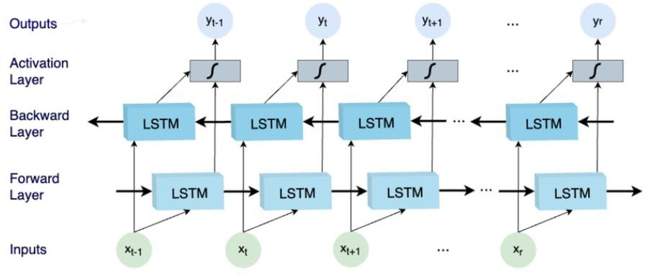
Fig.6. BiLSTM Architecture

Gated Recurrent Unit (GRU)

GRU is a simplified version of LSTM designed to solve the vanishing gradient problem while using fewer parameters. Unlike LSTM, GRU has only two gates (update and reset) and does not maintain a separate cell state. It directly updates the hidden state, making it faster and computationally efficient.
- Update Gate: Controls how much past information is carried forward.

𝑧_{𝑡} = 𝜎(𝑊_{𝑧}𝑥_{𝑡} + 𝑈_{𝑧}ℎ_{𝑡−1} + 𝑏_{𝑧})

- Reset Gate : Decides how much previous information to forget.

𝑟_{𝑡} = 𝜎(𝑊_{𝑟}𝑥_{𝑡} + 𝑈_{𝑟}ℎ_{𝑡−1} + 𝑏_{𝑟})

- Candidate Hidden State: Creates new memory using reset-controlled past info.

ℎ̃ = tanh(𝑊 𝑥
+ 𝑈 (𝑟 ⋅ ℎ
) + 𝑏 )

𝑡 ℎ 𝑡
ℎ 𝑡
𝑡−1 ℎ

- Final Hidden State : Combines old and new information.

ℎ_{𝑡} = (1 − 𝑧_{𝑡}) ⋅ ℎ_{𝑡−1} + 𝑧_{𝑡} ⋅ ℎ̃_{𝑡}
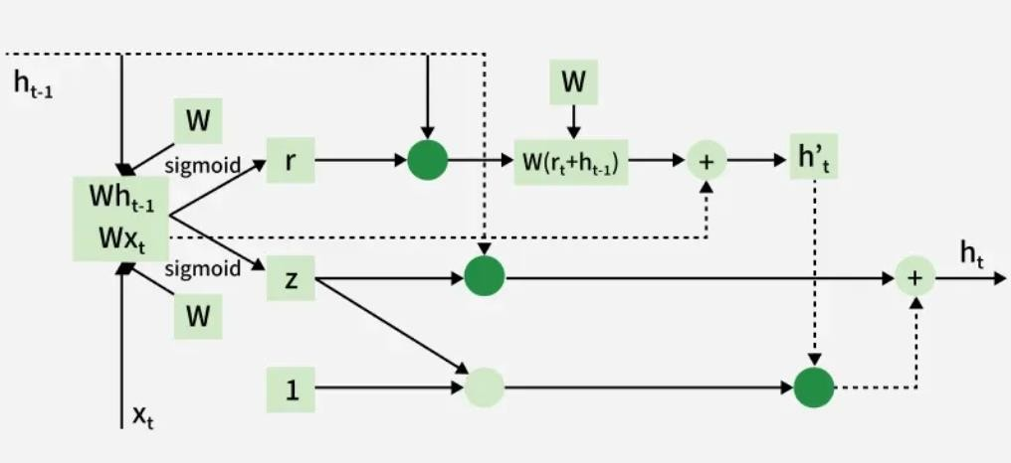
Fig. 7. Architecture

Temporal Convolutional Network (TCN)

TCN is a deep learning model designed for sequence data using 1D dilated causal convolutions. Unlike RNN/LSTM, TCN processes the entire sequence in parallel and captures long-term dependencies using dilation.
- Causal Convolution: Output at time 𝑡depends only on current and past inputs.

𝐾−1
𝑦_{𝑡} = ∑ 𝑤_{𝑘} ⋅ 𝑥_{𝑡−𝑘}
𝑘=0

- Dilated Convolution: 𝑦_{𝑡} = ∑^{𝐾−1} 𝑤_{𝑘} ⋅ 𝑥_{𝑡−𝑑⋅𝑘}
𝑘=0

Where:

  - 𝑑= dilation factor

  - 𝐾= kernel size

This is what makes TCN powerful — it skips steps to capture long-term patterns.

- Residual Connection: Helps prevent vanishing gradient and improves deep network training. 𝑜 = Activation(𝐹(𝑥) + 𝑥)
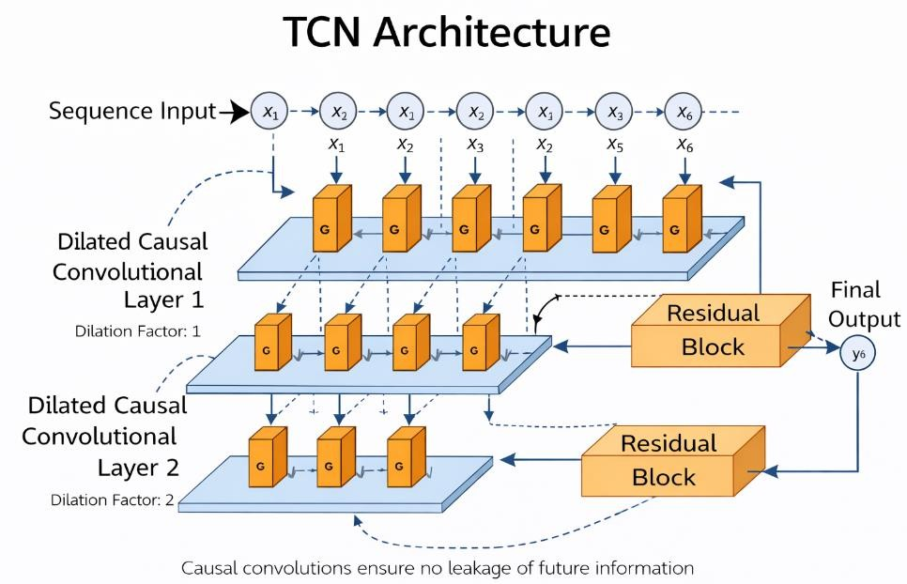
Fig. 8. TCN Architecture

DESIGN

INTRODUCTION
The design phase is an important part of system development. In this phase, we define how the system will be built and how different components will interact with each other. The design helps in converting the requirements into a structured form so that the system can be implemented easily. In this project, we design a deep learning-based intrusion detection system for CAN networks. The system is designed to process CAN data, detect different types of attacks, and provide results through a web-based platform.

The design includes UML diagrams to represent system behavior and structure, and module design to explain different parts of the system. These diagrams help in understanding how data flows and how different components work together. Unified modelling language (UML) is used to represent the software in a graphical format, that is it provides a standard way to visualize how a system is designed. Good UML design is followed for a better and precise software output. The UML provides different constructs for specifying, visualizing, constructing and documenting the artifacts of software systems. UML diagrams are used to better understand the system, to maintain the document information about the system and emphasizes on the roles, actors, actions, actions and process. The UML diagrams considered are:
- Use-case Diagram
- Class Diagram
- Sequence Diagram
Relationships: The relationships among different entities in the following diagrams are given below and in the figure 12:
- Association - This relationship tells how two entities interact with each other.
- Dependency - An entity is dependent on another if the change of that is reflecting the other.
- Aggregation - It is a special kind of association which exhibits part-of relationship.
- Generalization - This relationship describes the parent- child relationship among different entities.

- Realization - It is a kind of relationship in which one thing specifies the behaviour or a responsibility to be carried out, and the other thing carries out that behaviour.
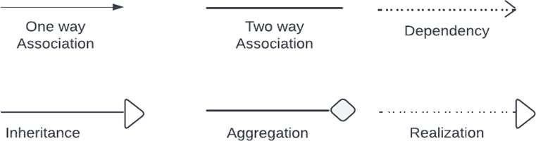

Fig. 9. Relationships in UML Diagrams
  - UML DIAGRAMS

Use-Case Diagrams
The use case diagram shows the interaction between users and the system. It explains what actions different users can perform.
In this system, there are three main users:
- Administrator
- Vehicle Owner
- Security Engineer

Administrator
The Administrator manages the system. They can register users, approve user access, create vehicles, and assign engineers to vehicles.

Vehicle Owner
The Vehicle Owner can view the security status of their vehicle. They can check whether any attack is detected and view reports.

Security Engineer
The Security Engineer is responsible for analyzing CAN data. They can upload CAN logs, monitor attack detection, and download reports for further analysis.
The system provides functions like login, upload CAN data, detect attacks, and display results. Here fig.13 use case diagram helps to understand how users interact with the
system.

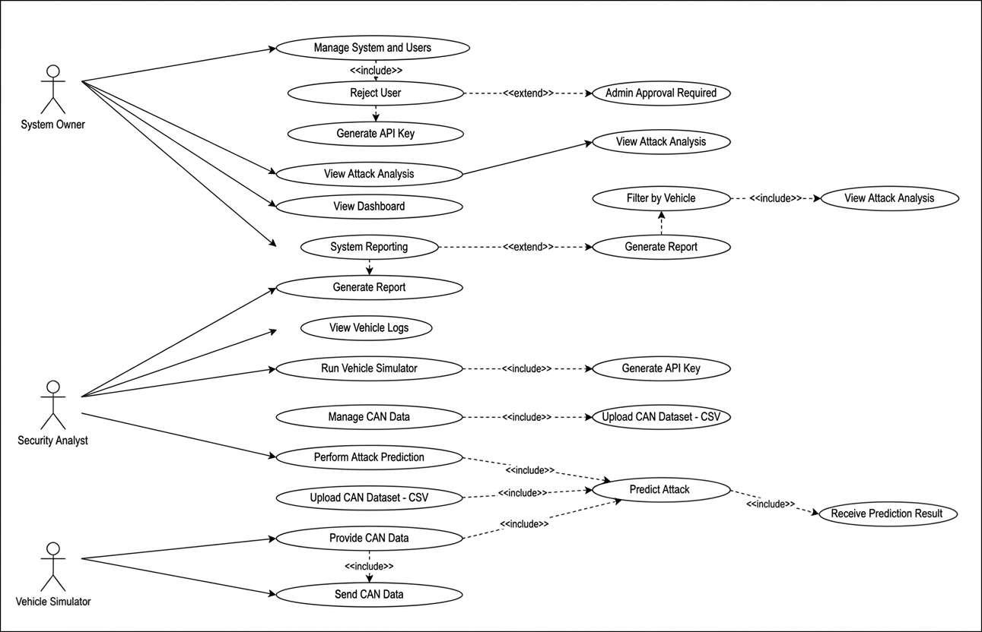

Fig. 10. Use case Diagram

Class Diagram
Class diagram is a static overview of the system used to highlight the important aspects as well as executables in the system. These are the only diagrams which can be mapped with the object-oriented systems. These diagrams show the responsibilities of a class and relationships among different classes in the system.

Class
The class represents similar objects and consists of name, responsibilities and attributes. The classes considered in the project are User, Vehicle, CAN Log, Detection model, Result. These are shown diagrammatically in the figure 14.
The name, attributes, relationships, responsibilities are explained in detail in the Table 4.

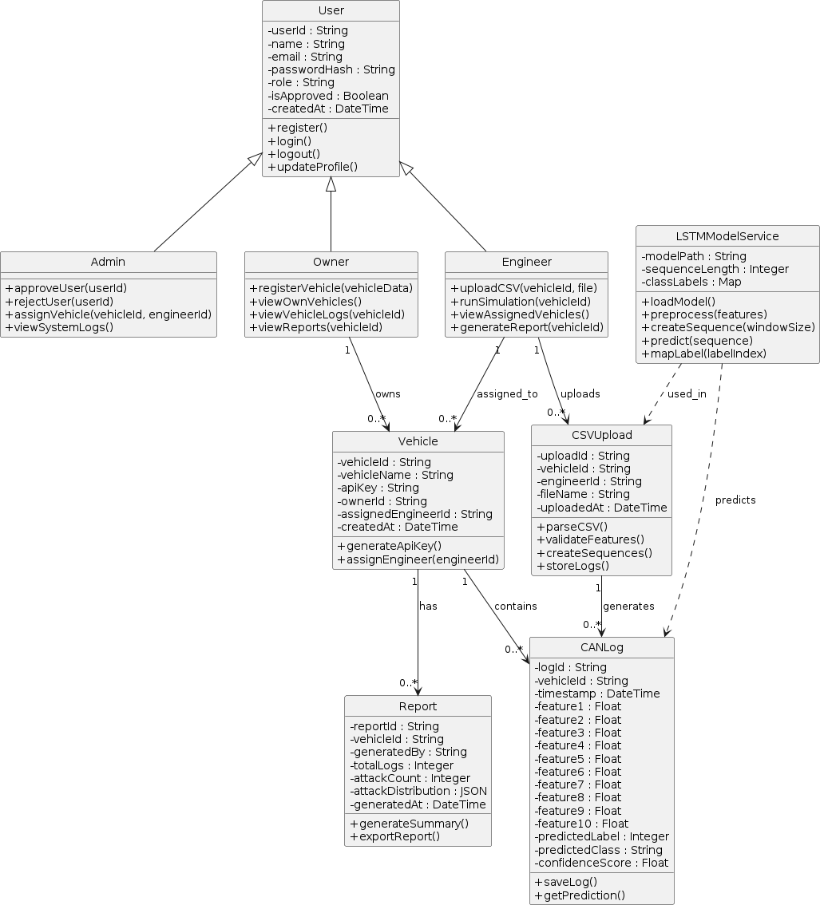

Fig. 11. Class Diagram

S. no. | Class Name | Attributes | Responsibilities
1 | User | user ID, name, email, password, role | login(), logout(), manage_system()
2 | Vehicle | Vehicle Id, owner Id, API key | egister_vehicle(), connect_vehicle()
3 | CAN Log | CAN ID, DLC (data length), payload, timestamp | store_data(), preprocess_data()
4 | Detection Model | Model type, accuracy, loss | train(), predict(), evaluate()
5 | Result | Attack type, confidence score, prediction time | display_result(), store_result()

Table 5. Class Diagram Artifacts

Sequence Diagram
The sequence diagram, also known as an event diagram, depicts the flow of messages through the system. It aids in the visualization of a variety of dynamic scenarios. It depicts communication between any two lifelines as a time-ordered series of events, as if
these lifelines were present at the same moment. The message flow is represented by a vertical dotted line that extends across the bottom of the page in UML, whereas the lifeline is represented by a vertical bar. It encompasses both iterations and branching. A sequence diagram in figure 15 simply displays the order in which things interact, or the order in which these interactions occur. A sequence diagram can also be referred to as an event diagram or an event scenario. Sequence diagrams show how and in what order the components of a system work together.
Notations of Sequence Diagram are,

Lifeline

A lifeline represents an individual participant in the sequence diagram. It is at the very top of the diagram. The lifeline for different participants starts at different times.

Actor

An actor is a character who interacts with the subject and plays a part. It isn't covered by the system's capabilities. It depicts a role in which human users interact with external devices or subjects. Here the user and admin are the actors.

Message

Message denotes the interactions between the messages. They are in the sequential order in the timeline. Here there are 8 messages which are both call and return messages with respective to the participants in the system.

Call message

By defining a specific communication between the interaction's lifelines, it shows that the target lifeline has invoked an operation.

Return Message

It specifies a specific communication between the interaction lifelines, which reflect the flow of data from the receiver of the associated caller message.
The sequence of messages is shown in the figure 12. The system here represents the GUI that the user interacts with and also predicts that the user is depressed or not.

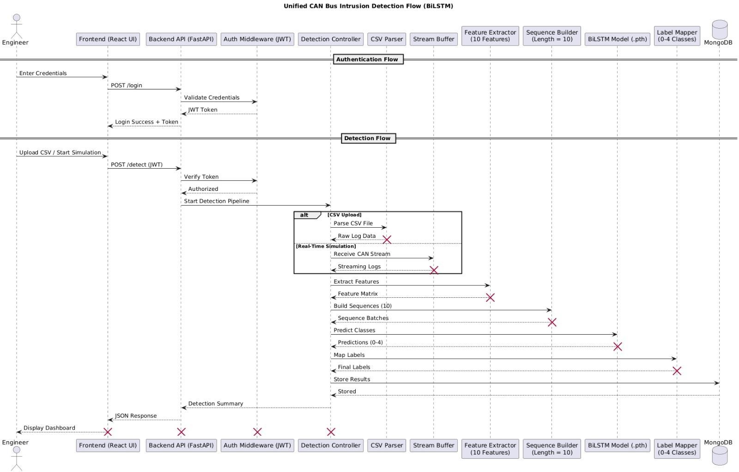
Fig. 12. Sequence Diagram

MODULE DESIGN
Module design divides the system into smaller parts so that each part can be developed and managed easily. Each module performs a specific function and interacts with other modules.

System Module
The system module is the core component of the project, responsible for handling the complete workflow of intrusion detection using CAN data. It is divided into multiple sub- modules, where each module performs a specific task and passes its output to the next stage. This modular design improves maintainability, scalability, and clarity of the system.
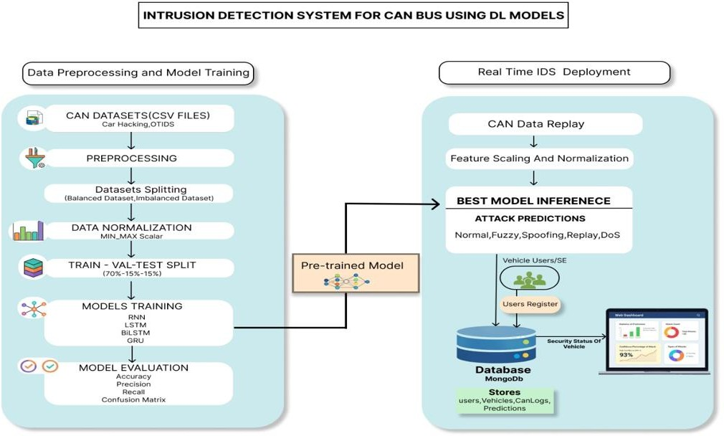

Fig.13. Module Design of Project

Data Ingestion Module
The Data Ingestion module is responsible for collecting CAN bus data from various sources such as real-time vehicle systems or simulation environments. The data includes CAN messages, identifiers, and payload information. This module ensures reliable data transfer to the backend system through APIs or data pipelines. It acts as the entry point of the system and ensures that the incoming data is structured and ready for further processing. This is visually presented in figure 17.
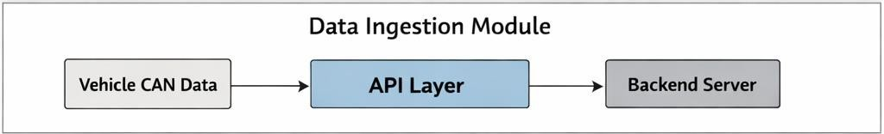

Fig. 14. Data Ingestion Module

Data Preprocessing Module
The Data Preprocessing module prepares raw CAN data for analysis by removing noise, handling missing or inconsistent values, and normalizing the data. It extracts relevant features such as CAN ID, timestamp, and payload values, which are essential for model training. Proper preprocessing improves data quality and directly impacts the performance of the detection models by ensuring consistent and meaningful input.
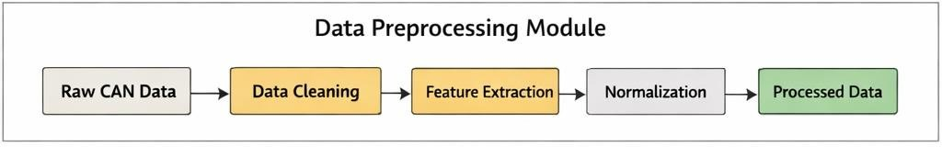

Fig.15. Data Pre-processing

Sequence Generation Module

The Sequence Generation module converts the preprocessed CAN data into sequential formats using techniques such as the sliding window method. This step is important because deep learning models like RNN, LSTM, and TCN require sequential input to learn temporal patterns. By grouping data into fixed-length sequences, this module helps capture time-based dependencies and patterns associated with normal and malicious

behavior.
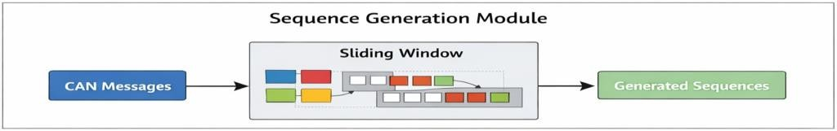

Fig.16. Sequence Generation Module

Detection Module

The Detection module is the core analytical component of the system where deep learning models are applied. Models such as RNN, LSTM, GRU, BiLSTM, and TCN are trained to analyze sequential CAN data and identify anomalies or attack patterns. Each model processes the input data differently to capture temporal dependencies and classify whether the data represents normal behavior or specific types of cyberattacks. This module plays a critical role in determining the accuracy and effectiveness of the system.
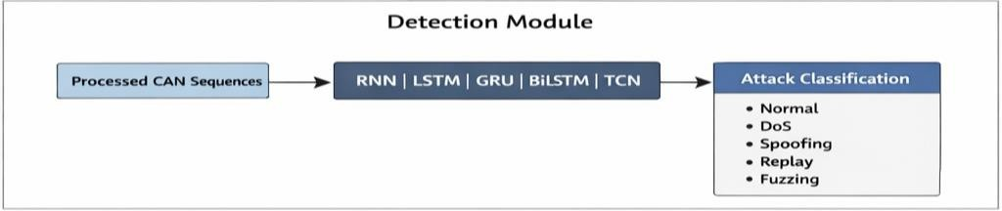

Fig.17. Detection Module

Database Module

The Database module is responsible for storing all relevant data, including raw CAN logs, processed data, prediction results, and user information. A NoSQL database such as MongoDB is used to efficiently manage large volumes of unstructured data. This module enables data retrieval for future analysis, model evaluation, and auditing purposes, ensuring that historical data is preserved and accessible.
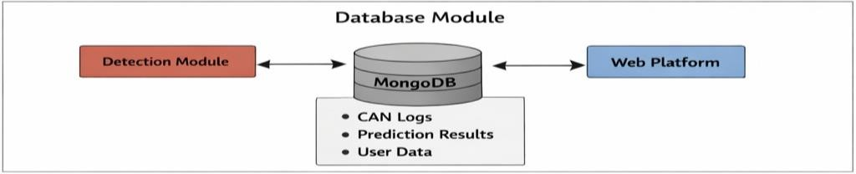
Fig.18. Database Module

Web Interface Module

The Web Interface module provides an interactive platform for users to interact with the system. It allows users to log in securely, upload CAN data, initiate detection processes, and view results. This module acts as a bridge between the user and the backend system, ensuring ease of use and accessibility. A well-designed interface improves user experience and makes the system more practical for real-world applications.
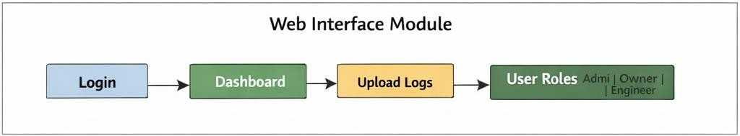

Fig.19. Web Interface Module

Visualization Module

The Visualization module presents the detection results in an understandable format using graphs, charts, and reports. It helps users interpret model outputs, identify attack patterns, and compare performance metrics such as accuracy, precision, recall, and F1-score. Effective visualization enhances decision-making by transforming complex data into clear and meaningful insights.
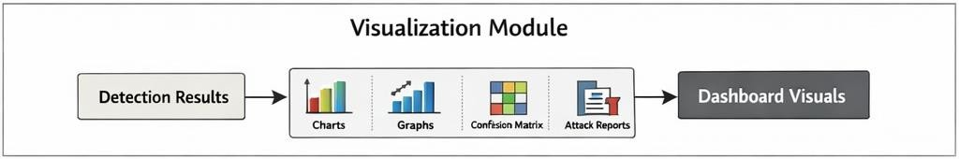
Fig.20. Visualization Module

IMPLEMENTATION AND RESULTS

INTRODUCTION
This chapter explains how the proposed CAN intrusion detection system is implemented and how the results are obtained. The system combines deep learning models with a web- based platform to detect cyber-attacks in vehicle networks. The implementation includes data preprocessing, model training, backend and frontend integration, and result analysis. The performance of different deep learning models is evaluated using standard metrics.

EXPLANATION OF KEY FUNCTIONS
The system consists of several important functions that work together to detect intrusions.

Data Ingestion Function: This function collects CAN data from datasets or simulator and sends it to the system through APIs.

Preprocessing Function: This function cleans the data, removes unwanted values, and normalizes the features between 0 and 1.

Sequence Generation Function: This function converts CAN messages into sequences using a sliding window technique to capture time-based patterns.

Prediction Function: This function uses trained deep learning models to classify data into normal or different attack types.

Storage Function: This function stores CAN logs and prediction results in MongoDB database.

Visualization Function: This function displays results using graphs and dashboards in the web interface.

Software Design:

Front-End Design:
The front-end of the proposed intrusion detection system is designed to provide an interactive and user-friendly interface for monitoring and analyzing network traffic predictions. The interface is developed using HTML, CSS, and JavaScript, ensuring responsiveness and ease of use.
HTML: HTML (HyperText Markup Language) is the standard language used to create web pages for display in web browsers. It defines the structure of content using elements like headings, paragraphs, links, and images. HTML works with CSS for styling and JavaScript for interactivity. Browsers interpret HTML tags to render content, but the tags themselves are not visible to users.

CSS: CSS, or Cascading Style Sheets, is a simple design language intended to make the process of making web pages presentable easier. Styles can be applied to web pages using CSS. More crucially, CSS allows you to do so without relying on the HTML that each web page contains.

JavaScript: JavaScript is used to handle dynamic interactions on the client side. It enables features such as sending user input to the backend, fetching prediction results through APIs, and dynamically updating the dashboard without reloading the page.

BACKEND:
The backend of the system is developed using FastAPI, a modern Python-based web framework that enables high-performance API development for machine learning applications.

FastAPI:
FastAPI is used to build RESTful APIs that handle communication between the front-end and the machine learning models. It provides efficient request handling, automatic documentation, and high-speed performance, making it suitable for real-time intrusion detection systems. Car-Hacking Dataset: Contains CAN network traffic data with normal and attack scenarios.
OTIDS Dataset: Includes labeled time-series intrusion data for evaluating model generalization
The backend is responsible for:
- Receiving input data (network sequences)
- Performing preprocessing
- Loading trained deep learning models
- Generating predictions
- Sending results back to the frontend

System Design:
The system follows a pipeline-based architecture for intrusion detection using deep learning models:

Dataset
Two datasets are used for training and evaluation:
Car-Hacking Dataset: Contains CAN network traffic data with normal and attack scenarios. OTIDS Dataset: Includes labeled time-series intrusion data for evaluating model generalization.
Both datasets are tested under:
Imbalanced conditions (original data)
Balanced conditions (after preprocessing techniques)

Data Preprocessing
Data preprocessing ensures data quality and improves model performance. The following steps are performed:
- Removal of missing and irrelevant values
- Feature scaling using normalization
- Conversion of raw data into structured format
- Splitting into training, validation, and testing sets

Sequence Generation
The preprocessed data is converted into sequences using a sliding window approach to support time-series models.
This helps in:
- Capturing temporal dependencies
- Improving detection of sequential attack patterns

Models Used
The following models are implemented and compared:
- Recurrent Neural Network (RNN)
- Long Short-Term Memory (LSTM)
- Bidirectional LSTM (BiLSTM)
- Gated Recurrent Unit (GRU)
- Temporal Convolutional Network (TCN)

Each model is trained and evaluated on both datasets.

Final Model Selection:
BiLSTM is selected as the final model due to its superior performance in:
- Accuracy
- Precision
- Recall
- F1-score
It captures both forward and backward dependencies, making it effective for intrusion detection.

Model Deployment:
The trained BiLSTM model is deployed using FastAPI. Deployment Flow:
- Load trained model
- Accept input data via API
- Perform preprocessing
- Generate predictions
- Return results to frontend
- Visualization
Model performance is analyzed using:
- Training vs Validation Accuracy
- Training vs Validation Loss
- Confusion Matrix
- Model comparison graphs

MODEL BUILDING

DEEP LEARNING MODELS
This Section explains how the deep learning models are built and trained. The datasets used are car hacking dataset and OTIDS dataset. The data is first preprocessed and converted into sequences. Then it is divided into training, validation and testing sets. Different deep learning models are trained and compared to find the best performing model.

5.3.1.1 Recurrent Neural Network:
Recurrent Neural Network (RNN) is used to process sequential CAN data where each input depends on previous inputs. In this project, the RNN model is implemented and executed using Google Colab with TensorFlow/Keras libraries. The dataset is first preprocessed and converted into sequences using a sliding window technique. These sequences are then passed as input to the RNN model. The model consists of an input layer, RNN hidden layer, and a dense output layer for classification.
The RNN model is compiled using the Adam optimizer and categorical cross-entropy loss function. During training, parameters such as epochs and batch size are defined to control the learning process. The model learns temporal dependencies but struggles with long-term patterns due to vanishing gradient problems.

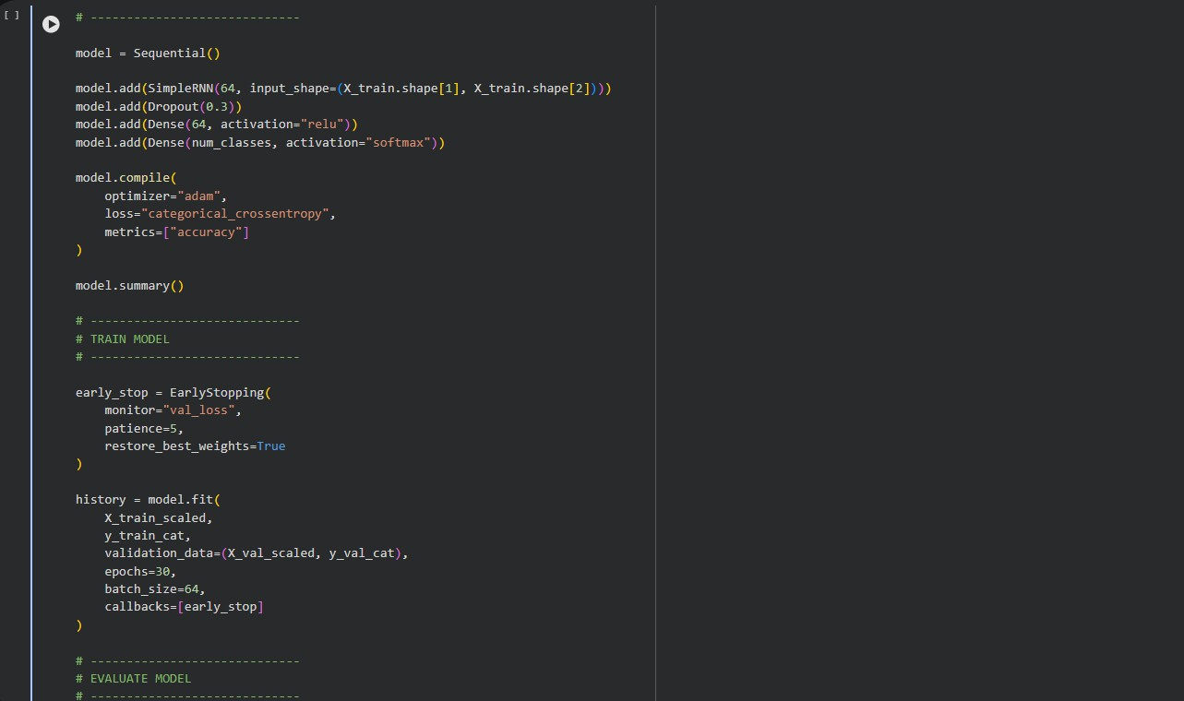
Screen-1: Recurrent Neural Network(RNN)

5.3.1.2 Long Short Term Memory:
Long Short-Term Memory (LSTM) improves RNN by introducing memory cells and gating mechanisms that allow the model to retain long-term dependencies. In this project, LSTM is executed in Colab to analyze CAN sequences more effectively. The LSTM model is built using Keras layers, where the sequential input is passed through LSTM units followed by dropout to reduce overfitting. The output layer performs classification.Hyperparameters such as number of LSTM units, epochs, and batch size are tuned to improve performance. LSTM provides better accuracy compared to RNN for intrusion detection tasks.

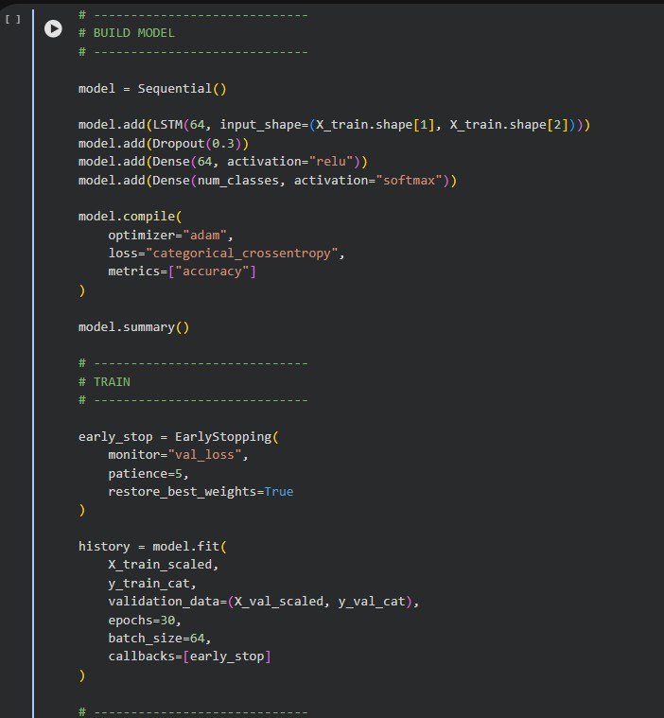
Screen-2: Long Short-Term Memory(LSTM)

Gated Recurrent Unit (GRU):
Gated Recurrent Unit (GRU) is a simplified version of LSTM with fewer parameters, making it faster and computationally efficient. In this project, GRU is implemented in Colab to process sequential CAN data. The GRU model uses update and reset gates to control information flow. It is trained using the same sequence data and evaluation process as other models. GRU achieves a balance between performance and training speed, making it suitable for real-time intrusion detection systems.
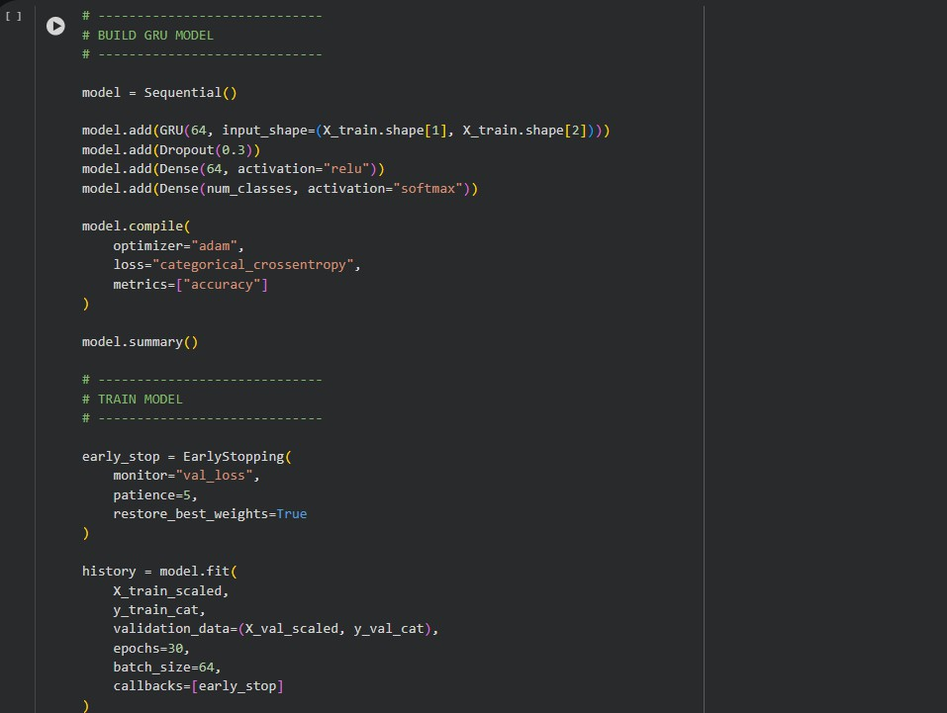
Screen-3: Gated Recurrent Unit(GRU)
Bidirectional LSTM (BiLSTM):
Bidirectional LSTM (BiLSTM) processes the sequence in both forward and backward directions, allowing the model to capture more contextual information. In this project, BiLSTM is executed in Colab for improved detection accuracy. The model consists of two LSTM layers running in opposite directions. Their outputs are combined and passed to a dense layer for classification. Although BiLSTM improves accuracy, it increases computational complexity and training time.
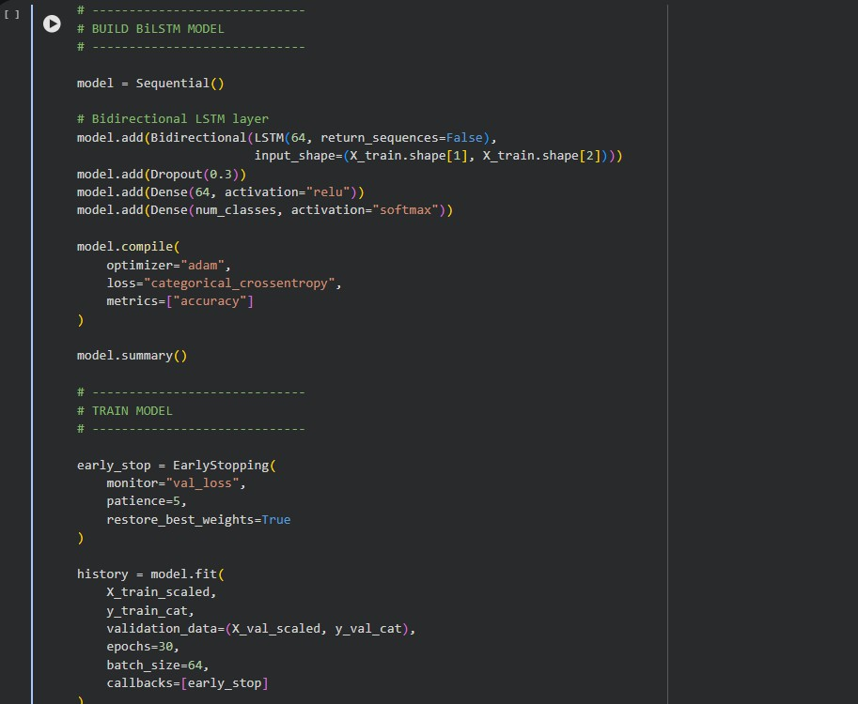
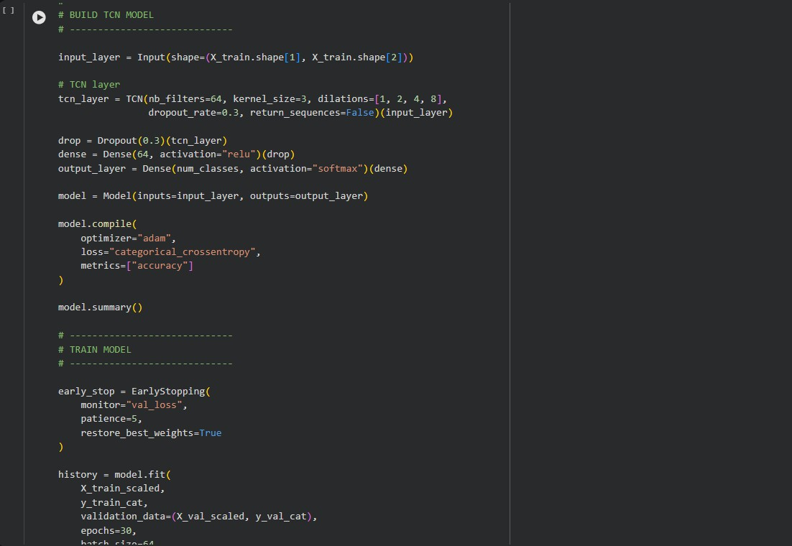
Screen-4: Bidirectional LSTM

Temporal Convolutional Network (TCN)
Screen-5: Temporal Convolutional Network(TCN)

Temporal Convolutional Network (TCN) uses convolutional layers instead of recurrent connections to process sequential data. It captures temporal dependencies using dilated causal convolutions. In this project, TCN is implemented in Colab using Conv1D layers with dilation and padding. It allows parallel computation, making training faster than RNN-based models. Key parameters include kernel size, number of filters, and dilation rate. TCN performs well for long sequences and avoids vanishing gradient problems.

PROJECT DIRECTORY STRUCTURE

Sample Code
The entire project is designed using a modular architecture with Python-based backend and deep learning models. The system is implemented using FastAPI for handling API requests and MongoDB for data storage. The project consists of multiple components including data processing scripts, model execution files, and database utilities.

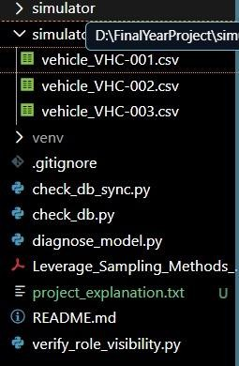
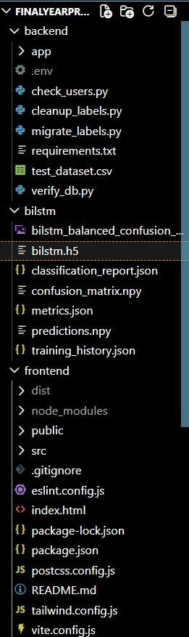

Screen-6:Project source code directory

Backend code

Check_users.py: Views are the Python functions that take a web request and return a response. The actual logic of the website will be written in this python file. This file includes all the backend process.
Code:
import asyncio
from motor.motor_asyncio import AsyncIOMotorClient from app.core.config import settings
async def cleanup():
print(f"Connecting to MongoDB: {settings.MONGODB_URL}") client = AsyncIOMotorClient(settings.MONGODB_URL)
db = client[settings.DATABASE_NAME]
# 1. Remove prediction field if it's "Unknown" or null print(" Removing 'Unknown' and null predictions...") # Update documents where prediction is "Unknown" res1 = await db.logs.update_many(
{"prediction": "Unknown"},
{"$unset": {"prediction": "", "confidence": ""}}
)
print(f" Unset 'Unknown' in {res1.modified_count} logs.") # Update documents where prediction is None/null
res2 = await db.logs.update_many(
{"prediction": None},
{"$unset": {"prediction": "", "confidence": ""}}
)
print(f" Unset null prediction in {res2.modified_count} logs.") # 2. Final check
counts = await db.logs.aggregate([
{"$group": {"_id": {"$type": "$prediction"}, "count": {"$sum": 1}}}
]).to_list(length=100)
print(f"Final Prediction Type Distribution: {counts}") client.close()
print(" Cleanup complete.")
if name == " main ":
asyncio.run(cleanup())

Verify_db.py:
import asyncio
from motor.motor_asyncio import AsyncIOMotorClient from app.core.config import settings
async def check():
client = AsyncIOMotorClient(settings.MONGODB_URL) db = client[settings.DATABASE_NAME]
# Check logs
print("--- Logs Statistics ---") cursor = db.logs.aggregate([
{"$group": {"_id": {"$type": "$prediction"}, "count": {"$sum": 1}}}
])
async for doc in cursor:
print(f"Type: {doc['_id']}, Count: {doc['count']}") # Check distinct values
preds = await db.logs.distinct("prediction") print(f"Distinct predictions: {preds}")
# Check forensic_reports
print("\n--- Forensic Reports Statistics ---")
report_preds = await db.forensic_reports.distinct("prediction") # If it exists there print(f"Distinct report predictions: {report_preds}")
client.close()
if name == " main ": asyncio.run(check())

Main.py
from contextlib import asynccontextmanager
from fastapi import FastAPI
from fastapi.middleware.cors import CORSMiddleware
from .core.database import connect_to_mongo, close_mongo_connection from .ml import model_loader
from .services.prediction_service import detector from .api.auth import router as auth_router
from .api.admin import router as admin_router from .api.owner import router as owner_router from .api.engineer import router as engineer_router from .api.analysis import router as analysis_router from .api.logs import router as logs_router
@asynccontextmanager
async def lifespan(app: FastAPI): # Startup
await connect_to_mongo() # Load Real Model model_loader.load_all() yield
# Shutdown
await close_mongo_connection() app = FastAPI(
title="CAN Intrusion Detection Platform",
description="Sequence-Based Multi-Class CAN IDS using LSTM with RBAC",

version="1.0.0", lifespan=lifespan,
# CORS
app.add_middleware( CORSMiddleware, allow_origins=["*"], allow_credentials=True, allow_methods=["*"], allow_headers=["*"],
)
# Register routers app.include_router(auth_router) app.include_router(admin_router) app.include_router(owner_router) app.include_router(engineer_router) app.include_router(analysis_router) app.include_router(logs_router) @app.get("/")
async def root():
return {"message": "CAN IDS Platform API is running"}

Frontend:

AttackChart.jsx
import { Pie, Bar, Line } from 'react-chartjs-2'; import {
Chart as ChartJS, ArcElement, Tooltip,
Legend, CategoryScale, LinearScale, BarElement, PointElement, LineElement, Filler,
} from 'chart.js'; ChartJS.register( ArcElement,
Tooltip, Legend,
CategoryScale, LinearScale, BarElement, PointElement, LineElement, Filler
);

// --- Theme Constants --- const COLORS = {
Normal: '#00E676', // Success Green DoS: '#FF3B3B', // Red
Fuzzing: '#FF8C42', // Orange Replay: '#B39DDB', // Purple Spoofing: '#FFD93D', // Yellow Accent: '#00C2FF', // Electric Blue
};

const DARK_TOOLTIP = { backgroundColor: 'rgba(11, 11, 11, 0.95)', titleColor: '#FFFFFF',
bodyColor: '#A0A0A0',
borderColor: 'rgba(255, 255, 255, 0.1)',
borderWidth: 1,
padding: 12,
cornerRadius: 8, displayColors: true, boxPadding: 6,
bodyFont: { family: 'Inter', size: 12 },
titleFont: { family: 'Inter', weight: 'bold', size: 13 },
};
export function AttackPieChart({ distribution }) { if (!distribution) return null;

const data = {
labels: Object.keys(distribution), datasets: [{
data: Object.values(distribution),
backgroundColor: Object.keys(distribution).map(k => COLORS[k] || COLORS.Accent),
borderWidth: 2, borderColor: '#0B0B0B',

hoverOffset: 12,
}],
};
const options = { responsive: true,
maintainAspectRatio: false, plugins: {
legend: {
position: 'bottom', labels: {
color: '#A0A0A0', usePointStyle: true, pointStyle: 'circle', padding: 20,
font: { family: 'Inter', size: 11, weight: '500' },
},
},

return (
<div className="glass-card animate-fadein" style={{ height: 340 }}>
<p className="section-title">Attack Distribution</p>
<div style={{ height: 260 }}>
<Pie data={data} options={options} />
</div>
</div>
);
}
export function AttackBarChart({ distribution }) { if (!distribution) return null;
const data = {
labels: Object.keys(distribution), datasets: [{
label: 'Detection Count',
data: Object.values(distribution),
backgroundColor: Object.keys(distribution).map(k => `${COLORS[k] || COLOR
return (
<div className="glass-card animate-fadein" style={{ height: 340 }}>
<p className="section-title">Attack Distribution</p>
<div style={{ height: 260 }}>
<Pie data={data} options={options} />
</div>
</div>
);
}
export function AttackBarChart({ distribution }) { if (!distribution) return null;
const data = {
labels: Object.keys(distribution), datasets: [{
label: 'Detection Count',
data: Object.values(distribution),
backgroundColor: Object.keys(distribution).map(k => `${COLORS[k] || COLORS.Accent}CC`),
borderRadius: 6,
barThickness: 32,
}],
};
const options = { responsive: true,
maintainAspectRatio: false, plugins: {
legend: { display: false }, tooltip: DARK_TOOLTIP,
},
scales: { x: {
grid: { display: false },
ticks: { color: '#666', font: { size: 10 } },
},
y: {
grid: { color: 'rgba(255,255,255,0.03)' },
ticks: { color: '#666', font: { size: 10 } }, beginAtZero: true,
},
},
};
return (
<div className="glass-card animate-fadein" style={{ height: 340 }}>
<p className="section-title">Class Breakdown</p>
<div style={{ height: 260 }}>
<Bar data={data} options={options} />
</div>
</div>
);
}
export function TimelineChart({ timeline }) {
if (!timeline || timeline.length === 0) return null; const data = {
labels: timeline.map(t => new Date(t.timestamp).toLocaleTimeString([], { hour: '2-digit', minute: '2-digit' })),
datasets: [{
label: 'Probability',
data: timeline.map(t => t.confidence),
borderColor: COLORS.Accent, backgroundColor: (context) => { const ctx = context.chart.ctx;
const gradient = ctx.createLinearGradient(0, 0, 0, 200);
gradient.addColorStop(0, 'rgba(0, 194, 255, 0.25)');
gradient.addColorStop(1, 'rgba(0, 194, 255, 0)'); return gradient;
},
fill: true, tension: 0.4,
pointRadius: 0,
pointHoverRadius: 5,
borderWidth: 2,
}],
};
const options = { responsive: true,
maintainAspectRatio: false, plugins: {
legend: { display: false }, tooltip: DARK_TOOLTIP,
},
scales: { x: {
hidden: true,
},
y: {
grid: { color: 'rgba(255,255,255,0.03)' },
ticks: { color: '#666', font: { size: 10 } }, suggestedMin: 0,
suggestedMax: 1,
},
},
interaction: { intersect: false, mode: 'index' },
};
return (
<div className="glass-card animate-fadein" style={{ height: 340 }}>
<p className="section-title">Prediction Confidence Trend</p>
<div style={{ height: 260 }}>
<Line data={data} options={options} />
</div>
</div>
);
}

DatasetUpload.jsx
import { useState, useRef, useMemo } from 'react'; import { Bar } from 'react-chartjs-2';
import {
Chart as ChartJS, CategoryScale, LinearScale, BarElement, Tooltip,
Legend,
} from 'chart.js'; import api from '../api';

ChartJS.register(CategoryScale, LinearScale, BarElement, Tooltip, Legend);

/* ── Icons
────────────────────────────────────────────────
─────── */
const FileIcon = () => (
<svg width="32" height="32" viewBox="0 0 24 24" fill="none" stroke="currentColor" strokeWidth="1.5" strokeLinecap="round" strokeLinejoin="round" style={{ opacity: 0.5 }}>
<path d="M14 2H6a2 2 0 0 0-2 2v16a2 2 0 0 0 2 2h12a2 2 0 0 0 2-2V8z"
/><polyline points="14 2 14 8 20 8" />
</svg>
);
const CheckIcon = () => (
<svg width="15" height="15" viewBox="0 0 24 24" fill="none" stroke="currentColor" strokeWidth="2.5" strokeLinecap="round" strokeLinejoin="round">
<polyline points="20 6 9 17 4 12" />
</svg>
);
const DownloadIcon = () => (
<svg width="14" height="14" viewBox="0 0 24 24" fill="none" stroke="currentColor" strokeWidth="2.5" strokeLinecap="round"
strokeLinejoin="round">
<path d="M21 15v4a2 2 0 0 1-2 2H5a2 2 0 0 1-2-2v-4" /><polyline points="7
10 12 15 17 10" /><line x1="12" y1="15" x2="12" y2="3" />
</svg>
);
/* ── Attack badge helper
─────────────────────────────────────── */ const ATTACK_COLORS = {
DoS: { bg: 'var(--red-dim)', color: 'var(--red)', border: 'rgba(255,59,59,0.25)' },
Fuzzing: { bg: 'var(--orange-dim)', color: 'var(--orange)', border: 'rgba(255,140,66,0.25)' },
Replay: { bg: 'var(--purple-dim)', color: 'var(--purple)', border: 'rgba(179,157,219,0.25)' },
Spoofing: { bg: 'var(--yellow-dim)', color: 'var(--yellow)', border: 'rgba(255,217,61,0.25)' },
Normal: { bg: 'var(--success-dim)', color: 'var(--success)', border: 'rgba(0,230,118,0.25)' },
};
const AttackBadge = ({ label }) => {
const c = ATTACK_COLORS[label] || ATTACK_COLORS.Normal; return (
<span style={{
display: 'inline-block', padding: '3px 10px', borderRadius: 6, fontSize: '0.7rem', fontWeight: 700, letterSpacing: '0.04em', textTransform: 'uppercase', background: c.bg, color: c.color, border: `1px solid ${c.border}`,
}}>{label}</span>
);
}
/* ── Confidence bar
─────────────────────────────────────────── */ const ConfBar = ({ value }) => {
const pct = Math.round(value * 100);
const color = pct >= 90 ? 'var(--red)' : pct >= 70 ? 'var(--orange)' : 'var(--yellow)'; return (
<div style={{ display: 'flex', alignItems: 'center', gap: 8 }}>
<div style={{ flex: 1, height: 5, background: 'rgba(255,255,255,0.07)', borderRadius: 3, overflow: 'hidden' }}>
<div style={{ width: `${pct}%`, height: '100%', background: color, borderRadius: 3, transition: 'width 0.4s' }} />
</div>
<span style={{ fontSize: '0.78rem', fontWeight: 700, color, minWidth: 34
}>{pct}%</span>
</div>
);
};
/* ── CSV Export
─────────────────────────────────────────────── */ function downloadCsv(summary, distribution, attackLogs, filename) {
const rows = [
['# CSV Dataset Analysis Report'],
['# Generated', new Date().toISOString()], ['# File', filename],
[],
['## Summary'],
['Total Logs', summary.total_logs],
['Total Sequences', summary.total_sequences], ['Attacks Detected', summary.attack_count], ['Normal Sequences', summary.normal_count], ['Attack Rate (%)', summary.attack_percentage], [],
['## Attack Distribution'],
...Object.entries(distribution).map(([k, v]) => [k, v]), [],
['## Detailed Attack Logs'],
['Timestamp', 'CAN ID', 'Payload', 'Attack Type', 'Confidence'],
...attackLogs.map(l => [l.timestamp, l.can_id, l.payload, l.label_name, (l.confidence * 100).toFixed(1) + '%']),
];
const csv = rows.map(r => r.join(',')).join('\n'); const blob = new Blob([csv], { type: 'text/csv' }); const url = URL.createObjectURL(blob);
const a = document.createElement('a'); a.href = url;
a.download = `attack_report_${Date.now()}.csv`; a.click();
URL.revokeObjectURL(url);
}
const PAGE_SIZE = 25;
const ATTACK_TYPES = ['All', 'DoS', 'Fuzzing', 'Replay', 'Spoofing']
/* ── Chart colours
──────────────────────────────────────────── */ const CHART_COLORS = [
'rgba(255,59,59,0.85)',
'rgba(255,140,66,0.85)',
'rgba(179,157,219,0.85)',
'rgba(255,217,61,0.85)',
];
const CHART_BORDERS = [ 'rgba(255,59,59,1)',
'rgba(255,140,66,1)',
'rgba(179,157,219,1)',
'rgba(255,217,61,1)',
];
/*Result View*/
function AnalysisResult({ data, filename, onReset }) {
const { summary, attack_distribution: dist, attack_logs: allLogs } = data; const [filter, setFilter] = useState('All');
const [sortDir, setSortDir] = useState('desc'); // 'desc' = highest confidence first const [page, setPage] = useState(1);
const filtered = useMemo(() => {
let logs = filter === 'All' ? allLogs : allLogs.filter(l => l.label_name === filter); logs = [...logs].sort((a, b) =>
sortDir === 'desc' ? b.confidence - a.confidence : a.confidence - b.confidence
);
return logs;
}, [allLogs, filter, sortDir]);
const totalPages = Math.ceil(filtered.length / PAGE_SIZE);
const pageSlice = filtered.slice((page - 1) * PAGE_SIZE, page * PAGE_SIZE); const labels = Object.keys(dist);
const chartData = { labels,
datasets: [{
label: 'Detected Attacks', data: Object.values(dist),
backgroundColor: CHART_COLORS, borderColor: CHART_BORDERS, borderWidth: 1.5,
borderRadius: 6,
};
const chartOptions = { responsive: true, plugins: {
legend: { display: false }, tooltip: {
backgroundColor: '#1a1a1a', borderColor: 'rgba(255,255,255,0.1)', borderWidth: 1,
titleColor: '#fff', bodyColor: '#a0a0a0',
callbacks: { label: ctx => ` ${ctx.raw} sequences` },
},
},
scales: { x: {
ticks: { color: '#a0a0a0', font: { size: 11 } },
grid: { color: 'rgba(255,255,255,0.04)' },
},
y: {
ticks: { color: '#a0a0a0', font: { size: 11 } },
grid: { color: 'rgba(255,255,255,0.04)' }, beginAtZero: true,
},
},
};
const statCard = (label, value, accent) => (
<div style={{
padding: '16px 20px', borderRadius: 14,
background: accent ? 'rgba(255,59,59,0.06)' : 'rgba(255,255,255,0.03)',
border: `1px solid ${accent ? 'rgba(255,59,59,0.15)' : 'var(--border)'}`,
}}>
<div style={{ fontSize: '0.68rem', color: 'var(--text-muted)', textTransform: 'uppercase', letterSpacing: '0.07em', marginBottom: 6 }}>{label}</div>
<div style={{ fontSize: '1.4rem', fontWeight: 800, color: accent ? 'var(--red)' : 'var(--text-primary)' }}>{value}</div>
</div>
);
return (
<div className="animate-fadein" style={{ display: 'flex', flexDirection:
'column', gap: 22 }}>
{/* ── Header ── */}
<div style={{ display: 'flex', alignItems: 'center', justifyContent: 'space- between', flexWrap: 'wrap', gap: 12 }}>
<div style={{ display: 'flex', alignItems: 'center', gap: 10, color: 'var(-- success)', fontWeight: 700 }}>
<div style={{ padding: 4, background: 'rgba(0,230,118,0.1)', borderRadius: '50%', display: 'flex' }}>
<CheckIcon />
</div>
Analysis Complete — <span style={{ color: 'var(--text-secondary)', fontWeight: 400, fontSize: '0.85rem' }}>{filename}</span>
</div>
<button
onClick={() => downloadCsv(summary, dist, allLogs, filename)} className="btn-primary btn-sm"
style={{ display: 'flex', alignItems: 'center', gap: 6 }} id="download-report-btn"
>
<DownloadIcon /> Download Report

}}>

true)}
</button>
</div>
{/* ── Section 1: Summary Cards ── */}
<div style={{ display: 'grid', gridTemplateColumns: 'repeat(3, 1fr)', gap: 12

{statCard('Logs Processed', summary.total_logs.toLocaleString())}
{statCard('Attacks Detected', summary.attack_count.toLocaleString(),

{statCard('Attack Rate', `${summary.attack_percentage}%`,

summary.attack_percentage > 0)}
</div>
{/* ── Section 2: Distribution Chart ── */}
<div className="glass-card-flat">
<div className="section-title">Attack Distribution</div>
<div style={{ height: 180 }}>
<Bar data={chartData} options={{ ...chartOptions, maintainAspectRatio:
false }} />
</div>
{/* Legend row */}
<div style={{ display: 'flex', gap: 16, marginTop: 12, flexWrap: 'wrap' }}>
{labels.map((lbl, i) => (
<div key={lbl} style={{ display: 'flex', alignItems: 'center', gap: 6 }}>
<div style={{ width: 10, height: 10, borderRadius: 3, background: CHART_COLORS[i] }} />
<span style={{ fontSize: '0.78rem', color: 'var(--text-secondary)'
}}>{lbl}: <strong style={{ color: 'var(--text-primary)'
}}>{dist[lbl]}</strong></span>
</div>
))}
</div>
</div>
{/* ── Section 3: Attack Table ── */}
<div className="glass-card-flat">
<div style={{ display: 'flex', alignItems: 'center', justifyContent: 'space- between', marginBottom: 14, flexWrap: 'wrap', gap: 10 }}>
<div className="section-title" style={{ marginBottom: 0 }}> Detected Attack Logs
<span style={{ marginLeft: 8, color: 'var(--accent-primary)', fontSize: '0.75rem' }}>({filtered.length})</span>
</div>
<div style={{ display: 'flex', gap: 8 }}>
{/* Filter */}
<select
id="attack-type-filter" value={filter}
onChange={e => { setFilter(e.target.value); setPage(1); }} className="input-field"
style={{ padding: '6px 10px', fontSize: '0.78rem', width: 'auto' }}
>
{ATTACK_TYPES.map(t => <option key={t} value={t}>{t ===
'All' ? 'All Types' : t}</option>)}
</select>
{/* Sort toggle */}
<button
onClick={() => setSortDir(d => d === 'desc' ? 'asc' : 'desc')} className="btn-secondary btn-sm"
style={{ display: 'flex', alignItems: 'center', gap: 4 }} title="Sort by confidence"
>
Confidence {sortDir === 'desc' ? '↓' : '↑'}
</button>
</div>
</div>
{filtered.length === 0 ? (
<div style={{ textAlign: 'center', padding: '32px 0', color: 'var(--text- muted)', fontSize: '0.85rem' }}>
No attacks found for the selected filter.
</div>
) : (
<>
<div style={{ overflowX: 'auto' }}>
<table className="data-table">
<thead>
<tr>
<th>Timestamp</th>
<th>CAN ID</th>
<th>Payload (Hex)</th>
<th>Attack Type</th>
<th style={{ minWidth: 140 }}>Confidence</th>
</tr>
</thead>
<tbody>
{pageSlice.map((log, idx) => (
<tr key={idx}>
<td className="mono" style={{ color: 'var(--text- secondary)', fontSize: '0.75rem' }}>
{log.timestamp.toFixed(3)}
</td>
<td className="mono" style={{ fontWeight: 600 }}>
{log.can_id.toUpperCase()}
</td>
<td className="mono" style={{ color: 'var(--text- secondary)', fontSize: '0.75rem', letterSpacing: '0.04em' }}>
{log.payload}
</td>
<td><AttackBadge label={log.label_name} /></td>
<td><ConfBar value={log.confidence} /></td>
</tr>
))}
</tbody>
</table>
</div>
{/* Pagination */}
{totalPages > 1 && (

<div style={{ display: 'flex', alignItems: 'center', justifyContent: 'center', gap: 8, marginTop: 16 }}>
<button
onClick={() => setPage(p => Math.max(1, p - 1))} disabled={page === 1}
className="btn-secondary btn-sm"
>← Prev</button>
<span style={{ fontSize: '0.78rem', color: 'var(--text-secondary)'

}}>

)}
</>
)}

Page {page} / {totalPages}
</span>
<button
onClick={() => setPage(p => Math.min(totalPages, p + 1))} disabled={page === totalPages}
className="btn-secondary btn-sm"
>Next →</button>
</div>

</div>

{/* ── Reset ── */}
<button onClick={onReset} className="btn-secondary" style={{ width: '100%' }} id="scan-another-btn">
Scan Another File
</button>
</div>
);
}
/*
════════════════════════════════════════════════
══════════════ Upload View
════════════════════════════════════════════════
══════════════ */
export default function DatasetUpload({ onUploadSuccess }) { const [file, setFile] = useState(null);
const [loading, setLoading] = useState(false); const [progress, setProgress] = useState(0); const [result, setResult] = useState(null);
const [error, setError] = useState(''); const fileInputRef = useRef();
const handleFileChange = (e) => { const f = e.target.files[0];
if (f && f.name.endsWith('.csv')) { setFile(f);
setError('');
} else {
setError('Please select a valid CSV file.');
}
};
const handleUpload = async () => { if (!file) return;
setLoading(true); setError(''); setProgress(0);
const formData = new FormData(); formData.append('file', file);
const savedName = file.name; try {
const res = await api.post('/analysis/upload-dataset', formData, {
onUploadProgress: (ev) => setProgress(Math.round((ev.loaded * 100) /
ev.total)),
});
setResult({ ...res.data, _filename: savedName }); if (onUploadSuccess) onUploadSuccess();
} catch (err) {
setError(err.response?.data?.detail || 'Analysis failed. Check file format.');
} finally { setLoading(false); setFile(null);
}
};
if (result) { return (
<AnalysisResult data={result}
filename={result._filename}
onReset={() => { setResult(null); setError(''); }});
}
return (
<div className="glass-card animate-fadein">
{/* Drop zone */}
<div
onClick={() => fileInputRef.current.click()} onDragOver={(e) => { e.preventDefault();
e.currentTarget.style.borderColor = 'var(--accent-primary)'; }}
onDragLeave={(e) => { e.currentTarget.style.borderColor = 'var(--border)';
}}
onDrop={(e) => { e.preventDefault();
const f = e.dataTransfer.files[0];
if (f?.name.endsWith('.csv')) setFile(f);

20px',
}}
style={{
border: '2px dashed var(--border)', borderRadius: 14, padding: '40px

textAlign: 'center', cursor: 'pointer', transition: 'all 0.2s', background: 'rgba(255,255,255,0.01)', marginBottom: 20,

}}
>
<input type="file" ref={fileInputRef} onChange={handleFileChange}
hidden accept=".csv" />
<div style={{ display: 'flex', justifyContent: 'center', marginBottom: 16 }}>
<FileIcon />
</div>
<p style={{ fontWeight: 600, color: 'var(--text-primary)', marginBottom: 4

}}>

{file ? file.name : 'Click or Drag CSV to analyze'}
</p>
<p style={{ fontSize: '0.78rem', color: 'var(--text-muted)' }}> Standard CAN log format · All rows must have dlc=8
</p>
</div>
{loading && (
<div style={{ marginBottom: 20 }}>
<div style={{ display: 'flex', justifyContent: 'space-between', fontSize:

'0.72rem', color: 'var(--text-secondary)', marginBottom: 6 }}>
<span>Processing dataset…</span>
<span>{progress}%</span>
</div>
<div style={{ width: '100%', height: 6, background: 'rgba(255,255,255,0.04)', borderRadius: 3, overflow: 'hidden' }}>
<div style={{ width: `${progress}%`, height: '100%', background: 'var(--accent-primary)', transition: 'width 0.3s' }} />
</div>
</div>
)}
{error && (
<div className="alert-error" style={{ marginBottom: 16, display: 'flex', gap: 8, alignItems: 'flex-start' }}>
<svg width="15" height="15" viewBox="0 0 24 24" fill="none" stroke="currentColor" strokeWidth="2" style={{ flexShrink: 0, marginTop: 1 }}>
<circle cx="12" cy="12" r="10" /><line x1="12" y1="8" x2="12" y2="12" /><line x1="12" y1="16" x2="12.01" y2="16" />
</svg>
<span>{error}</span>
</div>
)}
<button
id="start-scan-btn" onClick={handleUpload} disabled={!file || loading} className="btn-primary"
style={{ width: '100%', display: 'flex', alignItems: 'center', justifyContent: 'center', gap: 8 }}
>
{loading ? <div className="spinner" style={{ width: 14, height: 14 }} /> : 'Start Security Scan'}
</button>
</div>
);
}

Navbar.jsx
import { Link, useNavigate } from 'react-router-dom'; import { useAuth } from '../context/AuthCconst navigate = useNavigate(); const handleLogout = () => {
logout(); navigate('/login');
};
const roleLabel = { admin: '🛡️ Admin', owner: '🚗 Owner',
engineer: '🔧 Engineer',
};
return (
<nav className="flex items-center justify-between px-6 py-3" style={{
background: 'rgba(15,23,42,0.85)', backdropFilter: 'blur(12px)',
borderBottom: '1px solid rgba(99,102,241,0.15)', position: 'sticky', top: 0, zIndex: 50,
}}
>
{/* Logo */}
<Link to="/" className="flex items-center gap-2 no-underline">
<span className="text-2xl">🛡️</span>
<span className="font-bold text-lg"
style={{ background: 'linear-gradient(135deg, #6366f1, #22d3ee)',
WebkitBackgroundClip: 'text', WebkitTextFillColor: 'transparent' }}> CAN-IDS
</span>
</Link>
{/* Right side */}
{user && (
<div className="flex items-center gap-4">
<span className="text-sm" style={{ color: 'var(--color-text-muted)' }}>
{user.full_name}
</span>
<span className="badge" style={{ background: 'rgba(99,102,241,0.15)', color: '#818cf8' }}>
{roleLabel[user.role] || user.role}
</span>
<button onClick={handleLogout} className="btn-danger text-sm" style={{ padding: '6px 16px' }}>
Logout
</button>
</div>
)}
</nav>
);
}

App.jsx
import { BrowserRouter, Routes, Route, Navigate } from 'react-router-dom'; import { AuthProvider, useAuth } from './context/AuthContext';
import Login from './pages/Login'; import Register from './pages/Register';
import AdminDashboard from './pages/AdminDashboard'; import OwnerDashboard from './pages/OwnerDashboard'; import EngineerDashboard from './pages/EngineerDashboard'; function ProtectedRoute({ children, allowedRoles }) {
const { user, loading } = useAuth(); if (loading) return (
<div style={{ display: 'flex', alignItems: 'center', justifyContent: 'center', minHeight: '100vh' }}>
<div className="spinner" style={{ width: 32, height: 32 }} />
</div>
);
if (!user) return <Navigate to="/login" />;
if (allowedRoles && !allowedRoles.includes(user.role)) { console.warn('ProtectedRoute: Role mismatch. User role:', user.role, 'Allowed:',
allowedRoles);
return <Navigate to="/login" />;
}
return children;
}
function HomeRedirect() { const { user } = useAuth();
console.log('HomeRedirect: Current user:', user); if (!user) {
console.log('HomeRedirect: No user, going to /login'); return <Navigate to="/login" />;

const roleRoutes = {
admin: '/admin', owner: '/owner', engineer: '/engineer'
};
const target = roleRoutes[user.role]; if (!target) {
console.error('HomeRedirect: INVALID ROLE found:', user.role); return <Navigate to="/login" />;
}
console.log('HomeRedirect: Role', user.role, 'Redirecting to:', target); return <Navigate to={target} />;
}
function AppRoutes() {
const { user, loading } = useAuth();

if (loading) return (
<div style={{ display: 'flex', alignItems: 'center', justifyContent: 'center', minHeight: '100vh', background: 'var(--bg-base)' }}>
<div className="spinner" style={{ width: 36, height: 36 }} />
</div>
);
return (
<Routes>
<Route path="/" element={<HomeRedirect />} />
<Route path="/dashboard" element={<HomeRedirect />} />
<Route path="/login" element={user ? <HomeRedirect /> : <Login />} />
<Route path="/register" element={user ? <HomeRedirect /> : <Register />} />
<Route path="/admin" element={<ProtectedRoute allowedRoles={['admin']}><AdminDashboard /></ProtectedRoute>} />
<Route path="/owner" element={<ProtectedRoute allowedRoles={['owner']}><OwnerDashboard /></ProtectedRoute>} />
<Route path="/engineer" element={<ProtectedRoute allowedRoles={['engineer']}><EngineerDashboard /></ProtectedRoute>} />
<Route path="*" element={<HomeRedirect />} />
</Routes>
);
}
export default function App() { return (
<BrowserRouter>
<AuthProvider>
<AppRoutes />
</AuthProvider>
</BrowserRouter>
);
}

api.js
import axios from 'axios'; const api = axios.create({
baseURL: '/api',
});
// Attach JWT token to every request api.interceptors.request.use((config) => {
const token = localStorage.getItem('token'); if (token) {
config.headers.Authorization = `Bearer ${token}`;
}
return config;
});

// Handle 401 globally api.interceptors.response.use(
(res) => res, (err) => {
if (err.response?.status === 401) { localStorage.clear(); window.location.href = '/login';
}
return Promise.reject(err);
}
);
export const uploadDataset = (formData) => api.post('/analysis/upload-dataset', formData, {
headers: {
'Content-Type': 'multipart/form-data'
}
});
export default api;
@import url('https://fonts.googleapis.com/css2?family=Inter:wght@300;400;500;600;700;800 &family=JetBrains+Mono:wght@400;500&display=swap');
@tailwind base; @tailwind components; @tailwind utilities;
/* ── Design Tokens
─────────────────────────────────────────── */
:root {
--accent-primary: #00C2FF;
--accent-dim: #0090C0;
--accent-glow: rgba(0, 194, 255, 0.15);
--accent-border: rgba(255, 255, 255, 0.1);
--accent-border-strong: rgba(0, 194, 255, 0.4);
--bg-base: #0B0B0B;
--bg-surface: #141414;
--bg-card: rgba(255, 255, 255, 0.05);
--bg-card-hover: rgba(255, 255, 255, 0.08);
--bg-input: rgba(11, 11, 11, 0.8);
--bg-sidebar: #0B0B0B;

--text-primary: #FFFFFF;
--text-secondary: #A0A0A0;
--text-muted: #5A5A5A
--red: #FF3B3B;
--red-dim: rgba(255, 59, 59, 0.15);
--orange: #FF8C42;
--orange-dim: rgba(255, 140, 66, 0.15);
--yellow: #FFD93D;
--yellow-dim: rgba(255, 217, 61, 0.12);
--blue: #00C2FF;
--blue-dim: rgba(0, 194, 255, 0.12);
--purple: #B39DDB;
--purple-dim: rgba(179, 157, 219, 0.12);
--success: #00E676;
--success-dim: rgba(0, 230, 118, 0.15)
--border: rgba(255, 255, 255, 0.08);
--border-subtle: rgba(255, 255, 255, 0.04);
--radius: 12px;--radius-lg: 18px
font-family: 'Inter', system-ui, sans-serif;
}
/* ── Base Reset
────────────────────────────────────────────── */
*,
*::before,
*::after {
box-sizing: border-box;

body { margin: 0;
background: var(--bg-base); color: var(--text-primary); min-height: 100vh;
-webkit-font-smoothing: antialiased;

/* ── Scrollbar
─────────────────────────────────────────────── */
::-webkit-scrollbar { width: 5px;
height: 5px;
}
::-webkit-scrollbar-track { background: transparent;

::-webkit-scrollbar-thumb { background: rgba(255, 255, 255, 0.1); border-radius: 4px;

::-webkit-scrollbar-thumb:hover { background: rgba(255, 255, 255, 0.2);
}
/* ── Glass Card
─────────────────────────────────────────────── */
.glass-card {
background: var(--bg-card); backdrop-filter: blur(16px);
-webkit-backdrop-filter: blur(16px); border: 1px solid var(--border); border-radius: var(--radius-lg);
padding: 24px;
transition: border-color 0.25s, box-shadow 0.25s, background 0.25s;

.glass-card:hover {
border-color: var(--accent-border-strong); box-shadow: 0 0 24px var(--accent-glow); background: var(--bg-card-hover);

.glass-card-flat { background: var(--bg-card); backdrop-filter: blur(16px);
-webkit-backdrop-filter: blur(16px); border: 1px solid var(--border); border-radius: var(--radius-lg); padding: 24px;

/* ── Stat Card
────────────────────────────────────────────────
*/
.stat-card {
background: var(--bg-card); backdrop-filter: blur(16px); border: 1px solid var(--border); border-radius: var(--radius-lg); padding: 20px 24px;
position: relative; overflow: hidden;
transition: transform 0.2s, box-shadow 0.2s, border-color 0.2s, background 0.2s;

.stat-card::before { content: ''; position: absolute; inset: 0;
background: linear-gradient(135deg, var(--accent-glow) 0%, transparent 60%);
opacity: 0;
transition: opacity 0.25s;
}
.stat-card:hover {
transform: translateY(-2px);
box-shadow: 0 8px 32px var(--accent-glow); border-color: var(--accent-border-strong);
background: var(--bg-card-hover);
}
.stat-card:hover::before { opacity: 1;
}
/* ── Buttons
────────────────────────────────────────────────
─── */
.btn-primary {
background: var(--accent-primary); color: #000;
border: none; padding: 10px 22px; border-radius: 10px; font-weight: 700; font-size: 0.875rem; cursor: pointer; transition: all 0.2s;
letter-spacing: 0.01em;
box-shadow: 0 4px 12px rgba(0, 194, 255, 0.2);
}
.btn-primary:hover { background: #33CEFF;
box-shadow: 0 6px 20px rgba(0, 194, 255, 0.35); transform: translateY(-1px);
.btn-primary:disabled { opacity: 0.4;
cursor: not-allowed; transform: none;
}
.btn-secondary {
background: rgba(255, 255, 255, 0.05); color: var(--text-primary);
border: 1px solid var(--border); padding: 10px 22px;
border-radius: 10px; font-weight: 600; font-size: 0.875rem; btn-secondary:hover {
background: rgba(255, 255, 255, 0.09);
border-color: rgba(255, 255, 255, 0.2);

.btn-danger {
background: rgba(255, 59, 59, 0.1); color: var(--red);
border: 1px solid rgba(255, 59, 59, 0.25); padding: 10px 22px;
border-radius: 10px; font-weight: 600; font-size: 0.875rem; cursor: pointer; transition: all 0.2s;

.btn-danger:hover {
background: rgba(255, 59, 59, 0.2);
border-color: rgba(255, 59, 59, 0.5);

.btn-sm {
padding: 6px 14px; font-size: 0.8rem;

/* ── Input Fields
────────────────────────────────────────────── */
.input-field { width: 100%;
padding: 11px 14px;
background: rgba(255, 255, 255, 0.02);
border: 1px solid rgba(255, 255, 255, 0.1); border-radius: 10px;
color: var(--text-primary); font-size: 0.9rem;
font-family: 'Inter', sans-serif; outline: none;
transition: border-color 0.2s, box-shadow 0.2s;
}
.input-field::placeholder { color: var(--text-muted);
}
nput-field:focus {
border-color: var(--accent-primary);
box-shadow: 0 0 0 3px var(--accent-glow);
}

.input-field option { background: #141414; color: var(--text-primary);
}

/* ── Sidebar
────────────────────────────────────────────────
─── */
.sidebar { width: 240px;
min-height: 100vh; background: var(--bg-sidebar);
border-right: 1px solid var(--border); display: flex;
flex-direction: column; position: fixed;
top: 0;
left: 0;
z-index: 40;
padding: 0 0 24px 0;
}

.sidebar-logo {
padding: 24px 20px 20px;
border-bottom: 1px solid var(--border-subtle);
}

.sidebar-nav { flex: 1;
padding: 16px 12px; display: flex;
flex-direction: column; gap: 4px;
}
sidebar-item { display: flex;
align-items: center; gap: 12px;
padding: 11px 14px; border-radius: 10px; cursor: pointer;
color: var(--text-secondary); font-size: 0.875rem;
font-weight: 500; transition: all 0.18s;
border: 1px solid transparent; text-decoration: none;
}

.sidebar-item:hover {
background: rgba(255, 255, 255, 0.05); color: var(--text-primary);
}

.sidebar-item.active {
background: rgba(0, 194, 255, 0.08); color: var(--accent-primary);
border-color: rgba(0, 194, 255, 0.2);
}

/* ── Main Content Area
─────────────────────────────────────── */
.main-layout { display: flex;
min-height: 100vh; background: var(--bg-base);
}
.page-content { margin-left: 240px; flex: 1;
padding: 28px; min-height: 100vh;

/* ── Page Header
─────────────────────────────────────────────── */
page-header { display: flex;
align-items: center;
justify-content: space-between; margin-bottom: 24px;
}
.page-title {
font-size: 1.5rem; font-weight: 700;
color: var(--text-primary); letter-spacing: -0.01em;
}
.page-subtitle {
font-size: 0.85rem;
color: var(--text-secondary); margin-top: 2px;
}
/* ── Section Titles
──────────────────────────────────────────── */
.section-title {
font-size: 0.72rem; font-weight: 600; letter-spacing: 0.08em;
text-transform: uppercase; color: var(--text-muted); margin-bottom: 12px;

/* ── Data Table
────────────────────────────────────────────────
*/
.data-table { width: 100%;
border-collapse: collapse; font-size: 0.85rem;
}
.data-table thead tr {
border-bottom: 1px solid var(--border);
}
.data-table th { text-align: left;
padding: 12px 16px;
color: var(--text-secondary); font-weight: 600;
font-size: 0.75rem;
text-transform: uppercase; letter-spacing: 0.04em;
background: rgba(255, 255, 255, 0.02);
}
.data-table td { padding: 13px 16px;
border-bottom: 1px solid var(--border-subtle); color: var(--text-primary);
}

.data-table tbody tr { transition: background 0.15s;
}

.data-table tbody tr:hover td { background: rgba(255, 255, 255, 0.02);
}

/* ── Badges
────────────────────────────────────────────────
──── */
.badge {
display: inline-flex; align-items: center; padding: 3px 10px; border-radius: 6px; font-size: 0.72rem; font-weight: 700; letter-spacing: 0.02em;
text-transform: uppercase;
}

.badge-normal {
background: var(--success-dim); color: var(--success);
border: 1px solid rgba(0, 230, 118, 0.2);
}
.badge-dos {
background: var(--red-dim); color: var(--red);
border: 1px solid rgba(255, 59, 59, 0.2);
}

.badge-fuzzing {
background: var(--orange-dim); color: var(--orange);
border: 1px solid rgba(255, 140, 66, 0.2);
}

.badge-replay {
background: var(--purple-dim); color: var(--purple);
border: 1px solid rgba(179, 157, 219, 0.2);
}

.badge-spoofing {
background: var(--yellow-dim); color: var(--yellow);
border: 1px solid rgba(255, 217, 61, 0.2);
}

.badge-active {
background: var(--blue-dim); color: var(--blue);
border: 1px solid rgba(0, 194, 255, 0.2);
}

.badge-inactive { background: var(--red-dim); color: var(--red);
border: 1px solid rgba(255, 59, 59, 0.2);
}

/* ── Alerts / Messages
───────────────────────────────────────── */
.alert-success {
background: var(--success-dim);
border: 1px solid rgba(0, 230, 118, 0.2); color: var(--success);
border-radius: var(--radius); padding: 12px 16px;
font-size: 0.875rem;
}

.alert-error {
background: var(--red-dim);
border: 1px solid rgba(255, 59, 59, 0.25); color: var(--red);
border-radius: var(--radius); padding: 12px 16px;
font-size: 0.875rem;
}

/* ── Mono text
────────────────────────────────────────────────
— */
.mono {
font-family: 'JetBrains Mono', 'Fira Code', monospace; font-size: 0.8rem;
}

/* ── Animations
────────────────────────────────────────────────
*/
@keyframes fadeIn { from {
opacity: 0;
transform: translateY(8px);
}
to {
opacity: 1;
transform: translateY(0);
}
}

Main.jsx
import { StrictMode } from 'react'
import { createRoot } from 'react-dom/client' import './index.css'
import App from './App.jsx' createRoot(document.getElementById('root')).render(
<StrictMode>
<App />
</StrictMode>,
)

vehicle_simulator.py
"""
Vehicle CAN Log Simulator.
Reads a CSV file and streams rows to the backend API as CAN log entries. """
import csv import json import random import sys import time
from datetime import datetime, timedelta import requests
# ── Configuration
────────────────────────────────────────── API_URL = "http://localhost:8000/api/logs/ingest"
VEHICLE_API_KEY = "" # Set this after creating a vehicle via the admin API CSV_FILE = "simulator_data/vehicle_VHC-001.csv"
DELAY_MIN = 0.05 # 50 ms
DELAY_MAX = 0.10 # 100 ms
def stream_csv(csv_path: str, api_key: str):
"""Read CSV and POST each row to the ingestion endpoint.""" headers = {
"Content-Type": "application/json", "X-Vehicle-API-Key": api_key,
}
with open(csv_path, newline="") as f: reader = csv.DictReader(f)
count = 0
for row in reader:
# Construct data list from data_0...data_7
can_data = [int(row[f"data_{i}"]) for i in range(8)] payload = {
"timestamp": row["timestamp"], "can_id": int(row["can_id"]),
"dlc": int(row["dlc"]), "data": can_data
}
try:
resp = requests.post(API_URL, json=payload, headers=headers) resp.raise_for_status()
data = resp.json() count += 1
pred = data.get("prediction", "—") conf = data.get("confidence", "—") print(
f"[{count}] Sent ID={row['can_id']} DLC={row['dlc']} → " f"prediction={pred} confidence={conf}"
)
except Exception as e:
print(f"❌ Error sending row {count}: {e}") time.sleep(random.uniform(DELAY_MIN, DELAY_MAX))
print(f"\n✅ Done. Sent {count} log entries.") if name == " main ":
api_key = VEHICLE_API_KEY csv_path = CSV_FILE
if len(sys.argv) >= 2: api_key = sys.argv[1]
if len(sys.argv) >= 3: csv_path = sys.argv[2]
if not api_key:
print("Usage: python vehicle_simulator.py <VEHICLE_API_KEY> [csv_file]") sys.exit(1)
print(f"🚗 Starting CAN log simulation from {csv_path}") stream_csv(csv_path, api_key)

check_db.py
import asyncio
from motor.motor_asyncio import AsyncIOMotorClient async def check():
client = AsyncIOMotorClient("mongodb://localhost:27017") db = client.can_ids_db
users = await db.users.find().to_list(10) for u in users:
print(f"Email: {u['email']}, Role: {u['role']}, Approved: {u['approved']}") vehicles = await db.vehicles.find().to_list(10)
for v in vehicles:
print(f"Vehicle: {v['vehicle_id']}, Assigned Engineers:
{v.get('assigned_engineers', [])}") if name == " main ":
asyncio.run(check())

RESULTS

Output Screens
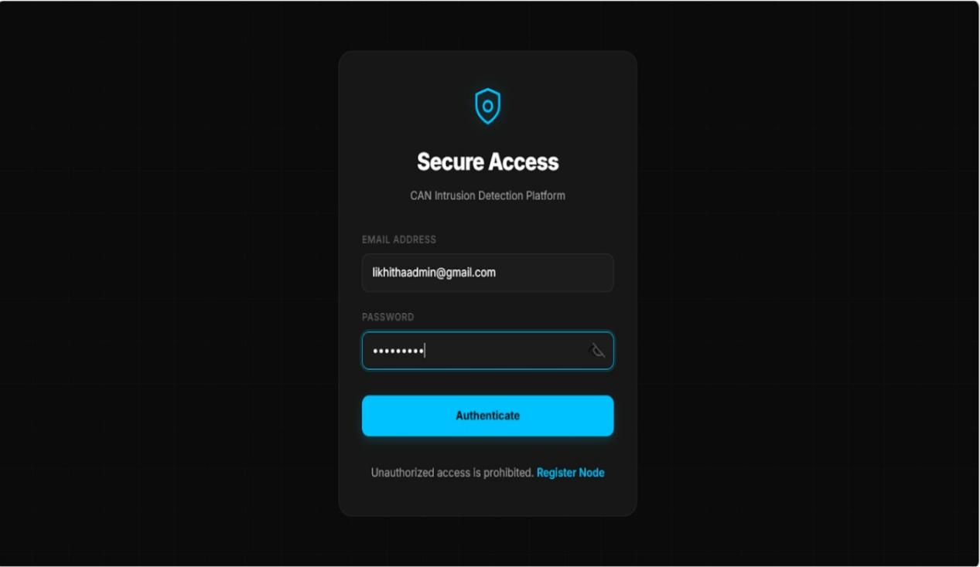
Login page: The figure shows the login interface of the CAN Intrusion Detection Platform, which acts as the authentication entry point for the system. It requires users to provide valid credentials, including an email address and password, to access the platform. This module ensures that only authorized users can access the platform, thereby maintaining system security and preventing unauthorized access.
Screen 7. Login page
System Overview Page: The System Overview Dashboard of the CAN Intrusion
Detection Platform, which provides a centralized interface for monitoring and managing system activities. This dashboard is primarily used by the administrator to obtain a real-time summary of the system status. The dashboard displays key metrics, including the total number of users, pending user approvals, managed vehicles, and total system logs, enabling quick assessment of platform activity. Shown in screen
A navigation panel is provided on the left side, allowing access to different modules such as Dashboard, User Approvals, Vehicles, and System Logs. Additionally, the interface includes a section for recent system logs, where important details such as timestamp, CAN ID, prediction (e.g., attack type), and confidence level are presented.
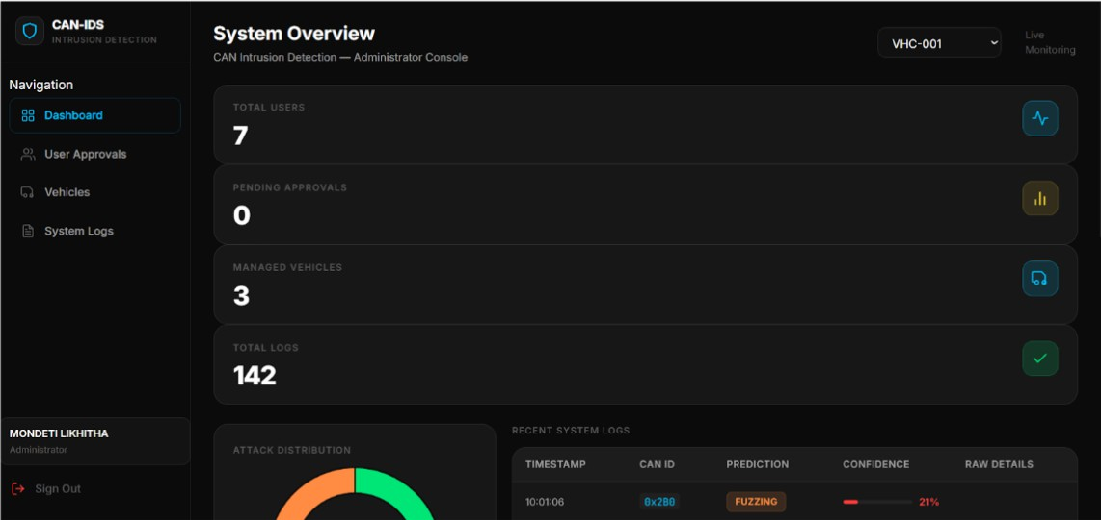
Screen 8 System Overview Page
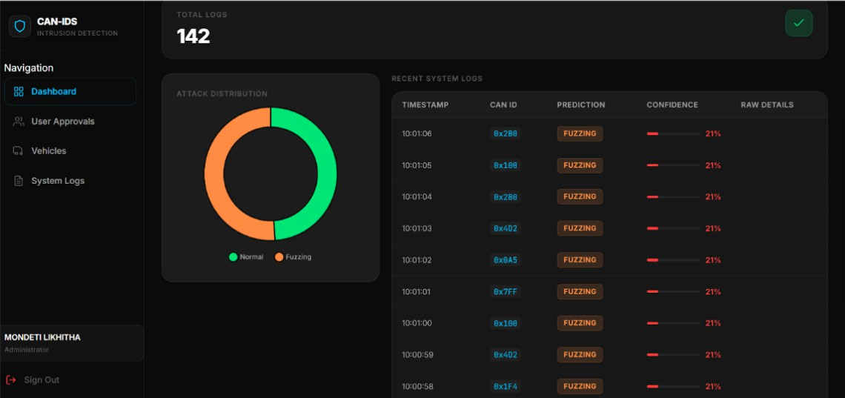

Screen 9. System Overview Page(2)

The Attack Distribution is visualized using a circular chart that represents the
proportion of normal and anomalous (e.g., fuzzing) CAN messages. This helps in quickly understanding the overall security status of the network.

User Management page:
As shown in screen The User Management module of the CAN Intrusion Detection Platform, specifically the Pending Approvals section. This interface allows the administrator to manage and review user or node registration requests before granting access to the system. The module provides a centralized view of all pending approval requests, enabling the administrator to approve or reject users based on authorization criteria. In the current state, the interface indicates that there are no pending approval requests.
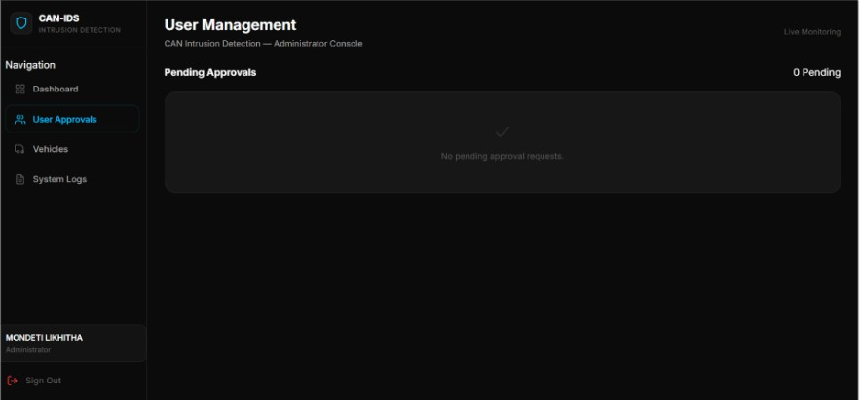

Screen 10. User Management page

Vehicle Registry Page: The Vehicle Registry module of the CAN Intrusion Detection Platform, which is used to manage and monitor registered vehicles within the system. This interface provides a structured view of all managed vehicles along with their associated details. The module displays key information such as Vehicle ID, Owner, Assigned Engineers, and Status. Each vehicle entry indicates whether it is active, allowing administrators to track operational status. Additionally, an “Assign Engineer” action is provided, enabling the administrator to allocate responsible engineers to specific vehicles for monitoring and maintenance purposes. This component facilitates efficient management of vehicle data and ensures proper assignment of responsibilities, thereby supporting effective monitoring and maintenance of the CAN network. Shown in screen
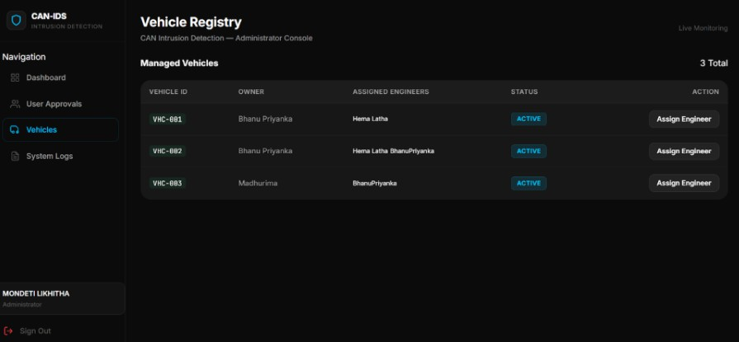
Screen 11. Vehicle Registry
System Logs page: The System Logs module of the CAN Intrusion Detection Platform, which provides a detailed record of CAN network activity and detected events. This module enables administrators to monitor and analyze incoming CAN messages in real time. he logs are presented in a tabular format, displaying key attributes such as timestamp, CAN ID, prediction (attack type), and confidence level. Each entry represents a processed CAN message along with its classification result, allowing identification of anomalous activities such as fuzzing attacks. A vehicle selection option is also available to filter logs specific to a particular vehicle. This facilitates targeted analysis and monitoring. The module supports effective tracking of network behavior and assists in identifying potential security threats within the CAN system.
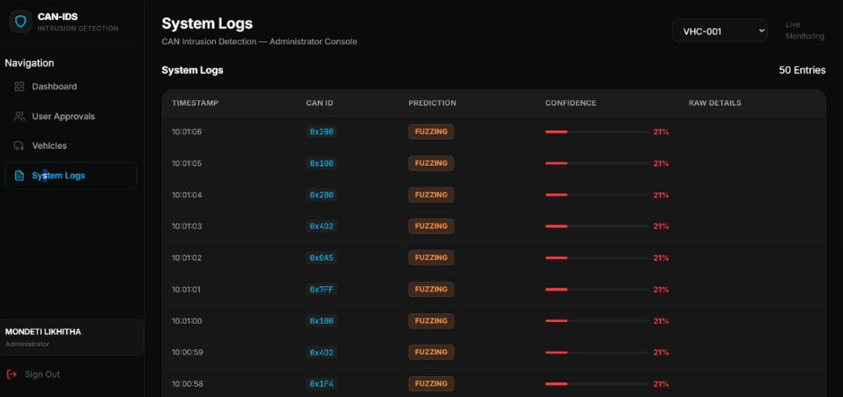
Screen 12. System Logs page
Live Logs page: The Live Logs module of the CAN Intrusion Detection Platform, which provides real-time monitoring of CAN bus messages. This module enables continuous observation and analysis of incoming data from connected vehicles. The logs are displayed in a tabular format, including attributes such as timestamp, vehicle
ID, CAN ID, DLC (Data Length Code), and payload. Each message is processed by the detection model, and the results are shown under prediction and confidence level, indicating whether the message is normal or potentially malicious. Additionally, a “Show Features” option is available for each entry, allowing detailed inspection of extracted features used for classification. This supports deeper analysis and understanding of model decisions. This module plays a critical role in real-time intrusion detection by enabling immediate identification of abnormal CAN messages and supporting prompt response to potential threats.
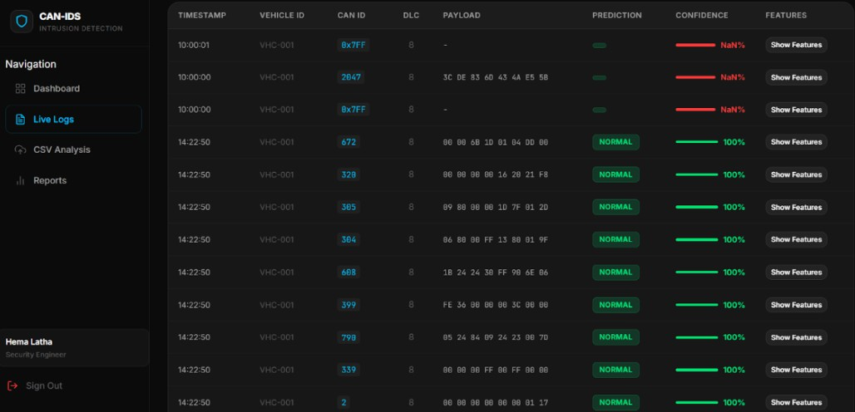

Screen 13. Live Logs page

CSV Analysis: The figure illustrates the CSV Analysis module of the CAN Intrusion Detection Platform, which allows users to analyze offline CAN bus datasets. This module is primarily used for batch processing and evaluation of recorded CAN messages. The interface provides an option to upload or drag-and-drop a CSV file containing CAN log data. The uploaded dataset must follow a standard format to ensure compatibility with the system. Once the file is uploaded, the user can initiate analysis using the “Start Security Scan” option. The system processes the dataset using the trained detection model and identifies whether the messages are normal or malicious. This module enables efficient offline analysis, supporting testing, validation, and investigation of CAN network data.
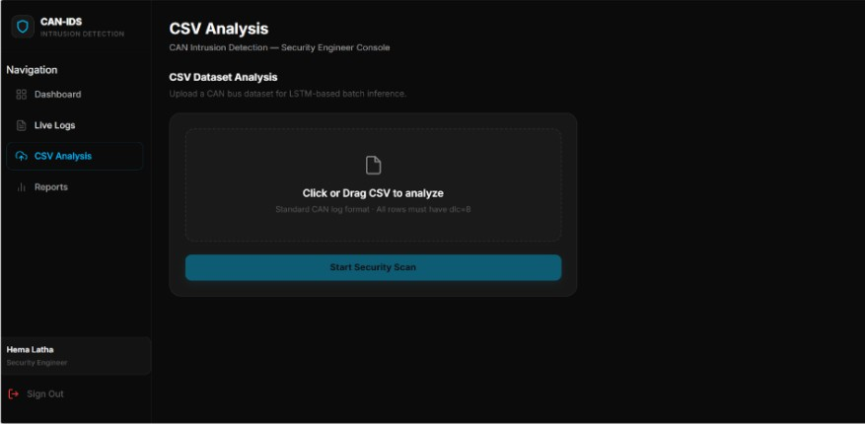
Screen 13. CSV Analysis
After processing the dataset, the system provides a summary of key metrics, including the total number of logs processed, number of detected attacks, and the overall attack rate. These metrics help in quickly assessing the level of anomalous activity present in the dataset. A graphical representation of attack distribution is also provided, showing the frequency of different attack types such as DoS, Fuzzing, Replay, and Spoofing.
Additionally, the module includes an option to download the analysis report, enabling further review and documentation of the results. Shown in screen
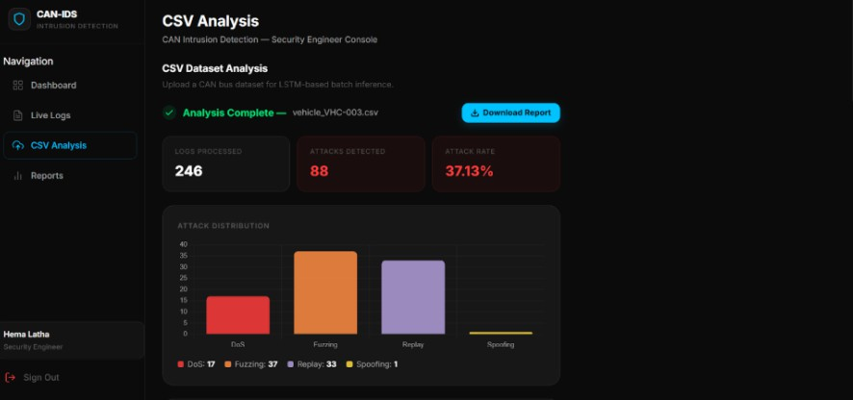
Screen 14 CSV Analysis(2)
Forensic Reports page: The Forensic Reports module of the CAN Intrusion Detection Platform, which provides a summarized analysis of detected events for a selected vehicle. This module is designed to support post-analysis and investigation of CAN network activity. The interface displays key metrics, including total events,
normal events, attack events, and the overall attack rate, enabling quick assessment of the security status.
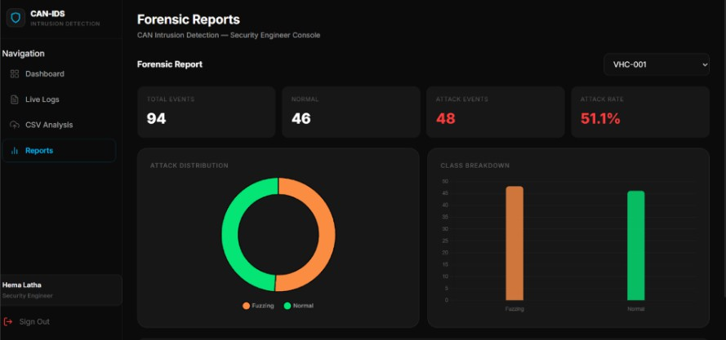
Screen 15. Forensic Reports page
Dashboard: the Fleet Overview Dashboard of the CAN Intrusion Detection Platform, designed for vehicle owners to monitor the status of their vehicles and associated CAN network activity. The dashboard provides key summary metrics, including the number of registered vehicles, total logs generated, attacks detected for the current day, and the current system status. These indicators help users quickly assess the overall security condition of their fleet. shown in screen
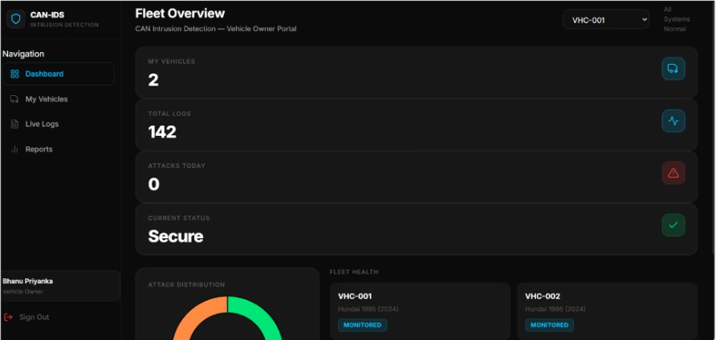
Screen 16. Dashboard

Vehicle Management Page: The Vehicle Management module of the CAN Intrusion Detection Platform, designed for vehicle owners to manage their registered vehicles within the system. The interface displays a list of vehicles along with key details such as vehicle ID, model information, license number, and assigned engineers. Each
vehicle is marked with its monitoring status, indicating whether it is actively being monitored by the system.
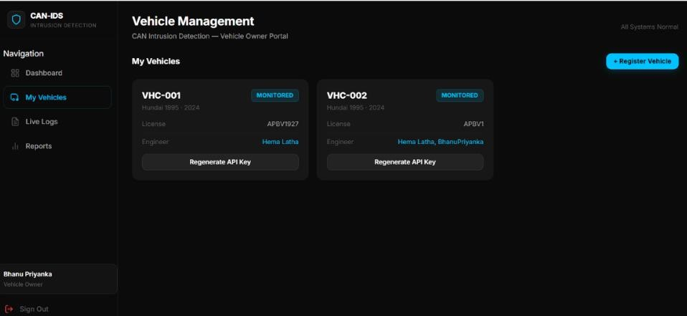
Screen 17. Vehicle Management Page

Security Reports Page: The Security Reports module of the CAN Intrusion Detection Platform, designed for vehicle owners to view summarized security insights for their vehicles.The interface presents key metrics such as total events, normal events, number of detected attacks, and the overall attack rate, enabling users to quickly evaluate the security status of the selected vehicle.
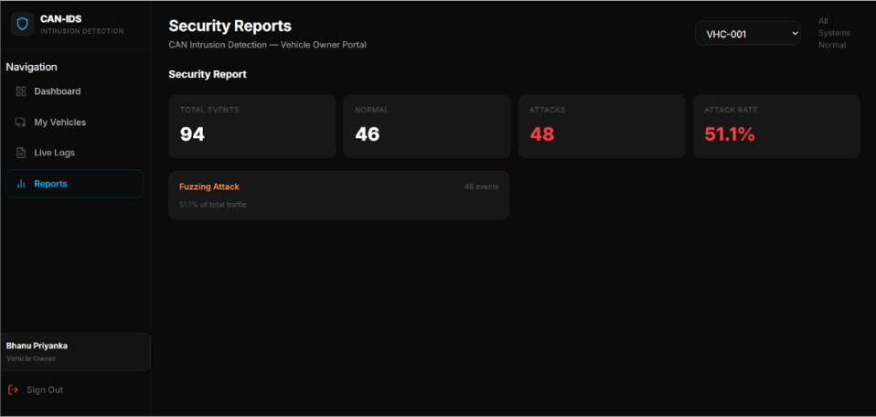
Screen 18. Security Reports Page

Graphs
The following figures 25 and 26 are graphs drawn to visualize the train accuracy of imbalanced and balanced carhacking dataset.
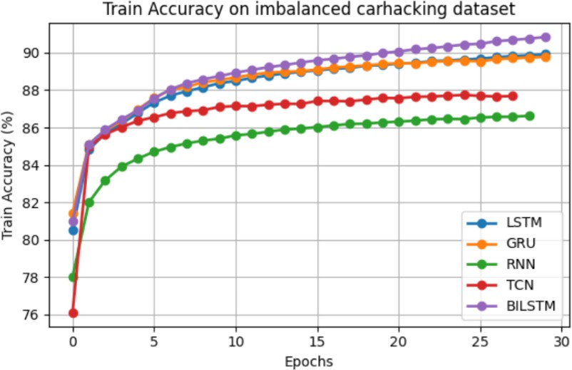

Fig. 25. Train Accuracy graphs on imbalanced for GRU, RNN, LSTM, BiLSTM, TCN model
At first all models get quickly. This means they are learning the CAN traffic patterns well. As time goes on the accuracy gets stable. This shows that the models are working well. The BiLSTM model does the best. It gets about 91% accuracy by the end. This is because it can look at the data in both directions. The LSTM and GRU models are also good. They get about 89-90% accuracy. This means that these kinds of models are good for CAN data. The TCN model is stable. Not as good as the others. It gets 87-88% accuracy. The RNN model is the worst. It gets 86-87% accuracy. This might be because it is not good at looking at long-term patterns. Overall the results show that models like BiLSTM and LSTM are better at learning from CAN traffic data. Shown in Fig 25
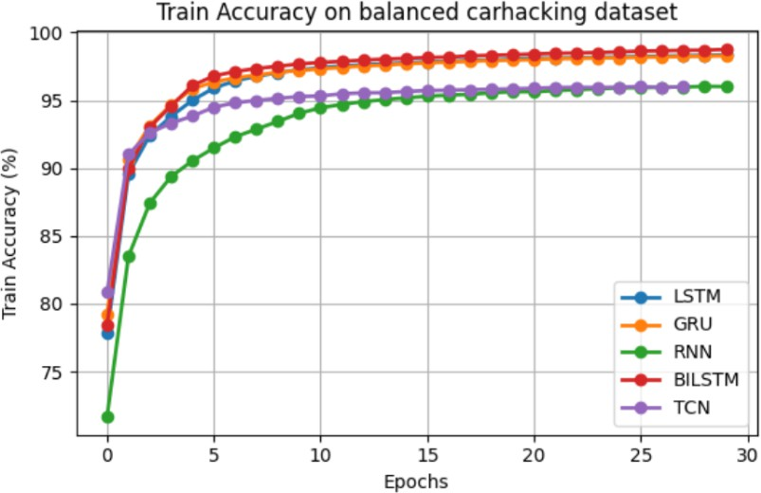
Fig. 26. Train Accuracy graphs on balanced for GRU, RNN, LSTM, BiLSTM, TCN model

All models do better because the data is balanced. The BiLSTM model does the best again. It gets about 99% accuracy. The LSTM and GRU models are also very good. They get about 98% accuracy. This shows that these models are good at looking at patterns in CAN message sequences. The TCN model is good. Not as good as the others. The RNN model is better than before but not as good as the others. It gets about 96% accuracy. The results show that balancing the data makes the models learn better. The BiLSTM model is always the best. This means it is very good at detecting CAN intrusions.
The following figures 27 and 28 are graphs drawn to visualize the train accuracy of imbalanced and balanced OTIDS dataset.
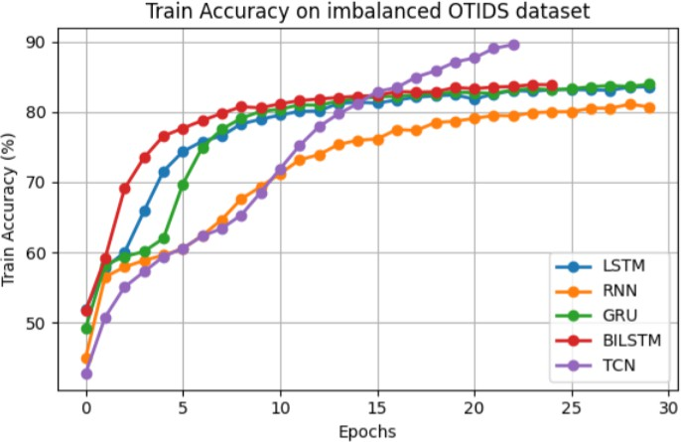

Fig. 27. Train Accuracy graphs on imbalanced for GRU, RNN, LSTM, BiLSTM, TCN model

At the beginning of the training process the models show an improvement in accuracy. This is because they are just starting to learn the patterns in the CAN traffic sequences. The OTIDS dataset is more complex than the Car Hacking dataset. So the models take a little longer to learn from it. The TCN model does the job. It reaches an accuracy of 89-90% by the end of the training process. This is because the TCN model uses a structure that can effectively extract temporal dependencies from the data. This allows the model to capture patterns in the CAN messages that're far apart. The BiLSTM model also does a job. It reaches an accuracy of 83-84%. The GRU and LSTM models are behind reaching an accuracy of around 82-84%. These models are good at capturing relationships in the data. However they are not as effective as the TCN model for this dataset. The RNN model does not do well. It only reaches an accuracy of 80-81%. This is because simple recurrent networks like RNN have trouble modeling long-term dependencies in data. Overall the results show that the TCN model is the best at learning from the imbalanced OTIDS dataset. This suggests that using convolution-based modeling can help capture complex patterns in CAN network traffic.

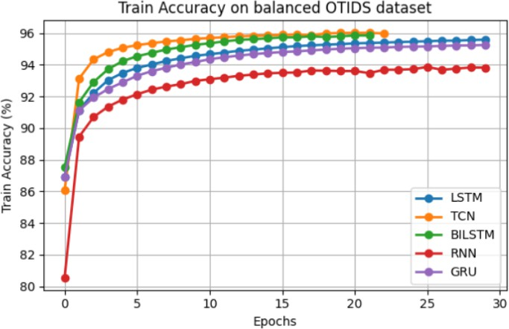
Fig. 28. Train Accuracy graphs on balanced for GRU, RNN, LSTM, BiLSTM, TCN model

TESTING AND VALIDATION

INTRODUCTION
Testing is a method to check whether the actual software product matches expected requirements and to ensure that software product is defect free. It involves execution of software/system components using manual or automated tools to evaluate one or more properties of interest.
Testing is a systematic process used to evaluate whether the developed CAN Bus Intrusion Detection System meets the specified requirements and operates without defects. It involves executing the system using both real-time CAN data and uploaded CSV datasets to verify correctness, performance, and reliability. Testing plays a critical role in identifying errors in early stages, ensuring that the system provides accurate attack detection results. A well-tested system improves reliability, enhances security, and ensures efficient detection of anomalies in vehicular networks.

Scope
A primary purpose for testing is to detect software failures so that defects may be uncovered and corrected. This is a non-trivial pursuit. Testing cannot establish that a product functions properly under all conditions but can only establish that it does not function properly under specific conditions. The scope of software testing often includes examination of code as well as execution of that code in various environments and conditions as well as examining the aspects of code: does it do what it is supposed to do and do what it needs to do. In the current culture of software development, a testing organization may be separate from the development team. There are various roles for testing team members. Information derived from software testing may be used to correct the process by which software is developed.

Defects and Failures
Defects in the system may arise due to:
- Incorrect preprocessing of CAN data
- Errors in sequence generation (sequence length = 20)
- Incorrect label mapping (0–4 classes)
- Model prediction inaccuracies A defect becomes a failure when: The system misclassifies an attack
The dashboard displays incorrect results CSV parsing fails for valid input
Some defects may not immediately cause failures but can impact performance under specific conditions.

Compatibility
Compatibility testing ensures that the system functions correctly across different environments and configurations. In this project, the system is tested in a Python 3.x environment with a backend developed using FastAPI and a frontend built with React, executed on modern web browsers such as Chrome and Edge. The database operations are handled using MongoDB to ensure reliable data storage and retrieval. To avoid compatibility issues, consistent library versions are maintained throughout the system, including PyTorch for implementing the BiLSTM model and Pandas and NumPy for data preprocessing. This ensures stable performance and smooth integration between different components of the system.

Input Combinations and Preconditions
Testing all possible CAN message combinations is impractical due to the high variability and volume of vehicle network data. Therefore, the system is designed to operate under specific preconditions, including a properly configured Python environment, availability of the trained BiLSTM model (.pth), loading of scaler and preprocessing files, a running MongoDB server, and correctly formatted CSV datasets. The system processes CAN logs by extracting relevant features, generating sequences of fixed length (e.g., 20 time steps), and feeding these sequences into the BiLSTM model for prediction.

Static Vs Dynamic Testing
Static testing is performed by reviewing the preprocessing logic, validating the API structure, and verifying the database schema design without executing the code. Dynamic testing involves executing the system in real conditions, such as uploading CSV files, running CAN data simulations, and observing prediction outputs and dashboard results. This ensures that the system behaves correctly and meets performance requirements during actual operation.

Software Verification and Validation
Verification: It is the process of checking that software achieves its goals without any bugs. It is the process to ensure whether the product is right or not.
Validation: It is the process of checking whether the software product is up to the mark or in other words product has high level requirements. It checks what we are developing is the right product.

Validation Testing
It is testing where testers performed functional and non-functional testing. Functional testing includes Unit Testing, Integration Testing and System Testing and non- functional testing includes User acceptance testing.
Testing Objectives:
- Testing is a process of executing a program with the intent of finding an error.
- A good test case is one that has a high probability of finding an as-yet- undiscovered error.
- A successful test uncovers an as-yet-undiscovered error.
Test Levels: The test strategy describes the test level to be performed. There are primarily three levels of testing.
- Unit Testing
- Integration Testing
- System Testing
In most software development organizations, the developers are responsible for unit testing. Individual testers or test teams are responsible for integration and system testing.

Unit Testing
Unit testing is done on individual modules as they are completed and become executable. It is confined only to the designer’s requirements. Each module can be tested using the following two strategies.

Black Box Testing
In this strategy some test cases are generated as input conditions that fully execute all functional requirements for the program. In this testing only the output is checked for correctness. The logical flow of the data is not checked. This testing has been uses to find errors in the following categories:
- Incorrect or mining functions
- Interface errors
- Errors in data structure or external database access
- Performance errors

White Box Testing
White Box Testing is software testing technique in which internal structure, design and coding of software is tested to verify flow of input-output and to improve design, usability and security. In white box testing, code is visible to testers so it is also called Clear box testing, Open box testing, Transparent box testing, Code-based testing and Glass box testing. In this test cases are generated on the logic of each module by drawing flow graphs of that module and logical decisions are tested on all the cases.

Integration Testing
Integration tests are designed to test integrated software components to determine if they actually run as one program. Testing is event driven and is more concerned with the basic outcome of screens or fields. Integration tests demonstrate that although the components were individually satisfaction, as shown by successfully unit testing, the combination of components is correct and consistent. Integration testing is specifically aimed at exposing the problems that arise from the combination of components.

System Testing
System testing ensures that the entire integrated software system meets requirements. It tests a configuration to ensure known and predictable results. An example of system testing is the configuration-oriented system integration test. System testing is based on process descriptions and flows, emphasizing pre-driven process links and integration points.

CONCLUSION
This project presented an intrusion detection system for vehicle networks using deep learning techniques. The system analyzes patterns in CAN bus communication to identify abnormal and malicious activities. Multiple models including RNN, LSTM, GRU, BiLSTM, and TCN were implemented and evaluated using features such as message IDs, data length, and payload bytes. The models were tested on two benchmark datasets, Car-Hacking and OTIDS, under both imbalanced and balanced conditions. Experimental results showed that deep learning models significantly outperform basic approaches in detecting intrusion patterns in sequential data. Among all models, BiLSTM achieved the best performance with an accuracy of 98.62%, along with high precision, recall, and F1-score. The study also demonstrated that data balancing improves model convergence and overall performance. Sequence-based models such as BiLSTM, LSTM, and GRU effectively captured temporal dependencies in CAN traffic, enabling accurate detection of multiple attack types including DoS, Fuzzy, Spoofing, and Replay attacks. Furthermore, the developed web-based system demonstrates the practical applicability of the proposed solution, integrating model prediction with a real-time interface for monitoring and analysis. This highlights the potential of deep learning in enhancing vehicle cybersecurity systems.

Future Scope
Although the proposed system achieves high accuracy in detecting intrusions in vehicle networks, several enhancements can be made to improve its real-world applicability and robustness. The system can be extended to support real-time intrusion detection by processing live CAN bus data instead of relying on offline datasets. Further optimization of the models can enable deployment on resource- constrained automotive systems such as embedded ECUs. Advanced deep learning architectures, including transformer-based models, can be explored to improve the detection of complex and evolving attack patterns. Additionally, the system can be enhanced to identify zero-day or previously unseen attacks using anomaly detection techniques. Finally, integrating the solution with actual vehicle environments and scalable cloud-based monitoring systems can make it more practical for large-scale deployment in modern automotive cybersecurity frameworks.

REFERENCE

- T.-T.-H. Le, Y. Hwang, J. Son, and H. Kim, “Leverage Sampling Methods and Deep Neural Networks for Fuzzer CAN Bus Message Detection,” IEEE Access, vol. 13, pp. 91533–91551, 2025, doi: 10.1109/ACCESS.2025.3572573.
- A. Yousseef et al., “Autonomous Vehicle Security: Hybrid Threat Modeling Approach,” IEEE Open J. Veh. Technol., vol. 6, pp. 1774–1795, 2025, doi: 10.1109/OJVT.2025.3580538.
- “Attacks to Automatous Vehicles: A Deep Learning Algorithm for Cybersecurity
| MDPI.” Accessed: Mar. 17, 2026. [Online]. Available: https://www.mdpi.com/1424- 8220/22/1/360
- A. Aloqaily, E. E. Abdallah, H. AbuZaid, A. E. Abdallah, and M. Al-hassan, “Supervised Machine Learning for Real-Time Intrusion Attack Detection in Connected and Autonomous Vehicles: A Security Paradigm Shift,” Informatics, vol. 12, no. 1, Jan. 2025, doi: 10.3390/informatics12010004.

