1. Find out the PG-13 rated comedy movies. DO NOT use the film_list table.

QUERY:
select f.film_id,f.title from film f,category c,film_category fc
where f.film_id=fc.film_id
and f.rating='PG-13'
and fc.category_id in
(select category_id from category
where fc.category_id=c.category_id
and c.name='Comedy');
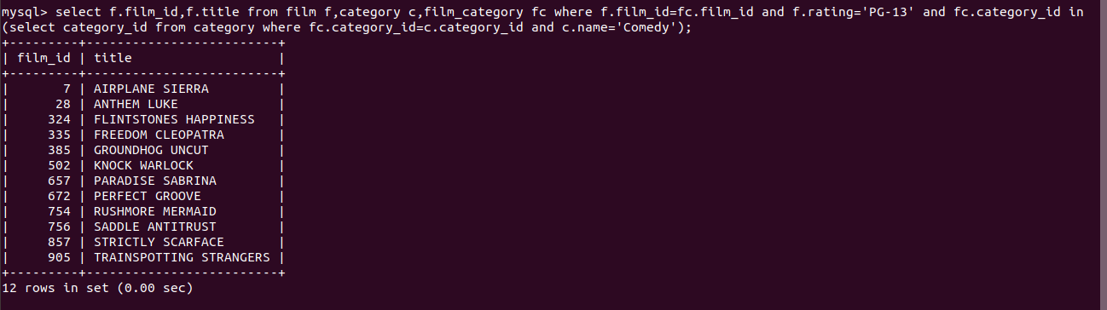

2. Find out the top 3 rented horror movies.

QUERY:
select fl.title, count(ALL fl.title) from film_list fl,inventory i,rental r
where fl.category = 'Horror'
and fl.FID = i.film_id
and i.inventory_id = r.inventory_id
group by title
order by count(ALL fl.title) desc limit 3;
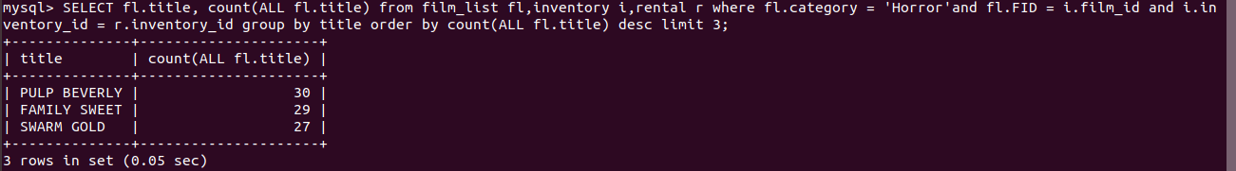
3. Find out the list of customers from India who have rented sports movies.

QUERY:
select cust.name from customer_list cust
where cust.country='INDIA'
and ID in
(select r.customer_id from film_list fl,inventory i,rental r
where fl.FID=i.film_id
and r.inventory_id=i.inventory_id
and fl.category='Sports'
group by r.customer_id);


4. Find out the list of customers from Canada who have rented “NICK WAHLBERG” movies.

QUERY:
select cust.name from customer_list cust
where cust.country='CANADA'
and ID in
(select r.customer_id from actor a,film_actor fa,inventory i,rental r
where a.first_name='NICK'
and a.last_name='WAHLBERG'
and a.actor_id=fa.actor_id
and fa.film_id=i.film_id
and r.inventory_id=i.inventory_id);
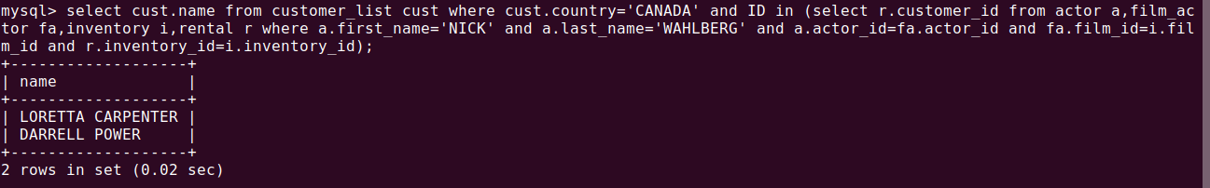

5. Find out the number of movies in which “SEAN WILLIAMS” acted.

QUERY:
select distinct count(fa.film_id) from actor a, film_actor fa
where a.first_name = 'SEAN'
and a.last_name = 'WILLIAMS'
and fa.actor_id = a.actor_id;
