1. Find out the number of documentaries with deleted scenes.

QUERY:
select count(distinct title) from film
where special_features like '%Deleted Scenes%'
and film.film_id in
(select film_category.film_id from film_category,category
where category.name='Documentary'
and category.category_id=film_category.category_id);

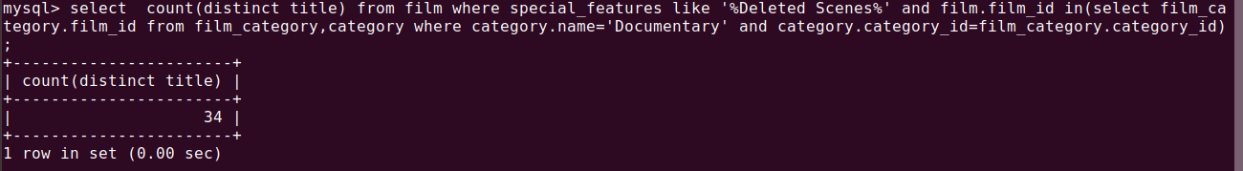
2. Find out the number of sci-fi movies rented by the store managed by Jon Stephens.

QUERY:
select count(*) from category c,film_category fc,inventory i,rental r,staff s
where c.name='Sci-fi'
and s.first_name='Jon'
and s.last_name='Stephens'
and fc.film_id=i.film_id
and c.category_id=fc.category_id
and i.inventory_id=r.inventory_id
and r.staff_id=s.staff_id;
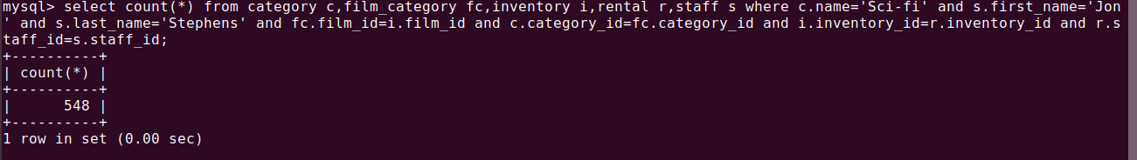
3. Find out the total sales from Animation movies.

QUERY:
select total_sales from sales_by_film_category where category='Animation';
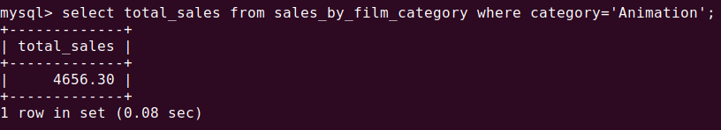

4. Find out the top 3 rented category of movies by “PATRICIA JOHNSON”.

QUERY:
select fl.category,count( fl.category) from film_list fl
where fl.FID in
(select i.film_id from customer_list cl,rental r,inventory i
where cl.name = 'PATRICIA JOHNSON'
and cl.ID = r.customer_id
and r.inventory_id = i.inventory_id g
roup by i.film_id)
group by fl.category
order by count(fl.category)
desc limit 3;
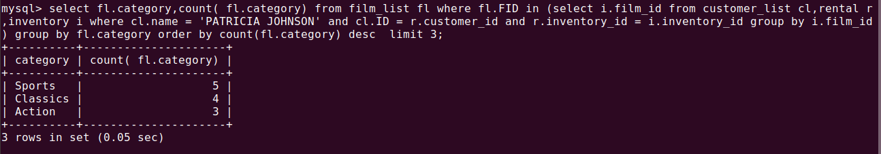

5. Find out the number of R rated movies rented by “SUSAN WILSON”.

QUERY:
select fl.title from film_list fl,inventory i,rental r,customer_list cl
where fl.rating = 'R'
and cl.name = 'SUSAN WILSON'
and fl.FID = i.film_id
and i.inventory_id = r.inventory_id
and r.customer_id = cl.ID ;
