./

– Report –

Calculator

**NAME: - Lakshmi Likhitha Vankayala**

Course Code: <CODE>



Version Number:1

Team Members: Lakshmi Likhitha Vankayala

Team No: 69

Module: **Stepin mini project**

**TABLE OF CONTENTS**

|  |  |  |
| --- | --- | --- |
| **SERIAL No.** | **CONTENT** | **PAGE No.** |
| 1 | Problem Statement | 3 |
| 2 | intro | 3 |
| 3 | Requirements | 3-4 |
| 4 | Architecture | 4-5 |
| 5 | Test Plan/Test cases | 6-9 |
| 7 | Conclusion | 10 |

**Introduction**

**Problem Statement:**

A Scientific calculator is a device which can perform some mathematical operations like arithmetic operations & scientific operations i.e., here In this project we are going to implement some calculator operations using C Language with a Command Line Interface ( CLI ) where it can perform operations like Arithmetic Operations Scientific Operations Trigonometric Operations.

# Requirements:

gcc compiler with a good system.

Any of the two linux/windows.

HIGH LEVEL REQUIREMENTS:

ID DESCRIPTION CATEGORY STATUS

HR01 User shall be able to work on windows or linux. Technical Implemented

HR02 User shall be able to choose strong password. Technical Implemented

HR03 User shall be able to remember its password. Scenario Implemented

HR04 User must have a decent system specification. Technical Implemented

LOW LEVEL REQUIREMENTS:

ID DESCRIPTION CATEGORY STATUS

HR01-LR01 User shall be able use Visual Studio/Code::Blocks software/Dev-C++. Technical Implemented

HR02-LR02 Password – contains/manages/handles password protection Technical Implemented

HR04-LR03 Minimum 10MB hard disk space required. Technical Implemented

HR04-LR04 Intel/Pentium powered system.Processor speed 1.7 GHZ required. Technical Implemented

**Hardware Requirements**

* Ram 512MB or higher.
* Minimum 10MB hard disk space.
* Intel/Pentium powered system.
* Processor speed 1.7 GHZ

**Software Requirements: -**

* Windows 8 or higher versions.
* Visual Studio/Dev-C++.

**Functional Requirements:**

* Scientific Calculator application is capable of performing following functions
  + Arithmetic Operations
    - MUL
    - SUB
    - DIV
    - ADD
  + Trigonometric Operations
    - SIN
    - COS
    - TAN
  + Scientific Operations
    - LOG
    - POWER
    - SQUARE ROOT

**Architecture:**

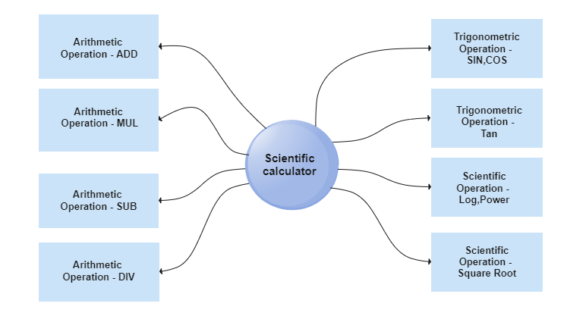

**Flow Chart Diagram:**

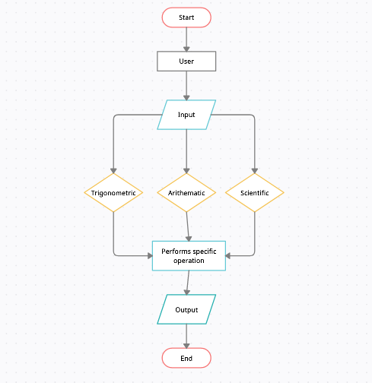

**Behavioural Diagram**

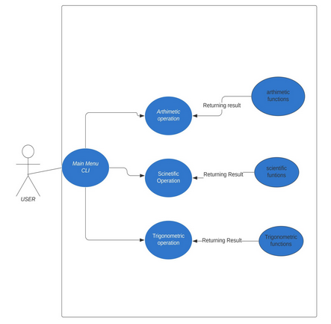

**Test Plan/Test cases**

## **High level test plan**

| **Test ID** | **Description** | **Exp I/P** | **Exp O/P** | **Actual Out** |
| --- | --- | --- | --- | --- |
| H_01 | Calling Arithmetic Menu | arithmetic_menu() | TRUE | TRUE |
| H_02 | Calling Scientific Menu | scientific_menu() | TRUE | TRUE |
| H_03 | Calling Trigonometric Menu | trigonometric_menu() | TRUE | TRUE |

## **Low level test plan**

| **Test ID** | **Description** | **HLID** | **Exp IN** | **Exp OUT** | **Actual Output** |  | **Type Of Test** |
| --- | --- | --- | --- | --- | --- | --- | --- |
| L_01 | Performing Arithmetic operation ‘**+'** | H_01 | (200,100) | 300 | 300 |  | Requirement based |
| L_02 | Performing Arithmetic operation **'+'** | H_01 | (20*2,-9+5) | 36 | 36 |  | Scenario based |
| L_03 | Performing Arithmetic operation **'+'** | H_01 | (-99999,99999) | 0 | 0 |  | Boundary based |
| L_04 | Performing Arithmetic operation **'-'** | H_01 | (15,5) | 20 | 20 |  | Requirement based |
| L_05 | Performing Arithmetic operation **'-'** | H_01 | (15*82,-5+28) | 1207 | 1207 |  | Scenario based |
| L_06 | Performing Arithmetic operation **'-'** | H_01 | (888889,77778) | 11111 | 11111 |  | Boundary based |
| L_07 | Performing Arithmetic operation **'*'** | H_01 | (159,286) | 45474 | 45474 |  | Requirement based |
| L_08 | Performing Arithmetic operation **'*'** | H_01 | (-15,-26) | 390 | 390 |  | Scenario based |
| L_09 | Performing Arithmetic operation **'*'** | H_01 | (159999,286666) | -126667 | -126667 |  | Boundary based |
| L_10 | Performing Arithmetic operation **'/'** | H_01 | (3888,24) | 162 | 162 |  | Requirement based |
| L_11 | Performing Arithmetic operation **'/'** | H_01 | (1,0) | ERROR_DIV_ZERO | ERROR_DIV_ZERO |  | Scenario based |
| L_12 | Performing Arithmetic operation **'/'** | H_01 | (9999,3) | 3333 | 3333 |  | Boundary based |
| L_13 | Performing Scientific operation **'Log'** | H_02 | (8869) | 3.95 | 3.95 |  | Requirement based |
| L_14 | Performing Scientific operation **'Log'** | H_02 | (124) | 3.95 | 2.09 |  | Scenario based |
| L_15 | Performing Scientific operation **'Log'** | H_02 | (124) | 3.95 | 2.09 |  | Scenario based |
| L_16 | Performing Scientific operation **'sqrt'** | H_02 | (24) | 4.09 | 4.09 |  | Requirement based |
| L_17 | Performing Scientific operation **'sqrt'** | H_02 | (45*32) | 37.95 | 37.95 |  | Scenario based |
| L_18 | Performing Scientific operation **'sqrt'** | H_02 | (9999) | 99 | 99 |  | Boundary based |
| L_19 | Performing Scientific operation **'power'** | H_02 | (5,20) | 95367433551872 | 95367433551872 |  | Requirement based |
| L_20 | Performing Scientific operation **'power'** | H_02 | (2*2,4) | 256 | 256 |  | Boundary based |
| L_21 | Performing Trigonometric operation **'Sin'** | H_03 | (10) | 0.17 | 0.17 |  | Requirement based |
| L_22 | Performing Trigonometric operation **'Sin'** | H_03 | (1000) | -0.98 | -0.98 |  | Boundary based |
| L_23 | Performing Trigonometric operation **'Cos'** | H_03 | (9) | 0.99 | 0.99 |  | Requirement based |
| L_24 | Performing Trigonometric operation **'Cos'** | H_03 | (8888) | -0.37 | -0.37 |  | Boundary based |
| L_25 | Performing Trigonometric operation **'Tan'** | H_03 | (6) | 0.11 | 0.11 |  | Requirement based |
| L_26 | Performing Trigonometric operation **'Tan'** | H_03 | (5555) | -0.47 | -0.47 |  | Boundary based |

**Conclusion**

Calculator gives the specified outcome of what the user wants to perform on operations like arithmetic, scientific, trigonometric using valid variables.

|  |  |  |  |  |  |
| --- | --- | --- | --- | --- | --- |
| **Ver. Rel. No.** | **Release Date** | **Prepared. By** | **Reviewed By** | **Approved By** | **Remarks/Revision Details** |
|  |  |  |  |  |  |
|  |  |  |  |  |  |
|  |  |  |  |  |  |
|  |  |  |  |  |  |
|  |  |  |  |  |  |

**Document History**