SQL is an acronym for structured query language pronounced at ‘SEQUEL’.The original version was developed by IBM. SQL is a standard language for storing, manipulating and retrieving data in databases.

* SQL is case insensitive. But it is a recommended practice to use keywords (like SELECT, UPDATE, CREATE, etc) in capital letters and use user defined things (liked table name, column name, etc) in small letters.
* We can write comments in SQL using “–” (double hyphen) at the beginning of any line.
* SQL is the programming language for relational databases (explained below) like MySQL, Oracle, Sybase, SQL Server, Postgre, etc. Other non-relational databases (also called NoSQL) databases like MongoDB, DynamoDB, etc do not use SQL

What Can SQL do?

* SQL can execute queries against a database
* SQL can retrieve data from a database
* SQL can insert records in a database
* SQL can update records in a database
* SQL can delete records from a database
* SQL can create new databases
* SQL can create new tables in a database
* SQL can create stored procedures in a database
* SQL can create views in a database
* SQL can set permissions on tables, procedures, and views

**What is Relational Database?**

* Relational database means the data is stored as well as retrieved in the form of relations (tables). Table 1 shows the relational database with only one relation called **STUDENT** which stores **ROLL_NO**, **NAME**, **ADDRESS**, **PHONE** and **AGE** of students.
* **STUDENT**

|  |  |  |  |  |
| --- | --- | --- | --- | --- |
| **ROLL_NO** | **NAME** | **ADDRESS** | **PHONE** | **AGE** |
| 1 | RAM | DELHI | 9455123451 | 18 |
| 2 | RAMESH | GURGAON | 9652431543 | 18 |
| 3 | SUJIT | ROHTAK | 9156253131 | 20 |
| 4 | SURESH | DELHI | 9156768971 | 18 |

These are some important terminologies that are used in terms of relation.

* **Attribute:** Attributes are the properties that define a relation. e.g.; **ROLL_NO**, **NAME** etc.
* **Tuple:** Each row in the relation is known as tuple. The above relation contains 4 tuples, one of which is shown as:

|  |  |  |  |  |
| --- | --- | --- | --- | --- |
| 1 | RAM | DELHI | 9455123451 | 18 |

* **Degree:** The number of attributes in the relation is known as degree of the relation. The **STUDENT** relation defined above has degree 5.
* **Cardinality:**The number of tuples in a relation is known as cardinality. The **STUDENT** relation defined above has cardinality 4.
* **Column:** Column represents the set of values for a particular attribute. The column **ROLL_NO** is extracted from relation STUDENT.

|  |
| --- |
| **ROLL_NO** |
| 1 |
| 2 |
| 3 |
| 4 |

The SQL is subdivided according to their functions as follows.

1)Data Definition Language (DDL)

2)Data Manipulation Language (DML)

3)Data Control Language (DCL)

4)Transaction Control Language (TCL)

The SQL Language supports different DataTypes.They are:

1.Char (Size)

2.Varchar (Size)

3.Int

4.Float

5.Real

6.Numeric (Size)

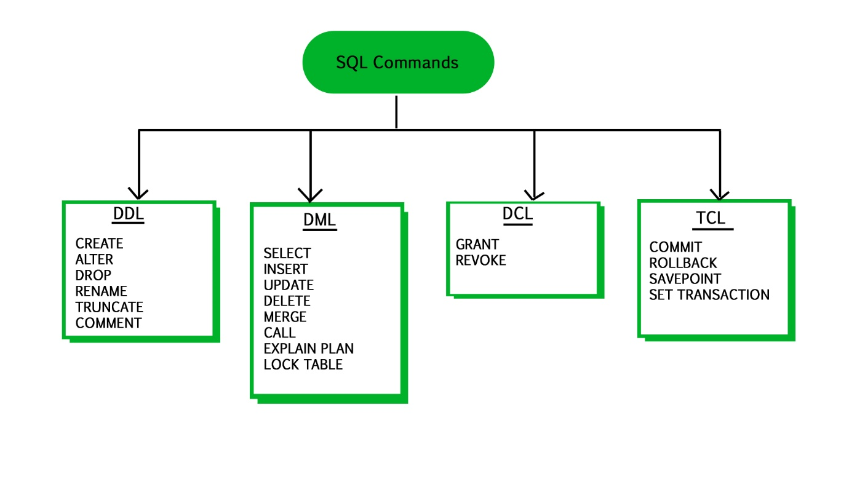

**DDL**: Data Definition Language is used to define the database structure or schema. DDL is also used to specify additional properties of the data. The storage structure and access methods used by the database system by a set of statements in a special type of DDL called a data storage and definition language.

**Some Commands:**

CREATE: to create objects in database

ALTER: alters the structure of database

DROP: delete objects from database

RENAME: rename an objects

Let’s see how will this commands work in DDL

1)create: The CREATE command is used to create new database in DBMS, and create new table in database. In other word we can say CREATE command used to create new database and table.

Syntax: **create table** Table_name  
(  
Column1 datatype(size),  
Column2 datatype(size),  
Column3 datatype(size)  
)

Let’s see one example:

SQL> create table stu_details46(sid int,sname char(20),saddress varchar(30),sphone number(10));

Table created.

SQL> desc stu_details46;

Name Type

----------------------------------------- -------- ----------------------------

SID NUMBER(38)

SNAME CHAR(20)

SADDRESS VARCHAR2(30)

SPHONE NUMBER(10)

2)Alter: The ALTER command used to modify the structure of table without deleting and recreating.

Once we created table in database, some time we may need to modify the definition of it. The ALTER command allows you to make changes to the structure of a table without deleting.

We can use **ADD,** **RENAME**and**DROP** command with ALTER command.

**ADD –** ADD used to add new columns in existing table.

**RENAME –** it renames the old column name to new column name of columns in table.

**DROP –** Remove the column from table.

### **1)Syntax of Add column:**

alter table table_name add column datatype(size);

SQL> alter table stu_details46 add smail varchar(30);

Table altered.

SQL> desc stu_details46;

Name Type

----------------------------------------- -------- ----------------------------

SID NUMBER(38)

SNAME CHAR(20)

SADDRESS VARCHAR2(30)

SPHONE NUMBER(10)

SMAIL VARCHAR(30)

2)Syntax for RENAME:

alter table stu_details46 rename column old column name to new column name;

SQL> alter table stu_details46 rename smail to smailid;

Table altered.

SQL> desc stu_details46;

Name Type

----------------------------------------- -------- ----------------------------

SID NUMBER(38)

SNAME CHAR(20)

SADDRESS VARCHAR2(30)

SPHONE NUMBER(10)

SMAILID VARCHAR(30)

3)Syntax for DROP:

alter table tablename drop column name;

SQL> alter table stu_details46 drop saddress;

Table altered.

SQL> desc stu_details46;

Name Type

----------------------------------------- -------- ----------------------------

SID NUMBER(38)

SNAME CHAR(20)

SPHONE NUMBER(10)

SMAIL VARCHAR(30)

### **Truncate:**

### The TRUNCATE TABLE command used to delete all the rows/records from entiretable.The TRUNCATE command also remove the index from columns.

If we want to delete the table structure then use DROP Command. The TRUNCATE TABLE Command only delete the data from the table not the structure of table from database.

The TRUNCATE TABLE command cannot delete any data that would violate FOREIGN KEY or any other constraints.

### **TRUNCATE TABLE Command Syntax:**

truncate table tablename;

tablename is the name of table to be truncated.

**SQL>truncate table stu_details46;**

Delete all the records from Student table when execute above truncate command.

SQL>desc stu_details46;

Name Type

----------------------------------------- -------- ----------------------------

### **The DROP TABLE Command Syntax:**

### drop table tablename;

### Tablename is the name of table to be deleted.

SQL>drop table stu_details46;

Table dropped.

If we want to insert any data in stu_details46 then it shows error I.e,

Table(stu_details46) doesnot exists.

So this is about DDL commands.