AI ASSISTED CODING
LAB ASSIGNMENT-1
Name: Likhitha Banna
HT.NO: 2303A51952
Batch: 22
Question-1: AI-Generated Logic Without Modularization (Factorial without Functions)
Prompt: # generate a code to get factorial of a number without using functions
Code and Output Screenshot:
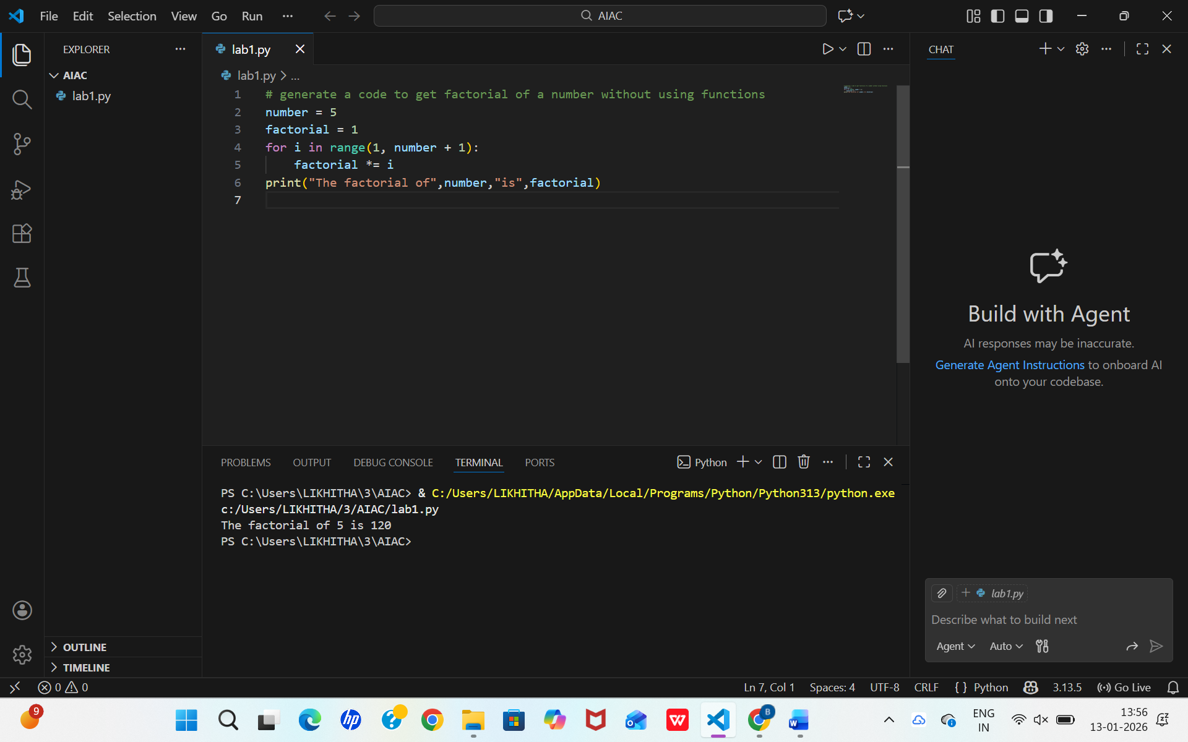
Observation:
GitHub Copilot was helpful for me being a beginner, it helped me with the right type of logic in loops. It shortened the time to consider syntax and basic control flow logic. Copilot made the things easy like initializing a variable properly and choosing good loop condition expressions. For new user it works more like an intelligent code assistant than an educator. Finally it improves confidence and quickness and must be done while also learning base skills.
Question-3: Modular Design Using AI Assistance (Factorial with Functions)
Prompt: # generate a code to get factorial of a number with using functions
Code and Output Screenshot:
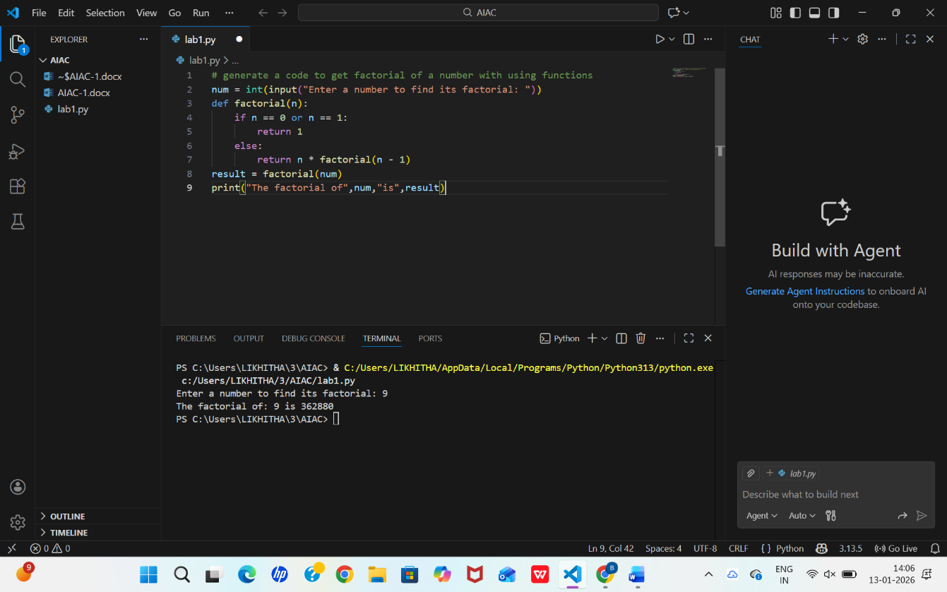
Observation:
Using GitHub Copilot for a modular design made the code more structured and easier to understand. Copilot suggested meaningful function names and clear parameters, which improves readability. The separation of logic into a function allows the same factorial computation to be reused across multiple programs. Inline comments generated by Copilot helped clarify each step of the logic for beginners. Copilot naturally encourages good programming practices through function-based design.

Question-4: Comparative Analysis – Procedural vs Modular AI Code (With vs Without Functions)
Prompt: No prompt
Code and Output Screenshot: No code
Comparison Table:
Features | Without Functions | With Functions
Code Structure | Simple and linear | Organized and Modular
Length of code | Shorter | Slightly long
Reusability | Cannot be reduced easily | Can be reused multiple times
Maintenance | Harder for large programs | Easy to debug and modify
Calling Mechanism | Runs directly | Function is called

Technical Report:
For logic clarity, the procedural version (without functions) is straightforward for very small scripts because all statements are visible in a single flow. Beginners can quickly trace the execution from input to output. However, as the logic grows, this approach becomes cluttered. The modular version (with functions) improves clarity by encapsulating the computation inside a well-named function, making the program’s purpose easier to understand at a glance.
For debugging procedural code can be simple to debug in small programs, but it becomes difficult when the script grows longer. Modular code simplifies debugging because errors can be isolated within a specific function. This makes testing individual components easier and faster.
For AI dependency risk, both approaches carry some risk if developers rely blindly on Copilot’s output. However, modular code reduces this risk slightly because clearer structure and naming make it easier for humans to review and validate AI-generated logic.

Question-5: AI-Generated Iterative vs Recursive Thinking
Iterative:
Prompt: # generate a code to get factorial iteratively
Code and Output Screenshots:
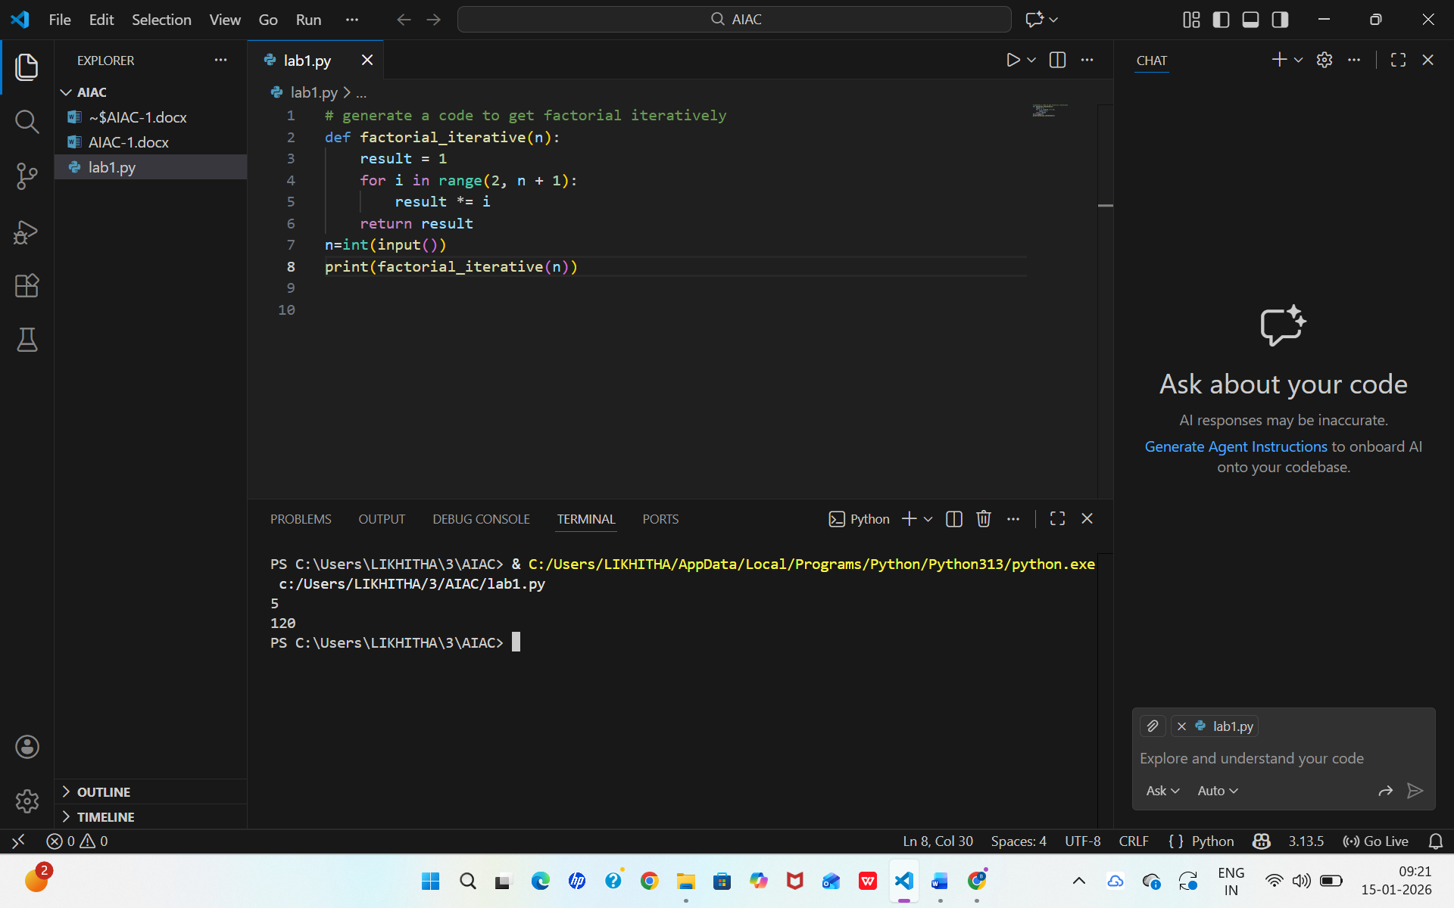
Recursive:
Prompt: # generate a code to get factorial recursively
Code and Output Screenshots:
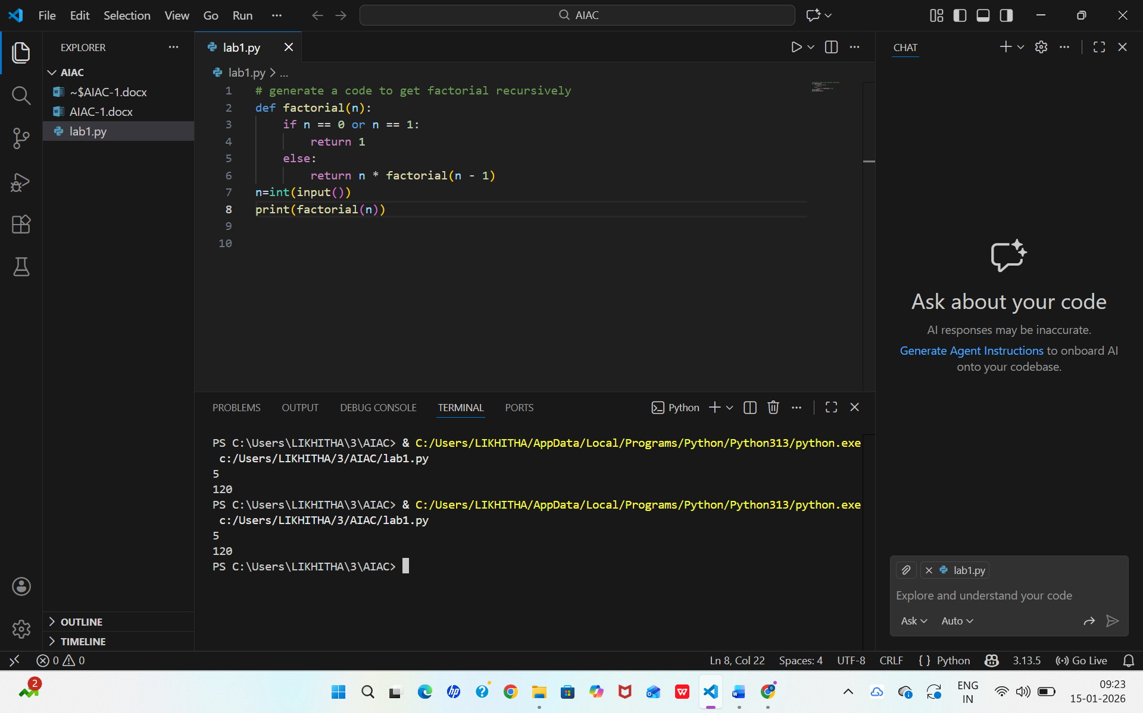
Execution Flow Explanation:
In iterative approach, the program starts with a result value of 1 and repeatedly multiplies it by each number from 1 up to the given input. The computation happens in a single loop, and the result is updated step by step until the loop ends.
In recursive approach, the function breaks the problem into smaller subproblems. Each function call waits for the result of the next call until it reaches the base case (1 or 0). Once the base case is reached, the results are returned back through the call stack and multiplied to produce the final factorial.
Comparative Analysis:
Readability
- Iterative code is easier for beginners to read and understand.
- Recursive code is more mathematically good but harder to trace.
Stack Usage
- Iterative implementation uses constant memory.
- Recursive implementation uses additional stack memory for each function call.
Performance Implications
- Iterative approach is generally faster and more memory-efficient.
- Recursive approach has overhead due to function calls and stack usage.
When Recursion Is Not Recommended
- When the input size is very large (risk of stack overflow).
- In performance-critical or memory-constrained applications.
- When the logic does not naturally fit a recursive pattern.

