AI ASSISTED CODING
LAB ASSIGNMENT-7
Name: Likhitha Banna
HT.NO: 2303A51952
Batch: 22
Lab 7: Error Debugging with AI: Systematic approaches to
finding and fixing bugs
Question-1: Analyse given code where a mutable default argument causes
unexpected behaviour. Use AI to fix it.
Screenshot:

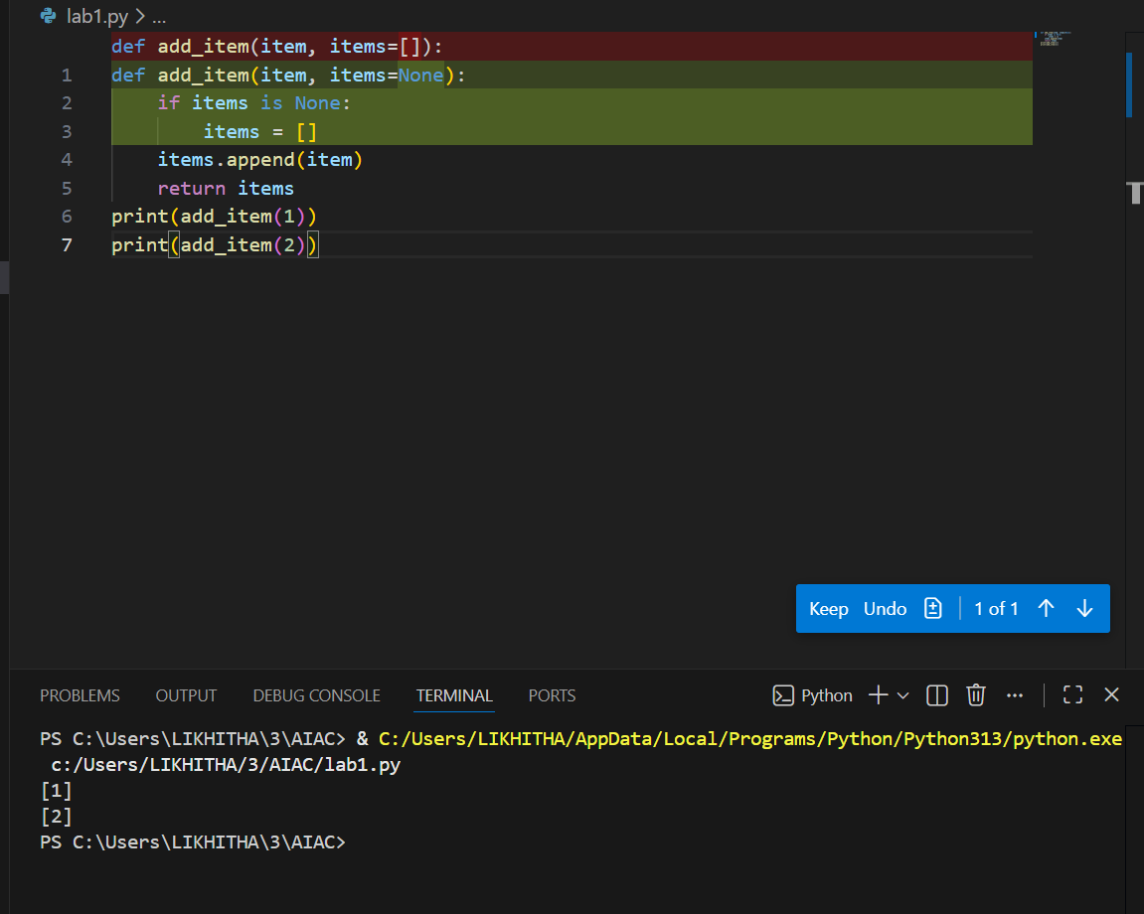

Question-2: Analyse given code where floating-point comparison fails. Use AI to correct with tolerance.
Screenshot:

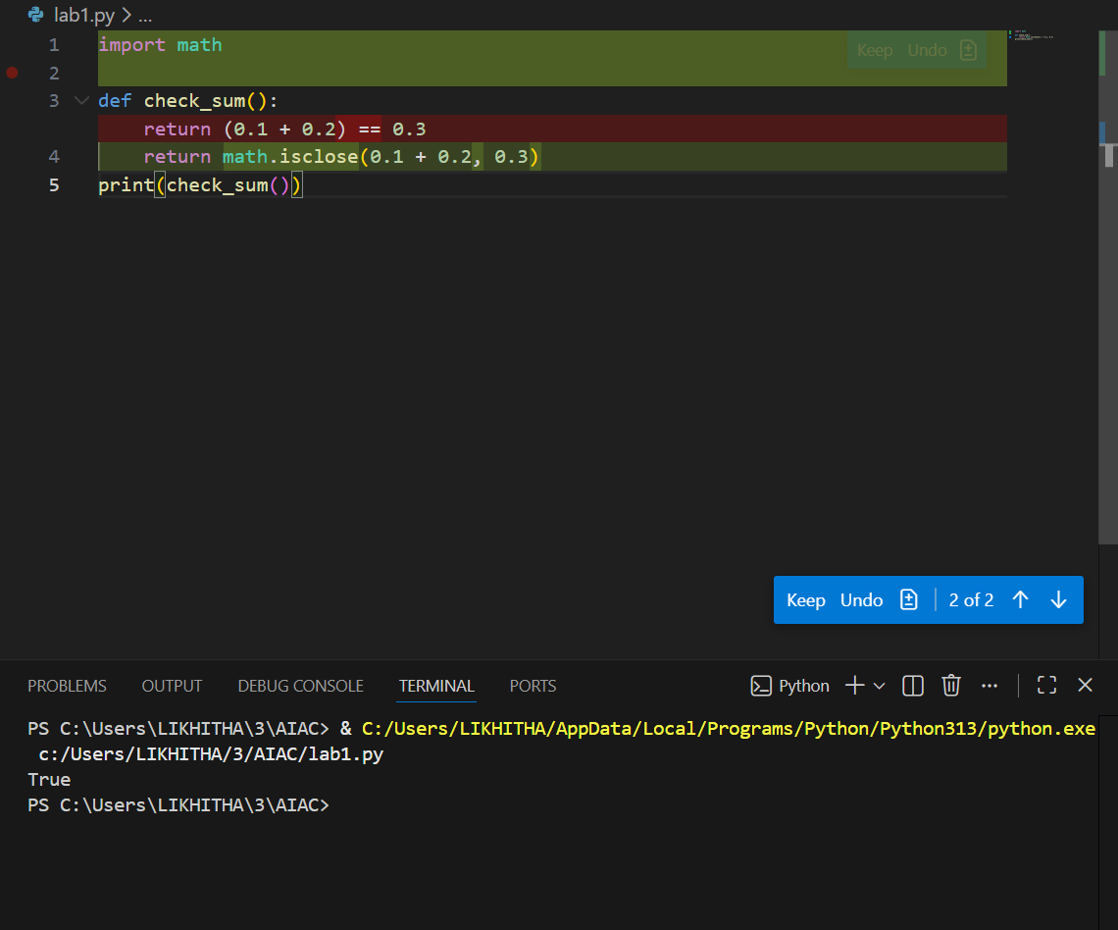

Question-3: Analyse given code where recursion runs infinitely due to missing base case. Use AI to fix. Generating using colab:
Screenshot:

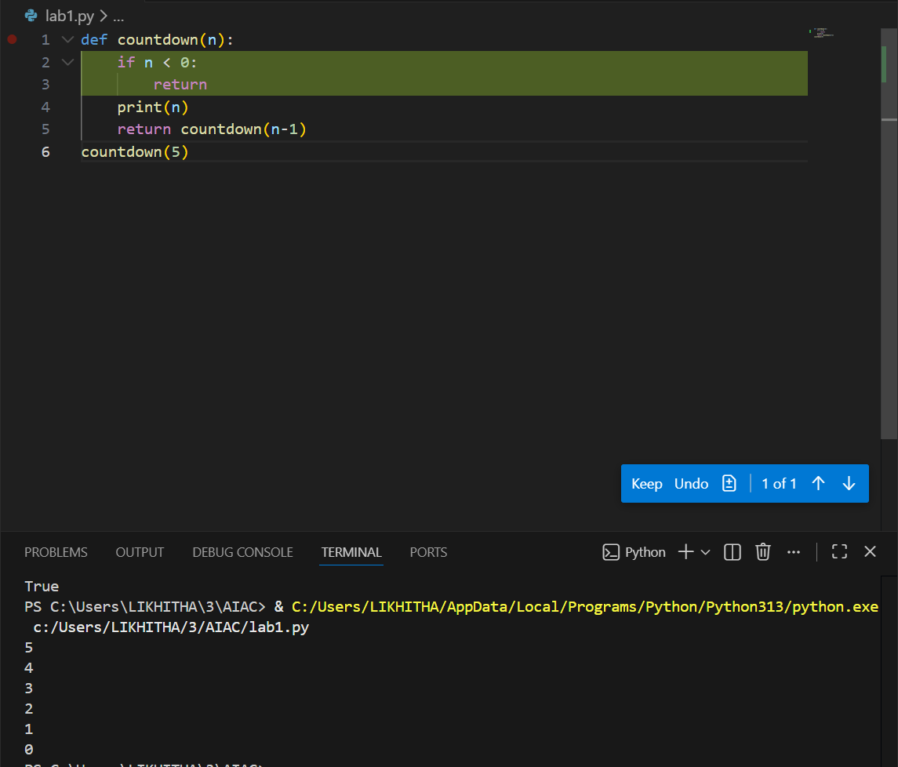

Question-4: Analyse given code where a missing dictionary key causes error. Use AI to fix it.
Screenshot:

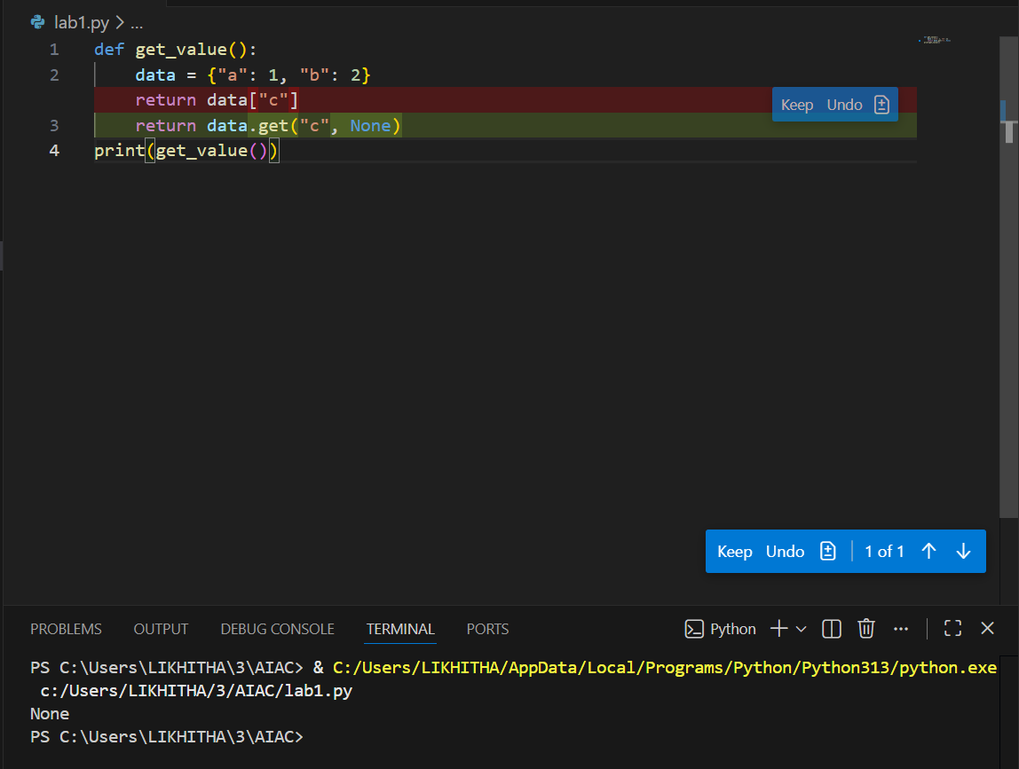

Question-5: Analyse given code where loop never ends. Use AI to detect and fix it.
Screenshot:

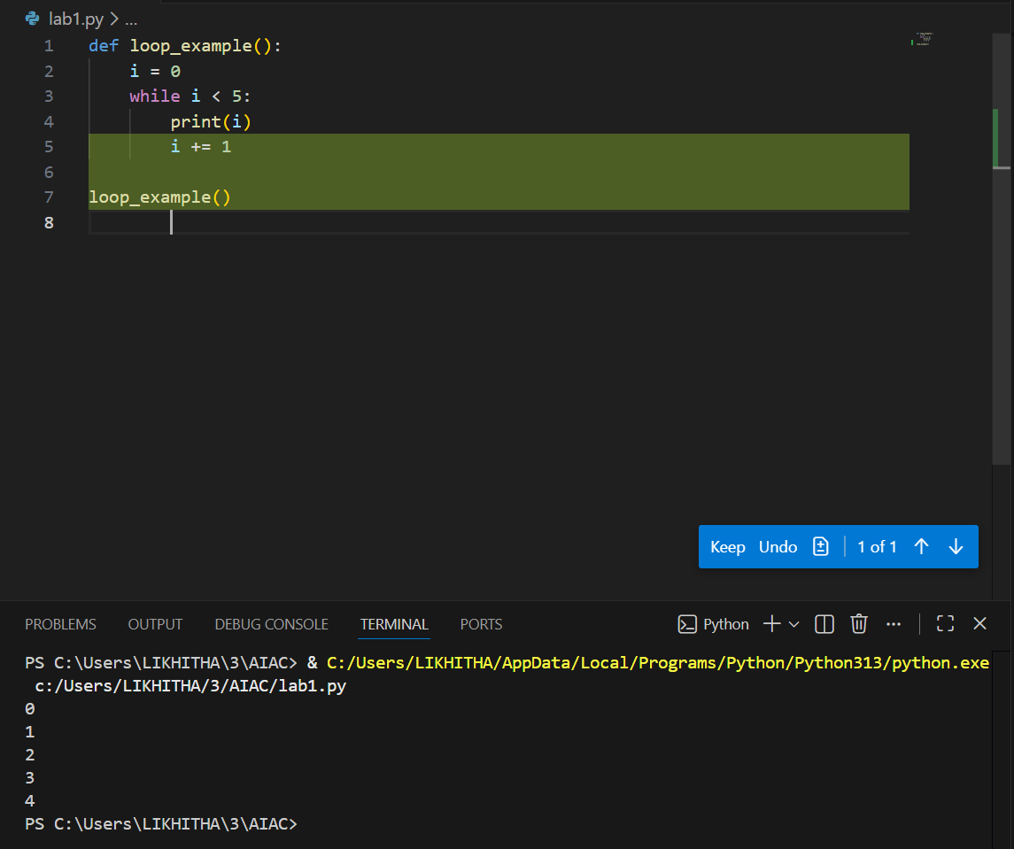

Question-6: Analyse given code where tuple unpacking fails. Use AI to
fix it.
Screenshot:

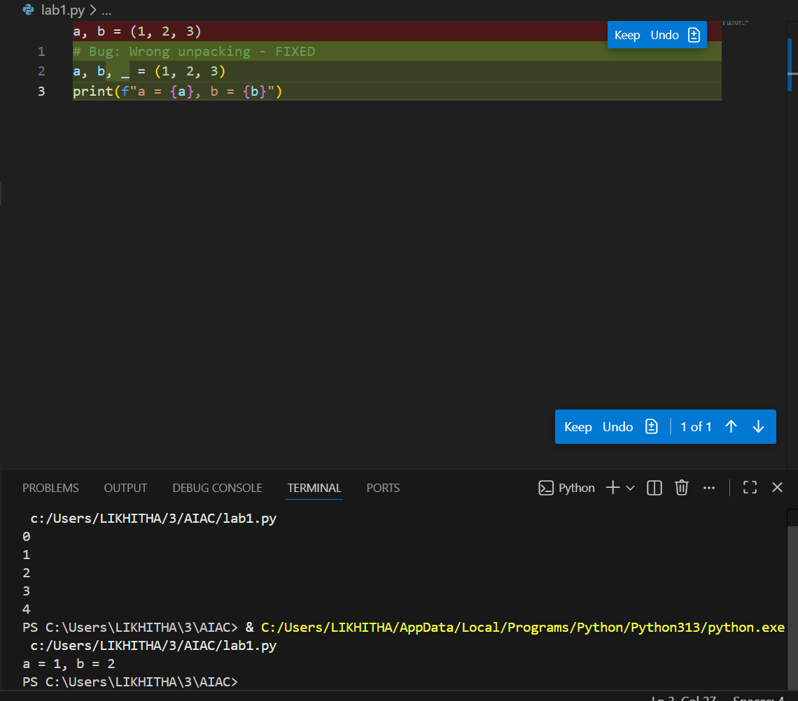

Question-7: Analyse given code where mixed indentation breaks execution. Use AI to fix it.
Screenshot:

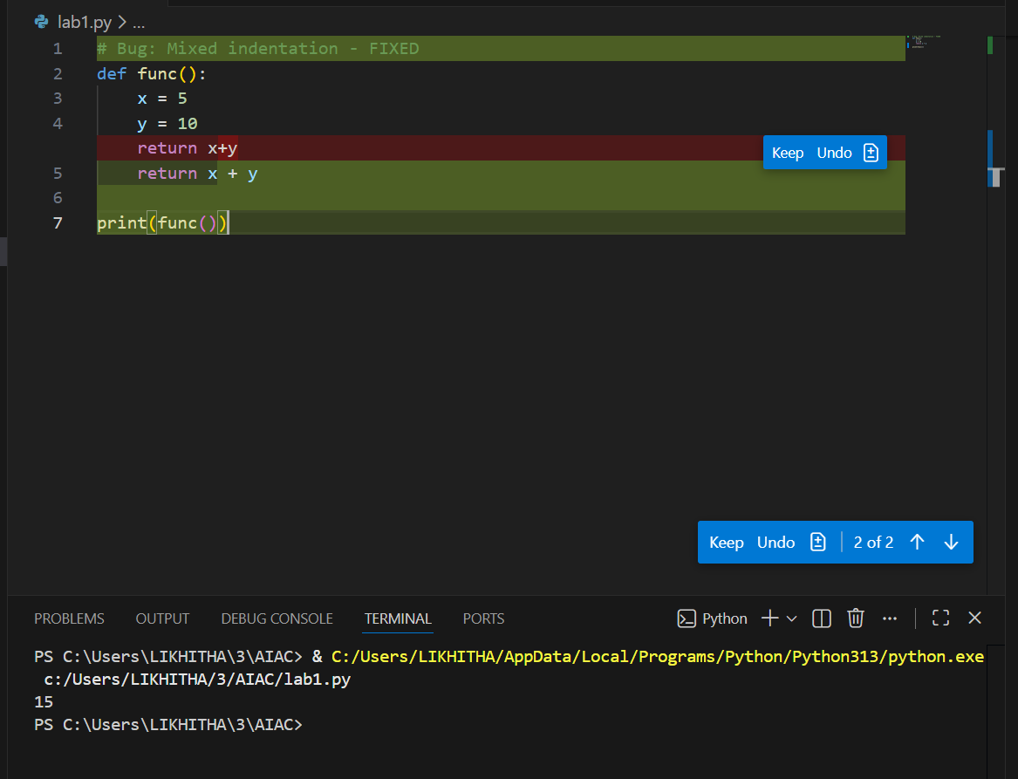

Question-8: Analyse given code with incorrect import. Use AI to fix.
Screenshot:

