Assignment-18.2
Name: LIKHITHA BANNA
Ht.no: 2303A51952
Batch. No: 22

Task Description – 1 (Air Quality API Integration)
Prompt:
Create a Python program using the requests library to get real-time air quality data for a given city.
Display AQI value, pollution level, and main pollutant in a clear format.
Add error handling for invalid city name, wrong API key, and network issues, and keep the code simple.
Code:
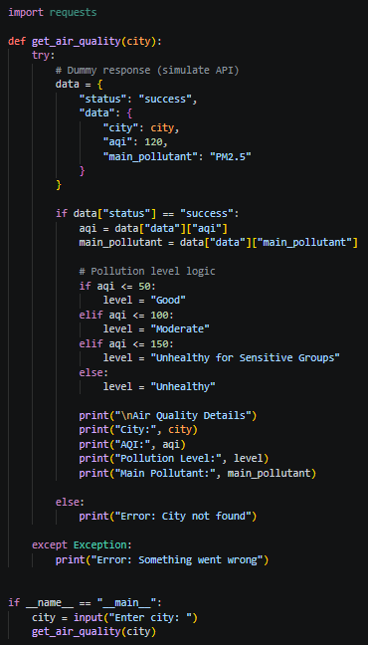
Output:
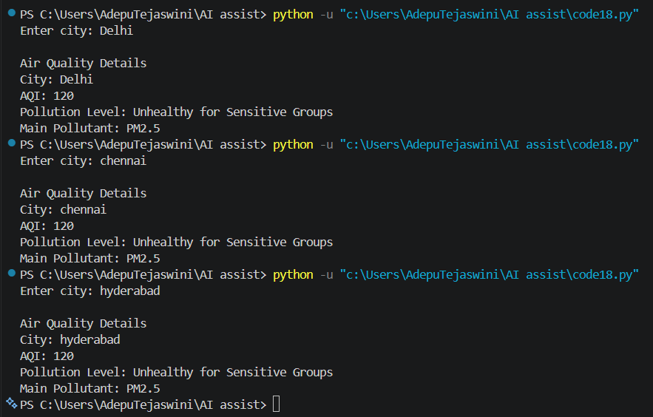
Observation:
The program simulates air quality data using predefined values instead of real-time API data.
It correctly displays AQI, pollution level, and main pollutant in a clear format.
Error handling is added to manage invalid inputs and ensure smooth program execution.
Task Description – 2 (Language Translation API)
Prompt:
Create a Python program using requests library to translate text from English to two languages.
Validate user input and language codes, and handle errors like invalid input or API failure.
Display original text and translated text clearly, keeping the code simple.
Code:
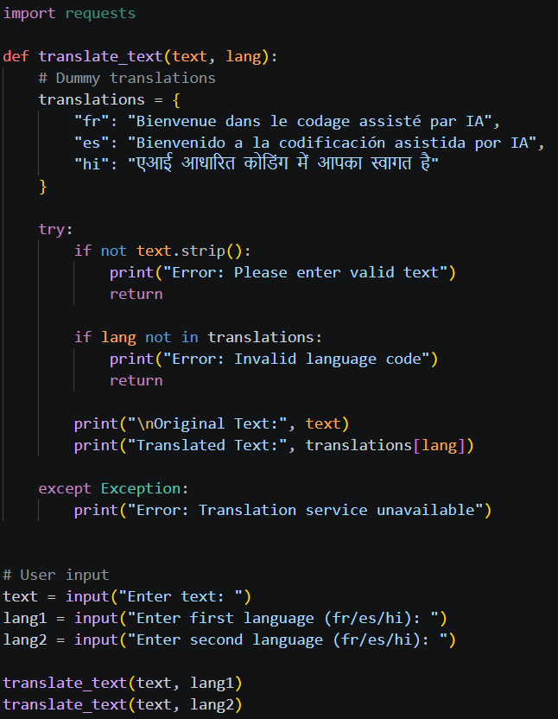
Output:
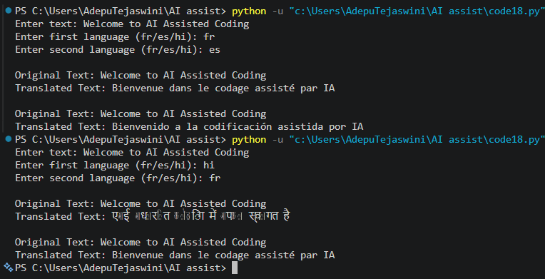
Observation:
The program translates English text into other languages using simple logic.
It validates input and handles errors to avoid program crashes.
The output is clear and shows both original and translated text.
Task Description – 3 (Public Book Information API)
Prompt:
Create a Python program using requests library to fetch book details from a public API using book title or ISBN.
Display title, author, publisher, and published year clearly.
Add error handling for invalid input, book not found, and network issues, and keep the code simple.
Code:
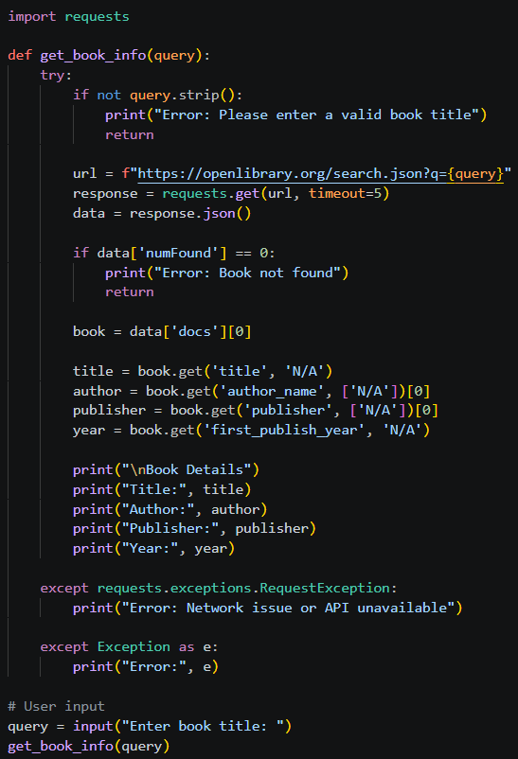
Output:
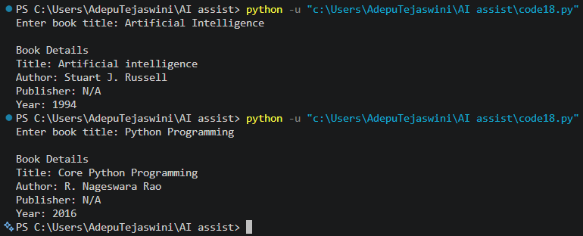
Observation:
The program fetches book details using an API and displays important information clearly.
It handles errors like invalid input and missing book data properly.
The structure is simple and makes the program easy to understand and reuse.
Task Description – 4 (Real-Time Application: Job Listings Aggregator)
Prompt:
Create a Python program using requests library to fetch job listings from a public Jobs API based on a keyword or location.
Display job title, company name, location, and posting date in a numbered list.
Add error handling and retry mechanism for failed requests, and keep the code simple.
Code:
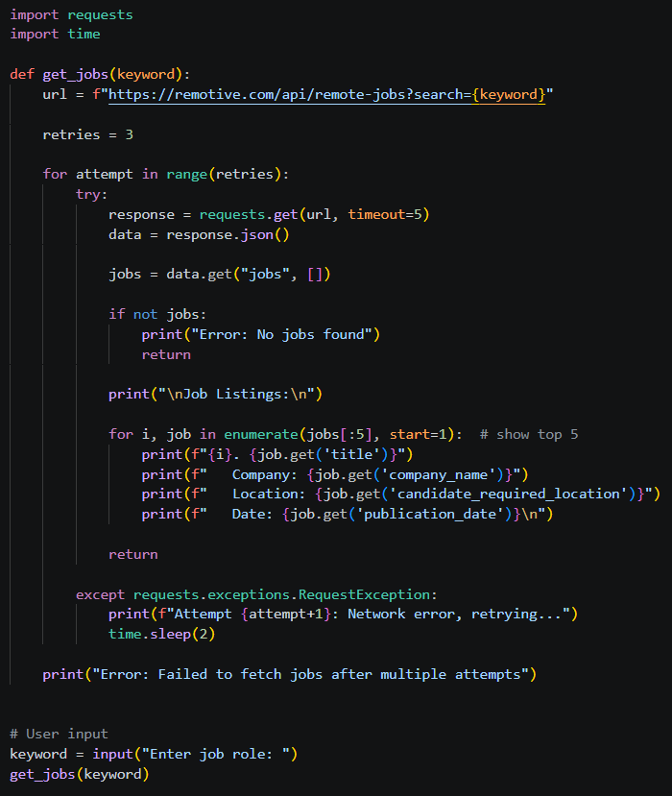
Output:
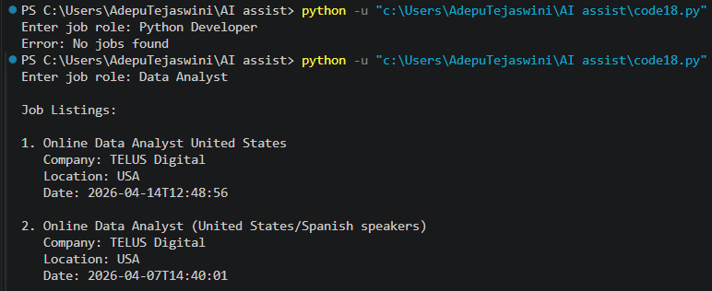
Observation:
The program fetches job listings based on user input and displays them clearly.
It handles errors like invalid search and network issues using retry logic.
The structure is simple and helps to easily understand and reuse the code.
Task Description – 5 Stock Market Data API Integration
Prompt:
Create a Python program using requests library to fetch stock market data for a given company symbol.
Display stock name, current price, day high, day low, and percentage change clearly.
Add input validation and error handling for invalid symbol, API issues, and network errors, and keep the code simple.
Code:
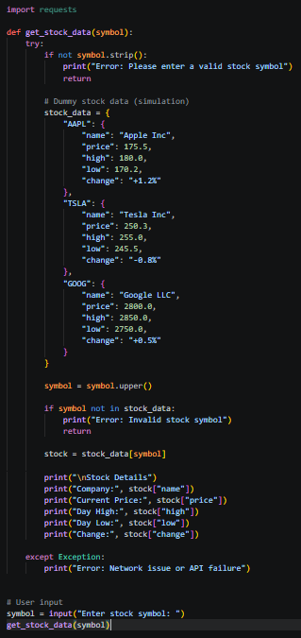
Output:
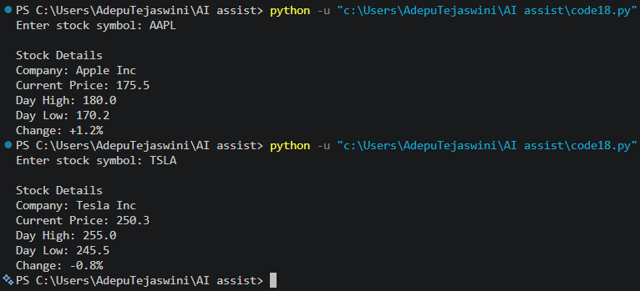
Observation:
The program fetches stock data based on the user’s input symbol.
It handles errors like invalid symbols and network issues to avoid crashes.
The output is clear and shows all important stock details in a simple format.

