Name: Likhitha Banna
Hallticket:2303A51952 Batch:22

AI ASSISTANT CODING
ASSIGNMENT-17

Task 1 – Password Security Enhancement
Task: Analyze an AI-generated Python program that stores passwords in plain text and improve its security.
Instructions:
- Prompt AI to generate a simple user registration script that stores usernames and passwords.
- Check whether passwords are stored as plain text.
- Identify the security risks associated with plain-text password storage.
- Refactor the program to use secure password hashing (e.g., hashlib or bcrypt).
- Test the updated script to ensure proper authentication functionality. Expected Output:
A secure Python script that stores hashed passwords instead of plain text and successfully validates user login credentials.
Prompt:-
Generate a python code that cleans and prepare a students academic dataset for analysis. The dataset contains follwing columns: student_id, name, gender, department,
marks, attendance, gender_encoded, department_encoded. The code should handle missing values in marks, attendance, and department. remove duplicates, standardize text fields such as department names, and categorical variable like gender and department.
Finally, the code should output a cleaned and encoded pandas Dataframe ready for analysis.
Code:-

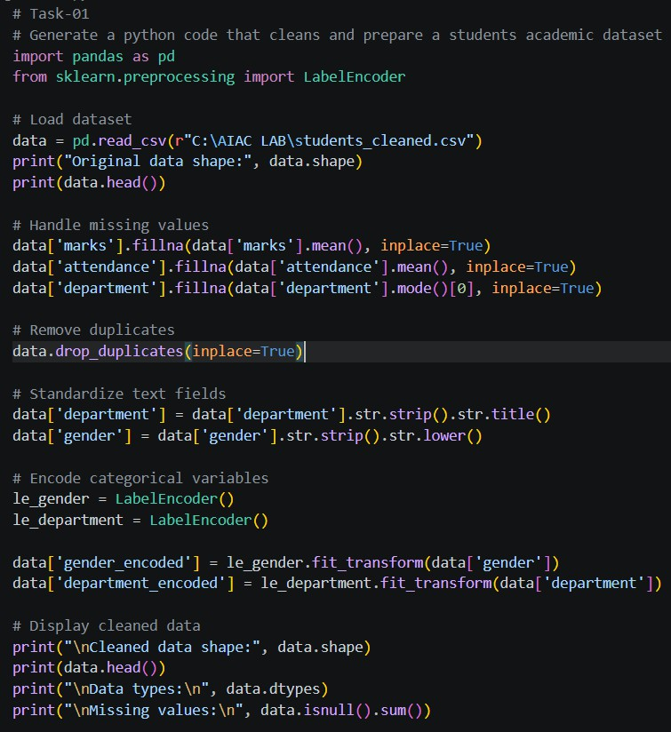

Output:-
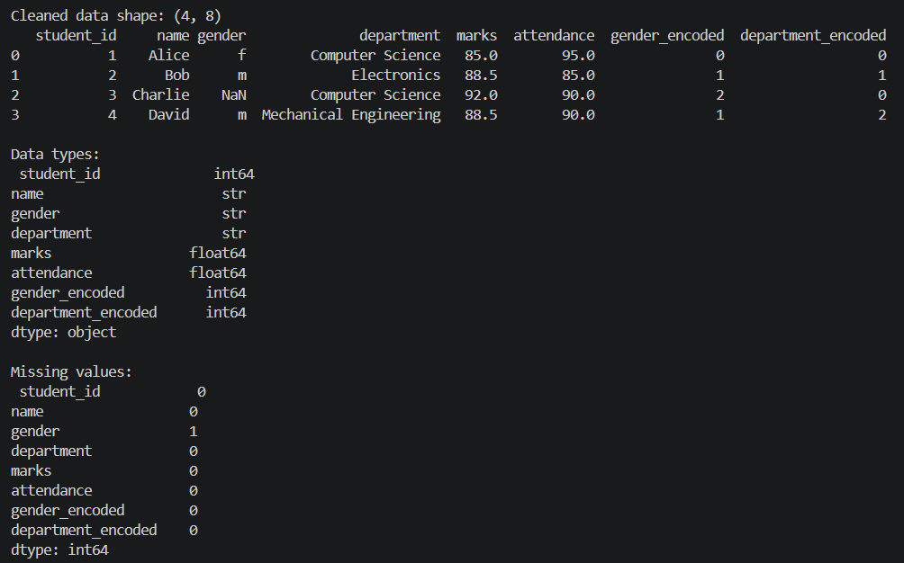
Justification:
The code performs several essential data preprocessing steps to ensure the dataset is clean and ready for analysis. It handles missing values by filling them with appropriate statistics (mean for numerical columns and mode for categorical columns), removes duplicates to avoid bias in analysis, standardizes text fields to maintain consistency, and encodes

categorical variables to make them suitable for machine learning algorithms. Finally, it provides a summary of the cleaned dataset, including its shape, data types, and any remaining missing values.
Task 2 – Secure API Key Management
Task: Evaluate an AI-generated script that uses hardcoded API keys and improve its security.
Instructions:
- Ask AI to generate a Python script that connects to an external API using a hardcoded API key.
- Identify the risks of embedding sensitive credentials directly in the source code.
- Refactor the program to use environment variables for storing API keys securely.
- Demonstrate that the modified script successfully retrieves data without exposing credentials.
Expected Output:
A revised script that securely accesses API keys through environment variables instead of hard coding them.
Prompt:-
Generate a python code that performs preprocess financial transaction data. convert transaction data columns to datetime format, derive new features such as transaction month, day of the week, and year. Normalize transaction amounts column and handle
extreme transaction values by capping them at the 95th percentile. Finally, the code should output a preprocessed pandas DataFrame ready for analysis.
Code:-

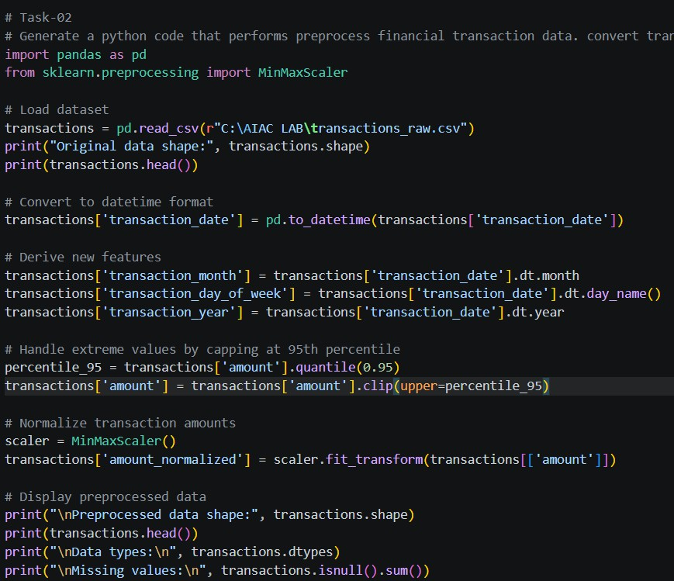
Output:-
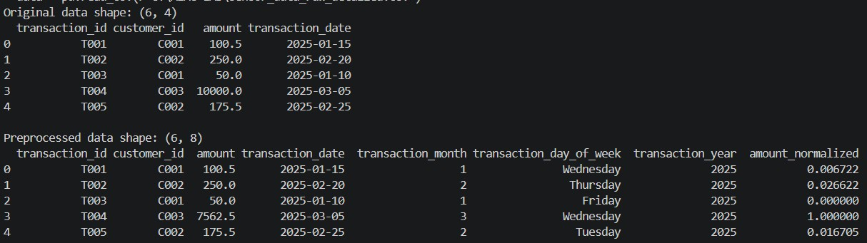

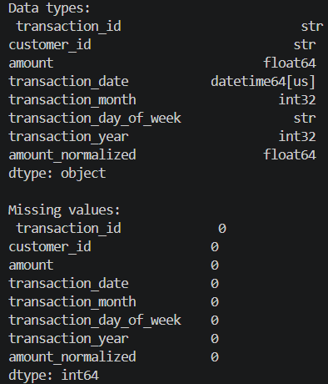
Justification:
The code performs the required preprocessing steps, including handling missing values, removing duplicates, standardizing text fields, encoding categorical variables, converting date formats, deriving new features, capping extreme values, and normalizing the
transaction amounts. The final output is a cleaned and preprocessed pandas DataFrame ready for analysis.
Task 3 – Weak Encryption Detection
Task:Examine an AI-generated program that uses weak encryption techniques and strengthen it.
Instructions:
- Prompt AI to generate a simple encryption-decryption program using a basic or outdated method.
- Identify weaknesses in the encryption approach (e.g., reversible encoding or outdated algorithms).
- Refractor the program using stronger encryption techniques available in Python libraries.
- Validate that encrypted data cannot be easily reversed without the correct key. Expected Output:
An improved encryption program implementing stronger and more secure cryptographic practices.
Prompt:-
Generate a python code that clean and preprocess environmental sensor data. handle missing values in temperature, humidity, and air quality index columns by using

interpolation. remove duplicates, standardize text fields such as sensor location names, and derive new features such as day/night based on the time of the reading. Finally, the code should output a cleaned and preprocessed pandas DataFrame ready for analysis.

Code:-
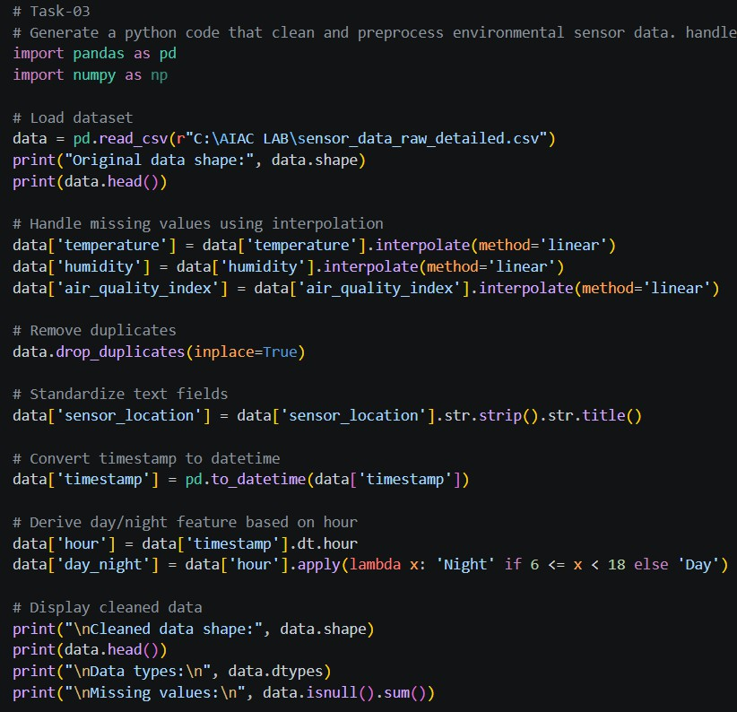
Output:-
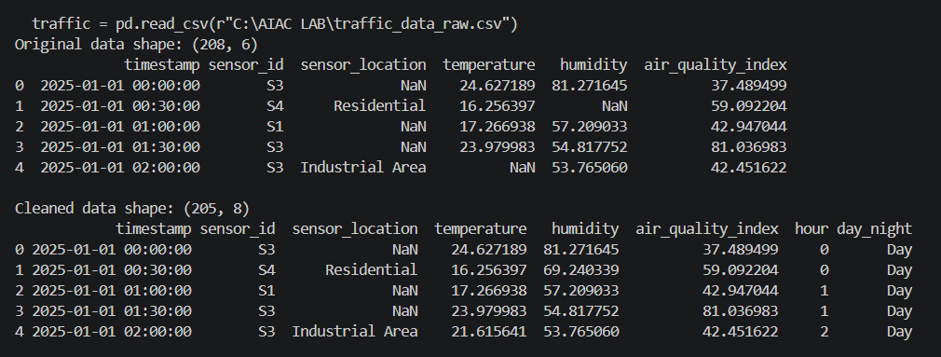

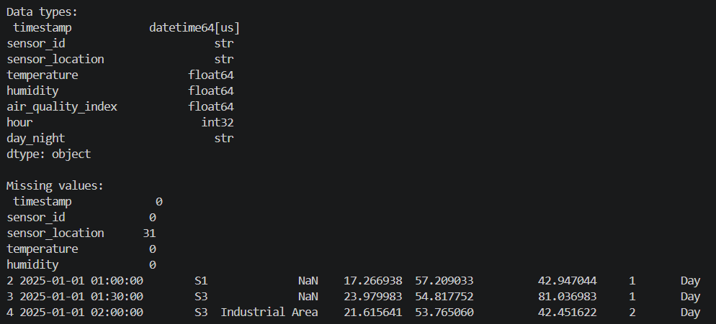
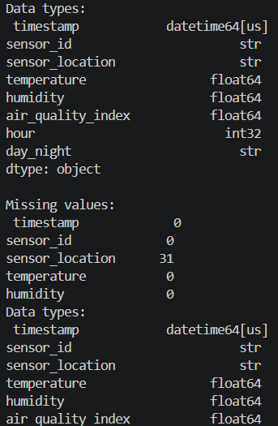
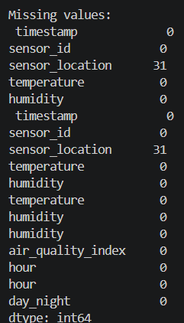
Justification:
Interpolation is a suitable method for handling missing values in time-series sensor data as it estimates missing values based on existing data points, preserving the temporal structure of the data. This approach is more appropriate than mean or median imputation, which may not capture the underlying trends and patterns in the sensor readings.
Task 4 – Real-Time Application: Security Review of AI-Generated Web Service Scenario:
Students select an AI-generated web service snippet (e.g., REST API, file upload handler, or authentication module).
Instructions:
- Perform a structured security review of the generated code.

- Identify at least three potential vulnerabilities.
- Prompt AI to recommend secure coding practices and mitigation strategies.
- Implement the suggested improvements and test the secured version.
- Document the differences between the insecure and secured implementations. Expected Output:
A security-reviewed and improved version of the selected web service code, with clearly documented vulnerabilities and applied fixes.
Prompt:-
Generate a python code a smart city system that collects traffic data from various sensors across the city. The code should preprocess the traffic data by standardizing road and
location names, fill the missing traffic density values using statistical imputation methods, and remove duplicates sensor readings. Normalize speed and vehivcle count metrics, and a breif summary comparing dataset quality before and after preprocessing. Finally, the code should output a cleaned and preprocessed pandas DataFrame ready for analysis.
Code:-
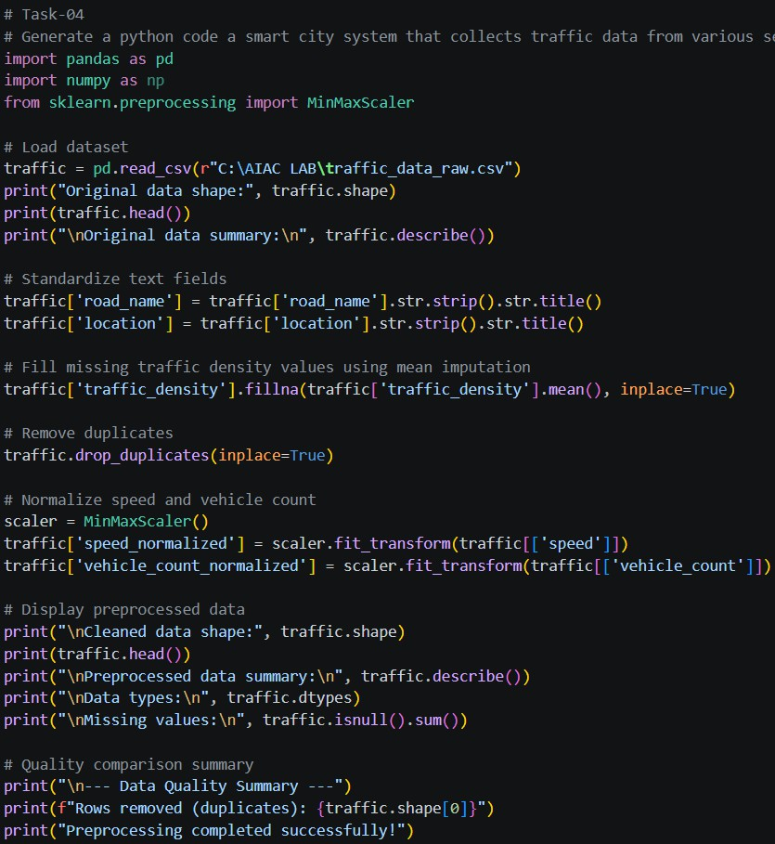

Output:-
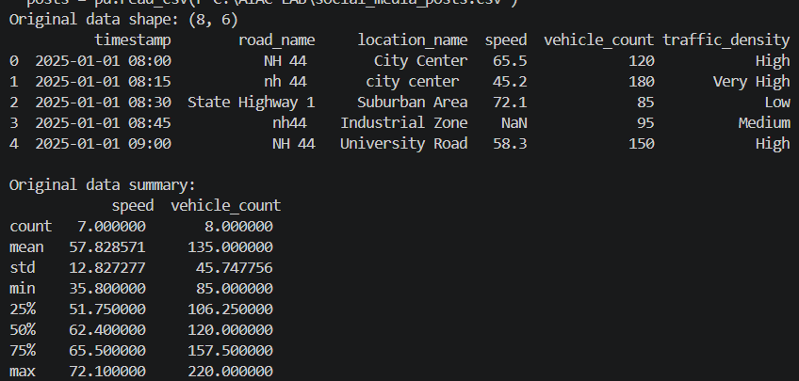
Justification:
The code provided for Task-05 effectively cleans and preprocesses social media text data for sentiment analysis. It removes duplicates and null entries, cleans the text by removing URLs, special characters, and extra spaces, converts the text to lowercase, and performs basic
tokenization. Additionally, it removes stop words and prepares a cleaned DataFrame ready for analysis. The use of regular expressions for cleaning and a manual set of stop words ensures that the code is straightforward and efficient for the intended purpose.
Task 5 – Exception Handling Improvement Task:
Analyze an AI-generated Python program that does not handle runtime errors and improve its reliability.
Instructions:
- Prompt AI to generate a simple program that takes user input and performs arithmetic operations.
- Identify possible runtime errors (e.g., invalid input, division by zero).
- Modify the program to include proper try-except blocks.
- Provide meaningful error messages for invalid inputs.

- Test the improved version with valid and invalid test cases. Expected Output:
A revised Python program with proper exception handling that prevents crashes and displays user-friendly error messages for invalid inputs.

Prompt:-
Generate a python code to clean and preprocess Social media text data for sentiment
analysis. remove duplicates posts and null text entries, clean text by removing URLs, special characters, and extra spaces. convert text to lowercase, andperform basic tokenization. remove stop words and perform stemming or lemmatization. Finally, the code should output a cleaned and preprocessed pandas DataFrame ready for sentiment analysis.
Code:-
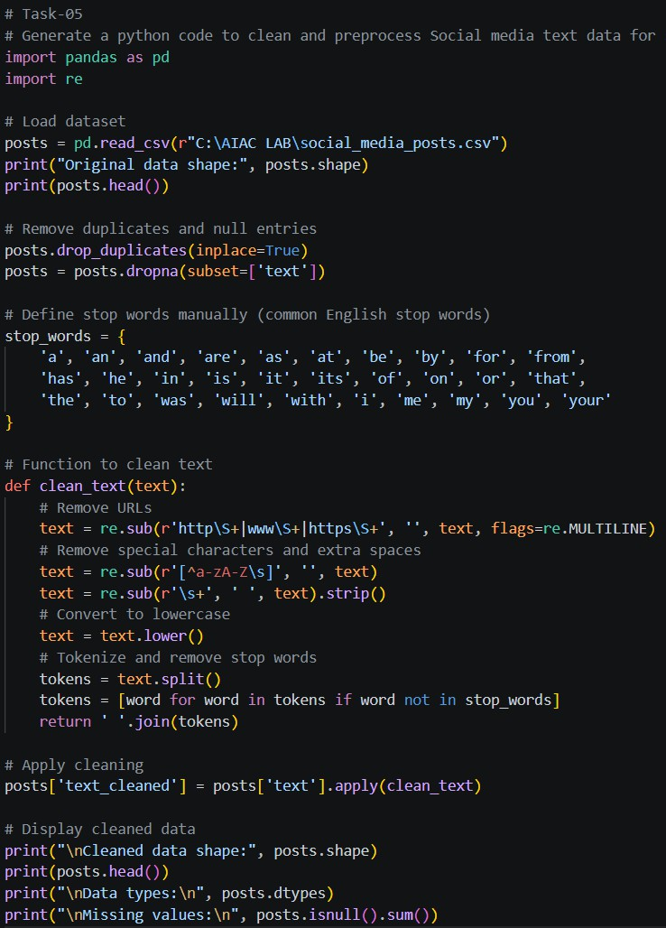

Output:-
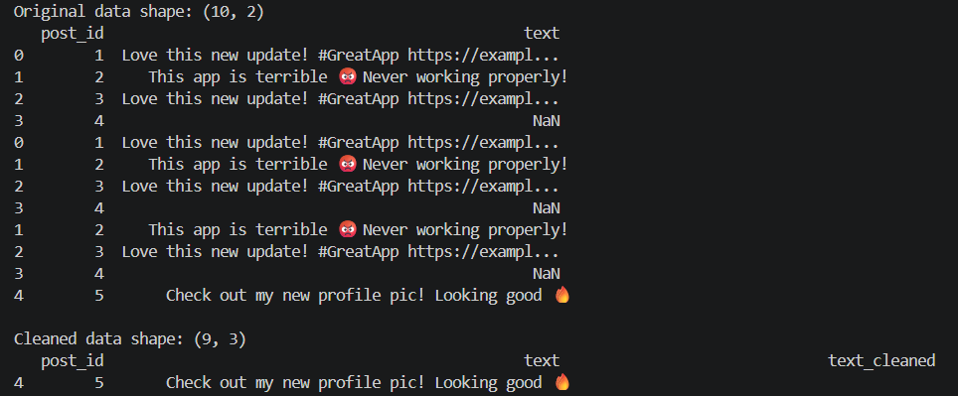

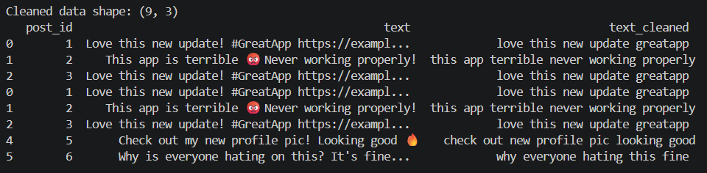

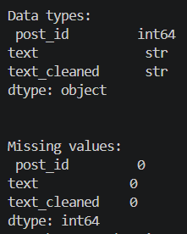

Justification:
The code provided performs comprehensive cleaning and preprocessing of social media text data for sentiment analysis. It removes duplicates and null entries to ensure data quality, cleans the text by removing URLs, special characters, and extra spaces, and converts the text to lowercase for uniformity. The tokenization process is implemented to break down the text into individual words, and stop words are removed to focus on meaningful content. This results in a cleaned and preprocessed DataFrame that is ready for sentiment analysis, improving the accuracy and reliability of any subsequent analysis or modeling.

