AIAC Assignment – 9.2

Name : Likhitha Banna

HT.NO : 2303A51952

Task Description -1 (Documentation – Function Summary Generation) Task:
Use AI to generate concise functional summaries for each Python function in a given script. Instructions:
- Provide a Python script to the AI.
- Ask the AI to write a short summary describing the purpose of each function.
- Ensure summaries are brief and technically accurate.
- Do not include code implementation details.
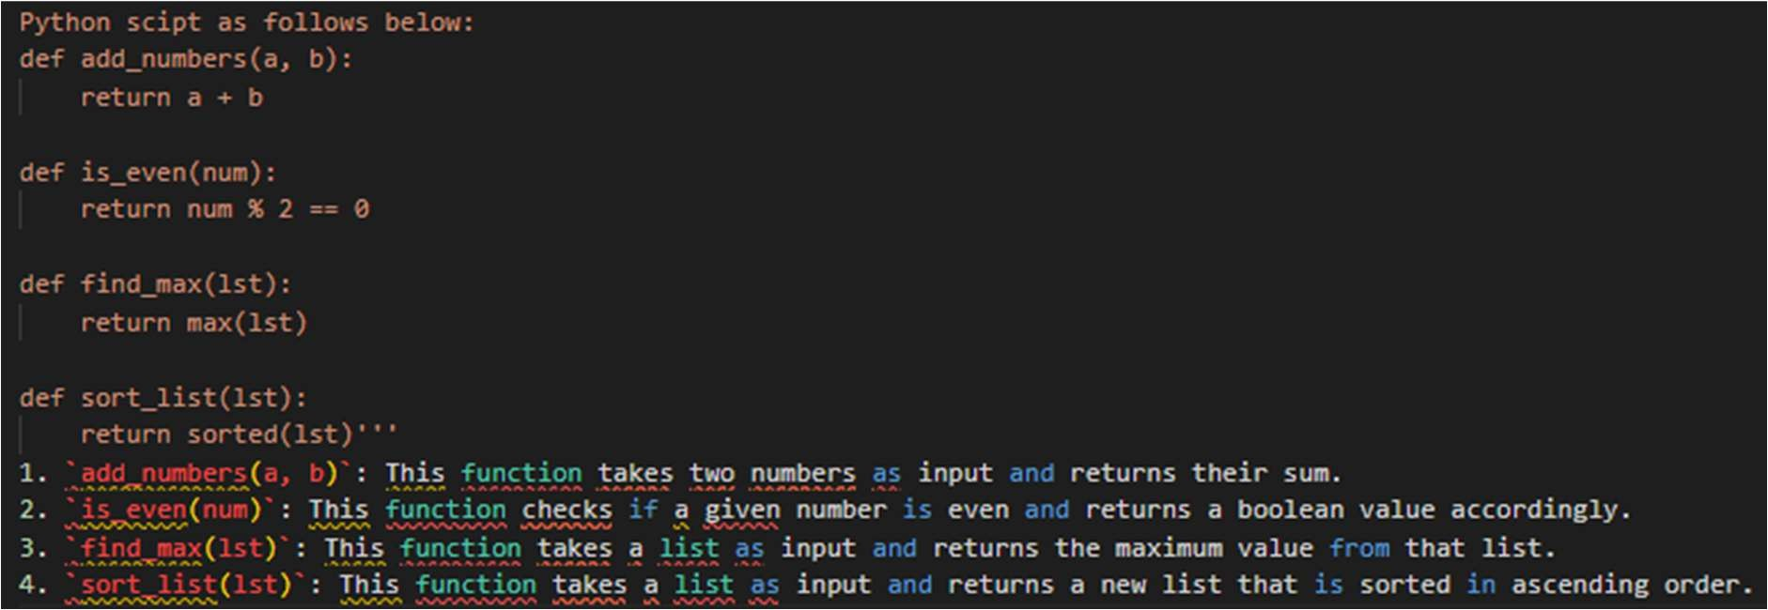
Task Description -2 (Documentation – Logical Explanation for Conditions and Loops) Task:
Use AI to document the logic behind conditional statements and loops in a Python program. Instructions:
- Provide a Python program without comments.
- Instruct AI to explain only decision-making logic and loop behavior.
- Skip basic syntax explanations.
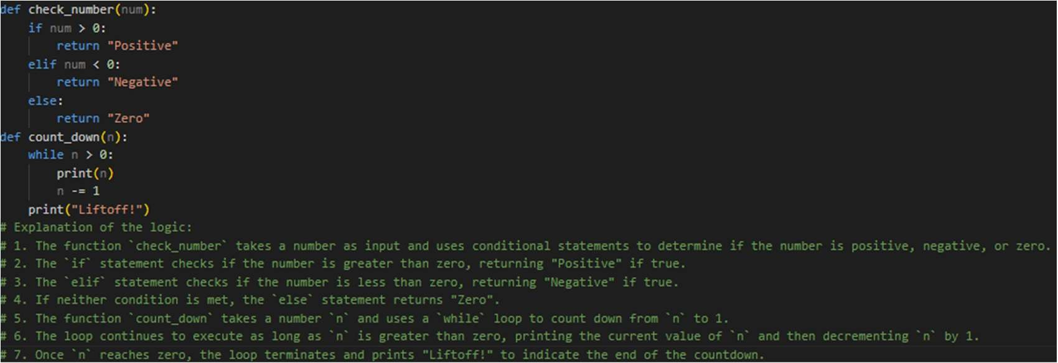

Task Description -3 (Documentation – File-Level Overview)
Task:
Use AI to generate a high-level overview describing the functionality of an entire Python file. Instructions:
- Provide the complete Python file to AI.
- Ask AI to write a brief overview summarizing the file’s purpose and functionality.
- Place the overview at the top of the file. Expected Output -3:
A Python file with a clear and concise file-level overview at the beginning.
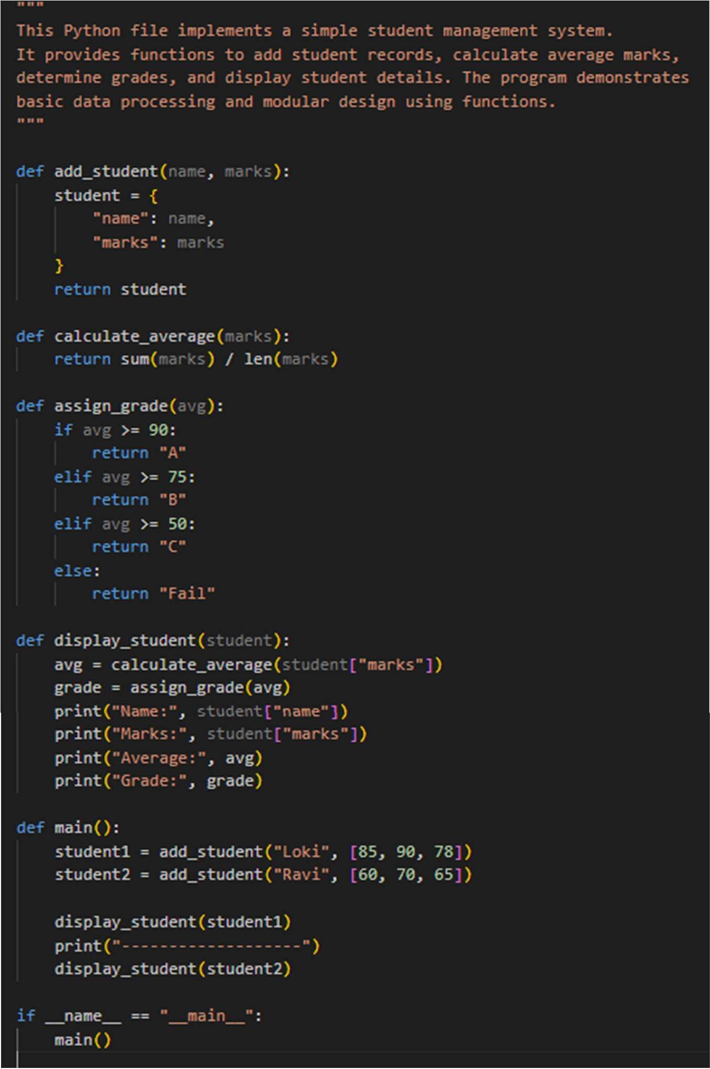

Task Description -4 (Documentation – Refine Existing Documentation)
Task:
Use AI to improve clarity and consistency of existing documentation in Python code. Instructions:
- Provide Python code containing basic or unclear comments.
- Ask AI to rewrite the documentation to improve clarity and consistency.
- Ensure technical meaning remains unchanged. Expected Output -4:
Python code with refined and improved documentation that is clear and consistent.
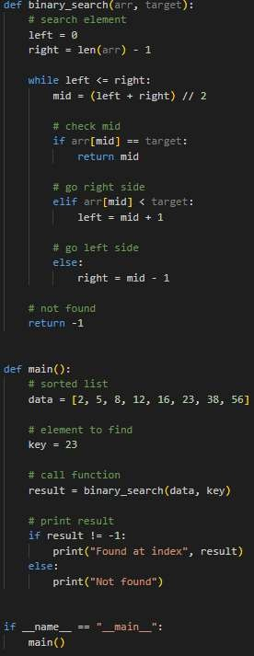

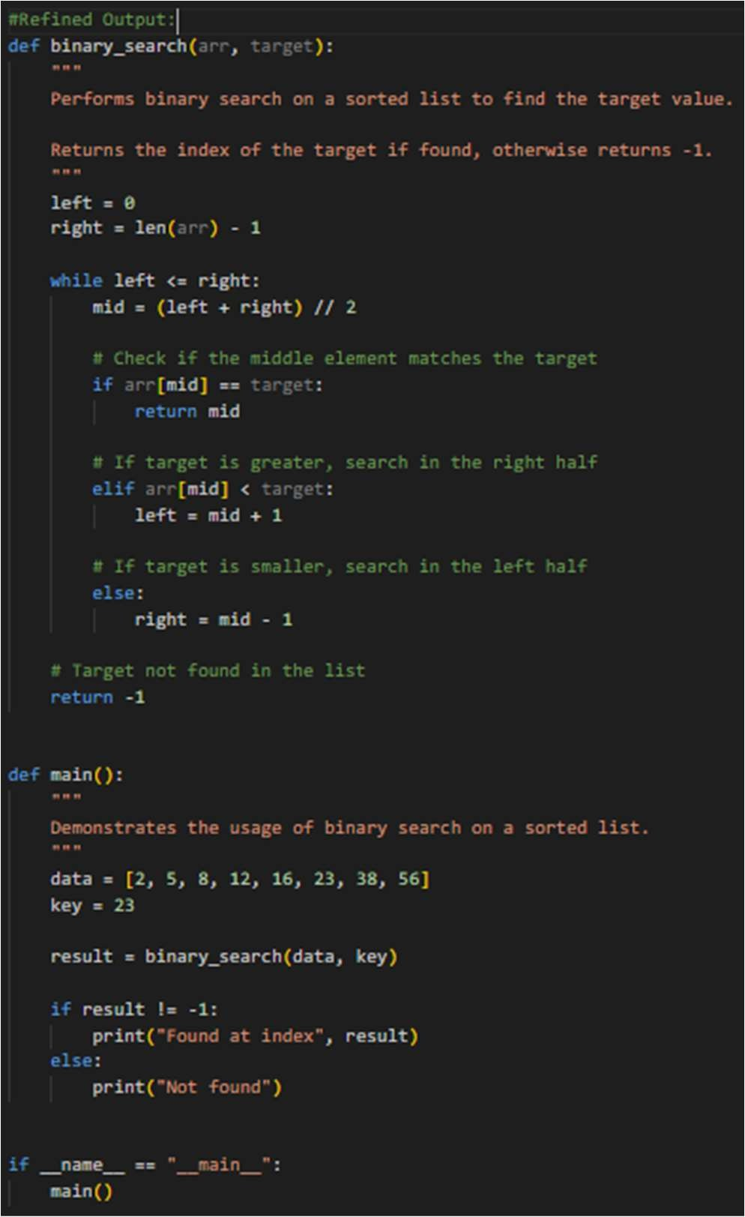
Task Description -5 (Documentation – Prompt Detail Impact Study) Task:
Study the impact of prompt detail on AI-generated documentation quality. Instructions:
Create two prompts: one brief and one detailed.
- Use both prompts to document the same Python function.
- Compare the generated outputs. Expected Output -5:
A comparison table highlighting differences in completeness, clarity, and accuracy of documentation.

