AIAC Assignment - 8.5

Name : Likhitha Banna
HT.NO : 2303A51952

Task Description #1 (Username Validator – Apply AI in Authentication Context)
- Task: Use AI to generate at least 3 assert test cases for a function is_valid_username(username) and then implement the function using Test-Driven Development principles.
- Requirements:
  - Username length must be between 5 and 15 characters.
  - Must contain only alphabets and digits.
  - Must not start with a digit.
  - No spaces allowed. Example Assert Test Cases:
assert is_valid_username("User123") == True assert is_valid_username("12User") == False assert is_valid_username("Us er") == False Expected Output #1:
- Username validation logic successfully passing all AI-generated test cases.

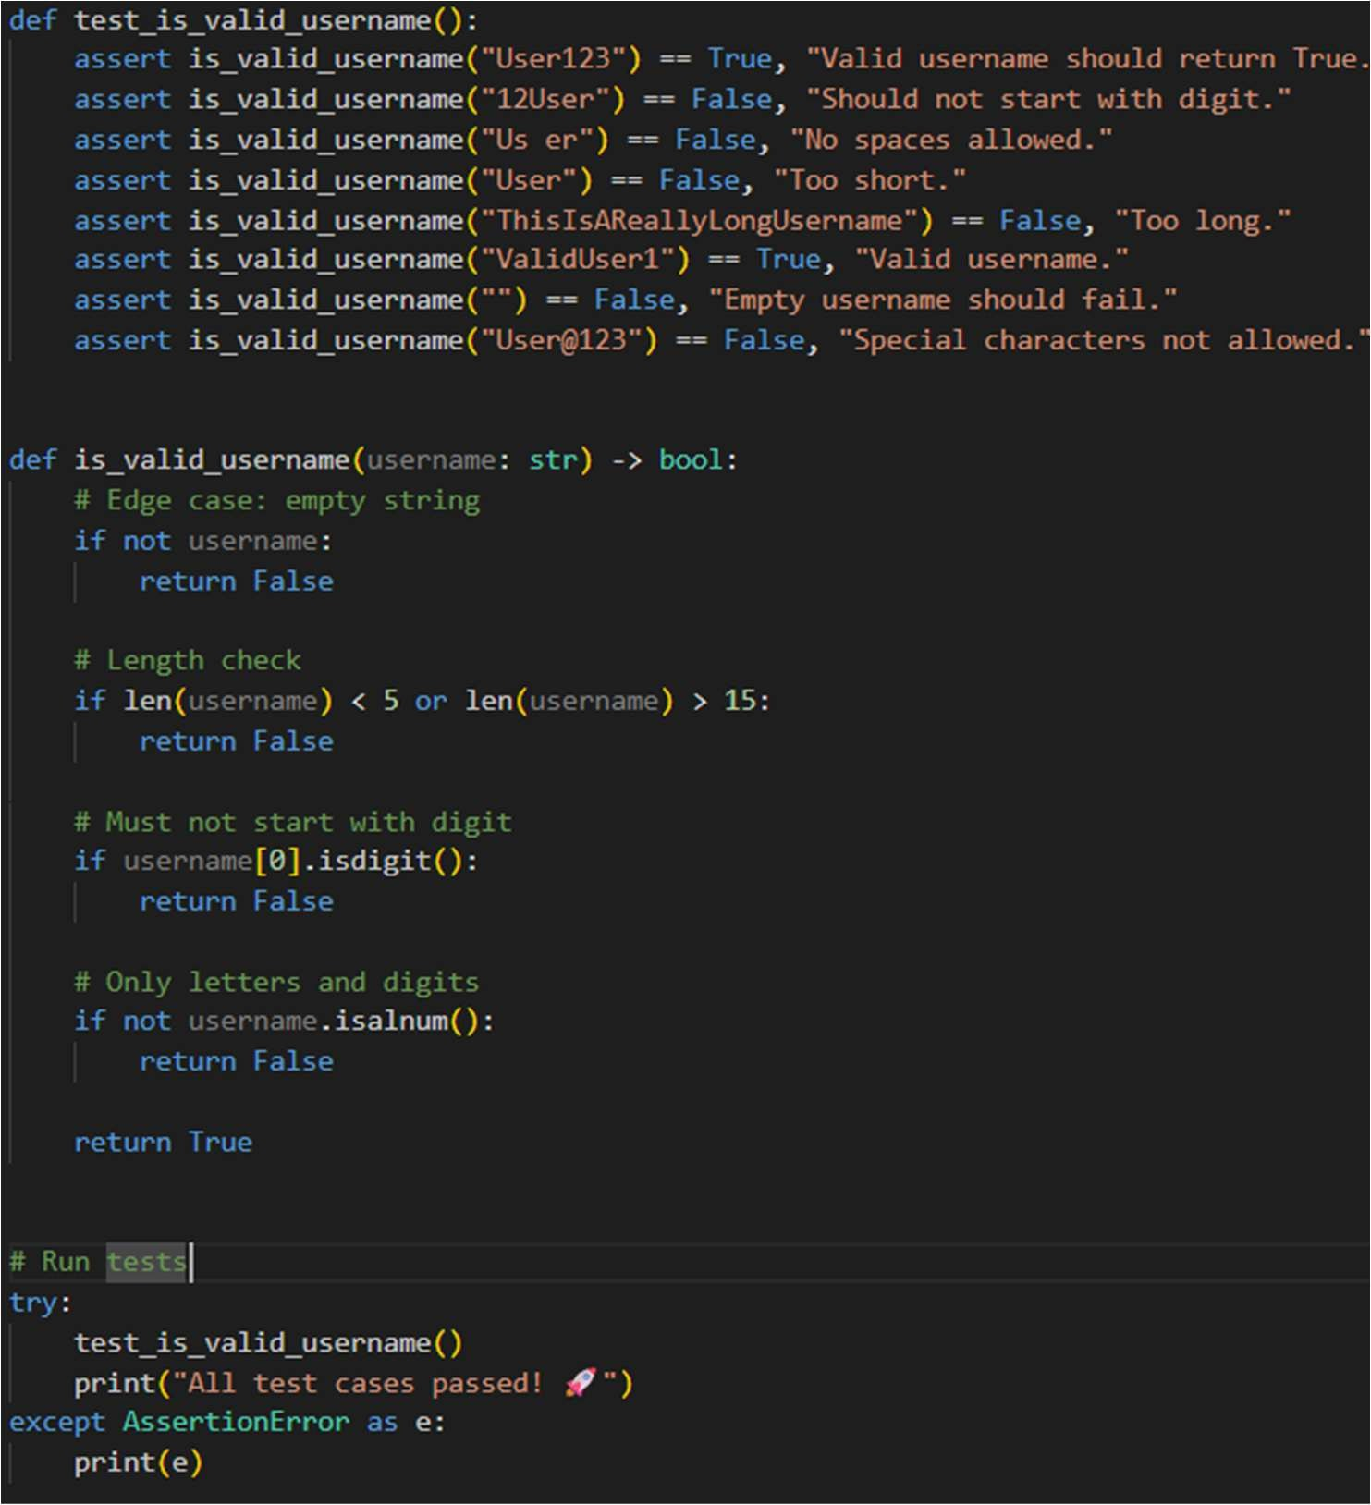

Output:
Task Description #2 (Even–Odd & Type Classification – Apply AI for Robust Input Handling)
- Task: Use AI to generate at least 3 assert test cases for a function classify_value(x) and implement it using conditional logic and loops.
- Requirements:
  - If input is an integer, classify as "Even" or "Odd".
  - If input is 0, return "Zero".
  - If input is non-numeric, return "Invalid Input". Example Assert Test Cases:
assert classify_value(8) == "Even" assert classify_value(7) == "Odd"
assert classify_value("abc") == "Invalid Input"

Expected Output #2:
- Function correctly classifying values and passing all test cases.
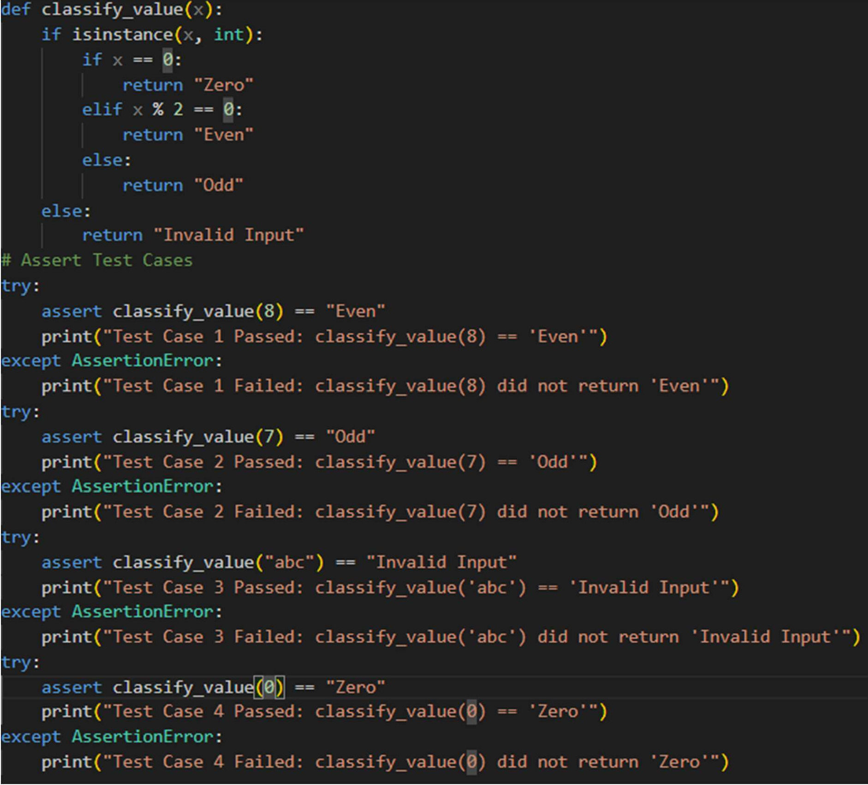

OUTPUT:
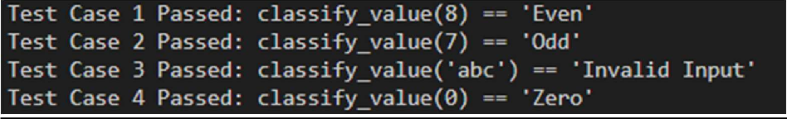
Task Description #3 (Palindrome Checker – Apply AI for String Normalization)
- Task: Use AI to generate at least 3 assert test cases for a function is_palindrome(text) and implement the function.
- Requirements:
  - Ignore case, spaces, and punctuation.
  - Handle edge cases such as empty strings and single characters. Example Assert Test Cases:

assert is_palindrome("Madam") == True
assert is_palindrome("A man a plan a canal Panama") == True assert is_palindrome("Python") == False
Expected Output #3:
- Function correctly identifying palindromes and passing all AI-generated tests.
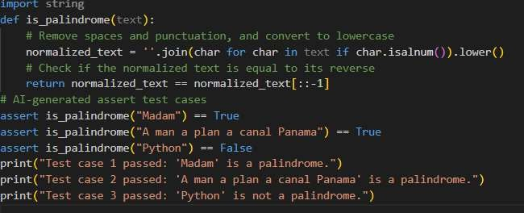

OUTPUT:
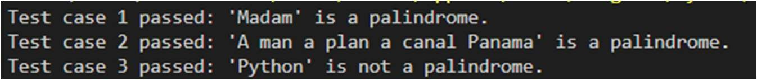
Task Description #4 (BankAccount Class – Apply AI for Object-Oriented Test-Driven Development)
- Task: Ask AI to generate at least 3 assert-based test cases for a BankAccount class and then implement the class.
- Methods:
  - deposit(amount)
  - withdraw(amount)
  - get_balance() Example Assert Test Cases:
acc = BankAccount(1000) acc.deposit(500)
assert acc.get_balance() == 1500 acc.withdraw(300)
assert acc.get_balance() == 1200 Expected Output #4:
Fully functional class that passes all AI-generated assertions

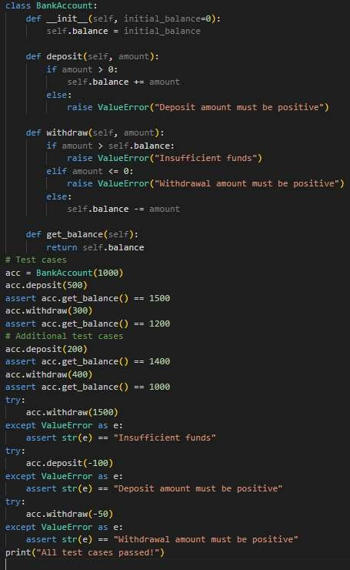

OUTPUT:
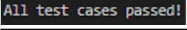
Task Description #5 (Email ID Validation – Apply AI for Data Validation)
- Task: Use AI to generate at least 3 assert test cases for a function validate_email(email) and implement the function.
- Requirements:
  - Must contain @ and .
  - Must not start or end with special characters.
  - Should handle invalid formats gracefully. Example Assert Test Cases:

assert validate_email("user@example.com") == True assert validate_email("userexample.com") == False assert validate_email("@gmail.com") == False Expected Output #5:
- Email validation function passing all AI-generated test cases and handling edge cases correctly.
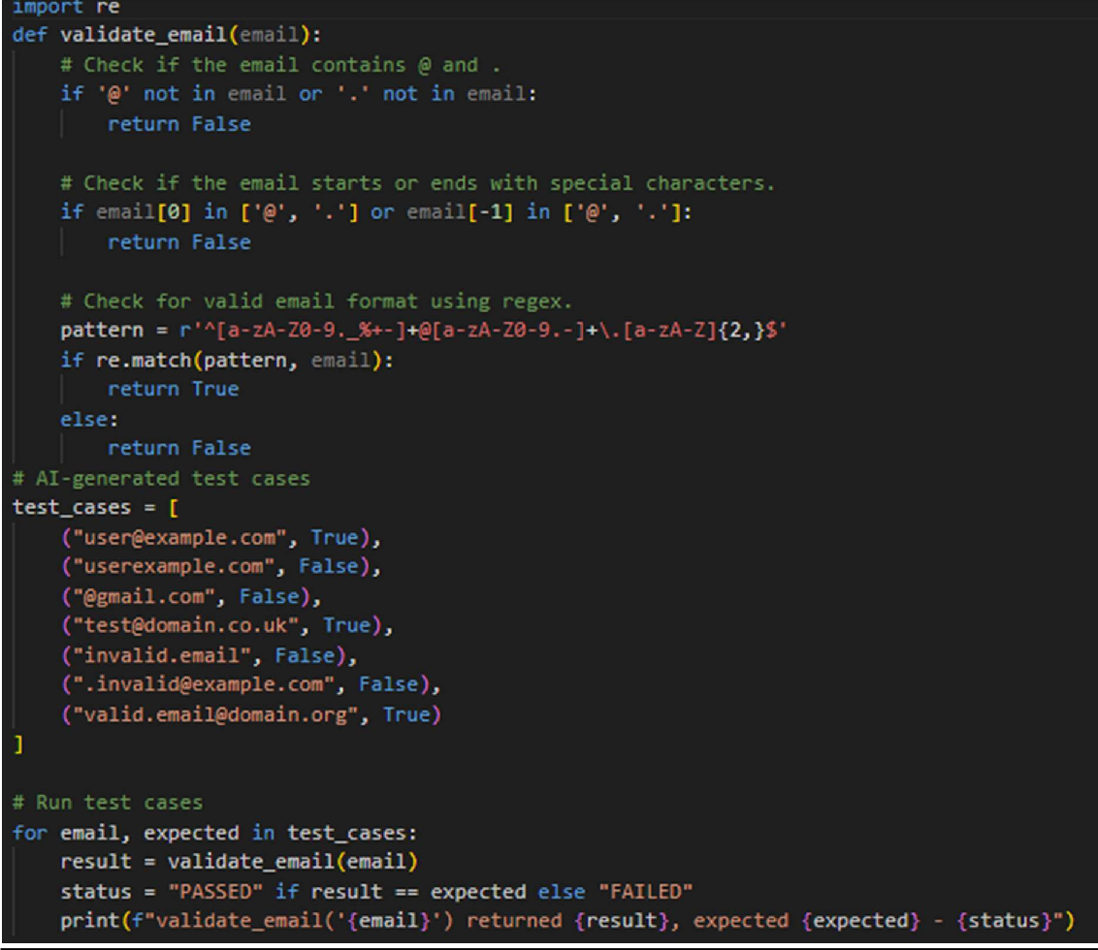
OUTPUT:
