AI ASSISTED CODING
LAB ASSIGNMENT-2
Name: Likhitha Banna
HT.NO: 2303A51952
Batch: 22
Question-1: Use Google Colab to generate a function that filters out all negative numbers from a list.
Prompt: # generate a function that filters out all negative numbers from a list.
Code Screenshot:
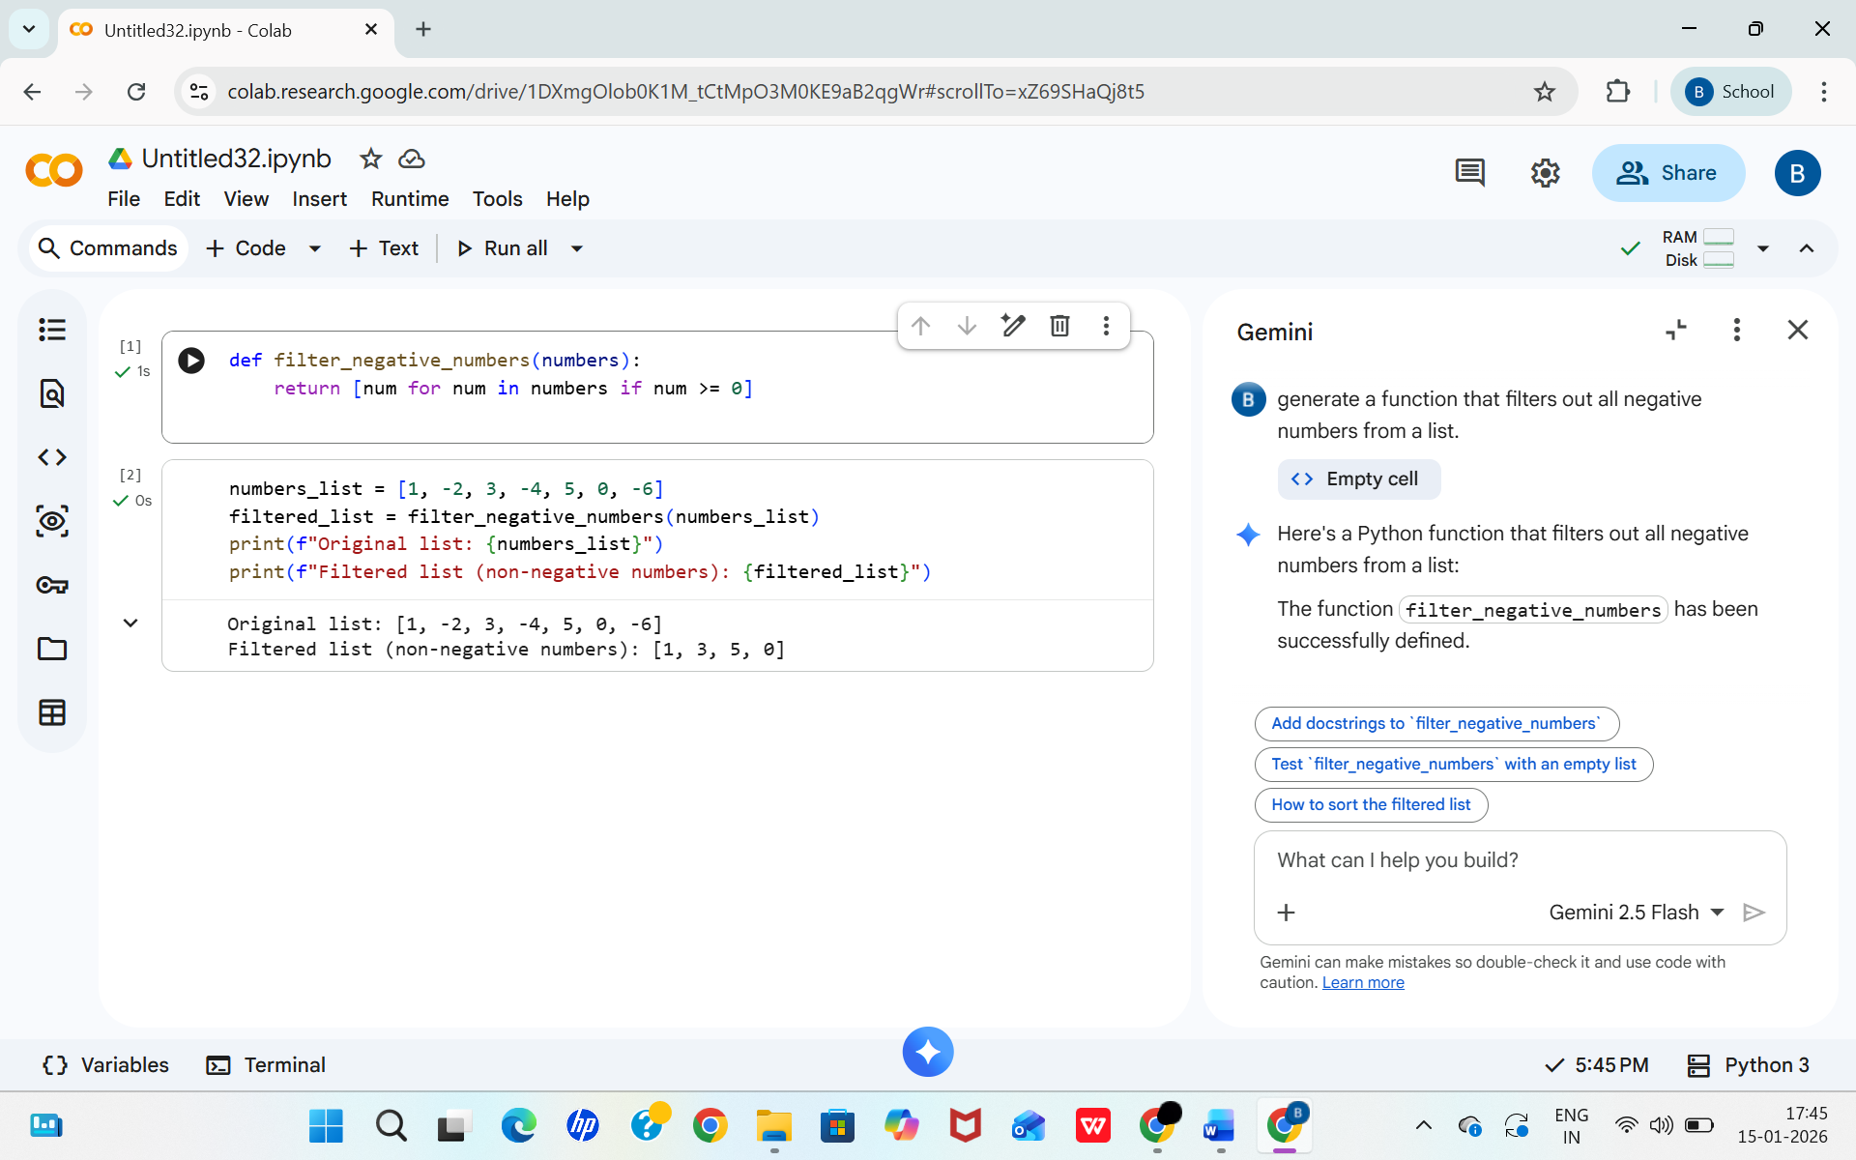

Before list and after list:
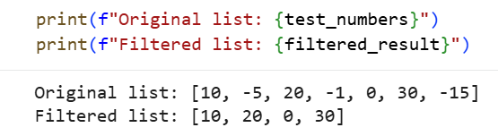

Question-2: Use Gemini to generate a Python function that counts vowels, consonants, and digits in a string.
Prompt: # generate a Python function that counts vowels, consonants, and digits in a string.
Code Screenshot:
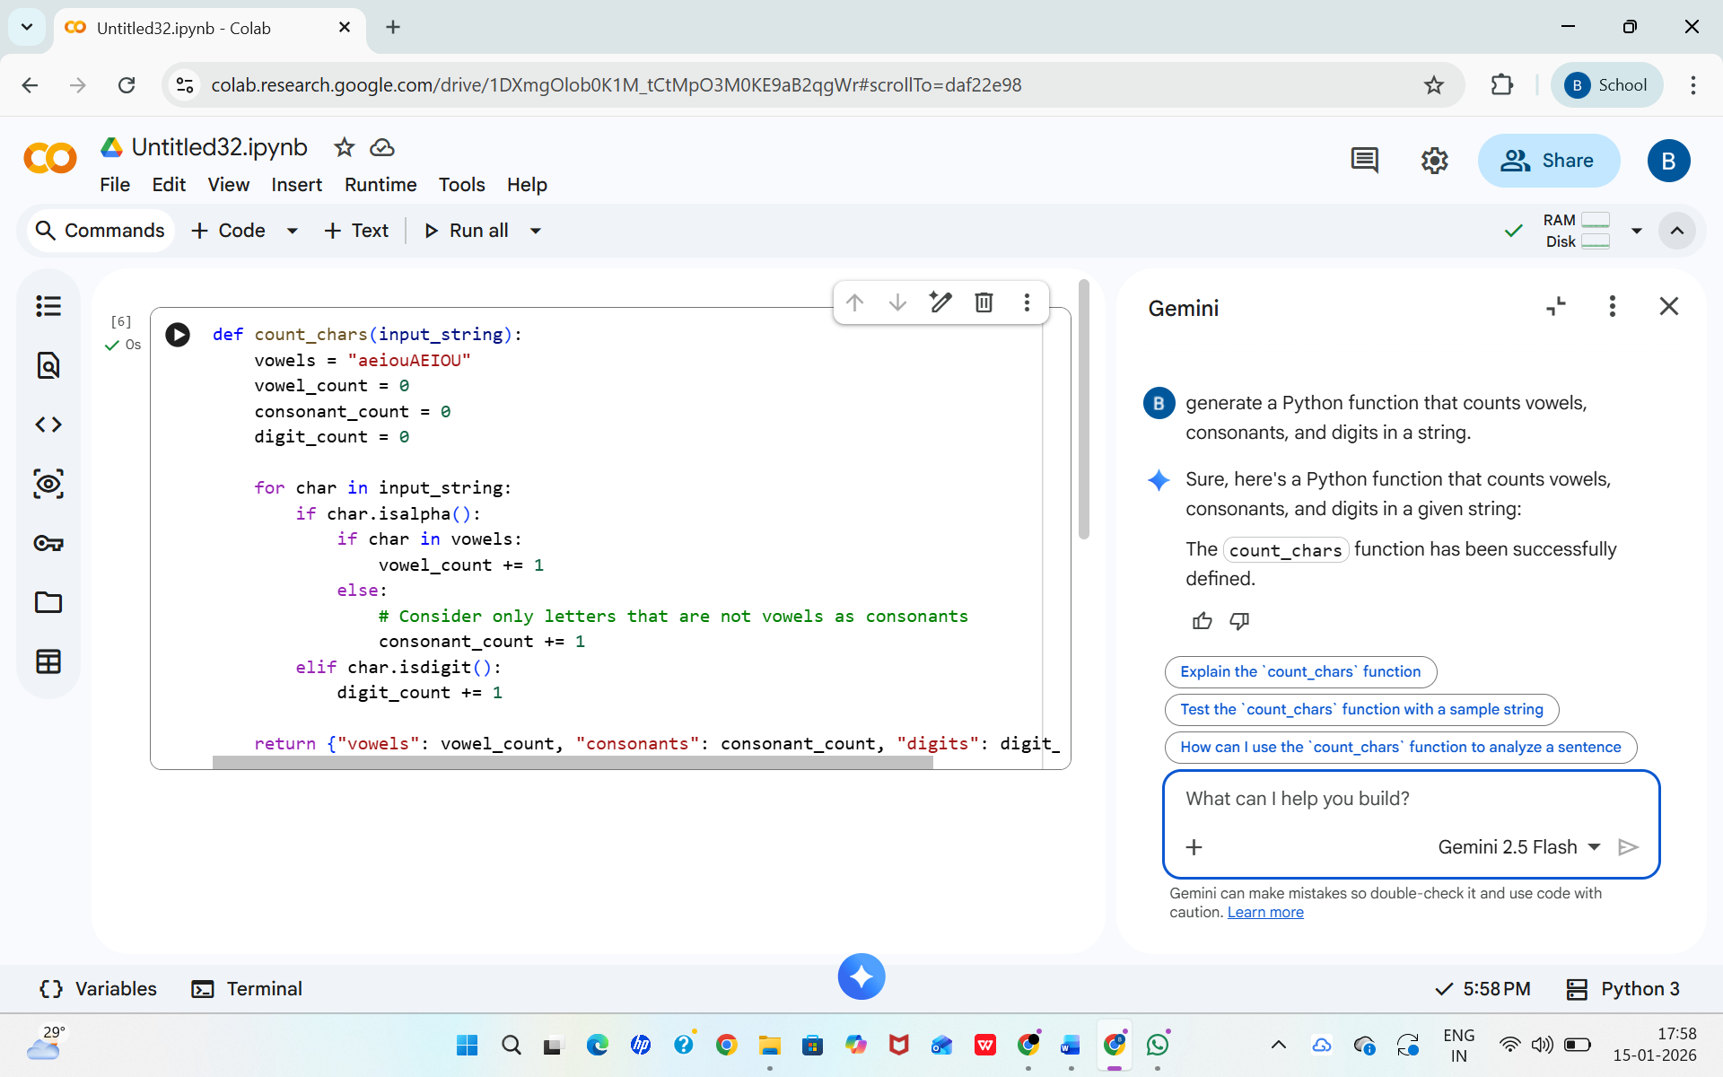

Sample Input and Output:
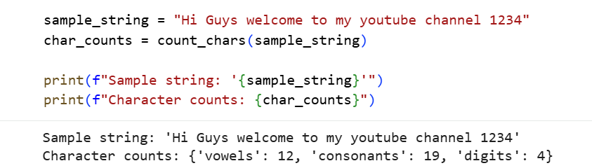

Question-3: Generate a palindrome-checking function using Gemini and Copilot, then compare the results.
Generating using colab:
Prompt: Generate a palindrome-checking function
Code Screenshot:
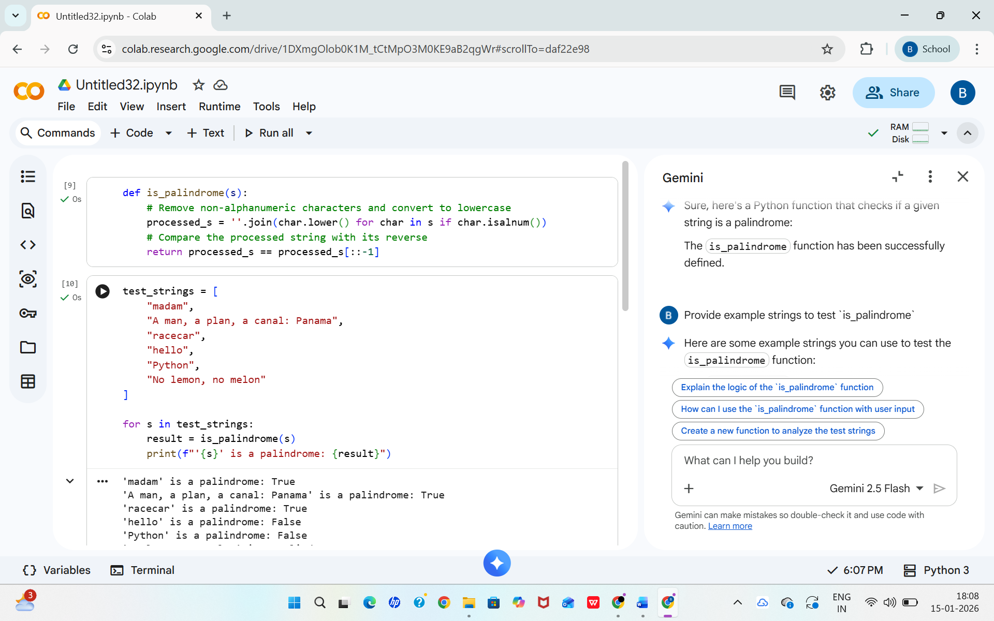

Sample Input and Output:
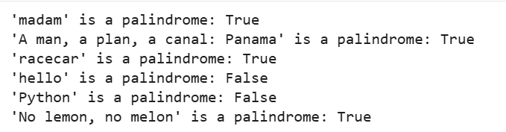

Generating Using Copilot:
Prompt: #generate a palindrome checking function in python using user defined functions

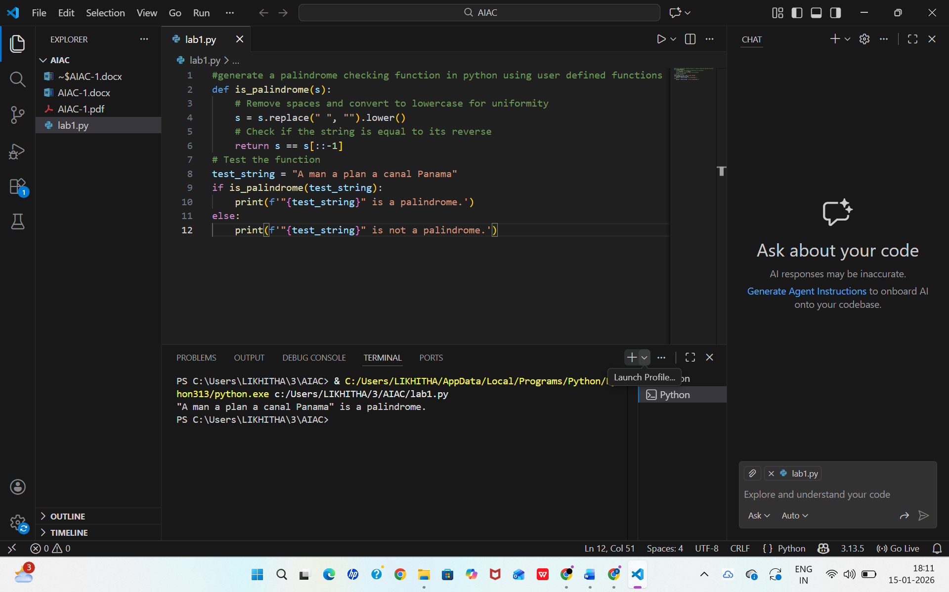
Observations on Clarity
Gemini Code: Very clear and well-documented. Includes a detailed docstring explaining the function’s purpose, arguments, and return value.
Copilot Code: Simple and easy to follow, especially for beginners. Uses a short variable name s, which is functional but less descriptive. Output is minimal—just True or False—without context.
Observations on Structure
Gemini Code: Structured professionally with a reusable function and multiple test cases. Handles edge cases by removing non-alphanumeric characters and ignoring case.
Copilot Code: Structurally simple and compact. Focuses only on removing spaces and converting to lowercase.
Conclusion:
Gemini’s version is more comprehensive, polished, and ready for broader use.
Copilot’s version is concise and beginner-friendly, great for learning or quick testing.
Question-4: Ask Gemini to explain a python function (prime check or Palindrome check) line by line.
Prompt: # explain palindrome function line by line
Code and Output Screenshots:
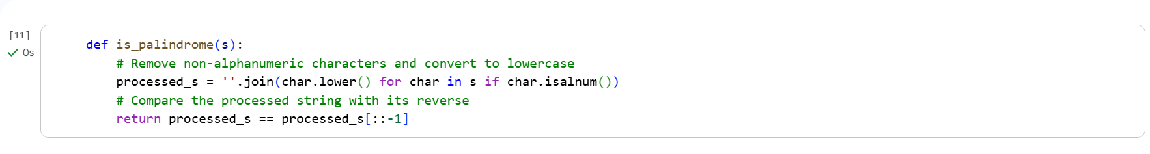
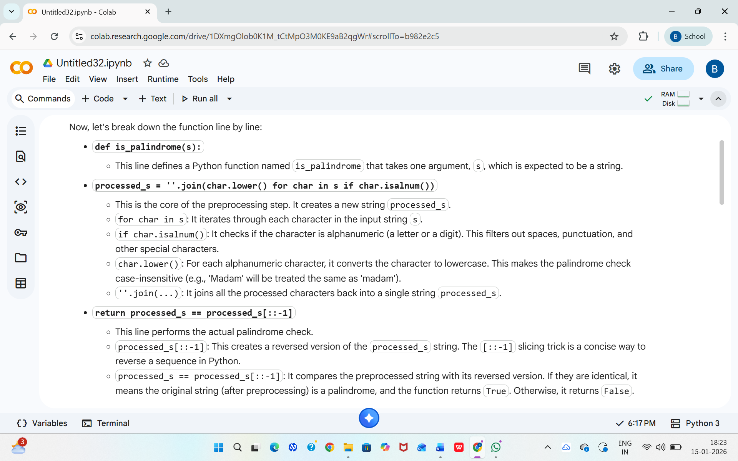

My own experience using both Gemini and GitHub Copilot:
While using Gemini in Google Colab, I found its explanations very clear and helpful for understanding the logic behind the code. It explained Python programs step by step, which made learning and analysis much easier. GitHub Copilot, on the other hand, was faster at generating code directly inside the editor and helped me complete tasks quickly. Copilot felt more suitable for continuous coding, whereas Gemini was better for gaining conceptual clarity. At last, using both tools together improved my understanding of programming and increased my coding efficiency.

