ASSIGNMENT-12.2
Name : Likhitha Banna
Batch : 22
Ht.no : 2303A51952
Task Description -1 (Data Structures – Stack Implementation with AI Assistance)
- Task: Use AI assistance to generate a Python program that implements a Stack data structure. Instructions:
Prompt AI to create a Stack class with the following methods:
- push(element) ➢ pop()
- peek() ➢ is_empty()
- Ensure proper error handling for stack underflow.
- Ask AI to include clear docstrings for each method. Expected Output:
- A functional Python program implementing a Stack using a class.
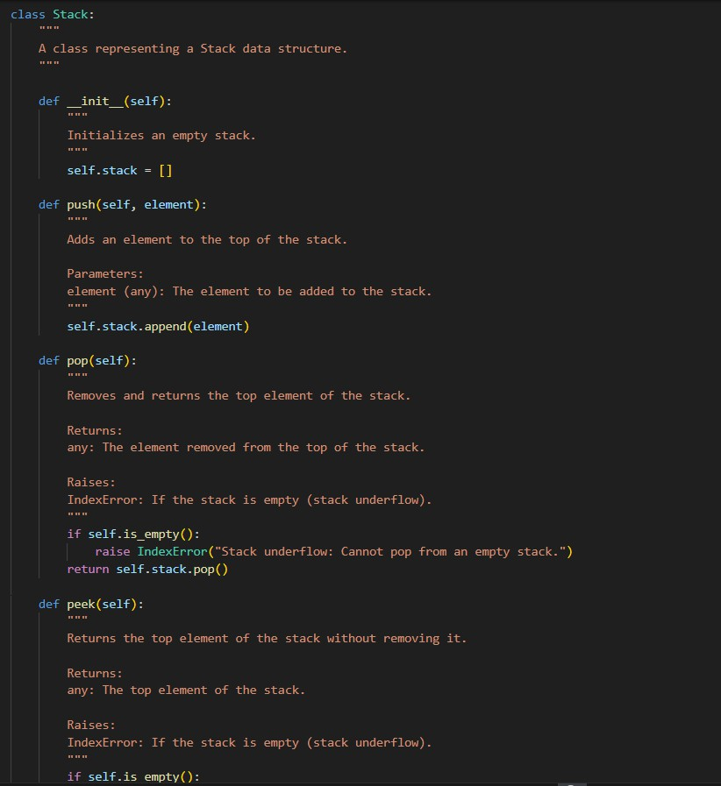
- Properly documented methods with docstrings. Output screenshot:

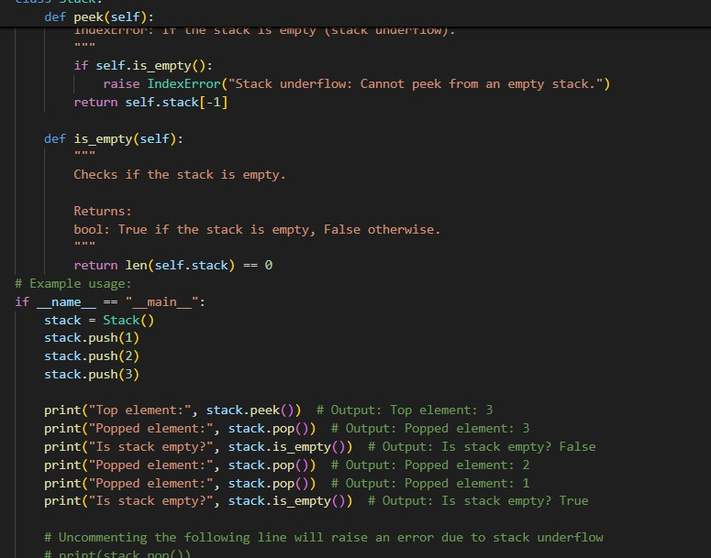
Output:
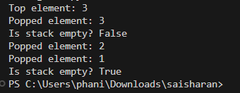
Task Description -2 (Algorithms – Linear vs Binary Search Analysis)
- Task: Use AI to implement and compare Linear Search and Binary Search algorithms in Python. Instructions:
- Prompt AI to generate: ➢ linear_search(arr, target)
- binary_search(arr, target) ➢ Include docstrings explaining:
- Working principle ➢ Test both algorithms using different input sizes. Expected Output:
- Python implementations of both search algorithms.
- AI-generated comments and complexity analysis.
- Test results showing correctness and comparison.

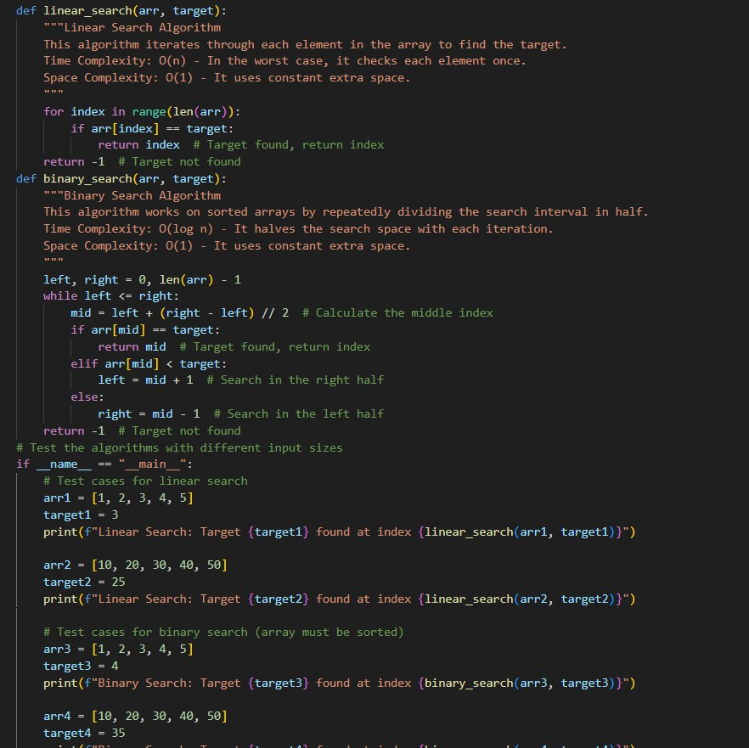
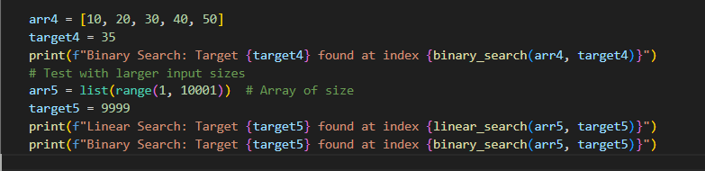
Output:
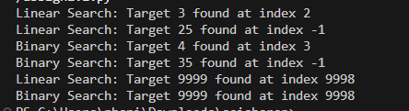

Task Description -3 (Test Driven Development – Simple Calculator Function)
- Task:
Apply Test Driven Development (TDD) using AI assistance to develop a calculator function.

Instructions:
- Prompt AI to first generate unit test cases for addition and subtraction.
- Run the tests and observe failures.
- Ask AI to implement the calculator functions to pass all tests.
- Re-run the tests to confirm success. Expected Output:
- Separate test file and implementation file.

➢ Test cases executed before implementation.
- Final implementation passing testcase
- Screenshots:
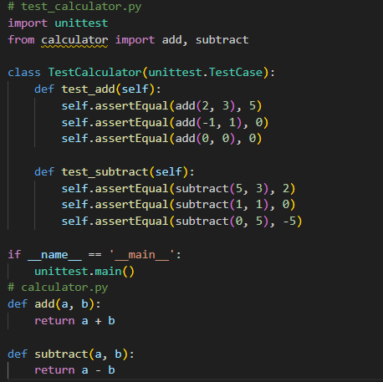

Task Description -4 (Data Structures – Queue Implementation with AI Assistance)
Use AI assistance to generate a Python program that implements a Queue data structure. Instructions:
- Prompt AI to create a Queue class with the following methods:
- enqueue(element) • dequeue()
- front() • is_empty()
- Handle queue overflow and underflow conditions.
- Include appropriate docstrings for all methods. Expected Output:
- A fully functional Queue implementation in Python. Code output:

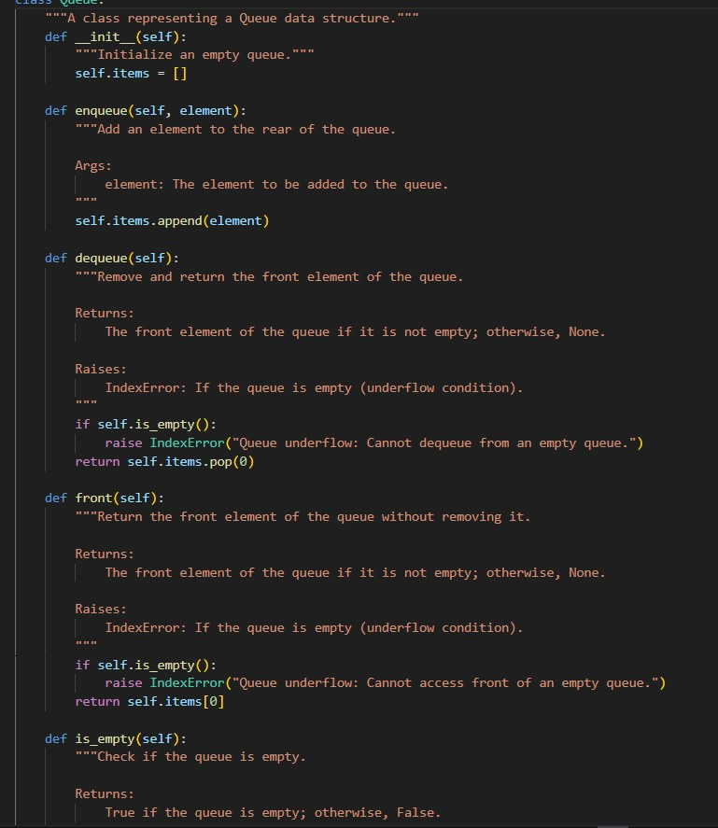

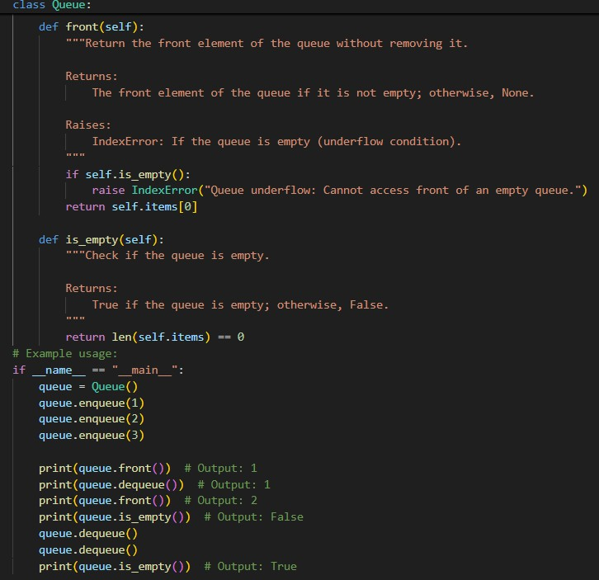

Output:
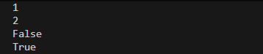

Task Description -5 (Algorithms – Bubble Sort vs Selection Sort)
- Task:
Use AI to implement Bubble Sort and Selection Sort algorithms and compare their behavior.
Instructions:
- Prompt AI to generate:
- bubble_sort(arr) • selection_sort(arr)
- Include comments explaining each step.
- Add docstrings mentioning time and space complexity. Expected Output:
- Correct Python implementations of both sorting algorithms.
- Complexity analysis in docstrings. Code output:
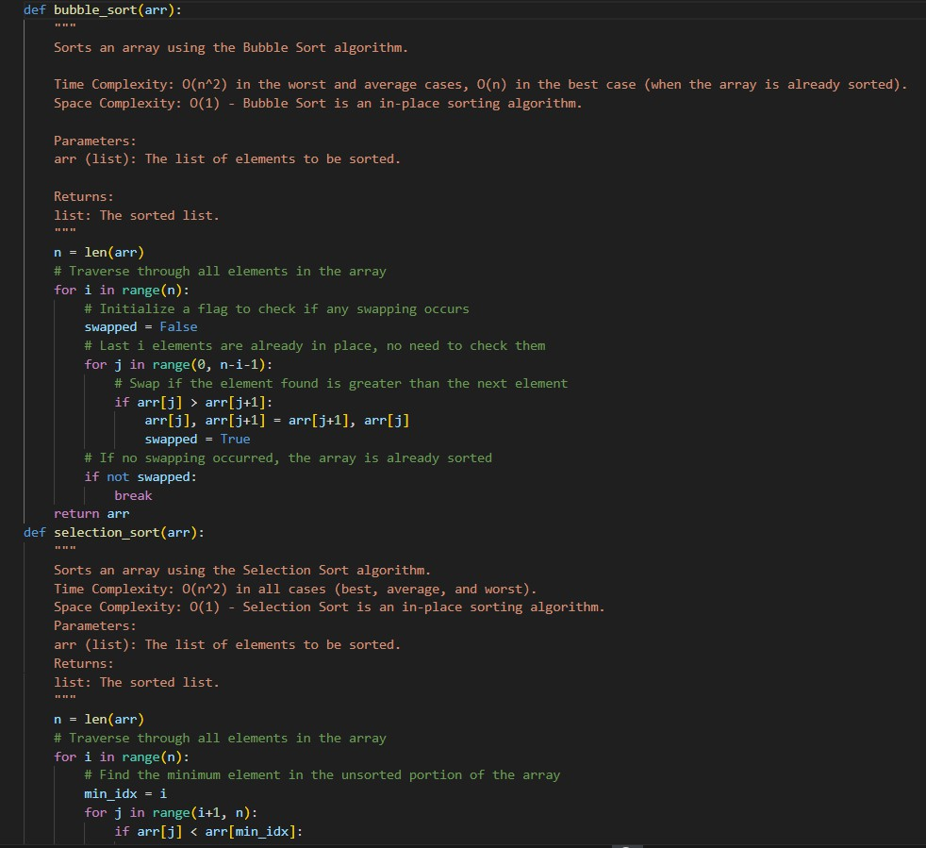

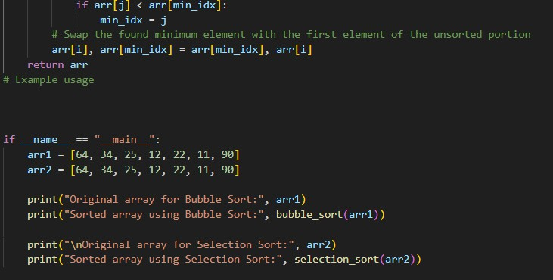
Output:
