AI ASSISTANT CODING
ASSIGNMENT-13
Name: Likhitha Banna
Hallticket:2303A51952
Batch:22

Task Description-1:(Refactoring – Removing Global Variables)
• Task: Use AI to eliminate unnecessary global variables from the
code.
• Instructions:
o Identify global variables used across functions.
o Refactor the code to pass values using function parameters.
o Improve modularity and testability.
• Sample Legacy Code:
rate = 0.1
def calculate_interest(amount):
return amount * rate
print(calculate_interest(1000))
code:
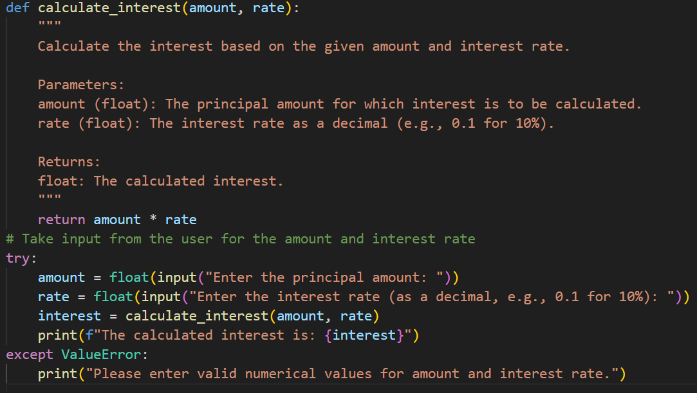
• Expected Output:
o Refactored version passing rate as a parameter or using a configuration structure.
Task Description-2: (Refactoring Deeply Nested Conditionals)
• Task: Use AI to refactor deeply nested if–elif–else logic into a cleaner structure.
• Focus Areas:
o Readability
o Logical simplification
Legacy Code:
score = 78
if score >= 90:
print("Excellent")
else:
if score >= 75:
print("Very Good")
else:
if score >= 60:
print("Good")
else:
print("Needs Improvement")
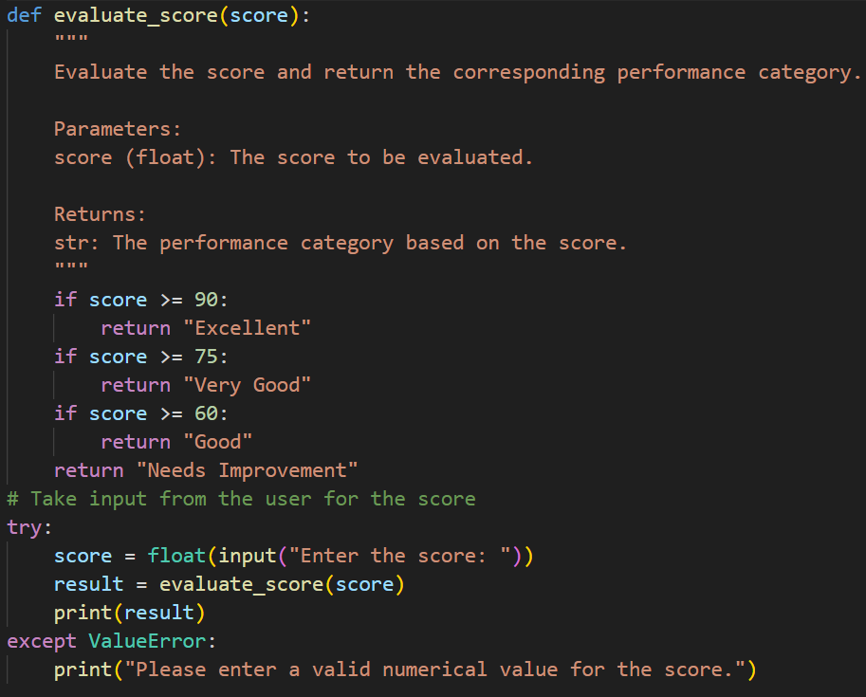
Expected Outcome:
o Flattened logic using guard clauses or a mapping-based approach.
Task-3:(Refactoring Repeated File Handling Code)
• Task: Use AI to refactor repeated file open/read/close logic.
• Focus Areas:
o DRY principle
o Context managers
Legacy Code:
f = open("data1.txt")
print(f.read())
f.close()
f = open("data2.txt")
print(f.read())
f.close()
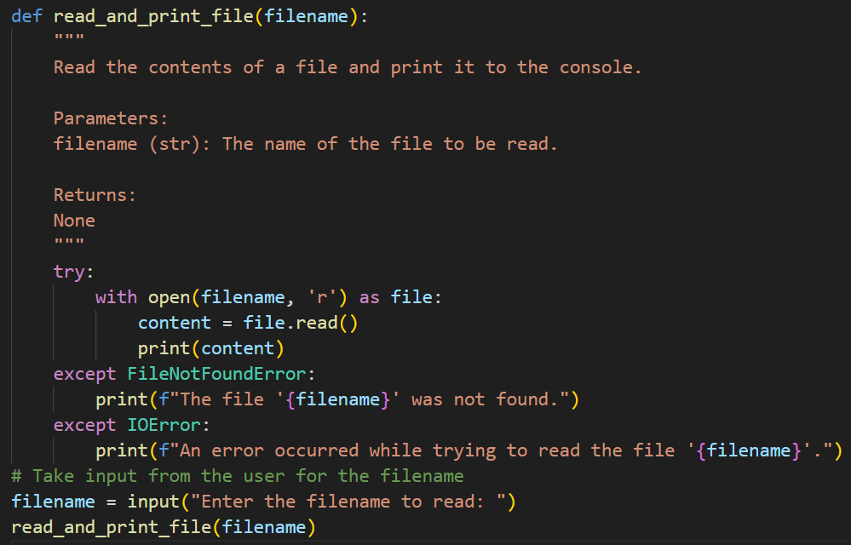
Output:
Expected Outcome:
o Reusable function using with open() and parameters.
Task 4 (Optimizing Search Logic)
• Task: Refactor inefficient linear searches using appropriate
data structures.
• Focus Areas:
o Time complexity
o Data structure choice
Legacy Code:
users = ["admin", "guest", "editor", "viewer"]
name = input("Enter username: ")
found = False
for u in users:
if u == name:
found = True
print("Access Granted" if found else "Access Denied")
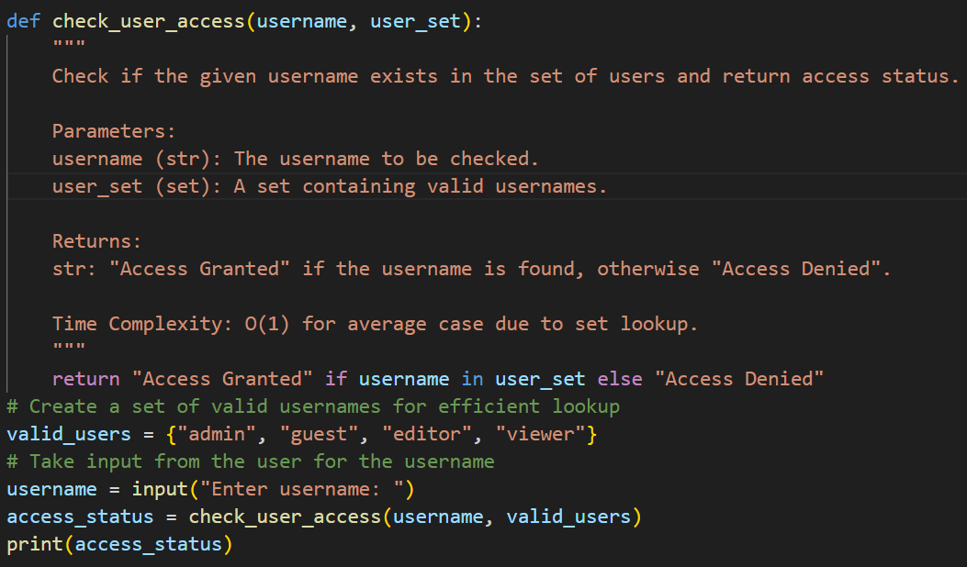
Output:
Expected Outcome:
o Use of sets or dictionaries with complexity justification.
Task 5 (Refactoring Procedural Code into OOP Design)
• Task: Use AI to refactor procedural code into a class-based
design.
• Focus Areas:
o Object-Oriented principles
Legacy Code:
salary = 50000
tax = salary * 0.2
net = salary – tax
print(net
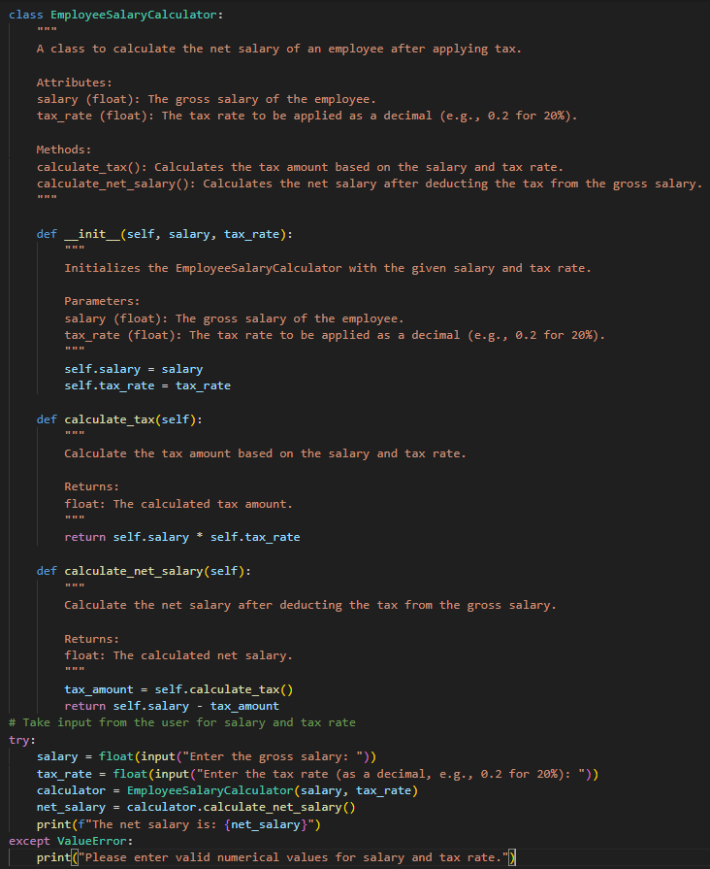

Output:
Expected Outcome:
o A class like Employee Salary Calculator with methods and attributes.

Task 6 (Refactoring for Performance Optimization)
• Task: Use AI to refactor a performance-heavy loop handling
large data.
• Focus Areas:
o Algorithmic optimization
o Use of built-in functions
Legacy Code:
total = 0
for i in range(1, 1000000):
if i % 2 == 0:
total += i
print(total)
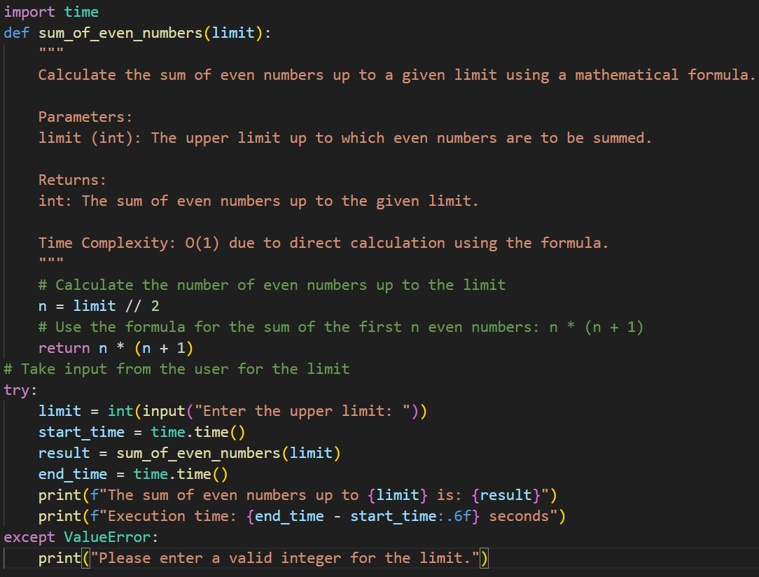
Expected Outcome:
o Optimized logic using mathematical formulas or comprehensions, with time comparison.

Task 7 (Removing Hidden Side Effects)
• Task: Refactor code that modifies shared mutable state.
• Focus Areas:
o Functional-style refactoring
o Predictability
Legacy Code:
data = []
def add_item(x):
data.append(x)
add_item(10)
add_item(20)
print(data)
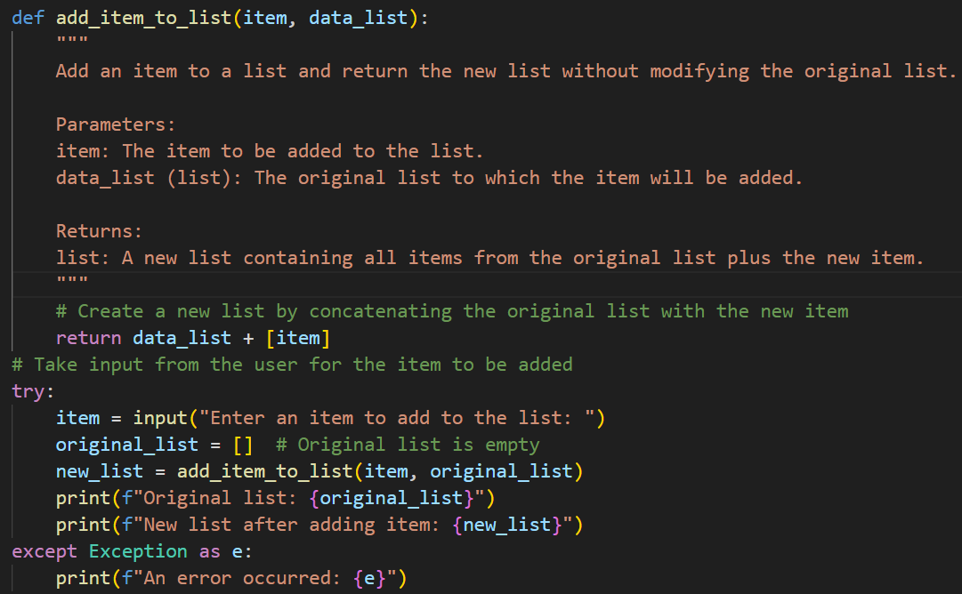
Expected Outcome:
o Refactored function returning values instead of mutating globals.

Task 8 (Refactoring Complex Input Validation Logic)
• Task: Use AI to simplify and modularize complex validation rules.
• Focus Areas:
o Readability
o Testability
Legacy Code:
password = input("Enter password: ")
if len(password) >= 8:
if any(c.isdigit() for c in password):
if any(c.isupper() for c in password):
print("Valid Password")
else:
print("Must contain uppercase")
else:
print("Must contain digit")
else:
print("Password too short")
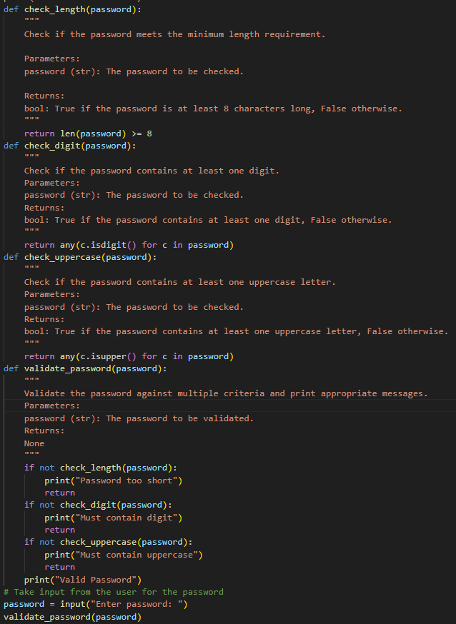
Expected Outcome:
o Separate validation functions with clear responsibility

