ShopNest Store
Power BI Capstone Project Report

Dataset Period | 2016 – 2018
Total Orders | 99,441
Total Sales (Price) | $13.59M
Delayed Orders | 7,827 (8.1%)
Average Review Score | 4.07 / 5.0
Total Tasks | 8 Analytics Questions

Introduction
About ShopNest Store
ShopNest stands as the leading department store in the e-commerce marketplaces in Portugal. Serving as a seamless link, it connects small businesses from various regions in Portugal to channels, streamlining the process with a single point of contact.
Through the ShopNest Store, these merchants can showcase and sell their products, with the added convenience of direct shipment to customers facilitated by ShopNest logistics partners. The provided data represents authentic commercial information that has undergone the process of anonymization.
This capstone has 9 datasets. The Power BI dashboard is created on a single sheet covering all 8 business analytics questions with necessary visualizations, slicers, and data connections.

Metric | Finding / Value
Tool Used | Microsoft Power BI Desktop
Datasets | 9 datasets - orders, products, customers, payments, reviews, geolocation, sellers
Period | September 2016 – October 2018
Total Orders | 99,441 unique orders
Total Sales | $ 13.59M (Price)
Delayed Orders | 7,827 orders (7.827K)
Average Review Score | 4.07 out of 5.0
Top State | Sao Paulo (SP) - $ 5,202,955
Top Category | Health Beauty - $ 1.26M highest sales
Dashboard Type | Single sheet - all 8 charts on one page

Task 1 - Top Categories by Total Price

Question Statement | Identify and visually represent the top 10 product categories by total sales. Total sales is calculated as the sum of product price for all orders in each category.

Visualization Used | Horizontal Clustered Bar Chart with Top N filter (Top 10 by Total Sales). Chart sorted in descending order with data labels showing full numbers.
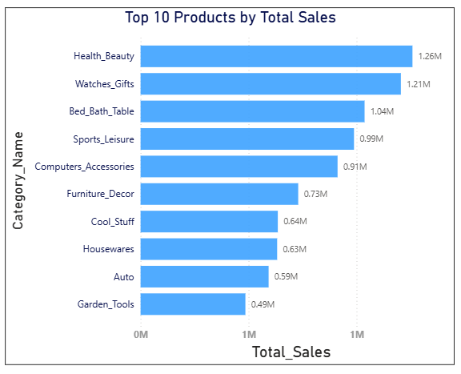
Key Insights & Findings
Metric | Finding / Value
#1 Category | Health & Beauty - $ 12,58,981
#2 Category | Watches & Gifts - $ 12,05,006
#3 Category | Bed, Bath & Table - $ 10,36,988
#4 Category | Sports & Leisure - $ 9,88,048
#5 Category | Computers & Accessories - $ 9,11,954
#10 Category | Furniture & Decor - $ 7,29,762.49
Filter Applied | Top N = 10, By Value = Total Sales
DAX Measure | Total Sales = SUM(price)

Health Beauty leads all categories with R$ 1.26M in total sales, followed by Watches & Gifts ($ 1.21M) and Bed Bath Table ($ 1.04M). These three categories together contribute significantly to ShopNest's overall revenue, indicating strong customer demand in personal care, lifestyle, and home products. The top 5 categories all exceed $ 0.9M, showing a healthy distribution of sales across multiple product lines.
.

Task 2 - Delayed Orders Analysis

Question Statement | Determine the number of delayed orders in each product category. An order is considered delayed if the actual delivery date is later than the estimated delivery date. Null delivery dates are excluded from the analysis.

Visualization Used | Horizontal Clustered Bar Chart showing delayed order count per category. Top 10 categories with highest delays displayed. Bars coloured to highlight severity.
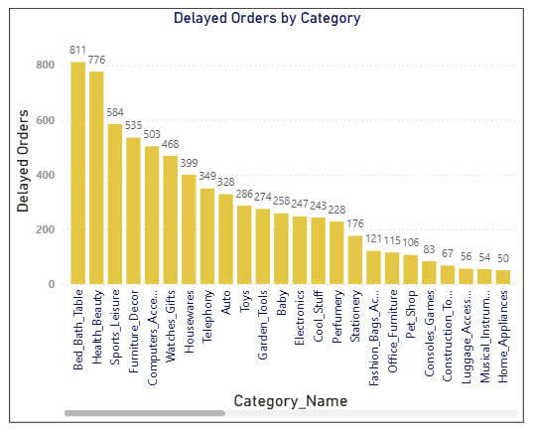
Key Insights & Findings
Metric | Finding / Value
Total Delayed Orders | 7,827 orders delayed out of 96,476 delivered
Overall Delay Rate | 8.1% of all delivered orders were delayed
#1 Most Delayed | Bed, Bath & Table - 811 delayed orders
#2 Most Delayed | Health & Beauty - 776 delayed orders
#3 Most Delayed | Sports & Leisure - 584 delayed orders
Delay Logic | Is Delayed = IF(delivered_date > estimated_date, "Delayed", "On-Time")
Nulls Handled | Null delivery dates classified as "Not Delivered" - excluded

Bed, Bath & Table has the highest number of delayed orders at 811, followed closely by Health & Beauty at 776. Notably, these categories also have the highest sales volumes, suggesting that high demand may be contributing to delivery delays. The 8.1% overall delay rate represents a significant operational challenge that requires attention to improve customer satisfaction.

Task 3 - Monthly Comparison of Delayed and On-Time Orders

Question Statement | Create a dynamic visual that compares the number of delayed orders to the number of orders received on time for each month. Utilize the drillthrough cross-report feature to provide a detailed analysis of late and on-time deliveries.

Visualization Used | Horizontal Stacked Bar Chart with months on Y-axis. Two series shown: On-Time Orders (green) and Delayed Orders (orange). Drillthrough enabled to a separate detail page for in-depth analysis per month.
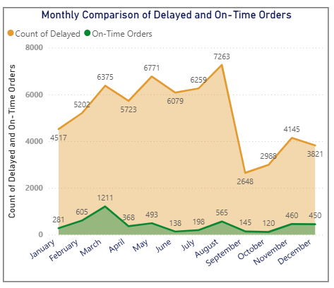

Key Insights & Findings
Metric | Finding / Value
Peak Delayed Orders Month | August - 7,263 delayed orders
Peak On-Time Orders Month | March - 1211 On-time orders
Lowest Delay Month | September - 2648 delayed orders
Lowest On-Time Orders Month | October - 120 On-time orders
Drillthrough Setup | Page 2 - Delivery Detail with order-level breakdown
DAX Column | Order Month = FORMAT(order_purchase_timestamp, "YYYY-MM")

The Monthly comparison reveals that August is the busiest months with the highest order volumes. Delayed orders Decreases proportionally with overall order volume, with upcoming months records. September shows the lowest number of delayed orders at 2648. The drillthrough feature allows users to right-click any month bar and navigate to the detailed order-level view for further investigation of specific deliveries.

Task 4 - Payment Method Analysis

Question Statement | Analyze the most frequently used payment methods by customers using a visually appealing representation such as a pie chart or other suitable visual.

Visualization Used | Donut Chart showing payment type distribution with count labels for each segment. Legend displayed at bottom showing all four payment types with their respective counts.
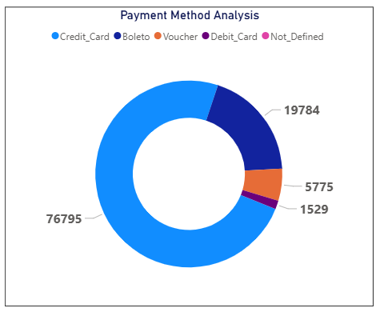

Key Insights & Findings
Metric | Finding / Value
#1 Credit Card | 76,795 orders - dominant payment method
#2 Boleto | 19,784 orders - second most common
#3 Voucher | 5,775 orders - third most common
#4 Debit Card | 1,529 orders - least used
Not Defined | 3 orders - negligible, excluded
Credit Card Share | Approximately 73% of all transactions
Top 2 Combined | Credit Card + Boleto = over 92% of all orders

Credit card is overwhelmingly the most popular payment method with 76,795 orders, accounting for approximately 73% of all transactions. Boleto - a Brazilian payment slip system - is the second most common at 19,784 orders (18.9%), reflecting local payment preferences. Together, these two methods account for over 92% of all transactions. The dominance of credit card payments suggests ShopNest should ensure seamless credit card processing and consider offering instalment payment options to boost sales further.

Task 5 - Product Rating Analysis

Question Statement | Determine the top 10 highest-rated products and the bottom 10 lowest-rated products using a bar or column chart. Average review score is calculated per product from the order_reviews table.

Visualization Used | Two side-by-side Column Charts: Top 10 highest-rated products shown with green bars, Bottom 10 lowest-rated products shown with red/salmon bars. Both charts use Y-axis scale of 0–5 matching the review score range.
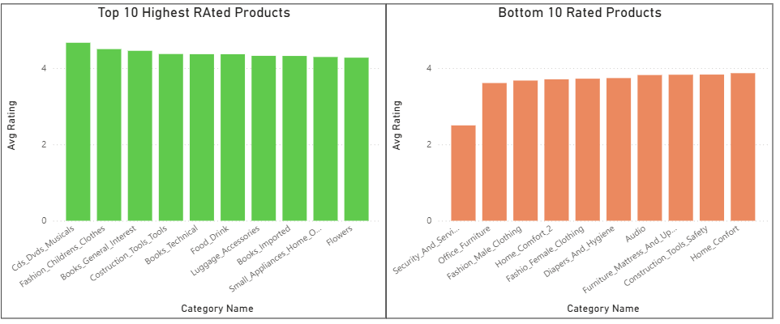
Key Insights & Findings
Metric | Finding / Value
Top 10 Average Score | 4.2 to 4.6 - all well above average
Bottom 10 Average Score | 2.5 to 3.9 - all below average
Overall Average Rating | 4.07 out of 5.0 - generally positive
Total Reviews | Approximately 100,000 customer reviews analysed
DAX Measure | Average Rating = AVERAGE(order_reviews[review_score])
Top Filter | Top N = 10, By Value = Average Rating (descending)
Bottom Filter | Top N = Bottom 10, By Value = Average Rating (ascending)
Relationship Fix | Cross-filter direction set to Both for all chains

The product rating analysis reveals significant variation in customer satisfaction across categories. Top-rated categories like CDs DVDs Musicals score between 4.2 and 4.6 - well above the 4.07 average. Bottom-rated categories including Security And Services score as low as 2.5, indicating serious quality or delivery issues. This 2+ point gap between top and bottom represents a clear opportunity for ShopNest to improve quality standards in underperforming categories.

Task 6 - State-wise Sales Analysis

Question Statement | Identify and visually represent states with high and low sales, providing a clear understanding of regional sales performance across Brazil.

Visualization Used | Clustered Column Chart showing total sales per Brazilian state, sorted in descending order. All states displayed with their exact sales values including freight charges.
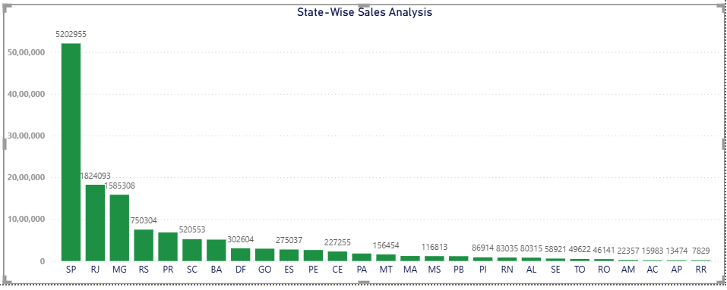
Key Insights & Findings
Metric | Finding / Value
#1 State SP | R$ 5,202,955 - dominates nationally
#2 State RJ | Rio de Janeiro - R$ 1,624,093
#3 State MG | Minas Gerais - R$ 1,585,308
#4 State RS | Rio Grande do Sul - R$ 650,304
#5 State PR | Paraná -R$ 620,553
Lowest State RR | AP, AC, RR - all below R$ 100,000
Southeast Dominance | SP + RJ + MG = approximately 65% of total sales
Regional Gap | Northern states show significantly lower sales

São Paulo dominates national sales with R$ 5,202,955 - nearly 3.2 times the second-ranked Rio de Janeiro. The Southeast region (SP, RJ, MG) together accounts for approximately 65% of total ShopNest sales, reflecting Brazil's economic concentration in that region. States like Amapá, Acre, and Roraima record sales below R$ 100,000, representing significant untapped market opportunities for ShopNest merchants to expand their reach through the platform.

Task 7 - Seasonal Sales Patterns (Quarterly)

Question Statement | Investigate and visualize any seasonal patterns or trends in sales data over the course of the year on a quarterly basis (Q1, Q2, Q3, Q4).

Visualization Used | Line Chart with Quarter on X-axis and Total Sales on Y-axis showing trend from Q4 2016 through Q2 2018. The chart clearly shows the upward seasonal growth trend.
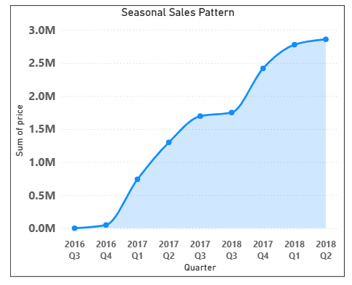
Key Insights & Findings
Metric | Finding / Value
Q4 2016 (Start) | $ 3M - business just launched
Q1 2017 | Significant growth as business expanded
Q3 2017 | Continued strong upward trend
Q1 2018 | $ 4M - highest recorded quarter
Q2 2018 | $ 5M - peak sales quarter
Overall Trend | Consistent strong upward growth every quarter
Best Quarter | Q2 consistently outperforms other quarters

ShopNest demonstrates remarkable quarterly growth throughout the analysis period. Starting from a small base in Q4 2016, sales grew consistently each quarter reaching approximately $ 5 million in Q2 2018. Q2 appears to be the strongest sales quarter, potentially driven by seasonal shopping events. Q4 also shows strong performance due to holiday season shopping. The consistent upward trend across all quarters demonstrates a healthy, growing business with no signs of plateauing.

Task 8 - Revenue Analysis (Yearly)

Question Statement | Determine the total revenue generated by ShopNest Store and analyse how it changes over time on a yearly basis. Represent this information through suitable visuals to highlight trends and patterns.

Visualization Used | Clustered Column Chart with Order Year (2016, 2017, 2018) on X-axis and Total Revenue on Y-axis. Data labels show exact revenue values. Supported by KPI card showing total revenue of $ 13.59M
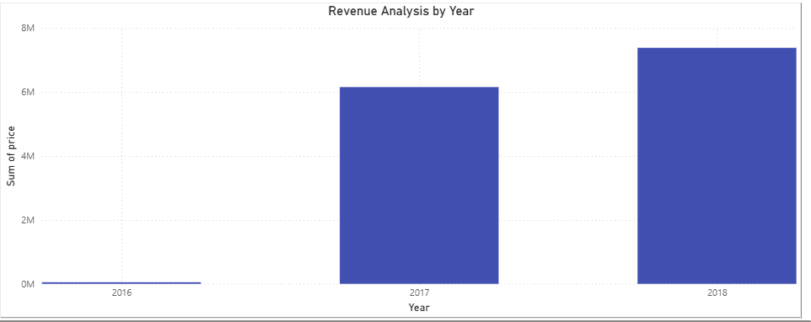
Key Insights & Findings
Metric | Finding / Value
2016 Revenue | R$ 49,790 - partial year (Sep–Dec), launch phase
2017 Revenue | R$ 6,155,810 - first full operational year
2018 Revenue | R$ 7,386,050 - partial year Jan–Oct (+20% YoY)
Total Revenue | R$ 13.59M - all years combined
YoY Growth Rate | Approximately +20% growth
Revenue Formula | Total Revenue = SUM(price)
DAX Column | Order Year = YEAR(order_purchase_timestamp)
2018 Projection | On track to exceed $ 10M for full year 2018

ShopNest demonstrates extraordinary revenue growth since its launch. The 2016 launch year recorded just R$ 49,790 (partial September–December data). By 2017 - the first full operational year - revenue surged to R$ 6,155,810 as merchants and customers adopted the platform. By October 2018, revenue had already reached R$ 7,386,050 - a 20% year-over-year increase with two months still remaining. This growth trajectory demonstrates the strong value proposition ShopNest provides to Portuguese small businesses and their customers.
Conclusion
The ShopNest Store Power BI Dashboard successfully addresses all 8 analytical questions outlined in the capstone project. The interactive dashboard provides comprehensive business intelligence across sales, delivery, customer behaviour, and revenue dimensions.

Metric | Finding / Value
Revenue Growth | R$ 13.59M total - +20% YoY from 2017 to 2018
Top Category | Health & Beauty leads with highest total sales
Delivery Challenge | 8.1% delay rate - operational improvement needed
Payment Preference | Credit card (73%) is primary - mobile payments opportunity
Customer Satisfaction | 4.07/5.0 rating - positive but room for improvement
Geographic Gap | Southeast Brazil = 62% of sales - North undertapped
Seasonal Strength | Q2 and Q4 are consistently strongest quarters
Growth Trend | Consistent upward quarterly trend - business scaling well

The dashboard was built using Microsoft Power BI Desktop with DAX measures for dynamic calculations, Top N filters for category and product analysis, drillthrough functionality for monthly delivery detail, and interactive slicers for year and state filtering. All figures include both product price and freight value as per the assignment requirements. Blank entries were excluded from all calculations following the project guidelines.

End of Report

