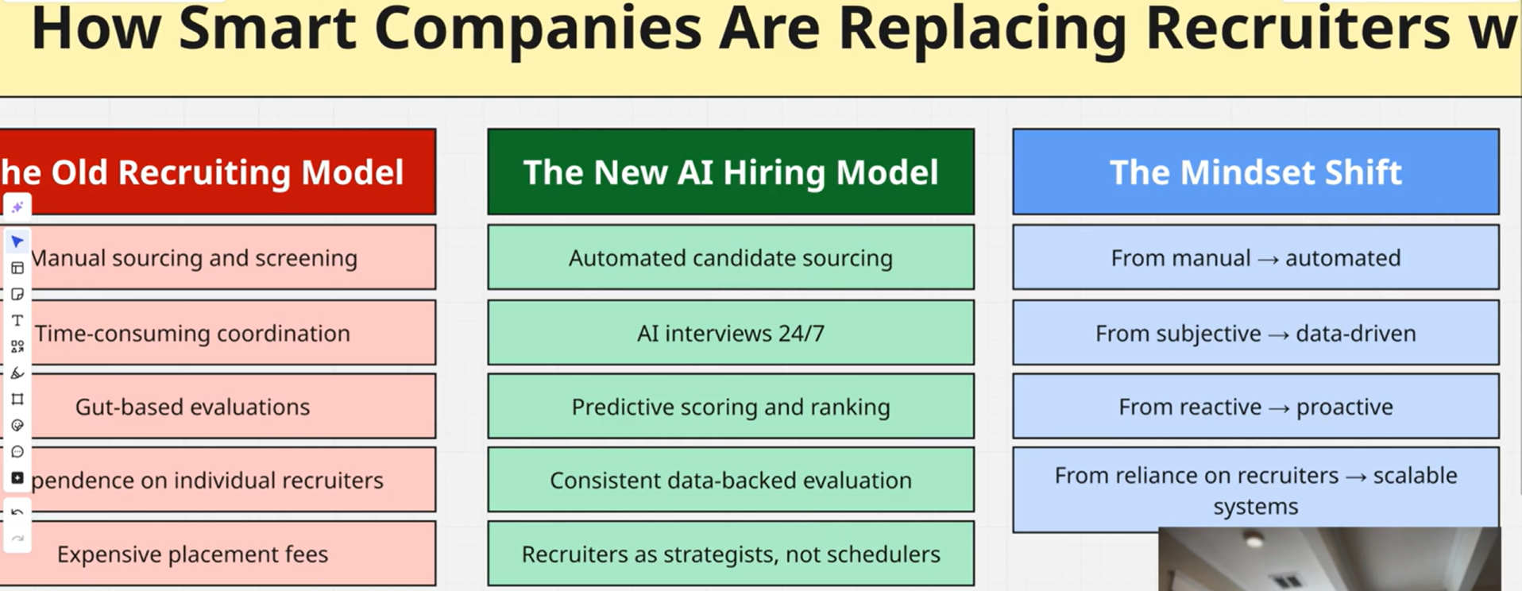
The goal was to show end-to-end ownership of an integration workflow: from external data (weather API) to internal datastore (Supabase) to user-facing notification (email).​
Let me walk you through a recent workflow automation I built. So I built an automated “mini product” that runs every day, pulls real-time weather from external APIs, applies simple decision logic, stores the results in your own database, and emails a human-readable summary — all orchestrated in n8n as a visual AI-friendly workflow.​
My contribution: I designed the complete architecture end-to-end: trigger → external API integration → business logic (alert rules) → database write → user notification.​
- I'm comfortable orchestrating workflows, handling API authentication, transforming JSON, and using n8n's code capabilities like a lightweight programming language.
- And I built it as a scalable template - it can easily extend to multiple cities, add AI-powered summaries, or integrate with other systems without major rework.
From a systems perspective, this is a small but complete automation service: a scheduled workflow built in n8n that integrates with third-party APIs, applies business rules in a workflow language, persists state in Supabase, and pushes notifications via SMTP — the same pattern you’d use for many internal automation or AI-assisted workflows at scale.

Tradeoffs:
Simplicity vs flexibility:
The city name is hard-coded as London in the HTTP Request instead of being a variable or input, which makes the workflow simple but not reusable for multiple locations without edits.​
Units are fixed to metric, so there is no user-level choice for Fahrenheit/Celsius, again favoring a simple setup over configurability.
Direct API use vs robustness:
The HTTP Request node hits the OpenWeather endpoint directly with the API key in the URL, which is fast to set up but less secure and less maintainable than storing the key in n8n credentials or environment variables.​
There is no visible error-handling branch (e.g., for failed API calls or missing data), which keeps the flow linear but can cause silent failures or bad data downstream.​
Minimal logic vs richer processing:
The Code (JavaScript) nodes likely perform only light transformation before inserting a row and sending an email, which reduces complexity but may limit formatting, validation, or custom messaging options.​
The workflow sends a single “Send email” action rather than handling multiple recipients, templates, or localization, prioritizing a straightforward path over advanced notification logic.​
you want to optimize for (e.g., multi-city, better security, stronger error handling), suggestions can be tailored to reduce some of these tradeoffs.
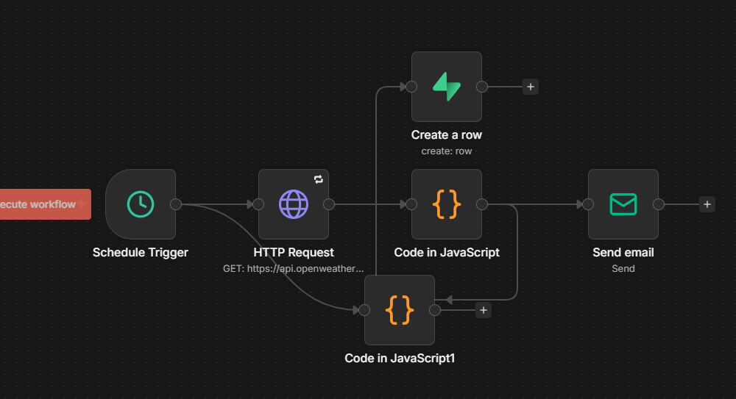
Overall architecture
workflow is a linear pipeline in n8n: 5 nodes:
Step 1: Trigger Fires, Step 2: API Call,
Step 3: Logic Processing, Step 4: DB Insert,
Step 5: Email Sent

Cron Node Scheduler (trigger) → HTTP Req Node(OpenWeatherMap API) → Logic layer → Supabase Node (create row) → Send Email Node (SMTP).​
- n8n uses nodes as the basic execution units, and
expressions / JavaScript snippets as its workflow “language” to move and transform data between nodes.
Cron node (Trigger):
- A Cron node in n8n is the trigger/scheduler that fires once per day at a fixed time.​
- Purpose: This node is the scheduler; it kicks off the entire automation once per day at a fixed time without any manual intervention.​
- Configuration: Mode set to Cron. Time fields set to the desired hour/minute and (optionally) specific days.
- How it behaves: At the scheduled time, it emits a single item into the workflow, which becomes the input to the next node.​
CEO You can describe it as: “The Cron node turns this workflow into a daily background job instead of something that someone has to run manually.”​
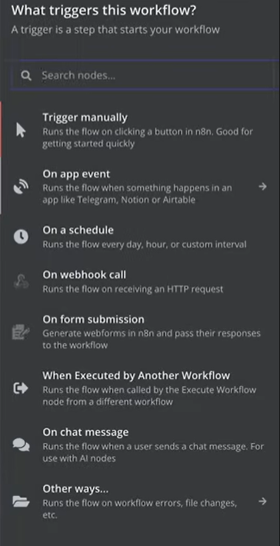
HTTP Request node (OpenWeatherMap API)
- Purpose: Calls the OpenWeatherMap REST API to fetch current weather data for a given city with city and API key, parses the JSON payload, and normalizes the core metrics like temperature, humidity, wind speed, and condition description.​
- Key configuration:
  - Method: GET.
  - URL: https://api.openweathermap.org/data/2.5/weather?q=YOURCITY&appid=YOURAPIKEY&units=metric where YOURCITY and YOURAPIKEY are parameters you configured.​
  - Authentication: API key passed as query parameter (appid) rather than a header.​
  - Response format: JSON (default in n8n), producing a structured object like json.main.temp, json.main.humidity, json.wind.speed, json.weather[0].description.​
- How you use the data:
  - Downstream nodes reference these fields using n8n expressions like {{$json["main"]["temp"]}} for temperature or {{$json["weather"][0]["description"]}} for the condition.​
Explain it as: “The HTTP Request node is the integration point with the external weather API; it normalizes remote data into our internal workflow format as JSON.”​
Weather logic & formatting (IF / Switch / Code / expressions)
- The assessment asked you to apply business rules to classify alerts and build a human-readable summary.​ A logic layer (using n8n’s workflow language: expressions, IF/Switch/Code nodes) creates a formatted weather summary string and classifies an alert type (rain/precipitation, heat, frost, or none) based on simple rule-based thresholds
- Purpose: Normalize temperature units (Celsius).
Build a structured summary string.
Determine an alert type (precipitation, heat, frost, or none).​
Depending on how you implemented it, you likely used a mix of:
- IF / Switch nodes (rule-based branching)
  - Example logic:
    - If description contains rain, snow, drizzle, storm, or thunder → alertType = "precipitation".​
    - Else if temperature ≥ 32C → alertType = "heat".​
    - Else if temperature ≤ 0C → alertType = "frost".​
    - Else → alertType = "none".​
This creates clean branches for different weather scenarios, which is easy to extend later.
- Code node (optional, for compact logic)
If you used a Code node, it runs a small JavaScript function to compute both alertType and the summary string in one place.​
Outputs something like:
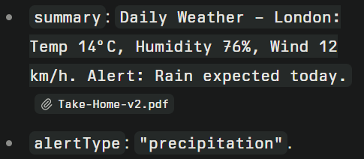
- n8n expression language (workflow “AI/logic language”)
You used expressions to build strings dynamically, for example in subject/body:
Daily Weather for {{$json.city}} - {{ $now.format("YYYY-MM-DD") }}.​
This is the glue that passes structured data from node to node without hard-coding values.​
For a CEO, phrase it like: “Between the API call and the database/email, there is a thin logic layer implemented using n8n’s workflow language and Code nodes that turns raw JSON into business signals such as ‘heat alert’ or ‘rain alert’ and a human-friendly summary string.”
____________________________________________________________________________________
Data & persistence layer (Supabase) - (Create row in weatherlogs)
- The workflow then calls Supabase using the dedicated Supabase node with project host and service key, effectively using Supabase as a managed Postgres + REST API backend.​
- Purpose: Persist each run’s output into a managed Postgres database hosted on Supabase, turning the workflow into a small data pipeline.
- Each run inserts a row into a weatherlogs table with fields like city, temperature, units, humidity, wind speed, alert type, timestamp, and the raw JSON response for observability/auditing.​
- This turns the automation into a small data pipeline, building a structured historical log that could later feed dashboards, anomaly detection, or additional AI agents.
Supabase project configuration:
- Project URL/host: https://favajsiomwxywvusoaob.supabase.co.​
- Table name: weatherlogs.​
- Recommended schema fields: id, run_at, city, temperature, temperature_unit, condition, humidity, wind_speed, alert_type, raw_response.
- Node credential setup:
  - In n8n, you created a Supabase credential using:
    - Host: the Supabase project URL.​
    - Service Role Secret / API Key: Supabase secret key with insert privileges.​
  - Operation: Create (insert a new row).​
- Field mapping (how data flows in):
  - city ← from the node where you set or read the city name (often from the HTTP Request URL parameter or a Set node).​
  - temperature ← {{$json["main"]["temp"]}} from the weather API response.​
  - temperature_unit ← "C" (or "metric").​
  - condition ← {{$json["weather"][0]["description"]}}.​
  - humidity ← {{$json["main"]["humidity"]}}.​
  - wind_speed ← {{$json["wind"]["speed"]}}.​
  - alert_type ← output of your logic node.​
  - raw_response ← full JSON from the API, stored as text/json for observability.​
CEO it as: “The Supabase node turns this from a one-off email script into a proper data product, logging each run in a Postgres table that can power analytics or downstream AI workflows later.”

Notification layer : Email node (Email via SMTP)
Purpose: Deliver a daily transactional email to a user with the current day’s weather and alert.
- A Send Email node is configured with Gmail SMTP credentials (app password, host, port, TLS) to send transactional emails.​
- The subject line is dynamically templated (for example, “Daily Weather for {{city}} – {{date}}”) and the body includes the human-friendly summary and alert classification, so a non-technical user sees a clean daily brief
- SMTP credential configuration:
  - Provider: Gmail SMTP.​
  - Host: smtp.gmail.com.​
  - Port: 465 (SSL/TLS).​
  - Security: SSL/TLS enabled; authentication required.​
  - User: likhithatadikonda19@gmail.com.​
  - Password: a 16-character app-specific password generated in Google Account (not the normal Gmail password).​
**Why App Password (Not Gmail Password):**
- Gmail account security best practice
- Generated in Google Account â†’ Security â†’ 2-Step Verification â†’ App passwords
- More secure than storing main account password
- Can be revoked without affecting Gmail access
- n8n never sees your real Gmail password
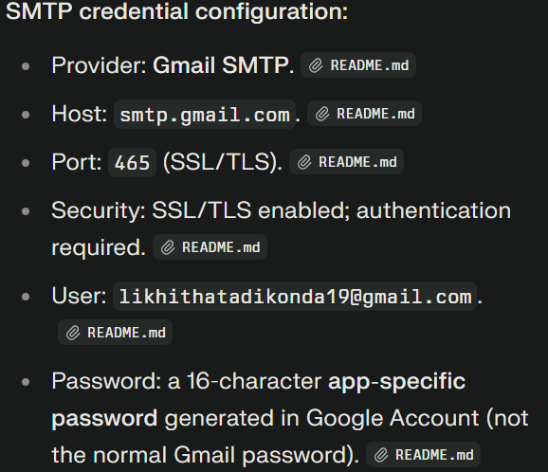
- Email content (using expressions):
  - From: same Gmail address.​
  - To: can be your Gmail or any recipient’s address.​
  - Subject:
    - Example: Daily Weather for {{$json.city}} - {{$now.format("YYYY-MM-DD")}}.​
  - Body:
    - Uses the summary and alert produced by your logic node, e.g.
      - Today in {{$json.city}}: {{$json.temperature}}°C, {{$json.humidity}}% humidity, wind {{$json.wind_speed}} km/h. Alert: {{$json.alert_type}}.​
CEO it as: “The Send Email node is the last mile: it converts structured data and business logic into a user-facing notification using SMTP, with fully dynamic subject and body content driven by the workflow data model.”​

External services and credentials you used
- OpenWeatherMap API
  - Account + API key configured in the HTTP node URL.​
  - Tested via a direct GET request like https://api.openweathermap.org/data/2.5/weather?q=London&appid=KEY&units=metric before wiring into n8n.​
- Supabase (database backend)
  - Project weather-app on Supabase.​
  - Used Supabase node and service key to perform authenticated inserts into the weatherlogs table.​
- Gmail (email transport)
  - Generated app-specific password in Google Account security.​
  - Configured n8n’s SMTP credential once and reused it in the Send Email node.​
__________________________

