**MACHINE LEARNING –ICP#3**

**Student Name**: Likhitha Parvathi Tadikonda

**Student Id**: 700752941

**Github Link**: https://github.com/LikhithaTadikonda/Machine-Learning-ICP-s/tree/master/ICP-3

**a. Using NumPy create random vector of size 15 having only Integers in the range 1-20.**

**1. Reshape the array to 3 by 5**

**2. Print array shape.**

**3. Replace the max in each row by 0**

**Create a 2-dimensional array of size 4 x 3 (composed of 4-byte integer elements), also print the shape, type and data type**

**of the array.**

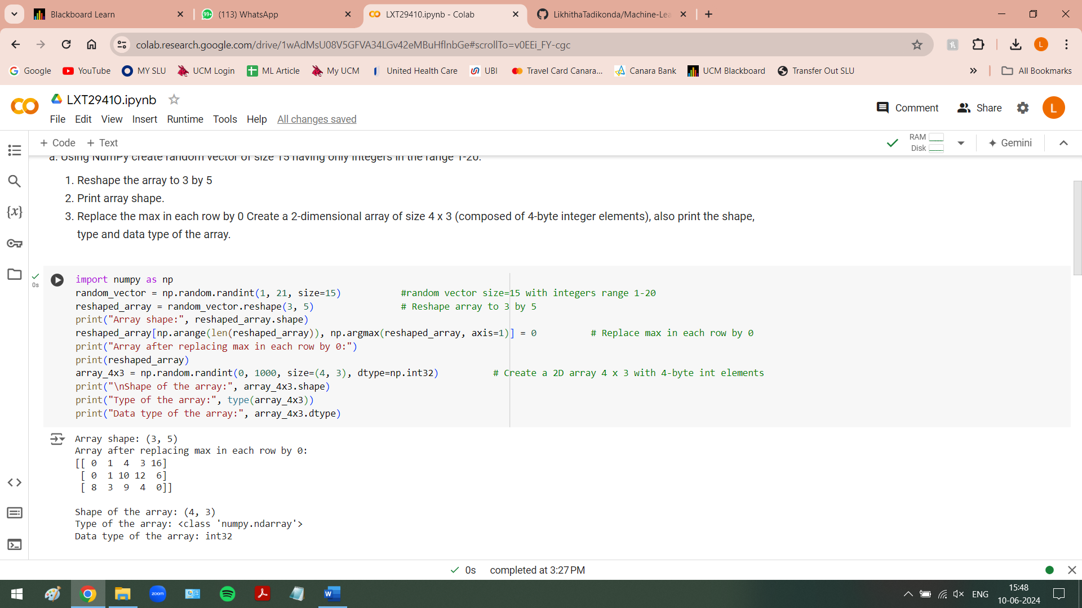

**b. Write a program to compute the eigenvalues and right eigenvectors of a given square array given below:**

**[[ 3 -2]**

**[1 0]]**

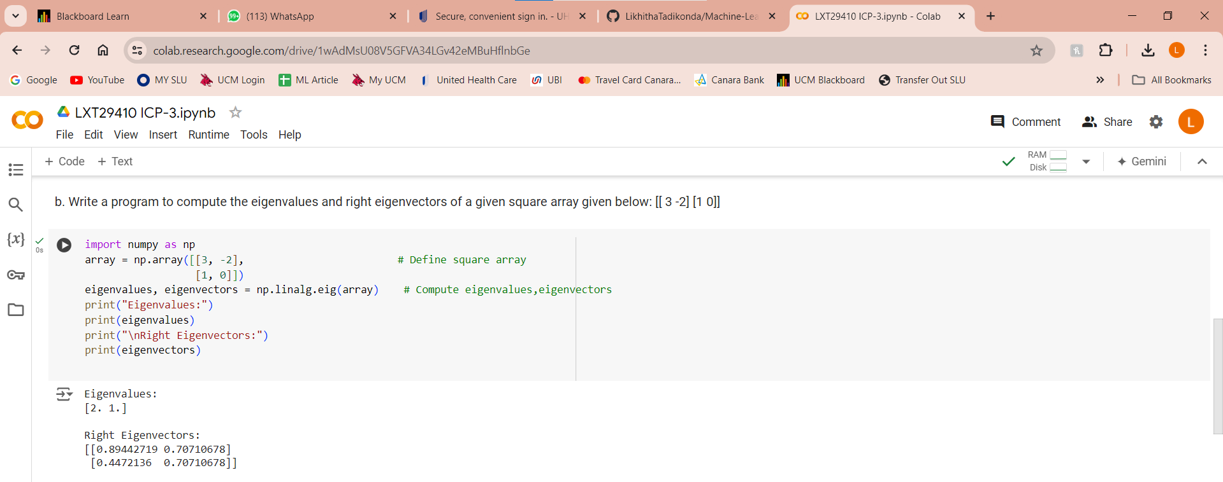

**c. Compute the sum of the diagonal element of a given array.**

**[[0 1 2]**

**[3.45]**

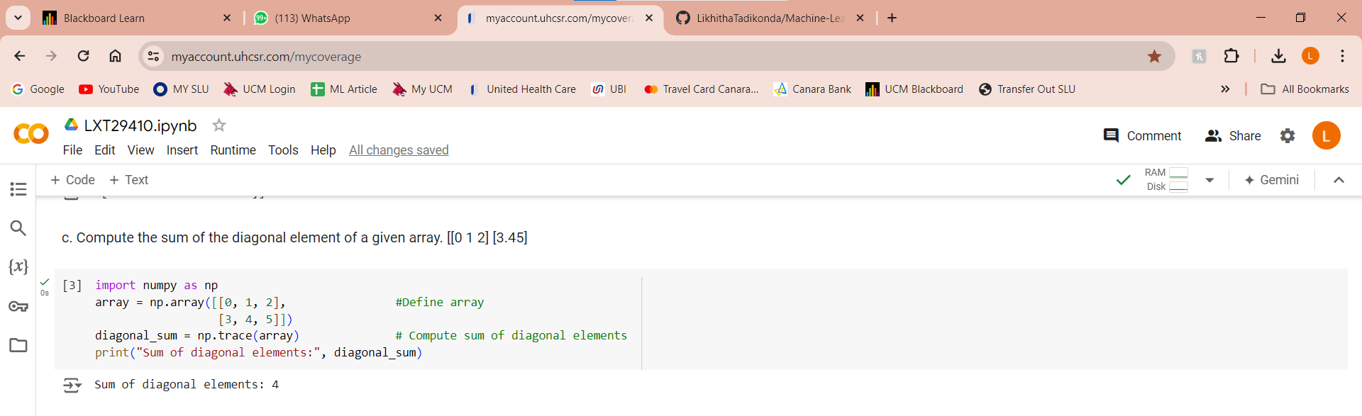

**d. Write a NumPy program to create a new shape to an array without changing its data.**

**Reshape 3x2:**

**[[1 2]**

**[3.4]**

**[5 6]**

**Reshape 2x3:**

**[[1 2 3]**

**[45 6]]**

