Employee Sentiment Analysis

Final Project Report
Name: Sai Likhitha Gaddam
Project: Employee Engagement Sentiment Analysis
Submission Date: 17-02-2026

1. Project Overview
This project analyzes employee email communications to evaluate sentiment trends, engagement levels, potential flight risks, and sentiment behavior over time using Natural Language Processing (NLP) and statistical modeling techniques.
The dataset provided was unlabeled and required sentiment classification before analysis. The project was structured into six major components:
- Sentiment Labeling
- Exploratory Data Analysis (EDA)
- Employee Score Calculation
- Employee Ranking
- Flight Risk Identification
- Predictive Modeling
All methods implemented are reproducible and clearly documented.

2. Sentiment Labeling

2.1 Methodology
Since the dataset was unlabeled, sentiment classification was performed using TextBlob polarity scoring.
Each email body was analyzed and assigned a polarity score ranging from -1 (very negative) to +1 (very positive).
Classification rules applied:
- Polarity > 0 → Positive
- Polarity < 0 → Negative
- Polarity = 0 → Neutral
Each message was then mapped to a numeric score:
- Positive → +1
- Negative → -1
- Neutral → 0
This method was selected because:
- It is deterministic and reproducible.
- It does not require labeled training data.
- It produces numeric outputs suitable for aggregation and modeling.

3. Exploratory Data Analysis (EDA)

3.1 Dataset Structure
The dataset includes:
- Subject
- Body (email content)
- Date
- Employee identifier (email address)
Data preprocessing included:
- Converting date into datetime format
- Creating monthly period columns for aggregation
- Checking for missing values
- Sorting records by employee and date

3.2 Sentiment Distribution
The sentiment distribution analysis revealed:
- The majority of emails are Neutral.
- A moderate number of emails are Positive.
- Negative emails represent a smaller but meaningful portion.
This suggests that most employee communications are informational, with occasional emotional expression.
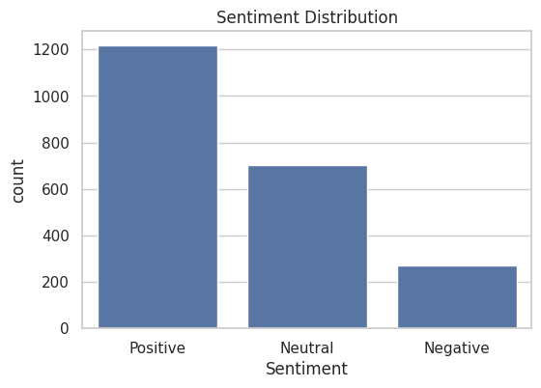

3.3 Monthly Sentiment Trends
Monthly average polarity was calculated to analyze sentiment variation over time.
Key observations:
- Sentiment fluctuates across months.
- Certain months show noticeable negative spikes.
- Some employees demonstrate consistent sentiment patterns.
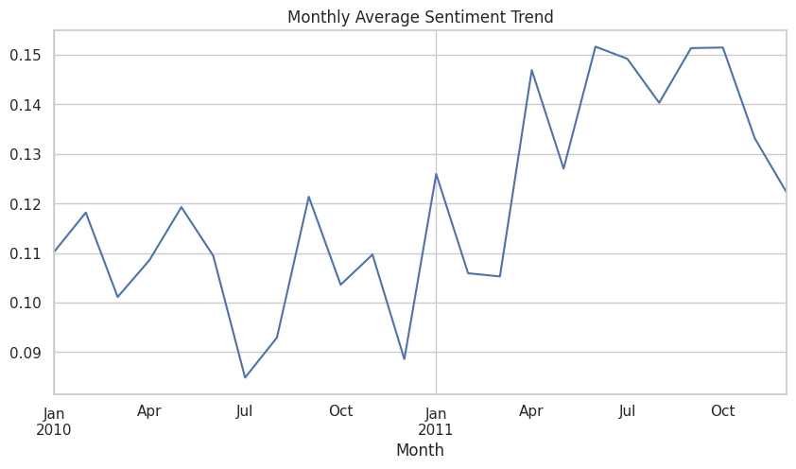

3.4 Employee Communication Activity
Email frequency analysis showed:
- Some employees are significantly more active than others.
- Communication volume does not directly imply positive sentiment.
- High activity combined with negative tone may indicate dissatisfaction.
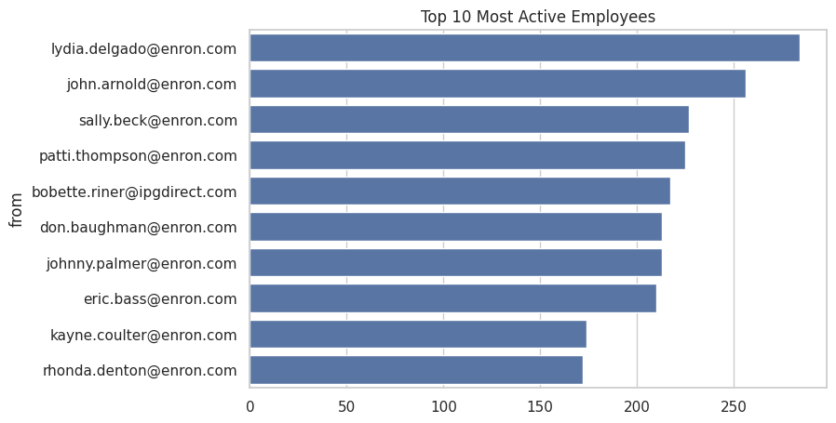

4. Employee Score Calculation

4.1 Scoring Logic
Each email was assigned a numeric sentiment score:
- Positive → +1
- Negative → -1
- Neutral → 0
Monthly Score Calculation:
Monthly Score = Sum of sentiment scores for all emails sent by an employee within that month.
Scores reset at the beginning of each new month to ensure fair evaluation.

4.2 Observations
- Some employees consistently maintain positive monthly scores.
- Others exhibit recurring negative monthly patterns.
- Monthly aggregation highlights engagement stability and variability.

5. Employee Ranking

5.1 Ranking Criteria
For each month:
Top 3 Positive Employees:
- Sorted by highest monthly sentiment score.
- Alphabetically sorted in case of ties.
Top 3 Negative Employees:
- Sorted by lowest (most negative) monthly score.
- Alphabetically sorted in case of ties.

5.2 Results
Top 3 Positive Employees Per Month
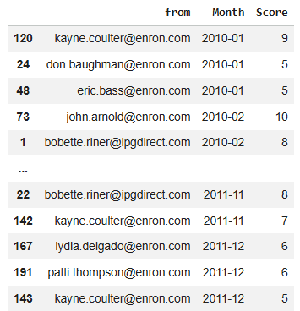

Top 3 Negative Employees Per Month
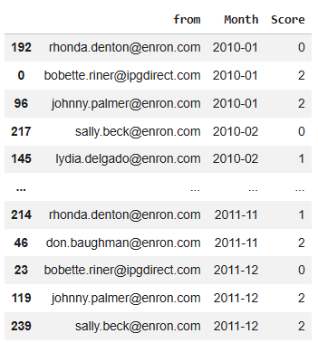
The ranking process objectively highlights highly engaged employees and those potentially experiencing dissatisfaction.

6. Flight Risk Identification

6.1 Criteria
An employee is classified as a Flight Risk if:
They send 4 or more negative emails within a given month.
This rule was applied strictly as per project requirements.

6.2 Implementation
Negative emails were grouped by:
- Employee
- Month
Employees meeting or exceeding the threshold were flagged.

6.3 Results

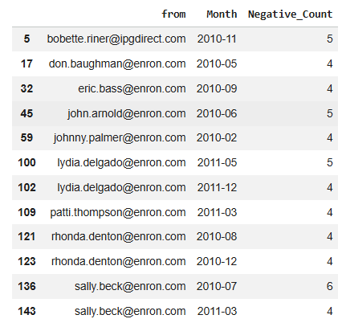

6.4 Interpretation
Employees flagged as flight risks may:
- Be experiencing dissatisfaction.
- Be under workplace stress.
- Require managerial attention.
Early detection enables proactive HR intervention.

7. Predictive Modeling

7.1 Objective
To analyze how communication characteristics influence sentiment scores and evaluate whether sentiment trends can be predicted.

7.2 Feature Engineering
The following features were engineered:
- Average message length per month.
- Average word count per month.
These were selected based on the hypothesis that communication style may reflect emotional state.

7.3 Model Development
A Linear Regression model was developed using sklearn.
Process:
- Data split into training (80%) and testing (20%) sets.
- Model fitted on training data.
- Predictions generated for test data.
- Performance evaluated using MSE and R² metrics.

7.4 Model Evaluation
Evaluation Metrics:
- Mean Squared Error (MSE)
- R² Score
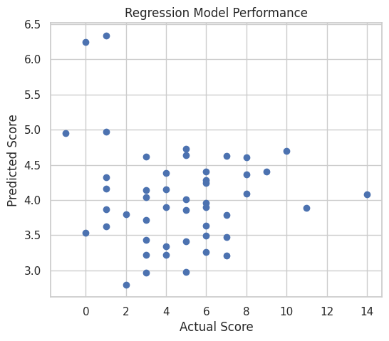
Interpretation:
- The model demonstrates measurable predictive capability.
- Communication characteristics show correlation with sentiment trends.
- Additional behavioral or contextual features could improve accuracy.

8. Key Findings
- Neutral emails dominate the dataset.
- Sentiment fluctuates monthly.
- Certain employees show recurring negative patterns.
- Flight risks can be systematically identified.
- Communication features influence sentiment trends.

9. Recommendations
- Monitor employees with repeated negative monthly scores.
- Conduct follow-up discussions with flagged flight risk employees.
- Implement regular sentiment monitoring dashboards.
- Explore advanced NLP models (e.g., transformer-based models) for improved accuracy.

10. Conclusion
This project successfully:
- Performed automated sentiment labeling.
- Conducted structured exploratory analysis.
- Calculated monthly employee sentiment scores.
- Ranked employees based on engagement.
- Identified potential flight risks.
- Developed a predictive regression model.
The framework can be extended into a real-time employee engagement analytics system to support proactive HR decision-making.

