Student Organization Portal QA Report
Team 7 | November 12, 2026 | Historical QA: ZIP (4) | Tested release: 4a74d05
The results below and the following screenshots record the earlier ZIP (4) QA run. A new broader regression was executed on verified ZIP (5), commit 4a74d05. Backend tests and the frontend build passed; mobile layout checks failed. See the executed regression addendum for results, evidence and remaining scope.
Case | Result | Observed behavior
QA-01 Manual | Pass | Registered and approved QA Manual Main 4. The member stayed active after reload and sign-in.
QA-01 Selenium | Pass | Approval persisted after reload and the application left the pending queue.
QA-02 | Pass | Member officer controls were absent. Restricted API requests returned HTTP 403.
QA-03 | Pass | Going, Not going and Going persisted. Counts updated correctly.
QA-04 | Pass | Start, Complete and Reopen persisted after reload.
QA-05 | Pass | Present and Absent persisted after reload. The record stayed unique. Members had no attendance management control.
QA-06 | Pass | All six checks passed. An approved member was added using the dropdown, remained after reload, was removed without open tasks and stayed absent after reload. Regular members had no officer controls.
API-01 | Pass | Officer attendance persisted without duplicates. Member attendance writes returned HTTP 403.

Test scope
The test environment used Windows, Chrome, Selenium WebDriver 4.51.0 and local H2. The frontend ran at localhost port 5174 and the gateway at port 8180. Some automated scenarios create synthetic data through the API before exercising the UI. QA-06 covers the six committee membership checks. QA-04 covers task status on an existing assignment. AI testing is handled separately.

Manual membership after reload
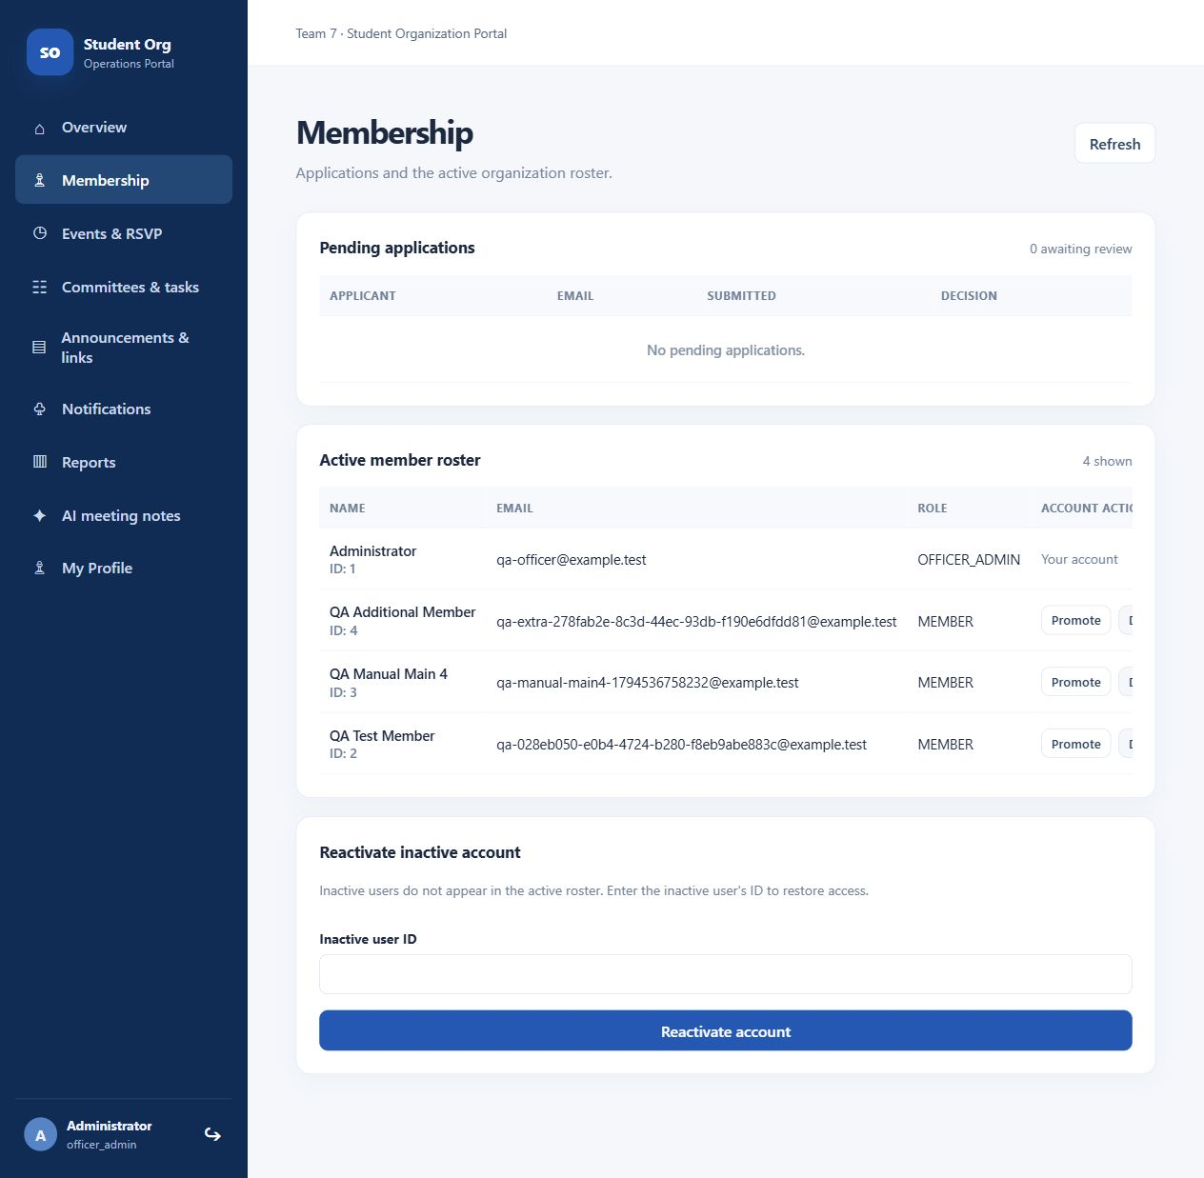

Selenium membership after reload
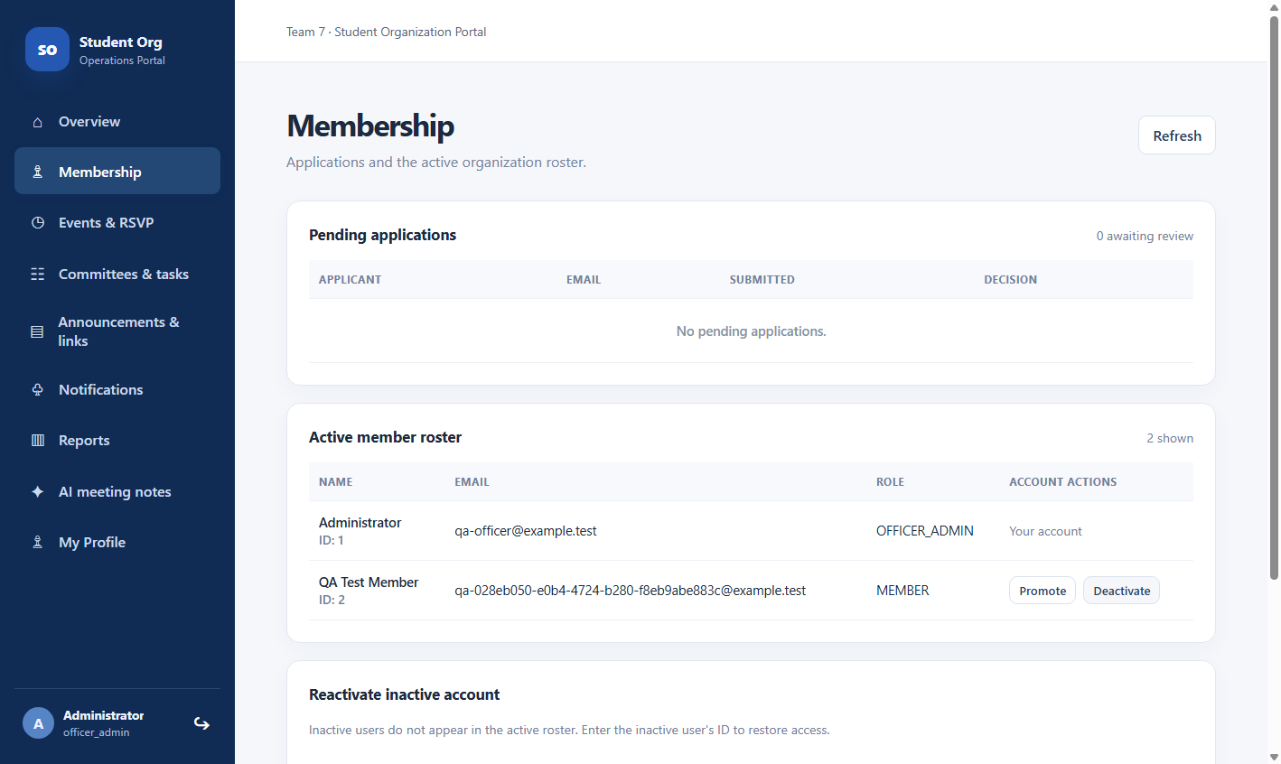

Regular member role restrictions
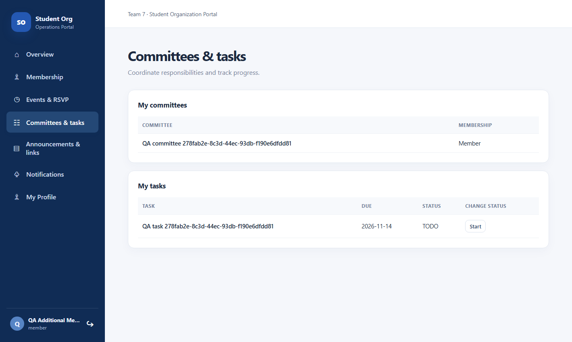

RSVP after reload
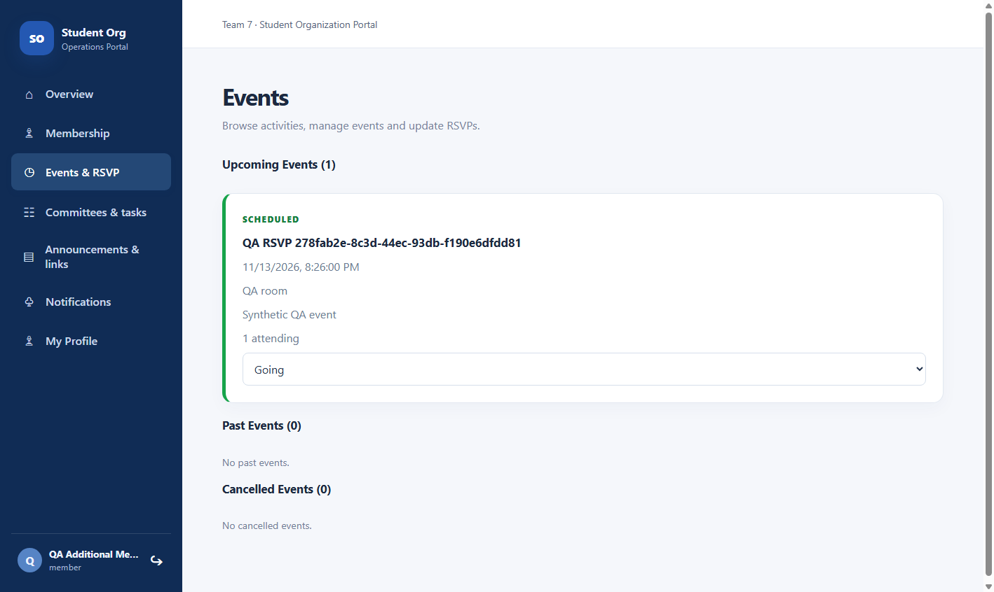

Task status after reload
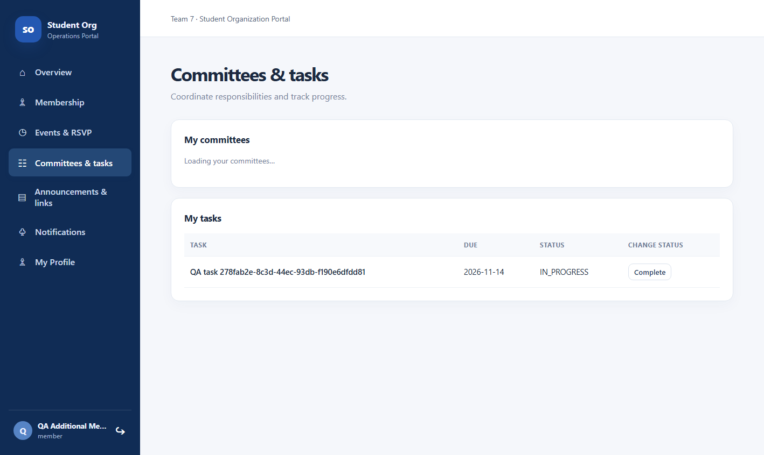

Present after reload
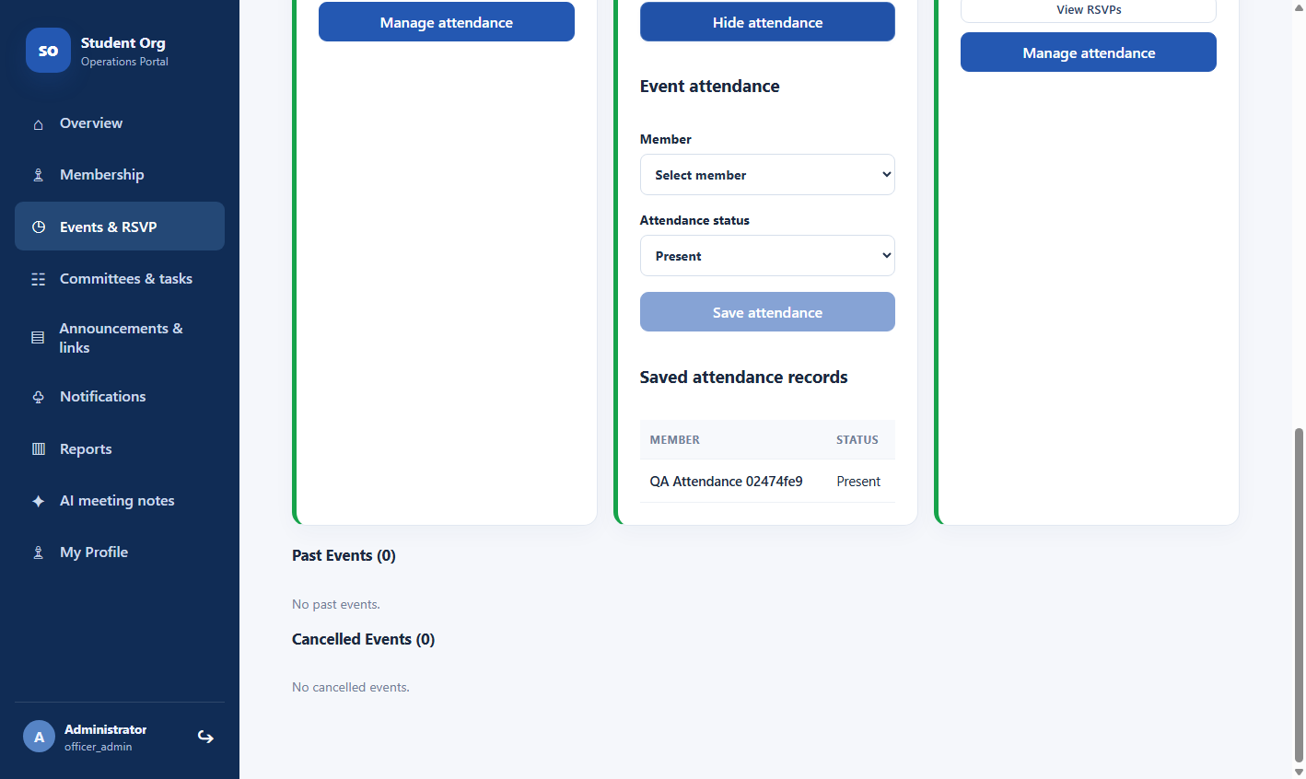

Absent after reload
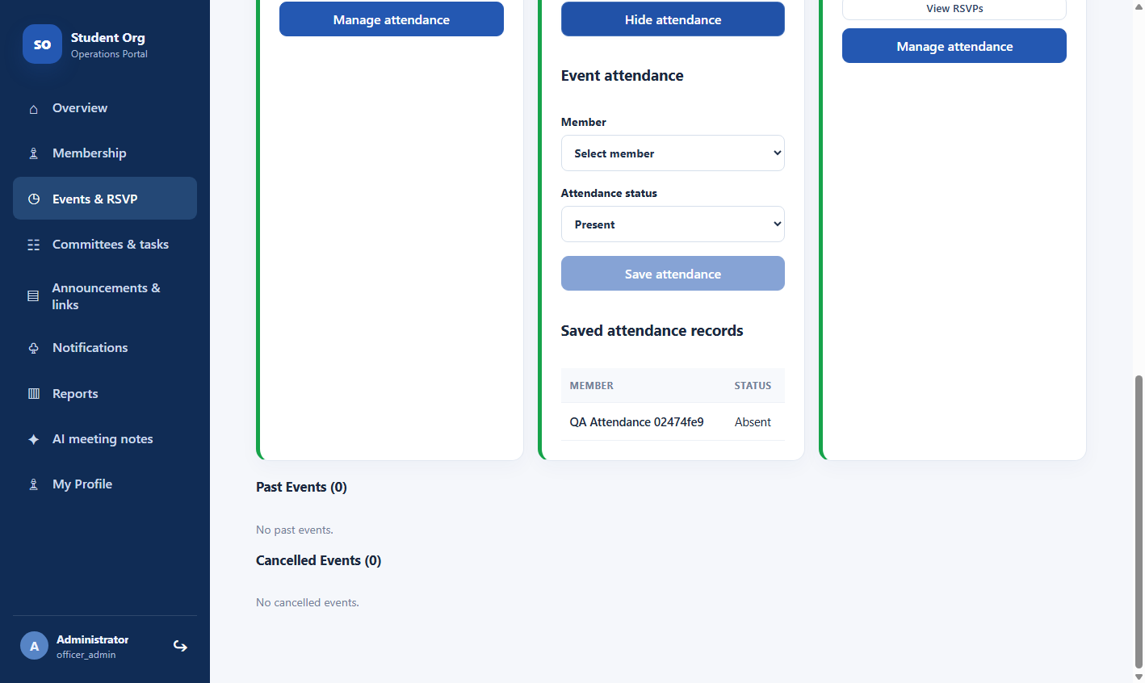

Committee addition after reload
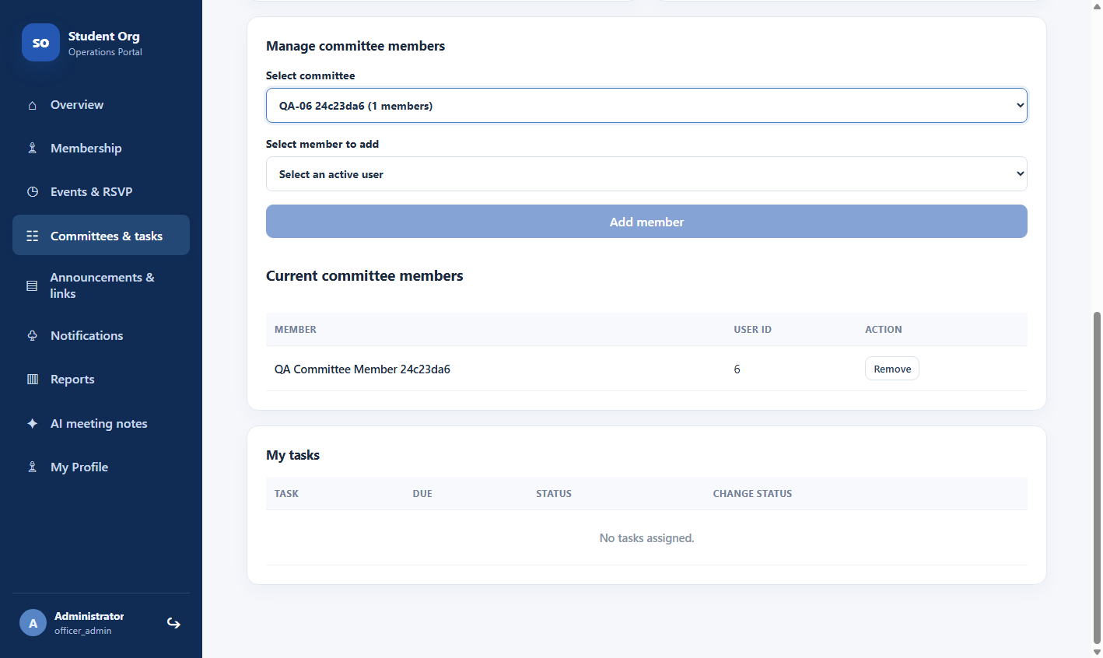

Committee removal after reload
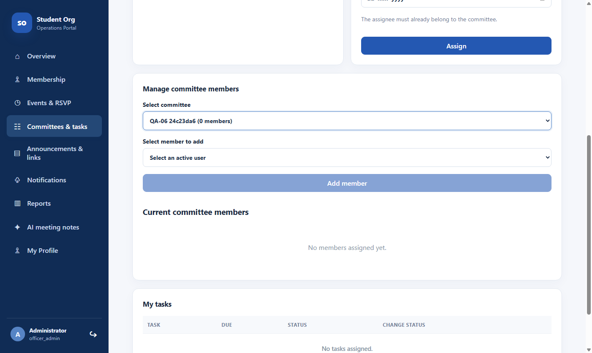

Regular member committee view
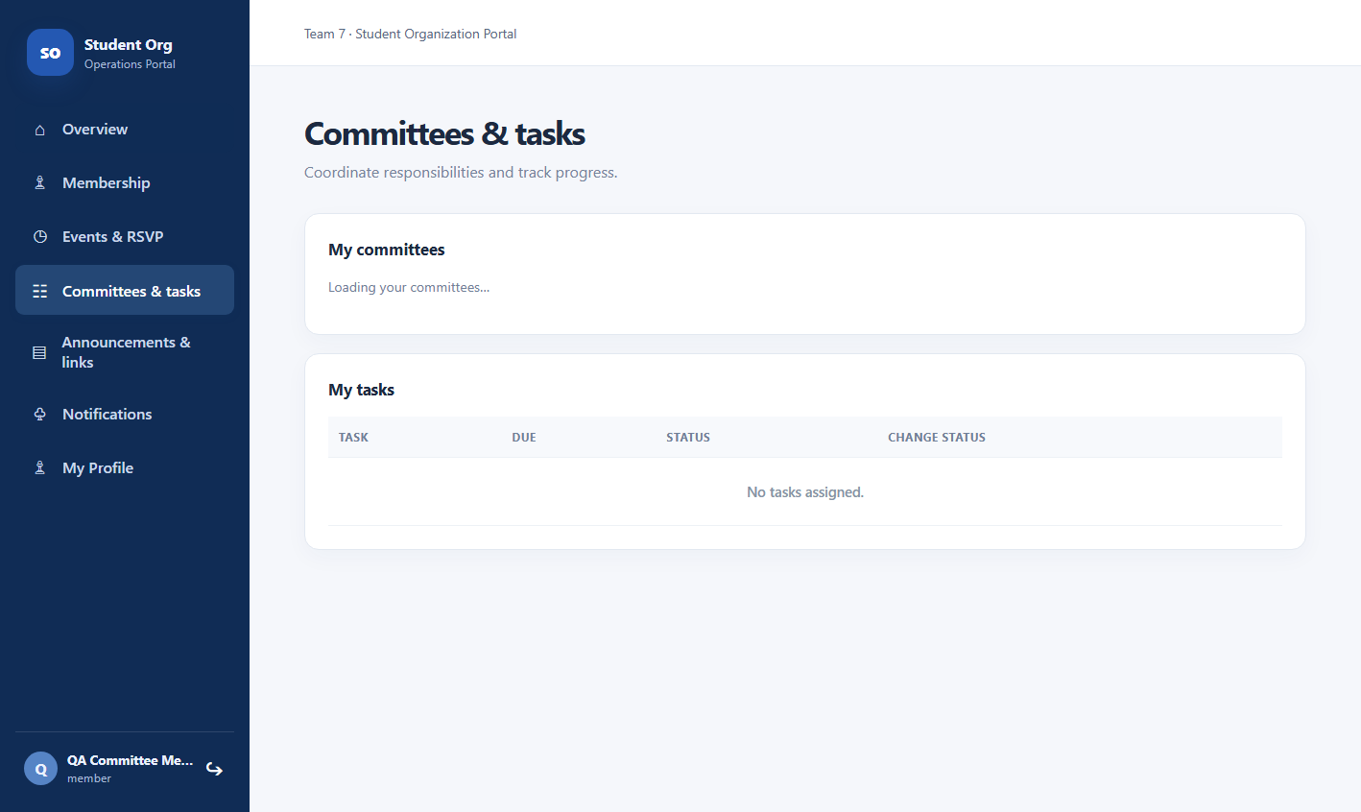

Executed broader regression summary
Release 4a74d05 was tested on November 12, 2026, US Central. Overall disposition: PARTIAL, with a confirmed mobile-layout failure. Passing backend/API checks do not establish that every browser scenario or live AI requirement passed.
Tested SHA: 4a74d05f89b1c4d837456cc06af4d85bd49c1045
Source: student-org-portal-main (5).zip. All 358 archive files matched this commit. The checkout remained unchanged during execution. Feature commit 84df45f is merged through PR #5; the earlier merge-pending status is superseded.
Check | Executed result
Backend verification | PASS — Maven verify on Java 21.0.13; 525 tests, zero failures, errors or skips; all configured JaCoCo coverage gates passed across nine modules.
Frontend build | PASS — npm ci and npm run build; TypeScript checking and Vite 5.4.21 production build succeeded.
Live API checks | 182 successful recorded assertions across the initial run, follow-up and restart run, including fixture creation. Two initial reporting assertions used the wrong UTC date and were superseded by passing Central-date checks. No unresolved API assertion failure remains.
Browser checks | Six original grouped UI checks and thirteen follow-up grouped checks passed; three mobile-layout observations failed. The follow-up covers officer events, report filters/CSV, task assignment, content publishing, review controls and expired-session logout.
Restart and timing | Ten restart-persistence checks passed. Follow-up browser-tool timings: 15/15 rendered-page loads or roster refreshes took 298–731 ms. Earlier API-only readings were 6.80–48.32 ms.
Environment | macOS ARM64; Java 21; local H2 file database; eight Java services/gateway on 8080–8087; Vite on localhost:5173; in-app browser for UI. Synthetic accounts and data only; no Supabase application test.
Evidence package: Regression_Evidence_4a74d05_Followup.zip contains original and follow-up scripts, JSON results, logs and captures. Earlier ZIP (4) screenshots remain historical.

Broader regression results by area
PASS below applies only to the stated executed scope. PARTIAL means useful checks passed but listed coverage remains open. FAIL identifies an observed requirement violation.
Area | Executed result | Follow-up and limits
BR-01 Core workflows | PASS for executed API approval/rejection/reapply, RSVP and attendance uniqueness, and task states. Browser task transitions passed. | New API/browser checks; original Selenium scripts were not supplied.
BR-02 Events | PASS for executed API and UI create/edit/cancel, RSVP counts/listing and persistence. | FOLLOW-UP PASS: upcoming, cancelled and ended-event grouping. Ended event hides RSVP/edit/cancel controls.
BR-03 Tasks and committees | PASS for API assignment, duplicate-member handling, open-task removal guard and committee persistence. | FOLLOW-UP PASS: UI committee creation, member addition and assignment; assignee sees task. Reassignment UI is absent.
BR-04 Reporting | PASS for API counts/CSV reconciliation and invalid date rejection. | FOLLOW-UP PASS: valid/alternate/reversed browser dates and filtered CSV download; activity counts 1/1, empty-range counts 0/0.
BR-05 Accounts and sessions | PASS for API profile/password, role changes, stale-token restrictions, deactivate/reactivate. | FOLLOW-UP PASS: 20-second test expiry returns 401 and UI login. Production two-hour wait not performed.
BR-06 Content and notices | PARTIAL: supported APIs, notifications, member viewing/read controls and officer publication/add-link UI passed. | Content edit/delete UI is absent; announcement edit API is absent. These are unsupported cases, not pending executions.
BR-07 AI | PARTIAL: validation, unavailable-error handling, controlled timeouts and manually entered review controls passed. | Live generation BLOCKED by Metal/model-loading error, including CPU-configured retry. Timeout: 30.544 s default; 60.306 s override.
BR-08 NFRs | FAIL: 390 px overflow reproduced. PASS: authorization matrix, restart persistence and all 15 browser timing samples. | Five-input privacy check passed for failure path. Successful-generation privacy and Supabase integration remain blocked.

Observed defects and final disposition

Mobile layout failure
At a 390 × 844 viewport, the officer membership page measured 1,575 px document scroll width. Member events and tasks each measured 1,258 px. All exceed the viewport and require horizontal scrolling. These are three observations of the same responsive-layout issue; NFR-04 cannot be marked PASS.
Reproduce: sign in at http://localhost:5173, set a 390 × 844 viewport, open Membership as officer or Events / Committees and tasks as a member, and compare document.documentElement.scrollWidth with window.innerWidth. Captures are included as ui-mobile-officer-overflow.png, ui-mobile-events.png and ui-mobile-tasks.png.

Content management coverage gap
The officer content screen supports publishing announcements and adding links, but exposes no edit/delete buttons. Document update/delete and announcement delete work through the API; announcement editing has no current endpoint. Treat the wider browser CRUD criterion as an unmet scope item until requirements are reconciled or controls are implemented and tested.

Test interpretation and limitations
The first report-count assertions queried the UTC date after midnight UTC, while stored activity belonged to November 12 in America/Chicago. Corrected Central-date queries returned one attended event and one completed task for the test member; every CSV row matched its JSON counts. The original failed assertions remain in the evidence log for traceability and are classified as test-setup errors, not product defects.
Original timing fixtures: 20 active members plus one officer, one pending applicant, 10 events and 30 tasks. Follow-up browser timings used 11 events and 31 tasks after new UI-created fixtures. Reload requires sign-in because tokens are kept in memory. Use the documented localhost origin; 127.0.0.1 was rejected by the default allowlist.
AI input limits differ by layer: the UI shows a 3,000-character maximum, while the backend accepts up to 5,000. This run checked empty and 5,001-character API inputs. Align the acceptance specification before claiming one consistent end-to-end limit. The log sentinel check is limited evidence and does not replace a full storage/payload privacy audit.

Release decision
Broader regression and follow-up execution are complete for the stated local scope. Record PARTIAL WITH FAILURES AND BLOCKERS: backend/API and executed UI checks passed; mobile layout failed; some management controls are absent; live AI is blocked by model loading and Supabase integration lacks a configured test database. Fixes require a new tested SHA. This is not an unconditional release PASS.
No application code was changed, and no remote CI run or repository update was created. These are local execution results for 4a74d05. The source SHA and test evidence should accompany the submitted report and release archive.

Follow up execution of remaining checks
November 12, 2026, US Central • same unchanged source SHA 4a74d05. This follow-up replaces the earlier blanket pending descriptions. Runtime overrides were isolated test configurations and were not committed to the release.
Check | Observed follow-up result
Officer browser workflows | PASS — event create/edit/cancel; scheduled/cancelled/past grouping; committee creation, member addition and task assignment; fresh member login sees the assignment; announcement publication and HTTPS link creation.
Report filters and export | PASS — valid activity date range, alternate empty range, reversed-date validation and filtered CSV download. Browser date fields required native ISO-value entry through the test tool.
Rendered page timing | PASS for sampled local scenario — 5 roster refreshes, 5 event-page loads and 5 task-page loads, all 298–731 ms. Measurements include browser-tool overhead; warm local H2/Vite environment, not production performance.
Session expiry and logout | PASS — same source with 20-second JWT expiry override; post-expiry navigation returned to login. Separately checked API access before/after expiry. This verifies expiry handling, not an idle timer or a two-hour elapsed wait.
AI timeout boundary | PASS — controlled delayed HTTP provider behind a separate gateway: default 30 s produced HTTP 503 at 30.544 s; a 60 s runtime override produced HTTP 503 at 60.306 s. The release remains configured to 30 s.
AI review controls | PASS — manually entered synthetic summary could be edited and copied; clipboard content matched; Discard cleared it. Successful generated-summary review remains dependent on a working model runtime.
Five-input privacy check | PASS for checked failure path — five distinct synthetic inputs contained no emails, student IDs or fixture passwords; raw notes absent from application service logs. H2 ai_request_log has only metadata columns. Successful generation path was not exercised.
Live model attempts: official Ollama v0.40.16 and llama3.2:3b were downloaded; cold/two repeat requests and four additional cases returned 503 because the runtime could not create a Metal command queue. A num_gpu=0 derived model also failed. Cold/warm successful-generation latency is BLOCKED, not PASS. No synthetic model output is presented as real inference.
Still unresolved: confirmed 390 px overflow; absent content edit/delete and task-reassignment UI; live-AI generation/quality; Supabase integration (no configured test database). These are explicitly failed, unsupported, blocked or unexecuted subcases rather than a blanket “broader regression pending” label.

