Assignment-10.5
Name: K.LIKHITH
Rollno:2303A51331
Batch-20
Task1: Variable Naming Issues
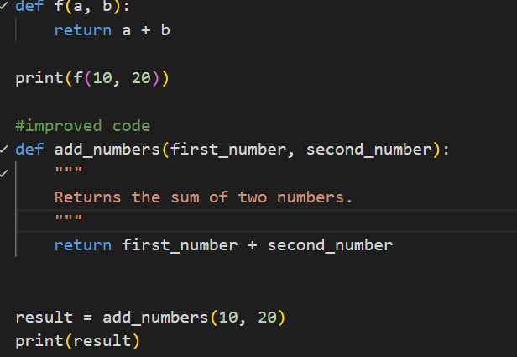
Output:
Observation:
Meaningful function and variable names improve code clarity and understanding.
Following PEP 8 naming conventions makes the code more professional and maintainable.

Task2: – Missing Error Handling
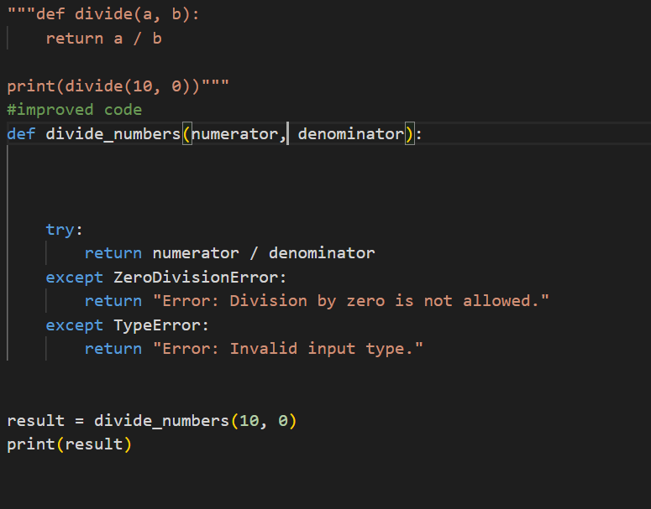
Output:
Observation: Adding exception handling prevents runtime crashes and improves
program reliability.Clear error messages help users understand what went wrong.
Task-3: Student Marks Processing System
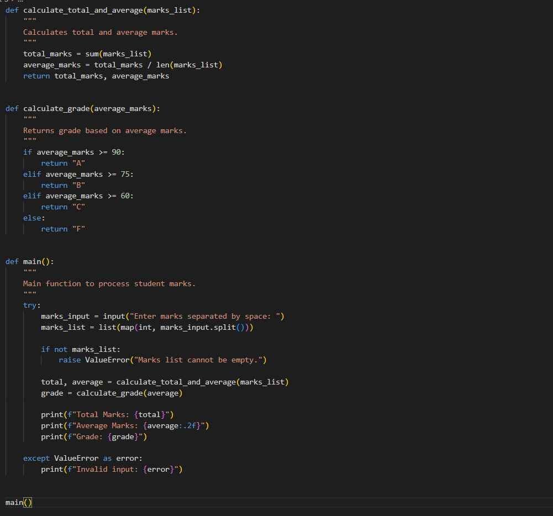
Output:
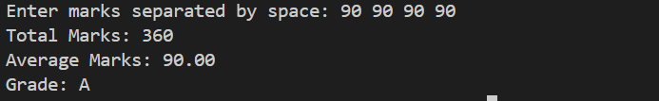
Observation: Refactoring into functions improves modularity and code organization.
Input validation and proper naming enhance readability and robustness.
Task-4: Use AI to add docstrings and inline comments
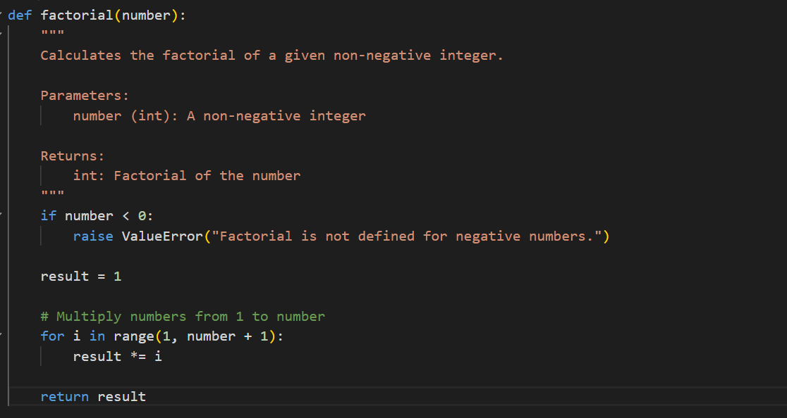
Observation: Docstrings provide clear documentation about function purpose and usage.
Inline comments improve code understanding for future maintenance.

Task5: Password Validation System (Enhanced)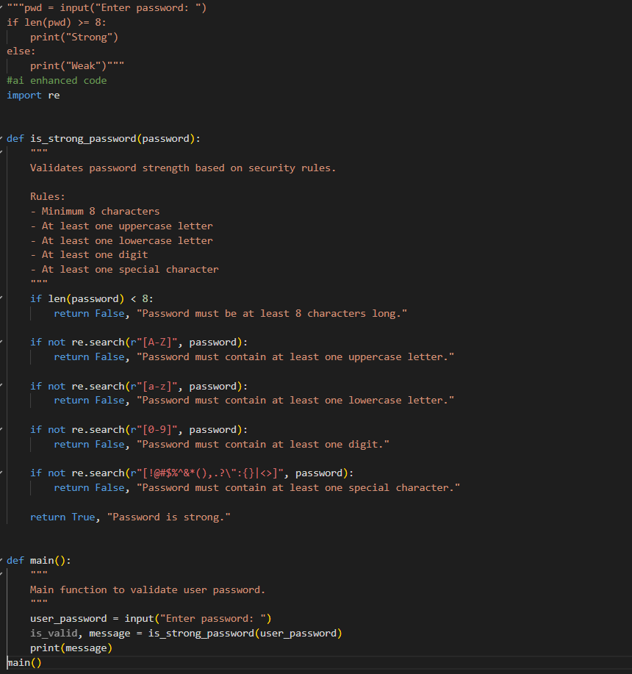
Output:
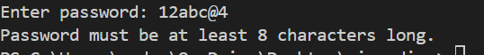
Observation: Adding multiple validation rules increases password security and strength.
Structured functions and proper naming improve reusability and maintainability.

