Assignment-11.5
Name:k.likhith
Rollno:2303A51331
Batch-20
Task1: Smart Contact Manager (Arrays & Linked Lists) scenario
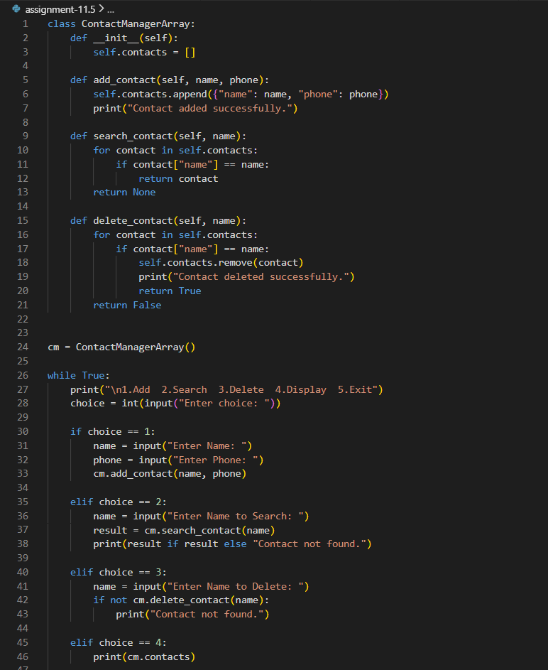
Output:
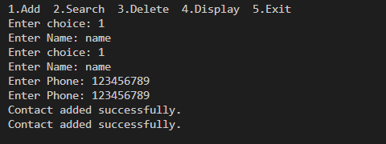
Observation: Array is simple but deletion requires shifting elements (O(n)).
Linked List allows dynamic insertion and deletion without shifting, but searching is O(n).

Using linked list code
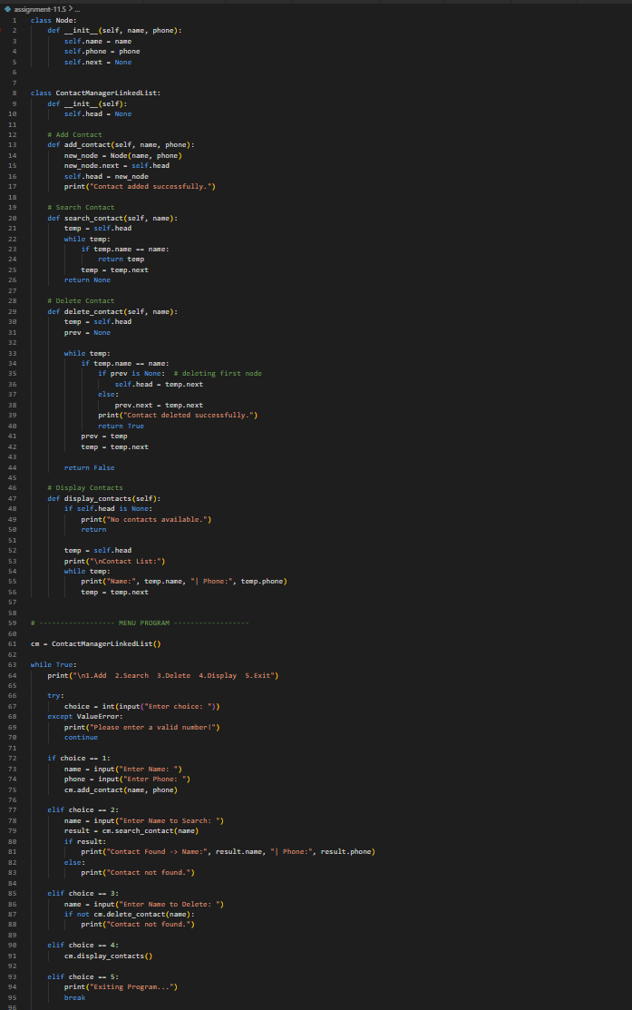
Output:
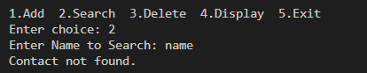
Observation: Observation: Array is simple but deletion requires shifting elements (O(n)).
Linked List allows dynamic insertion and deletion without shifting, but searching is O(n).

Task2: Library Book Search System (Queues & Priority Queues)
Scenario
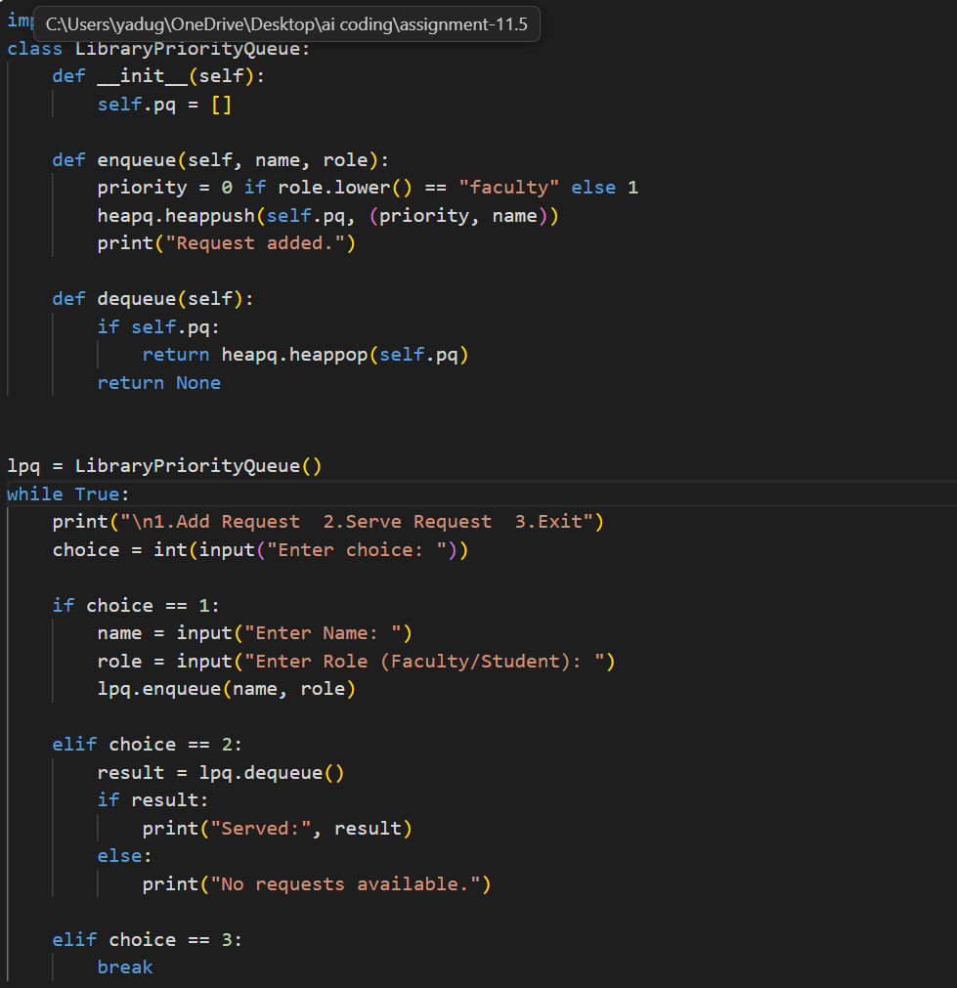
Output: 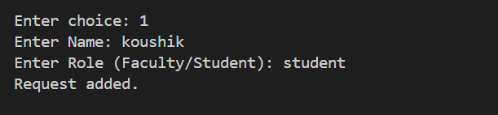
Observation: Queue follows FIFO order for normal requests.
Priority Queue ensures faculty requests are served before students.
Task3: Emergency Help Desk (Stack Implementation)
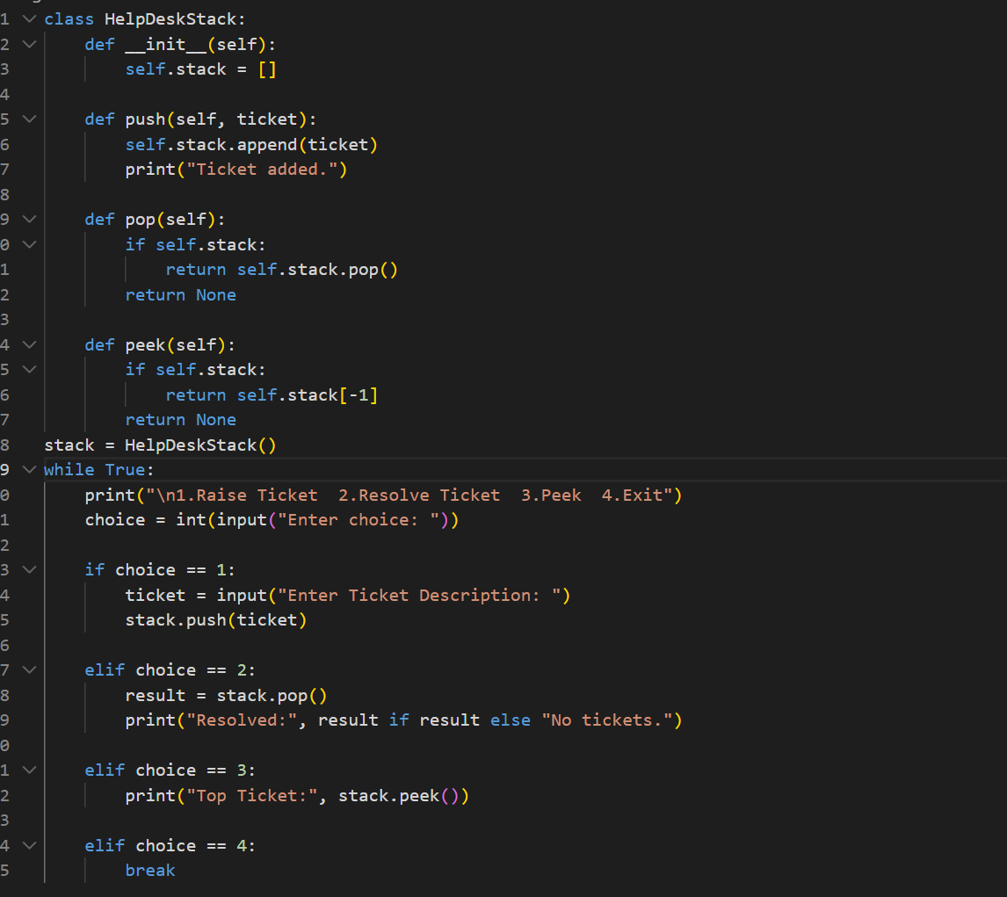
Output:
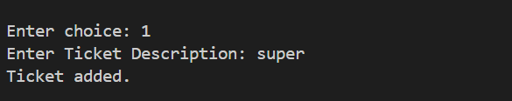
Observation: Stack follows LIFO where the last ticket raised is resolved first.
Push and pop operations are efficient with O(1) time complexity.

Task4: Hash Table
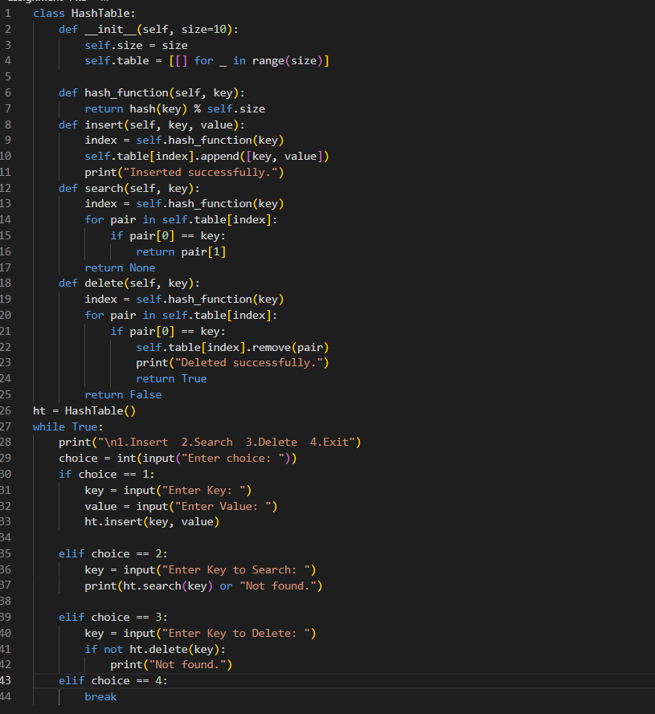
Output:
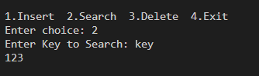
Observation: Hash table provides fast searching using key-based indexing.
Collision handling using chaining ensures multiple elements can be stored safely.

Task5: Real-Time Application Challenge
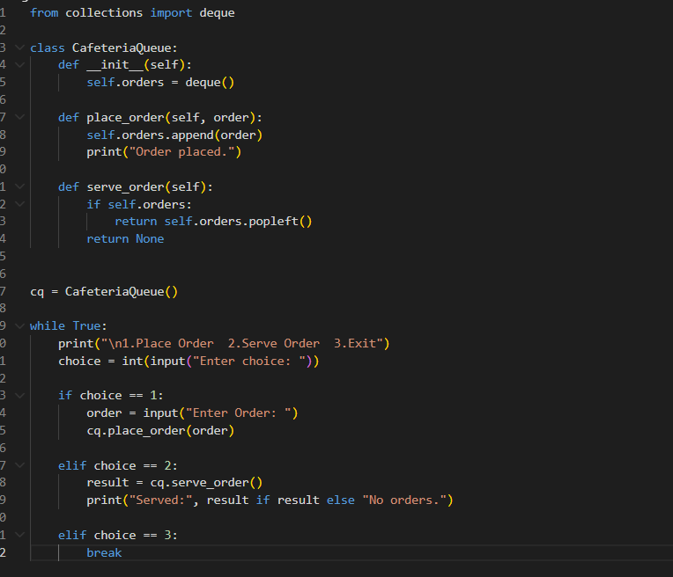
Output:
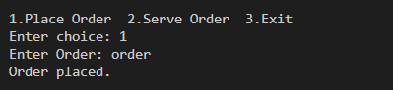
Observation: Different real-world features require different data structures for efficiency.
Choosing the correct data structure improves performance and system design.

