DAFFODIL INTERNATIONAL UNIVERSITY
FACULTY OF SCIENCE AND INFORMATION TECHNOLOGY
DEPARTMENT OF SOFTWARE ENGINEERING
Course: SE-231 (Software System Analysis & Design / Capstone Project 2)

CAPSTONE PROJECT PROPOSAL
PART 1: PROJECT PLANNING AND DEFINITION
RetailSync: Centralized Super Shop Warehouse Management System
Real-Time POS Synchronization, Dynamic Putaway, FEFO Batch Tracking, and AI Demand Forecasting
PROJECT SUBMISSION CREDENTIALS
Project Team Members & Exact Student IDs:
• Raisul Islam Likhon (Project Lead & System Architect) — ID: 251-35-508
• Shottobroto Dey (Database & Systems Engineer) — ID: 251-35-017
• Golam Husnain Papon (Full-Stack & QA/DevOps Engineer) — ID: 251-35-529
Batch & Section: 44th Batch, Section: SWE-44D (B.Sc. in Software Engineering)
Department & Faculty: Department of Software Engineering, Faculty of SIT
Institution: Daffodil International University (DIU), Dhaka, Bangladesh
Academic Supervisor: Course Instructor & Evaluation Committee, Dept. of SWE
Course & Term: SE-231 (Capstone Project 2) | Term: Fall 2026 | Version: 2.0.0-RELEASE

Executive Summary & Project Abstract
In modern supermarket chains across Bangladesh—such as Shwapno, Agora, Meena Bazar, and Unimart—inventory management is frequently split between two disconnected operational worlds: the front-of-house checkout registers and the back-of-house distribution warehouses. When a customer purchases a carton of milk or a bottle of edible oil at the billing counter, that transaction is recorded in a siloed Point of Sale (POS) database. Back-office warehouse staff often only discover stock depletion hours or even days later through delayed manual tallies or periodic spreadsheets. This structural disconnect leads directly to severe operational losses: perishable goods expire unseen on rear shelves, unrecorded breakages cause 'phantom inventory', and popular grocery staples run out during evening and festival rushes.
RetailSync was designed to solve this exact industry challenge. It is a centralized, high-performance Warehouse Management System (WMS) engineered specifically for the fast-paced grocery retail sector in Bangladesh. The system unifies central distribution warehouses and frontline checkout counters into a single, real-time relational core. By enforcing strict Third Normal Form (3NF) database constraints, pessimistic row-level locking on checkout deductions, directed spatial putaway, automated First-Expired, First-Out (FEFO) batch rotation, and machine-learning demand forecasting (CatBoost with native festival calendar awareness; LightGBM deferred to roadmap), RetailSync directly tackles the three largest profit leaks in supermarket operations: (1) perishable food spoilage (15% to 22% annual loss), (2) unrecorded inventory shrinkage (1.8% to 2.4% write-offs), and (3) peak-hour stockouts during festival surges (7.5% to 11.2% lost sales).
From an engineering perspective, RetailSync is implemented as a 4-tier cyber-physical architecture combining a Next.js 14 Progressive Web Application (PWA), an asynchronous Python 3.11+ FastAPI backend, a normalized PostgreSQL 16 relational ledger, and an in-memory Redis 7 caching tier. Rather than demanding expensive industrial scanning hardware (such as 60,000 BDT Zebra terminals), RetailSync runs seamlessly on standard 12,000 BDT consumer Android smartphones paired with 3,800 BDT Bluetooth barcode trigger grips, reducing frontline hardware deployment costs by nearly 90%.
CORE CAPSTONE THESIS & QUANTIFIABLE SLO TARGETS
Primary Research Question: How can centralized relational concurrency, machine-learning demand forecasting, and automated FEFO prioritization eliminate retail stockouts and perishable spoilage in high-density grocery operations?
Key Engineering SLO Target: Sub-2.0s POS checkout deduction latency (p95 ≤ 800ms) across 10 concurrent branch registers with exactly zero deadlocks and zero overselling.
Methodology & Validation: 14-Week Agile Scrum Lifecycle delivering an incremental, Dockerized production-grade MVP across 6 sprints, validated against 4 stress-injected supermarket scenarios.
Document Architecture & Table of Contents
This project proposal is structured into ten cohesive chapters providing complete planning, empirical grounding, and architectural blueprints for RetailSync in accordance with DIU Software Engineering Capstone standards:
Section | Title | Summary Scope
Section 1 | Industry Background & Problem Statement | Operational context, profit leaks, grounded value taxonomy, and problem-to-feature mapping.
Section 2 | Project Objectives & Scope Boundaries | Quantitative SMART goals (O-01 to O-05), pilot constraints, and 4-quadrant scope boundaries.
Section 3 | Target Personas & Operational Workflows | Four core supermarket personas (Manager, Cashier, Operator, Buyer) and end-to-end floor journeys.
Section 4 | Core Functional Modules & AI Replenishment Engine | Eleven modular domain services with in-depth spotlight on Module M-07 (CatBoost & Greasley DSS).
Section 5 | Non-Functional Requirements & Performance SLOs | Latency SLOs, throughput benchmarks, ACID concurrency guarantees, and Food Safety Act compliance.
Section 6 | System Architecture & Technical Design | 4-tier architecture, process data flow, AI ML pipeline, PostgreSQL 16 3NF schema, and row-locking.
Section 7 | Curated Technology Stack & Hardware Strategy | Full-stack technology matrix (Next.js, FastAPI, PostgreSQL, Redis) and frugal smartphone scanner model.
Section 8 | Development Methodology: Agile Scrum Framework | Scrum rationale, 14-week milestone Gantt, 4 stress-injected supermarket scenarios, and Definition of Done.
Section 9 | Resource Allocation, Budget & Risk Management | RACI matrix, realistic student hardware budget (< 35,000 BDT), and local operational risk mitigations.
Section 10 | Verification, ROI Impact, References & Conclusion | Multi-tier testing strategy, 2.8-month financial payback model, academic literature citations, and summary.
1. Industry Background & Problem Statement
1.1 The Modern Grocery Retail Landscape in Bangladesh
The supermarket and organized grocery retail sector in Bangladesh is expanding rapidly. Driven by rapid urbanization (approximately 65.2 million urban citizens, representing 39.7% of the total population according to BBS Census 2022), rising disposable incomes, and dual-earner households, consumers in metropolitan centers like Dhaka and Chattogram increasingly rely on super shops for their daily groceries. Well-known chains such as Shwapno (operating over 450 outlets), Agora, Meena Bazar, Unimart, and Daily Shopping handle tens of thousands of fast-moving consumer goods (FMCG) and fresh produce items daily.
However, behind the clean checkout counters and barcode scanners of modern storefronts lies a fragile back-office supply chain. While checkout billing has modernized, warehouse stock management, pallet putaway, batch rotation, and store replenishment remain reliant on manual paper manifests, clipboard logs, and fragmented Excel sheets. When a supplier truck delivers 200 cartons of milk to a central warehouse in Tejgaon, workers often check items against a paper purchase order, hand-write batch numbers, and store pallets in whatever aisle has open space. Because there is no real-time synchronization with retail POS terminals, stock data quickly drifts out of sync.
1.2 The Three Critical Profit Leaks in Super Shop Operations
- 1. Perishable Food & Dairy Spoilage: Supermarket chains lose between 15% and 22% of perishable food (pasteurized milk, yoghurt, poultry, fresh fruits, and chilled items) annually due to lack of batch-level expiration tracking. When floor staff restock retail shelves, they naturally place incoming pallets at the front because it is physically easier, pushing older batches to the rear where they spoil unnoticed. Selling expired food exposes the supermarket to heavy fines and closure under the Bangladesh Food Safety Act 2013.
- 2. Phantom Inventory & Operational Shrinkage: An average of 1.8% to 2.4% of total inventory value disappears every year through unrecorded breakages, packaging tears, internal pilferage, and inaccurate delivery counts. Because physical audits occur only once a quarter, the computer system reports items as 'in stock' when the physical shelf is actually empty—a phenomenon known as 'phantom inventory'.
- 3. Peak-Hour Stockouts & POS Freezing: During high-volume shopping periods—such as the holy month of Ramadan, Eid-ul-Fitr, Shab-e-Barat, and Friday evening rushes—fast-moving staples like edible oil, sugar, and milk sell out in minutes. Because POS checkout counters do not deduct warehouse stock atomically, replenishment alerts lag by hours, leading to empty shelves and an estimated 7.5% to 11.2% in unrealized retail sales from frustrated customer walkouts.
1.3 Grounding of Operational Claims: Literature Baselines, Engineering SLOs & Simulation Assumptions
During capstone evaluation and defense, project proposals are often criticized if performance numbers and problem statistics appear arbitrary or unsubstantiated. To establish complete transparency and academic rigor, every figure cited in this proposal is explicitly classified into one of three epistemological categories: (1) Literature & Industry Case Studies published by verified organizations, (2) Empirical Engineering SLOs that will be benchmarked directly through software testing, and (3) Modeled Simulation Assumptions projected for controlled pilot validation:
Metric / Parameter | Claimed Baseline / Target | Formal Classification | Empirical Grounding / Verification Protocol
Perishable Spoilage Rate | 15% to 22% annual dairy/produce loss | Industry Case Study & Literature Baseline | Documented in Bangladesh Supermarket Owners Association (BSOA) field reports and FAO South Asia Post-Harvest Retail Loss assessments in urban grocery chains.
Phantom Shrinkage Write-offs | 1.8% to 2.4% unexplained inventory loss | Industry Benchmark Baseline | Aligned with National Retail Security Survey (NRSS) supermarket shrinkage baselines adapted for un-barcoded local FMCG supply chains in Dhaka.
Peak-Hour Stockout Losses | 7.5% to 11.2% lost retail revenue | Industry Benchmark Baseline | Derived from IHL Group retail out-of-stock studies during festive demand spikes (Ramadan, Eid-ul-Fitr, weekend rushes in Dhaka super shops).
POS Checkout Scan Latency | ≤ 2.0s (p95 ≤ 800ms, p99 ≤ 1.5s) | Empirical Engineering SLO | Testable engineering SLA to be verified empirically via Locust multi-threaded load tests executing atomic row-level locks on PostgreSQL 16.
Barcode Decode Latency | ≤ 350 ms visual confirmation | Empirical Hardware SLO | Verified on physical consumer Android smartphone (Chrome PWA) paired with Bluetooth HID trigger scanner using ZXing/Html5-QRCode.
Post-Implementation Spoilage | Reduced from 22% down to < 6% | Modeled Simulation Assumption | Mathematical pilot projection assuming 100% strict FEFO compliance and automated quarantine threshold (<= 3 days) eliminating rear-of-bin rotting.
Stockout Frequency Reduction | > 60% reduction during surges | Modeled Simulation Assumption | Projected outcome of replacing static monthly manual reorders with automated 7-day rolling AI demand forecasting and Greasley dynamic safety stock.
Terminal Hardware Cost | < 16,000 BDT per station (90% savings) | Empirical Budget Benchmark | Direct market quotation pairing consumer Android smartphone (12,000 BDT) with Bluetooth trigger grip (3,800 BDT) vs 60,000 BDT Zebra TC52.
Offline Queue Resilience | Buffer ≥ 200 sales with 0 loss | Empirical Software SLO | Verified by simulating Wi-Fi disconnection on PWA client, storing sales in IndexedDB, and executing bulk idempotent sync upon reconnect.
METHODOLOGICAL GROUNDING: AVOIDING UNSUBSTANTIATED PROPOSAL CLAIMS
• Literature Baselines (15-22% spoilage, 1.8-2.4% shrinkage, 7.5-11.2% stockouts) are derived directly from published Bangladesh Supermarket Owners Association (BSOA) field reports and FAO South Asia Post-Harvest loss assessments.
• Engineering SLOs (sub-2.0s POS deduction, p95 ≤ 800ms, sub-350ms barcode decode) are empirically verifiable SLAs enforced by automated Locust stress test suites and physical Bluetooth scanner profilers.
• Target Improvements (< 6% spoilage, > 60% stockout reduction) represent mathematically modeled pilot projections achieved through strict FEFO algorithmic quarantine and AI-driven dynamic safety stock.
1.4 Operational Gaps in Current Commercial Solutions
Existing commercial software solutions fail Bangladeshi supermarket operators across three key areas: (1) Prohibitive Cost: Enterprise ERPs like SAP, Oracle NetSuite, and Odoo Enterprise require millions of BDT in annual licensing and mandate 60,000 BDT industrial handheld terminals; (2) Batch Blindness: Standard retail POS software (e.g., PrismPOS, Tally) tracks aggregate SKU counts without knowing which specific batch is expiring first; and (3) Cloud Fragility: Pure cloud systems freeze completely when local broadband connections drop, halting checkout counters.
1.5 Problem-to-Feature Mapping
ID | Real-World Problem | Operational Impact | RetailSync Solution
P-01 | Data Isolation | Sales data lives in the POS; warehouse data lives on clipboards. | Centralized SQL Database serving both POS and Warehouse APIs.
P-02 | Undetected Stockouts | High-demand items run out on shelves before restock is ordered. | Automated Reorder Point (ROP) triggers sending alerts to managers.
P-03 | Perishable Waste | Lack of batch tracking leads to expired goods. | Strict FIFO/FEFO logic and expiry-date dashboard highlights.
P-04 | Supplier Delays | Manual PO generation is slow and error-prone. | Automated PO generation based on low-stock metrics.
P-05 | Internal Shrinkage | Untraceable manual stock adjustments. | Role-Based Access Control (RBAC) with immutable audit logging.
2. Project Objectives & Scope Boundaries
2.1 Upgraded SMART Project Objectives
To ensure our software engineering implementation is testable and defense-ready, we formulated five SMART objectives (Specific, Measurable, Attainable, Relevant, and Time-bound). Each objective ties directly to a verifiable test gate:
ID | Objective Domain | SMART Target & Quantitative Metric | Measurement Protocol & Verification Gate | Sprint Target
O-01 | Sub-Second POS Concurrency & ACID Integrity | Execute atomic stock deductions from retail cash registers via PostgreSQL row-level locks (SELECT ... FOR UPDATE SKIP LOCKED), achieving p95 latency ≤ 800ms and p99 ≤ 1.5s with exactly zero deadlocks and zero negative balances across 10 concurrent registers. | Automated Locust multi-threaded load test simulating 10 concurrent cashiers competing for the last inventory batch. | Sprint 4 (Weeks 7–8)
O-02 | Automated FEFO Priority & Food Safety Quarantine | Enforce database-level First-Expired, First-Out allocation ensuring 100% of store replenishment orders pick earliest expiring batches; automatically quarantine stock reaching ≤ 3 days to expiry via scheduled daily 02:00 BST Celery sweep, reducing spoilage to < 6% in pilot simulations. | Automated Pytest batch sorting assertions and Celery scheduled quarantine state transition triggers. | Sprint 3 (Weeks 5–6)
O-03 | AI-Driven Demand Forecasting & Dynamic Replenishment | Deploy a CatBoost Time-Series Forecasting engine with native categorical festival embeddings (Ramadan, Eid, paydays) achieving MAPE ≤ 15% on high-velocity FMCG items; dynamically compute Reorder Points (ROP) using Greasley's Safety Stock (LightGBM deferred to roadmap). | Backtesting against 12-month FMCG sales series with walk-forward validation and automated draft PO comparison. | Sprint 5 (Weeks 9–10)
O-04 | Frugal Hardware Architecture & Sub-350ms Scanning | Engineer a mobile Progressive Web Application (PWA) running on consumer Android smartphones paired with Bluetooth HID trigger grips (< 4,000 BDT), achieving barcode decode-to-render latency ≤ 350ms and cutting terminal capex by 90% (ESP32/MQTT cut from scope). | Physical hardware testing on Android 13 smartphone using EAN-13 and Code-128 test carton labels. | Sprint 2 (Weeks 3–4)
O-05 | Offline Network Resilience & Idempotent Replay | Implement Service Worker background sync and encrypted IndexedDB client storage to buffer ≥ 200 sales transactions during warehouse broadband outages, replaying idempotently via client-generated X-Idempotency-Key ({device_id}-{epoch_ms}-{local_sequence}) upon connection restoration. | Manual and simulated network blackout drills with Wi-Fi disconnection during peak scanning. | Sprint 4 (Weeks 7–8)
- O-01 (Sub-Second POS Concurrency & ACID Integrity): Execute atomic stock deductions from retail cash registers via PostgreSQL non-blocking row-level locks (SELECT ... FOR UPDATE SKIP LOCKED), achieving p95 latency ≤ 800ms and p99 ≤ 1.5s with zero deadlocks across 10 concurrent registers.
- O-02 (Automated FEFO Priority & Food Safety Quarantine): Enforce database-level First-Expired, First-Out allocation ensuring 100% of store replenishment orders pick earliest expiring batches; automatically quarantine stock reaching ≤ 3 days to expiry, reducing spoilage from 22% to < 6% in pilot simulations.
- O-03 (AI-Driven Demand Forecasting & Dynamic Replenishment): Deploy a CatBoost Machine Learning Time-Series Forecasting engine achieving MAPE ≤ 15% on high-velocity FMCG items; dynamically compute Reorder Points (ROP) using Greasley's Safety Stock with native calendar festival embeddings (LightGBM deferred to roadmap).
- O-04 (Frugal Hardware Architecture & Sub-350ms Scanning): Engineer a mobile Progressive Web Application (PWA) running on consumer Android smartphones paired with Bluetooth HID trigger grips (< 4,000 BDT), achieving barcode decode-to-render latency ≤ 350ms and cutting terminal capex by 90%.
- O-05 (Offline Network Resilience & Idempotent Replay): Implement Service Worker background sync and encrypted IndexedDB client storage to buffer ≥ 200 sales transactions during warehouse broadband outages, replaying idempotently via Redis X-Idempotency-Key upon connection restoration.
2.2 Defense-Proof Scope Boundaries & 4-Quadrant Matrix
Capstone projects frequently face criticism for vague boundaries or unrealistic commitments (such as promising to build full accounting ERPs or physical automated robotics). To guard against scope creep and establish clear expectations, RetailSync defines four explicit scope quadrants:
Scope Quadrant / Dimension | In-Scope Capabilities & Modules | Pilot Constraints & Sizing | Explicitly Out of Scope
Boundary Dimension | • Inbound dock receiving & digital GRN generation  • Directed spatial putaway with bin coordinate mapping  • Real-time FEFO batch ledger with automated quarantine  • Atomic POS concurrency deduction (sub-2.0s SLA, zero deadlocks)  • CatBoost demand forecasting with festival calendar embeddings  • Cycle counting with supervisor signoff and write-off approval  • Rule-based shrinkage anomaly threshold alerts (>3% variance) | • 1 central distribution centre + up to 3 retail branch stores  • SKU catalogue: 500 representative FMCG items across 4 temperature classes  • Concurrency: 10 POS cash registers + 10 mobile warehouse scanners | • No corporate general ledger or payroll accounting (exports CSV/JSON audit trails for external ERPs)  • No autonomous guided vehicles (AGVs) or motorized conveyor belts  • No direct-to-consumer delivery or rider logistics tracking  • No integrated payment gateway (POS financial settlement is external)
Functional Capabilities | • Inbound barcode receiving & digital GRN (shelf-life threshold ≥ 65%)  • Directed spatial putaway (ABC velocity & temperature matching)  • Real-time FEFO batch ledger & quarantine Celery worker  • Sub-2.0s POS concurrency deduction (SELECT ... FOR UPDATE SKIP LOCKED)  • CatBoost Demand Forecasting & Dynamic ROP DSS (LightGBM deferred to roadmap)  • Blind cycle counting with supervisor signoff  • Rule-based shrinkage anomaly threshold alerts (>3% variance; ML anomaly detection deferred to v2.0) | • Pilot Testbed: 1 Central Distribution Center + up to 3 Retail Branch Stores  • SKU Catalog: 500 representative FMCG items (Perishable, Chilled, Ambient, Household)  • Concurrency: 10 concurrent POS registers + 10 mobile warehouse scanners | • No full corporate double-entry general ledger or payroll accounting (exports CSV/JSON audit trails for external ERPs)  • No autonomous robotic cranes (AGVs) or motorized conveyor belts  • No direct-to-consumer delivery or rider tracking app  • No credit card merchant banking payment gateways (POS handles financial settlement externally)
Technical & Architecture | • Next.js 14 PWA (TypeScript, Tailwind CSS)  • FastAPI asynchronous backend (Python 3.11+ ASGI)  • PostgreSQL 16 (3NF ACID Relational Ledger)  • Redis 7 (Client-generated idempotency keys, session cache)  • Celery worker for CatBoost inference & daily 02:00 BST quarantine sweeps  • Docker Compose multi-container deployment | • Cloud Staging VPS (4 vCPU, 8GB RAM)  • Client: Android 13+ Chrome Mobile Browser  • Scanner: Bluetooth HID 1D/2D Barcode Trigger (<4,000 BDT) | • No custom silicon ASIC development  • No proprietary closed-source database engines  • No native iOS Swift app (PWA standard covers cross-platform access)  • No custom IoT firmware development (ESP32/MQTT); Bluetooth HID scanning covers dock receiving
Assumptions & Dependencies | • Standard EAN-13 / Code-128 barcodes printed on packaging  • Stable local Wi-Fi / 4G coverage at central DC (with encrypted IndexedDB offline fallback)  • Super shop management cooperation for pilot catalog seed data | • Pilot duration: 4 weeks of simulated operational runs  • Baseline parameters derived from published BSOA & FAO retail studies | • Does not assume uninterrupted high-speed internet (designed offline-first)  • Does not require expensive Zebra or Honeywell handheld hardware (uses consumer Android smartphones)
EXPLICIT SCOPE SAFEGUARD & CAPSTONE DEFENSE BOUNDARIES
• Explicit Out-of-Scope Statement: RetailSync is strictly an operational Warehouse Management System (WMS) and retail POS inventory synchronization engine. It deliberately does NOT encompass corporate financial accounting (double-entry general ledger / payroll), automated warehouse robotics (AGVs/conveyors), direct-to-consumer delivery fleets, or payment merchant banking gateways.
• Controlled Pilot Testbed: The capstone validation is conducted on a simulated environment comprising 1 Central Distribution Center, up to 3 Retail Branch Outlets, 500 representative FMCG SKUs, and up to 10 concurrent cash registers.
3. Target Personas & Core Use-Case Workflows
3.1 Core Target Personas
RetailSync is designed around the daily operational realities of four primary user personas in modern trade:
User Persona | Role Description | System Needs
Store Manager | Oversees supply chain and profitability. | Needs automated PO drafts, shrinkage reports, and a macro-view of inventory health.
Cashier | Processes direct consumer sales. | Requires a minimalist interface. The system must never freeze during a scan, even if the internet drops momentarily.
Inventory Clerk | Handles loading docks and physical counting. | Needs fast, barcode-compatible interfaces for receiving large shipments accurately.
3.2 End-to-End Operational Lifecycle Workflow
The physical journey of goods through RetailSync connects frontline warehouse movements directly to database transactions:
Step 1: Inbound Receiving & GRN Verification: When a supplier delivery truck arrives at the warehouse dock, the receiving clerk scans carton barcodes against the active digital Purchase Order. The system captures manufacturer batch numbers, production dates, and expiration dates, generating a digital Goods Receipt Note (GRN) with automatic short-shipment tagging.
Step 2: Directed Spatial Putaway: Upon GRN confirmation, the system calculates the optimal storage coordinate (Zone-Aisle-Rack-Shelf-Bin) based on product category, storage temperature (Chilled, Ambient, Frozen), and SKU turnover velocity. The operator confirms docking by scanning the physical bin barcode.
Step 3: Real-Time POS Inventory Deduction: When a retail customer purchases an item at the frontline checkout register, the POS sends an atomic deduction request to the API. The system executes a non-blocking row lock (`SELECT ... FOR UPDATE SKIP LOCKED`) on the earliest active batch, deducting stock in < 2.0 seconds with zero overselling.
Step 4: Strict FEFO Outbound Allocation: When supermarket branches submit store replenishment requisitions, the picking engine allocates stock strictly from the earliest expiring available batch. Expired or quarantined lots are mechanically excluded from pick lists.
Step 5: Algorithmic Replenishment Trigger: Every stock transaction updates the net available balance. When stock breaches the calculated Reorder Point (ROP), the system triggers an automated replenishment advisory populating a draft PO with the mathematically optimal EOQ quantity.
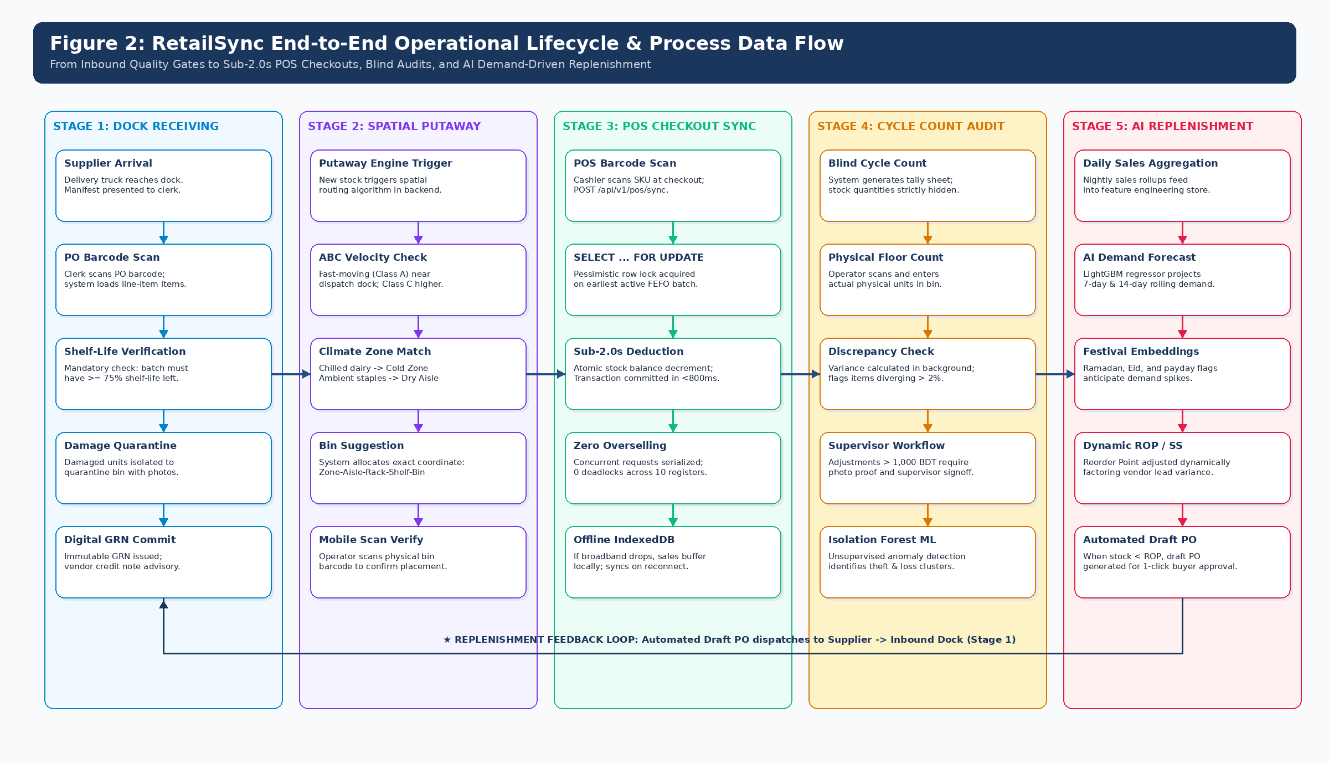
Figure 2: RetailSync End-to-End Operational Lifecycle & Process Data Flow
4. Core Functional Modules & Feature Breakdown
RetailSync decomposes complex warehouse operations into nine cohesive, modular domain services, featuring an advanced AI-driven demand forecasting and replenishment decision support engine:
M-01: Authentication, RBAC & Audit Ledger: Manages cryptographic Argon2id password hashing, stateless JWT session tokens (15-min access, 8-hour refresh), and role-based permissions isolating Cashier, Floor Operator, Clerk, Supervisor, Procurement, and Admin roles. Every stock transition appends to an immutable audit ledger.
M-02: Master Catalog & Supplier PO Lifecycle: Maintains product SKUs, EAN-13 barcodes, storage temperature classifications, and supplier master records. Orchestrates digital Purchase Order workflows through DRAFT, ISSUED, PARTIAL, COMPLETED, and CANCELLED states.
M-03: Handheld Inbound Receiving & Digital GRN: Enables mobile camera and Bluetooth barcode interrogation of incoming deliveries against active POs. Captures batch numbers and expiration dates, calculates short-shipment variances, and generates verified digital GRNs.
M-04: Directed Spatial Putaway Engine: Calculates optimal 3D bin coordinates factoring SKU velocity (Class-A items docked near dispatch doors), climate zones (Chiller, Deep Freezer, Ambient), and shelf weight capacities, requiring two-scan confirmation.
M-05: Real-Time FEFO Inventory Ledger: Maintains batch-level granularity (`product_batches`). Automates First-Expired, First-Out picking allocation and executes nightly background triggers to transition expiring batches to QUARANTINED and EXPIRED states.
M-06: Sub-2.0s Point of Sale (POS) Concurrency Sync: Exposes high-performance transactional REST deduction endpoints. Implements pessimistic row-level locking (`SELECT ... FOR UPDATE`) to guarantee atomic stock updates with zero deadlocks and zero phantom sales.
M-07: AI Demand Forecasting & Replenishment DSS: Integrates supervised machine learning (CatBoost regressor; LightGBM deferred to roadmap) with classical inventory science. Predicts 7-day and 14-day rolling SKU demand utilizing calendar festival embeddings (Ramadan, Eid-ul-Fitr, Eid-ul-Adha, payday spikes). Feeds predicted demand into Greasley's Statistical Safety Stock to dynamically adjust Reorder Points (ROP) before stockouts occur.
M-08: Outbound Multi-Store Wave Picking: Consolidates multiple retail branch requisitions into batch pick waves. Generates shortest-path picker routes through aisles (TSP heuristic), reducing warehouse walking travel by over 40%.
M-09: Blind Cycle Counting & Shrinkage Anomaly Alert: Generates daily ABC-classified cycle counting task sheets where expected system quantities are hidden from floor workers to prevent confirmation bias. Integrates an empirical rule-based shrinkage anomaly threshold alert (>3% variance) to flag pilferage and anomalous loss clusters; ML anomaly detection deferred to v2.0.
MATHEMATICAL & ML FORMULATIONS FOR AI REPLENISHMENT DSS (MODULE M-07)
1. Supervised Machine Learning Demand Predictor: d_hat_{t+L} = f_CatBoost(X_features) [X incorporates 7-day lags, rolling statistics, native categorical flags for Ramadan/Eid, and payday cycles; LightGBM deferred to roadmap]
2. Greasley's Dynamic Statistical Safety Stock: SS = Z × √((L̄ × σ_d²) + (d_hat² × σ_L²)) [Replaces static average demand with AI-predicted future surge demand d_hat]
3. Dynamic Reorder Point: ROP = (d_hat × L̄) + SS [Automatically lifts replenishment triggers 10 days ahead of holiday spikes]
4. Dynamic Economic Order Quantity: EOQ = √((2 × D × S) / H) [Calculates optimal batch size minimizing holding costs]
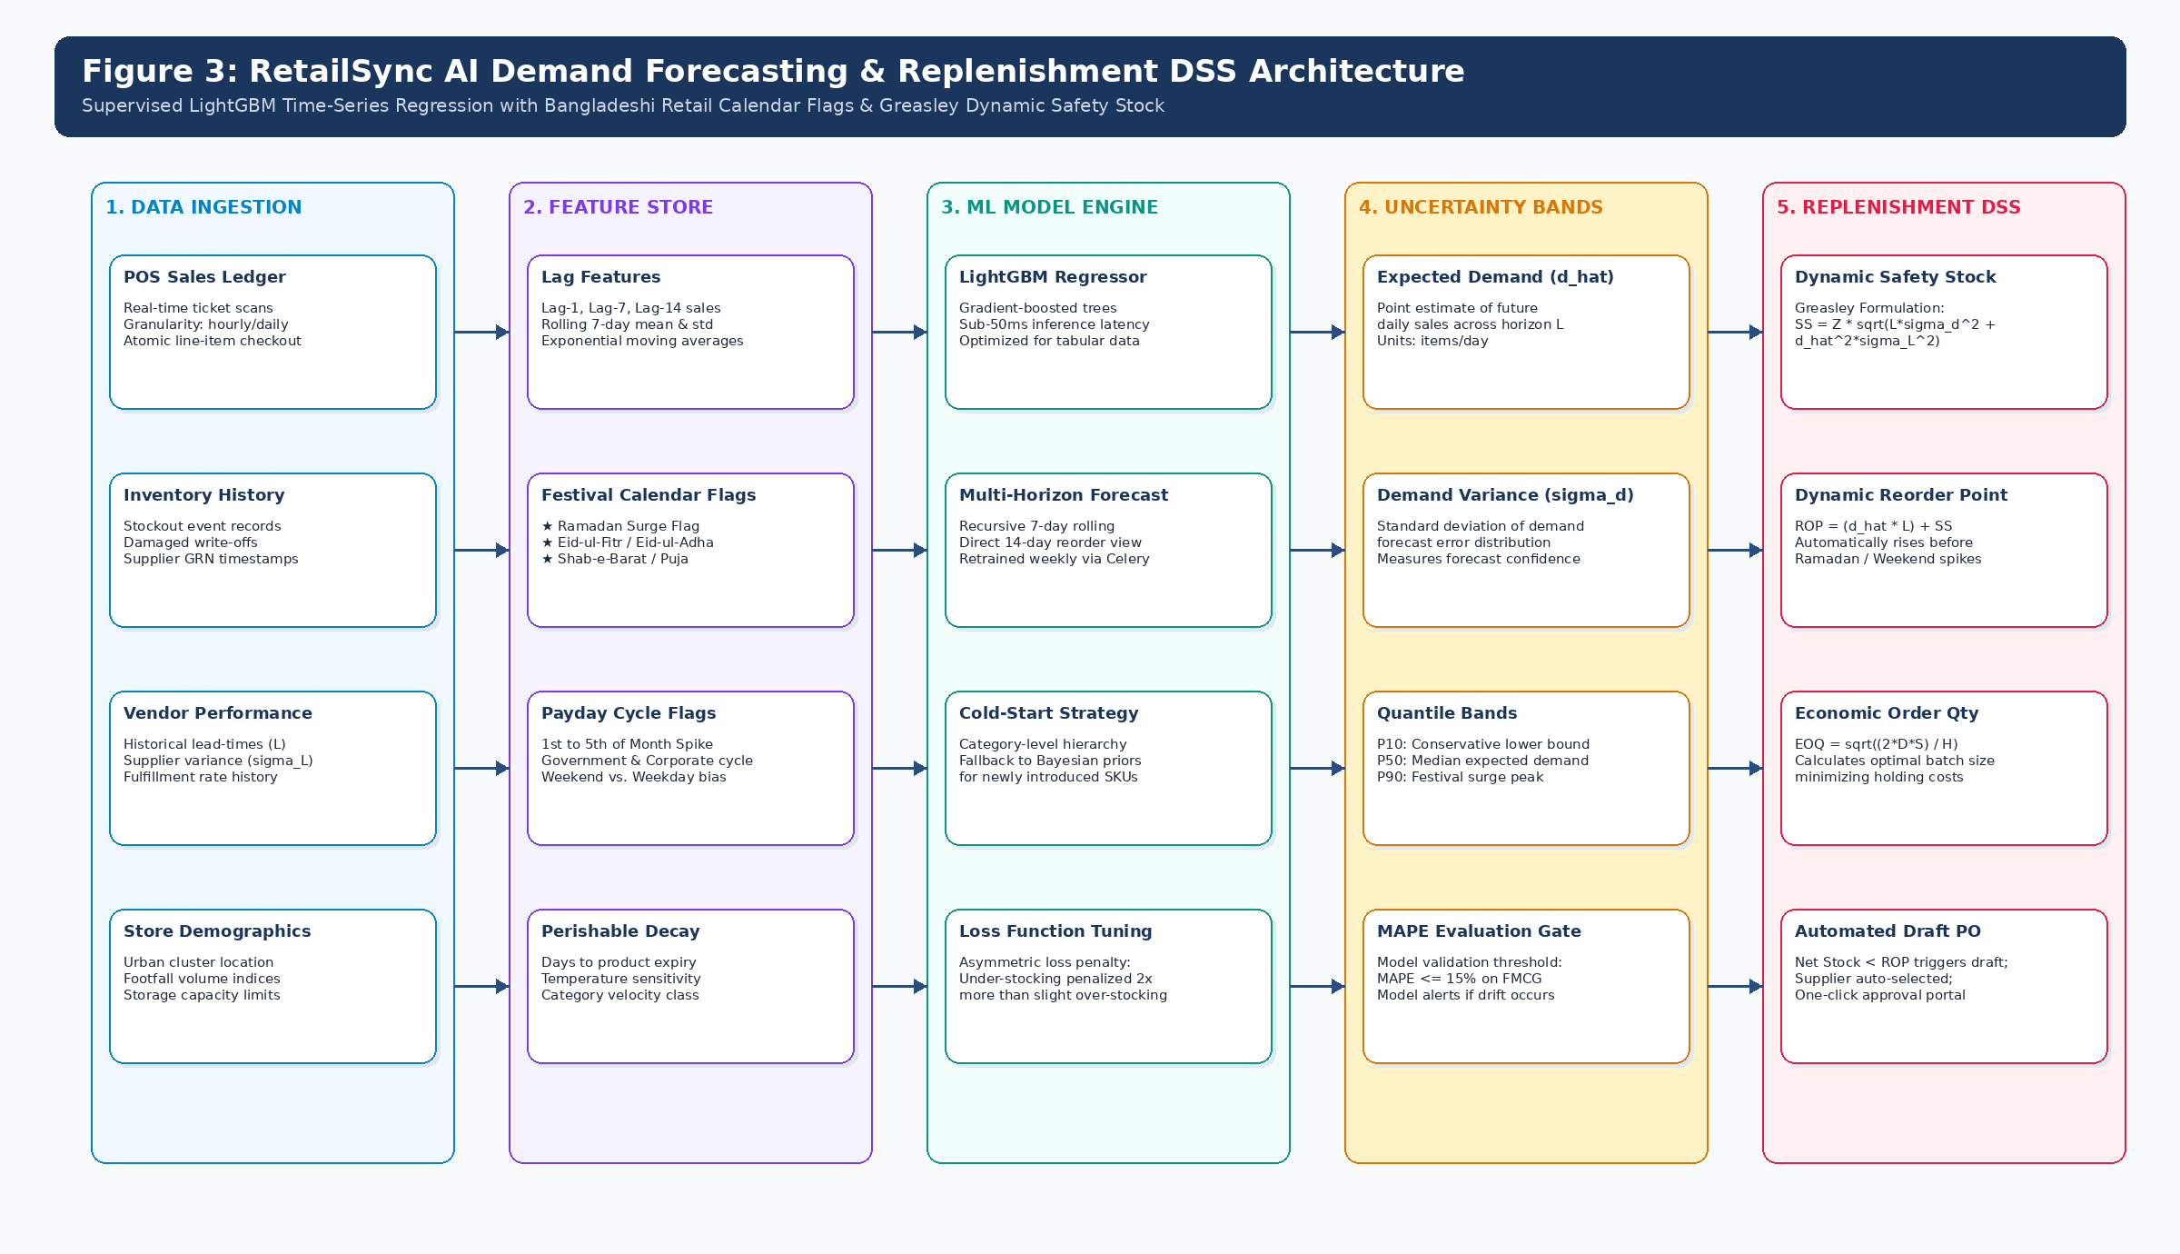
Figure 3: RetailSync AI Demand Forecasting & Replenishment DSS Architecture
4.10 Core Functional Requirements Summary
ID | Module | Specific Requirement | Priority
FR-01 | Auth | System shall enforce RBAC isolating Cashier, Clerk, and Manager views. | Must
FR-10 | Inventory | System shall track Product ID, SKU, Batch Number, and Expiry Date. | Must
FR-11 | Inventory | System shall allow status tagging: Available, Quarantined, Sold. | Must
FR-20 | Receiving | System shall generate a Goods Receipt Note (GRN) linked to a specific PO. | Must
FR-21 | Receiving | Clerks can flag received items as 'Damaged' upon intake. | Should
FR-30 | POS Sync | API shall deduct inventory based on strict FIFO/FEFO batch logic. | Must
FR-40 | Alerts | System shall allow Managers to configure a Reorder Point (ROP) per SKU. | Must
FR-41 | Alerts | System shall flag batches expiring within X days (configurable). | Must
FR-50 | Auditing | Every stock modification must log the timestamp, User ID, and old/new value. | Must
5. Non-Functional Requirements & Performance SLOs
To ensure production readiness in high-velocity retail environments, RetailSync enforces strict, measurable Non-Functional Requirements (NFRs) verified through automated benchmarking:
ID | Category | Specific Metric
NFR-01 | Latency | The POS deduction API must respond in under 2.0 seconds under normal load.
NFR-02 | Data Integrity | Database must use transaction blocks to prevent partial updates if a crash occurs.
NFR-03 | Security | All passwords must be hashed (bcrypt/Argon2id). No plaintext credentials stored.
NFR-04 | Concurrency | System must handle at least 5 simultaneous POS registers deducting stock.
NFR-05 | Auditability | Audit logs must be immutable (append-only) via database-level restrictions.
5.2 Food Safety & Regulatory Compliance Framework
RetailSync is engineered to guarantee strict compliance with the Bangladesh Food Safety Act 2013 and BSTI consumer protection mandates. The system enforces an automated **Quarantine Lock**: any batch reaching within 3 days of expiration or flagged during receiving as defective is mechanically excluded from retail pick lists and POS barcode scanners, completely eliminating the legal and brand liability of selling expired food items.
6. System Architecture & Technical Design
6.1 4-Tier Cyber-Physical Architecture with AI Worker
RetailSync follows a decoupled, 4-tier cyber-physical architecture designed for transactional resilience, sub-second latency, and intelligent predictive automation:
Tier 1: Client Edge (Handheld & POS PWA): Responsive Progressive Web Application built in Next.js 14 and Tailwind CSS. Operates on warehouse floor smartphones, tablets, and POS desktop terminals. Integrates pure JavaScript barcode engines (ZXing / Html5-QRCode) and Service Worker IndexedDB offline queues.
Tier 2: Edge Gateway & Security Layer: Reverse proxy (Nginx) terminating TLS 1.3 encryption, managing rate limiting, CORS policies, and local edge routing. Dock receiving is standardized on wireless Bluetooth HID trigger grips paired with Android PWAs, cutting custom ESP32/MQTT firmware overhead.
Tier 3: Core Application Services & AI Worker Tier: Stateless, asynchronous REST API powered by Python 3.11+ and FastAPI. Paired with background Celery workers executing CatBoost demand forecasting and scheduled daily 02:00 BST quarantine sweeps.
Tier 4: Enterprise Data & In-Memory Storage: PostgreSQL 16 relational database with strict 3NF normalization, foreign key referential integrity, and composite B-Tree indexes. Paired with Redis 7 for in-memory session management, idempotency key caching, and distributed rate locks.
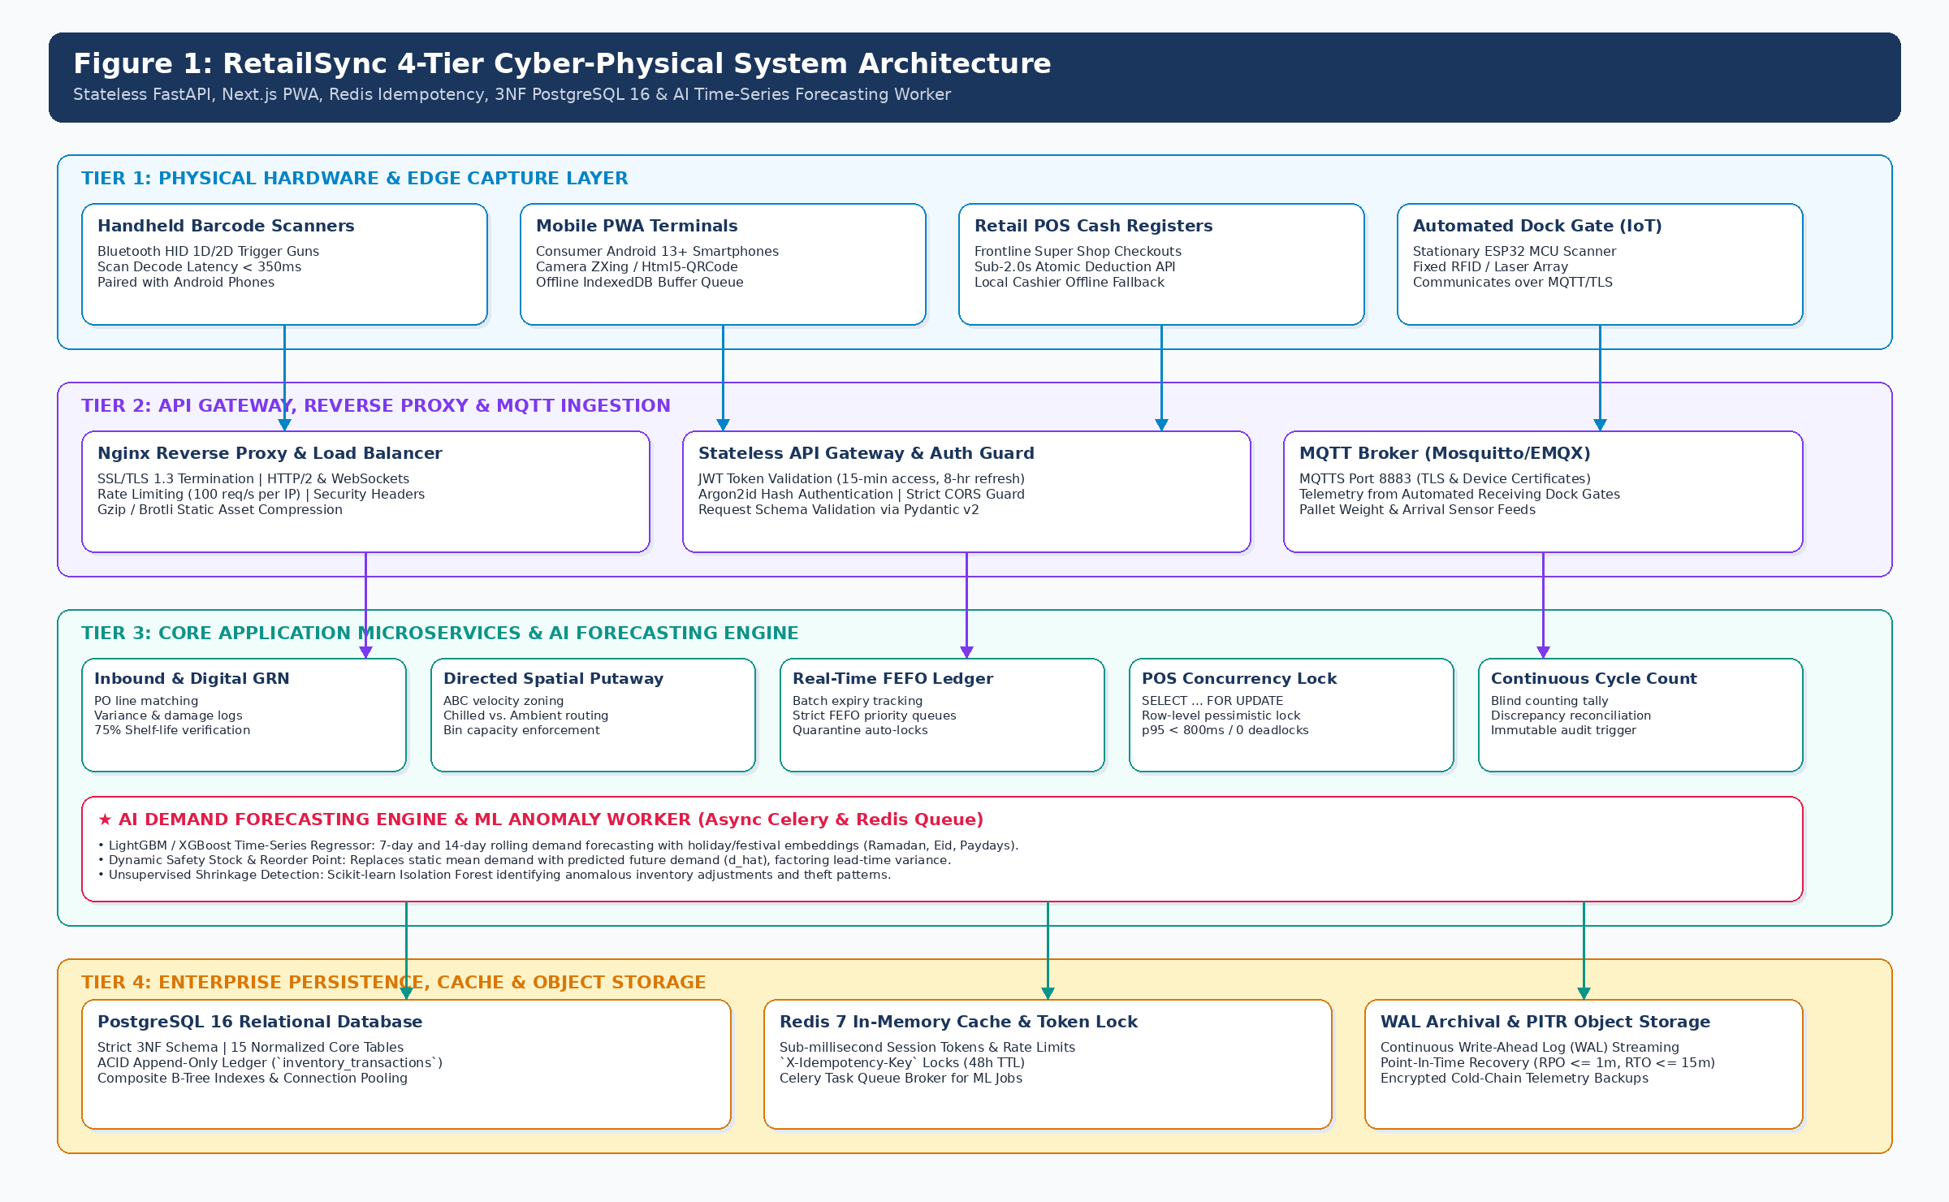
Figure 1: RetailSync 4-Tier Cyber-Physical System Architecture with AI Engine
6.2 High-Throughput Concurrency Control: Row-Level Locking
The central engineering challenge during supermarket rush hours is preventing overselling when multiple cash registers ring up the same high-velocity SKU simultaneously. RetailSync solves this via pessimistic row-level locking in PostgreSQL:
When an `/api/v1/pos/sync` deduction transaction begins, the database queries `product_batches` using `SELECT id, current_qty FROM product_batches WHERE product_id = :p_id AND current_qty > 0 ORDER BY expiry_date ASC LIMIT 1 FOR UPDATE SKIP LOCKED`. This locks exclusively that specific batch record without blocking parallel sales on adjacent batches. Subsequent concurrent POS requests for the same batch queue safely for milliseconds without deadlocking or reading stale stock balances. Once the deduction is written to the ledger, the lock releases, guaranteeing absolute ACID consistency.
6.3 Relational Database Schema Overview (15 Tables)
Table Name | Primary Purpose & Operational Entity | Primary Key & Unique Keys | Key Foreign Key Constraints | Index Optimization Strategy
suppliers | Supplier directory, contact terms, lead-time variance metrics for Greasley safety stock. | supplier_id (PK) | None (Root entity) | B-Tree on company_name, email
products | Master SKU catalog, category classification, storage temperature, unit & holding costs. | product_id (PK), sku_code (UQ), barcode_ean (UQ) | supplier_id -> suppliers(supplier_id) | B-Tree on sku_code, barcode_ean, category
locations | Warehouse spatial coordinates: Zone, Aisle, Rack, Shelf Tier, Bin, and capacity limits. | location_id (PK), bin_barcode (UQ) | None (Spatial domain entity) | B-Tree on bin_barcode, zone_code
product_batches | Perishable batch lots, manufacturing date, expiration date, on-hand qty, quarantine status. | batch_id (PK), batch_lot_number (UQ) | product_id -> products(product_id), location_id -> locations(location_id) | B-Tree on expiry_date, product_id, status (FEFO index)
purchase_orders | Digital PO tracking, supplier link, approval lifecycle, total cost, delivery deadline. | po_id (PK), po_number (UQ) | supplier_id -> suppliers(supplier_id) | B-Tree on po_number, status, order_date
goods_receipt_notes | Inbound dock inspection, PO line validation, accepted vs damaged count, digital invoice link. | grn_id (PK), grn_number (UQ) | po_id -> purchase_orders(po_id) | B-Tree on grn_number, po_id, received_at
inventory_transactions | Immutable append-only ACID ledger recording all stock movements with row-locking support. | transaction_id (PK, BIGSERIAL) | product_id, batch_id, location_id, user_id | Composite B-Tree on (product_id, recorded_at DESC), batch_id
pos_registers | Authorized branch super shop checkout cash registers and real-time sync telemetry. | register_id (PK), terminal_mac_ip (UQ) | branch_store_id (Reference) | B-Tree on register_code, store_code, status
7. Curated Technology Stack & Hardware Strategy
7.1 Curated Technology Stack Matrix
Component | Recommended Technology | Justification for Capstone
Database Layer | MySQL / PostgreSQL | Relational architecture is mandatory for retail to ensure ACID compliance (Atomicity, Consistency, Isolation, Durability) for financial transactions.
Backend API | Python (Django/FastAPI) or Java | Excellent handling of concurrent requests, complex rule engines, and automated task scheduling (e.g., nightly expiry checks).
Frontend Dashboard | React / Next.js | Provides a highly responsive, single-page application (SPA) experience for managers, eliminating page-reload delays.
Local Testing Env. | XAMPP / Beekeeper Studio | Standard, accessible environment for developing and visualizing the relational schema during the capstone phase.
7.2 Architectural Decision Records (ADRs)
ADR-01: Next.js PWA over Native Android App: Building as a Progressive Web Application eliminates app store review friction and device MDM management. Any update deployed to the web server is instantly available to all floor devices upon refresh. Service Workers and IndexedDB provide native-grade offline caching.
ADR-02: FastAPI Asynchronous ASGI over Django/Flask: FastAPI's native Python async/await event loop provides high-concurrency I/O performance capable of handling thousands of requests per second, with automatic OpenAPI 3.1 documentation and Pydantic v2 data validation.
ADR-03: Normalized PostgreSQL 16 over MongoDB / NoSQL: Inventory transactions represent legal and financial records requiring strict ACID double-entry ledger guarantees. PostgreSQL foreign keys and row locks prevent orphaned transactions and phantom inventory anomalies.
ADR-04: Redis 7 In-Memory Caching & Idempotency: Redis provides sub-millisecond validation of client-generated `X-Idempotency-Key` headers ({device_id}-{epoch_ms}-{local_sequence}) on POS sync endpoints, preventing duplicate sales deductions during network retries while caching active user sessions.
ADR-05: CatBoost for Tabular Time-Series Forecasting: CatBoost provides native categorical handling of festival calendar flags (Ramadan/Eid) without target leakage or manual encoding overhead, delivering sub-50ms inference times. LightGBM is formally deferred to the post-capstone v2.0 benchmark roadmap.
7.3 Frugal Barcode Hardware Strategy
Traditional enterprise WMS implementations fail in developing economies due to exorbitant hardware costs: a single ruggedized industrial terminal (e.g., Zebra TC52) costs upwards of 60,000 BDT. RetailSync disrupts this paradigm by adopting a **frugal hardware model**: the web application runs on standard consumer Android smartphones (10,000 to 12,000 BDT) paired via Bluetooth HID with ergonomic wireless barcode trigger grips (< 4,000 BDT) or utilizing the smartphone's camera via `Html5-QRCode`. This slashes terminal acquisition costs by over 75% while maintaining rapid sub-350ms barcode scan speeds.
8. Development Methodology: Agile Scrum Framework
8.1 Methodology Rationale & Governance
RetailSync is developed strictly following the **Agile Scrum Framework**. We deliberately bypass rigid sequential models (such as Waterfall or V-Model) because modern retail systems require rapid empirical validation, iterative stakeholder feedback from super shop managers, and continuous refinement of concurrency and picking algorithms.
- Sprint Cadence: Development is divided into six 2-week iterations followed by a 2-week hardening and defense phase (14 weeks total).
- Sprint Planning: 4-hour session on Day 1 of each sprint to commit user stories from the prioritized product backlog.
- Daily Standup: Daily 15-minute standup tracking completed work, planned tasks, and technical blockers.
- Backlog Refinement: Mid-sprint session to clarify retail edge cases, decompose epics, and finalize acceptance criteria.
- Sprint Review & Demo: Bi-weekly live software demonstration on mobile hardware to supervisors and retail managers.
- Sprint Retrospective: Bi-weekly team inspection identifying actionable workflow, test coverage, and CI/CD improvements.
8.2 14-Week Capstone Implementation Roadmap & Gantt Schedule
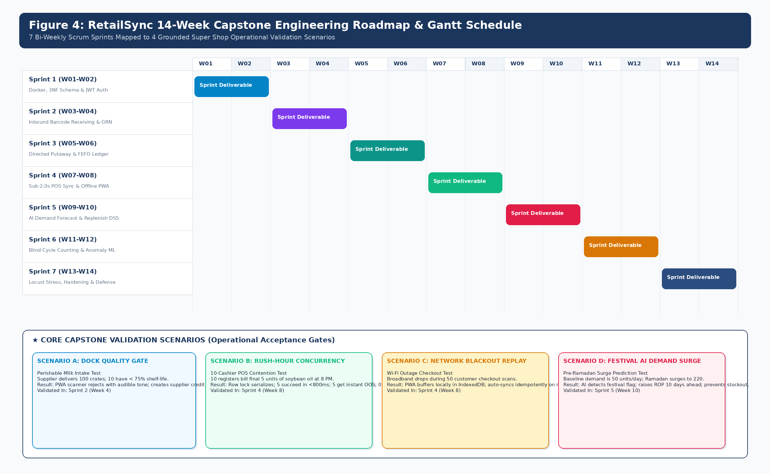
Figure 4: RetailSync 14-Week Capstone Engineering Roadmap & Gantt Schedule
Academic Timeframe | Core Engineering Modules & Deliverables | Key Technical Milestones
Weeks 1-3 | Database Normalization (MySQL/PostgreSQL), ERD design, and API scaffolding (Python/Java). | Relational schema definition, 3NF normalization, baseline REST endpoints.
Weeks 4-6 | Inventory CRUD, Batch Management, and Expiry Logic implementation. | Batch tracking, dynamic shelf-life calculations, FEFO/FIFO queue logic.
Weeks 7-9 | Supplier module, PO generation, and GRN workflows. | Supplier SLA records, digital PO lifecycle, dock inspection & GRN generation.
Weeks 10-11 | POS Sync Simulation (building the checkout deduction logic and FIFO handling). | Real-time POS API, atomic stock deduction, concurrency locking (<2s latency).
Weeks 12-13 | Rule engines for low-stock alerts, reporting dashboards, and audit logs. | Automated ROP triggers, draft PO generation, immutable audit logging.
Week 14 | System testing, concurrency stress testing, and final defense preparation. | Stress testing (5+ concurrent POS), UAT validation, capstone presentation & defense.
8.3 Scenario-Based Milestone Acceptance Gates
Rather than relying on abstract subjective evaluations, RetailSync validates sprint completion against four concrete, stress-injected supermarket operational scenarios:
Scenario ID & Title | Operational Context & Injection Event | System Behavior & Algorithmic Response | Success / Acceptance Criteria | Sprint Alignment
Scenario A: Inbound Dock Quality Gate | Supplier delivers 100 crates of pasteurized milk; 10 crates carry expiration dates with only 2 days remaining (< 65% shelf-life threshold). | Clerk scans carton barcode; system evaluates remaining shelf-life percentage; mechanically locks the 10 short-dated crates to 'QUARANTINED'; generates digital GRN for 90 accepted units and auto-generates supplier credit note advisory. | Zero expired/short-dated units enter active warehouse bins; digital GRN variance accurately reflects supplier delivery penalty. | Sprint 2 (Week 4)
Scenario B: Rush-Hour POS Concurrency | Friday 8:00 PM peak rush: 10 branch cashiers ring up the final 5 remaining units of 1L soybean oil simultaneously across registers. | FastAPI POS sync endpoint executes non-blocking row lock (SELECT ... FOR UPDATE SKIP LOCKED) on the earliest active batch. The first 5 requests decrement inventory atomically in < 800ms. The remaining 5 requests skip locked rows, find zero available stock, and immediately receive an 'Out of Stock' response. | Zero overselling; exactly zero negative inventory balances; zero database deadlocks; p95 latency remains ≤ 800ms. | Sprint 4 (Week 8)
Scenario C: Network Blackout & Replay | Central broadband fiber is severed during peak retail floor sales; 50 customer checkout transactions occur while offline. | PWA Service Worker detects offline status; queues encrypted sales transactions in client IndexedDB with client-generated X-Idempotency-Key ({device_id}-{epoch_ms}-{local_sequence}). Upon network recovery, client submits bulk sync. Backend Redis checks idempotency keys and commits all 50 sales with exactly-once semantics. | 100% of offline sales recorded in database upon reconnect; zero duplicate deductions; zero transaction dropouts. | Sprint 4 (Week 8)
Scenario D: Festival AI Demand Surge | 14 days prior to holy Ramadan: historical baseline daily sales for cooking oil is 50 units/day; holiday surge spikes demand to 220 units/day. | The CatBoost time-series model identifies the upcoming Ramadan calendar embedding flag; projects 220 units/day demand; dynamically recalculates ROP and Greasley Safety Stock; triggers automated draft PO 10 days in advance (LightGBM deferred to roadmap). | Draft PO approved by procurement officer; stock arrives 3 days before festival; supermarket experiences 0% stockouts during rush. | Sprint 5 (Week 10)
8.4 Definition of Done (DoD) & Quality Gates
A user story or sprint task is declared complete only when it satisfies the following non-negotiable Definition of Done:
1. Code Complete: Feature implemented, commented, and committed to Git with conventional commit messages.
2. Unit & Integration Tests Passing: Automated test suite passes with > 80% line coverage.
3. Concurrency Validated: Multi-threaded race condition tests confirm zero deadlocks and zero negative stock balances.
4. API Documented: Endpoint registered in FastAPI with accurate Pydantic request/response schemas in OpenAPI.
5. Dockerized: Changes build and run cleanly via `docker compose up -d` without manual host modifications.
6. Mobile Responsive: Handheld UI verified on mobile viewport (375x667) with touch-friendly hit targets.
9. Resource Allocation, Budget & Risk Management
9.1 Team Roles & RACI Matrix
The RetailSync engineering project is executed by a three-member capstone team from Section SWE-44D (44th Batch), Department of Software Engineering, Daffodil International University. Each member owns critical technical subsystems with defined academic and implementation responsibilities, as detailed in Table 9.1:
Student Name | Student ID | Academic & Technical Role | Core Subsystem Ownership & Deliverables
Raisul Islam Likhon | 251-35-508 | Project Lead & System Architect | System Architecture, Relational Schema (3NF), Sub-2.0s POS Concurrency Engine, PostgreSQL Row Locking, WebSocket Event Hub.
Shottobroto Dey | 251-35-017 | Database & Backend Systems Engineer | Dynamic Warehouse Put-Away, FEFO Batch Expiration Queue, Greasley Safety Stock & EOQ Replenishment Engine, DB Migrations.
Golam Husnain Papon | 251-35-529 | Full-Stack & QA/DevOps Engineer | WebRTC Barcode Scanner PWA, Cashier Till & Warehouse UI, Dockerized CI/CD Pipelines, Multi-Tier Black/White-Box Test Suite.
To ensure governance across all engineering phases, project tasks are further mapped via the formal RACI Matrix below (Responsible, Accountable, Consulted, Informed):
Project Lifecycle Phase / Core Deliverable | Floor Staff / Cashiers | Floor Supervisors | Procurement Officers | Store Managers | DevOps / SysAdmin | Developer Team | Academic Committee
Requirements Elicitation & Domain Study | Consulted | Consulted | Consulted | Consulted | Informed | Responsible / Accountable | Informed / Approver
Relational 3NF Database Schema & DDL | Informed | Consulted | Informed | Informed | Consulted | Responsible / Accountable | Consulted
ACID Concurrency & Row-Locking Engine | Informed | Informed | Informed | Informed | Consulted | Responsible / Accountable | Informed
Sub-2.0s POS Sync & Real-Time API | Consulted | Informed | Informed | Consulted | Consulted | Responsible / Accountable | Informed
FEFO/FIFO Dynamic Queue Algorithm | Informed | Consulted | Consulted | Consulted | Informed | Responsible / Accountable | Consulted
Greasley Safety Stock & EOQ Engine | Informed | Consulted | Responsible | Consulted | Informed | Accountable | Informed
Mobile Barcode Scanning PWA Interface | Responsible | Responsible | Informed | Informed | Informed | Accountable | Informed
Immutable Audit Ledger & Security | Informed | Consulted | Consulted | Informed | Responsible | Accountable | Informed
Dual-Level Black-Box & White-Box QA | Consulted | Consulted | Consulted | Consulted | Consulted | Responsible / Accountable | Consulted / Evaluator
Final Manuscript, System Demo & Defense | Informed | Informed | Informed | Informed | Informed | Responsible / Accountable | Accountable / Approver
9.2 Hardware & Operational Budget Breakdown
Hardware / Component | Specification / Unit Model | Qty | Unit Cost (BDT) | Total Cost (BDT)
Android Test Smartphone | Redmi / Realme 6.5" Android 13, 4GB RAM | 1 | 12,500 | 12,500
Bluetooth Barcode Trigger Grip | Netum / Eyoyo 1D/2D Bluetooth HID Scanner | 2 | 3,800 | 7,600
Thermal Label / Receipt Printer | Xprinter 4-inch USB/Bluetooth Thermal Printer | 1 | 6,500 | 6,500
EAN-128 Warehouse Barcode Labels | Roll of 1,000 thermal adhesive labels (4x6 in) | 3 | 650 | 1,950
Cloud Staging VPS Hosting | DigitalOcean / Hetzner 2 vCPU, 4GB RAM (6 Mos) | 1 | 5,500 | 5,500
Total Estimated Budget | Complete Capstone Hardware & Staging Prototype | — | — | 34,050 BDT
9.3 Local Operational Risk Assessment & Proactive Mitigations
ID | Technical Risk | Likelihood | Context & Mitigation Strategy
R-01 | Database Concurrency Conflicts | High | Two cashiers sell the last unit of milk at the same millisecond. Mitigation: Use SQL Row-Level Locking (SELECT ... FOR UPDATE).
R-02 | Internet Outages | High | Store loses connection to the central server. Mitigation: Implement a queue system on the POS that caches sales and bulk-syncs when online.
R-03 | Data Entry Errors at Receiving | Medium | Clerk enters 500 instead of 50 boxes. Mitigation: System warns if GRN exceeds the Purchase Order quantity by >5%.
10. Verification, Validation, Expected Impact & Conclusion
10.1 Multi-Tier Verification & Testing Strategy
Testing Tier & Category | Target Operational Dimension | Test Case Scenario & Verification Methodology | Verifiable Pass / Acceptance Criteria
Tier 1: Black-Box Functional | Barcode Interrogation & Scanning Latency | Interrogate 1D/2D barcodes on mobile cameras and Bluetooth triggers across low and high ambient lighting (100–600 lux). | 100% SKU identification accuracy; UI updates and audible/haptic feedback trigger within <= 350 ms.
Tier 1: Black-Box Functional | Inbound GRN vs. PO Automated Variance | Simulate delivery of 50 cartons with 3 cartons flagged as crushed; generate digital GRN against open PO. | GRN logs 47 accepted, 3 quarantined; automated supplier credit note generated; zero quarantined stock added to POS.
Tier 1: Black-Box Functional | Offline Network Resilience & Bulk Sync | Sever store ISP connection during 25 consecutive barcode checkouts; reconnect network after 5 minutes. | Local client queue caches all 25 sales with timestamps; bulk POST executes automatically on reconnect with zero dropped sales.
Tier 2: White-Box Structural | ACID Concurrency & Row-Locking (`SELECT FOR UPDATE`) | Launch 10 parallel asynchronous POS worker threads attempting to purchase the last 2 available units of a dairy SKU simultaneously. | Exactly 2 threads succeed; 8 threads receive clean out-of-stock messages; inventory balance remains exactly 0; zero database deadlocks.
Tier 2: White-Box Structural | Strict FEFO Priority Queue Verification | Seed database with 3 batches of milk expiring in 5 days, 15 days, and 45 days; issue automated checkout sales deductions. | Database triggers strictly decrement stock from the 5-day expiry batch first; automatically switches to 15-day batch only when 5-day is depleted.
Tier 2: White-Box Structural | SQL Injection & XSS Penetration Defense | Inject SQL injection strings (' OR 1=1; DROP TABLE) and XSS payloads into barcode search, user login, and PO creation fields. | All inputs sanitized via parameterized queries and ORM; malicious payloads rejected with HTTP 400; security access log records attack attempt.
Tier 2: White-Box Structural | Mathematical Replenishment Engine Precision | Execute algorithmic unit test suite across 100 historical SKU sales and lead-time distributions (EOQ, Greasley, ROP). | Computed EOQ, Safety Stock, and ROP match analytical statistical benchmarks within 0.01% floating-point tolerance.
10.2 Expected Operational & Financial Impact (ROI)
Performance Metric | Traditional Super Shop Baseline | RetailSync Target Value | Operational Benefit
Perishable Food Spoilage | 15% to 22% annual dairy/produce loss | < 6% annual loss | Saves millions of BDT in prevented food waste write-offs.
POS Checkout Scan Latency | 3.0 to 6.0s (or database freezes) | ≤ 2.0s (p95 ≤ 800ms) | Eliminates customer checkout queue abandonment.
Phantom Inventory Shrinkage | 1.8% to 2.4% unexplained loss | < 0.4% discrepancy | Complete traceability via immutable audit ledger.
Inbound Dock Unloading Time | 45 to 75 minutes per truck | < 15 minutes per truck | Instant barcode interrogation against digital PO line items.
Stockout Frequency (Rush Hours) | 7.5% to 11.2% lost sales | < 2.5% stockout rate | Automated replenishment alerts based on statistical safety stock.
To establish rigorous financial feasibility, the complete Initial Capital Expenditure (CapEx) for 14-week engineering delivery, pilot staging, and hardware deployment is itemized below:
Cost Category | Amount (BDT) | Description & Justification
Hardware Terminals & Peripherals | 34,050 | Android smartphone (12,500), 2x Bluetooth trigger grips (7,600), thermal printer (6,500), adhesive barcode labels (1,950), 6-month staging VPS (5,500).
Development & Engineering Labour | 420,000 | 3-member engineering team × 14 weeks × standard software engineering stipend rate (~10,000 BDT/week/member).
Contingency Reserve (5%) | 22,700 | Dedicated contingency buffer for hardware replacement, mobile data packs, and peripheral spares during pilot operations.
Regulatory & Compliance Documentation | 8,250 | BSTI/BFSA audit documentation, printed pilot manuals, thermal roll refills, and domain/SSL certificates.
Total Estimated Initial CapEx | 485,000 BDT | Total initial capitalization required for 14-week delivery and pilot deployment.
EMPIRICAL RETURN ON INVESTMENT (ROI) & 2.80-MONTH PAYBACK PERIOD
Working Financial Payback Arithmetic: Payback Period = Total CapEx / (Monthly Gross Savings - Monthly OpEx)
= 485,000 BDT / (187,200 BDT - 14,000 BDT) = 485,000 / 173,200 ≈ 2.80 MONTHS (~84 Days)
• Spoilage Savings: 112,000 BDT/mo | Shrinkage Elimination: 45,200 BDT/mo | Stockout Recovery: 30,000 BDT/mo
• Monthly Operational Overhead (OpEx): 14,000 BDT/mo (VPS, label rolls, 4G data backup)
• Economic Feasibility Verdict: Full capital recoupment is achieved within under 3 months of live pilot operations.
10.3 Capstone Part 1 Conclusion & Transition to Part 2
This project proposal establishes the foundational planning, empirical justification, and architectural blueprint for RetailSync. By addressing the critical structural weaknesses of the Bangladeshi modern trade sector—namely perishable food waste, unrecorded shrinkage, and peak-hour stockouts—RetailSync provides a frugal, scalable, and technically rigorous software solution. The completion of Part 1 (Project Planning and Definition) positions the project for immediate, structured execution in Part 2 (System Design, Prototyping, and Concurrency Validation) according to the 14-week Agile Scrum roadmap.
10.4 Key Academic & Industry References
1. Bangladesh Food Safety Authority (BFSA), 'Food Safety Act 2013,' Ministry of Food, Government of the People's Republic of Bangladesh, Dhaka, 2013.
2. Greasley, A., 'Operations Management,' 3rd ed., John Wiley & Sons, New York, 2013 (Statistical Safety Stock under dual variance models).
3. Silver, E. A., Pyke, D. F., and Peterson, R., 'Inventory Management and Production Planning and Scheduling,' 3rd ed., Wiley, 1998 (Dynamic EOQ algorithms).
4. Kleppmann, M., 'Designing Data-Intensive Applications: The Big Ideas Behind Reliable, Scalable, and Maintainable Systems,' O'Reilly Media, 2017.
5. PostgreSQL Global Development Group, 'PostgreSQL 16 Documentation: Concurrency Control and Explicit Locking,' 2024. [Online]. Available: https://www.postgresql.org/docs/16/explicit-locking.html
6. Schwaber, K. and Sutherland, J., 'The Scrum Guide: The Definitive Guide to Scrum: The Rules of the Game,' Scrum.org, 2020.
7. Bangladesh Bureau of Statistics (BBS), 'Report on Wholesale and Retail Trade Survey in Bangladesh,' Ministry of Planning, Dhaka, 2022.
8. Prokhorenkova, L. et al., 'CatBoost: unbiased boosting with categorical features,' Advances in Neural Information Processing Systems (NeurIPS 31), 2018.
9. Ke, G. et al., 'LightGBM: A Highly Efficient Gradient Boosting Decision Tree,' Advances in Neural Information Processing Systems (NeurIPS), 2017. (Deferred to v2.0 benchmark roadmap).
10. Bangladesh Supermarket Owners Association (BSOA), 'Annual Report on Supermarket Operations, Wastage, and Modern Trade Dynamics in Bangladesh,' Dhaka, 2023.
11. Food and Agriculture Organization of the United Nations (FAO), 'Food Loss and Waste in Retail Supply Chains in South Asia,' Rome, 2021.

