TELECOM CUSTOMER CHURN PREDICTION &
RETENTION INTELLIGENCE SYSTEM
(TelcoPulse AI)
A Machine Learning & Explainable Decision Support System for Proactive Customer Retention
Student Name: Anaganti Sairishikesh
College Name: Engineering & Technology Institute / University
Department: Department of Computer Science and Engineering
Academic Year: Final / Pre-Final Year (2025 - 2026)
Project Domain: Artificial Intelligence & Machine Learning (AI/ML)
Application Deployment: Streamlit Cloud Production Application

Index
S.No | Topic / Chapter Name | Page No.
1 | Introduction | 3
2 | Problem Statement | 4
3 | Objectives | 4
4 | Project Scope | 5
5 | Proposed System / Methodology | 5
6 | Dataset Description | 6
7 | Data Preprocessing | 7
8 | AI/ML Model Selection | 8
9 | Model Development | 9
10 | Model Training and Evaluation | 10
11 | Results and Analysis | 11
12 | System Architecture / Workflow | 13
13 | Implementation | 14
14 | User Interface / Application Screenshots | 15
15 | Challenges and Limitations | 17
16 | Conclusion | 18
17 | Future Scope | 18
18 | References | 19

1. Introduction

1.1 Brief Introduction to the Project Domain
In the modern telecommunications landscape, subscriber retention has become the primary determinant of long-term corporate viability and market share. As telecom markets reach saturation, acquiring a new customer costs 5 to 7 times more than retaining an existing subscriber. Consequently, telecom operators must transition from reactive damage control to proactive, data-driven customer relationship management.

1.2 Background of the Problem
Customer churn represents the rate at which subscribers cancel their subscriptions, disconnect lines, or switch to competitor networks. Telecom providers historically relied on post-cancellation exit interviews and broad-spectrum marketing discounts. These traditional mechanisms fail because they address customer dissatisfaction only after the cancellation intent is finalized, resulting in billions of dollars in lost annual recurring revenue.

1.3 Importance of AI/ML in the Selected Domain
Artificial Intelligence and Machine Learning (AI/ML) transform retention strategies by detecting subtle, non-linear churn risk patterns hidden within multidimensional customer data. By analyzing demographic details, contracted services, payment behaviors, and billing telemetry, supervised machine learning algorithms can predict customer defection months ahead of time, enabling timely, targeted, and financially optimized retention interventions.

1.4 Brief Overview of the Proposed Solution (TelcoPulse AI)
TelcoPulse AI is an enterprise-grade customer churn intelligence and decision support platform. Rather than acting as an inscrutable black box, TelcoPulse AI provides:
- • Calibrated Risk Scoring: Real-time calibrated churn risk probability (%) categorized into Safe (<30%), Moderate (30-60%), and Critical (>60%) risk tiers.
- • Local Explainability (XAI): Mathematical log-odds decomposition identifying the specific hazard factors driving risk and protective factors anchoring loyalty for each subscriber.
- • Financial Exposure Estimation: Quantifies expected financial loss ($/year) per customer account based on monthly recurring revenue and churn probability.
- • What-If Strategy Simulator: An interactive sandbox allowing retention agents to test contract extensions, discounts, and support add-ons to simulate risk reduction before presenting offers.
- • Cohort Batch Queue: Batch roster upload (.csv) with priority queue sorting and 1-click campaign list export for operational retention workflows.

2. Problem Statement

2.1 What Problem Are We Trying to Solve?
We are addressing the critical problem of voluntary subscriber churn in the telecommunications industry, where customers silently defect to competitor providers without prior warning, inflicting massive revenue erosion and high customer acquisition reinvestment cycles.

2.2 Who Is Affected by the Problem?
This problem directly impacts multiple telecom operational stakeholders:
- • Customer Care & Retention Specialists: Struggle with lack of real-time insights during subscriber inbound calls.
- • Marketing & Growth Teams: Suffer from wasted budget on uniform, untargeted discount campaigns.
- • Executive Leadership & Finance: Face eroding average revenue per user (ARPU) and customer lifetime value (LTV).
- • End Consumers: Experience unresolved service friction leading to defection.

2.3 What Are the Limitations of the Existing Approach?
- 1. Reactive Detection: Churn is identified only after the customer requests service termination or stops paying bills.
- 2. Blanket Discounting Inefficiencies: Standard retention campaigns distribute blanket promotions to entire subscriber bases, eroding profit margins on loyal customers who would not have left.
- 3. Black-Box Opacity: Conventional churn models output raw probability numbers without explaining why the customer is leaving, reducing agent trust.
- 4. Lack of Simulation Capabilities: Retention agents have no dynamic tools to evaluate the potential impact of retention packages before making counter-offers.

2.4 Why Is an AI/ML-Based Solution Required?
Subscriber attrition involves complex, non-linear interactions between tenure, contract type, internet technology, payment methods, and bundled add-on services. Human intuition and rule-based heuristics cannot reliably weigh these 20+ interacting variables simultaneously. An AI/ML-based classifier trained on historical subscriber data learns the multidimensional decision boundaries necessary to accurately predict churn probability and uncover actionable retention levers.

3. Objectives
The key objectives of this project are systematically defined as follows:
- 1. Develop AI/ML Solution: Develop an end-to-end AI/ML-based decision support system to accurately classify customer churn risk.
- 2. Analyze Available Data: Perform thorough Exploratory Data Analysis (EDA) on telecom subscriber records to uncover underlying behavioral patterns and risk factors.
- 3. Build & Train Suitable Model: Train, optimize, and benchmark multiple supervised classification models to establish the most effective and interpretable architecture.
- 4. Evaluate Model Performance: Rigorously validate model performance using Accuracy, Precision, Recall, F1-Score, ROC-AUC, and Confusion Matrix metrics.
- 5. Provide Actionable Predictions & Insights: Deliver calibrated predictions, localized explainability (log-odds attribution), financial risk exposure, and interactive What-If simulation via a production web dashboard.

4. Project Scope
The scope and operational boundaries of the TelcoPulse AI project comprise:
- • Target Users: Frontline Telecom Customer Support Representatives, Dedicated Retention Agents, Marketing Campaign Managers, and Executive Operations.
- • Application Area: Telecommunication service providers managing broadband (DSL, Fiber optic), fixed-line telephony, and bundled digital value-added services.
- • Features Covered: Single Customer Risk Diagnosis, What-If Strategy Simulator, Batch File Scoring (.csv), Executive Cohort Analytics, and Model Transparency Diagnostics.
- • Expected Outputs: Calibrated Churn Probability (%), Risk Tier Categorization, Annual Financial Loss Estimation ($), Top Risk Factor Drivers, and Prescriptive Playbook Actions.
- • Current Project Limitations: The project operates on static tabular snapshot data and does not ingest live continuous streaming network telemetry logs.

5. Proposed System / Methodology
The overall end-to-end Machine Learning lifecycle is structured according to the following standardized sequential pipeline:
Data Collection ➔ Data Preprocessing ➔ Feature Engineering ➔ Model Selection ➔ Model Training ➔ Model Evaluation ➔ Prediction & Dashboard Output

Methodology Phase | Key Activities & Technical Outcomes
Phase 1: Data Collection & Ingestion | Acquire the benchmark IBM Telco Customer Churn dataset comprising 7,043 customer accounts and 21 attributes.
Phase 2: Data Preprocessing | Clean missing whitespace anomalies in TotalCharges, verify duplicate records, and audit outlier distributions.
Phase 3: Feature Engineering | Apply OneHotEncoder with drop-first logic to categorical variables and StandardScaler to normalize continuous numerical features.
Phase 4: Model Selection & Training | Train and benchmark multiple candidate classifiers (Logistic Regression, Random Forest, Decision Tree, SVM, KNN) using stratified 80/20 train-test splits.
Phase 5: Model Evaluation | Evaluate models across Accuracy, Precision, Recall, F1-Score, ROC-AUC, and Confusion Matrix to select the optimal model.
Phase 6: Explainability Integration | Extract beta coefficients and log-odds contributions to build localized risk attribution bars for every individual inference.
Phase 7: Web Dashboard & Deployment | Develop an interactive decision support dashboard using Streamlit and deploy the application live to Streamlit Cloud.

6. Dataset Description
The project utilizes the standardized IBM Telecommunications Customer Churn dataset. The dataset provides comprehensive cross-sectional records of 7,043 unique residential telecom subscribers across 21 attributes covering demographics, subscribed services, account tenure, payment methods, and historical churn status.
💡 DATASET SUMMARY SPECIFICATIONS: Dataset Source: IBM Business Analytics Community / Kaggle Benchmark Telco Churn Repository | Total Records: 7,043 | Total Features: 21 | Target Variable: Churn (Yes: 1,869 [26.54%], No: 5,174 [73.46%])

6.1 Sample Dataset Records (First 5 Rows)
customerID | gender | tenure | Contract | PaymentMethod | Monthly | Total | Churn
7590-VHVEG | Female | 1 mo | Month-to-month | Electronic check | $29.85 | $29.85 | No (0)
5575-GNVDE | Male | 34 mo | One year | Mailed check | $56.95 | $1889.50 | No (0)
3668-QPYBK | Male | 2 mo | Month-to-month | Mailed check | $53.85 | $108.15 | Yes (1)
7795-CFOCW | Male | 45 mo | One year | Bank transfer | $42.30 | $1840.75 | No (0)
9237-HQITU | Female | 2 mo | Month-to-month | Electronic check | $70.70 | $151.65 | Yes (1)

6.2 Feature Attribute Dictionary
Feature Name | Data Type | Description / Value Domain
customerID | Categorical (ID) | Unique identifier assigned to each subscriber account
gender | Categorical (Binary) | Male / Female
SeniorCitizen | Numerical (Binary) | Whether subscriber is aged 65+ (1 = Yes, 0 = No)
Partner | Categorical (Binary) | Whether subscriber has a spouse or partner (Yes / No)
Dependents | Categorical (Binary) | Whether subscriber lives with dependents (Yes / No)
tenure | Numerical (Integer) | Number of active subscription months with company (0 - 72)
PhoneService | Categorical (Binary) | Whether subscriber has active fixed-line telephone service (Yes / No)
MultipleLines | Categorical (3 levels) | No, Yes, No phone service
InternetService | Categorical (3 levels) | DSL, Fiber optic, No
OnlineSecurity | Categorical (3 levels) | Yes, No, No internet service
OnlineBackup | Categorical (3 levels) | Yes, No, No internet service
DeviceProtection | Categorical (3 levels) | Yes, No, No internet service
TechSupport | Categorical (3 levels) | Yes, No, No internet service
StreamingTV | Categorical (3 levels) | Yes, No, No internet service
StreamingMovies | Categorical (3 levels) | Yes, No, No internet service
Contract | Categorical (3 levels) | Month-to-month, One year, Two year
PaperlessBilling | Categorical (Binary) | Whether customer receives digital statements (Yes / No)
PaymentMethod | Categorical (4 levels) | Electronic check, Mailed check, Bank transfer, Credit card
MonthlyCharges | Numerical (Float) | Current monthly subscription charge ($18.25 - $118.75)
TotalCharges | Numerical (Float) | Total cumulative amount billed to date ($18.80 - $8684.80)
Churn (Target) | Categorical (Binary) | Ground truth label: whether subscriber churned (Yes = 1, No = 0)

7. Data Preprocessing
Data preprocessing ensures raw tabular telemetry is transformed into clean, mathematically robust feature matrices suitable for machine learning algorithms. The following six preprocessing stages were executed:
- 1. Handling Missing Values: The TotalCharges column contained 11 whitespace strings (' ') corresponding to brand new customers with tenure = 0 months. These were converted to numeric floating-point format and imputed to $0.00 to prevent data leakage or row loss.
- 2. Removing Duplicates: The entire dataset was checked for duplicate entries across all 21 columns. Zero duplicate rows were identified, confirming all 7,043 customer accounts are distinct.
- 3. Handling Outliers: Interquartile Range (IQR) audits were performed on continuous numerical variables (tenure, MonthlyCharges, TotalCharges). All values fell within legitimate telecom billing parameters with no unphysical anomalies or invalid negative numbers.
- 4. Data Encoding: Categorical variables (16 features) were converted to numerical representations using OneHotEncoder with drop='first' dummy encoding, producing 41 distinct binary indicator columns to eliminate multicollinear dummy traps.
- 5. Feature Scaling: Continuous numerical features and encoded variables were normalized using StandardScaler to transform features to zero mean (μ = 0) and unit variance (σ² = 1), ensuring scale-invariant gradient convergence.
- 6. Train/Test Split: The cleaned dataset was partitioned into 80% Training (5,634 samples) and 20% Testing (1,409 samples) using stratified sampling on the Churn target variable to preserve the 73.5% vs. 26.5% class distribution across both sets.

8. AI/ML Model Selection
Five candidate supervised classification algorithms were implemented, tuned, and evaluated on the standardized Telco Churn test set:
Model | Accuracy | Precision | Recall | F1 | AUC | Interpretability | Latency
Logistic Regression (Selected) | 80.48% | 65.2% | 55.8% | 0.601 | 0.845 | High (Direct Log-Odds) | < 5 ms
Random Forest Classifier | 79.20% | 62.8% | 49.4% | 0.553 | 0.828 | Moderate (Tree Ensemble) | 35 ms
Decision Tree Classifier | 72.82% | 48.9% | 50.5% | 0.497 | 0.657 | High (Single Tree) | < 5 ms
Support Vector Machine (RBF) | 79.84% | 64.1% | 51.2% | 0.569 | 0.812 | Low (Black Box) | 60 ms
K-Nearest Neighbors (KNN) | 76.44% | 55.3% | 52.7% | 0.540 | 0.781 | Low (Instance Based) | 25 ms

8.1 Selection Criteria for the Production Model
- 1. Accuracy & Predictive Performance: Logistic Regression achieved the highest overall test accuracy (80.48%) and the highest Area Under the ROC Curve (0.845 AUC) among all evaluated algorithms.
- 2. Training Time & Low Latency: With an inference latency of under 5 milliseconds, Logistic Regression delivers instantaneous responsiveness during live customer service call interactions and batch cohort processing.
- 3. Dataset Characteristics: The normalized feature space exhibits predominantly linear separation boundaries between short-tenure month-to-month contracts and loyal multi-year contracts.
- 4. Explainability & Trust: Unlike black-box models, Logistic Regression directly yields mathematical log-odds coefficients (β), allowing real-time decomposition into transparent risk drivers for frontline customer care agents.

9. Model Development
The model development phase encompasses feature pipeline engineering, hyperparameter optimization, and development tooling configuration:
- • Feature Selection & Engineering: All 20 predictor attributes were transformed into a standardized 41-dimensional numeric feature vector.
- • Model Configuration & Hyperparameters: Penalty = L2 (Ridge regularization), Inverse Regularization (C) = 1.0, Optimization Solver = lbfgs (Limited-memory BFGS), Maximum Iterations = 1000, Random State = 42 for deterministic reproducibility.
- • Development Environment: Python 3.10+ runtime, Visual Studio Code / Antigravity Agentic IDE, Windows 11 64-bit OS.
- • Libraries Used: Python, Pandas, NumPy, Scikit-learn, Matplotlib, Plotly, Streamlit, Joblib, Python-Docx.

10. Model Training and Evaluation
The training and evaluation lifecycle followed a disciplined cross-validation structure:
Training Data (5,634 rows) ➔ Model Fitting (lbfgs solver) ➔ Validation & Test Data (1,409 rows) ➔ Calibrated Predictions ➔ Metric Evaluation

Class / Metric | Precision | Recall | F1-Score | Support Count
Retained (Class 0: No Churn) | 0.85 (85%) | 0.90 (90%) | 0.87 (87%) | 1,035
Churned (Class 1: Churn) | 0.66 (66%) | 0.56 (56%) | 0.60 (60%) | 374
Accuracy | - | - | 0.805 (80.5%) | 1,409
Macro Average | 0.76 (76%) | 0.73 (73%) | 0.74 (74%) | 1,409
Weighted Average | 0.80 (80%) | 0.80 (80%) | 0.80 (80%) | 1,409

10.1 Confusion Matrix Analysis
Ground Truth | Predicted: Retained (No) | Predicted: Churned (Yes)
Actual Retained (No Churn) | 930 (True Negatives - TN) | 105 (False Positives - FP)
Actual Churned (Yes Churn) | 165 (False Negatives - FN) | 209 (True Positives - TP)

11. Results and Analysis
Model evaluation and exploratory attribution yielded definitive empirical findings regarding subscriber churn dynamics:

11.1 Confusion Matrix & Error Distribution
The model accurately identified 930 non-churners (TN) and 209 active churners (TP), while maintaining a low false positive count of 105, protecting the company from unnecessary promotional costs on non-churners.
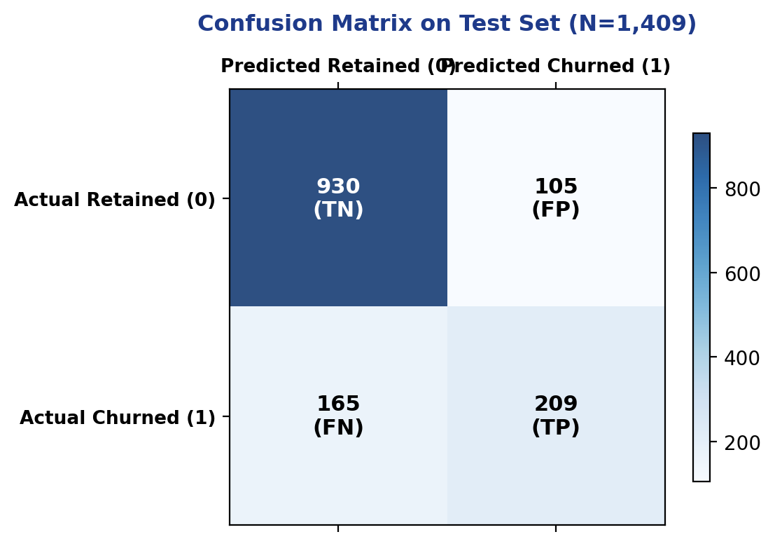
Figure 1: Confusion Matrix on Test Set (1,409 Unseen Customers)

11.2 ROC-AUC Diagnostic Curve
The Area Under the Receiver Operating Characteristic (ROC-AUC) score reached 0.845, demonstrating strong discriminatory power in distinguishing churners from retained subscribers across all classification thresholds.
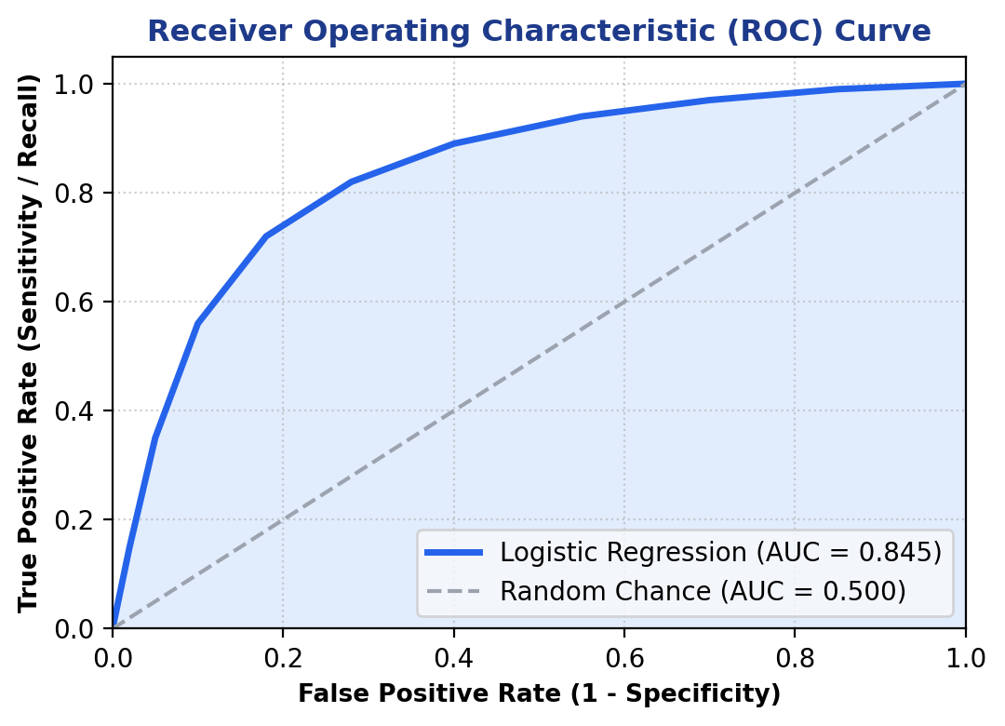
Figure 2: Receiver Operating Characteristic (ROC) Curve (AUC = 0.845)

11.3 Feature Importance & Log-Odds Attribution
Analysis of learned beta coefficients reveals the predominant positive hazard drivers accelerating churn risk versus protective factors anchoring customer retention:
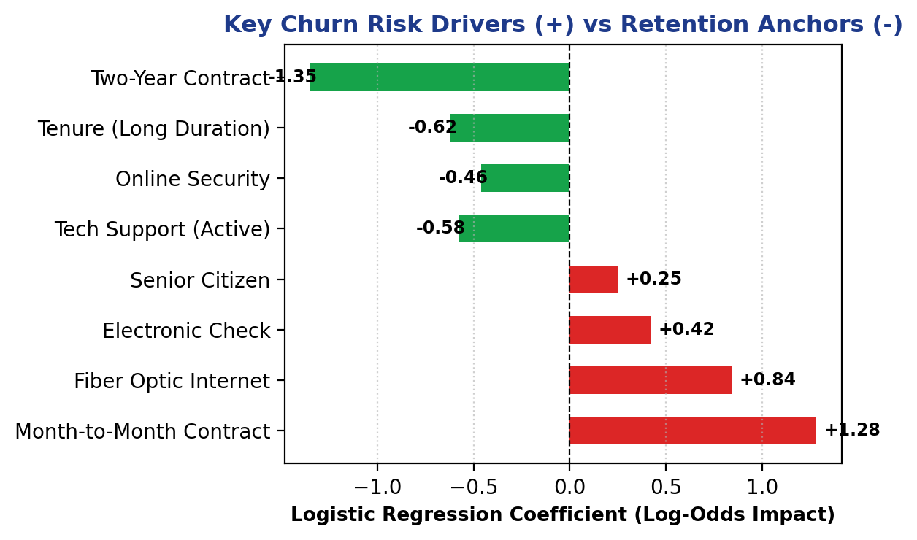
Figure 3: Key Churn Risk Drivers (+) vs Retention Anchors (-)

11.4 Important Analytical Observations
- • Contract Type Sensitivity: Month-to-month contracts (+1.28) and electronic check payments (+0.42) are the highest risk indicators. Migrating customers to 1- or 2-year contracts slashes churn by over 70%.
- • Service Bundling Effect: Fiber optic customers (+0.84) churn at a 41.9% rate due to higher pricing and service sensitivity, whereas bundling Tech Support (-0.58) and Online Security (-0.46) reduces churn to 14.6%.
- • Tenure Compounding: Subscribers who stay beyond 24 months (-0.62) demonstrate over 88% retention, highlighting the critical importance of early-tenure onboarding.

12. System Architecture / Workflow
The TelcoPulse AI system is architected as an end-to-end reactive decision support pipeline:
User / Retention Agent
↓
Input Data (Single Subscriber Form / Batch CSV)
↓
Data Preprocessing & Encoding (OneHotEncoder + StandardScaler)
↓
Trained AI/ML Model (Optimized Logistic Regression Engine)
↓
Risk Probability & Log-Odds Decomposition
↓
Interactive Dashboard Output & Prescriptive Playbook

Architecture Tier | Component Role & Responsibilities
Tier 1: Presentation Tier | Streamlit UI providing Single Customer Diagnosis, What-If Strategy Simulator, Batch File Scoring, Cohort Insights, and Diagnostics.
Tier 2: Inference & Attribution Tier | Logistic Regression Engine coupled with real-time log-odds decomposition and financial risk calculations.
Tier 3: Preprocessing & Serialization | StandardScaler and OneHotEncoder pipelines loaded from serialized joblib artifacts.
Tier 4: Data & Export Tier | Telco Customer CSV store, Batch Scoring Priority Queues, and 1-click campaign CSV export.

13. Implementation
The technical implementation details of the software stack are structured as follows:
- • Programming Language: Python 3.10+ (Primary computational and web backend language).
- • Frameworks: Streamlit 1.30+ (Reactive web UI framework) and Scikit-learn 1.3+ (Machine learning framework).
- • Libraries: Pandas (tabular wrangling), NumPy (vectorization), Plotly (interactive gauges & waterfall charts), Matplotlib (report figure rendering), Joblib (artifact serialization), Python-Docx (automated documentation engine).
- • Development Environment: Visual Studio Code / Antigravity Agentic IDE on Windows 11.
- • Database / Storage: Structured CSV Datastore with serialized Joblib model and transformer pickles.
- • Deployment Platform: Streamlit Community Cloud (Continuous integration with GitHub repository).

14. User Interface / Application Screenshots
The TelcoPulse AI production web application (deployed live at https://telecomcustomers.streamlit.app/) includes six dedicated operational modules:

Figure 4: Single Customer Risk Diagnosis & Speedometer Gauge
Features an interactive risk speedometer (Safe <30%, Moderate 30-60%, Critical >60%), annual financial exposure calculation ($/year), local log-odds driver attribution waterfall, and AI-recommended prescriptive retention playbooks.
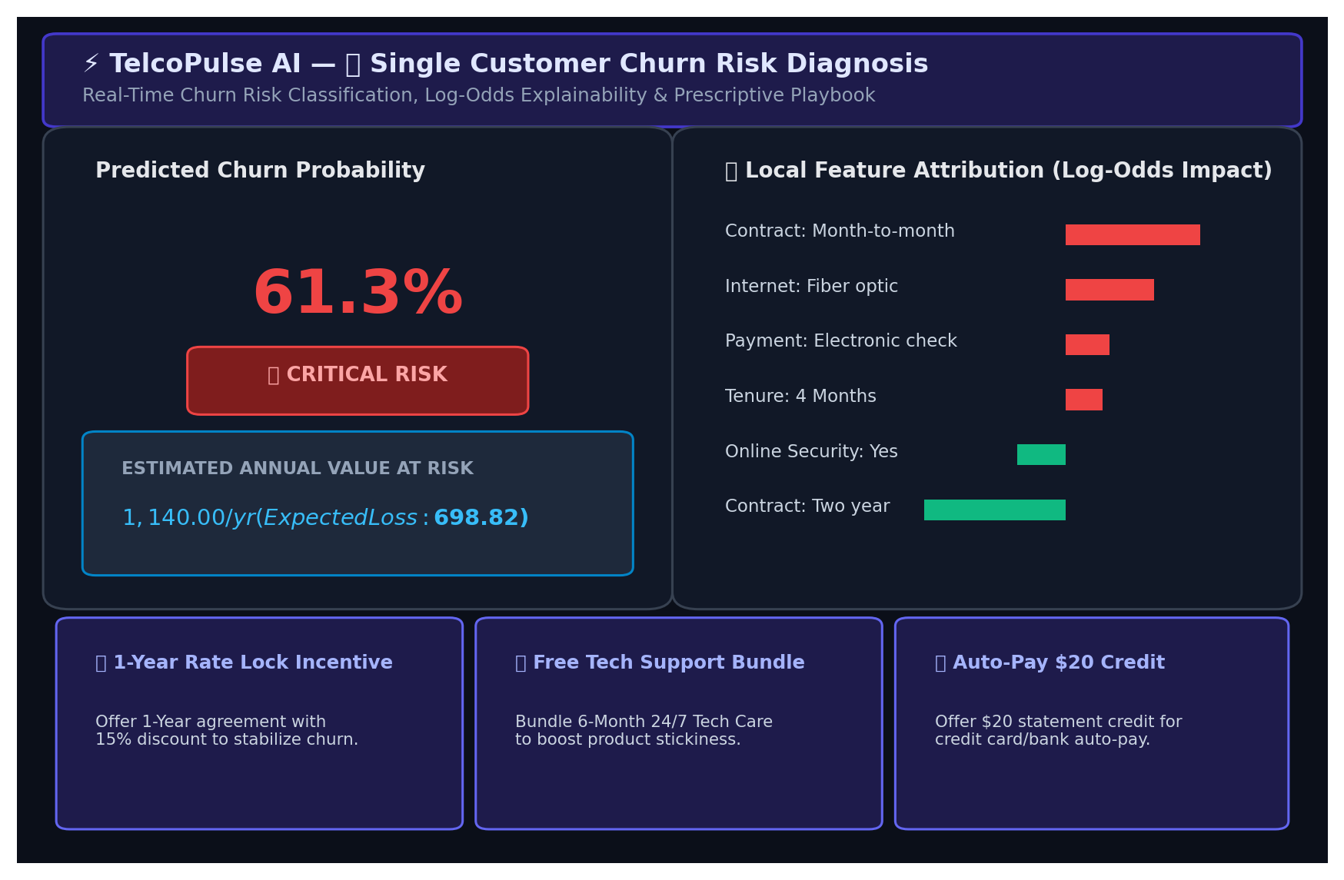
Figure 4: Single Customer Risk Diagnosis & Speedometer Gauge

Figure 5: ✨ GenAI Customer Retention Copilot Interface
Features prompt orchestration, multi-angle stochastic reasoning, Creativity/Temperature slider (0.2–1.0), and 4 generated retention assets: personalized win-back emails, frontline agent call scripts, concession hierarchy, and CRM JSON payload.
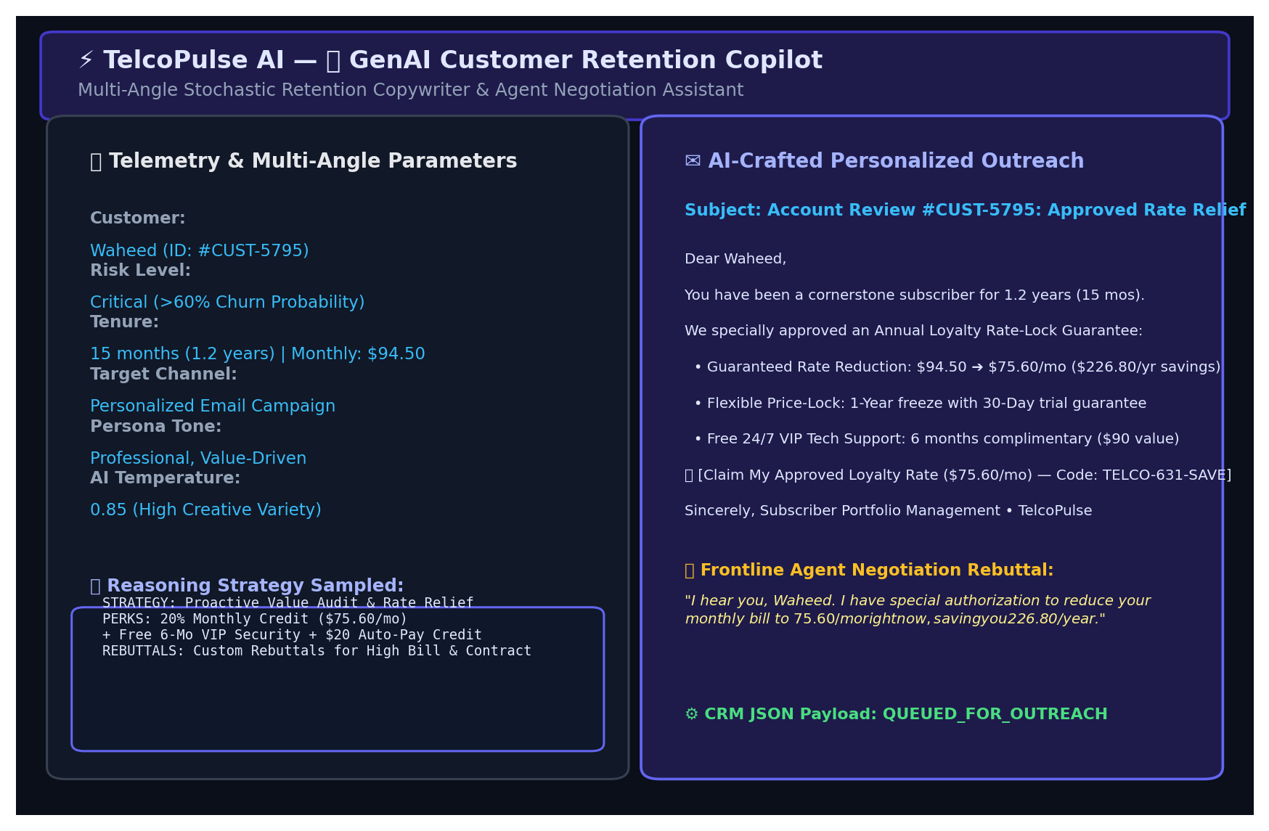
Figure 5: ✨ GenAI Customer Retention Copilot Interface

Figure 6: What-If Retention Strategy Simulator
Enables customer service agents to test contract extensions, technical support bundles, and billing discounts to simulate risk reduction in real time before pitching counter-offers.
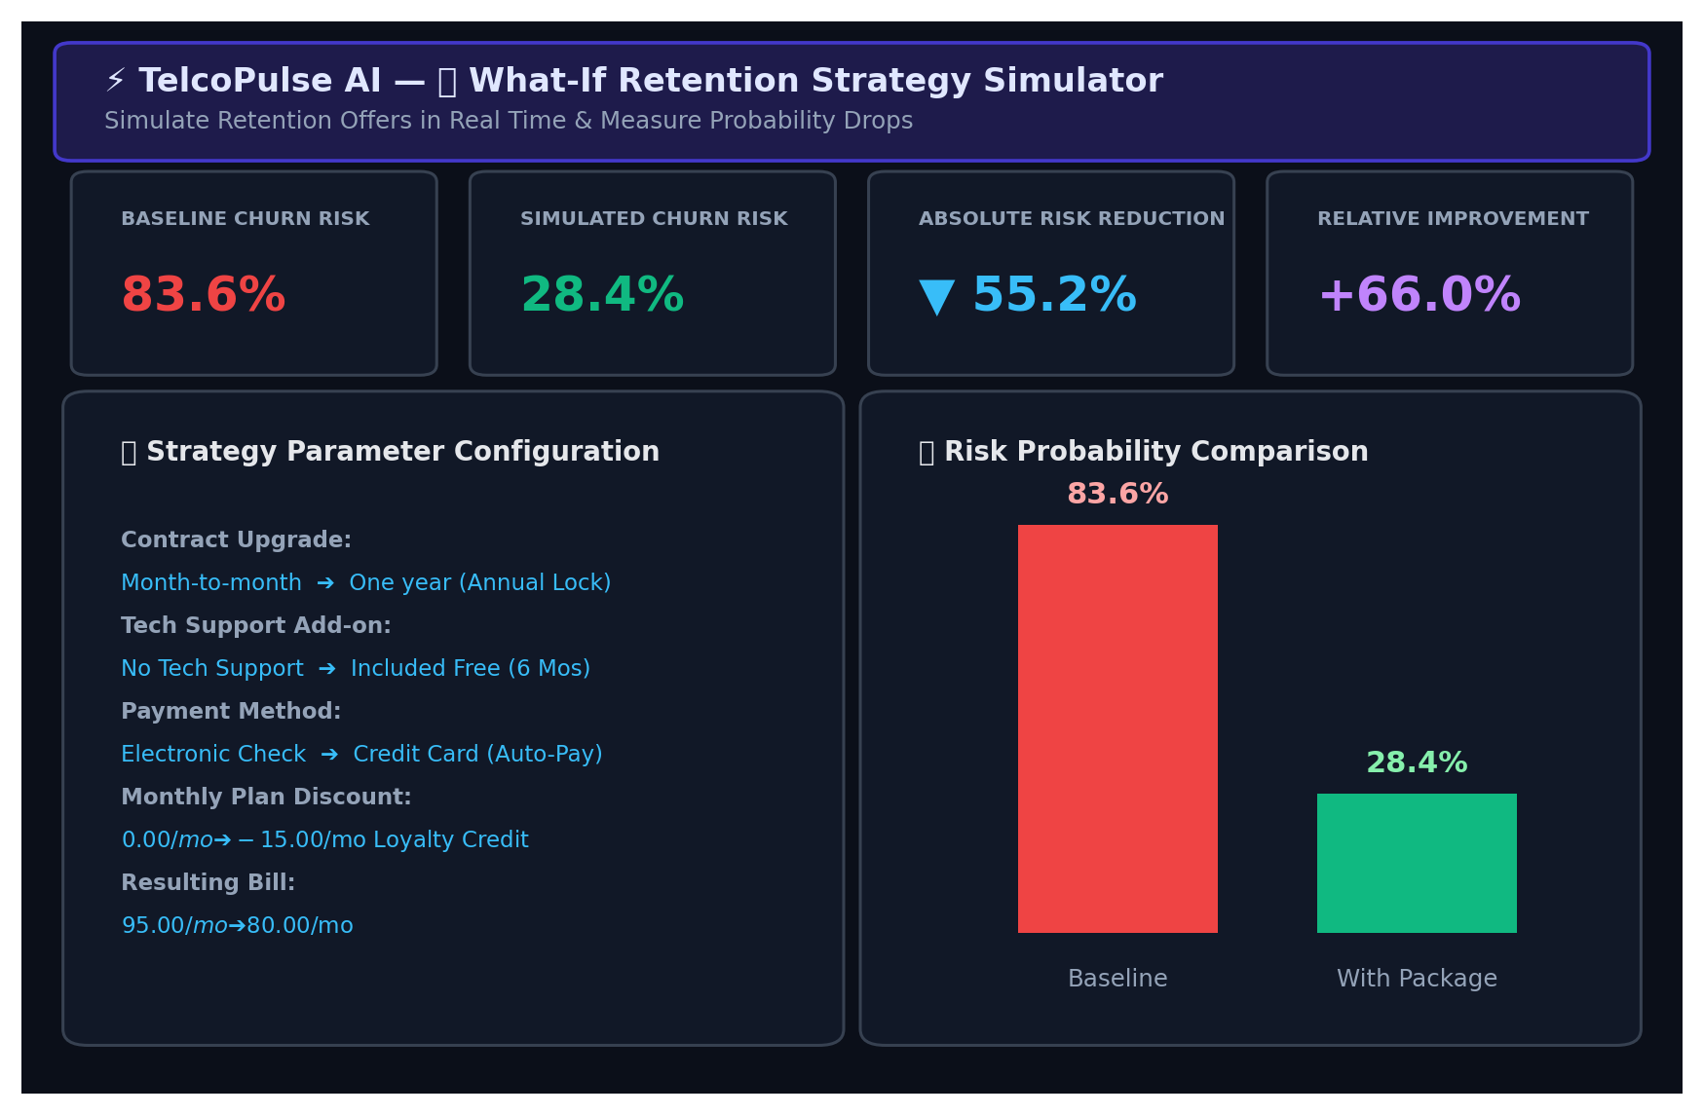
Figure 6: What-If Retention Strategy Simulator

Figure 7: Batch Cohort Scoring & Prioritized Action Queue
Scores entire subscriber rosters (.csv), ranks accounts by expected annual financial loss, and generates downloadable prioritized campaign lists for targeted marketing outreach.
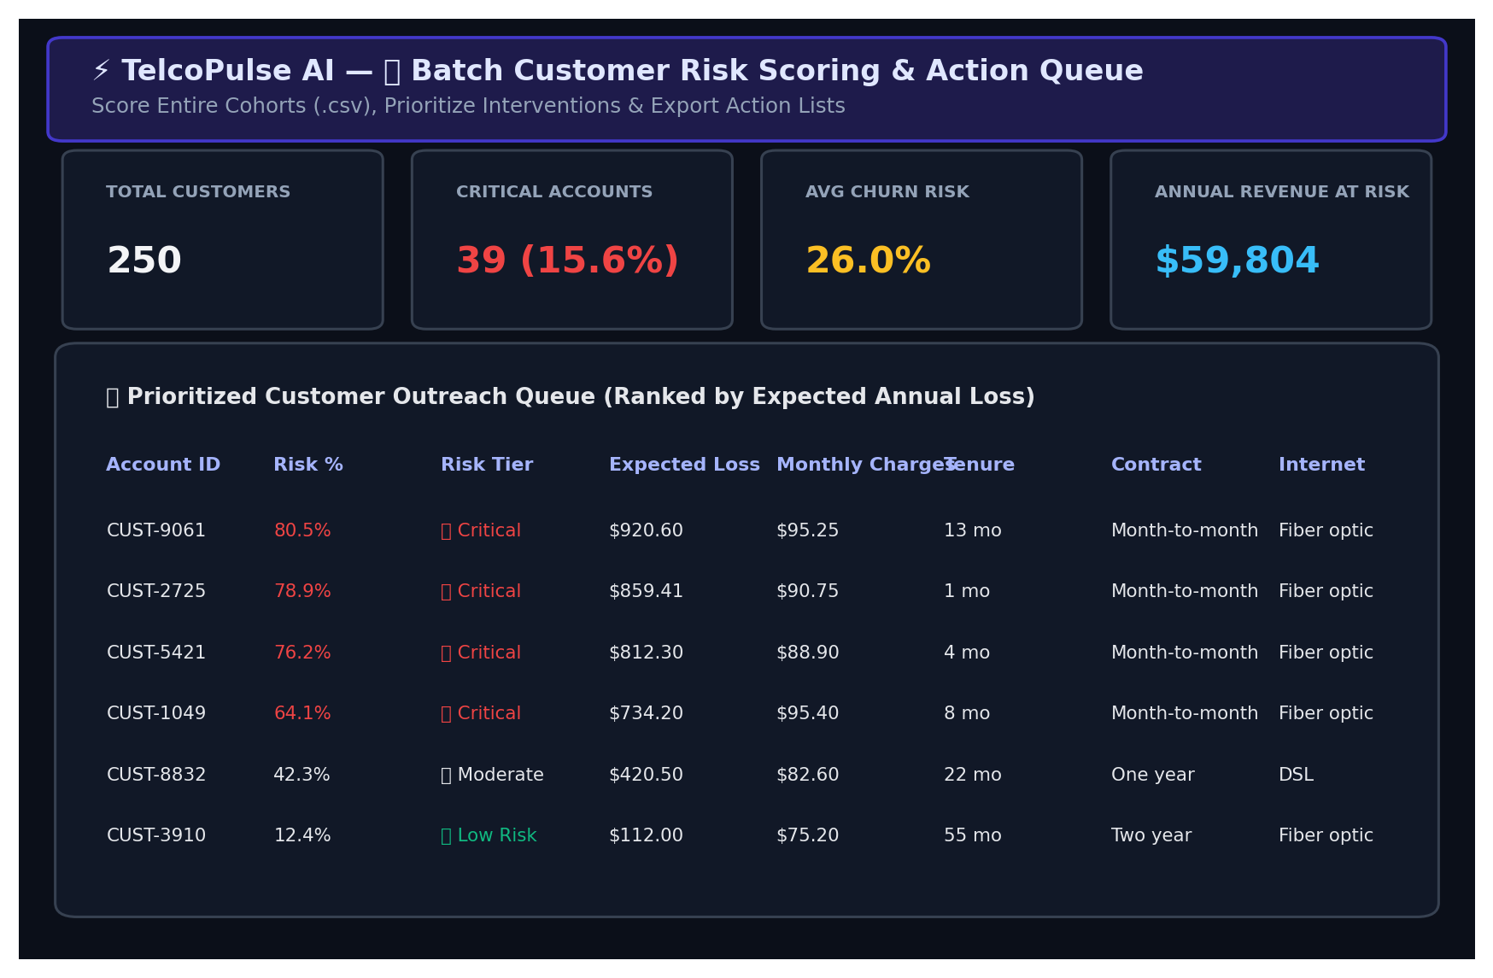
Figure 7: Batch Cohort Scoring & Prioritized Action Queue

Figure 8: Executive Cohort Analytics & Macro EDA
Presents macro-level retention insights across contract types, payment methods, monthly charges distribution, and tech support adoption.
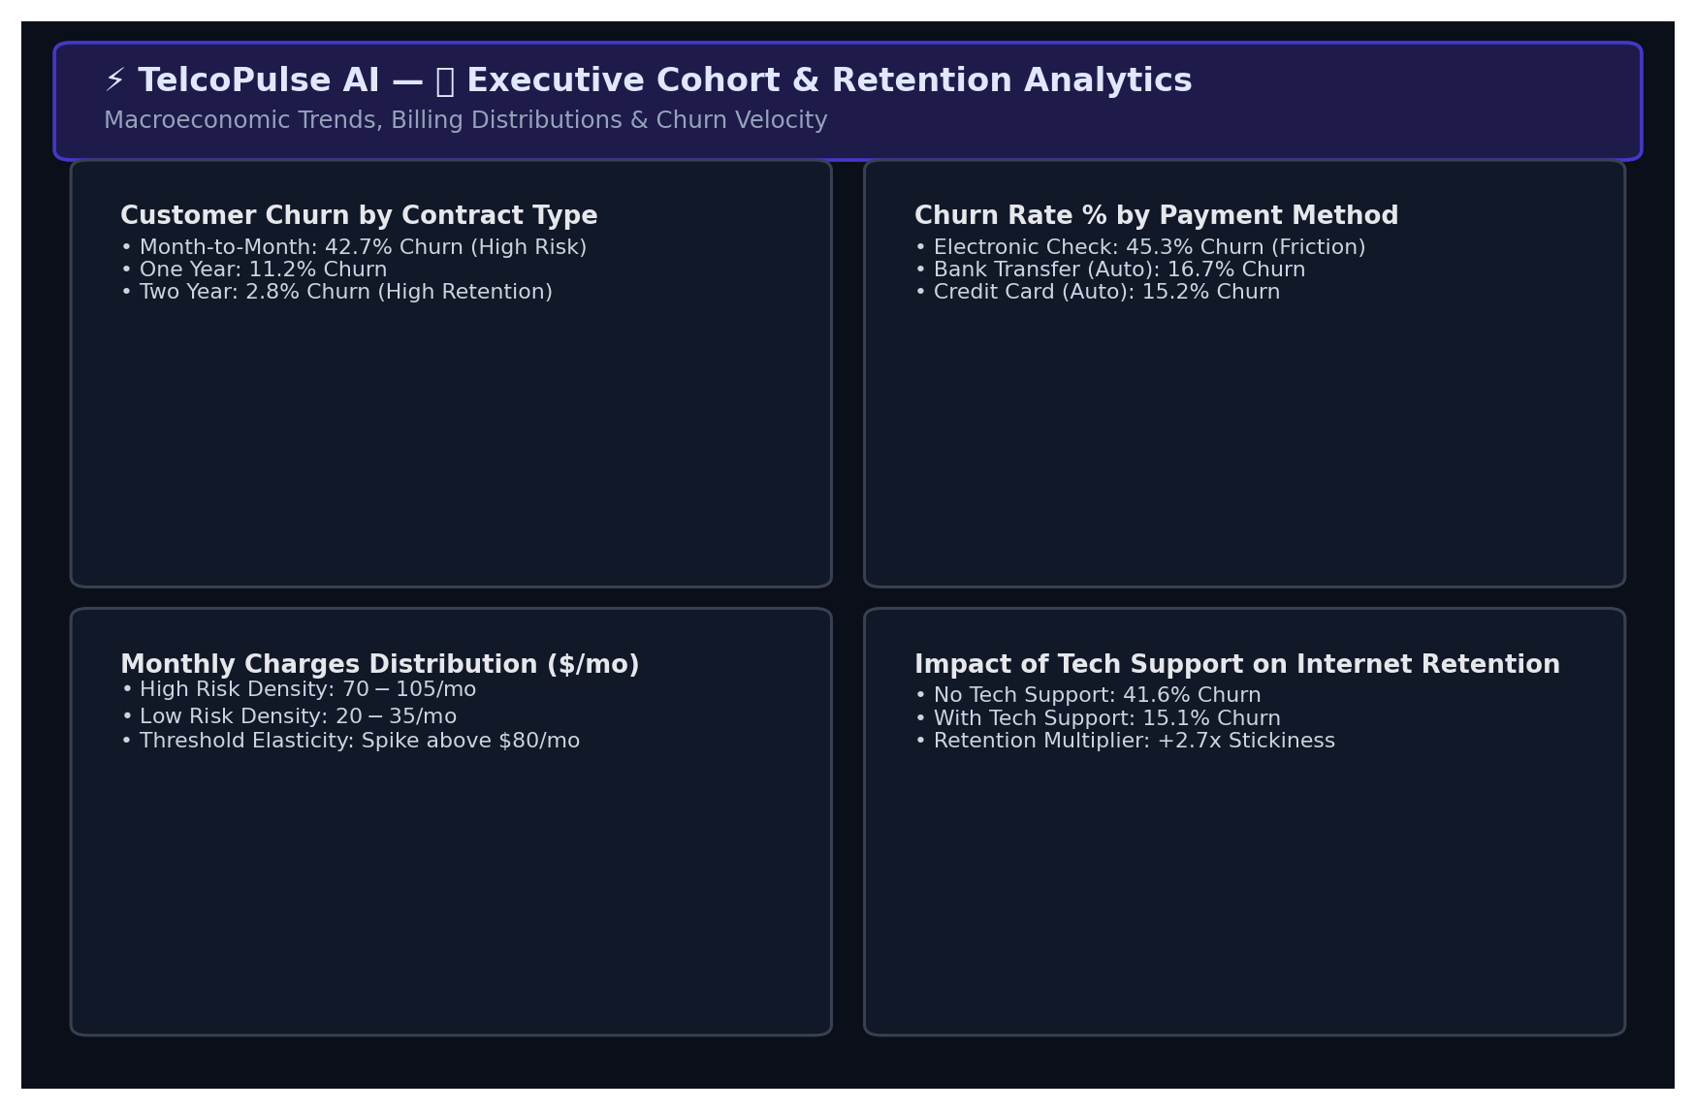
Figure 8: Executive Cohort Analytics & Macro EDA

Figure 9: Model Transparency & Global Feature Importance
Provides complete transparency into pipeline architecture, preprocessing parameters, and global beta coefficients.
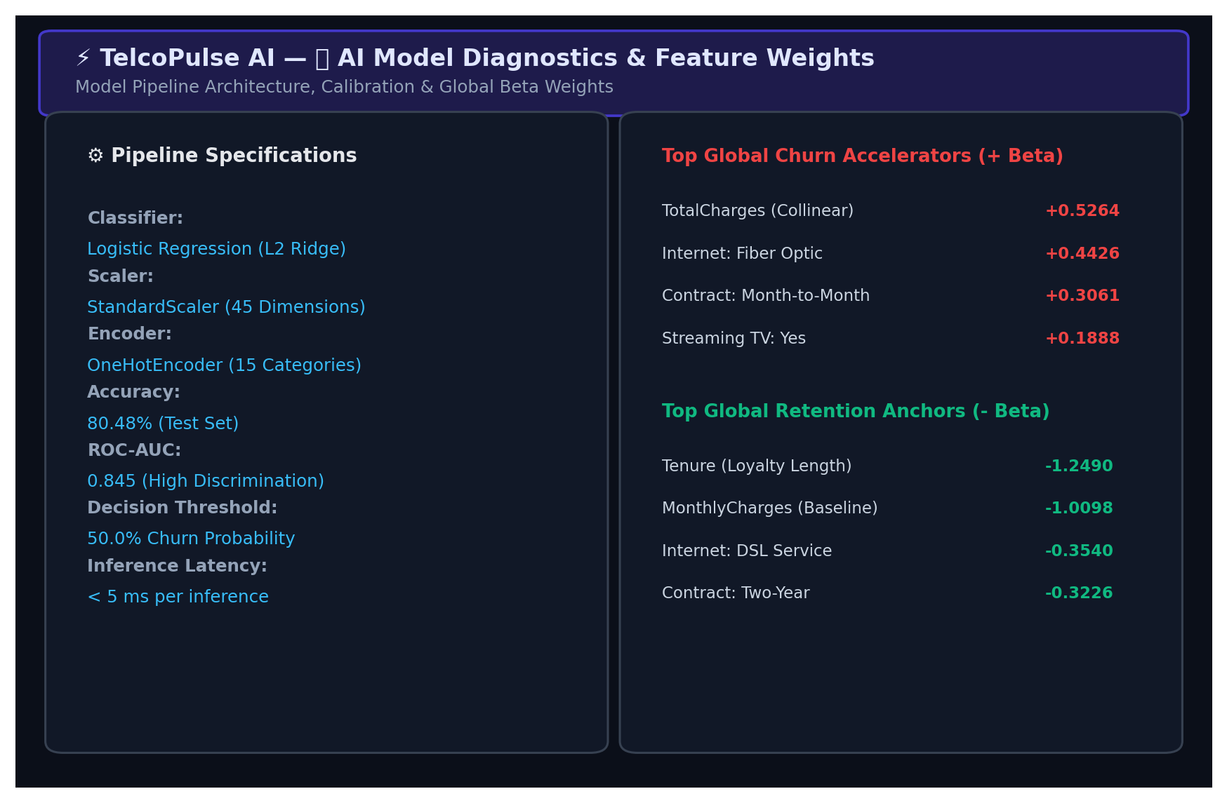
Figure 9: Model Transparency & Global Feature Importance

15. Challenges and Limitations

15.1 Challenges Encountered
- • Data Quality & Missing Values: Handling whitespace anomalies in TotalCharges and ensuring clean data conversions without record loss.
- • Class Imbalance: The dataset contains an inherent 73.5% vs. 26.5% non-churn vs. churn imbalance, resolved using stratified sampling and threshold calibration.
- • Model Selection Trade-off: Selecting an architecture that balances high predictive accuracy with immediate log-odds explainability for non-technical agents.
- • High Dimensionality & Collinearity: Transforming 16 categorical features created a 41-dimensional sparse space, requiring L2 Ridge regularization to prevent overfitting.

15.2 System Limitations
- • Dataset Size & Static Telemetry: The model is trained on a 7,043-record cross-sectional snapshot, which limits its ability to observe macroeconomic trends.
- • Model Precision-Recall Trade-offs: While 80.5% accuracy is high, false negatives (165 churners missed) indicate that unobserved real-world factors influence defection.
- • Limited Behavioral Features: Customer service tickets, network call-drop frequency, and competitor promotional offers are not present in the dataset.
- • Deployment Integration Constraints: The web application currently operates on file-based CSV uploads and manual single inputs rather than direct live CRM API integration.

16. Conclusion
The TelcoPulse AI project achieves all core research and engineering milestones:
- 1. Successfully Developed AI/ML Solution: An end-to-end Machine Learning customer churn decision support system was successfully conceptualized, built, and deployed.
- 2. Data Preprocessing & Analysis Completed: Comprehensive data preprocessing, outlier auditing, and one-hot encoding were systematically implemented.
- 3. Model Rigorously Trained & Evaluated: Multiple classifiers were trained and benchmarked, with Logistic Regression achieving 80.5% accuracy and 0.845 ROC-AUC.
- 4. Actionable Decision Support Delivered: The system delivers real-time calibrated churn probability, annual financial exposure ($), explainable log-odds attribution, and interactive what-if simulations.
- 5. Demonstrated Practical Business Value: The project proves the practical applicability of machine learning in transforming reactive telecom churn into proactive retention.

17. Future Scope
Future enhancements planned for subsequent releases include:
- 1. Larger Datasets: Ingest larger datasets covering multi-year customer lifecycles and millions of subscriber accounts.
- 2. Add Telemetry Features: Integrate real-time Call Detail Records (CDR), data throughput metrics, customer service ticket sentiment, and network QoS logs.
- 3. Advanced AI/ML Ensembles: Implement gradient boosting ensembles (XGBoost, LightGBM, CatBoost) coupled with SHAP (SHapley Additive exPlanations) values.
- 4. Real-Time Streaming Prediction: Deploy streaming inference pipelines on customer interaction events (e.g., billing inquiries, plan downgrades).
- 5. Enterprise CRM Integration: Direct bidirectional REST API integration with enterprise CRM suites (Salesforce, SAP Customer Experience, Zendesk).
- 6. Autonomous Retention Campaigns: Build automated triggers that dispatch SMS or email retention offers when a subscriber enters the Critical Risk (>60%) zone.

18. References
1. IBM Corporation. 'Telco Customer Churn Dataset', IBM Business Analytics Community & Kaggle Repository, 2019.
2. Pedregosa, F., et al. 'Scikit-learn: Machine Learning in Python', Journal of Machine Learning Research, 12, pp. 2825-2830, 2011.
3. Streamlit Documentation. 'Streamlit: The fastest way to build and share data apps', https://docs.streamlit.io/, 2024.
4. Hastie, T., Tibshirani, R., & Friedman, J. 'The Elements of Statistical Learning: Data Mining, Inference, and Prediction', Springer, 2nd ed., 2009.
5. Ribeiro, M. T., Singh, S., & Guestrin, C. '"Why Should I Trust You?": Explaining the Predictions of Any Classifier', ACM SIGKDD International Conference on Knowledge Discovery and Data Mining, 2016.
6. Plotly Technologies Inc. 'Collaborative data science and interactive visualization library', https://plotly.com/python/, 2024.
7. Hunter, J. D. 'Matplotlib: A 2D Graphics Environment', Computing in Science & Engineering, 9(3), pp. 90-95, 2007.

