

CERTIFICATE

This is to certify that __________________, of Class XII, VENKAT INTERNATIONAL PUBLIC SCHOOL, Rajajinagar, Bangalore has successfully undertaken the project titled _____________________________________________________under the guidance of Mr. Satchinathan P, as prescribed by CBSE for AISSE

course in the year 2017-18.

Teacher In Charge Principal

External Examiner

ACKNOWLEDGEMENT

I wish to acknowledge my utmost gratitude to Shri T.Balakrishna, Chairman, Venkat International Public School, for the help rendered for the successful completion of this project.

I thank Dr. Sulochana Balakrishna, Venkat International Public School, with a warm heart for encouragement and guidance throughout the project. I am indebted to our Research Heads of Departments for their kind support.

I wish to place on record, my immense regard and heartfelt thanks to my teacher Mr. Satchinathan, for his constant supervision without which the success of this project wouldn’t have been achieved.

***INDEX***

***SL.No TOPIC PAGE No***

01 CLASS NAMES 4

02 MEMBER FUNCTIONS 5-6

03 SYNOPSIS 7

03 SOURCECODE 8-43

04 OUTPUT SCREENS 43-50

05 BIBILIOGRAPHY 51

***CLASS NAMES***

1. *CUSTOMER*
2. *PLANT*
3. *BILL*
4. *KIT*
5. *KITBILL*
6. *HELPCARE*
7. *COMPOST*

***MEMBER FUNCTIONS***

*1)CLASS NAME: CUSTOMER*

MEMBER FUNTIONS:

1. void Cinput()

2. void cdisplay()

3.int retcid()

4.long retcph()

*2)CLASS NAME: PLANT*

MEMBER FUNCIONS

1. void plantinput()
2. void plantdisplay()
3. void draw(int n)
4. void deposit(int n)
5. void ptype()
6. char* rettyppr(int a )

*3)CLASS NAME: BILL*

MEMBER FUNCTIONS

1. void billcustdisplay()
2. void billplantdisplay()
3. char* plant::retype(int a)
4. void plantdisplay()

4)*CLASS NAME: KIT*

MEMBER FUNCTIONS

1.void display()

2.void insert()

3. int iid()

5)*CLASS NAME: KITBILL*

MEMBER FUNCTIONS

1.void display()

6)*CLASS NAME: HELPCARE*

MEMBER FUNCTIONS

1.void helpinput()

2.void helpdisplay()

7)*CLASS NAME: COMPOST*

***SYNOPSIS***

We at Jaivika planters are driven by a force aiming to beautify every part of earth though small contributions like setting up gardens and working hand in hand with our customers to provide a joyful and an educative experience.

At Jaivika we strongly believe that being one with nature helps one live a happy live.

Or as we coin it “the healthy decoration”.

We are glad to know that you have shown interest and are willing to live a healthy green and a happy lifestyle.To support you on this journey we provide the state of the art tools and highest customer rated services to make the most from this endeavour.

We help you get started off by offering you a vast array of plant choices ranging from medicinal plants to bright flowing plants. We let you exploit the benefits of the experience to its fullest by letting to pick from our best in class seed collection.

We are extremely proud to offer garden maintenance services to help make it a fidget free experience. We also provide fertile manure and compost to justify this eco-friendly mission.If you ever decide to take this hobby to the next level we stand by you as we offer green house building and maintenance services too.

We hope you make the most from this voyage and board on the ship to a happy life style.

KEEP PLANTING GO GREE

The project offers the following menu options.

The admin menu option offers ways to add plant details, modify and delete plant details. It also provides customer details and kit details.

The A-Z menu option provides a list of all the plants available for our customers to pick from

The indoor plant menu provides ways to purchase indoor plants and also carter to their needs by providing maintenance

Search type helps you navigate though our large plant database

The help care menu option offers ways to help towards the maintained of plants

The compost menu option helps buy various types of compost

The report menu option gives a complete report of all the plants that the customer has purchased, summarises the kits, maintained and construction of green houses

***CODE***

**#include<iostream.h>**

**#include<fstream.h>**

**#include<conio.h>**

**#include<process.h>**

**#include<stdio.h>**

**#include<iomanip.h>**

**#include<string.h>**

**#include<dos.h>**

**#include<graphics.h>**

**#include<stdlib.h>**

**void main();**

**void first();**

**class customer**

**{**

**public:**

**int cid;**

**char cname[20],cadd[50];**

**long ph;**

**void cinput();**

**void cdisplay();**

**int retcid();**

**long retcph();**

**};**

**void customer::cinput()**

**{**

**cout<<"\n\nEnter Customer ID :";cin>>cid;**

**cout<<"\n\nEnter Customer Name :";gets(cname);**

**cout<<"\n\nEnter Customer Address :";gets(cadd);**

**cout<<"\n\nEnter Customer Phone Number:";cin>>ph;**

**}**

**void customer::cdisplay()**

**{**

**cout<<cid<<" "<<cname<<" "<<cadd<<" "<<ph<<endl;**

**}**

**int customer::retcid()**

**{ return cid;}**

**long customer::retcph()**

**{ return ph;}**

**void cid_modify()**

**{ ifstream in;ofstream out;cleardevice(); gotoxy(40,3);**

**in.open("customer.dat",ios::binary);**

**out.open("t.dat",ios::binary);**

**customer c,a;**

**int x;**

**cout<<"\nEnter Customer ID:";**

**cin>>x;**

**while(in.read((char*)&c,sizeof(c)))**

**{**

**if(c.cid==x)**

**{**

**cleardevice();**

**cout<<"\nEnter New Details of Customer :";**

**a.cinput();**

**out.write((char*)&a,sizeof(a));**

**}**

**else**

**out.write((char*)&c,sizeof(c));**

**}**

**in.close();**

**out.close();**

**remove("customer.dat");**

**rename("t.dat","customer.dat");**

**}**

**void cph_modify()**

**{**

**ifstream in;ofstream out;cleardevice(); gotoxy(40,3);**

**in.open("customer.dat",ios::binary);**

**out.open("t.dat",ios::binary);**

**customer c,a;**

**long x;**

**cleardevice();**

**cout<<"\n\nEnter Customer Phone Number:";**

**cin>>x;**

**while(in.read((char*)&c,sizeof(c)))**

**{**

**if(c.ph==x)**

**{**

**cout<<"\n\nEnter New Details of Customer :";**

**a.cinput();**

**out.write((char*)&a,sizeof(a));**

**}**

**else**

**out.write((char*)&c,sizeof(c));**

**}**

**in.close();**

**out.close();**

**remove("customer.dat");**

**rename("t.dat","customer.dat");**

**}**

**void cust_add()**

**{**

**ofstream out;cleardevice(); gotoxy(40,3);**

**out.open("customer.dat",ios::binary|ios::app);**

**customer c;**

**cout<<"\n\n\nEnter Customer Details:";**

**c.cinput();**

**out.write((char*)&c,sizeof(c));**

**out.close();**

**cout<<"\n\nAre You Member of Jaivika Plants Experts?\n\n";**

**}**

**void cid_del()**

**{**

**ifstream in;cleardevice(); gotoxy(40,3);**

**ofstream out;**

**out.open("t.dat",ios::binary);**

**in.open("customer.dat",ios::binary);**

**int x;**

**cout<<"\n\nEnter Customer ID:";cin>>x;**

**customer c;**

**while(in.read((char *)&c,sizeof(c)))**

**{**

**if(c.cid!=x)**

**out.write((char*)&c,sizeof(c));**

**}**

**in.close();**

**out.close();**

**remove("customer.dat");**

**rename("t.dat","customer.dat");**

**cout<<"\n\n Deleted successfully...";**

**}**

**void cph_del()**

**{**

**ifstream in;cleardevice(); gotoxy(40,3);**

**ofstream out;**

**out.open("t.dat",ios::binary);**

**in.open("customer.dat",ios::binary);**

**long x;**

**cout<<"\n\nEnter Customer Phone Number:";cin>>x;**

**customer c;**

**while(in.read((char *)&c,sizeof(c)))**

**{**

**if(c.cid!=x)**

**out.write((char*)&c,sizeof(c));**

**}**

**in.close();**

**out.close();**

**remove("customer.dat");**

**rename("t.dat","customer.dat");**

**cout<<"\n\nDeleted successfully....";**

**}**

**void custdisp()**

**{**

**ifstream in;cleardevice(); gotoxy(40,3);**

**in.open("customer.dat",ios::binary);**

**customer c;**

**int x=0;**

**cout<<"\n\n~~~~~~~~~~~~~~~~~~~~~~~~~~~~~~~~~~~~~~~~~~~~~~~~~~~~~~~~~~~~~"<<endl;**

**cout<<"\n\nID NAME ADDRESS PHONE NUMBER"<<endl;**

**cout<<"\n\n~~~~~~~~~~~~~~~~~~~~~~~~~~~~~~~~~~~~~~~~~~~~~~~~~~~~~~~~~~~~~~"<<endl;**

**while(in.read((char*)&c,sizeof(c)))**

**{**

**c.cdisplay();**

**if (x%3==0)**

**getch();**

**}**

**in.close();**

**}**

**void cc()**

**{**

**int opt;**

**do**

**{**

**cleardevice();gotoxy(40,3);**

**cout<<"\n\n\t\t\t\t Customer Details \n\n";**

**cout<<"\n\n1.Insert\n\n2.Delete id\n\n3.Modify\n\n4.delete ph\n\n5.modify ph\n\n6. Display all \n\n7. Return to Menu\n\nEnter your Choice:";**

**cin>>opt;**

**cleardevice();**

**switch(opt)**

**{**

**case 1:cust_add();break;**

**case 2:cid_del();break;**

**case 3:cid_modify();break;**

**case 4:cph_del();break;**

**case 5:cph_modify();break;**

**case 6:custdisp();break;**

**case 7:first(); break;**

**}**

**getch();**

**}while(opt<7);**

**}**

**class plant**

**{**

**public:**

**int pid,qty;**

**char pname[50],sname[50],type[50],ps;**

**double amount;**

**void plantinput();**

**void plantdisplay();**

**void draw(int n)**

**{ qty=qty-n;}**

**void deposit(int n)**

**{qty=qty+n;}**

**void ptype()**

**{**

**cout<<"\n\t\t\t1.Flowering House Plant \n";**

**cout<<"\t\t\t2.Common House Plant\n";**

**cout<<"\t\t\t3.Easy to Grow and Low Light House Plant \n";**

**cout<<"\t\t\t4.Selection of Foliago House Plant\n";**

**cout<<"\t\t\t5.Indoor Palm Plant \n";**

**cout<<"\t\t\t6.Hanging Basket Plant \n";**

**cout<<"\t\t\t7.Climbers and Trailing Plants\n";**

**cout<<"\t\t\t8.Selection of Bulb type House Plant\n";**

**cout<<"\t\t\t9.Christmas Plants\n";**

**cout<<"\t\t\t10.Unusual House Plants\n";**

**cout<<"\t\t\t11.Selection of Office Plant\n";**

**cout<<"\t\t\t12.Succulent House Plant\n";**

**cout<<"\t\t\t13.Easiest of Ferns to grow as House plant\n";**

**cout<<"\t\t\t14.Selection of Living Stones plant\n";**

**cout<<"\t\t\t15.Large House Plant\n";**

**}**

**char *rettype(int a);**

**};**

**class bill**

**{**

**public:**

**int billno,pid,qty,maint,cid,mm,dd,yy;**

**char pname[30],sname[30],type[30],ps,cname[30],cadd[30];**

**double amount,total;**

**long ph;**

**void billcustdisplay()**

**{**

**cout<<"Name : "<<cname<< " ID"<<cid<<endl;**

**cout<<"Address : "<<cadd<<endl;**

**cout<<"Phone number : "<<ph<<endl;**

**}**

**void billplantdisplay()**

**{**

**cout<<pid<<" "<<pname<<" "<<sname<<" "<<type<<" "<<amount<<" "<<qty<<" "<<ps<<endl;**

**}**

**};**

**char* plant:: rettype(int a)**

**{**

**switch(a)**

**{**

**case 1:return "Flowering House Plant";**

**case 2:return "Common House Plant";**

**case 3:return "Easy to Grow and Low Light House Plant";**

**case 4:return "Selection of Foliago House Plant";**

**case 5:return "Indoor Palm Plant";**

**case 6:return "Hanging Basket Plant";**

**case 7:return "Climbers and Trailing Plants";**

**case 8:return "Selection of Bulb type House Plant";**

**case 9:return "Christmas Plants";**

**case 10:return "Unusual House Plants";**

**case 11:return "Selection of Office Plant";**

**case 12:return "Succulent House Plant";**

**case 13:return "Easiest of Ferns to grow as House plant";**

**case 14:return "Selection of Living Stones plant";**

**case 15:return "Large House Plant";**

**}**

**}**

**void plant::plantinput()**

**{**

**int n;**

**cout<<"\n\n Enter pid : ";**

**cin>>pid;**

**cout<<"\n\n Enter plant name : ";**

**gets(pname);**

**cout<<"\n\n Enter scienfitic name : ";**

**gets(sname);**

**cout<<"\n\n Enter type : ";**

**ptype();**

**cin>>n;**

**strcpy(type,rettype(n));**

**cout<<"\n\n Enter Quantity : ";**

**cin>>qty;**

**cout<<"\n\n Enter Amount : ";**

**cin>>amount;**

**cout<<"\n\nEnter Plant or Seed (p/s) : ";**

**cin>>ps;**

**}**

**int globalx=0;**

**void plant::plantdisplay()**

**{**

**globalx=globalx+1;**

**cout<<"\n~~~~~~~~~~~~~~~~~~~~~~~~~~~~~~~~~~~~~~~~~~~~~~~~~~~~~~~~~~~~~~~~~~~~~~~~~~~~~~~~";**

**cout<<"\t\tPlant Type:"<<type<<"\n\n\tPlantID:"<<pid<<"\t\tPlantname:"<<pname<<"\t\tScientificName:"<<sname<<"\n\tQuantity:"<<qty<<"\t\tAmount:"<<amount<<"\t\tP/S:"<<ps<<endl;**

**cout<<"\n~~~~~~~~~~~~~~~~~~~~~~~~~~~~~~~~~~~~~~~~~~~~~~~~~~~~~~~~~~~~~~~~~~~~~~~~~~~~~~~~\n" ;**

**if(globalx%3==0)**

**getch();**

**}**

**void pcreate()**

**{**

**cleardevice();**

**gotoxy(40,3);**

**ofstream out;**

**out.open("plant.dat",ios::binary|ios::out|ios::app);**

**cleardevice();**

**plant p;**

**cout<<"\n\tEnter Details of the Plant \n";**

**p.plantinput();**

**out.write((char *)&p,sizeof(p));**

**out.close();**

**}**

**void pdisplay()**

**{**

**ifstream in; cleardevice(); gotoxy(40,3);**

**in.open("plant.dat", ios::binary);**

**plant p;**

**while(in.read((char*)&p,sizeof(p)))**

**{**

**p.plantdisplay();**

**}**

**in.close();**

**getch();**

**}**

**void pmodify()**

**{**

**int p;**

**cleardevice();**

**gotoxy(40,3);**

**cout<<"\n\n Enter Plant id : ";**

**cin>>p;**

**ifstream in;**

**ofstream out;**

**plant pl;**

**in.open("plant.dat",ios::binary);**

**out.open("temp.dat",ios::binary);**

**while(in.read((char*)&pl,sizeof(pl)))**

**{**

**if(p==pl.pid)**

**{**

**pl.plantinput();**

**out.write((char *)&pl,sizeof(pl));**

**}**

**else**

**out.write((char *)&pl,sizeof(pl));**

**}**

**in.close();**

**out.close();**

**remove("plant.dat");**

**rename("temp.dat","plant.dat");**

**}**

**void pdelete()**

**{**

**int p;**

**cleardevice();**

**gotoxy(40,3);**

**cout<<"\n\n Enter Plant id : ";**

**cin>>p;**

**ifstream in;**

**ofstream out;**

**plant pl;**

**in.open("plant.dat",ios::binary);**

**out.open("temp.dat",ios::binary);**

**while(in.read((char*)&pl,sizeof(pl)))**

**{**

**if(p!=pl.pid)**

**out.write((char *)&pl,sizeof(pl));**

**}**

**in.close();**

**out.close();**

**remove("plant.dat");**

**rename("temp.dat","plant.dat");**

**}**

**void pp()**

**{**

**cleardevice();**

**gotoxy(40,3);**

**int opt;**

**do**

**{**

**cleardevice();**

**gotoxy(40,3);**

**cout<<" \n\n\t\t\tP L A N T \n";**

**cout<<"\n\t\t1. New Arrival\n";**

**cout<<"\n\t\t2. Change \n";**

**cout<<"\n\t\t3. Delete\n";**

**cout<<"\n\t\t4. Display\n";**

**cout<<"\n\t\t5. Way to Menu\n";**

**cout<<"\n\t\tEnter your option : ";**

**gotoxy(60,26);**

**cin>>opt;**

**switch(opt)**

**{**

**case 1:pcreate();**

**break;**

**case 2:pmodify();**

**break;**

**case 3:pdelete();**

**break;**

**case 4:pdisplay();**

**break;**

**case 5:first();**

**}**

**getch();**

**}while(opt<=4);**

**}**

**void indoor()**

**{**

**cleardevice();**

**gotoxy(40,3);**

**plant p1;**

**bill b1;**

**ifstream in;**

**in.open("bill.dat",ios::binary);**

**in.seekg(0,ios::end);**

**int n=in.tellg()/sizeof(b1);**

**in.close();**

**cout<<n;**

**getch();**

**ofstream out;**

**out.open("bill.dat",ios::binary);**

**int ccid;**

**cleardevice();**

**customer c1;**

**char mem;**

**ifstream in1;**

**ifstream in2;**

**in1.open("customer.dat",ios::binary|ios::in);**

**in2.open("plant.dat",ios::binary|ios::in);**

**b1.billno=n+1;**

**cout<<"\n\n \t\t\tAre you be member of Jaivika Plants Experts?";**

**cin>>mem;**

**if (mem=='y')**

**{**

**int f=-1;**

**cleardevice();**

**cout<<"\n\n\t\tEnter Customer Id :";**

**cin>>ccid;**

**while(in1.read((char *)&c1,sizeof(c1)))**

**{**

**if(ccid==c1.cid)**

**{**

**f=1;**

**b1.cid=c1.cid;**

**strcpy(b1.cname, c1.cname);**

**strcpy(b1.cadd,c1.cadd);**

**b1.ph=c1.ph;**

**c1.cdisplay();**

**}**

**}**

**if(f==-1)**

**{**

**cout<<"\n\n\n\n\t\tInvalid Id Number";**

**getch();**

**indoor();**

**}**

**in1.close();**

**loop:**

**cout<<"\n\n Select any one : ";**

**p1.ptype();**

**int tno;**

**struct date d;**

**getdate(&d);**

**b1.dd=d.da_day;**

**b1.mm=d.da_mon;**

**b1.yy=d.da_year;**

**cout<<"\nEnter type number to purchase : \n";**

**cin>>tno;**

**int qty;**

**while(in2.read((char *)&p1,sizeof(p1)))**

**{**

**if(strcmp(p1.rettype(tno),p1.type)==0 )**

**{ p1.plantdisplay();}**

**}**

**in2.close();**

**ifstream i;**

**i.open("plant.dat",ios::binary);**

**int ppp;**

**cout<<"\n\n Enter Plant id : ";**

**cin>>ppp;**

**while(i.read((char *)&p1,sizeof(p1)))**

**{**

**if(ppp==p1.pid)**

**{**

**p1.plantdisplay();**

**cout<<"\n\n Enter Quantity :";**

**cin>>qty;**

**p1.draw(qty);**

**b1.pid=p1.pid;**

**strcpy(b1.pname,p1.pname);**

**strcpy(b1.sname, p1.sname);**

**strcpy(b1.type,p1.type);**

**b1.amount=p1.amount;**

**b1.qty=qty;**

**b1.ps=p1.ps;**

**b1.total=qty*p1.amount;**

**char m;**

**cout<<"\n\n Do you wish accept maintenance y/n : ";**

**cin>>m;**

**if(m=='y')**

**{ float t=p1.amount*10/100; b1.total=t;}**

**}**

**}**

**char y;**

**out.write((char *)&b1,sizeof(b1));**

**i.close();**

**ifstream o;**

**ofstream t;**

**t.open("plantqty.dat",ios::binary);**

**o.open("plant.dat",ios::binary|ios::out|ios::in);**

**while(o.read((char *)&p1,sizeof(p1)))**

**{**

**if(ppp==p1.pid)**

**{**

**p1.draw(qty);**

**t.write((char *)&p1,sizeof(p1));**

**}**

**else**

**t.write((char *)&p1,sizeof(p1));**

**}**

**o.close();**

**t.close();**

**remove("plant.dat");**

**rename("plantqty.dat","plant.dat");**

**cout<<"\n\n Do you wish to purchase any more y/n : ";**

**cin>>y;**

**if (y=='y')**

**goto loop;**

**else**

**{**

**out.close();**

**bill b2,b3;**

**ifstream in4;**

**in4.open("bill.dat",ios::binary);**

**ofstream out1,out2;**

**out2.open("temp.dat",ios::binary);**

**out1.open("billfinal.dat",ios::binary);**

**cout<<"\n\n Items which are purchased :\n";**

**char copt;**

**double amt=0;**

**while(in4.read((char*)&b1,sizeof(b1)))**

**{**

**if(n+1==b1.billno)**

**{**

**b2=b1;**

**b1.billplantdisplay();**

**cout<<"\n\t\t\t\t Wish to confirm ? y/n :";**

**cin>>copt;**

**if (copt=='y')**

**{**

**out2.write((char *)&b1, sizeof(b1));**

**out1.write((char *)&b1,sizeof(b1));**

**amt=amt+b1.total;**

**}**

**else**

**cout<<"\n\n\n\t\t\t Item cancelled ";**

**}**

**out1.close();**

**out2.close();**

**in4.close();**

**in1.close();**

**remove("bill.dat");**

**cleardevice();**

**cout<<"Preparation of bill\n\n";**

**ifstream out3;**

**out3.open("temp.dat",ios::binary);**

**out3.read((char *)&b1,sizeof(b1));**

**b1.billcustdisplay();**

**cout<<"\n\t\t\t\t Date : "<<b1.dd<<"/"<<b1.mm<<"/"<<b1.yy<<endl;**

**out3.seekg(0,ios::beg);**

**while(out3.read((char *)&b1, sizeof(b1)))**

**{**

**b1.billplantdisplay();**

**}**

**cout<<"\n\n\nTotal amount ="<<amt;**

**out3.close();**

**}**

**}**

**}**

**}**

**class kit**

**{**

**public:**

**int itemid;**

**char itemname[20];**

**float rate;**

**void insert();**

**int iid()**

**{ return itemid;}**

**void display();**

**};**

**void kit::insert()**

**{**

**cout<<"\n\n\t\tEnter Item ID :";**

**cin>>itemid;**

**cout<<"\n\n\t\tEnter Item Name :";**

**gets(itemname);**

**cout<<"\n\n\t\tEnter Rate :";**

**cin>>rate;**

**}**

**void kit::display()**

**{**

**cout<<"\n\n\t\t\tItem ID :"<<itemid;**

**cout<<"\n\n\t\t\tRate :"<<rate;**

**cout<<"\n\n\t\t\tItem Name :";**

**puts(itemname);**

**}**

**void create()**

**{**

**char ch;**

**cleardevice();**

**gotoxy(40,3);**

**ofstream out;**

**out.open("kit.dat",ios::binary|ios::app);**

**kit k;**

**do**

**{**

**cleardevice();**

**gotoxy(40,3);**

**k.insert();**

**out.write((char *)&k, sizeof(k));**

**cout<<"\n\nDo you want to enter enter more tools(y/n): ";**

**cin>>ch;**

**}while(ch=='y'||ch=='Y');**

**out.close();**

**}**

**void displaykit ()**

**{**

**cleardevice();**

**gotoxy(40,3);**

**ifstream in;**

**in.open("kit.dat",ios::binary|ios::in);**

**kit k;**

**gotoxy(0,0);**

**cout<<" K I T I T E M S \n";**

**while(in.read((char*)&k,sizeof (k)))**

**{**

**k.display();**

**}**

**}**

**void remove()**

**{**

**cleardevice();**

**gotoxy(40,3);**

**ifstream in;**

**ofstream out;**

**in.open("kit.dat",ios::binary||ios::in);**

**out.open("temp.dat",ios::binary||ios::out);**

**int c;**

**kit k;**

**cout<<"\n\n\t\tEnter the ItemID to be deleted:";**

**cin>>c;**

**while(in.read((char *)&k,sizeof(k)))**

**{**

**if(c!=k.iid())**

**out.write((char*)&k,sizeof(k));**

**}**

**out.close();**

**in.close();**

**remove("kit.dat");**

**rename("temp.dat","kit.dat");**

**}**

**class kitbill**

**{**

**public:**

**int itemid,cid;**

**float rate;**

**char itemname[20],cname[20],cadd[50];**

**long ph;**

**};**

**void kititem()**

**{**

**cleardevice();**

**gotoxy(40,3);**

**int opt;**

**cout<<"\n\n\t\t\t1. New items";**

**cout<<"\n\n\t\t\t2. Delete";**

**cout<<"\n\n\t\t\t3. Display";**

**cout<<"\n\n\t\t\t4. Back to main menu";**

**cout<<"\n\n\tEnter Your option:";**

**cin>>opt;**

**switch(opt)**

**{**

**case 1:create();**

**break;**

**case 2:remove();**

**break;**

**case 3:displaykit();**

**break;**

**case 4:first();**

**}**

**getch();**

**}**

**void kit1()**

**{**

**cleardevice();**

**gotoxy(40,3);**

**int opt;**

**ofstream ki;**

**ki.open("kitbill.dat",ios::binary);**

**char ch;**

**cout<<"\n\n\t\t\t\tGreen Kit Items";**

**cout<<"\n\n\t\t 1. Whole Set Kit ";**

**cout<<"\n\n\t\t 2. Purchase Kit Items";**

**cout<<"\n\n\t\t 3.Back to Main Menu";**

**cout<<"\n\n\t\tEnter Your Option \n";**

**cin>>opt;**

**cout<<"\n\t\t\tAre you new member(y/n) ? ";**

**cin>>ch;**

**if (ch=='n')**

**{**

**cout<<"\n\n\t\t\tAdd yourself as member ...";**

**first();**

**}**

**else**

**{**

**int custid;**

**cout<<"\n\n \t\t\tEnter customer id";**

**cin>>custid;**

**ifstream in;**

**customer c;**

**kitbill k;**

**in.open("customer.dat",ios::binary);**

**int flag=-1;**

**while(in.read((char *)&c,sizeof(c)))**

**{**

**if(custid==c.cid)**

**{**

**flag=1;**

**k.cid=c.cid;**

**strcpy(k.cname,c.cname);**

**strcpy(k.cadd, c.cadd);**

**k.ph=c.ph;**

**}**

**}**

**if(flag==-1)**

**{**

**cout<<"Not found";**

**first();**

**}**

**in.close();**

**char kch;**

**float krate=9999;**

**if(opt==1)**

**{**

**cout<<"\n\n\t\t\t\tKit Rate is "<<krate;**

**k.itemid=10001;**

**strcpy(k.itemname,"Whole Green kit");**

**k.rate=krate;**

**cout<<"\n\nWish to confirm ? ";**

**cin>>kch;**

**if(kch=='y')**

**ki.write((char *)&k, sizeof(k));**

**else**

**cout<<"\n\nItem cancelled....";**

**ki.close();**

**}**

**else if(opt==2)**

**{**

**kit k;**

**fstream in;**

**ofstream out;**

**out.open("kitbill.dat",ios::binary);**

**kitbill ki;**

**loop:**

**in.open("kit.dat",ios::binary|ios::out|ios::in);**

**while(in.read((char *)&k, sizeof(k)))**

**{ k.display();}**

**in.seekg(0,ios::beg);**

**int id;**

**cout<<"\n\nEnter Kit item id :";**

**cin>>id;**

**int f1=-1;**

**while(in.read((char *)&k, sizeof(k)))**

**{**

**if(id==k.iid())**

**{**

**f1=1;**

**ki.itemid=k.itemid;**

**strcpy(ki.itemname, k.itemname);**

**ki.rate=k.rate;**

**}**

**}**

**float t=0;**

**if(f1==1)**

**{**

**char mop;**

**out.write((char*)&ki,sizeof(ki));**

**k.display();**

**t=t+ki.rate;**

**cout<<"\n\nWish to purchase any more (y/n):";**

**cin>>mop;**

**if(mop=='y')**

**goto loop;**

**out.close();**

**}**

**else**

**cout<<"\n\nWrong input";**

**}**

**}**

**}**

**void construction()**

**{**

**cleardevice();**

**gotoxy(40,3);**

**ifstream in;**

**char ch;**

**in.open("customer.dat",ios::binary);**

**fstream out;**

**out.open("kitbill.dat",ios::binary);**

**cout<<"\n\n\t\t\t Are you new member(y/n) :";**

**cin>>ch;**

**if (ch=='y')**

**{**

**cout<<"\n\nAdd yourself as member";**

**getch();**

**first();**

**}**

**else**

**{**

**int custid;**

**cout<<"\n\n Enter customer id";**

**cin>>custid;**

**ifstream in;**

**customer c;**

**kitbill k;**

**in.open("customer.dat",ios::binary);**

**int flag=-1;**

**while(in.read((char *)&c,sizeof(c)))**

**{**

**if(custid==c.cid)**

**{**

**flag=1;**

**k.cid=c.cid;**

**strcpy(k.cname,c.cname);**

**strcpy(k.cadd, c.cadd);**

**k.ph=c.ph;**

**}**

**}**

**if(flag==-1)**

**{**

**cout<<"Not found";**

**getch();**

**first();**

**}**

**in.close();**

**char kch;**

**float area;**

**float krate=400;**

**cout<<"\n\n\t\t Area per sqft" <<krate;**

**k.itemid=10002;**

**strcpy(k.itemname,"Construction for Green House");**

**cout<<"\n\n\t\t\tEnter Area : ";**

**cin>>area;**

**k.rate=krate*area;**

**cout<<"\n\nAmount : "<<k.rate;**

**cout<<"\n\nWish to confirm : ";**

**cin>>kch;**

**if(kch=='y')**

**out.write((char *)&k, sizeof(k));**

**else**

**cout<<"\n\n Item cancelled";**

**out.close();**

**getch();**

**}**

**}**

**void maintenance()**

**{**

**int opt;**

**cleardevice();**

**gotoxy(40,3);**

**cout<<"\n\n\n\n\t\t\tMaintenace \n";**

**cout<<"\n\n1. Garden \n";**

**cout<<"\n\n2. Indoor plants \n";**

**cout<<"\n\n3. Enter your option : ";**

**cin>>opt;**

**ifstream in;**

**in.open("customer.dat",ios::binary);**

**char ch;**

**cout<<"\n\nAre you a member(y/n) : ";**

**cin>>ch;**

**if (ch=='n')**

**{**

**cout<<"\n\nAdd yourself as member ...";**

**first();**

**}**

**else**

**{**

**int custid;**

**cout<<"\n\n Enter customer id : ";**

**cin>>custid;**

**ifstream in;**

**customer c;**

**kitbill k;**

**ofstream ki;**

**ki.open("kitbill.dat",ios::binary);**

**in.open("customer.dat",ios::binary);**

**int flag=-1;**

**while(in.read((char *)&c,sizeof(c)))**

**{**

**if(custid==c.cid)**

**{**

**flag=1;**

**k.cid=c.cid;**

**strcpy(k.cname,c.cname);**

**strcpy(k.cadd, c.cadd);**

**k.ph=c.ph;**

**}**

**}**

**if(flag==-1)**

**{**

**cout<<"\n\n Not found";**

**first();**

**}**

**in.close();**

**if(opt==1)**

**{**

**char kch;**

**float area;**

**float krate=200;**

**cout<<" Rate per sqft : " <<krate;**

**k.itemid=10003;**

**strcpy(k.itemname,"Garden Maintenance");**

**cout<<"\n\n\t\t\tEnter Area ";**

**cin>>area;**

**k.rate=krate*area;**

**cout<<"\n\t\tWish to confirm";**

**cin>>kch;**

**if(kch=='y')**

**{**

**ki.write((char *)&k, sizeof(k));**

**cout<<"\n\n\n Amount :"<<k.rate;**

**getch();**

**}**

**else**

**cout<<"\n\t\t\tItem cancelled";**

**ki.close();**

**}**

**else if(opt==2)**

**{**

**char kch;**

**float area,krate=300;**

**cout<<"\n\t\t\t Rate per sqft : " <<krate;**

**k.itemid=10004;**

**strcpy(k.itemname,"Indoor Plant Maintenance");**

**cout<<"\n\nEnter Number of days ";**

**cin>>area;**

**k.rate=krate*area;**

**cout<<"\n\nWish to confirm ?(y/n) ";**

**cin>>kch;**

**if(kch=='y')**

**{**

**ki.write((char *)&k, sizeof(k));**

**cout<<"\n\n Amount :"<<k.rate;**

**}**

**else**

**cout<<"\n\nItem cancelled";**

**ki.close();**

**}**

**}**

**}**

**void Greenkit()**

**{**

**int opt;**

**cleardevice();**

**do**

**{**

**gotoxy(40,3);**

**cout<<"\n\n\t\t\t\tMENU";**

**cout<<"\n\n\t1.Construction";**

**cout<<"\n\n\t2.Kit";**

**cout<<"\n\n\t3.House Plants";**

**cout<<"\n\n\t4.Maintenance";**

**cout<<"\n\n\t5.Back to Main menu\n";**

**cout<<"\n\nEnter your choice:";**

**cin>>opt;**

**switch(opt)**

**{**

**case 1:construction(); getch(); cleardevice();**

**break;**

**case 2:kit1(); getch(); cleardevice();**

**break;**

**case 3:indoor(); getch(); cleardevice();**

**break;**

**case 4:maintenance(); getch(); cleardevice();**

**break;**

**case 5:first(); getch(); cleardevice();**

**}**

**}while(opt<=5);**

**getch();**

**}**

**void searchby_pid()**

**{**

**plant p;**

**ifstream in;**

**in.open("plant.dat",ios::binary);**

**int x;int flag=-1;**

**cout<<"\nEnter The Plant ID:";cin>>x;**

**while(in.read((char*)&p,sizeof(p)))**

**{ if(x==p.pid)**

**{ p.plantdisplay();flag=1;}**

**}**

**if(flag==-1)**

**cout<<"\nPlant Doesn't Exist.";**

**in.close();**

**}**

**void searchby_sname()**

**{**

**plant p;**

**ifstream in;**

**in.open("plant.dat",ios::binary);**

**char x[50] ;int flag=-1;**

**cout<<"\nEnter The Scientific Plant Name :";gets(x);**

**while(in.read((char*)&p,sizeof(p)))**

**{ if(strcmp(x,p.sname)==0)**

**{ p.plantdisplay();flag=1;}**

**}**

**if(flag==-1)**

**cout<<"\nPLant Doesn't Exist.";**

**in.close();**

**}**

**void searchby_pname()**

**{**

**plant p;**

**ifstream in;**

**in.open("plant.dat",ios::binary);**

**char x[50];int flag=-1;**

**cout<<"\nEnter The Plant Name:";gets(x);**

**while(in.read((char*)&p,sizeof(p)))**

**{ if(strcmp(x,p.pname)==0)**

**{ p.plantdisplay();flag=1;}**

**}**

**if(flag==-1)**

**cout<<"\nPLant Doesn't Exist.";**

**in.close();**

**}**

**void searchtype()**

**{**

**int opt;**

**do**

**{**

**cleardevice();gotoxy(40,3);**

**cout<<"\n\nSearch By\n~~~~~~~~~~\n\n1.Search By Plant ID";**

**cout<<"\n\n2.Search By PLant Name.\n\n3.Search By Scientific Plant Name.";**

**cout<<"\n\n4.Way to Menu.";**

**cout<<"\n\n\nEnter Your Choice:";**

**cin>>opt;**

**switch(opt)**

**{**

**case 1:searchby_pid();**

**break;**

**case 2:searchby_pname();**

**break;**

**case 3:searchby_sname();**

**break;**

**case 4:first();**

**}**

**getch();**

**}while(opt<4);**

**}**

**class helpcare**

**{**

**public:**

**helpcare()**

**{**

**strcpy(type,"\0");**

**strcpy(reason,"\0");**

**strcpy(serviceadd,"nill");**

**}**

**int cid,noofdays;**

**char cname[30],cadd[30];**

**long ph;**

**float servicecharge;**

**char type[30],reason[20],serviceadd[25];**

**void helpinput();**

**void helpdisplay();**

**};**

**void helpcare::helpinput()**

**{**

**cout<<"\n\n\tEnter number of days of service : ";**

**cin>>noofdays;**

**}**

**void helpcare::helpdisplay()**

**{**

**for(int i=0;i<80;i++)**

**cout<<"_";**

**cout<<"ID"<<" "<<"No of days"<<" "<<"Service charge"<<" "<<"Type"<<" "<<"Reason"<<" "<<"Address"; cout<<"\n";**

**cout<<cid<<" "<<noofdays <<" "<<servicecharge <<" "<<type <<" "<<reason <<" "<<serviceadd<<"\n";**

**for( i=0;i<80;i++)**

**cout<<"_";**

**}**

**int z;**

**void cust_helpcare()**

**{**

**cleardevice();**

**ofstream out;**

**out.open("help.dat",ios::binary|ios::app);**

**helpcare h;**

**gotoxy(0,0);**

**outtextxy(40,40,"Are you a new customer : ");**

**char x;**

**cin>>x;**

**int id;**

**if(x=='n')**

**{**

**cout<<"\n\nEnter ID";**

**cin>>id;**

**ifstream in;**

**in.open("customer.dat",ios::binary);**

**customer c;**

**int fl2=-1;**

**while(in.read((char *)&c, sizeof(c)))**

**{**

**if (id==c.cid)**

**{**

**fl2=1;**

**h.cid=c.cid;**

**strcpy(h.cname,c.cname);**

**strcpy(h.cadd,c.cadd);**

**h.ph=c.ph;**

**}**

**}**

**in.close();**

**if(fl2==-1) { cout<<"Sorry Wrong id"; first(); }**

**h.helpinput();**

**cout<<"\n\nEnter type service required : ";**

**cout<<"\n\n1.Garden\n\n2.Indoor";**

**int y;**

**cin>>y;**

**if(y==1)**

**{**

**strcpy(h.type,"Garden service");**

**h.servicecharge=100*h.noofdays;**

**}**

**else if(y==2)**

**{**

**strcpy(h.type,"Indoor service");**

**cout<<"\n\nEnter mode of service : \n\n1.Home service\n\n2.Manual service";**

**int q;**

**cin>>q;**

**if(q==1)**

**{**

**cout<<"\nEnter address where the service is to be provided : ";**

**gets(h.serviceadd);**

**h.servicecharge=500*h.noofdays;**

**}**

**else if(q==2)**

**h.servicecharge=200*h.noofdays;**

**}**

**cout<<"\nEnter reason for seeking service : ";**

**cout<<"\n\n1.Demonstration\n\n2.Vacation\n\n3.Emergency\n\n4.Other reason ";**

**cin>>z;**

**switch(z)**

**{**

**case 1:strcpy(h.reason,"Demonstration");break;**

**case 2:strcpy(h.reason,"Vacation");break;**

**case 3:strcpy(h.reason,"Emergency");break;**

**case 4:strcpy(h.reason,"Other reason");break;**

**}**

**}**

**else**

**{**

**int r;**

**cout<<"\nEnter customer ID : ";**

**cin>>r;**

**h.cid=r;**

**cout<<"\nEnter number of days : ";**

**cin>>h.noofdays;**

**cout<<"\n\nEnter type service required : ";**

**cout<<"\n\n1.Garden\n\n2.Indoor \n\n";**

**int y,z;**

**cin>>y;**

**if(y==1)**

**{**

**strcpy(h.type,"Garden service");**

**h.servicecharge=100*h.noofdays;**

**}**

**else if(y==2)**

**{**

**strcpy(h.type,"Indoor service");**

**cout<<"\n\nEnter mode of service : \n\n1.Home service\n\n2.Manual service";**

**int q;**

**cin>>q;**

**if(q==1)**

**{**

**cout<<"\nEnter address where the service is to be provided : ";**

**gets(h.serviceadd);**

**h.servicecharge=500*h.noofdays;**

**}**

**else if(q==2)**

**h.servicecharge=200*h.noofdays;**

**}**

**cout<<"\nEnter reason for seeking service : ";**

**cout<<"\n\n1.Demonstration\n\n2.Vacation\n\n3.Emergency\n\n4.Other reason\n\n ";**

**cin>>z;**

**switch(z)**

**{**

**case 1:strcpy(h.reason,"Demonstration");break;**

**case 2:strcpy(h.reason,"Vacation");break;**

**case 3:strcpy(h.reason,"Emergency");break;**

**case 4:strcpy(h.reason,"Other reason");break;**

**}**

**}**

**out.write((char*)&h,sizeof(h));**

**getch();**

**out.close();**

**int g;**

**do**

**{**

**cleardevice();**

**gotoxy(4,4);**

**cout<<"\n 1.Display\n\n2.Modify\n\n3.Summary\n\n4.Back to main menu\n\n Enter choice : ";**

**ifstream dis;**

**cin>>g;**

**helpcare hn,tem;**

**int eleid;**

**ofstream mout;**

**switch(g)**

**{**

**case 1:**

**dis.open("help.dat",ios::binary);**

**while(dis.read((char*)&tem,sizeof(tem)))**

**{**

**tem.helpdisplay();**

**cout<<"\n";**

**}**

**dis.close();**

**break;**

**case 2:**

**dis.open("help.dat",ios::binary);**

**mout.open("temp.dat",ios::binary);**

**cout<<"\nEnter customer ID to be modified :";**

**cin>>eleid;**

**while(dis.read((char*)&tem,sizeof(tem)))**

**{**

**if(eleid==tem.cid)**

**{**

**int r;**

**cout<<"\nEnter customer ID : ";**

**cin>>r;**

**hn.cid=r;**

**cout<<"\nEnter number of days : ";**

**cin>>hn.noofdays;**

**cout<<"\nEnter type service required : ";**

**cout<<"\n1.Garden\n2.Indoor";**

**int y,z;**

**cin>>y;**

**if(y==1)**

**strcpy(hn.type,"Garden service");**

**else if(y==2)**

**{**

**strcpy(hn.type,"Indoor service");**

**cout<<"\nEnter mode of service : \n1.Home service\n2.Manual service";**

**int q;**

**cin>>q;**

**if(q==1)**

**{**

**cout<<"\nEnter address where the service is to be provided : ";**

**gets(hn.serviceadd);**

**hn.servicecharge=500*hn.noofdays;**

**}**

**else if(q==2)**

**hn.servicecharge=200*hn.noofdays;**

**}**

**cout<<"\nEnter reason for seeking service : ";**

**cout<<"\n\n1.Demonstration\n2.Vacation\n3.Emergency\n4.Other reason ";**

**cin>>z;**

**switch(z)**

**{**

**case 1:strcpy(hn.reason,"Demonstration");break;**

**case 2:strcpy(hn.reason,"Vacation");break;**

**case 3:strcpy(hn.reason,"Emergency");break;**

**case 4:strcpy(hn.reason,"Other reason");break;**

**}**

**mout.write((char*)&hn,sizeof(hn));**

**}**

**else**

**mout.write((char*)&tem,sizeof(tem));**

**}**

**dis.close();**

**mout.close();**

**remove("help.dat");**

**rename("temp.dat","help.dat");**

**break;**

**case 3:**

**dis.open("help.dat",ios::binary);**

**cout<<"\nEnter ID ";**

**cin>>eleid;**

**helpcare ty;**

**while(dis.read((char*)&ty,sizeof(ty)))**

**{**

**if(eleid==ty.cid)**

**{ ty.helpdisplay();**

**cout<<"\n";**

**}**

**}**

**dis.close();**

**break;**

**case 4:**

**first();**

**}**

**getch();**

**}while(g<5);**

**}**

**void Help()**

**{**

**char ch;**

**cleardevice();**

**do**

**{**

**gotoxy(5,5);**

**cust_helpcare();**

**cout<<"\nDo you wish to continue(y/n) : ";**

**cin>>ch;**

**}while(ch=='y');**

**}**

**class compost**

**{**

**public:**

**int cid,comid,qty;**

**char cname[30],cadd[50];**

**long int ph;**

**float amt;**

**};**

**void compost_home()**

**{**

**cleardevice();gotoxy(40,3);**

**int opt,x,choice,qty=0;float total=0;**

**ifstream in;**

**ofstream out;**

**customer c;**

**compost a;**

**in.open("customer.dat",ios::binary);**

**out.open("compost.dat",ios::binary|ios::app);**

**cleardevice();**

**cout<<"\n\n* * * * * C O M P O S T * * * * * ";**

**cout<<"\n\n1.Buy a Ready-to-use Compost Kit.";**

**cout<<"\n\n2.Buy Compost Bin for Your Home.";**

**cout<<"\n\nEnter Your Choice:";**

**cin>>opt;**

**switch(opt)**

**{**

**case 1:**

**cleardevice();**

**gotoxy(40,3);**

**cout<<"\n\n1.Ready-to-go Bin (01 Litre Capacity) @ Rs.500";**

**cout<<"\n\n2.Ready-to-go Bin (05 Litre Capacity) @ Rs.2200";**

**cout<<"\n\n3.Ready-to-go Bin (15 Litre Capacity) @ Rs.6000";**

**cout<<"\n\nEnter Your Choice:";cin>>choice;**

**cout<<"\n\nEnter Quantity:";cin>>qty;**

**cout<<"\n\nEnter Customer ID:";cin>>x;**

**if(choice==1)**

**total=qty*500;**

**else if(choice==2)**

**total=qty*2200;**

**else if(choice==3)**

**total=qty*6000;**

**int f=-1;**

**while(in.read((char*)&c,sizeof(c)))**

**{**

**if(x==c.cid)**

**{**

**f=1;**

**cout<<"\n\nCustomer Found In Database.";**

**strcpy(a.cadd,c.cadd);**

**strcpy(a.cname,c.cname);**

**a.cid=c.cid;**

**a.ph=c.ph;**

**a.amt=total;**

**a.qty=qty;**

**out.write((char *)&a, sizeof(a));**

**cout<<"\n\n***********THANK YOU***********\n";**

**getch();**

**}**

**}**

**if(f==-1)**

**{**

**cout<<"\n\nCustomer Not found in Database.";**

**getch();**

**first();**

**cout<<"\n\n***********THANK YOU***********\n";**

**getch();**

**}**

**break;**

**case 2:**

**cleardevice();gotoxy(40,3);**

**customer c;compost a;**

**cout<<"\n\n1.Smart Bin (01L Capacity) @ Rs.700";**

**cout<<"\n\n2.Smart Bin (05L Capacity) @ Rs.3000";**

**cout<<"\n\n3.Smart Bin (15L Capacity) @ Rs.8000";**

**cout<<"\n\nEnter Your Choice:";cin>>choice;**

**cout<<"\n\nEnter Quantity :";cin>>qty;**

**cout<<"\n\nEnter Customer ID:";cin>>x;**

**if(choice==1)**

**total=qty*700;**

**else if(choice==2)**

**total=qty*3000;**

**else if(choice==3)**

**total=qty*8000;**

**int f1=-1;**

**while(in.read((char*)&c,sizeof(c)))**

**{**

**if(x==c.cid)**

**{**

**f1=1;**

**cout<<"\n\nCustomer Found in Database";**

**strcpy(a.cadd,c.cadd);**

**strcpy(a.cname,c.cname);**

**a.cid=c.cid;**

**a.ph=c.ph;**

**a.amt=total;**

**a.qty=qty;**

**out.write((char*)&a, sizeof(a));**

**}**

**}**

**if(f1==1)**

**cout<<"\n\nDelivered with bill";**

**cout<<"\n\n***********THANK YOU***********\n";**

**getch();**

**if(f1==-1)**

**{**

**cout<<"\n\nCustomer Not found in Database."; getch();**

**first();**

**getch();**

**}**

**}**

**out.close();**

**in.close();**

**cout<<"Total Amount ="<<total<<endl;**

**getch();**

**}**

**void report()**

**{**

**ifstream in1, in2, in3;**

**in1.open("billfinal.dat",ios::binary);**

**bill b;**

**gotoxy(0,0);**

**outtextxy(10,40," Plant Details ");**

**cout<<"\n\n";**

**while(in1.read((char *)&b, sizeof(b)))**

**{**

**b.billplantdisplay();**

**}**

**in1.close();**

**getch();**

**cleardevice();**

**in2.open("kitbill.dat",ios::binary);**

**kit k;**

**cout<<" Kit Details \n\n";**

**while(in2.read((char *)&k, sizeof(k)))**

**{**

**k.display();**

**}**

**in2.close();**

**getch();**

**}**

**void exe()**

**{**

**setcolor(YELLOW);**

**setfillstyle(1,CYAN);**

**settextstyle(10,0,6);**

**floodfill(75,180,YELLOW);**

**delay(500);**

**ellipse(300,225,0,360,295,80);**

**int x=70;**

**outtextxy(x,150,"T");**

**delay(300);**

**x=x+50;**

**outtextxy(x,150,"H");**

**delay(250);**

**x=x+50;**

**outtextxy(x,150,"A");**

**delay(200);**

**x=x+50;**

**outtextxy(x,150,"N");**

**delay(150);**

**x=x+50;**

**outtextxy(x,150,"K");**

**delay(100);**

**x=x+50;**

**outtextxy(x,150," ");**

**delay(90);**

**x=x+50;**

**outtextxy(x,150,"Y");**

**delay(80);**

**x=x+50;**

**outtextxy(x,150,"O");**

**delay(50);**

**x=x+50;**

**outtextxy(x,150,"U");**

**delay(30);**

**x=x+50;**

**outtextxy(x,150,"!");**

**delay(10);**

**settextstyle(4,0,4);**

**outtextxy(240,250," ");**

**int xa=295;**

**int ya=80;**

**for(int i=0;i<10;i++)**

**{**

**delay(200);**

**setcolor(i);**

**ellipse(300,225,0,360,295,ya);**

**ya=ya+10;**

**}**

**settextstyle(4,0,4);**

**setcolor(BLUE);**

**outtextxy(50,400,"Project by PRATHIK LIKITH NEERAJ ");**

**getch();**

**}**

**void homescreen()**

**{setbkcolor(WHITE);**

**int xa=295;**

**int ls=98;**

**int le=550;**

**int lr=65;**

**int ya=20;**

**for(int i=0;i<26;i++)**

**{if(i<=19)**

**{**

**delay(50);**

**setcolor(i);**

**circle(2,4,ya);**

**circle(650,4,ya);**

**ya=ya+5;**

**}**

**else**

**{**

**int q=0;**

**lr=lr+5+q;**

**q+= 2;**

**ls-=5;**

**le+=5;**

**line(ls,lr,le,lr);**

**setcolor(i);**

**settextstyle(6,0,6);**

**outtextxy(400,270,"Planted by :");**

**settextstyle(7,0,3);**

**outtextxy(410,330,"Prathik ");**

**outtextxy(410,380,"Likith ");**

**outtextxy(410,430,"Neeraj ");**

**}**

**settextstyle(7,0,7);**

**setcolor(i);**

**delay(20);**

**outtextxy(120,2 ,"J");**

**delay(20);**

**outtextxy(180,2 ,"A");**

**delay(20);**

**outtextxy(240,2 ,"I");**

**delay(20);**

**outtextxy(300,2 ,"V");**

**delay(20);**

**outtextxy(360,2 ,"I");**

**delay(20);**

**outtextxy(420,2 ,"K");**

**delay(20);**

**outtextxy(480,2 ,"A");**

**delay(20);**

**}**

**setcolor(BROWN);**

**setfillstyle(SOLID_FILL,BROWN);**

**rectangle(90,250,110,445);**

**floodfill(97,260,BROWN);**

**setcolor(WHITE);**

**setfillstyle(SOLID_FILL,GREEN);**

**line(20,250,190,250);**

**line(20,250,100,100);**

**line(100,100,190,250);**

**floodfill(55,200,WHITE);**

**setcolor(RED);**

**setcolor(GREEN);**

**for(int e=0;e<20;e++)**

**{**

**int x=0,z=0,y=0;**

**if(e%2==0)**

**{**

**y=y+40+random(5);**

**x=x+45+random(100);**

**z=z+420+random(50);**

**arc(x,z,0,70,y);**

**arc(x+80,z,110,180,y);}**

**else{ y=y+40-random(5);**

**x=x+45-random(70);**

**z=z+420-random(50);**

**arc(x,z,0,70,y);**

**arc(x+80,z,110,180,y);**

**}**

**}**

**arc(35,455,0,70,40);**

**arc(115,455,110,180,40);**

**arc(45,455,0,70,40);**

**arc(125,455,110,180,40);**

**arc(55,455,0,70,40);**

**arc(135,455,110,180,40);**

**arc(65,455,0,70,40);**

**arc(145,455,110,180,40);**

**arc(85,455,0,70,40);**

**arc(165,455,110,180,40);**

**arc(85,405,0,70,40);**

**arc(165,405,110,180,40);**

**arc(75,435,0,70,40);**

**arc(155,435,110,180,40);**

**for(i=0;i<21;i++)**

**{delay(100);**

**setbkcolor(i);**

**}setcolor(BROWN);**

**for(i=0;i<12;i++)**

**{delay(80);**

**setfillstyle(1,12);**

**fillellipse(280,235,40,40);**

**}**

**setfillstyle(CLOSE_DOT_FILL,YELLOW);**

**fillellipse(280,235,20,20);**

**getch();**

**}**

**void main()**

**{**

**int gdriver = DETECT, gmode, errorcode;**

**initgraph(&gdriver, &gmode, "c:\\turboc3\\bgi");**

**homescreen();**

**first();**

**}**

**void first()**

**{**

**cleardevice();**

**setcolor(WHITE);**

**rectangle(10,10,630,470);**

**setfillstyle(SOLID_FILL,GREEN);**

**floodfill(65,65,WHITE);**

**int opt;**

**do**

**{**

**setbkcolor(BLACK);**

**cleardevice();**

**settextstyle(10,0,3);**

**setcolor(RED);**

**outtextxy(100,30,"Jaivika Planters");**

**outtextxy(100,70,"~~~~~~~~~~~~~~~~");**

**settextstyle(7,0,3);**

**setcolor(YELLOW);**

**outtextxy(50,90 ,"1. ADMIN");**

**outtextxy(50,120,"2. A-Z PLANTS");**

**outtextxy(50,150,"3. INDOOR PLANTS");**

**outtextxy(50,180,"4. GREEN HOUSE");**

**outtextxy(50,210,"5. SEARCH TYPE");**

**outtextxy(50,240,"6. GARDEN MAINTENANCE");**

**outtextxy(50,270,"7. HELP CARE");**

**outtextxy(50,300,"8. COMPOST");**

**outtextxy(50,330,"9. REPORT");**

**outtextxy(50,360,"10. EXIT");**

**outtextxy(50,390," ENTER YOUR OPTION :");**

**gotoxy(60,25);**

**cin>>opt;**

**cleardevice();**

**switch(opt)**

**{**

**int ch;**

**case 1:**

**cleardevice();gotoxy(40,3);**

**cout<<"\n\n\t\t Entry Option\n\n";**

**cout<<"\n1. Plant\n\n";**

**cout<<"\n2. Customer\n\n";**

**cout<<"\n3. Green House Kit items\n\n";**

**cout<<"\n4. Back to main menu\n";**

**cout<<"\n\nEnter your option : ";**

**cin>>ch;**

**if(ch==1)**

**pp();**

**else if(ch==2)**

**cc();**

**else if(ch==3)**

**kititem();**

**else if(ch==4)**

**first();**

**break;**

**case 2:**

**cout<<" Plants in out Organization\n\n ";**

**pdisplay();**

**break;**

**case 3:**

**indoor();**

**break;**

**case 4:**

**Greenkit();**

**break;**

**case 5:**

**searchtype();**

**break;**

**case 6:**

**maintenance();**

**break;**

**case 7:**

**Help();**

**break;**

**case 8:**

**compost_home();**

**break;**

**case 9:**

**report();**

**break;**

**case 10:**

**exe();**

**exit(0);**

**}**

**getch();**

**} while(opt<=10);**

**}**

*OUTPUT SCREEN*

***WELCOMESCREEN***

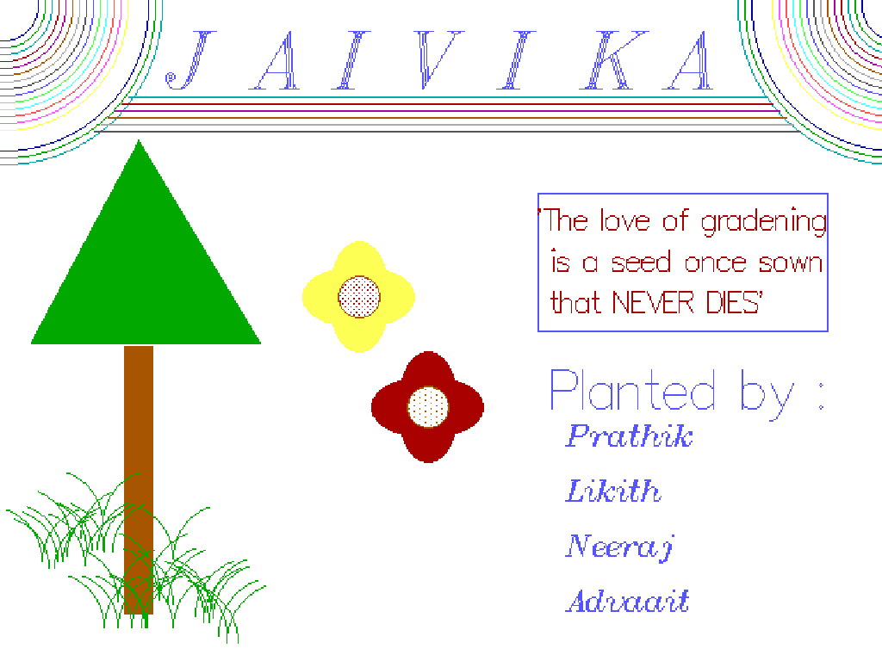

***EXIT SCREEN***



***MAIN MENU***

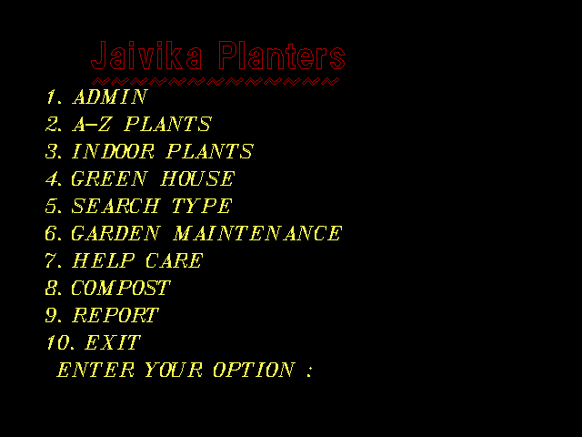

**ADMIN**

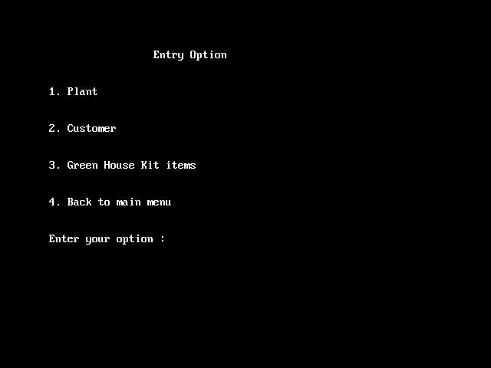

***PLANT MENU***

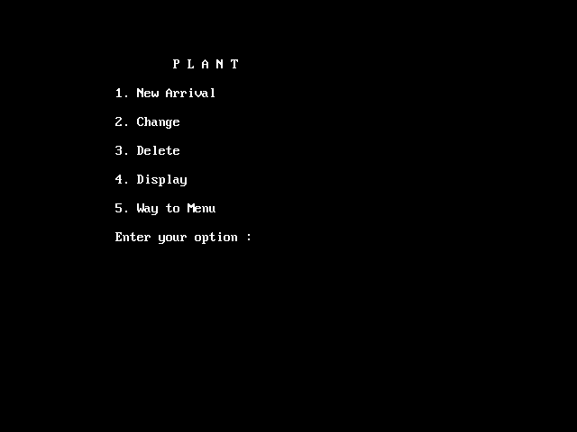

**CUSTOMER DETAILS**

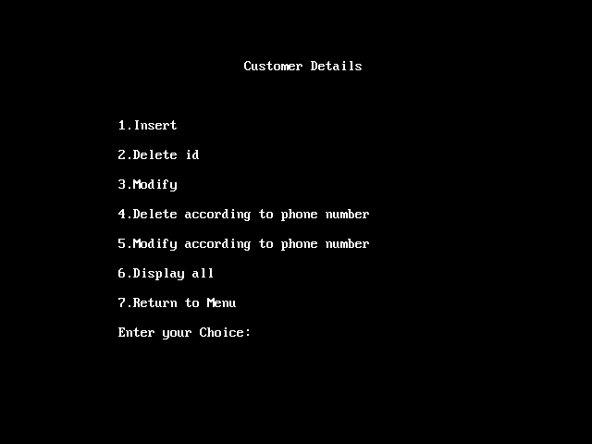

**INSERT CUSTOMER DETAILS**

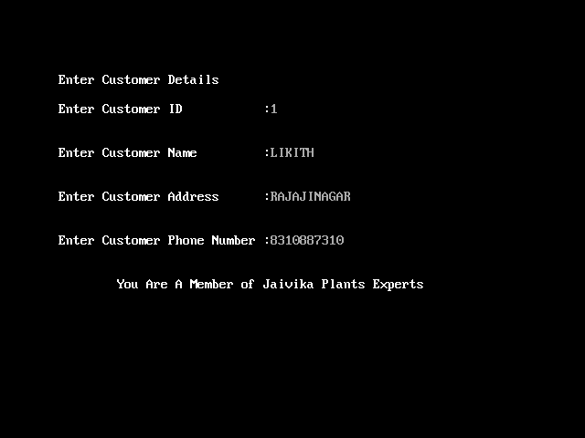

**INDOOR PLANTS**

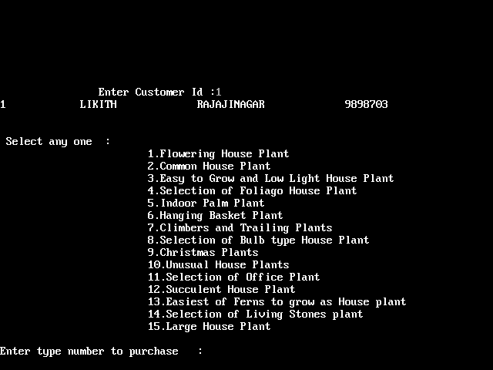

***GREEN HOUSE***

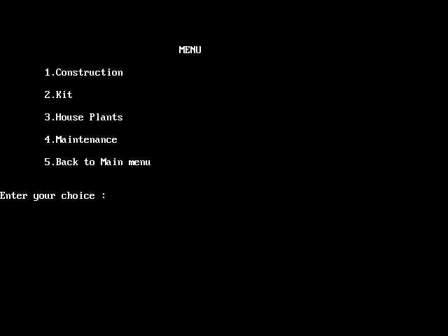

**GREEN KIT ITEMS**

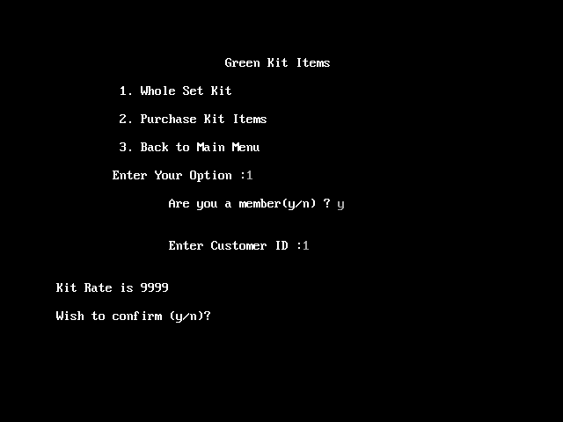

**MAINTENANCE**

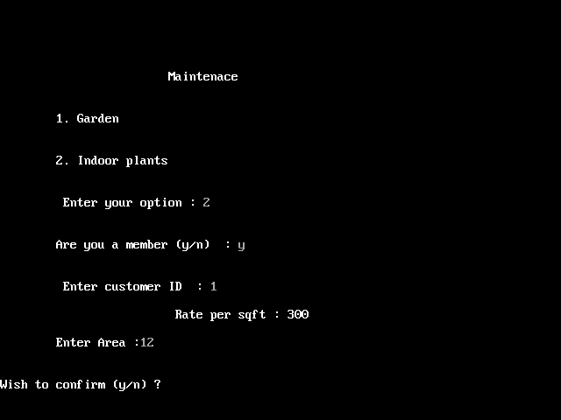

***SEARCH TYPE***

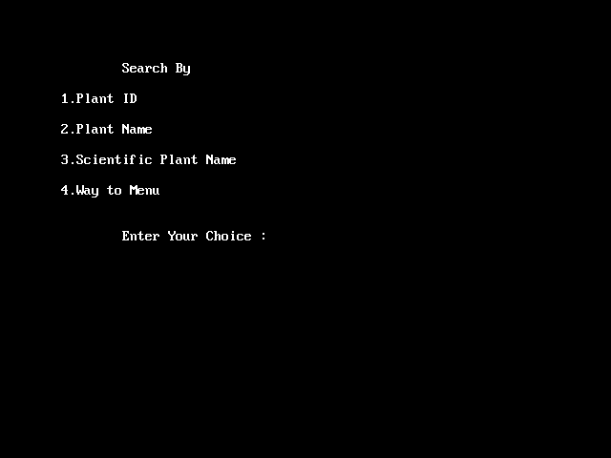

***GARDEN MAINTAINANCE***

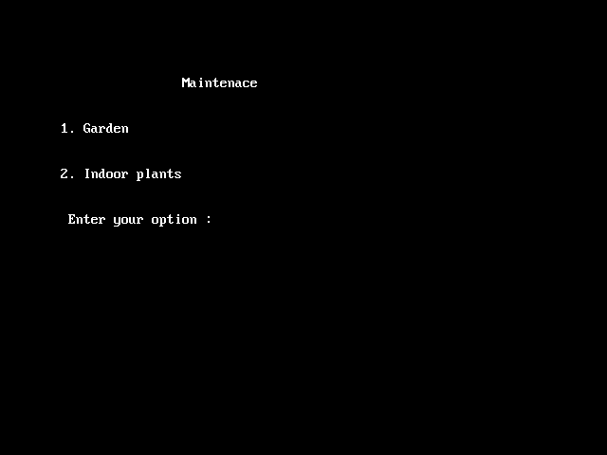

***HELP CARE***

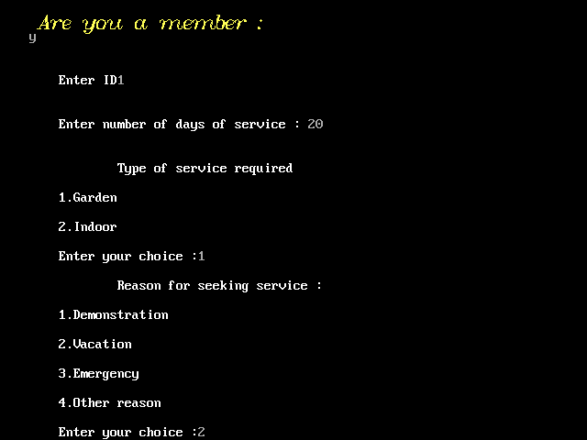

***COMPOST***

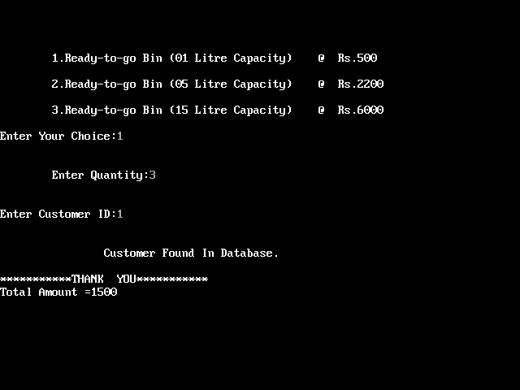

***EXIT SCREEN***

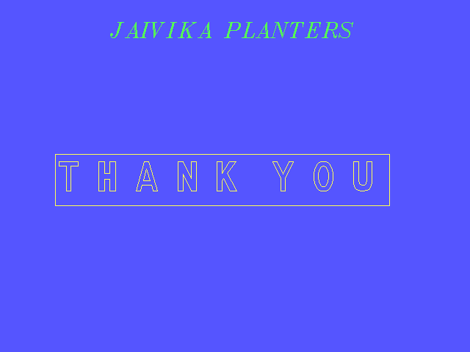

***BIBILOGRAPHY***

1. COMPUTER SCIENCE WITH C++ FOR CLASS 12(VOL 1&2)-Sumitha Arora
2. VISUALS FOR C++-B.B.Publishers
3. COMPUTATIONAL GEOMERTY AND COMPUTER GRAPHICS IN C++-Micheal J.L
4. MASTERING C++- Ravi Shankar