SALESFORCE VIRTUAL INTERSHIP

**A CRM application to handle the clients and their property related Requirements**

Dreams World Properties integrates Salesforce to streamline customer interactions. Website management triggers automated record creation in Salesforce, capturing customer details and preferences. Salesforce categorizes users as approved or non-approved, offering tailored property selections to approved users. This enhances user experience and efficiency, providing personalized recommendations and broader listings. Seamless integration optimizes operations, improving customer engagement andfacilitating growth in the real estate market

### Milestone 1 :- Create a Jotform and integrate it with the org to create a record of customers automatically.

### Activity 1

1. Open your browser and search for jotform and log in.
2. After login click on create form and click on start from scratch
3. Now create a form to get the customer details like Name, Phone,Email, Address and type 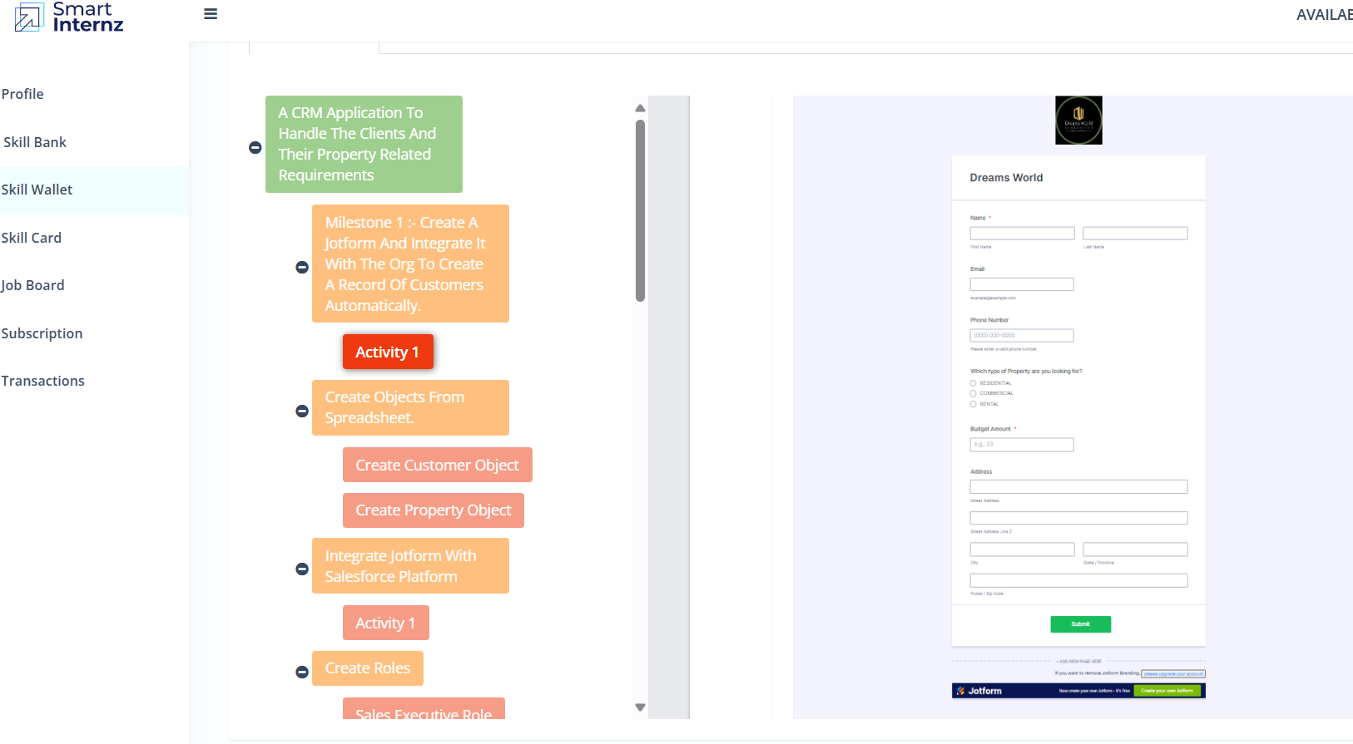of property the customer is interested in.
4. Once the form is created, publish it by clicking on publish.

https://www.jotform.com/form/240031134484041

### Create Customer object

1. Go to your object manager and and click on create object from spreadsheet.
2. Click on the link to get the spreadsheet
3. [customer](https://docs.google.com/spreadsheets/d/1OnrKr4zVsbXrGvU6r0edgB6XOUlp4eCpfzHMSj8MN78/edit?usp=sharing)
4. After downloading, upload the file, map the fields and upload to create an object.

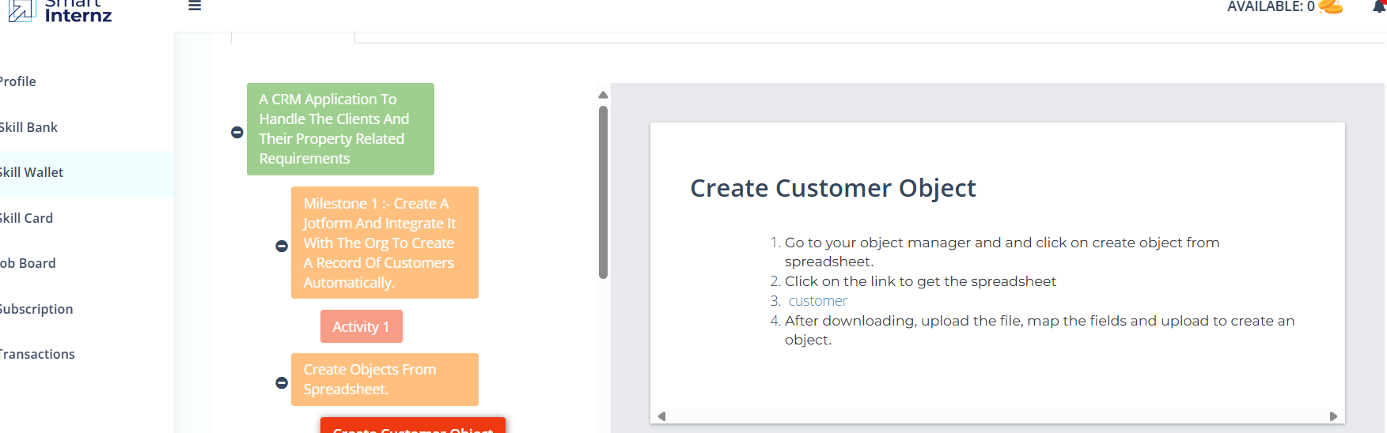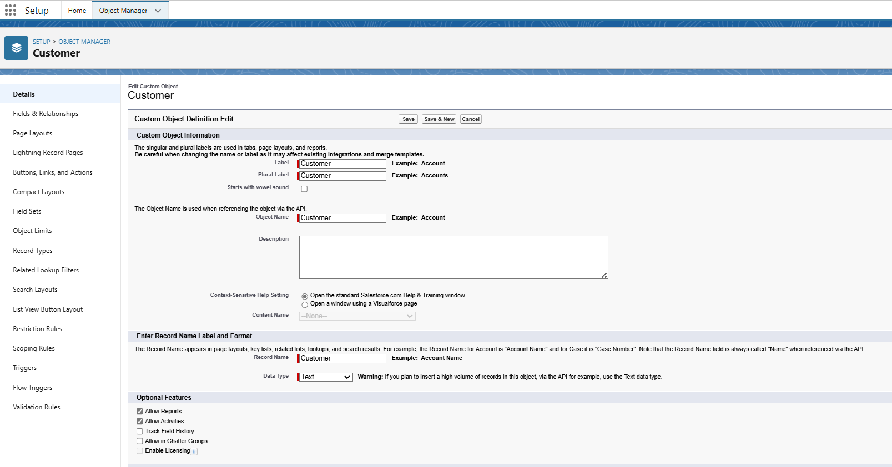

### Create Property object

1. Follow the same from the customer object to create the Property Object

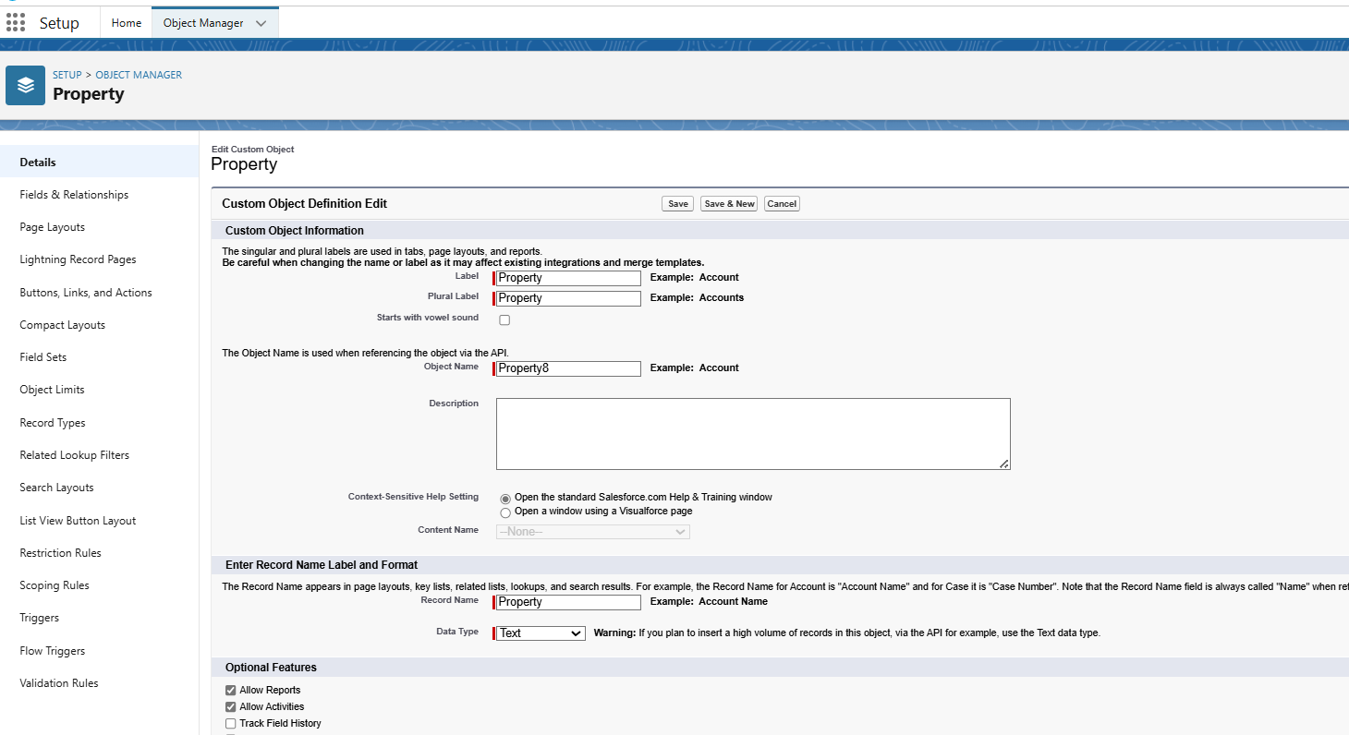

### Integrate Jotform with Salesforce Platform

In this Milestone we are going to integrate jotform with Salesforce

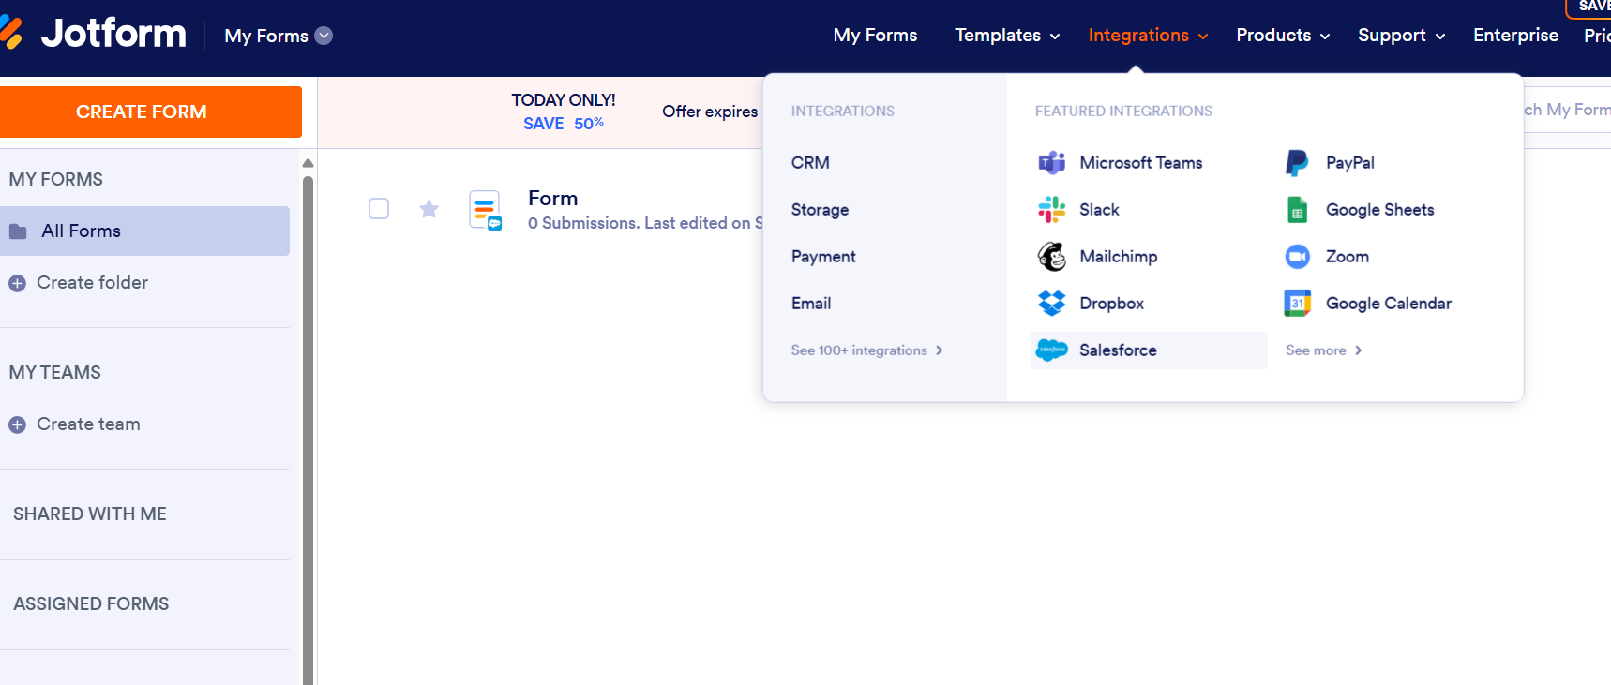

### Activity 1

1. On the Jotform Platform, Click on Integration and choose Salesforce.

2. Click on User Integration and choose “Add to From”.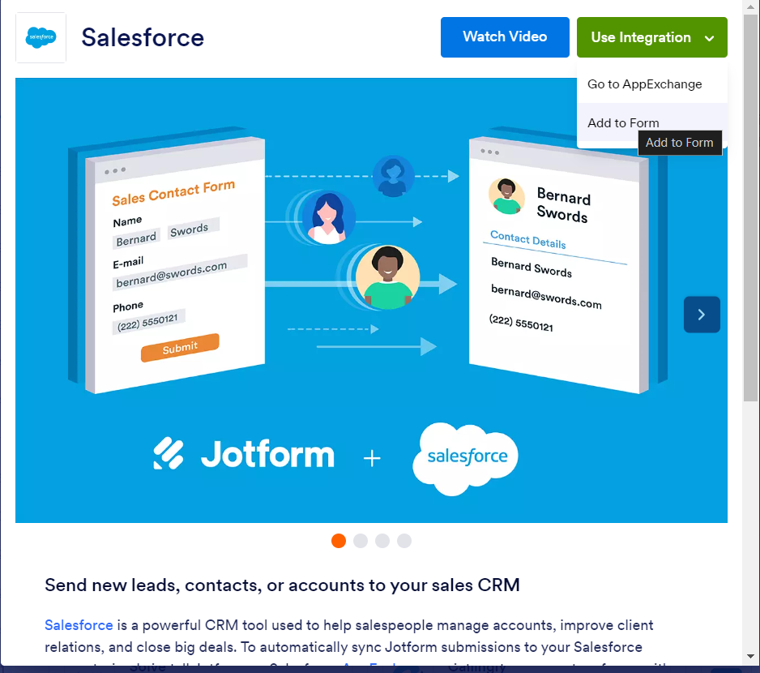

1. Select the Org with which you want to Integrate your jotform with.
2. Select an Action - Create a record.

Select a Salesforce Object : - Customer

5.Map Each and every field on the Object with the fields on the form and “Save Action”.

1. Then “Save the Integration” and “Finish”.

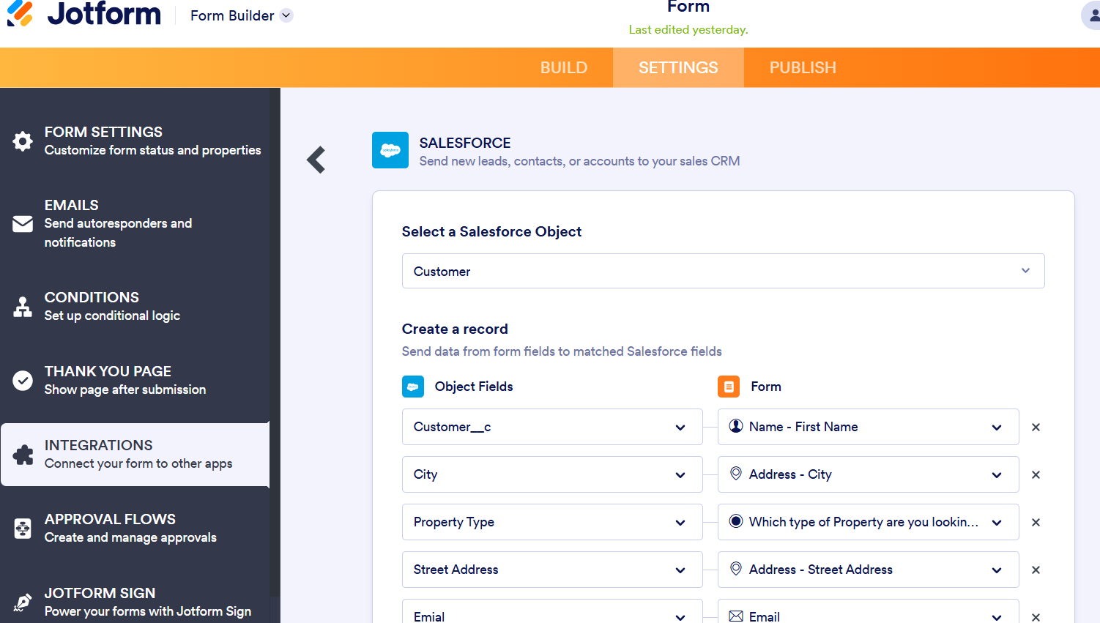

### Create Roles

### Create a Property Details App

1. From Setup>> Go to App Manager and click on New Lightning App and Name it as “Property Details” and add “Customer” and “Property” Object.

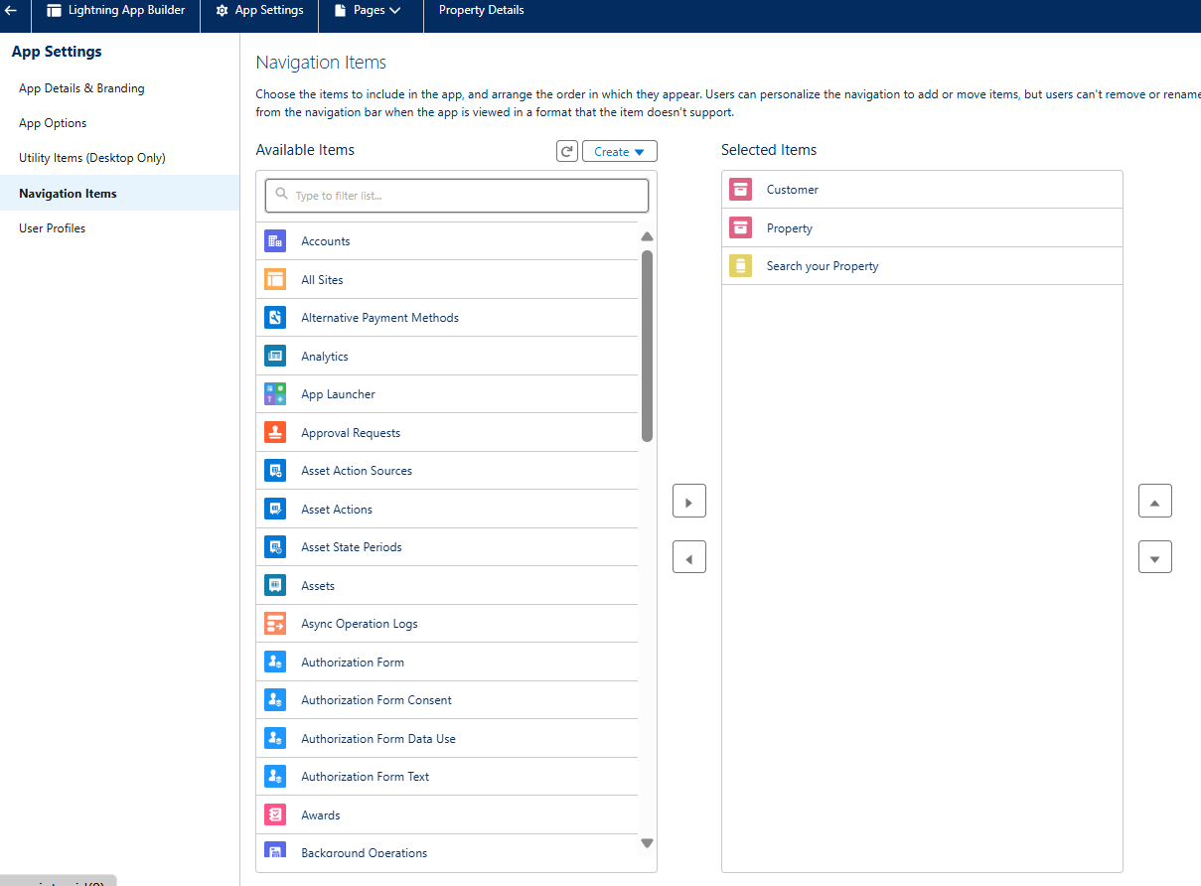

### Create Profiles

### Customer

### Manager

### Create a Check Box field on user

### 

### Create Users

### 

### Create an Approval Process for Property Object

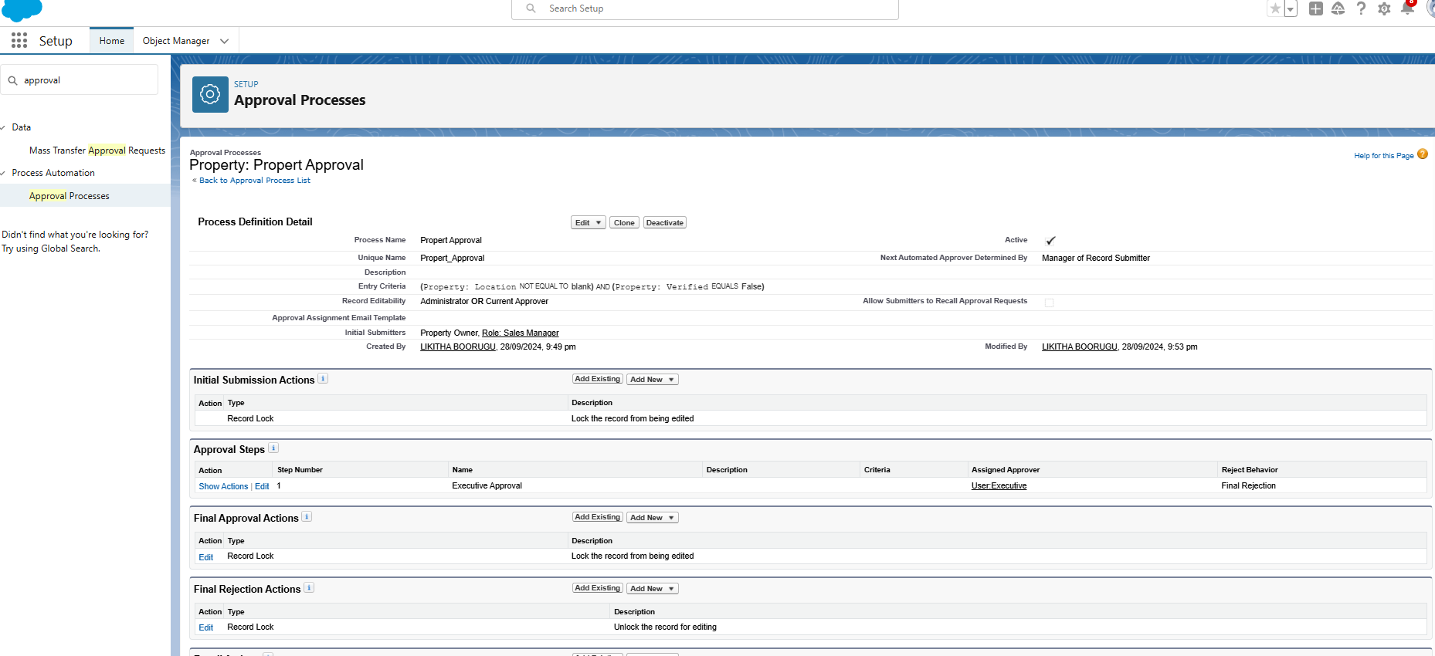

### Create a Record trigger flow to submit the Approval Process Automatically.

### Create an App Page

### Create a LWC Component

* Create an LWC Component for the customers so that only verified customers can access the verified properties and non Verified customers can access non verified properties, and deploy it on “Search your Property Page”

### Drag this Component to your App Page

### Give Access of Apex Classes to Profiles

