MomentumLens
AI Tactical Shift Explainer
Complete project document for the IBM June Innovation Challenge
Theme: Soccer, AI, and the World Cup
Purpose: Explain why match momentum changed, not just what the score was.

Project summary
MomentumLens detects turning points in a soccer match, identifies likely tactical causes, and uses IBM Granite to generate clear, human-friendly explanations for fans, analysts, and new viewers.

1. Problem Statement
During a World Cup match, viewers often notice that the game suddenly changes: one team starts dominating possession, a substitution shifts the tempo, or a card alters the balance of play. Traditional statistics tell us what happened, but they do not explain why the momentum changed or which tactical decision mattered most.
MomentumLens solves this by combining match-event analysis with AI-generated explanations.

2. Proposed Solution
MomentumLens is an AI-powered tactical explainer. It ingests match data, detects momentum shifts, links those shifts to events such as substitutions, cards, or pressure spikes, and then produces a concise explanation in plain language.

3. System Flowchart
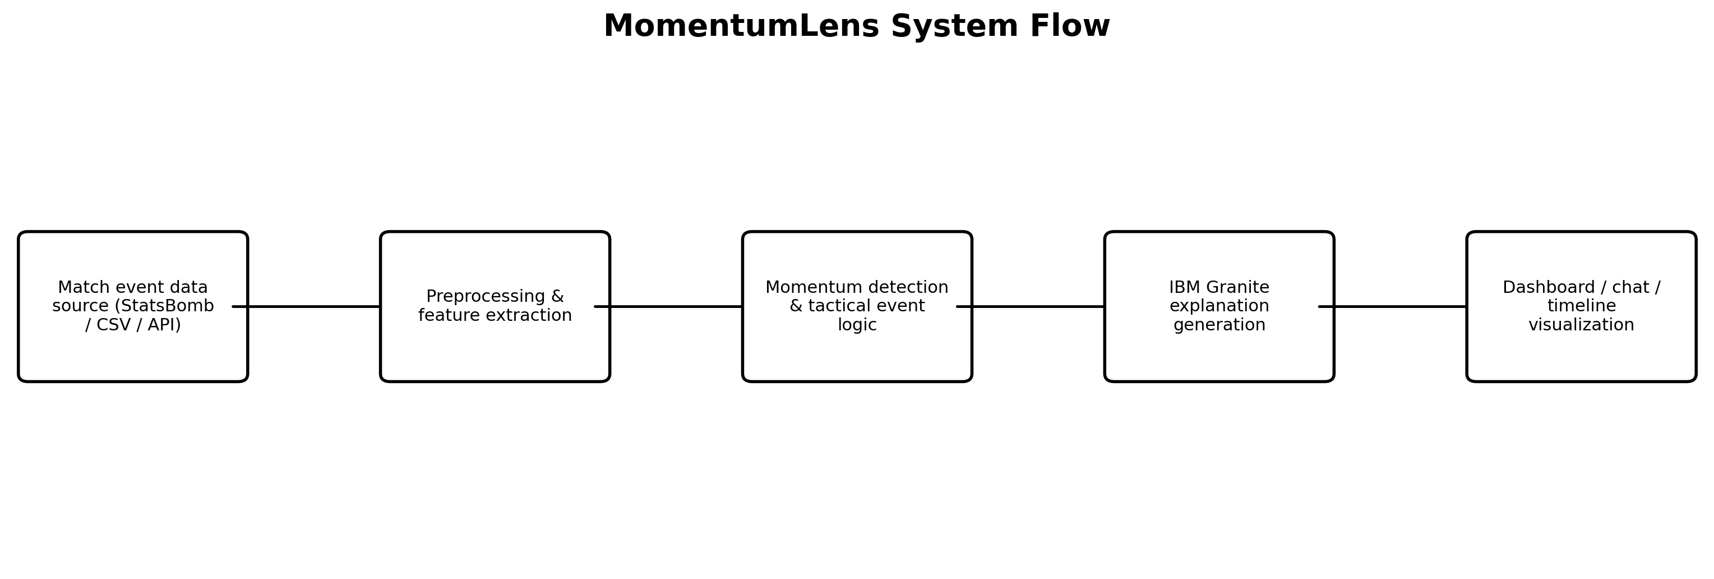
Figure 1. High-level architecture of MomentumLens.

4. Step-by-Step Process
- Step 1: Choose the data source
Use a public soccer event dataset such as StatsBomb Open Data or a CSV of match events. Start with a single match to keep the prototype focused.
- Step 2: Clean and standardize the events
Normalize timestamps, team names, player names, and event types. Remove duplicates and make sure every event has a usable minute/second value.
- Step 3: Create match features
Derive signals such as possession trend, shot frequency, pass intensity, pressure windows, card events, and substitution timing.
- Step 4: Detect momentum shifts
Calculate a momentum score over time. Identify moments where the score changes sharply, indicating a turning point.
- Step 5: Link each shift to possible causes
Check what happened around each turning point: a substitution, a red card, a tactical shape change, a burst of shots, or a drop in possession.
- Step 6: Retrieve supporting context
Pull relevant match facts or notes so the explanation stays grounded in real evidence rather than generic commentary.
- Step 7: Generate the explanation with IBM Granite
Send the detected signals and supporting facts to Granite. Ask it to explain the moment clearly, briefly, and with a fan-friendly tone.
- Step 8: Present the result in the UI
Show a timeline, a highlighted turning point, and a text explanation. Add a chat box so users can ask follow-up questions such as “Why did the momentum shift after minute 60?”
- Step 9: Validate with examples
Test the prototype on a few matches and compare its explanations with known turning points from match reports or expert commentary.
- Step 10: Package the demo for submission
Prepare the GitHub repository, README, short demo video, and a simple walkthrough that shows the input, the detected shift, and the final explanation.

5. Development Workflow Diagram
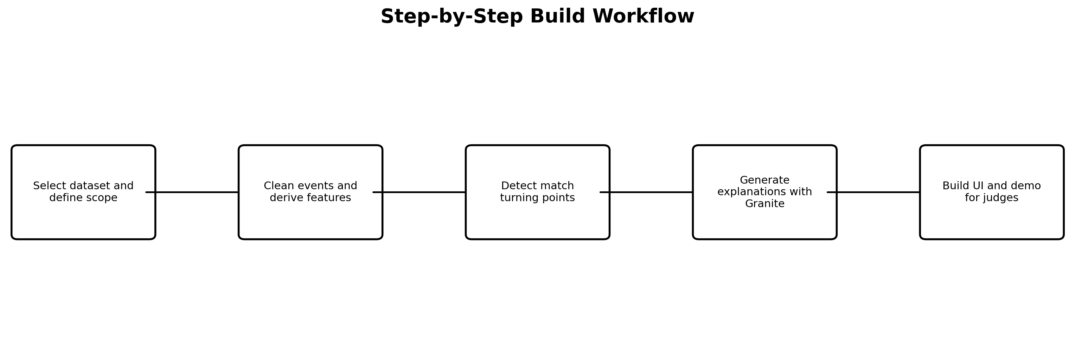
Figure 2. Recommended build sequence from data to demo.

6. Recommended Technology Stack
Layer | Recommended Technology | Purpose
AI / reasoning | IBM Granite | Generate human-readable explanations and summarize the tactical cause of a momentum shift.
Orchestration | LangChain or LangFlow | Connect feature extraction, retrieval, prompts, and response generation.
Data processing | Python, Pandas, NumPy | Clean match events and compute derived metrics.
Momentum logic | Custom Python rules or lightweight ML | Detect turning points and rank likely causes.
Visualization | Plotly or Matplotlib | Show match timelines and highlight key moments.
User interface | Streamlit or React | Create a polished demo for judges and teammates.
Document ingestion | Docling | Convert match reports or rule documents into structured text if needed.
Storage | SQLite or PostgreSQL | Persist match events, features, and explanation results.
Version control | GitHub | Host code, README, and submission artifacts.

7. What the User Sees
A strong demo should include four visible elements:
- A match selection screen or data upload area
- A momentum timeline with turning points highlighted
- A plain-English explanation generated by AI
- A follow-up chat panel for questions and deeper analysis
Example output: “Momentum shifted in the 63rd minute after a double substitution increased central midfield control. Possession rose, pressing improved, and the opponent created fewer chances for the next 12 minutes.”

8. Why This Fits the Challenge
- It uses AI as a core function, not as a decorative add-on.
- It focuses on explainability, transparency, and understanding.
- It helps both new fans and experienced viewers interpret the game.
- It fits the World Cup context because momentum and tactical decisions are central to how matches are discussed.

9. Suggested Prototype Scope
To finish on time, build a single-match prototype first. Use one dataset, one momentum scoring method, and one explanation template. After that works reliably, add one extra feature such as multilingual summaries or a question-and-answer chat.

10. Submission Checklist
- Working prototype or proof of concept
- Public GitHub repository with a clear README
- Short 3-minute demo video
- Project submission page published before the deadline
- Clear explanation of how IBM technology is used

11. Final Recommendation
Build MomentumLens as a tactical explainer that shows when the match changed, why it changed, and how the change affected the game. Use IBM Granite for the explanation layer, LangChain/LangFlow for orchestration, and a simple visual timeline for the demo.

