**Team-14 Project Documentation**

CORPORATE RECRUITMENT SYSTEM

Ketaki Chinchorkar

1001408873

[ketaki.chinchorkar@mavs.uta.edu](mailto:ketaki.chinchorkar@mavs.uta.edu)

Likitha Seeram

1001363714

[likitha.seeram@mavs.uta.edu](mailto:likitha.seeram@mavs.uta.edu)

Contents

1. Abstraction 3

2. Problem Statement 4

3. English Queries 5

4. Assumptions 6

4.1 Entities and Attributes 6

4.2 Nature of Relationships 7

5. ERR Modelling 8

6. Relational Schema 9

7. Relational Algebra 10

8. SQL scripts 12

8.1 Interface 12

8.2 DDL Script 12

8.3 DML Script 12

8.4 DROP Script 12

8.5 SQL Queries Script 12

9.Application Development and Demonstration 13

10. Conclusion 14

# 

# 1. Abstraction

This project titled **“Corporate Recruitment System”** is an online Job Portal that will ease recruitment process by notifying Job Seekers the availability of current jobs.

This corporate recruitment service system will primarily focus on the posting and searching of job vacancies. However, this can be the initial step towards achieving the long term goal of delivering broader services to support recruitment.

This will provide service to the potential job applicants to search for working opportunities. It is planned that ultimately all vacancies will be posted online by Job Providers, so that Job Seekers will be able to take maximum benefit out of it to succeed. CRS will reduce communication gap between Job providers and Job Seekers. Tt will be beneficial not only for experienced candidates but also for the freshers.

# 2. Problem Statement

This project titled **“Corporate Recruitment System”** is an online Job Portal that will ease recruitment process by notifying Job Seekers the availability of current jobs.

This corporate recruitment service system will primarily focus on the posting and searching of job vacancies. However, this can be the initial step towards achieving the long term goal of delivering broader services to support recruitment.

This will provide service to the potential job applicants to search for working opportunities. It is planned that ultimately all vacancies will be posted online by Job Providers, so that Job Seekers will be able to take maximum benefit out of it in order to succeed. CRS will reduce communication gap between Job providers and Job Seekers. It will be beneficial not only for experienced candidates but also for the fresher’s.

# 3. English Queries

List of few realistic English queries:

**(Job Seeker’s perspective)**

* Give me details of the companies which are on the Fortune 500 list.
* List of companies with minimum GPA_Requirement of 3.5 along with vacancies.
* Show me the companies where both IT and Non-IT jobs are available.
* What is the average salary of every company?
* What is the maximum salary for JOB_SEEKER depending on his experience?
* Show me the details of the Jobs based on my final year project technology.
* What is the average salary for Fortune 500 companies?
* What is the maximum salary that I will get depending on my GPA?

**(Job Provider’s perspective)**

* Show me the list of available jobs in the system
* How many Job Providers are registered/associated with the system?
* How many candidates are having more than 3 years of experience (sorted in descending order)? Are there any fresher candidates having Internship experience with us?
* Show me the count of both experienced and fresher candidates who are eligible.
* Show me the list of candidates (both experienced and fresher) having highest GPA and who worked with us.

**(Admin’s perspective)**

* How many Job Providers are registered/associated with the system?
* Show me the list of available jobs in the system.

# 4. Assumptions

## 4.1 Entities and Attributes

There are 8 entities in our Mini world.List of Entities and their corresponding attributes:

**Person** (Composite Primary key – LoginID, Pname, Password)

LoginID

Pname

Password

**Job Provider** (Composite Primary key – RegID; CompanyName, Foreign key -LoginID)

Reg ID

LoginID

Company Name

FoundationYear

Contact_Number

Email_ID

Fortune_500_Company (YES or NO)

**Job Seeker** (Primary key – SSN, Foreign key -LoginID)

SSN

LoginID

Name

Contact_Number

Email_ID

Major

GPA

**Experienced Candidate** (Primary key – ESSN; Foreign key -SSN)

ESSN

Last_Company_Name

Experienced_Years

Previous_salary

Technology (Multivalued)

**Fresher Candidate** (Primary key – FSSN; Foreign key -SSN)

FSSN

Internship_Company_Name

Internship_Duration

Final_Year_Project_Technology

**Job** (Composite Primary key – JobID, CompanyName; Foreign key –RegID, CompanyName)

JobID

RegID

Company Name

Salary

Experience Requirement

GPA Requirement

Vacancy Count

Job Type (IT or Non-IT)

PostingDate

**Resume** (Primary key – SSN, WeakEntity Primary Key – FileName; Foreign key -SSN)

SSN

FileName

Description

## **4.2 Nature of Relationships**

## We have implemented specialization relationships. User can be either Job Provider or Job Seeker or an Admin. Similarly, a Job Seeker can be either an Experienced Candidate or a Fresher.

We have implemented one-to-one, one-to-many, many-to-many relationships.

UPLOAD - Between Job Seeker and Resume – 1:1 (one-to-one)

SEARCH - Between Job and Job Seeker – M:N (many-to-many)

POST - Between Job Provider and Job – 1:N (one-to-many)

SEARCH - Between Job Provider and Job Seeker – M:N (many-to-many)

UPDATE - Between Admin and Job – 1:N (one-to-many)

# 5. ERR Modelling

We have made few changes to the ER diagram. Please find the enhanced version below:

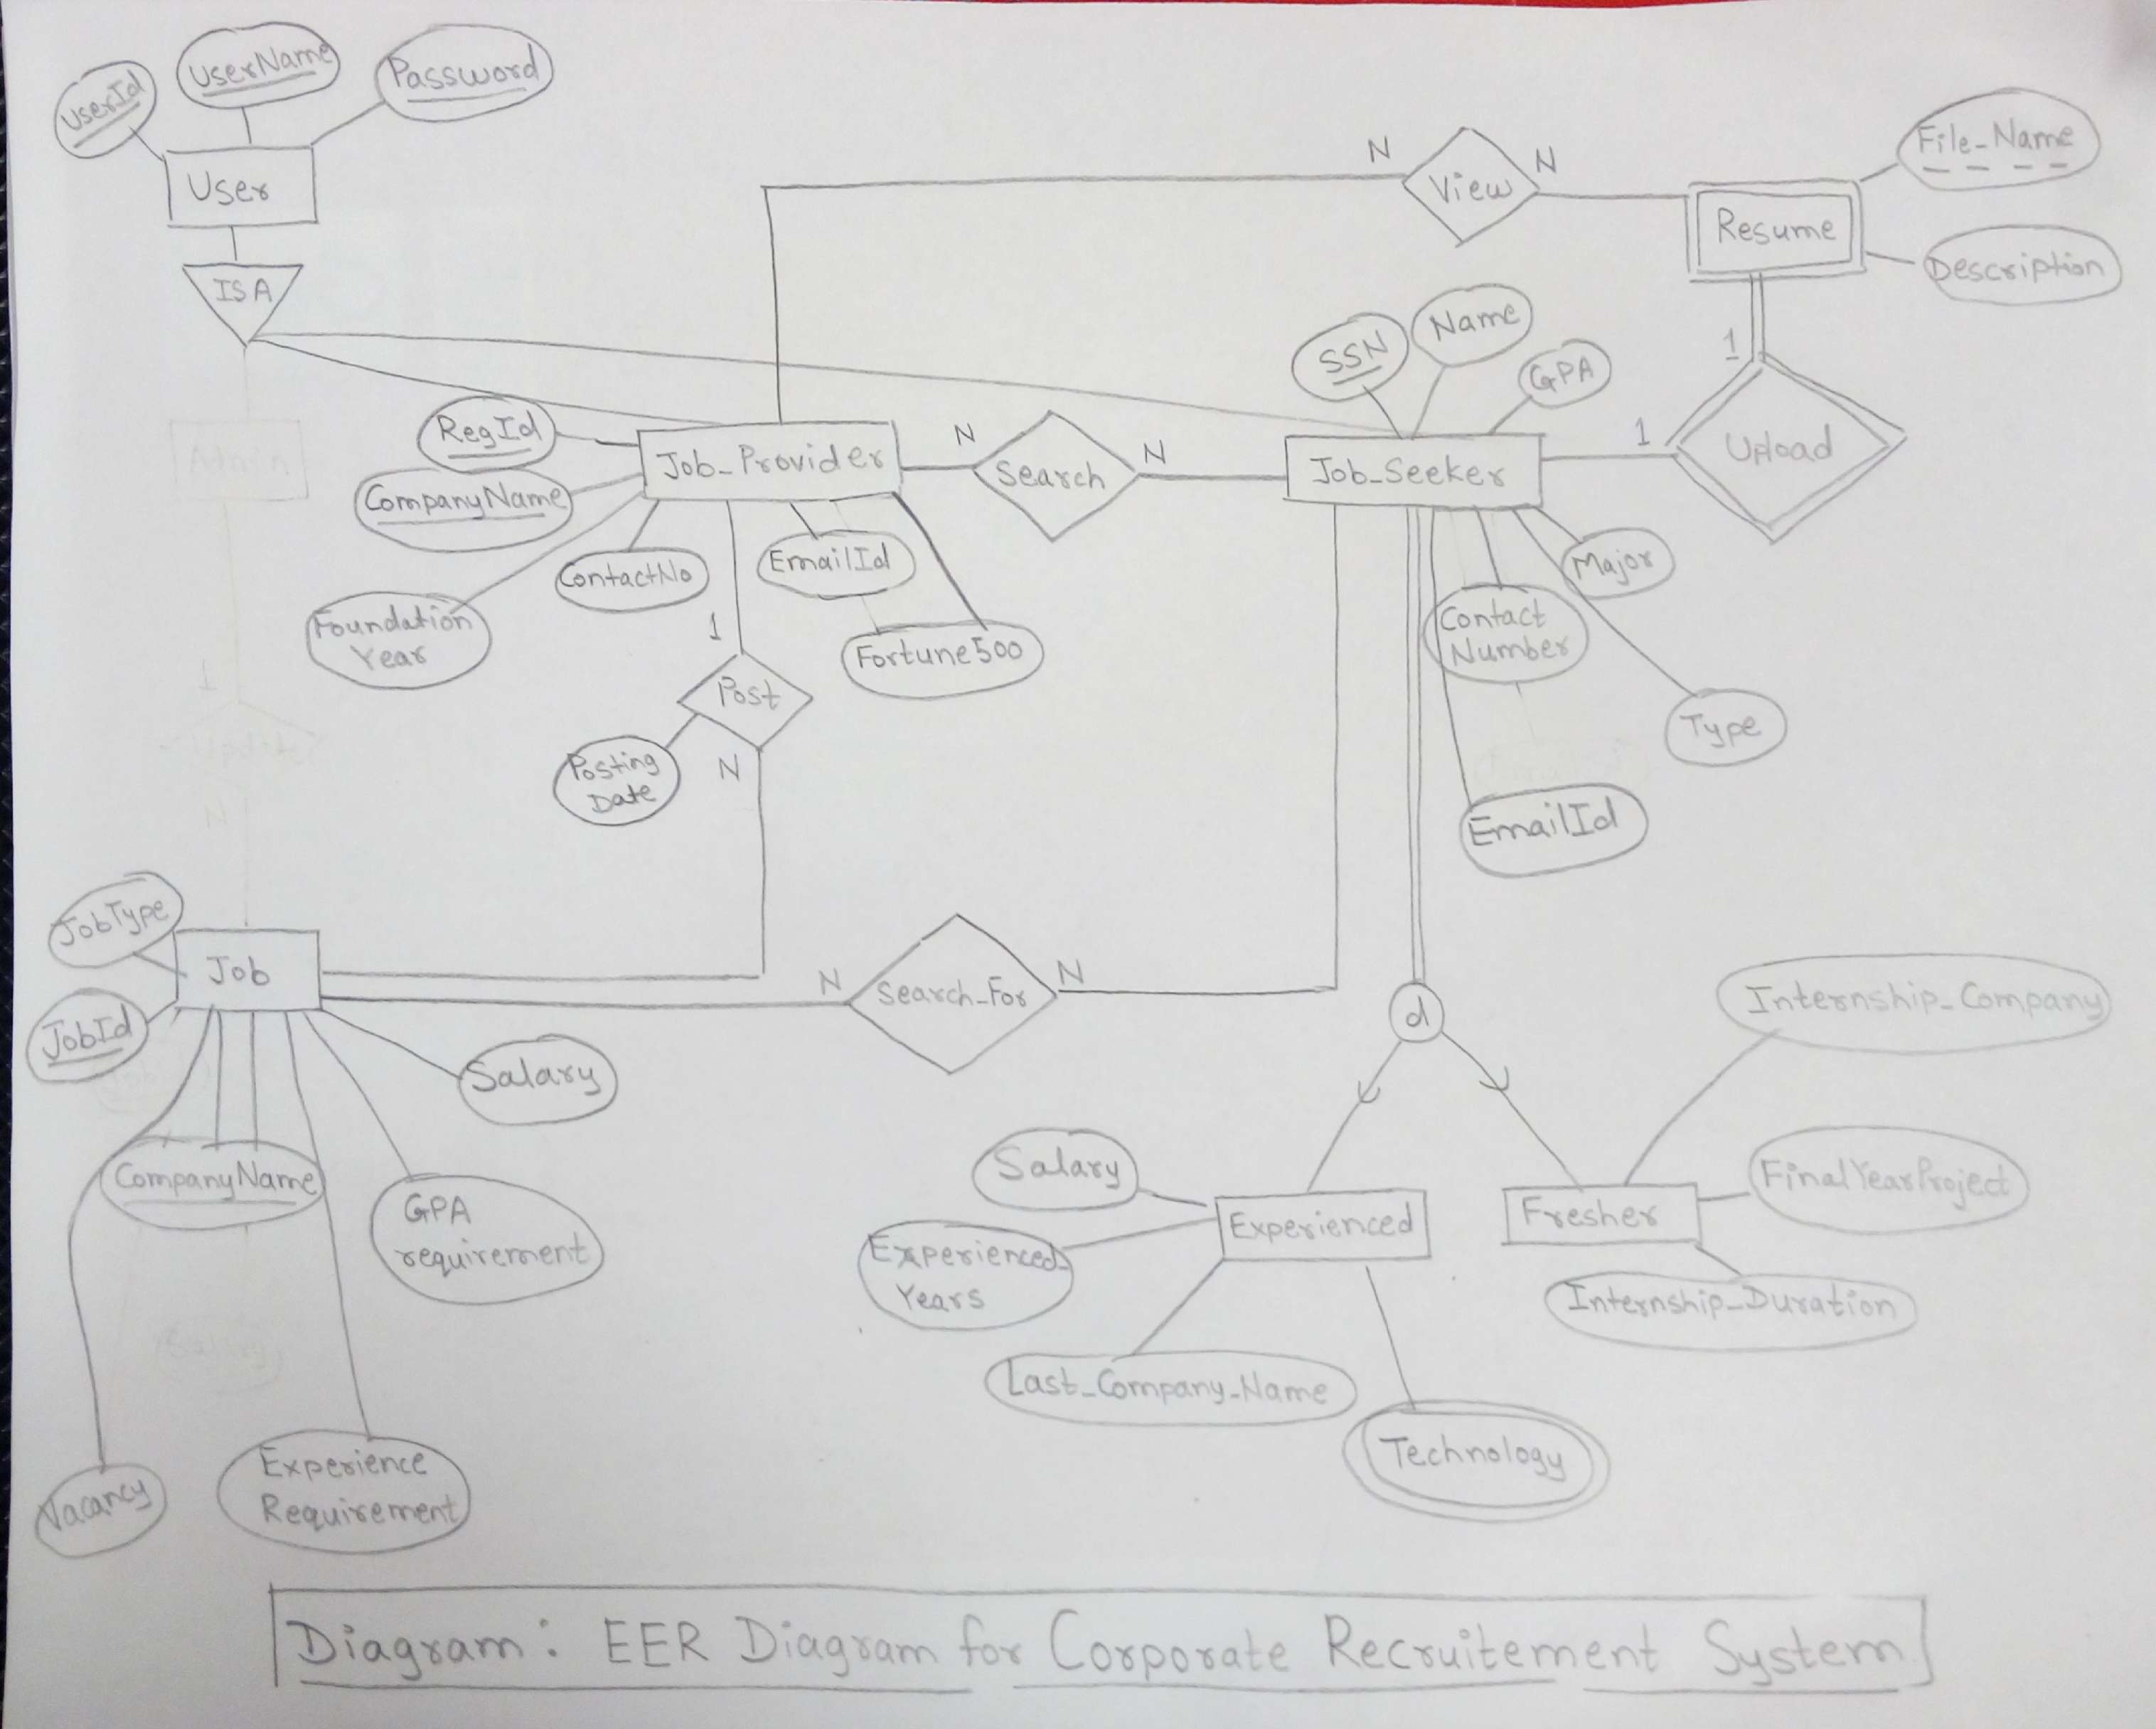

# 6. Relational Schema

We have made few changes to the Relational Schema. Below is the enhanced one:

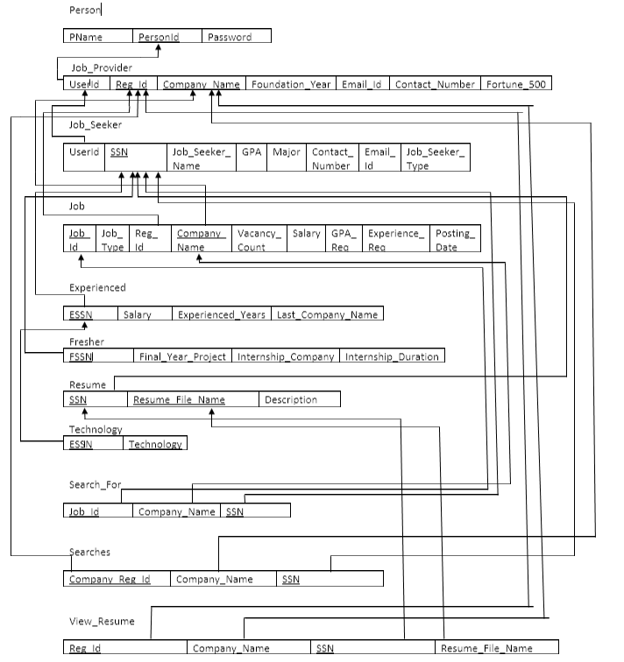

# 7. Relational Algebra

(

**(Job Seeker’s perspective)**

* Give me details of the companies which are on the Fortune 500 list -
* List of companies along with vacancies for which I am eligible –
* Show me the companies where both IT and Non-IT jobs are available along with vacancies - **Job) )**
* What is the average salary of all companies? – **CompanyName**
* What is the maximum salary depending on GPA? -

**(Job Provider’s perspective)**

* How many candidates have worked with us previously? -
* How many candidates are having more than 3 years of experience (sorted in descending order)? -
* Are there any fresher candidates having Internship experience with us? -
* Show me the count of both experienced and fresher candidates who are eligible. -

**(Admin’s perspective)**

* How many Job Providers are registered/associated with the system? -
* Show me the list of available jobs in the system -

# 8. SQL scripts

## 8.1 Interface

For this phase, we have used Oracle database by connecting to the SSH Secure shell client.

## 8.2 DDL Script



## 8.3 DML Script



## 8.4 DROP Script



## 8.5 SQL Queries Script



# 9. Application Development and Demonstration

Project Demonstration:

**Introduction**

Online dedicated portals are popular nowadays; people use them to get services and information all around the world regardless of their physical location and around the clock. Today's emerging technology and tight labor market have incited a stampede to electronic recruiting.

**Executive summary of the project**

In this project we demonstrate a prototype solution in which we built a dedicated website for job seekers, students, or graduates on one hand, and potential employers on the other, the aim is to enable them reach and match each other's requirements using an advanced instant custom and automatic search feature. Both can have access to the website which is introduced in the form of online portal holding their details in a database and allowing searches to match seekers with providers and vice versa. Inclusion of Resume builder will help job seeker to build a professional CV, or covering letter. For this project, we used Xampp, **XAMPP** stands for Cross-Platform (X), Apache (A), MySQL (M), PHP (P) and Perl (P).

**Source-code**



Screenshots:

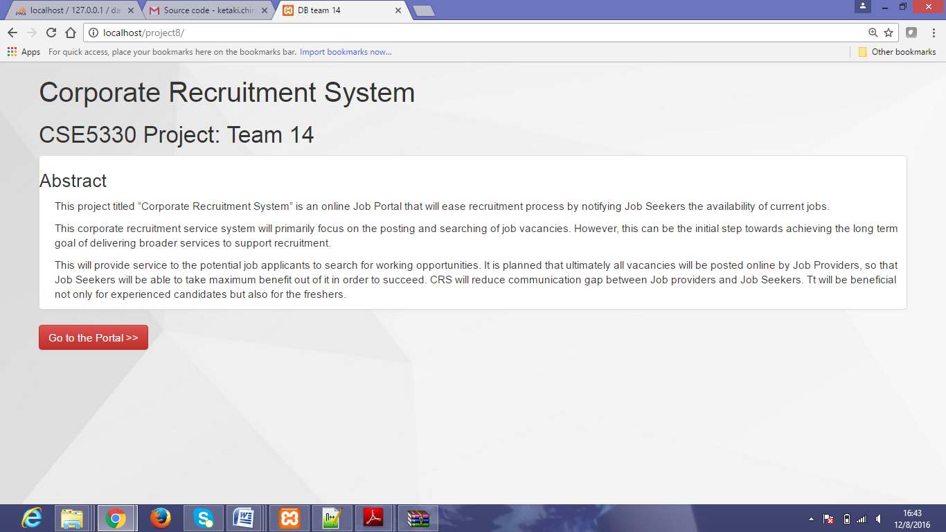

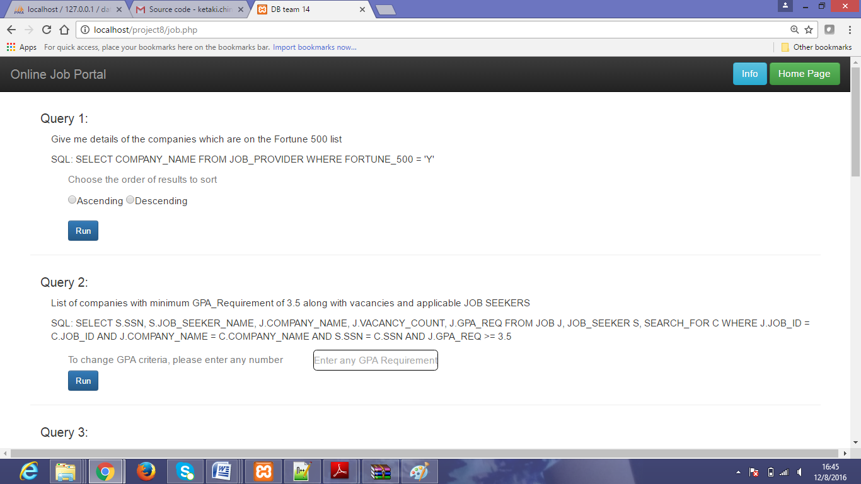

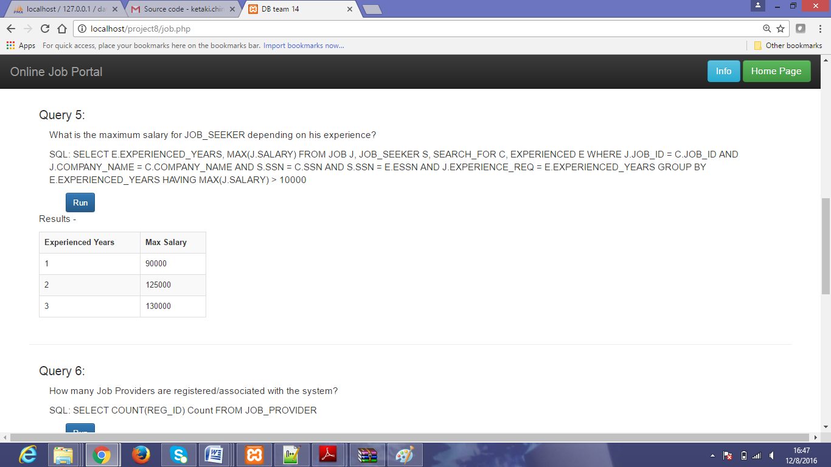

# 10. Conclusion

Online recruitment is one of the most active ecommerce areas; the growth of web recruitment has been driven by a combination of actual costs savings in the recruitment process, increased ease and efficiency for the employer along with an improved experience for candidate. In this application, we successfully implemented major functionalities, such as job posting and job searching. Opportunity is provided to job seeker by allowing them to post their Resume in the system, which will be available for employers. While working on this project, we learned lot of things right from creation of our own mini-world in initial phase, we have learned and implemented basic database concepts entities and relationships, making English queries for the system. We dealt with key constraints and specialization relationships. In phase 2, we focused on conceptual/logical database design. We got hands-on experience in drawing ER diagram and creating relations. We did EER and relational modeling along with formulation of English queries with relational algebra. In phase 3, we developed our schema by creation of schema objects such as tables, view. We also implemented key constraints as per the requirement of our system. In final phase, we implemented the user interface using combination of php and MySQL.

While looking for online jobs and careers portal and services, we found that there are many functionalities that can be included in our mini-world, such as email notification, job interview process that will be beneficial to both the entities. So, such functionalities will definitely enhance our project.