**CSE 5335-002 Web Data Management**

**Project 3**

**Design Document**

Seeram Likitha

1001363714

[likitha.seeram@mavs.uta.edu](mailto:likitha.seeram@mavs.uta.edu)

Table of Contents

1. Project Description 3

2. Requirement Analysis 3

2.1 Software Requirements 3

2.2 Hardware Requirements 3

2.3 Other Requirements 3

3. Assumptions 3

4. Implementation 4

4.1 Home Page 4

4.2 About-Us Page 4

4.3 Artist-List Page 4

4.4 Artist-Details Page 4

4.5 Artwork-Details Page 4

4.6 Search Page 5

4.7 CSS File 5

5. Conclusion 6

# Project Description

Assignment – 3 is a web project where a site needs to be developed which displays Artists information along with the information of their corresponding Artworks. In this project, ‘Bootstrap’ is being used to style the website. Along with this, JQuery libraries are also included to support a few bootstrap classes. The entire website is built on PHP.

# Requirement Analysis

## 2.1 Software Requirements

Following software are required for the project:

* XAMP Control Panel (for windows users)
* Sublime Text Editor
* A Web browser

## 2.2 Hardware Requirements

A minimum of following hardware is necessary for this project:

* An Operating System to support the above software
* 2GB RAM

## 2.3 Other Requirements

* Bootstrap
* JQuery Library
* Localhost PHP Admin for DataBase

# Assumptions

Following are few of my assumptions made while developing this web project:

* The Search Field available in every page’s navigation bar searches only by ‘Title’. If the ‘SEARCH’ button is clicked without entering anything in the text field, then the page is redirected to the search page. The following code handles this:

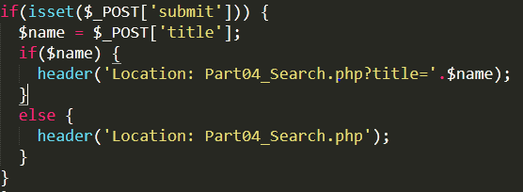

* In the ‘Search Page’, when the form is submitted without giving any input in the text fields, then all the artworks are displayed in the result.

# Implementation

## 4.1 Home Page

It consists of three sections. They are:

* **Navigation bar:** It has links to other pages in the site and also a search form to view Artworks.
* **Information:** This section gives information about the site and its owner.
* **Links Section:** This section has a short description about other pages in the site along with links to those pages.

## 4.2 About-Us Page

This page gives basic information about the owner of the website.

## 4.3 Artist-List Page

This page has a list of Artists available in the Database as links to the Artist-Details page. This list is sorted in the ascending order of Artist’s Last Name.

A PHP function called **“utf8_encode()”** in the website to encode special characters while displaying names and description .



## 4.4 Artist-Details Page

This page has displays the details of every single Artist. It has three sections. They are:

* **Navigation bar**
* **Artist Details:** This section has image of the artist and also details taken from ‘Artists’ table.
* **Artwork Details:** This section has the list of all Artworks available for an Artist. Each Artwork is a panel consisting of an Artwork Image, Title, Artwork year and buttons. This panel has linking to the Artwork-Details page.

Any invalid ID given is redirected to ‘Error Page’ which is handled by the code:

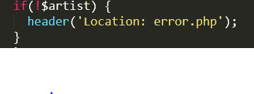

‘Header’ redirects the current page to an error page.

## 4.5 Artwork-Details Page

This page has displays the details of an Artist’s work. It has three sections. They are:

* Navigation bar
* Artwork Details: Displays Image and Details of an Artwork from the tables – Artists, Artworks, Subjects, Genres, Orders, etc.
* Modal window: A modal window is popped upon clicking the Artwork Image. This window displays a bigger Image and is handled by using the following script:

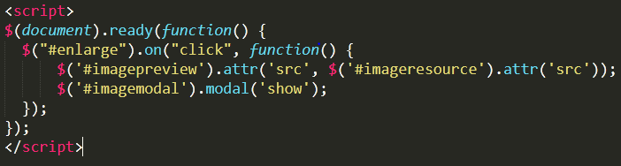

## 4.6 Search Page

This page is handled in three different ways:

* Search Page upon search by Title
* Search Page upon search by Description
* Search Page upon searching using No Filter

Each case is handled in PHP using ‘isset()’ method which checks the selection of the form elements in the page and thus redirects the page to the required content and displays results. ‘Header’ method is used for redirecting.

The results contain image, title and description of Artworks sorted by the ArtWork ID. These are links to the Artwork-Details page.

A method is used the highlight the description input given while displaying the results retrieved by search on description. The following code handles it:

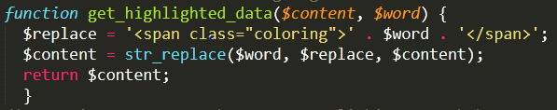

## 4.7 CSS File

A separate CSS file called ‘art.css’ file is maintained to give extra styling other than Bootstrap classes.

# Conclusion

This project has made me learn the following technologies:

1. PHP
2. JQuery
3. Bootstrap
4. CSS
5. AJAX

As this project requires us to use all the technologies to work on a single site and traverse among different pages in the site, it really made me understand the concepts very well.