**CSE 5335-002 Web Data Management**

**Project 4**

**Design Document**

Seeram Likitha

1001363714

[likitha.seeram@mavs.uta.edu](mailto:likitha.seeram@mavs.uta.edu)

Table of Contents

1. Project Description 3

2. Requirement Analysis 3

2.1 Software Requirements 3

2.2 Hardware Requirements 3

2.3 Other Requirements 3

3. Assumptions 4

4. Additional Functionality 4

5. Implementation 6

4.1 PHP Files 6

4.2 CSS File 6

4.3 MySQL File 6

4.4 TesTData 6

6. Conclusion 7

# Project Description

Assignment – 4 is a web project where a site needs to be developed which displays Books information and users can login and purchase books. In this project, ‘Bootstrap’ is being used to style the website. Along with this, JQuery libraries are also included to support a few bootstrap classes. The entire website is built on PHP, HTML5, CSS, jQuery.

# Requirement Analysis

## 2.1 Software Requirements

Following software are required for the project:

* XAMP Control Panel (for windows users)
* Sublime Text Editor
* A Web browser

## 2.2 Hardware Requirements

A minimum of following hardware is necessary for this project:

* An Operating System to support the above software
* 2GB RAM

## 2.3 Other Requirements

* Bootstrap
* JQuery Library
* Localhost PHP Admin for DataBase

# Assumptions

Following are few of my assumptions made while developing this web project:

1. Registration Page

Users are assumed to give a unique name for registering into the site. Fields – User needs to provide all the fields.

1. Shopping Page

* Initial Search: When Users do not provide anything the text box, entire results are displayed i.e., when user clicks on ‘Search by Title’ without providing any data, all the books are displayed in the result
* Add to Cart: Here Users are required to mention a ‘Quantity’ and then add items to the Cart. Maximum quantity is assumed to be ‘5’.

1. Cart Page

In the cart page, after clicking on the ‘BUY’ option ‘ShippingOrder’ details are displayed which includes the previous confirmed orders of the logged in user

1. Maintaining Baskets

Whenever user adds an item to the cart, selected items are added to the SESSION variable and as well as to the ‘ShoppingBasket’. Data from ‘ShoppingBasket’ and ‘Contains’ are removed whenever user buys the items in the cart or whenever a session is logged out.

1. Stock Maintenance

‘Stocks’ table details are updated only after confirming the order. When user adds items to the basket, only the maximum limit is checked depending upon the availability of stock.

# Additional Functionality

Following are the few aspects that are included additionally other than requirement:

1. ‘Login’ option provided after Registration to redirect to the login page.
2. Quantity attribute is taken in to consideration while adding items to cart. Here validation is also done basing on the maximum availability of stock in a warehouse.

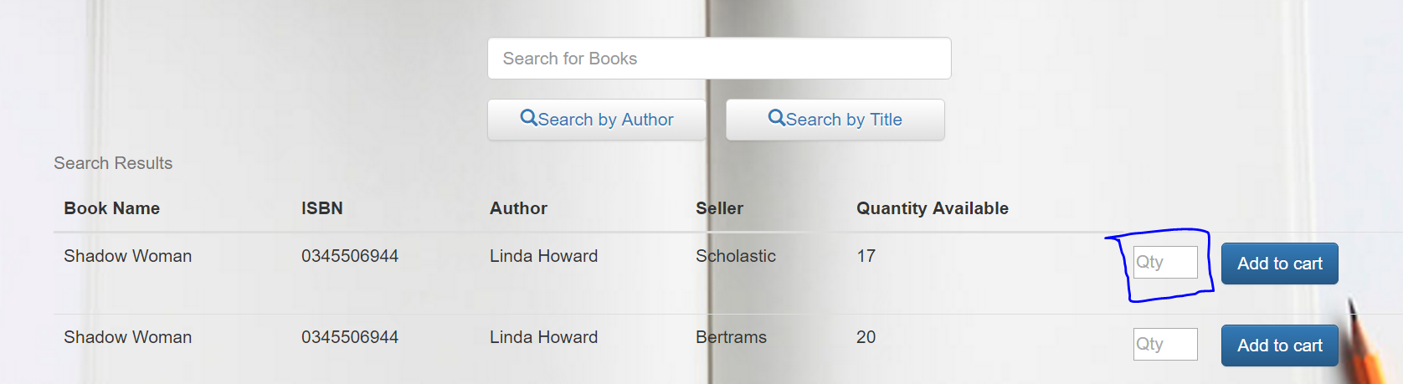

1. Shipping order details are printed after confirming the order and also logout button is provided.

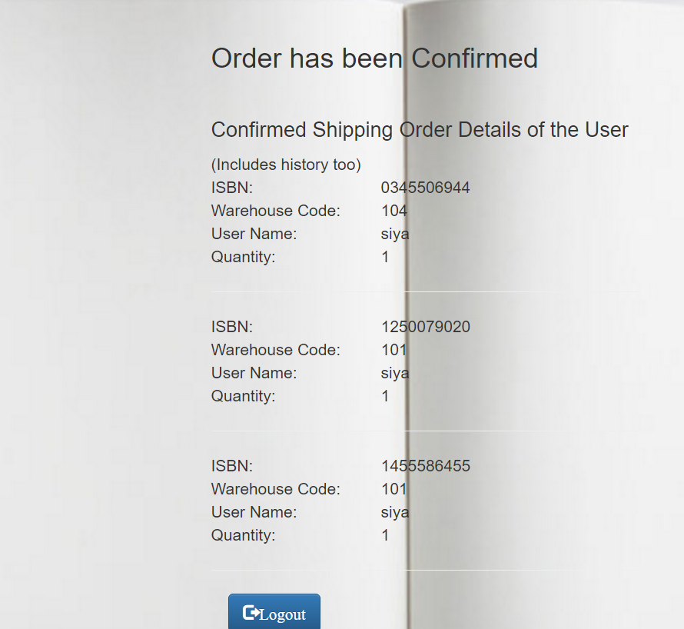

# Implementation

## 4.1 PHP Files

All the four PHP pages are implemented as per requirement. Comment for explanation are included in the files.

## 4.2 CSS File

A separate CSS file called ‘art.css’ file is maintained to give extra styling other than Bootstrap classes.

## 4.3 MySQL File

Database is designed as per the requirement.

## 4.4 TestData

**STEPS TO BE FOLLOWED WHILE TESTING THE APPLICATION:**

1. Create a Database Schema ‘cheapbook’ in phpMyAdmin. Then make an sql import of the database file ‘CheapBookDatabase.sql’.
2. Run the localhost using the url – **localhost/project4_seeram_likitha/customere.php**
3. Register a new User and provide all the fields.
4. Now Login with the registered user.
5. In the shopping page, search for books and add them to the cart by specifying a quantity.
6. Click on the cart icon to make the purchase.
7. In the cart page, click on ‘BUY’ to confirm.
8. Logout after checking the confirmation message.

# Conclusion

This project has made me learn the following technologies:

1. PHP
2. JQuery
3. Bootstrap
4. CSS
5. AJAX

As this project requires us to use all the technologies to work on a single site and traverse among different pages in the site and validate every step, it really made me how an actual online store works.