CIS 641 01 - IP - Systems Analysis and Design (F24) IC3 - CRC + Class + Object Models

Team members:

* **Likitha Magham**
* **Bhavana Arla**
* **Swethasarayu Simhadri CRC card(s):**

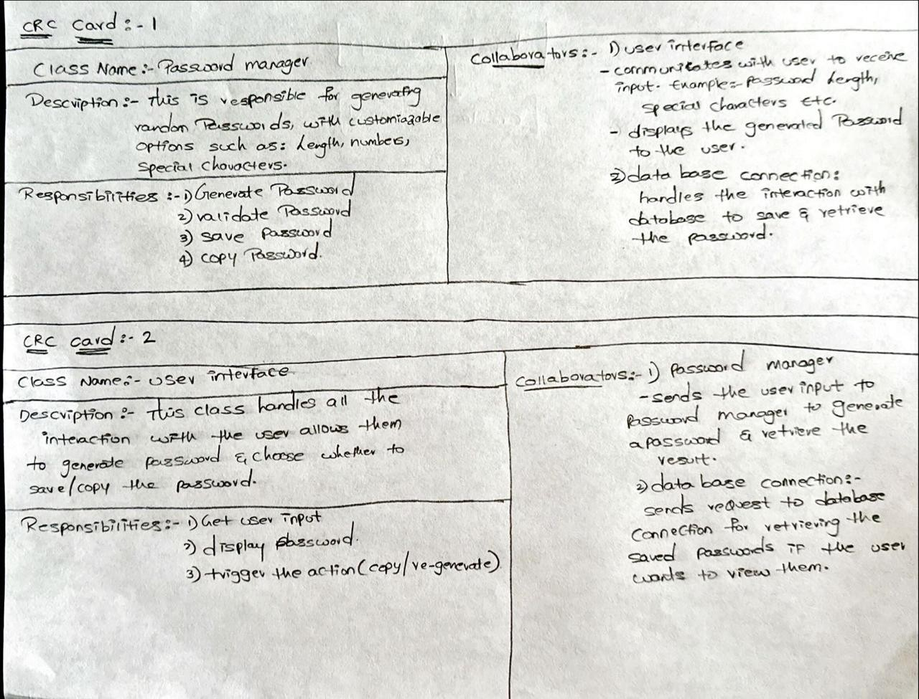

Class diagram: Class diagrams for adding a password and random password generator:

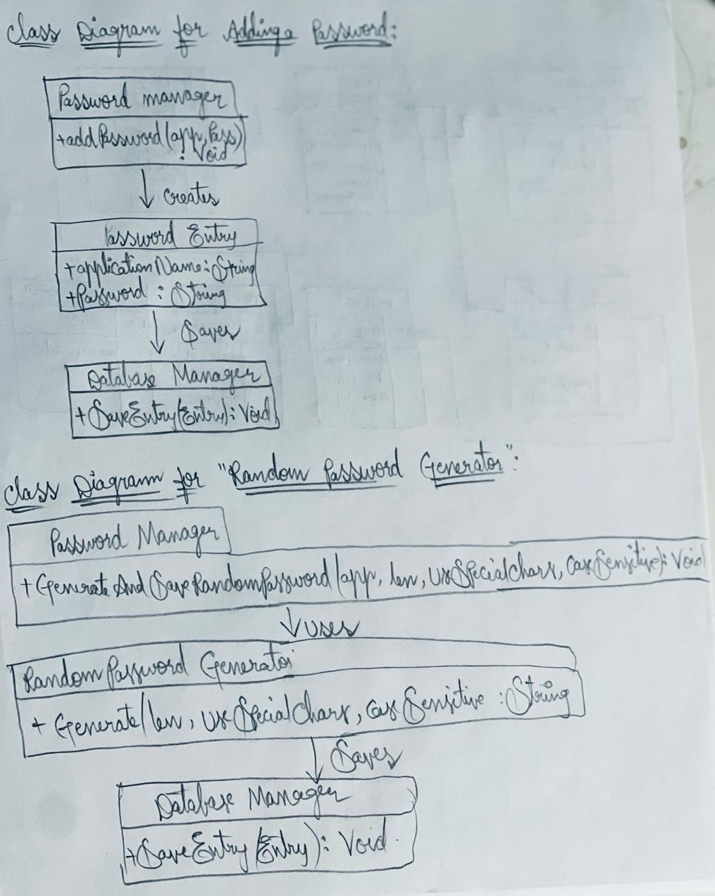

Object diagram for Random password generator:

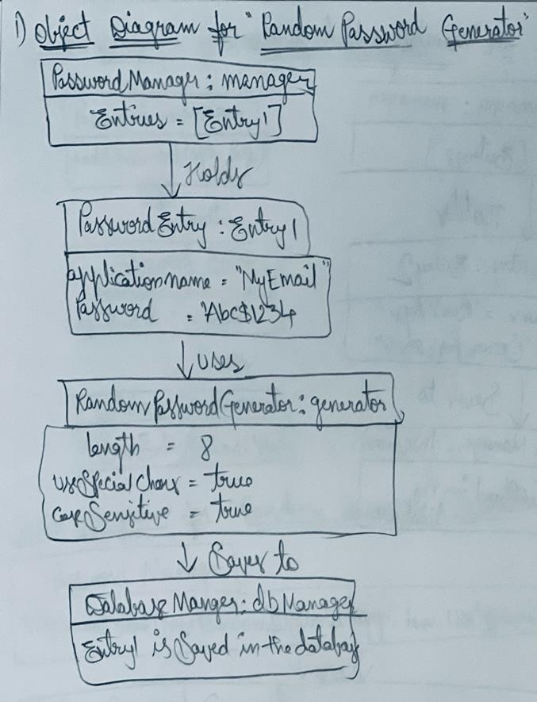

Object diagram for Manually added password:

