CIS 641 01 - IP - Systems Analysis and Design (F24) IC4 - Sequence + State Diagrams

State Diagram For Online Password Manager.

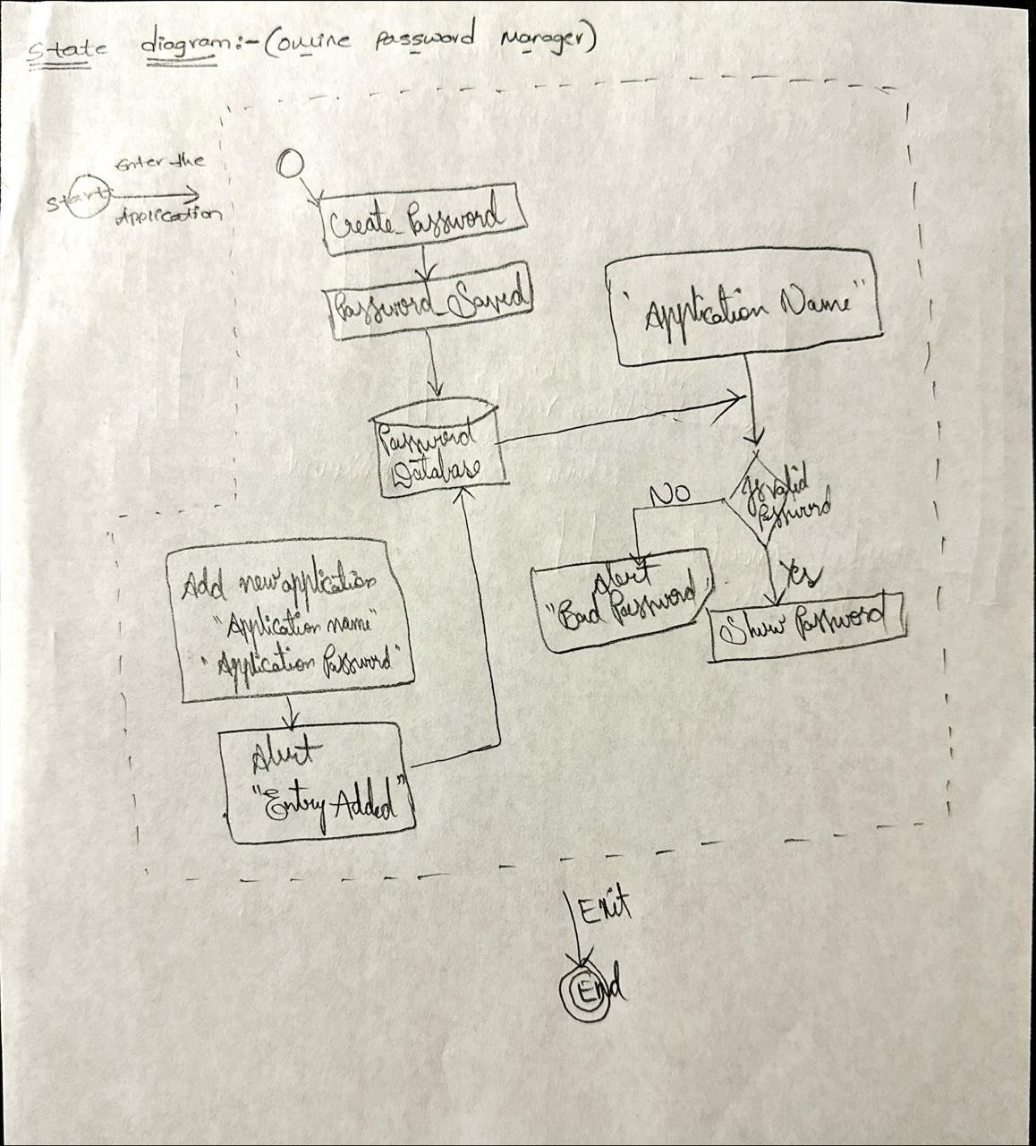

Sequence Diagram For Random Password Generator in Online Password Mnager

