BLDC Motor Hall-Sensor Fault Detection
Project Report

1. Problem Statement
Brushless DC (BLDC) motors rely on Hall-effect sensors to correctly time the switching of current between their three phase windings. If a Hall sensor becomes physically displaced or mistimed, the motor's phase currents become distorted in ways that are difficult to detect manually but can severely affect motor performance and reliability over time.
This project addresses the problem of automatically detecting Hall-sensor displacement faults in a BLDC motor using its phase-current measurements, converted into image form, and classified using deep learning. The specific goals set for this project were to:
- Reproduce a published, peer-reviewed AI-based fault-detection pipeline on its own published dataset.
- Correctly adapt that pipeline to the real structure, scale, and class balance of the actual downloaded data.
- Compare multiple deep learning architectures to identify which is best suited to this task.
- Evaluate detection performance across three different fault severities.
- Investigate a supplementary engineering question: could a single current sensor be used instead of three, via mathematical reconstruction of the missing two phases?

2. Sources Used
Dataset: IEEE DataPort - BLDC Hall Sensor Displacement (BLDC-HSD). Provides phase-current measurements for a BLDC motor under four conditions: healthy operation (no_delay) and three Hall-sensor delay severities (0.0001s, 0.005s, 0.01s), each supplied both as raw current signals and as pre-converted 224x224 RGB images for CNN input.
Reference code: GitHub repository yklee1014/BLDC-Fault-Detection, providing a reference transfer-learning pipeline comparing 8 pretrained CNN architectures for this classification task, associated with a published paper on compact MobileNet-based fault identification.
The reference code was written against the original authors' private file structure and required substantial adaptation before it could run on the actual downloaded dataset (see Section 4).

3. Tools and Technologies Used
Category | Tools / Technologies
Language | Python 3.12
Deep learning | TensorFlow 2.21, Keras (MobileNetV1/V2, VGG16, ResNet50, DenseNet121, InceptionV3, Xception, EfficientNetB0)
Data handling | pandas, NumPy, openpyxl, Pillow
Signal analysis | SciPy (FFT-based cross-correlation)
Visualization | Matplotlib
ML utilities | scikit-learn (train/test split, classification metrics, class weighting)
Web dashboard | Flask, Chart.js
Environment | Python venv, PowerShell, VS Code
Version control | Git, GitHub

4. What I Did: Environment Setup and Data Preparation

4.1 Environment setup
The lab machine's default Python installation (3.14.2) was too new for TensorFlow, which required 3.10-3.13. A compatible Python 3.12 installation was added alongside the existing one, and a dedicated virtual environment was created for the project. A separate issue was very slow package installation caused by running the project from a USB flash drive, which is poorly suited to installing software (many small files). This was resolved by relocating the project code to the internal drive while keeping the (large) dataset on the USB drive, with paths updated accordingly.

4.2 Dataset structure
The dataset provides, per condition, pre-converted RGB images (already augmented) and raw three-phase current Excel files. A key characteristic discovered during setup was a significant class imbalance: the healthy (no_delay) class contains only 120 images, while each fault condition contains approximately 715-719 images - roughly a 6:1 imbalance.

4.3 Correcting the reference pipeline
The original reference script pointed to the authors' own private folder paths and assumed a single folder containing both classes, distinguished by filename prefix. This did not match the actual downloaded dataset's structure (separate folders per class) and had to be rewritten. Class imbalance was initially addressed using class weighting, which proved insufficient (the model collapsed to predicting only the majority class); random undersampling of the majority class to match the minority class size (120 vs. 120) was ultimately used instead, and produced far more balanced, genuine classification performance.

5. Methodology: CNN-Based Fault Detection

5.1 Approach
Each of the 8 architectures uses transfer learning: an ImageNet-pretrained backbone is frozen, and a new classification head (GlobalAveragePooling2D -> Dense(1024, relu) -> Dense(2, softmax)) is trained on the motor image data. Data augmentation (random flip, rotation, zoom) is applied during training only. Training uses EarlyStopping with restore_best_weights=True and ModelCheckpoint, ensuring the reported result reflects the best-performing epoch rather than simply the last one.

5.2 Experimental design
The comparison loops over all 3 fault conditions and all 8 architectures (24 total training runs), automatically logging every result to a CSV file. This was run twice: once with the reference implementation's preprocessing approach, and again with a correction applied (Section 6.4).

6. Results: CNN Model Comparison

6.1 Run 1 (Original)
Test accuracy (%) per model per condition, using MobileNet-specific preprocessing for all 8 models (inherited from the reference implementation):
Model | 0.0001s | 0.005s | 0.01s | Average
MobileNetV1 | 72.9 | 79.2 | 70.8 | 74.3
InceptionV3 | 64.6 | 68.8 | 66.7 | 66.7
Xception | 60.4 | 66.7 | 68.8 | 65.3
DenseNet121 | 66.7 | 62.5 | 56.2 | 61.8
VGG16 | 60.4 | 50.0 | 68.8 | 59.7
MobileNetV2 | 60.4 | 54.2 | 64.6 | 59.7
ResNet50 | 50.0 | 50.0 | 70.8 | 56.9
EfficientNetB0 | 50.0 | 50.0 | 50.0 | 50.0

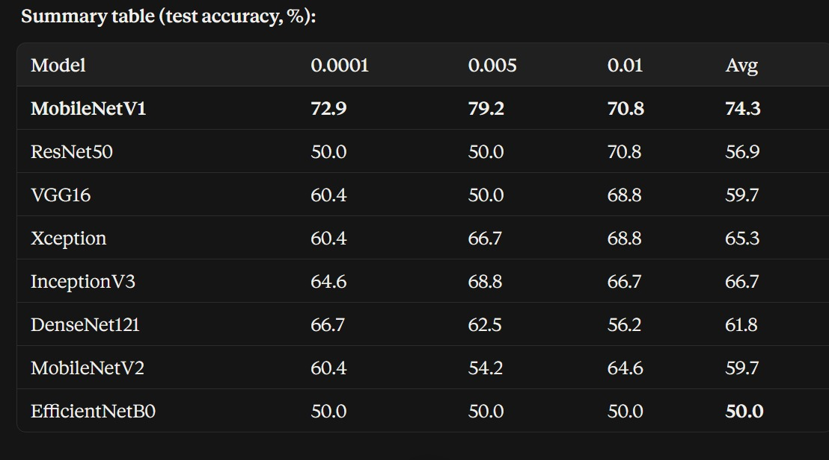
Figure 1: Run 1 (original) CNN model comparison, test accuracy (%) across the three fault severities.
Observation: MobileNetV1 appeared to win clearly. EfficientNetB0, ResNet50, and VGG16 frequently collapsed to exactly 50% accuracy (pure majority-class guessing), suspected to be caused by a preprocessing mismatch -- investigated further below.

6.2 Run 2 (Corrected Preprocessing)
Each architecture was given its own correct preprocess_input function (e.g. resnet50.preprocess_input, vgg16.preprocess_input, efficientnet.preprocess_input) instead of all models sharing MobileNet's. Every other variable (undersampling, augmentation, early stopping) was kept identical. Results were saved to a separate file so the original run remains available for direct comparison, not overwritten.
Model | 0.0001s | 0.005s | 0.01s | Average | Change
EfficientNetB0 | 72.9 | 75.0 | 72.9 | 73.6 | +23.6
MobileNetV1 | 66.7 | 70.8 | 66.7 | 68.1 | -6.2
ResNet50 | 62.5 | 68.8 | 68.8 | 66.7 | +9.8
InceptionV3 | 66.7 | 68.8 | 64.6 | 66.7 | 0.0
VGG16 | 68.8 | 68.8 | 60.4 | 66.0 | +6.3
DenseNet121 | 54.2 | 70.8 | 68.8 | 64.6 | +2.8
Xception | 52.1 | 70.8 | 62.5 | 61.8 | -3.5
MobileNetV2 | 54.2 | 64.6 | 47.9 | 55.6 | -4.1

Key finding: the preprocessing theory was confirmed dramatically for EfficientNetB0 -- it moved from complete class collapse (50.0%, always predicting "fault") to the single best-performing architecture overall (73.6%), a +23.6 point improvement from fixing preprocessing alone. ResNet50 (+9.8) and VGG16 (+6.3) also improved meaningfully, consistent with the hypothesis.
On MobileNetV1's small drop: its preprocessing never changed between runs, so the 74.3% to 68.1% shift is attributed to ordinary run-to-run variance from the random undersampling step (only 120 of ~715+ available fault images are sampled each run) rather than a real regression.
Revised conclusion: the original "MobileNetV1 wins clearly" finding was itself partly an artifact of the preprocessing bug. With it corrected, EfficientNetB0 and MobileNetV1 emerge as the two strongest architectures, both meaningfully ahead of the rest. Both runs are preserved as a demonstration of investigating a surprising result rather than accepting it at face value.

7. The Last Piece: Can a Single Current Sensor Replace Three?

7.1 Motivation
In a healthy three-phase motor, the three phase currents are ideally the same waveform shifted by 120 degrees and 240 degrees from each other. This raised a practical engineering question: could a single current sensor be sufficient, with the other two phases reconstructed mathematically, rather than requiring three physical sensors? This would offer meaningful hardware cost and complexity savings in a real deployment.

7.2 Experimental design
This was tested rigorously rather than assumed. The raw Excel files were found to already contain all three phase currents (ia, ib, ic) together per file - each file instead represents a specific Hall-sensor fault scenario (e.g. 0.01_delay_A.xlsx = 0.01s delay injected on Hall sensor A).
- Calibration: the timing lag and amplitude ratio between ia and ib/ic were measured using only the healthy (no_delay) data, simulating a realistic deployment where the reconstruction method is calibrated when the system is known to be healthy.
- Blind application: this fixed calibration was applied without adjustment to reconstruct ib and ic from ia across all four conditions, using a held-out time window distinct from the calibration window.
- Scoring: reconstruction accuracy was measured via normalized RMSE and correlation between reconstructed and actual signals.
An important preliminary finding during this process: a startup transient in the first ~10,000 samples of each recording was initially distorting measurements and was excluded by using a steady-state window (samples 300,000-360,000 for calibration; 400,000-460,000 for testing) deeper in each ~600,000-sample recording.

7.3 Results
Condition | ib norm-RMSE | ib correlation | ic norm-RMSE | ic correlation
no_delay (healthy) | 0.056 | 0.998 | 0.057 | 0.999
0.0001s (mild) | 0.165 | 0.986 | 0.247 | 0.970
0.005s (moderate) | 0.511 | 0.880 | 0.750 | 0.667
0.01s (severe) | 0.970 | 0.364 | 0.992 | 0.140

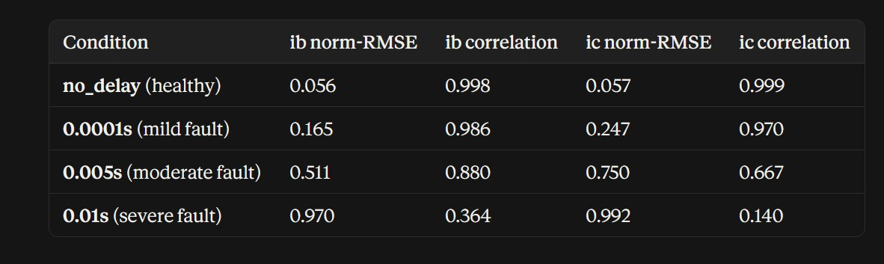
Figure 2: Phase-reconstruction accuracy (normalized RMSE and correlation) versus fault severity.
Reconstruction accuracy degrades monotonically across all four conditions and both reconstructed phases - a highly consistent trend across all 8 measurements taken.

7.4 Interpretation and Conclusion on This Question
Single-sensor reconstruction is not a viable replacement for three physical current sensors. While the method reconstructs healthy-condition currents near-perfectly (over 99.8% correlation), it fails specifically and severely under fault conditions - exactly when accurate sensing matters most. A control system relying on this reconstruction would behave normally when healthy, but receive badly corrupted phase-current estimates during an actual fault.
However, this failure mode is itself a valuable finding: because reconstruction error increases predictably and monotonically with fault severity, the reconstruction error itself is a viable, lightweight, AI-free fault indicator - requiring only a single sensor and a threshold on reconstruction error. This reframes the original question from "can 1 sensor fully replace 3?" (no) into "can reconstruction failure be used as a cheap health-check?" (promising, and a strong candidate for future work alongside the CNN-based approach).

8. Limitations
- Small dataset per condition for the CNN comparison (~240 images after balancing) -- causes some run-to-run variance from random undersampling, visible when comparing Run 1 and Run 2 results.
- Random undersampling discarded a majority of available fault images to achieve class balance.
- All training and analysis was performed on CPU only.
- The corrected run (Section 6.2) fixes input preprocessing but does not explore other architecture-specific tuning (e.g. native input resolution, unfreezing later layers).
- The phase-reconstruction experiment used a fixed linear (shift + scale) model; more sophisticated reconstruction methods were not explored.

9. Conclusion
This project successfully adapted a published reference AI pipeline to a real IEEE-published BLDC motor fault dataset, diagnosing and correcting genuine environment-setup, data-imbalance, and preprocessing obstacles along the way. The comparison was run twice: an original pass that appeared to show MobileNetV1 as a clear winner, and a corrected pass with proper per-model preprocessing that revealed EfficientNetB0 and MobileNetV1 as the two strongest architectures, with EfficientNetB0 improving by 23.6 percentage points once its preprocessing was fixed. Both runs are preserved for direct comparison, illustrating the value of investigating a surprising result rather than reporting it at face value.
A supplementary investigation into single-sensor reconstruction produced a clear, well-evidenced negative result for its original purpose, while uncovering a promising secondary application: reconstruction error as a simple, low-cost fault indicator. Together, these pieces represent a complete investigation - a working, comparative AI system refined through genuine debugging, and a rigorously tested engineering hypothesis with an honest, data-backed conclusion.

