**23CSE111**

**OBJECT ORIENTED PROGRAMMING**

**LAB REPORT**



**Department of Computer Science Engineering**

**Amrita School of Computing**

**Amrita Vishwa Vidyapeetham, Amaravati Campus**

**Name: P.LIKITHA LEKHYA**

**Verified By Roll No: 24240**

**WEEK-1**

**1) Explain the process of Installing JDK (Java Development Kit)**

**Installing of JDK (Java Development Kit):**

1. **Download JDK:**
   * Go to the Oracle JDK download page in your web browser and click on JDK-21 version which is Long term support (LTS) version.
   * Click on the download link for your operating system (Windows, macOS, or Linux).
2. **Install JDK:**
   * Once downloaded, run the installer.
   * Follow the instructions and keep clicking "Next" until it's done.
3. **Set Environment Variables (Windows):**
   * Open file explorer, then right click on This PC next select on properties then it will take you to the settings app then click on advanced system settings and then  
     click on **Environment Variables**.
   * Click **New** under **System Variables**:
     + **Set Variable name as:** java_home
     + **Variable value:** The folder address where JDK is installed (like C:\Program Files\Java\jdk-21\bin)
   * Find Path under **System Variables**, click **Edit**, and add the path of the jdk-21(C:\Program Files\Java\jdk-21\bin)
   * 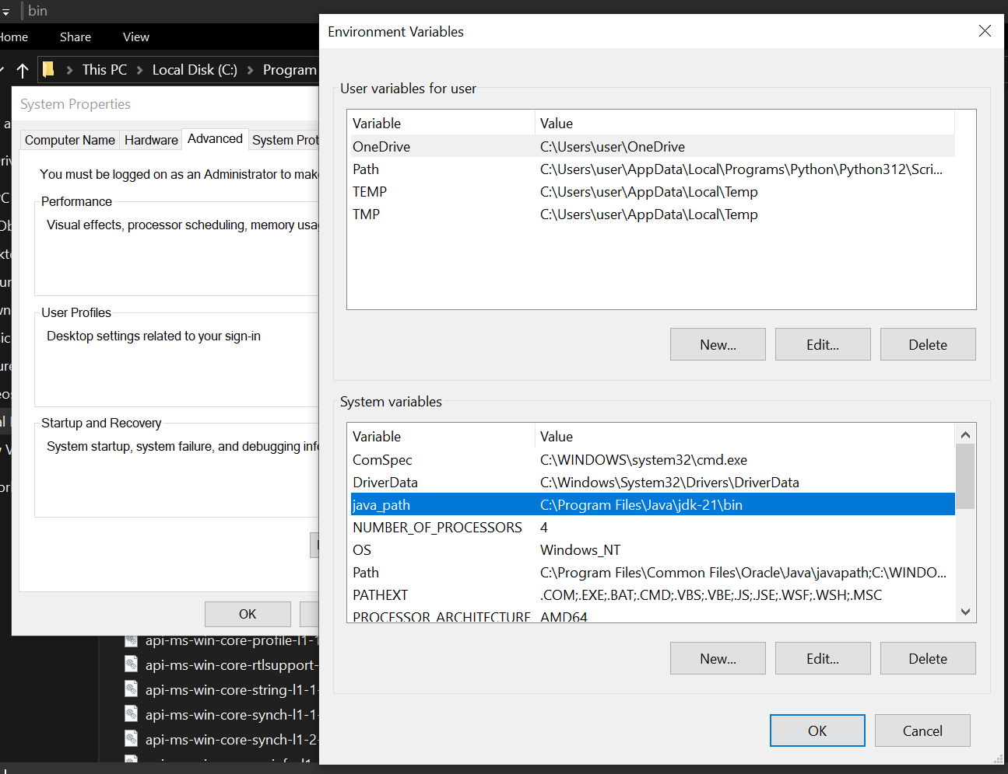

**Checking of JDK Version:**

1. **Open Command Prompt:**
   * Press win+R, type cmd, and press Enter.
2. **Check Version:**
   * Type java --version and press Enter.
   * Type javac --version and press Enter.

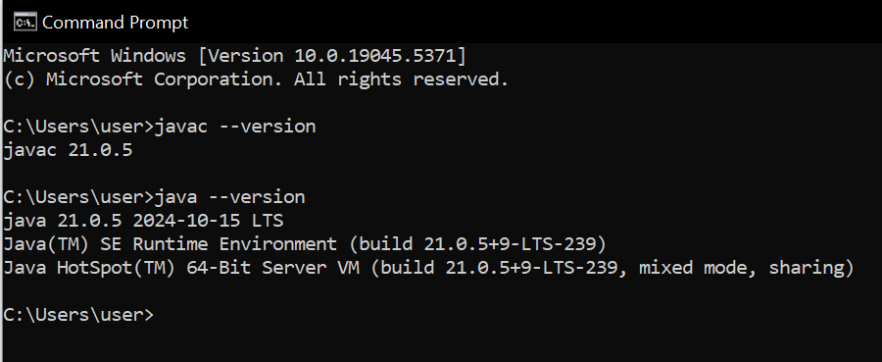

**TASK-1 Print helloworld:-**

public class helloworld {

public static void main(String[] args) {

System.out.println("Hello World");

}

}

**Output:**

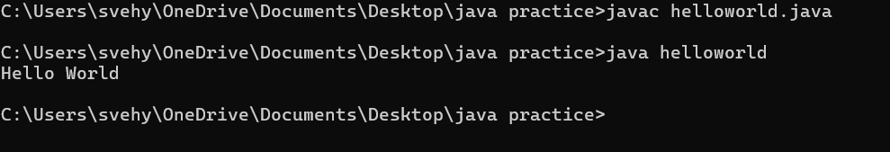

**STUDENT DETAILS:**

public class Studentsdetails {

public static void main(String[] args){

System.out.println("Name:Likitha Lekhya");

System.out.println("rollno:24240");

System.out.println("course:btech");

}

}

**OUTPUT:**

