**R.LIKITHA**

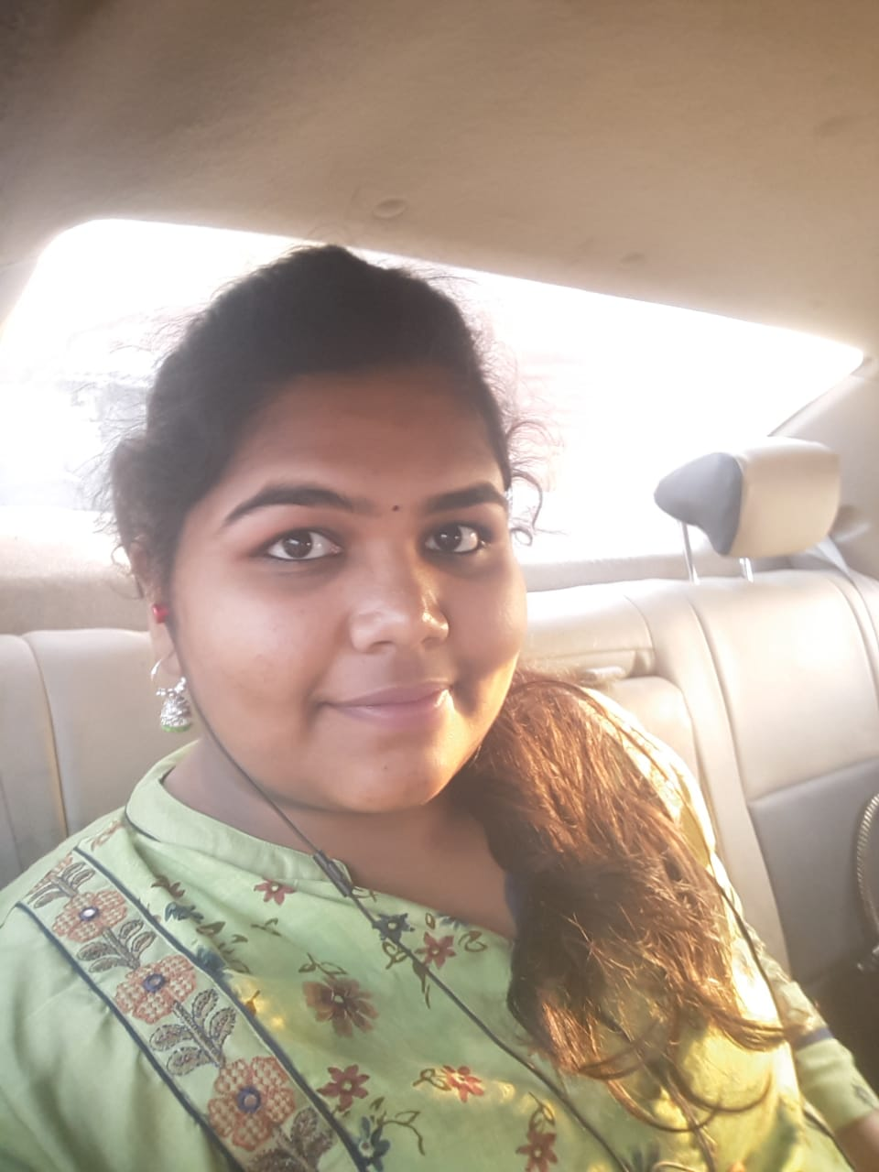

E-mail:likithavsln.642@gmail.com

Contact:9840715940

Linkdin:Likitha R

**CAREER OBJECTIVE:**

To work in a company where I can showcase my knowledge and skills for the growth of the company and to enhance my skills. To progressively improve on skills and tocome with strong technical knowledge, programming, and design skills.

**EDUCATIONAL QUALIFICATION:**

|  |  |  |  |  |  |
| --- | --- | --- | --- | --- | --- |
| **S.NO** | **Name of the course** | **Institution** | **Board/University** | **Year** | **Marks** |
| 1. | B.E (CSE) | Panimalar Institute of Technology. | Anna University | 2021 | 7.94 |
| 2 | Intermediate | VelammalVidhyashram  Surapet | Central Board of Secondary Education | 2017 | 71% |
| 3. | SSC | VelammalVidhyashram  Surapet | Central Board of Secondary Education | 2015 | 82% |

**TECHNICAL SKILLS:**

Programming Languages : C ,Python and basics of oops , DBMS basics

Basics : MS Word,MS excel and MS powerpoint

Areas of Interest : Block chain Technology, Artificial Intelligence.

**ACHIEVEMENTS:**

* Won many prizes in quiz competitions& talent tests conducted by specific organisations during my schooling.
* Won prizes in drawing and music competitions.

**ACCOMPLISHMENTS:**

* Attended short term course on “**INTERNET OF THINGS**” through Industry Institute Training by M/S.INFoZIANT SYSTEMS PVT.LTD.
* Attended short term course on “**WEB DESIGNING**” through Industry Institute Training by M/S.INFoZIANT SYSTEMS PVT.LTD.
* Implant training at Doordarshan Kendra.
* Participated in ” QUIZ COMPETITION” held at Panimalar Institute of Technology,chennai.
* Participated in Implant Training on “MOBILE APP DEVELOPMENT” conducted by Infoziantat Chennai.
* Attended flutter learning as a short-term course.
* Completed a online career edge conducted by TCS “Knockdown the Lockdown”.

**PERSONALITY TRAITS:**

* Dedication, self-motivation, positive attitude and confidence to achieve goals.
* Willingness to learn and contribute to the growth of organization.
* Fast Learner, positive Attitude & Deep analysis
* Problem Solver.
* Good etiquette & optimistic
* Success motivated & good communication skills

**INTERESTS:**

Travelling, Playing shuttle, Coding simple programs and Reading novels.

**PERSONAL PROFILE:**

* Name : R.LIKITHA
* Father’s Name : R.VENKATA RAMANIAH
* Date of Birth : 06/04/2000
* Nationality : Indian.
* Permanent address : NO.15/89A 8TH STREET

NORTH JAGANATH NAGAR

VILLIVAKKAM CHENNAI:49

* Languages Known : English, Telugu,Tamil and Hindi

**DECLARATION:**

I hereby declare that the information furnished above is authentic to the best of my knowledge and belief.

Place: Chennai

DATE

LIKITHA