Name: LIKITHA KONDURU
Student ID No: 16316157
Module Name: Machine Learning and Big Data
Module Code: 7006SCN
Assignment Title: Individual Coursework Assignment
GitHub Link: https://github.com/Likitha8k/cifer_faurd_detection.git

Tableau Dashboard Link: https://public.tableau.com/views/Dataqualityandpipelinemonitoring_17722191177230/ScalabilityAnalysis?:language=en-US&:sid=&:redirect=auth&publish=yes&showOnboarding=true&:display_count=n&:origin=viz_share_link

Abstract
This report shows the PySpark workflow of detecting fraud in large scale financial transaction data is challenging because of the class imbalance and computational. This report shows the Pyspark workflow by using a Medallion architecture. The Cifer Fraud Detection dataset is 1.84GB of csv files data was downloaded through Hugging Face and fed into a Bronze layer through Spark RDDs. A Silver layer uses validation, standardisation of types, and feature engineering of domains, and stores curated Parquet partitioned by day and type of transaction. A Gold layer makes aggregates of analytics and pushes single CSV files to Tableau dashboards. A 10% sample of the data is fitted by a Spark MLlib pipeline using four classifiers (Logistic Regression, Decision Tree, Random Forest, GBT) to train the classifiers to fit within the Colab compute budget. The PR-AUC and ROC-AUC are used to compare the models The Decision tree gave the best PR-AUC score 0.001264 but the difference between models is small and extra care is needed during evaluating the models on highly imbalanced big data accompanied by paired bootstrap testing and diagnostic plots.

Table of Contents
Abstract 2
1. Introduction 4
2. Dataset Overview 4
3. Description of The Dataset and Explotation 4
4. Exploratory Data Analysis 5
5. Big Data Challenges 5
6. Methodology 6
6.1 Preprocessing pipeline 6
6.2 Data Splitting Stratergy 6
6.3 Model Selection And Justification 6
6.4 Performance Metrics………………………………………………………………………7
6.5 Computational Considerations…………………………………………………………….7
7. Results 8
8. Discussion 8
9. Conclusions and Future Work 9
References 10
Appendices 11
Appendix 1: Code 11
Appendix 2: Tableau Dashboards 41

1. Introduction
The classification involves large, imbalanced transaction data, which is a very expensive undertaking for fraud detection (Gupta, et al., 2023). Previous research have This project develops an end-to-end workflow, which can facilitate scalable ingestion, data-layered reproducibility, distributed modelling, and a dashboard product. The objectives that the work would achieve include:
- Instantiate Bronze, Silver, and Gold layers in traceability and reuse.
- Compare a set of MLlib models in a unified preprocessing pipeline.
- Generate Tableau-ready output to monitor, provide insights and discuss scalability.

2. Dataset Overview
In this project, snapshot_download of the dataset is used to retrieve the dataset of CiferAI/Cifer-Fraud-Detection-Dataset-AF (Frey, et al., 2026). It has 11 fields that consist of step, type of transaction, amount, origin and destination account balance variables and two binary labels (isFraud and isFlaggedFraud). The target of the modelling is Fraud. Another derived variable step_day, is also generated as step/24 in order to partition and monitor on a daily basis. The data is received in the form of files of several CSV parts that allow ingesting data in parallel.

3. Description of The Dataset and Exploration
Exploration is based on distributed checks to prevent loading of complete data into local memory (Tang, et al., 2020). The strict schema is used in the course of ingestion to ensure that numeric and label fields are typed properly. Since parsing is confirmed by a small sample after Bronze ingestion. Spark aggregation in Silver logs the number of rows, null values of key fields, the number of negative amounts and label domain violations, and these checks are stored as JSON evidence. The type of EDA output that is treated as the main is the gold aggregates as it is reproducible and can be used directly in a dashboard.

4. Exploratory Data Analysis
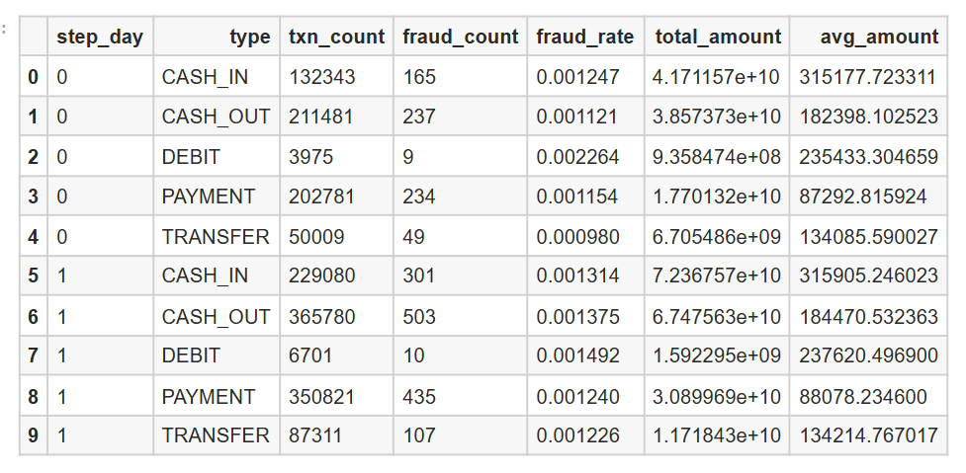
Figure 1: Gold results
The table of EDA is summarised in the Gold tables. The table of the day is sorted by step day and type and the number of transactions, number of frauds, the fraud rate, amount, and average amount. CASH_IN has 132,343 transactions on day 0 with fraud rate of 0.001247 and avg amount of 315,177.72 and CASH_OUT has 211,481 transactions with a fraud rate of 0.001121 and an avg amount of 182,398.10. CASH_OUT of 365,780 transactions and a fraud rate of 0.001375 appear on day 1, which shows that both the volume and risk vary. More Gold views include hourly (hour of day by type) and amount-band risk (less than 10 or greater than or equal to 10k). One row of the null-rate profile can be used to monitor completeness.

5. Big Data Challenges
Raw CSV parsing is costly because RDD can only do Bronze ingestion, and DataFrames are then applied to optimise Spark SQL (Karau & Warren, 2017). The caching limits of Colab memory make caching the entire dataset of silver risky and thus the pipeline does not save the entire dataset but only a 1% sample, showing that caching the entire dataset is safe. The step-day and type step-by partitioning and storage of shuffle-heavy group-bys are done using Parquet. Adaptive query execution is enabled and it is configured to use shuffle partitions of 200 to balance between parallelism and overhead in local mode.

6. Methodology

6.1 Pre-processing pipeline
Bronze reads the CSV files through SparkContext.textFile, filters them of their performances, characterises each line defensively, and constructs a DataFrame, which shows a clear-cut scheme. The steps followed are ingestion_ts and step_day added and the Parquet partitioned step-day written by bronze. Silver interprets Bronze Parquet, normalises type, casts numerical values, requires amounts greater than 0 and labels limited to 0 or 1. Silver functions to calculate org balance delta, dest balance delta, and the hour of day after which a parquet containing the step of day and type is written. Gold parses and makes four curated datasets: daily KPIs by type, hourly KPIs by type, amount-band KPIs by type, and a null-rate profile. All of the Gold datasets are also exported as a single CSV file in Tableau as tableau_csv.

6.2 Data Splitting Strategy
A 10% sample in Silver data is used in training so as to stay within possibilities and leave the engineering pipeline on full-scale data. Domain Feature Engineer is a custom transformer that generates amount log 1p, absolute balance deltas and a flag of zero balance. It is a transaction that is coded with a StringIndexer and OneHotEncoder. Vector Assembler is used to assemble features and StandardScaler is used to scale features.

6.3 Model Selection & Justification
Four MLlib classifiers are trained using the same preprocesses their maxIter is 30, 8, 80 and 10, respectively Logistic Regression, Decision Tree, Random Forest, and Gradient Boosted Trees. Randomisation is done with a seed of 80% training and 20% test.

6.4 Performance Metrics
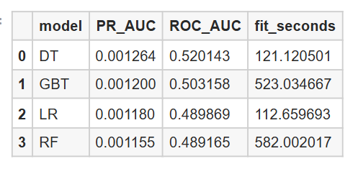
Figure 2: Model results
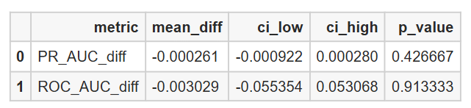
Figure 3: Significance tests results
Assessed reports PR-AUC and ROC-AUC with PR-AUC given precedence in case of imbalance. Paired bootstrap testing compares the best two models on up to 200,000 rows of evaluations: the difference in the PR-AUC of the models is -0.000261 (interval -0.000922 to 0.000280, p=0.426667), and the difference in the ROC-AUC of the models is -0.003029 (interval -0.055354 to 0.053068). The visual evidence consists of a confusion matrix (threshold 0.5), ROC and precision -recall curve, a learning curve and feature importance plot indicating balance delta variables and destination balance fields.

6.5 Computational Considerations
The silver write runtime is written in silver_write_seconds in the file write_seconds.json. Decision Tree was outperformed by ROC-AUC 0.520143 and PR-AUC 0.001264 with the corresponding fit time of 121.12 seconds. GBT achieved PR-AUC 0.001200 and ROC-AUC 0.503158 in 523.03 seconds. PR-AUC 0.001180 and ROC-AUC 0.489869 values of LR and RF were 112.66 seconds and 582.00 seconds, respectively.

7. Results
The pipeline generated Medallion storage and Tableau-needs outputs comprehensively. Bronze eliminates the multiple parsing of raw text, Silver enhances consistency and is capable of pruning through partitioning, and Gold offers curated aggregates and a small null-rate profile. In this run Model comparison places Decision Tree first on PR-AUC though ensemble methods need much longer to fit, impacting cost and iteration speed. The testing of significance implies that there is not much separation between the best models, the operational constraints and stability should also be considered during the process of model selection.
To perform dashboarding, four Gold CSV files are generated: gold_volume_by_day_type.csv to monitor data on a daily basis, gold_hourly_by-type.csv to track data on an hourly basis, gold_amount-bands-by-type.csv to segment data by amount, and gold-quality-null-rates.csv to represent data quality KPIs. These files are purposely small in comparison with the raw data since these files are an aggregate of measures and not row transactions, making Tableau much quicker. The same Gold outputs can also be used to compare timing and volume across runs, such as comparing write seconds to rows processed, and to examine the influence of shuffle partitions on the time to do aggregation. This design saves reload time and enables repetitive reporting of stakeholders.

8. Discussion
The engineering design addresses big data requirements by using RDD ingest, DataFrame optimisation, and layered storage, which isolates raw, cleaned, and curated data. Dividing by step-day and type facilitates typical access trends of analytics. The modelling findings are also weaker when there is an imbalance and sampling and the bootstrap findings show apparent ranking differences cannot be robust. The feature importance indicates that balance movement is informative, and that more features of behaviour, imbalance handling, and threshold tuning are probably necessary to enhance practical recall without too many false positives. Scalability has been shown using storage design, partitioning, shuffle controls, and recorded ETL runtime, and multi-node and GPU benchmarking have yet to be performed.

9. Conclusions and Future Work
This project provided a complete workflow of large-scale (big-data) fraud-detection in PySpark. Bronze consumed raw CSV data through RDD and the partitioned Parquet was stored. Silver implemented validation and feature engineering and captured ETL runtime evidence. Gold generated curated aggregates and single CSV files, which were sent to Tableau dashboards. The comparison of four MLlib classifiers trained based on PR-AUC and ROC-AUC was supported by the bootstrap testing and diagnostic plots. It should be enhanced in the future with more robust imbalance management, more features, and threshold optimisation according to business costs, and introduce grading of scalability to multi-node runtimes with CPUs and GPUs to provide more robust evidence of cost-performance.

References
Frey, J., Tuna, T., Fu, F., Patterson, K., Xu, T., Fallon, M., ... & Hutter, M. (2026). GrandTour: A Legged Robotics Dataset in the Wild for Multi-Modal Perception and State Estimation. arXiv preprint arXiv:2602.18164. https://doi.org/10.48550/arXiv.2602.18164
Gupta, P., Varshney, A., Khan, M. R., Ahmed, R., Shuaib, M., & Alam, S. (2023). Unbalanced credit card fraud detection data: A machine learning-oriented comparative study of balancing techniques. Procedia Computer Science, 218, 2575-2584. https://doi.org/10.1016/j.procs.2023.01.231
Karau, H., & Warren, R. (2017). High performance Spark: best practices for scaling and optimizing Apache Spark. " O'Reilly Media, Inc.". https://books.google.com/books?hl=en&lr=&id=90glDwAAQBAJ&oi=fnd&pg=PP1&dq=Raw+CSV+parsing+is+costly+because+RDD+can+only+do+Bronze+ingestion,+and+DataFrames+are+then+applied+to+optimise+Spark+SQL.+&ots=FBaKL2Xjxd&sig=or0OXqo3bUGcTnqna7R4-5oCbM4
Tang, M., Yu, Y., Mahmood, A. R., Malluhi, Q. M., Ouzzani, M., & Aref, W. G. (2020). Locationspark: In-memory distributed spatial query processing and optimization. Frontiers in big Data, 3, 30. https://doi.org/10.3389/fdata.2020.00030

Appendices

Appendix 1: Code
%%capture
!pip -q install -U pyspark pyarrow scikit-learn matplotlib huggingface_hub
from pathlib import Path

PROJECT_ROOT = Path("/content")

DATA_DIR = PROJECT_ROOT / "data"
BRONZE_DIR = DATA_DIR / "bronze"
SILVER_DIR = DATA_DIR / "silver"
GOLD_DIR = DATA_DIR / "gold"

TABLEAU_DIR = GOLD_DIR / "tableau_csv"

OUTPUTS_DIR = PROJECT_ROOT / "outputs"
FIGURES_DIR = OUTPUTS_DIR / "figures"
METRICS_DIR = OUTPUTS_DIR / "metrics"

HF_CACHE_DIR = PROJECT_ROOT / ".hf_cache"
HF_DATASET_DIR = PROJECT_ROOT / "hf_dataset"

for p in [BRONZE_DIR, SILVER_DIR, GOLD_DIR, TABLEAU_DIR, FIGURES_DIR, METRICS_DIR, HF_CACHE_DIR, HF_DATASET_DIR]:
p.mkdir(parents=True, exist_ok=True)
1 Spark session
from pyspark.sql import SparkSession

spark = (
SparkSession.builder
.appName("CiferFraudColab")
.master("local[*]")
.config("spark.sql.shuffle.partitions", "200")
.config("spark.sql.adaptive.enabled", "true")
.config("spark.sql.execution.arrow.pyspark.enabled", "true")
.config("spark.local.dir", str(OUTPUTS_DIR / "spark_local_dir"))
.getOrCreate()
)

spark.sparkContext.setLogLevel("WARN")

2 Download dataset files (raw CSV)
from huggingface_hub import snapshot_download
from pathlib import Path
import glob

DATASET_REPO = "CiferAI/Cifer-Fraud-Detection-Dataset-AF"

snapshot_download(
repo_id=DATASET_REPO,
repo_type="dataset",
cache_dir=str(HF_CACHE_DIR),
local_dir=str(HF_DATASET_DIR),
local_dir_use_symlinks=False,
)

csv_files = sorted(glob.glob(str(HF_DATASET_DIR / "**" / "*.csv"), recursive=True))
if len(csv_files) == 0:
raise RuntimeError("CSV files not found in hf_dataset")

Output:
/usr/local/lib/python3.12/dist-packages/huggingface_hub/utils/_validators.py:202: UserWarning: The `local_dir_use_symlinks` argument is deprecated and ignored in `snapshot_download`. Downloading to a local directory does not use symlinks anymore.
warnings.warn(
/usr/local/lib/python3.12/dist-packages/huggingface_hub/utils/_auth.py:94: UserWarning:
The secret `HF_TOKEN` does not exist in your Colab secrets.
To authenticate with the Hugging Face Hub, create a token in your settings tab (https://huggingface.co/settings/tokens), set it as secret in your Google Colab and restart your session.
You will be able to reuse this secret in all of your notebooks.
Please note that authentication is recommended but still optional to access public models or datasets.
warnings.warn(
Download complete: 1.84GB [13:00<00:00, 530MB/s]
Fetching 16 files: 100% | 16/16 [00:12<00:00, 2.21it/s]
3 Bronze (RDD raw ingestion -> Parquet)
import csv
from io import StringIO
from pyspark.sql import Row
from pyspark.sql.types import StructType, StructField, IntegerType, StringType, DoubleType
from pyspark.sql import functions as F

schema = StructType([
StructField("step", IntegerType(), True),
StructField("type", StringType(), True),
StructField("amount", DoubleType(), True),
StructField("nameOrig", StringType(), True),
StructField("oldbalanceOrg", DoubleType(), True),
StructField("newbalanceOrig", DoubleType(), True),
StructField("nameDest", StringType(), True),
StructField("oldbalanceDest", DoubleType(), True),
StructField("newbalanceDest", DoubleType(), True),
StructField("isFraud", IntegerType(), True),
StructField("isFlaggedFraud", IntegerType(), True),
])

HEADER_PREFIX = "step,"

def parse_line(line):
try:
fields = next(csv.reader(StringIO(line)))
if len(fields) != 11:
return None
return Row(
step=int(fields[0]),
type=fields[1],
amount=float(fields[2]),
nameOrig=fields[3],
oldbalanceOrg=float(fields[4]),
newbalanceOrig=float(fields[5]),
nameDest=fields[6],
oldbalanceDest=float(fields[7]),
newbalanceDest=float(fields[8]),
isFraud=int(fields[9]),
isFlaggedFraud=int(fields[10]),
)
except Exception:
return None

rdd = spark.sparkContext.textFile(",".join(csv_files))
rdd = rdd.filter(lambda x: x and not x.startswith(HEADER_PREFIX))
good = rdd.map(parse_line).filter(lambda x: x is not None)

df_bronze = spark.createDataFrame(good, schema=schema)

df_bronze = (
df_bronze.withColumn("ingestion_ts", F.current_timestamp())
.withColumn("step_day", (F.col("step") / F.lit(24)).cast("int"))
)

(df_bronze.repartition("step_day")
.write.mode("overwrite")
.partitionBy("step_day")
.parquet(str(BRONZE_DIR / "transactions_parquet")))

df_bronze.select("step", "type", "amount", "isFraud").limit(5).toPandas()
 | step | type | amount | isFraud
0 | 371 | CASH_OUT | 367336.05 | 0
1 | 368 | TRANSFER | 238.63 | 0
2 | 141 | CASH_OUT | 254.93 | 0
3 | 191 | CASH_IN | 501547.39 | 0
4 | 169 | TRANSFER | 71832.00 | 0
4 Silver (cleaning + validation -> Parquet)
import json
import time
from pyspark.sql import functions as F
from pyspark.storagelevel import StorageLevel

df = spark.read.parquet(str(BRONZE_DIR / "transactions_parquet"))

qc = df.agg(
F.count("*").alias("rows"),
F.sum(F.col("step").isNull().cast("int")).alias("null_step"),
F.sum(F.col("type").isNull().cast("int")).alias("null_type"),
F.sum((F.col("amount") < 0).cast("int")).alias("neg_amount"),
F.sum((~F.col("isFraud").isin([0, 1])).cast("int")).alias("isFraud_not_01"),
F.sum((~F.col("isFlaggedFraud").isin([0, 1])).cast("int")).alias("isFlaggedFraud_not_01"),
).collect()[0].asDict()

(METRICS_DIR / "silver_quality_checks.json").write_text(json.dumps(qc, indent=2))

df_silver = (
df.withColumn("type", F.upper(F.trim(F.col("type"))))
.withColumn("amount", F.col("amount").cast("double"))
.withColumn("oldbalanceOrg", F.col("oldbalanceOrg").cast("double"))
.withColumn("newbalanceOrig", F.col("newbalanceOrig").cast("double"))
.withColumn("oldbalanceDest", F.col("oldbalanceDest").cast("double"))
.withColumn("newbalanceDest", F.col("newbalanceDest").cast("double"))
.withColumn("isFraud", F.col("isFraud").cast("int"))
.withColumn("isFlaggedFraud", F.col("isFlaggedFraud").cast("int"))
)

df_silver = df_silver.filter(F.col("amount") >= 0)
df_silver = df_silver.filter(F.col("isFraud").isin([0, 1]) & F.col("isFlaggedFraud").isin([0, 1]))

df_silver = (
df_silver.withColumn("org_balance_delta", F.col("newbalanceOrig") - F.col("oldbalanceOrg"))
.withColumn("dest_balance_delta", F.col("newbalanceDest") - F.col("oldbalanceDest"))
.withColumn("hour_of_day", (F.col("step") % 24).cast("int"))
)

t0 = time.time()

(df_silver
.write.mode("overwrite")
.partitionBy("step_day", "type")
.parquet(str(SILVER_DIR / "transactions_parquet")))

t1 = time.time()
(METRICS_DIR / "silver_write_seconds.json").write_text(json.dumps({"write_seconds": round(t1 - t0, 3)}, indent=2))

df_cache_sample = df_silver.sample(False, 0.01, seed=42).persist(StorageLevel.MEMORY_AND_DISK)
_ = df_cache_sample.count()
df_cache_sample.unpersist()

spark.read.parquet(str(SILVER_DIR / "transactions_parquet")).select("step", "type", "amount", "isFraud").limit(5).toPandas()
 | step | type | amount | isFraud
0 | 107 | CASH_OUT | 97613.37 | 0
1 | 109 | CASH_OUT | 200527.00 | 0
2 | 100 | CASH_OUT | 478927.38 | 0
3 | 99 | CASH_OUT | 6461.69 | 0
4 | 98 | CASH_OUT | 682863.52 | 0
5 Gold
import shutil
from pathlib import Path
from pyspark.sql import functions as F

df = spark.read.parquet(str(SILVER_DIR / "transactions_parquet"))

gold_volume = (
df.groupBy("step_day", "type")
.agg(
F.count("*").alias("txn_count"),
F.sum(F.col("isFraud")).alias("fraud_count"),
(F.sum(F.col("isFraud")) / F.count("*")).alias("fraud_rate"),
F.sum("amount").alias("total_amount"),
F.avg("amount").alias("avg_amount"),
)
)

gold_hourly = (
df.groupBy("hour_of_day", "type")
.agg(
F.count("*").alias("txn_count"),
F.sum(F.col("isFraud")).alias("fraud_count"),
(F.sum(F.col("isFraud")) / F.count("*")).alias("fraud_rate"),
F.avg("amount").alias("avg_amount"),
)
)

gold_amount_bands = (
df.withColumn(
"amount_band",
F.when(F.col("amount") < 10, "<10")
.when(F.col("amount") < 100, "10-99")
.when(F.col("amount") < 1000, "100-999")
.when(F.col("amount") < 10000, "1k-9.9k")
.otherwise(">=10k")
)
.groupBy("amount_band", "type")
.agg(
F.count("*").alias("txn_count"),
F.sum("isFraud").alias("fraud_count"),
(F.sum("isFraud") / F.count("*")).alias("fraud_rate"),
F.avg("amount").alias("avg_amount"),
)
)

cols = ["step", "type", "amount", "nameOrig", "oldbalanceOrg", "newbalanceOrig",
"nameDest", "oldbalanceDest", "newbalanceDest", "isFraud", "isFlaggedFraud"]

total = df.count()
exprs = [(F.sum(F.col(c).isNull().cast("int")) / F.lit(total)).alias(f"null_rate_{c}") for c in cols]
gold_quality = df.agg(*exprs)

def write_gold_parquet(df_in, name):
df_in.write.mode("overwrite").parquet(str(GOLD_DIR / name / "parquet"))

def write_single_csv(df_in, out_file: Path):
tmp_dir = out_file.parent / (out_file.stem + "_tmp")
if tmp_dir.exists():
shutil.rmtree(tmp_dir)
(df_in.coalesce(1)
.write.mode("overwrite")
.option("header", True)
.csv(str(tmp_dir)))
part = next(tmp_dir.glob("part-*.csv"))
if out_file.exists():
out_file.unlink()
part.replace(out_file)
shutil.rmtree(tmp_dir)

write_gold_parquet(gold_volume, "gold_volume_by_day_type")
write_gold_parquet(gold_hourly, "gold_hourly_by_type")
write_gold_parquet(gold_amount_bands, "gold_amount_bands_by_type")
write_gold_parquet(gold_quality, "gold_quality_null_rates")

write_single_csv(gold_volume, TABLEAU_DIR / "gold_volume_by_day_type.csv")
write_single_csv(gold_hourly, TABLEAU_DIR / "gold_hourly_by_type.csv")
write_single_csv(gold_amount_bands, TABLEAU_DIR / "gold_amount_bands_by_type.csv")
write_single_csv(gold_quality, TABLEAU_DIR / "gold_quality_null_rates.csv")

gold_volume.orderBy("step_day", "type").limit(10).toPandas()

 | step_day | type | txn_count | fraud_count | fraud_rate | total_amount | avg_amount
0 | 0 | CASH_IN | 132343 | 165 | 0.001247 | 4.171157e+10 | 315177.723311
1 | 0 | CASH_OUT | 211481 | 237 | 0.001121 | 3.857373e+10 | 182398.102523
2 | 0 | DEBIT | 3975 | 9 | 0.002264 | 9.358474e+08 | 235433.304659
3 | 0 | PAYMENT | 202781 | 234 | 0.001154 | 1.770132e+10 | 87292.815924
4 | 0 | TRANSFER | 50009 | 49 | 0.000980 | 6.705486e+09 | 134085.590027
5 | 1 | CASH_IN | 229080 | 301 | 0.001314 | 7.236757e+10 | 315905.246023
6 | 1 | CASH_OUT | 365780 | 503 | 0.001375 | 6.747563e+10 | 184470.532363
7 | 1 | DEBIT | 6701 | 10 | 0.001492 | 1.592295e+09 | 237620.496900
8 | 1 | PAYMENT | 350821 | 435 | 0.001240 | 3.089969e+10 | 88078.234600
9 | 1 | TRANSFER | 87311 | 107 | 0.001226 | 1.171843e+10 | 134214.767017

6 ML pipeline (Spark MLlib) + model comparison table
import time
import pandas as pd
import numpy as np
import matplotlib.pyplot as plt
from pyspark.sql import functions as F
from pyspark.ml import Pipeline
from pyspark.ml.feature import StringIndexer, OneHotEncoder, VectorAssembler, StandardScaler
from pyspark.ml.classification import LogisticRegression, DecisionTreeClassifier, RandomForestClassifier, GBTClassifier
from pyspark.ml.evaluation import BinaryClassificationEvaluator
from pyspark.ml import Transformer
from pyspark.ml.util import DefaultParamsReadable, DefaultParamsWritable
from pyspark.sql import DataFrame

TRAIN_SAMPLE_FRACTION = 0.10

df = spark.read.parquet(str(SILVER_DIR / "transactions_parquet")).sample(False, TRAIN_SAMPLE_FRACTION, seed=42)

label_col = "isFraud"

class DomainFeatureEngineer(Transformer, DefaultParamsReadable, DefaultParamsWritable):
def _transform(self, dataset: DataFrame) -> DataFrame:
return (
dataset
.withColumn("amount_log1p", F.log1p(F.col("amount")))
.withColumn("abs_org_delta", F.abs(F.col("org_balance_delta")))
.withColumn("abs_dest_delta", F.abs(F.col("dest_balance_delta")))
.withColumn("is_zero_newbalanceOrig", (F.col("newbalanceOrig") == 0).cast("int"))
)

feat_eng = DomainFeatureEngineer()

type_indexer = StringIndexer(inputCol="type", outputCol="type_idx", handleInvalid="keep")
type_ohe = OneHotEncoder(inputCols=["type_idx"], outputCols=["type_ohe"])

numeric_cols = [
"amount", "oldbalanceOrg", "newbalanceOrig", "oldbalanceDest", "newbalanceDest",
"org_balance_delta", "dest_balance_delta", "hour_of_day", "isFlaggedFraud",
"amount_log1p", "abs_org_delta", "abs_dest_delta", "is_zero_newbalanceOrig"
]

assembler = VectorAssembler(inputCols=["type_ohe"] + numeric_cols, outputCol="features_raw", handleInvalid="keep")
scaler = StandardScaler(inputCol="features_raw", outputCol="features", withStd=True, withMean=False)

base_stages = [feat_eng, type_indexer, type_ohe, assembler, scaler]

train, test = df.randomSplit([0.8, 0.2], seed=42)

evaluator_pr = BinaryClassificationEvaluator(labelCol=label_col, rawPredictionCol="rawPrediction", metricName="areaUnderPR")
evaluator_roc = BinaryClassificationEvaluator(labelCol=label_col, rawPredictionCol="rawPrediction", metricName="areaUnderROC")

models = {
"LR": LogisticRegression(featuresCol="features", labelCol=label_col, maxIter=30),
"DT": DecisionTreeClassifier(featuresCol="features", labelCol=label_col, maxDepth=8),
"RF": RandomForestClassifier(featuresCol="features", labelCol=label_col, numTrees=80, maxDepth=10),
"GBT": GBTClassifier(featuresCol="features", labelCol=label_col, maxIter=50, maxDepth=5),
}

fitted = {}
rows = []

for name, clf in models.items():
pipe = Pipeline(stages=base_stages + [clf])
t0 = time.time()
m = pipe.fit(train)
t1 = time.time()
pred = m.transform(test)
pr = float(evaluator_pr.evaluate(pred))
roc = float(evaluator_roc.evaluate(pred))
rows.append({"model": name, "PR_AUC": pr, "ROC_AUC": roc, "fit_seconds": float(t1-t0)})
fitted[name] = m

metrics_df = pd.DataFrame(rows).sort_values("PR_AUC", ascending=False).reset_index(drop=True)
(METRICS_DIR / "spark_mllib_metrics.json").write_text(metrics_df.to_json(orient="records", indent=2))
metrics_df
 | model | PR_AUC | ROC_AUC | fit_seconds
0 | DT | 0.001264 | 0.520143 | 121.120501
1 | GBT | 0.001200 | 0.503158 | 523.034667
2 | LR | 0.001180 | 0.489869 | 112.659693
3 | RF | 0.001155 | 0.489165 | 582.002017
7 Significance tests + curves + confusion matrix
from pyspark.sql import functions as F
from pyspark.ml.functions import vector_to_array

from sklearn.metrics import (
average_precision_score, roc_auc_score,
roc_curve, precision_recall_curve,
confusion_matrix
)

best_two = metrics_df.loc[:1, "model"].tolist()

eval_df = test.sample(False, 0.20, seed=7).limit(200000)

def get_scores(model_name):
p = fitted[model_name].transform(eval_df).select(
F.col(label_col).cast("int").alias("y"),
vector_to_array("probability")[1].alias("p")
)
return p.toPandas()

pdf_a = get_scores(best_two[0])
pdf_b = get_scores(best_two[1])

y = pdf_a["y"].to_numpy()
pa = pdf_a["p"].to_numpy()
pb = pdf_b["p"].to_numpy()

import numpy as np
import pandas as pd
import matplotlib.pyplot as plt

def paired_bootstrap_pvalue(y_true, p1, p2, metric_fn, n_boot=300, seed=42):
rng = np.random.RandomState(seed)
n = len(y_true)
idx = np.arange(n)
diffs = []
for _ in range(n_boot):
b = rng.choice(idx, size=n, replace=True)
diffs.append(metric_fn(y_true[b], p1[b]) - metric_fn(y_true[b], p2[b]))
diffs = np.array(diffs)
p = float(2 * min((diffs <= 0).mean(), (diffs >= 0).mean()))
return float(diffs.mean()), float(np.quantile(diffs, 0.025)), float(np.quantile(diffs, 0.975)), p

pr_mean, pr_lo, pr_hi, pr_p = paired_bootstrap_pvalue(y, pa, pb, average_precision_score, n_boot=300)
roc_mean, roc_lo, roc_hi, roc_p = paired_bootstrap_pvalue(y, pa, pb, roc_auc_score, n_boot=300)

sig = pd.DataFrame([
{"metric": "PR_AUC_diff", "mean_diff": pr_mean, "ci_low": pr_lo, "ci_high": pr_hi, "p_value": pr_p},
{"metric": "ROC_AUC_diff", "mean_diff": roc_mean, "ci_low": roc_lo, "ci_high": roc_hi, "p_value": roc_p},
])
(METRICS_DIR / "paired_bootstrap_significance.json").write_text(sig.to_json(orient="records", indent=2))

thr = 0.5
cm = confusion_matrix(y, (pa >= thr).astype(int))

fig = plt.figure()
ax = fig.add_subplot(111)
ax.imshow(cm)
ax.set_xlabel("Predicted")
ax.set_ylabel("Actual")
ax.set_title("Confusion Matrix")
for (i, j), v in np.ndenumerate(cm):
ax.text(j, i, str(v), ha="center", va="center")
fig.tight_layout()
fig.savefig(FIGURES_DIR / "confusion_matrix.png", dpi=200)
plt.show()

fpr, tpr, _ = roc_curve(y, pa)
fig = plt.figure()
ax = fig.add_subplot(111)
ax.plot(fpr, tpr)
ax.set_xlabel("False Positive Rate")
ax.set_ylabel("True Positive Rate")
ax.set_title("ROC Curve")
fig.tight_layout()
fig.savefig(FIGURES_DIR / "roc_curve.png", dpi=200)
plt.show()

prec, rec, _ = precision_recall_curve(y, pa)
fig = plt.figure()
ax = fig.add_subplot(111)
ax.plot(rec, prec)
ax.set_xlabel("Recall")
ax.set_ylabel("Precision")
ax.set_title("Precision-Recall Curve")
fig.tight_layout()
fig.savefig(FIGURES_DIR / "pr_curve.png", dpi=200)
plt.show()

sig
Output:
Output:
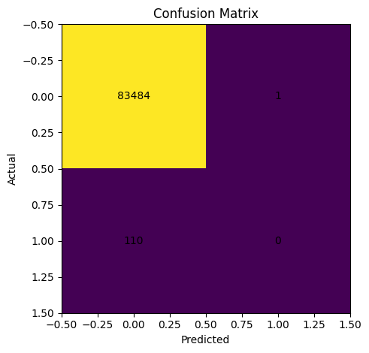
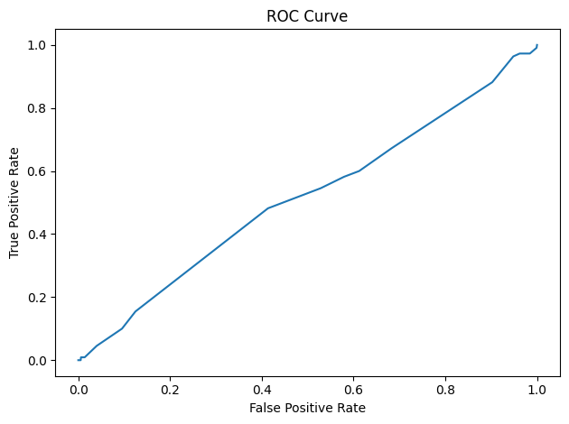
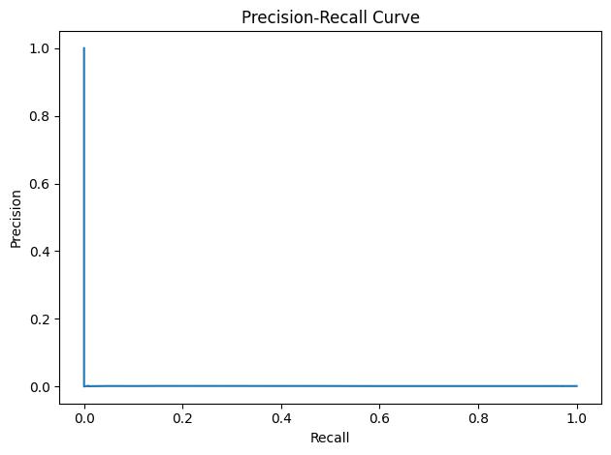
 | metric | mean_diff | ci_low | ci_high | p_value
0 | PR_AUC_diff | -0.000261 | -0.000922 | 0.000280 | 0.426667
1 | ROC_AUC_diff | -0.003029 | -0.055354 | 0.053068 | 0.913333
8 Learning curve + feature importance plots
import pandas as pd
from sklearn.model_selection import train_test_split
from sklearn.preprocessing import OneHotEncoder
from sklearn.compose import ColumnTransformer
from sklearn.pipeline import Pipeline as SkPipeline
from sklearn.linear_model import LogisticRegression as SkLR
from sklearn.ensemble import RandomForestClassifier
from sklearn.metrics import average_precision_score

base_pdf = (
spark.read.parquet(str(SILVER_DIR / "transactions_parquet"))
.sample(False, 0.01, seed=10)
.select("type", "amount", "oldbalanceOrg", "newbalanceOrig", "oldbalanceDest", "newbalanceDest",
"org_balance_delta", "dest_balance_delta", "hour_of_day", "isFlaggedFraud", "isFraud")
.limit(300000)
.toPandas()
)

X = base_pdf.drop(columns=["isFraud"])
y2 = base_pdf["isFraud"].astype(int)

cat_cols = ["type"]
num_cols = [c for c in X.columns if c not in cat_cols]

pre = ColumnTransformer([
("cat", OneHotEncoder(handle_unknown="ignore"), cat_cols),
("num", "passthrough", num_cols),
])

Xt, Xv, yt, yv = train_test_split(X, y2, test_size=0.2, random_state=42, stratify=y2)

sizes = [20000, 50000, 100000, 200000]
scores = []
for s in sizes:
m = SkPipeline(steps=[("pre", pre), ("clf", SkLR(max_iter=300, n_jobs=-1))])
m.fit(Xt.iloc[:s], yt.iloc[:s])
p = m.predict_proba(Xv)[:, 1]
scores.append(float(average_precision_score(yv, p)))

lc = pd.DataFrame({"train_size": sizes, "PR_AUC": scores})
(METRICS_DIR / "learning_curve_pr_auc.json").write_text(lc.to_json(orient="records", indent=2))

fig = plt.figure()
ax = fig.add_subplot(111)
ax.plot(lc["train_size"], lc["PR_AUC"])
ax.set_xlabel("Train size")
ax.set_ylabel("PR-AUC")
ax.set_title("Learning Curve (PR-AUC)")
fig.tight_layout()
fig.savefig(FIGURES_DIR / "learning_curve.png", dpi=200)
plt.show()

rf = SkPipeline(steps=[("pre", pre), ("clf", RandomForestClassifier(n_estimators=200, n_jobs=-1, random_state=42))])
rf.fit(Xt, yt)

try:
feature_names = rf.named_steps["pre"].get_feature_names_out()
except Exception:
feature_names = np.array([f"f{i}" for i in range(rf.named_steps["clf"].feature_importances_.shape[0])])

imp = rf.named_steps["clf"].feature_importances_
imp_df = pd.DataFrame({"feature": feature_names, "importance": imp}).sort_values("importance", ascending=False).head(20)
(METRICS_DIR / "feature_importance_top20.json").write_text(imp_df.to_json(orient="records", indent=2))

fig = plt.figure(figsize=(8, 6))
ax = fig.add_subplot(111)
ax.barh(imp_df["feature"][::-1], imp_df["importance"][::-1])
ax.set_xlabel("Importance")
ax.set_title("Feature Importance (Top 20)")
fig.tight_layout()
fig.savefig(FIGURES_DIR / "feature_importance.png", dpi=200)
plt.show()

imp_df
/usr/local/lib/python3.12/dist-packages/sklearn/linear_model/_logistic.py:1184: FutureWarning: 'n_jobs' has no effect since 1.8 and will be removed in 1.10. You provided 'n_jobs=-1', please leave it unspecified.
warnings.warn(msg, category=FutureWarning)
/usr/local/lib/python3.12/dist-packages/sklearn/linear_model/_logistic.py:1184: FutureWarning: 'n_jobs' has no effect since 1.8 and will be removed in 1.10. You provided 'n_jobs=-1', please leave it unspecified.
warnings.warn(msg, category=FutureWarning)
/usr/local/lib/python3.12/dist-packages/sklearn/linear_model/_logistic.py:1184: FutureWarning: 'n_jobs' has no effect since 1.8 and will be removed in 1.10. You provided 'n_jobs=-1', please leave it unspecified.
warnings.warn(msg, category=FutureWarning)
/usr/local/lib/python3.12/dist-packages/sklearn/linear_model/_logistic.py:1184: FutureWarning: 'n_jobs' has no effect since 1.8 and will be removed in 1.10. You provided 'n_jobs=-1', please leave it unspecified.
warnings.warn(msg, category=FutureWarning)
Output:
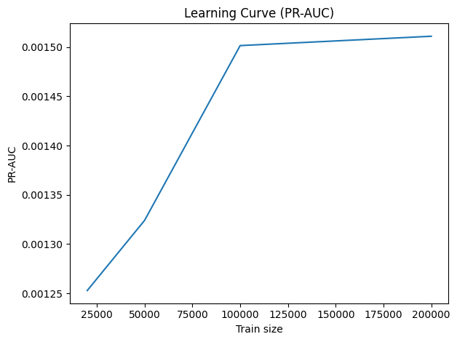
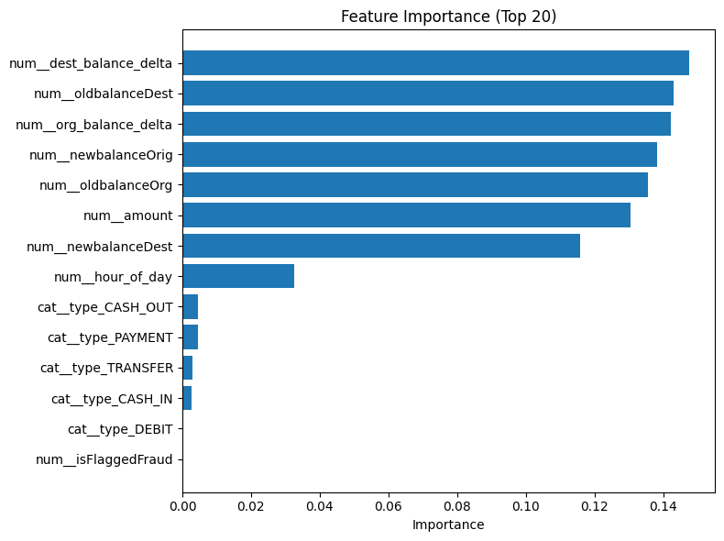
 | feature | importance
11 | num__dest_balance_delta | 0.147641
8 | num__oldbalanceDest | 0.142984
10 | num__org_balance_delta | 0.142187
7 | num__newbalanceOrig | 0.138233
6 | num__oldbalanceOrg | 0.135658
5 | num__amount | 0.130452
9 | num__newbalanceDest | 0.115698
12 | num__hour_of_day | 0.032534
1 | cat__type_CASH_OUT | 0.004489
3 | cat__type_PAYMENT | 0.004448
4 | cat__type_TRANSFER | 0.002968
0 | cat__type_CASH_IN | 0.002668
2 | cat__type_DEBIT | 0.000039
13 | num__isFlaggedFraud | 0.000000

Appendix 2: Tableau Dashboards
Dashboard 1: Data Quality and pipeline monitoring
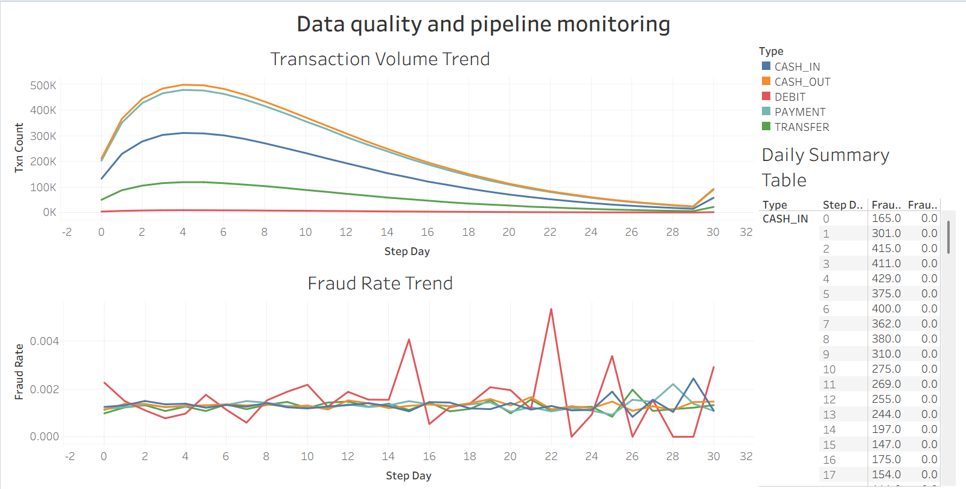
Dashboard 2: Model performance and feature importance
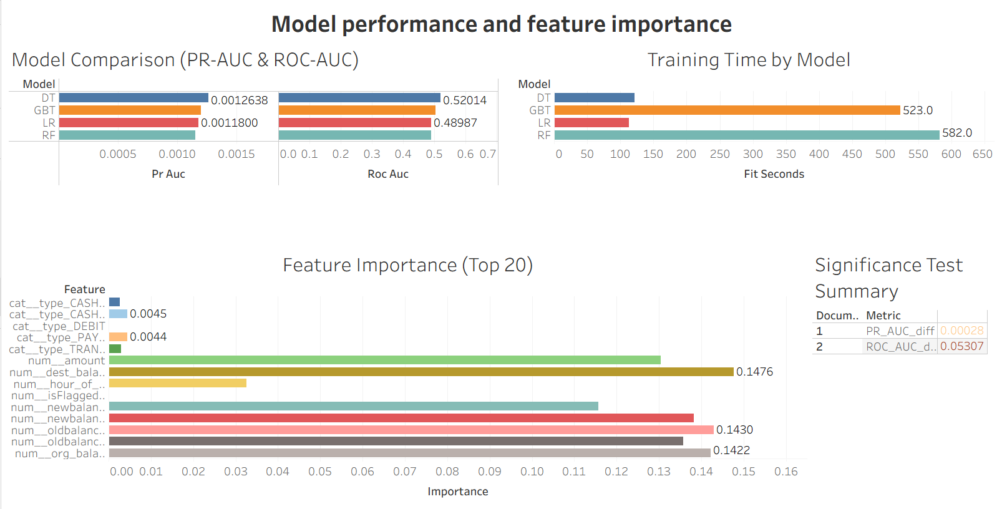

Dashboard 3: Business Insights
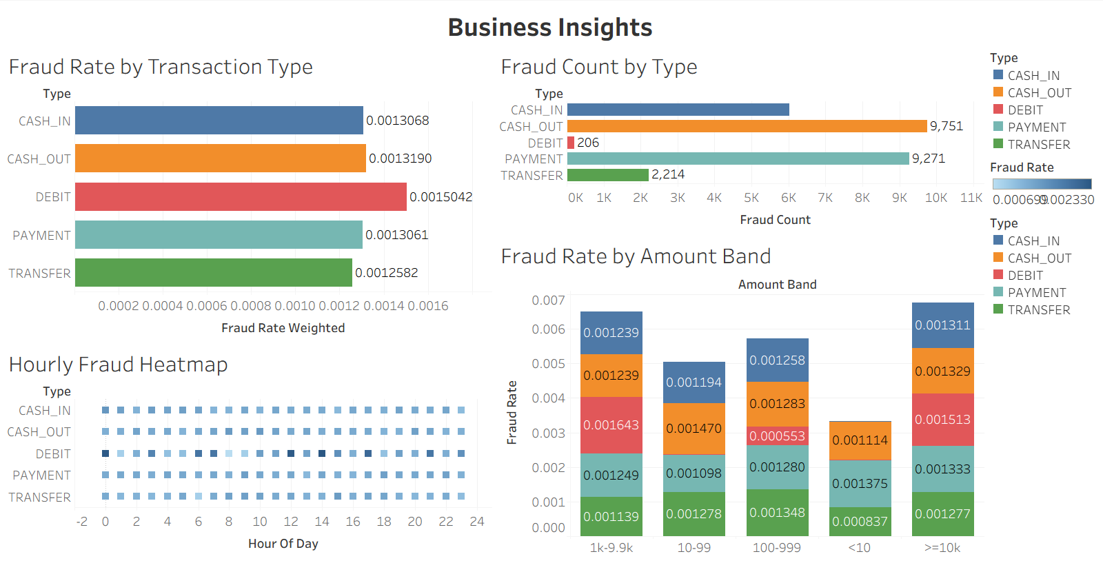
Dashboard 4: Scalability Analysis
