**WEEK-2-PL/SQL**

**Exercise 1: Control Structures**

**Scenario 1:** The bank wants to apply a discount to loan interest rates for customers above 60 years old.

**Question:** Write a PL/SQL block that loops through all customers, checks their age, and if they are above 60, apply a 1% discount to their current loan interest rates.

**Query:**

BEGIN

FOR cust IN (SELECT c.CustomerID, l.LoanID, l.InterestRate, c.DOB

FROM Customers c

JOIN Loans l ON c.CustomerID = l.CustomerID) LOOP

IF MONTHS_BETWEEN(SYSDATE, cust.DOB) / 12 > 60 THEN

UPDATE Loans

SET InterestRate = InterestRate - 1

WHERE LoanID = cust.LoanID;

END IF;

END LOOP;

END;

/

**Output:**

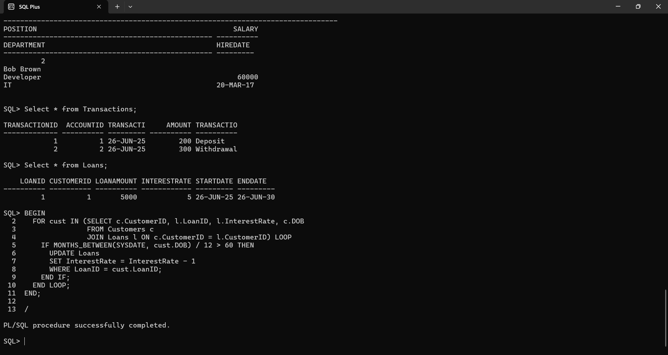

**Scenario 2:** A customer can be promoted to VIP status based on their balance.

* + **Question:** Write a PL/SQL block that iterates through all customers and sets a flag IsVIP to TRUE for those with a balance over $10,000.

**Query:**

BEGIN

FOR cust IN (SELECT CustomerID FROM Customers WHERE Balance > 10000) LOOP

UPDATE Customers

SET IsVIP = 'TRUE'

WHERE CustomerID = cust.CustomerID;

END LOOP;

END;

/

Output:

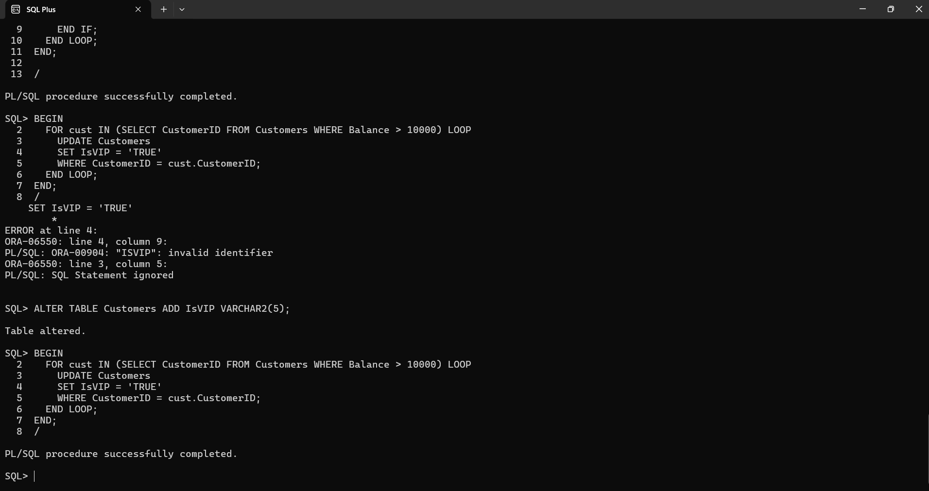

**Scenario 3:** The bank wants to send reminders to customers whose loans are due within the next 30 days.

* + **Question:** Write a PL/SQL block that fetches all loans due in the next 30 days and prints a reminder message for each customer.

**Query:**

BEGIN

FOR l IN (SELECT LoanID, CustomerID, EndDate

FROM Loans

WHERE EndDate BETWEEN SYSDATE AND SYSDATE + 30) LOOP

DBMS_OUTPUT.PUT_LINE('Reminder: Customer ' || l.CustomerID || ' has a loan due on ' || TO_CHAR(l.EndDate, 'YYYY-MM-DD'));

END LOOP;

END;

/

**Output:**

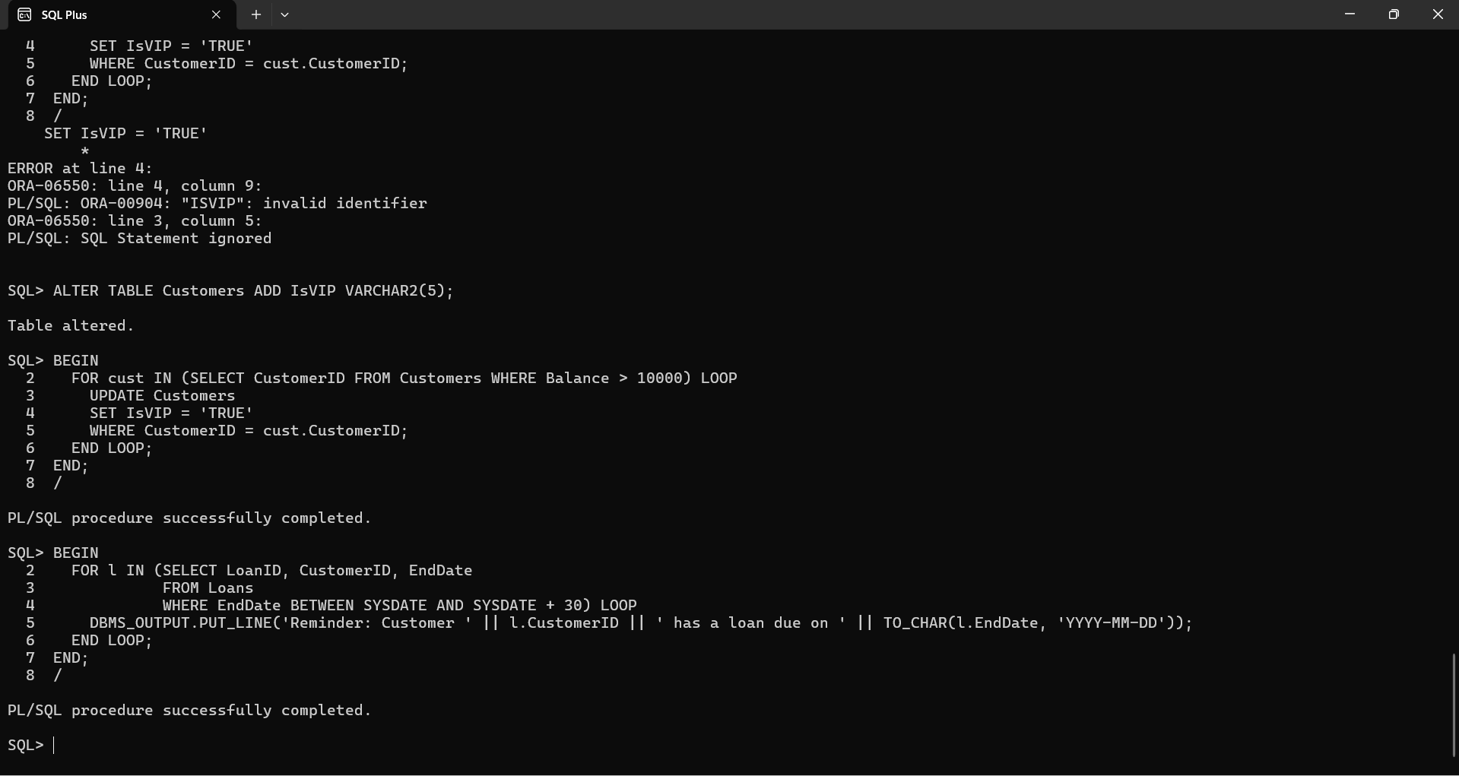

**Exercise 2: Error Handling**

**Scenario 1:** Handle exceptions during fund transfers between accounts.

* + **Question:** Write a stored procedure **SafeTransferFunds** that transfers funds between two accounts. Ensure that if any error occurs (e.g., insufficient funds), an appropriate error message is logged and the transaction is rolled back.

**Query:**

CREATE OR REPLACE PROCEDURE SafeTransferFunds(

p_FromAccountID IN NUMBER,

p_ToAccountID IN NUMBER,

p_Amount IN NUMBER

) AS

v_FromBalance NUMBER;

BEGIN

SELECT Balance INTO v_FromBalance FROM Accounts WHERE AccountID = p_FromAccountID;

IF v_FromBalance < p_Amount THEN

RAISE_APPLICATION_ERROR(-20001, 'Insufficient funds.');

END IF;

UPDATE Accounts SET Balance = Balance - p_Amount WHERE AccountID = p_FromAccountID;

UPDATE Accounts SET Balance = Balance + p_Amount WHERE AccountID = p_ToAccountID;

COMMIT;

EXCEPTION

WHEN OTHERS THEN

ROLLBACK;

DBMS_OUTPUT.PUT_LINE('Error: ' || SQLERRM);

END;

**Output:**

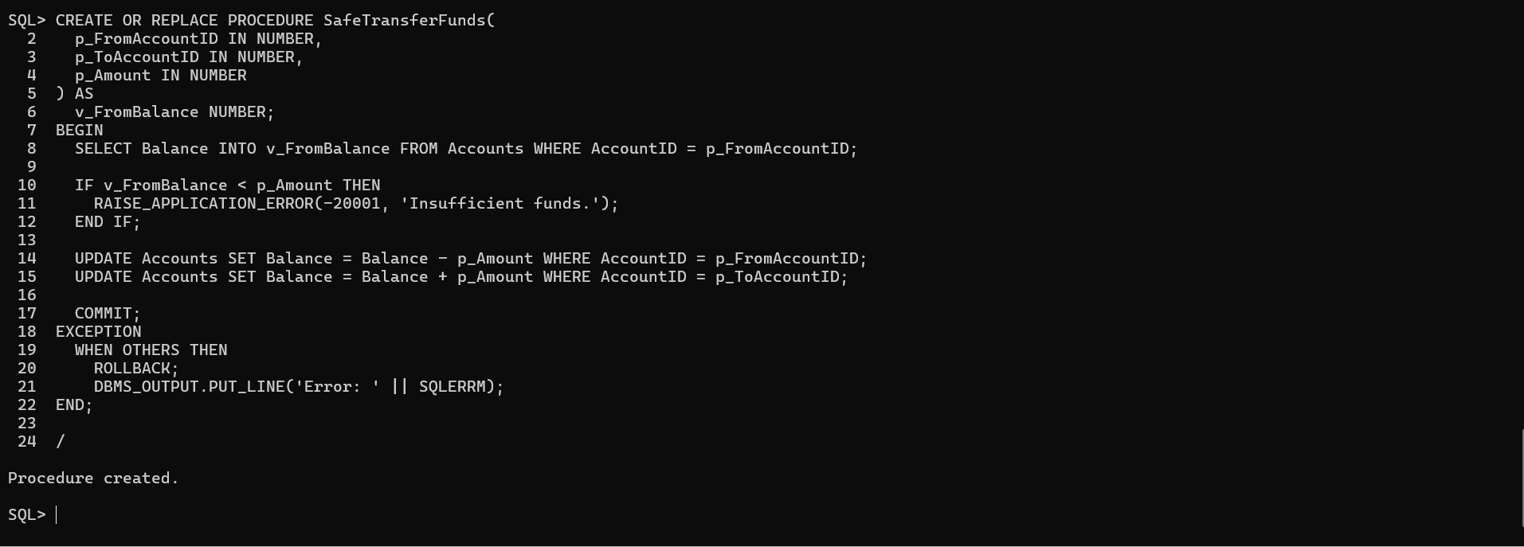

**Scenario 2:** Manage errors when updating employee salaries.

* + **Question:** Write a stored procedure **UpdateSalary** that increases the salary of an employee by a given percentage. If the employee ID does not exist, handle the exception and log an error message.

**Query:**

CREATE OR REPLACE PROCEDURE UpdateSalary(

p_EmployeeID IN NUMBER,

p_Percent IN NUMBER

) AS

BEGIN

UPDATE Employees

SET Salary = Salary + (Salary * p_Percent / 100)

WHERE EmployeeID = p_EmployeeID;

IF SQL%ROWCOUNT = 0 THEN

RAISE_APPLICATION_ERROR(-20002, 'Employee ID not found.');

END IF;

COMMIT;

EXCEPTION

WHEN OTHERS THEN

DBMS_OUTPUT.PUT_LINE('Error updating salary: ' || SQLERRM);

ROLLBACK;

END;

/

**Output:**

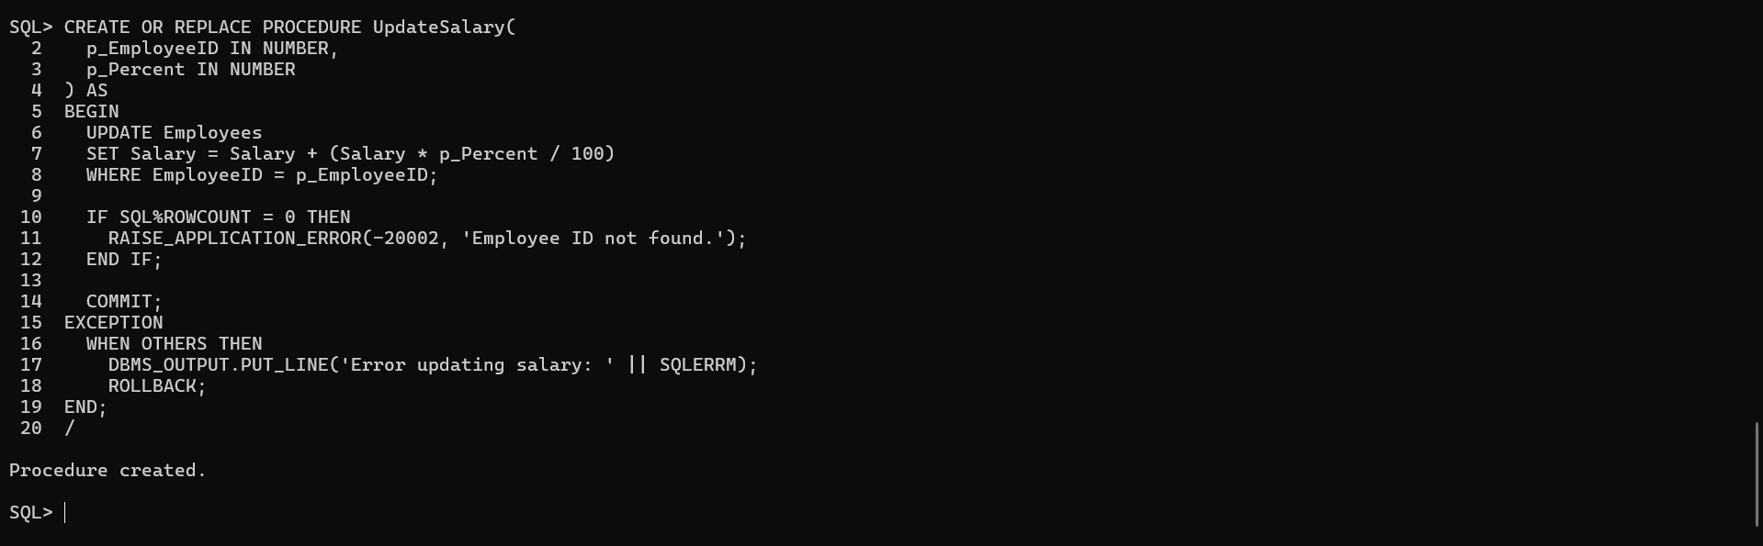

**Scenario 3:** Ensure data integrity when adding a new customer.

* + **Question:** Write a stored procedure **AddNewCustomer** that inserts a new customer into the Customers table. If a customer with the same ID already exists, handle the exception by logging an error and preventing the insertion.

**Query:**

CREATE OR REPLACE PROCEDURE AddNewCustomer(

p_CustomerID IN NUMBER,

p_Name IN VARCHAR2,

p_DOB IN DATE,

p_Balance IN NUMBER

) AS

BEGIN

INSERT INTO Customers (CustomerID, Name, DOB, Balance, LastModified)

VALUES (p_CustomerID, p_Name, p_DOB, p_Balance, SYSDATE);

COMMIT;

EXCEPTION

WHEN DUP_VAL_ON_INDEX THEN

DBMS_OUTPUT.PUT_LINE('Error: Customer with ID ' || p_CustomerID || ' already exists.');

ROLLBACK;

WHEN OTHERS THEN

DBMS_OUTPUT.PUT_LINE('Unexpected Error: ' || SQLERRM);

ROLLBACK;

END;

/

**Output:**

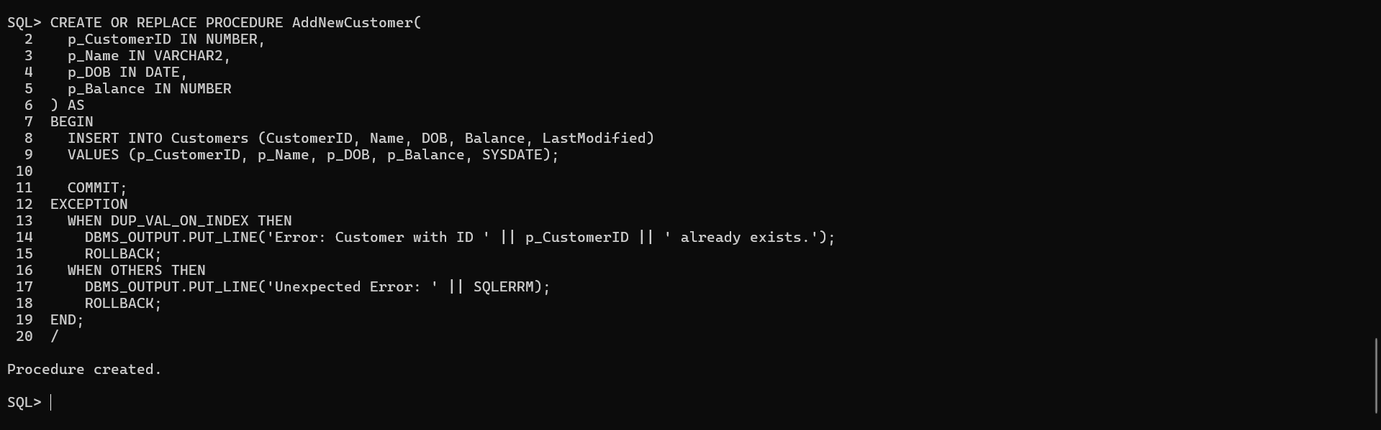

**Exercise 3: Stored Procedures**

**Scenario 1:** The bank needs to process monthly interest for all savings accounts.

* + **Question:** Write a stored procedure **ProcessMonthlyInterest** that calculates and updates the balance of all savings accounts by applying an interest rate of 1% to the current balance.

**Query:**

CREATE OR REPLACE PROCEDURE ProcessMonthlyInterest AS

BEGIN

FOR acc IN (SELECT AccountID, Balance FROM Accounts WHERE AccountType = 'Savings') LOOP

UPDATE Accounts

SET Balance = Balance + (acc.Balance * 0.01),

LastModified = SYSDATE

WHERE AccountID = acc.AccountID;

END LOOP;

COMMIT;

END;

/

**Output:**

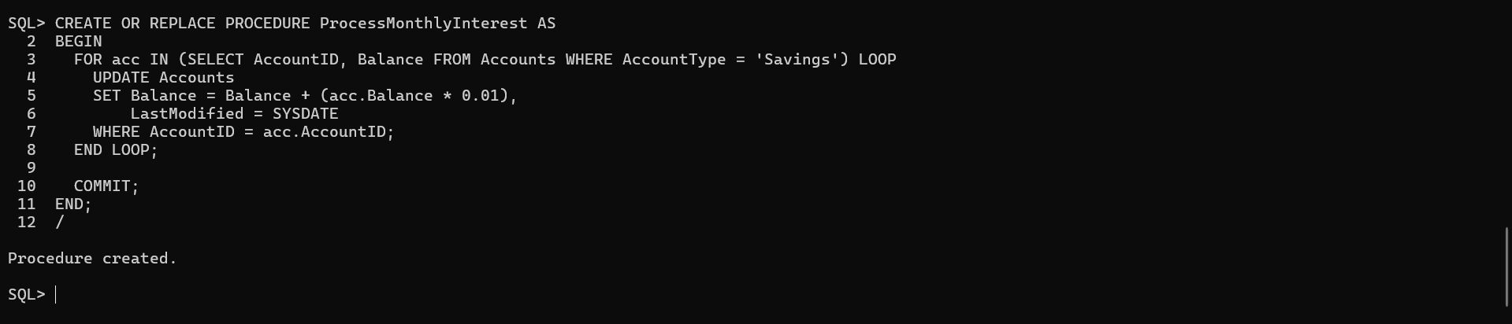

**Scenario 2:** The bank wants to implement a bonus scheme for employees based on their performance.

* + **Question:** Write a stored procedure **UpdateEmployeeBonus** that updates the salary of employees in a given department by adding a bonus percentage passed as a parameter.

**Query:**

CREATE OR REPLACE PROCEDURE UpdateEmployeeBonus(

p_Department IN VARCHAR2,

p_BonusPercent IN NUMBER

) AS

BEGIN

UPDATE Employees

SET Salary = Salary + (Salary * p_BonusPercent / 100)

WHERE Department = p_Department;

COMMIT;

END;

/

**Output:**

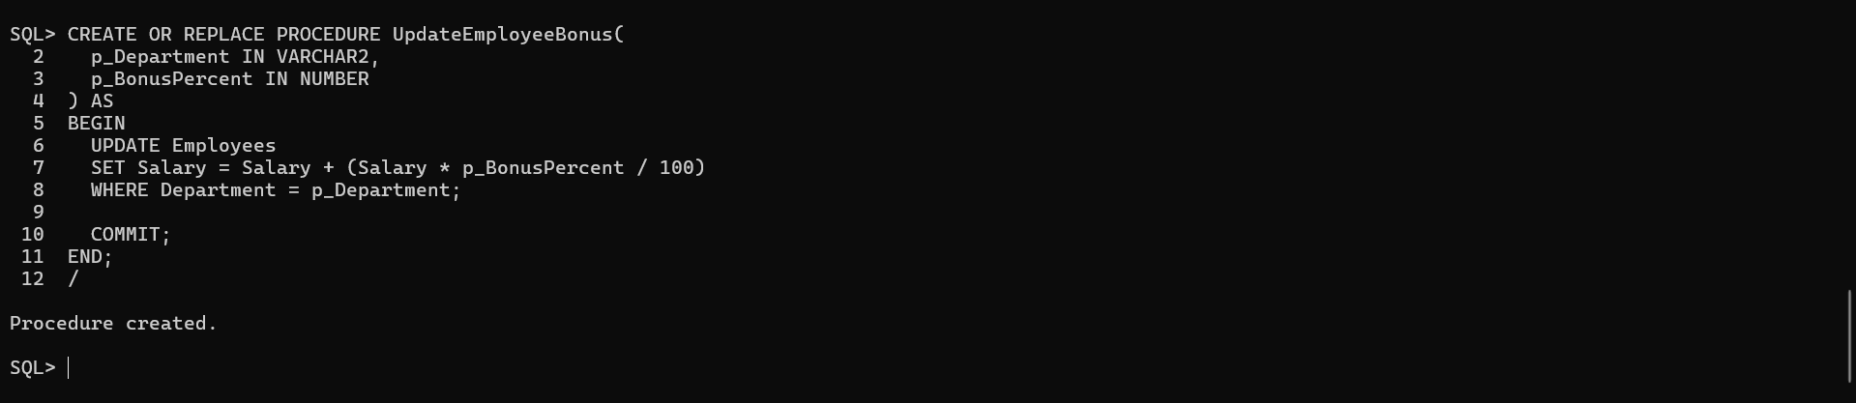

**Scenario 3:** Customers should be able to transfer funds between their accounts.

* + **Question:** Write a stored procedure **TransferFunds** that transfers a specified amount from one account to another, checking that the source account has sufficient balance before making the transfer.

**Query:**

CREATE OR REPLACE PROCEDURE TransferFunds(

p_FromAccountID IN NUMBER,

p_ToAccountID IN NUMBER,

p_Amount IN NUMBER

) AS

v_FromBalance NUMBER;

BEGIN

SELECT Balance INTO v_FromBalance FROM Accounts WHERE AccountID = p_FromAccountID;

IF v_FromBalance < p_Amount THEN

RAISE_APPLICATION_ERROR(-20003, 'Insufficient balance.');

END IF;

UPDATE Accounts SET Balance = Balance - p_Amount WHERE AccountID = p_FromAccountID;

UPDATE Accounts SET Balance = Balance + p_Amount WHERE AccountID = p_ToAccountID;

COMMIT;

EXCEPTION

WHEN OTHERS THEN

ROLLBACK;

DBMS_OUTPUT.PUT_LINE('Transfer failed: ' || SQLERRM);

END;

/

**Output:**

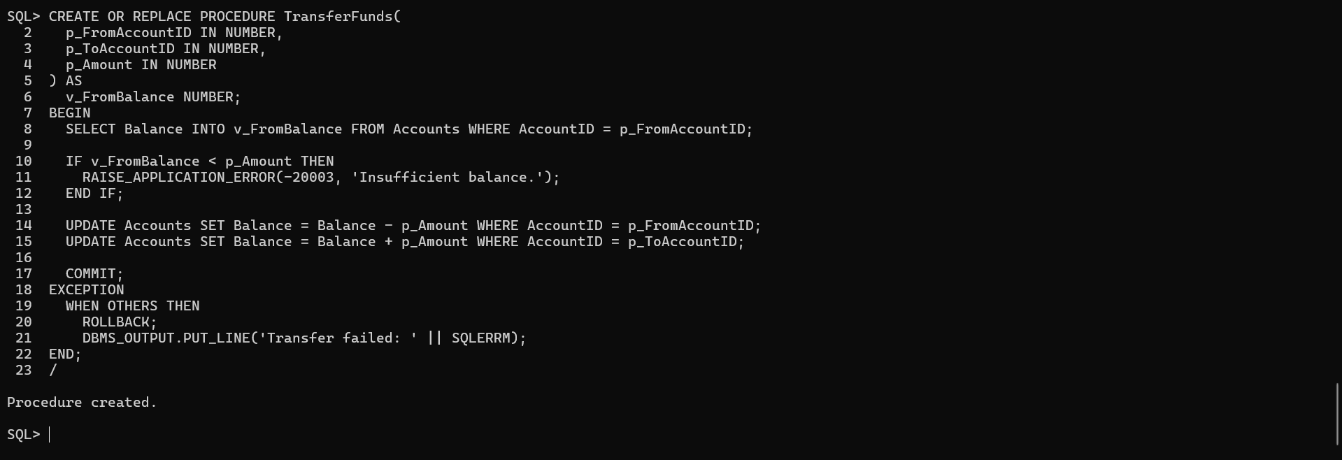

**Exercise 4: Functions**

**Scenario 1:** Calculate the age of customers for eligibility checks.

* + **Question:** Write a function CalculateAge that takes a customer's date of birth as input and returns their age in years.

**Query:**

CREATE OR REPLACE FUNCTION CalculateAge(p_DOB IN DATE)

RETURN NUMBER IS

v_Age NUMBER;

BEGIN

v_Age := FLOOR(MONTHS_BETWEEN(SYSDATE, p_DOB) / 12);

RETURN v_Age;

END;

/

**Output:**

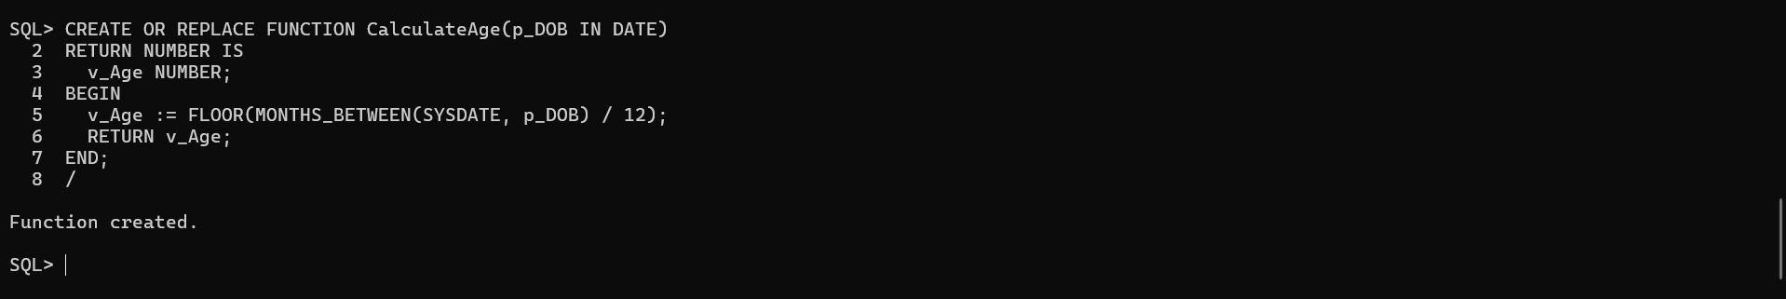

**Scenario 2:** The bank needs to compute the monthly installment for a loan.

* + **Question:** Write a function **CalculateMonthlyInstallment** that takes the loan amount, interest rate, and loan duration in years as input and returns the monthly installment amount.

**Query:**

CREATE OR REPLACE FUNCTION CalculateMonthlyInstallment(

p_LoanAmount IN NUMBER,

p_AnnualRate IN NUMBER,

p_DurationYears IN NUMBER

)

RETURN NUMBER IS

v_MonthlyRate NUMBER := p_AnnualRate / (12 * 100);

v_Months NUMBER := p_DurationYears * 12;

v_Installment NUMBER;

BEGIN

IF v_MonthlyRate = 0 THEN

v_Installment := p_LoanAmount / v_Months;

ELSE

v_Installment := p_LoanAmount * v_MonthlyRate * POWER(1 + v_MonthlyRate, v_Months) /

(POWER(1 + v_MonthlyRate, v_Months) - 1);

END IF;

RETURN ROUND(v_Installment, 2);

END;

/

**Output:**

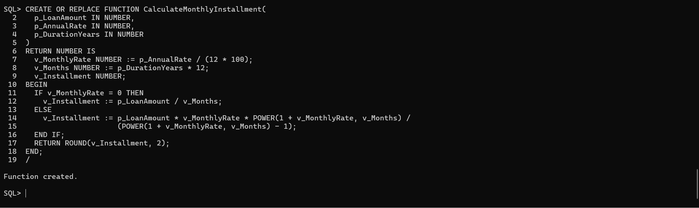

**Scenario 3:** Check if a customer has sufficient balance before making a transaction.

* + **Question:** Write a function **HasSufficientBalance** that takes an account ID and an amount as input and returns a boolean indicating whether the account has at least the specified amount.

**Query:**

CREATE OR REPLACE FUNCTION HasSufficientBalance(

p_AccountID IN NUMBER,

p_Amount IN NUMBER

)

RETURN BOOLEAN IS

v_Balance NUMBER;

BEGIN

SELECT Balance INTO v_Balance FROM Accounts WHERE AccountID = p_AccountID;

RETURN v_Balance >= p_Amount;

EXCEPTION

WHEN NO_DATA_FOUND THEN

RETURN FALSE;

WHEN OTHERS THEN

RETURN FALSE;

END;

/

**Output:**

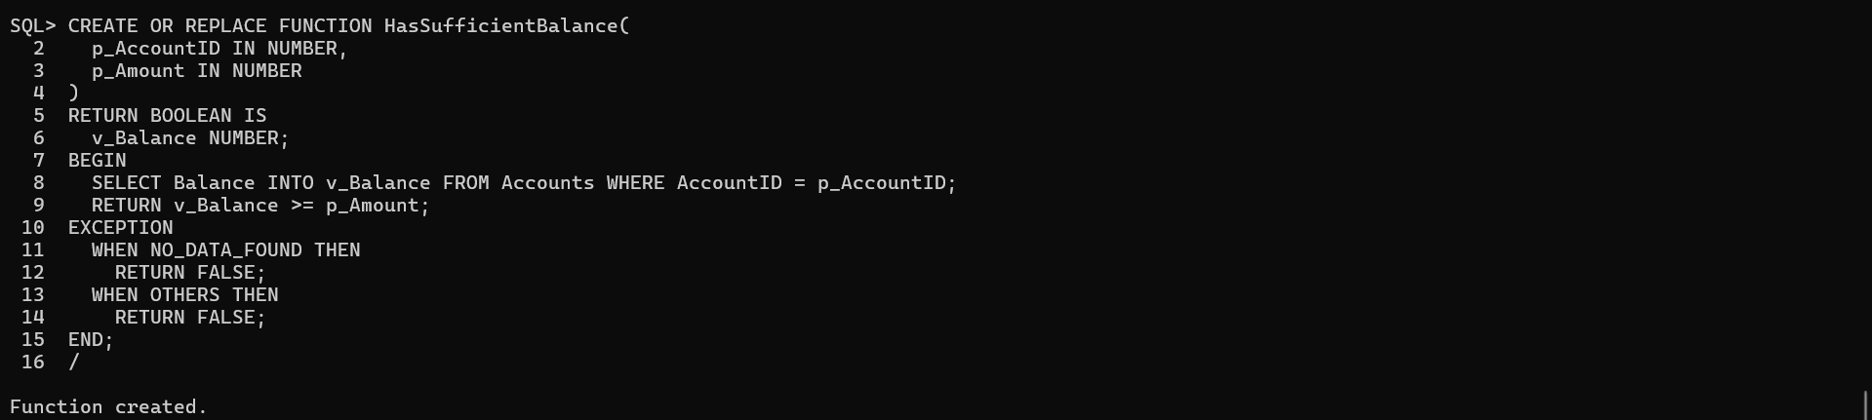

**Exercise 5: Triggers**

**Scenario 1:** Automatically update the last modified date when a customer's record is updated.

* + **Question:** Write a trigger **UpdateCustomerLastModified** that updates the LastModified column of the Customers table to the current date whenever a customer's record is updated.

**Query:**

CREATE OR REPLACE TRIGGER UpdateCustomerLastModified

BEFORE UPDATE ON Customers

FOR EACH ROW

BEGIN

:NEW.LastModified := SYSDATE;

END;

/

**Output:**

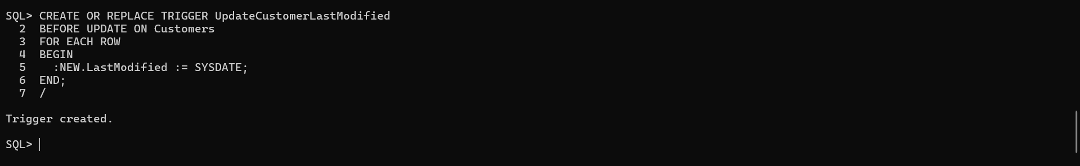

**Scenario 2:** Maintain an audit log for all transactions.

* + **Question:** Write a trigger **LogTransaction** that inserts a record into an AuditLog table whenever a transaction is inserted into the Transactions table.

**Query:**

CREATE TABLE AuditLog (

LogID NUMBER GENERATED BY DEFAULT ON NULL AS IDENTITY PRIMARY KEY,

TransactionID NUMBER,

AccountID NUMBER,

Amount NUMBER,

TransactionType VARCHAR2(10),

LoggedDate DATE DEFAULT SYSDATE

);

**Output:**

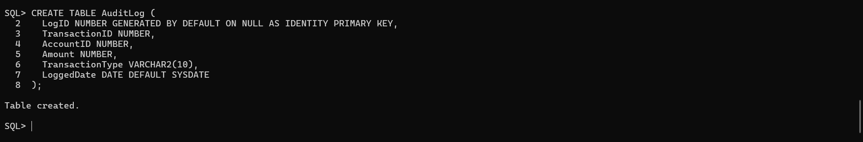

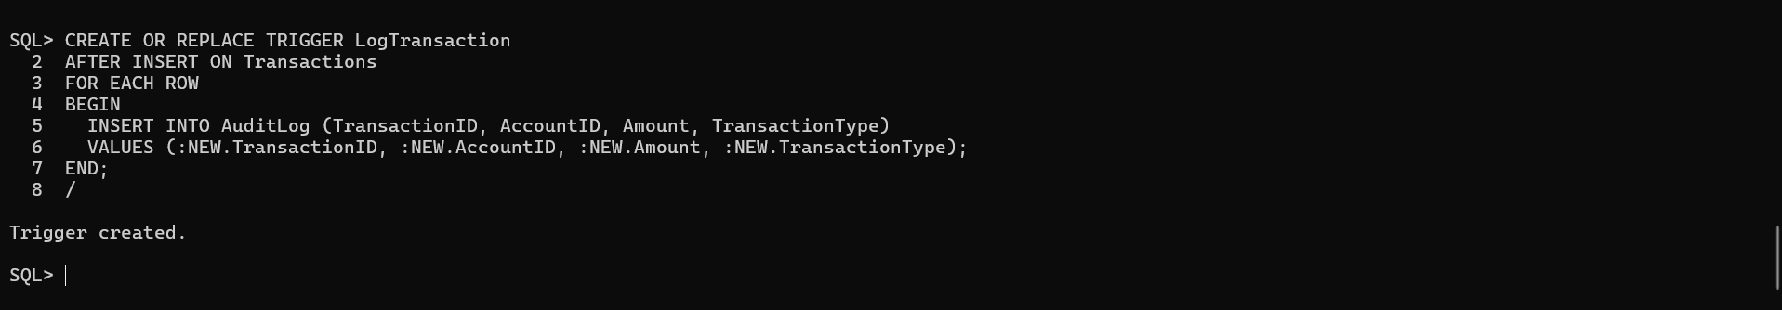

**Scenario 3:** Enforce business rules on deposits and withdrawals.

* + **Question:** Write a trigger **CheckTransactionRules** that ensures withdrawals do not exceed the balance and deposits are positive before inserting a record into the Transactions table.

**Query:**

CREATE OR REPLACE TRIGGER CheckTransactionRules

BEFORE INSERT ON Transactions

FOR EACH ROW

DECLARE

v_Balance NUMBER;

BEGIN

SELECT Balance INTO v_Balance FROM Accounts WHERE AccountID = :NEW.AccountID;

IF :NEW.TransactionType = 'Withdrawal' AND :NEW.Amount > v_Balance THEN

RAISE_APPLICATION_ERROR(-20004, 'Insufficient balance for withdrawal.');

ELSIF :NEW.TransactionType = 'Deposit' AND :NEW.Amount <= 0 THEN

RAISE_APPLICATION_ERROR(-20005, 'Deposit amount must be positive.');

END IF;

END;

/

**Output:**

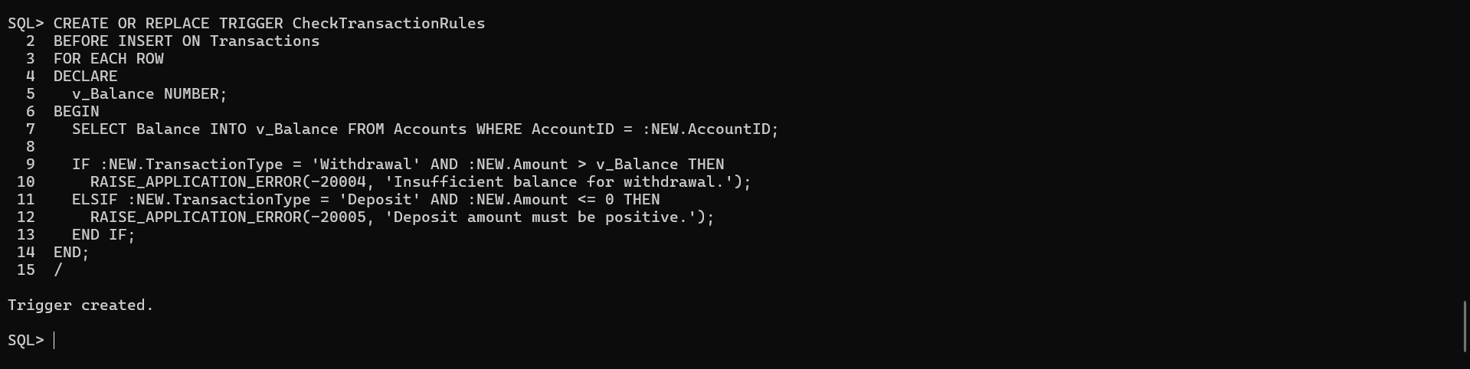

**Exercise 6: Cursors**

**Scenario 1:** Generate monthly statements for all customers.

* + **Question:** Write a PL/SQL block using an explicit cursor **GenerateMonthlyStatements** that retrieves all transactions for the current month and prints a statement for each customer.

**Query:**

DECLARE

CURSOR txn_cursor IS

SELECT c.CustomerID, c.Name, t.TransactionDate, t.Amount, t.TransactionType

FROM Customers c

JOIN Accounts a ON c.CustomerID = a.CustomerID

JOIN Transactions t ON a.AccountID = t.AccountID

WHERE TRUNC(t.TransactionDate, 'MM') = TRUNC(SYSDATE, 'MM')

ORDER BY c.CustomerID, t.TransactionDate;

v_custID Customers.CustomerID%TYPE;

v_name Customers.Name%TYPE;

v_date DATE;

v_amount NUMBER;

v_type VARCHAR2(10);

BEGIN

OPEN txn_cursor;

LOOP

FETCH txn_cursor INTO v_custID, v_name, v_date, v_amount, v_type;

EXIT WHEN txn_cursor%NOTFOUND;

DBMS_OUTPUT.PUT_LINE('Customer: ' || v_name || ' | Date: ' || v_date ||

' | ' || v_type || ' | Amount: ' || v_amount);

END LOOP;

CLOSE txn_cursor;

END;

/

**Output:**

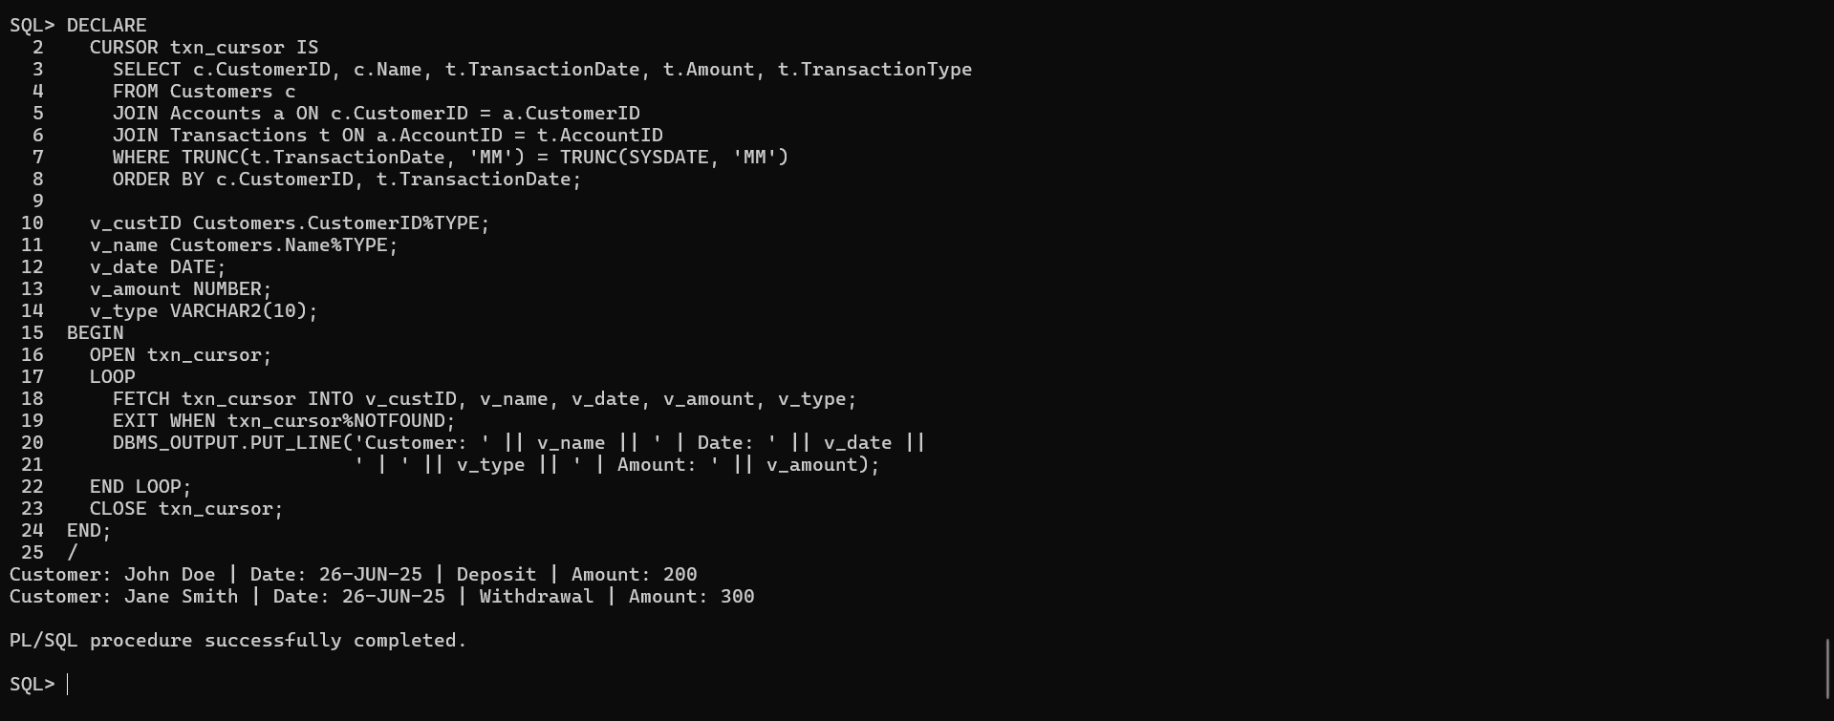

**Scenario 2:** Apply annual fee to all accounts.

* + **Question:** Write a PL/SQL block using an explicit cursor **ApplyAnnualFee** that deducts an annual maintenance fee from the balance of all accounts.

**Query:**

DECLARE

CURSOR acc_cursor IS

SELECT AccountID, Balance FROM Accounts;

v_accID Accounts.AccountID%TYPE;

v_balance Accounts.Balance%TYPE;

v_fee CONSTANT NUMBER := 100;

BEGIN

OPEN acc_cursor;

LOOP

FETCH acc_cursor INTO v_accID, v_balance;

EXIT WHEN acc_cursor%NOTFOUND;

UPDATE Accounts

SET Balance = Balance - v_fee,

LastModified = SYSDATE

WHERE AccountID = v_accID;

END LOOP;

CLOSE acc_cursor;

COMMIT;

END;

/

**Output:**

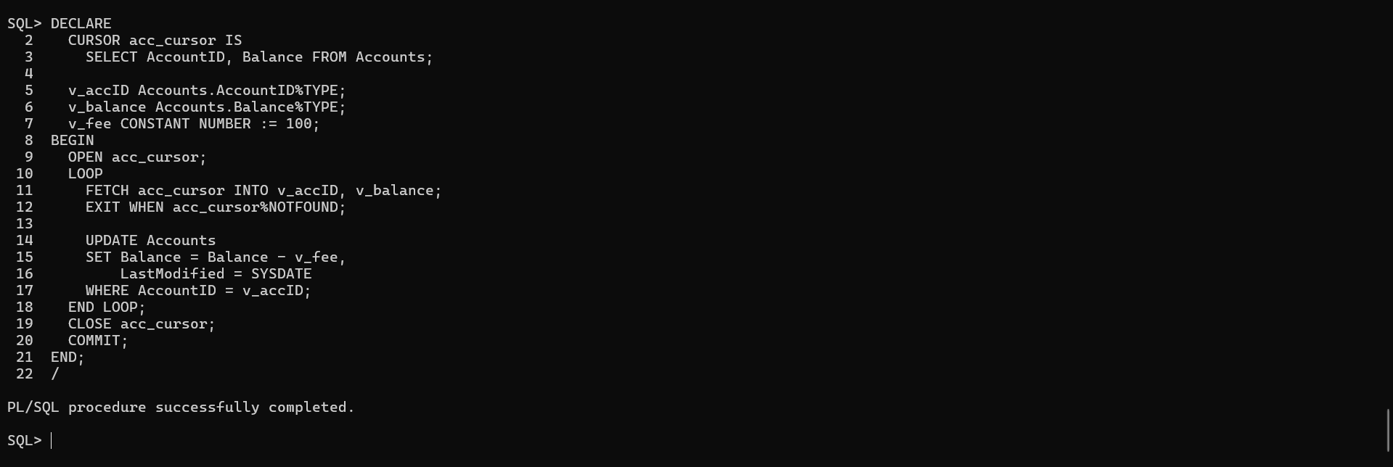

**Scenario 3:** Update the interest rate for all loans based on a new policy.

* + **Question:** Write a PL/SQL block using an explicit cursor **UpdateLoanInterestRates** that fetches all loans and updates their interest rates based on the new policy.

**Query:**

DECLARE

CURSOR loan_cursor IS

SELECT LoanID, InterestRate FROM Loans;

v_loanID Loans.LoanID%TYPE;

v_rate Loans.InterestRate%TYPE;

BEGIN

OPEN loan_cursor;

LOOP

FETCH loan_cursor INTO v_loanID, v_rate;

EXIT WHEN loan_cursor%NOTFOUND;

UPDATE Loans

SET InterestRate = v_rate + 0.5

WHERE LoanID = v_loanID;

END LOOP;

CLOSE loan_cursor;

COMMIT;

END;

/

**Output:**

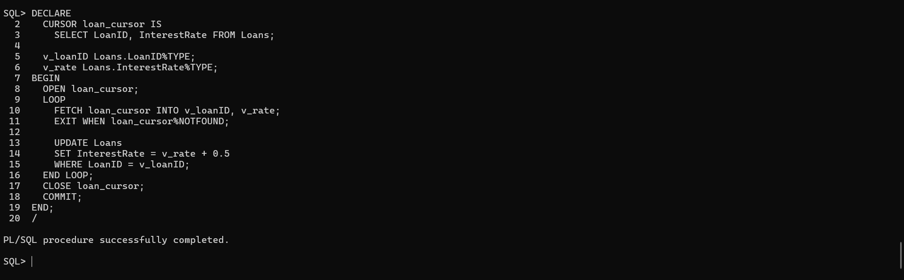

**Exercise 7: Packages**

**Scenario 1:** Group all customer-related procedures and functions into a package.

* + **Question:** Create a package **CustomerManagement** with procedures for adding a new customer, updating customer details, and a function to get customer balance.

**Query:**

-- Package Specification

CREATE OR REPLACE PACKAGE CustomerManagement AS

PROCEDURE AddCustomer(p_CustomerID NUMBER, p_Name VARCHAR2, p_DOB DATE, p_Balance NUMBER);

PROCEDURE UpdateCustomer(p_CustomerID NUMBER, p_Name VARCHAR2, p_Balance NUMBER);

FUNCTION GetCustomerBalance(p_CustomerID NUMBER) RETURN NUMBER;

END CustomerManagement;

/

-- Package Body

CREATE OR REPLACE PACKAGE BODY CustomerManagement AS

PROCEDURE AddCustomer(p_CustomerID NUMBER, p_Name VARCHAR2, p_DOB DATE, p_Balance NUMBER) IS

BEGIN

INSERT INTO Customers(CustomerID, Name, DOB, Balance, LastModified)

VALUES(p_CustomerID, p_Name, p_DOB, p_Balance, SYSDATE);

EXCEPTION

WHEN DUP_VAL_ON_INDEX THEN

DBMS_OUTPUT.PUT_LINE('Customer already exists.');

END;

PROCEDURE UpdateCustomer(p_CustomerID NUMBER, p_Name VARCHAR2, p_Balance NUMBER) IS

BEGIN

UPDATE Customers

SET Name = p_Name, Balance = p_Balance, LastModified = SYSDATE

WHERE CustomerID = p_CustomerID;

END;

FUNCTION GetCustomerBalance(p_CustomerID NUMBER) RETURN NUMBER IS

v_Balance NUMBER;

BEGIN

SELECT Balance INTO v_Balance FROM Customers WHERE CustomerID = p_CustomerID;

RETURN v_Balance;

EXCEPTION

WHEN NO_DATA_FOUND THEN

RETURN NULL;

END;

END CustomerManagement;

/

**Output:**

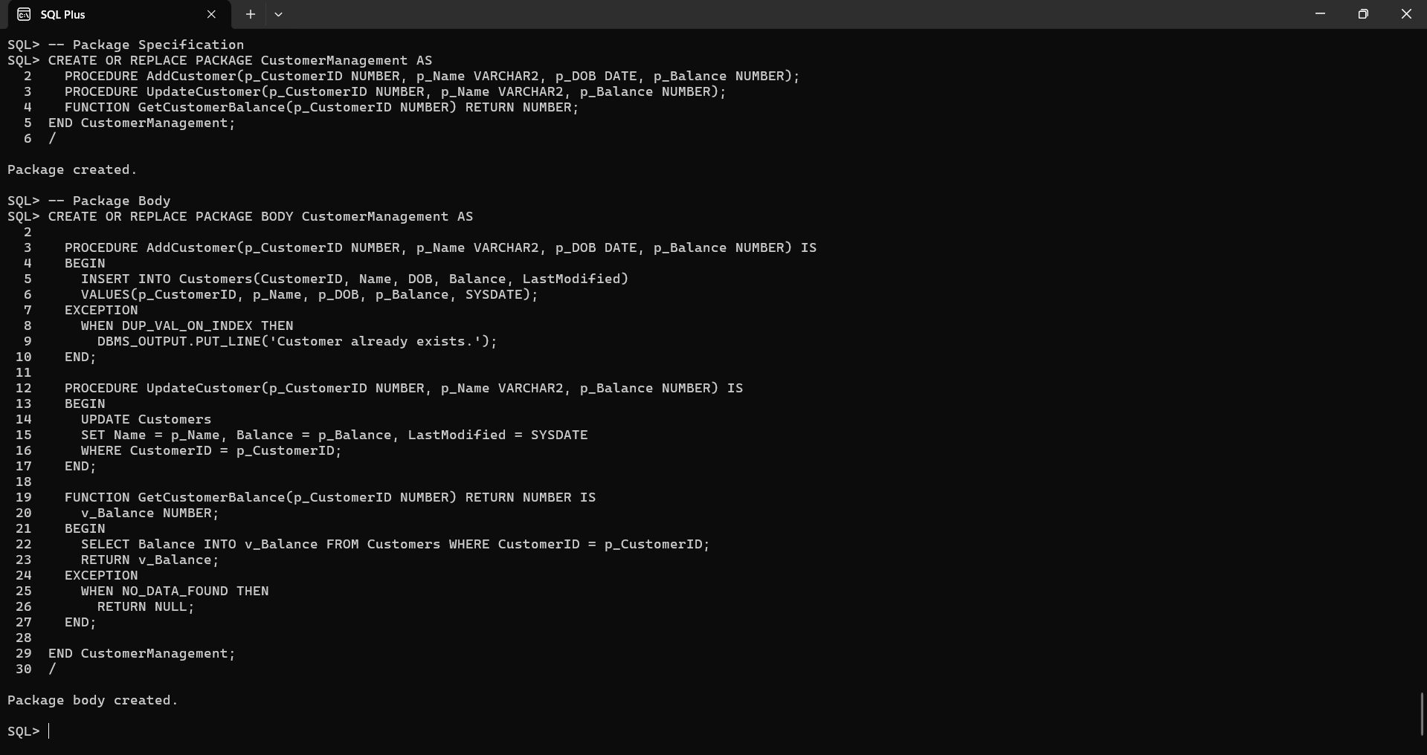

**Scenario 2:** Create a package to manage employee data.

* + **Question:** Write a package **EmployeeManagement** with procedures to hire new employees, update employee details, and a function to calculate annual salary.

**Query:**

-- Package Specification

CREATE OR REPLACE PACKAGE EmployeeManagement AS

PROCEDURE HireEmployee(p_EID NUMBER, p_Name VARCHAR2, p_Position VARCHAR2,

p_Salary NUMBER, p_Dept VARCHAR2, p_HireDate DATE);

PROCEDURE UpdateEmployee(p_EID NUMBER, p_Salary NUMBER, p_Dept VARCHAR2);

FUNCTION GetAnnualSalary(p_EID NUMBER) RETURN NUMBER;

END EmployeeManagement;

/

-- Package Body

CREATE OR REPLACE PACKAGE BODY EmployeeManagement AS

PROCEDURE HireEmployee(p_EID NUMBER, p_Name VARCHAR2, p_Position VARCHAR2,

p_Salary NUMBER, p_Dept VARCHAR2, p_HireDate DATE) IS

BEGIN

INSERT INTO Employees(EmployeeID, Name, Position, Salary, Department, HireDate)

VALUES(p_EID, p_Name, p_Position, p_Salary, p_Dept, p_HireDate);

END;

PROCEDURE UpdateEmployee(p_EID NUMBER, p_Salary NUMBER, p_Dept VARCHAR2) IS

BEGIN

UPDATE Employees

SET Salary = p_Salary, Department = p_Dept

WHERE EmployeeID = p_EID;

END;

FUNCTION GetAnnualSalary(p_EID NUMBER) RETURN NUMBER IS

v_Salary NUMBER;

BEGIN

SELECT Salary INTO v_Salary FROM Employees WHERE EmployeeID = p_EID;

RETURN v_Salary * 12;

EXCEPTION

WHEN NO_DATA_FOUND THEN

RETURN NULL;

END;

END EmployeeManagement;

/

**Output:**

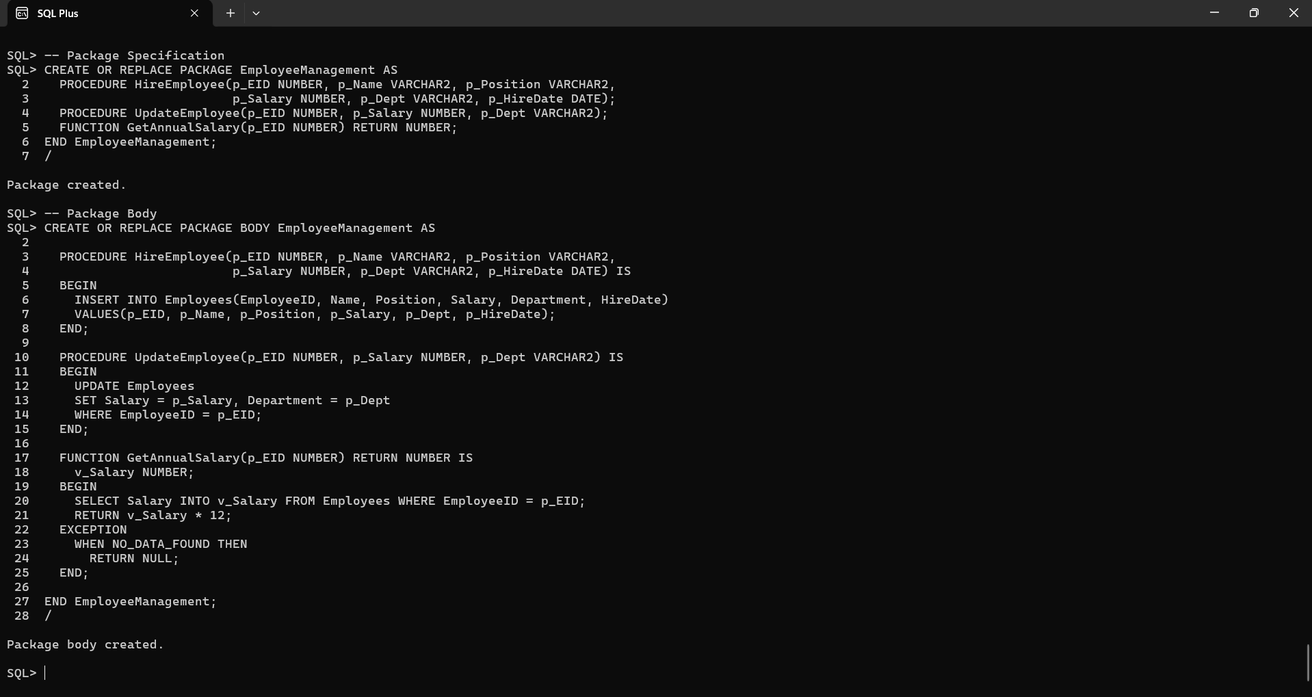

**Scenario 3:** Group all account-related operations into a package.

* + **Question:** Create a package **AccountOperations** with procedures for opening a new account, closing an account, and a function to get the total balance of a customer across all accounts.

**Query:**

-- Package Specification

CREATE OR REPLACE PACKAGE AccountOperations AS

PROCEDURE OpenAccount(p_AccountID NUMBER, p_CustomerID NUMBER, p_Type VARCHAR2, p_Balance NUMBER);

PROCEDURE CloseAccount(p_AccountID NUMBER);

FUNCTION GetTotalBalance(p_CustomerID NUMBER) RETURN NUMBER;

END AccountOperations;

/

-- Package Body

CREATE OR REPLACE PACKAGE BODY AccountOperations AS

PROCEDURE OpenAccount(p_AccountID NUMBER, p_CustomerID NUMBER, p_Type VARCHAR2, p_Balance NUMBER) IS

BEGIN

INSERT INTO Accounts(AccountID, CustomerID, AccountType, Balance, LastModified)

VALUES(p_AccountID, p_CustomerID, p_Type, p_Balance, SYSDATE);

END;

PROCEDURE CloseAccount(p_AccountID NUMBER) IS

BEGIN

DELETE FROM Accounts WHERE AccountID = p_AccountID;

END;

FUNCTION GetTotalBalance(p_CustomerID NUMBER) RETURN NUMBER IS

v_Total NUMBER;

BEGIN

SELECT SUM(Balance) INTO v_Total FROM Accounts WHERE CustomerID = p_CustomerID;

RETURN NVL(v_Total, 0);

END;

END AccountOperations;

/

**Output:**

