WEEK-6 HANDSON
REACTJS
1.ReactJS-HOL
Code:
import './App.css';

function App() {
return (
<h1>Welcome the first session of React</h1>
);
}
export default App;
Output:
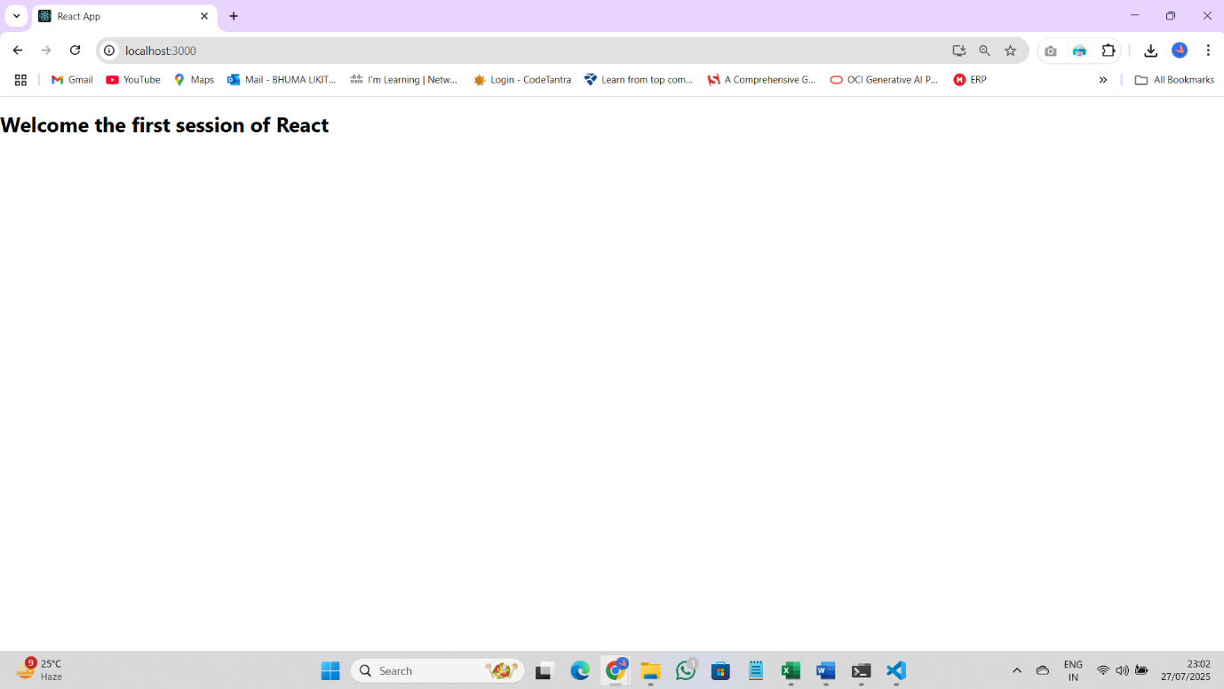

2.ReactJS-HOL:
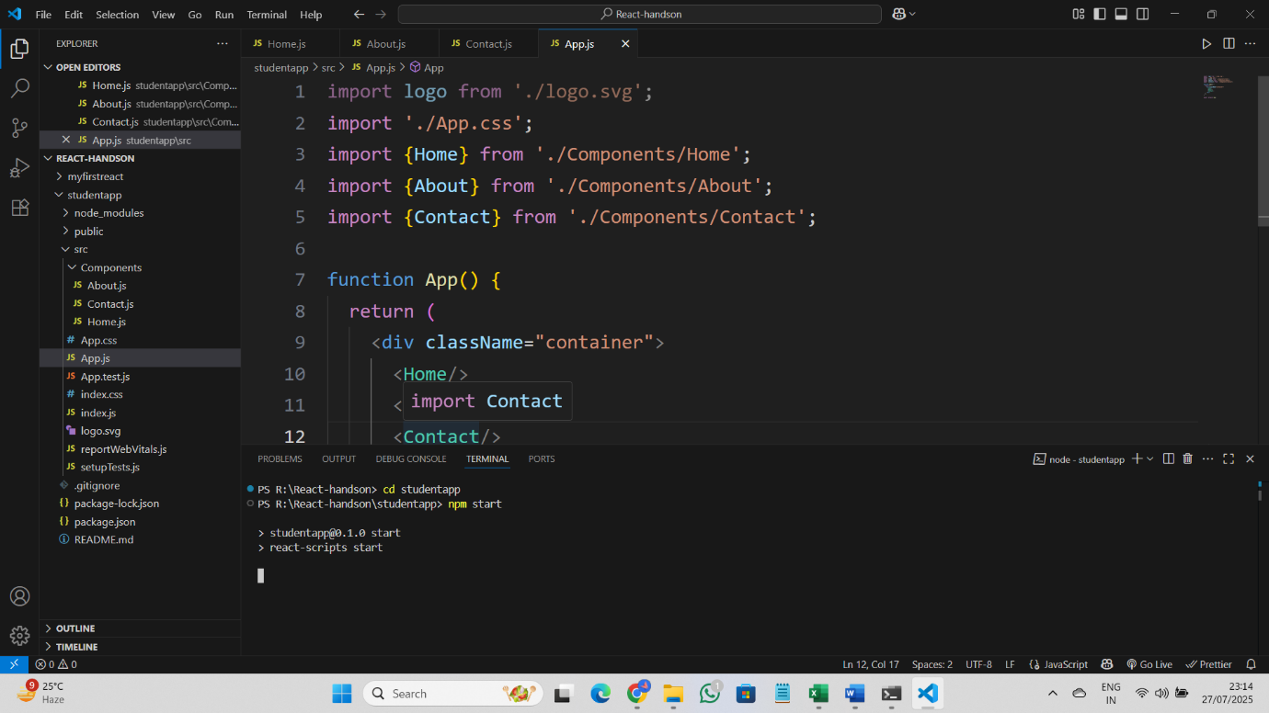
Code:
Home.js:
import React,{Component} from 'react';
class Home extends Component{
render(){
return(
<div>
<h3>Welcome to the Home Page of Student Management Portal</h3>
</div>
);}
}
export default Home;

About.js:
import React,{Component} from 'react';
class About extends Component{
render(){
return(
<div>
<h3>Welcome to the About Page of Student Management Portal</h3>
</div>
);}
}
export default About;

Contact.js:
import React,{Component} from 'react';
class Contact extends Component{
render(){
return(
<div>
<h3>Welcome to the Contact Page of Student Management Portal</h3>
</div>
);}
}
export default Contact;

App.js:
import logo from './logo.svg';
import './App.css';
import Home from './Components/Home';
import About from './Components/About';
import Contact from './Components/Contact';

function App() {
return (
<div className="container">
<Home/>
<About/>
<Contact/>
</div>
);
}

export default App;

Output:
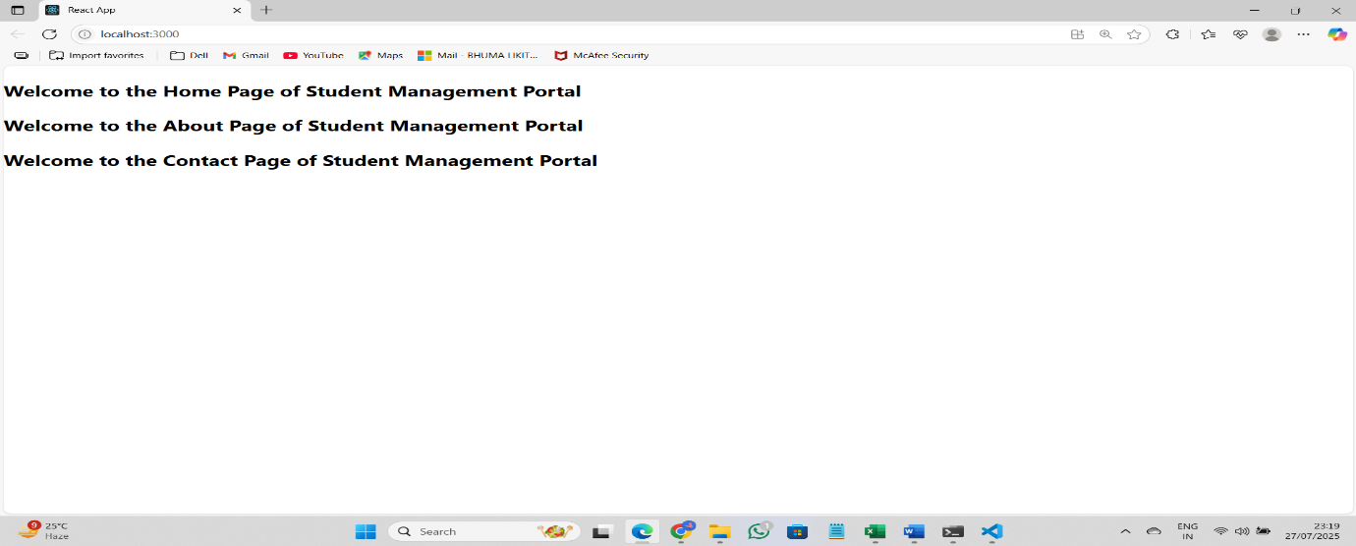

3.ReactJS-HOL
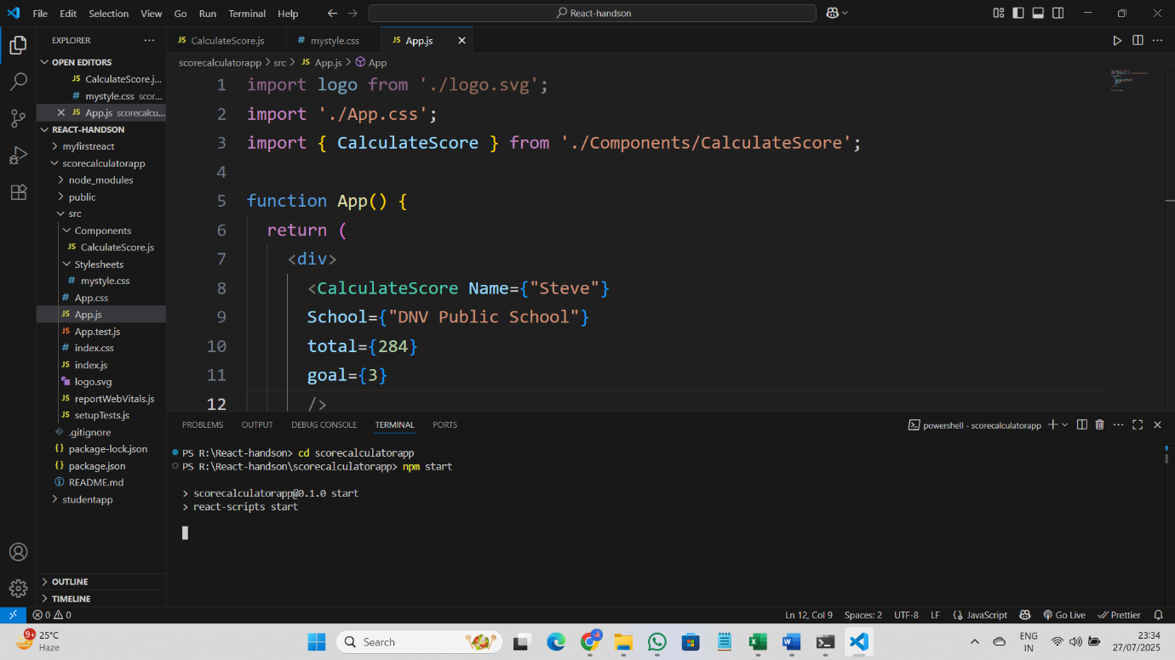
Code:
CalculateScore.js:
import '../Stylesheets/mystyle.css';
const percentToDecimal= (decimal) => {
return (decimal.toFixed(2) + '%')
}
const calcScore = (total, goal) => {
return percentToDecimal(total/goal)
}

export const CalculateScore = ({Name, School, total, goal}) => (
<div className="formatstyle">
<h1><font color="Brown">Student Details:</font></h1>
<div className="Name">
<b> <span> Name: </span></b>
<span>{Name}</span>
</div>
<div className="School">
<b> <span> School: </span> </b>
<span>{School}</span>
</div>
<div className="Total">
<b><span>Total:</span></b>
<span>{total}</span>
<span>Marks</span>
</div>
<div className="Score">
<b>Score:</b>
<span>{calcScore(total,goal )}</span>
</div>
</div>
)
Mystyle.css:
.Name{
font-weight: 300;
color:blue;
}
.School{
color:crimson;
}
.Total{
color:darkmagenta;
}
.formatstyle{
text-align: center;
font-size: large;;
}
.Score{
color:forestgreen;
}
App.js:
import logo from './logo.svg';
import './App.css';
import { CalculateScore } from './Components/CalculateScore';

function App() {
return (
<div>
<CalculateScore Name={"Steve"}
School={"DNV Public School"}
total={284}
goal={3}
/>
</div>
);
}
export default App;
Output:
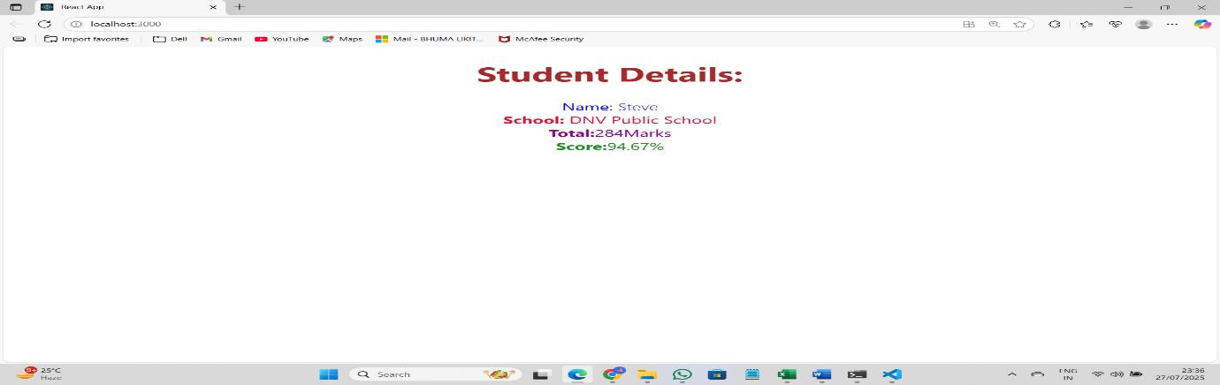

4.ReactJS-HOL:
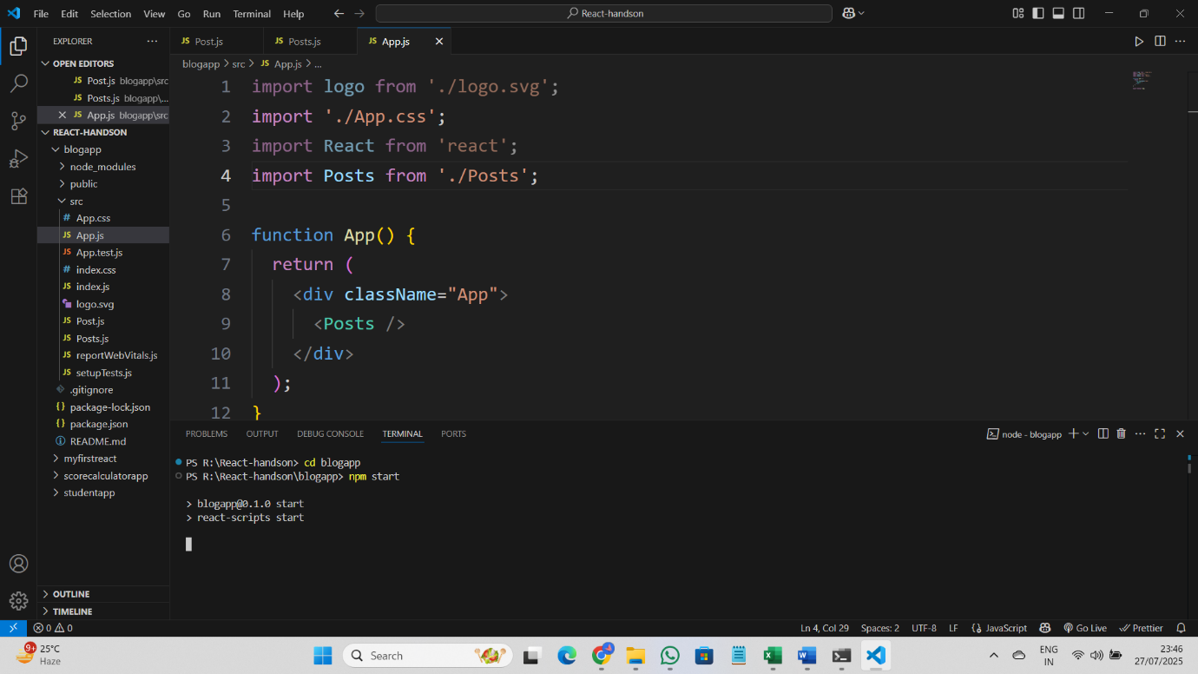
Code:
Post.js:
class Post {
constructor(id, title, body) {
this.id = id;
this.title = title;
this.body = body;
}
}
export default Post;

Posts.js:
import React from 'react';
import Post from './Post';

class Posts extends React.Component {
constructor(props) {
super(props);
this.state = {
posts: [],
hasError: false
};
}

loadPosts() {
fetch('https://jsonplaceholder.typicode.com/posts')
.then(res => res.json())
.then(data => {
const posts = data.map(p => new Post(p.id, p.title, p.body));
this.setState({ posts });
})
.catch(error => {
console.error("Fetch error:", error);
this.setState({ hasError: true });
});
}

componentDidMount() {
this.loadPosts();
}

componentDidCatch(error, info) {
// code
alert("An error occurred while rendering posts.");
console.error(error, info);
}

render() {
if (this.state.hasError) {
return <h2>Error loading posts!</h2>;
}

return (
<div>
<h1>Posts</h1>
{this.state.posts.map(post => (
<div key={post.id}>
<h3>{post.title}</h3>
<p>{post.body}</p>
</div>
))}
</div>
);
}
}

export default Posts;

App.js:
import React from 'react';
import Posts from './Posts';

function App() {
return (
<div className="App">
<Posts />
</div>
);
}
export default App;

Output:
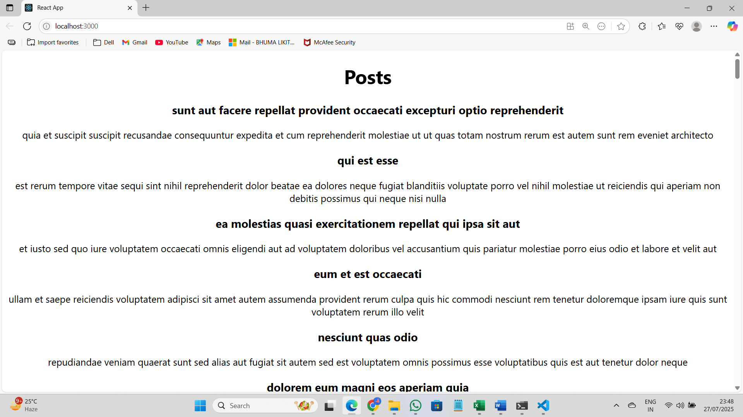

5.ReactJS-HOL:

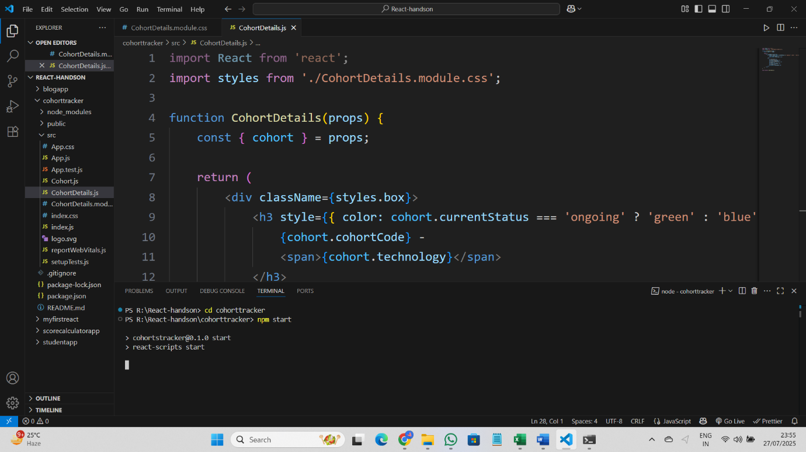

Code:
CohortDetails.module.css:
.box {
width: 300px;
display: inline-block;
margin: 10px;
padding: 10px 20px;
border: 1px solid black;
border-radius: 10px;
}

dt {
font-weight: 500;
}

CohortDetails.js:
import React from 'react';
import styles from './CohortDetails.module.css';

function CohortDetails(props) {
const { cohort } = props;

return (
<div className={styles.box}>
<h3 style={{ color: cohort.currentStatus.toLowerCase().trim() === 'ongoing' ? 'green' : 'blue' }}>

{cohort.cohortCode} -
<span>{cohort.technology}</span>
</h3>
<dl>
<dt>Started On</dt>
<dd>{cohort.startDate}</dd>
<dt>Current Status</dt>
<dd>{cohort.currentStatus}</dd>
<dt>Coach</dt>
<dd>{cohort.coachName}</dd>
<dt>Trainer</dt>
<dd>{cohort.trainerName}</dd>
</dl>
</div>
);
}

export default CohortDetails;

Output:
