WEEK-7 ReactJS
9.ReactJS-HOL:
CODE:
ListofPlayers.js:
export default function ListofPlayers({ players }) {
return (
players.map((item, idx) => {
return (
<div key={idx}>
<li>
Mr. {item.name}
<span> {item.score} </span>
</li>
</div>
)
})
)
}
Scorebelow70.js:
export default function Scorebelow70({ players }) {
var players70 = [];
(players || []).map((item) => {
if (item.score <= 70) {
players70.push(item);
}
return null;
});

return (
<div>
<ul>
{players70.map((item, idx) => (
<li key={idx}>
Mr. {item.name} <span> {item.score} </span>
</li>
))}
</ul>
</div>
)
}

OddPlayers.js:
export function OddPlayers({ players }) {
if (!Array.isArray(players)) return null;
const [first, , third, , fifth] = players;
return (
<div>
<ul>
<li> First : {first} </li>
<li> Third : {third} </li>
<li> Fifth : {fifth} </li>
</ul>
</div>
)
}

EvenPlayers.js:
export function EvenPlayers({ players }) {
if (!Array.isArray(players)) return null;
const [, second, , fourth, , sixth] = players;
return (
<div>
<ul>
<li> Second : {second} </li>
<li> Fourth : {fourth} </li>
<li> Sixth : {sixth} </li>
</ul>
</div>
)
}

ListofIndianPlayers.js:
const T20Players = ['First Player', 'Second Player', 'Third Player'];
const RanjiTrophyPlayers = ['Fourth Player', 'Fifth Player', 'Sixth Player'];

export const IndianPlayers = [...T20Players, ...RanjiTrophyPlayers];

export default function ListofIndianPlayers({ IndianPlayers }) {
return (
<div>
<ul>
{IndianPlayers.map((p, i) => (
<li key={i}>Mr. {p}</li>
))}
</ul>
</div>
)
}

App.js:
import React from "react";
import ListofPlayers from "./ListofPlayers";
import Scorebelow70 from "./Scorebelow70";
import { OddPlayers } from "./OddPlayers";
import { EvenPlayers } from "./EvenPlayers";
import ListofIndianPlayers, { IndianPlayers } from "./ListofIndianPlayers";

function App() {
var flag = false; // true => show players + below70;

const players = [
{ name: "Jack", score: 50 },
{ name: "Michael", score: 70 },
{ name: "John", score: 40 },
{ name: "Ann", score: 61 },
{ name: "Elisabeth", score: 61 },
{ name: "Sachin", score: 95 },
{ name: "Dhoni", score: 100 },
{ name: "Virat", score: 84 },
{ name: "Jadeja", score: 64 },
{ name: "Raina", score: 75 },
{ name: "Rohit", score: 80 }
];

const IndianTeam = ["Sachin1", "Dhoni2", "Virat3", "Rohit4", "Yuvaraj5", "Raina6"];

if (flag === true) {
return (
<div>
<h1> List of Players </h1>
<ListofPlayers players={players} />
<hr />
<h1> List of Players having Scores Less than 70 </h1>
<Scorebelow70 players={players} />
</div>
);
} else {
return (
<div>
<div>
<h1> Odd Players </h1>
<OddPlayers players={IndianTeam} />
<hr />
<h1> Even Players </h1>
<EvenPlayers players={IndianTeam} />
</div>
<hr />
<div>
<h1> List of Indian Players Merged: </h1>
<ListofIndianPlayers IndianPlayers={IndianPlayers} />
</div>
</div>
);
}
}

export default App;

Output:
Flag=true
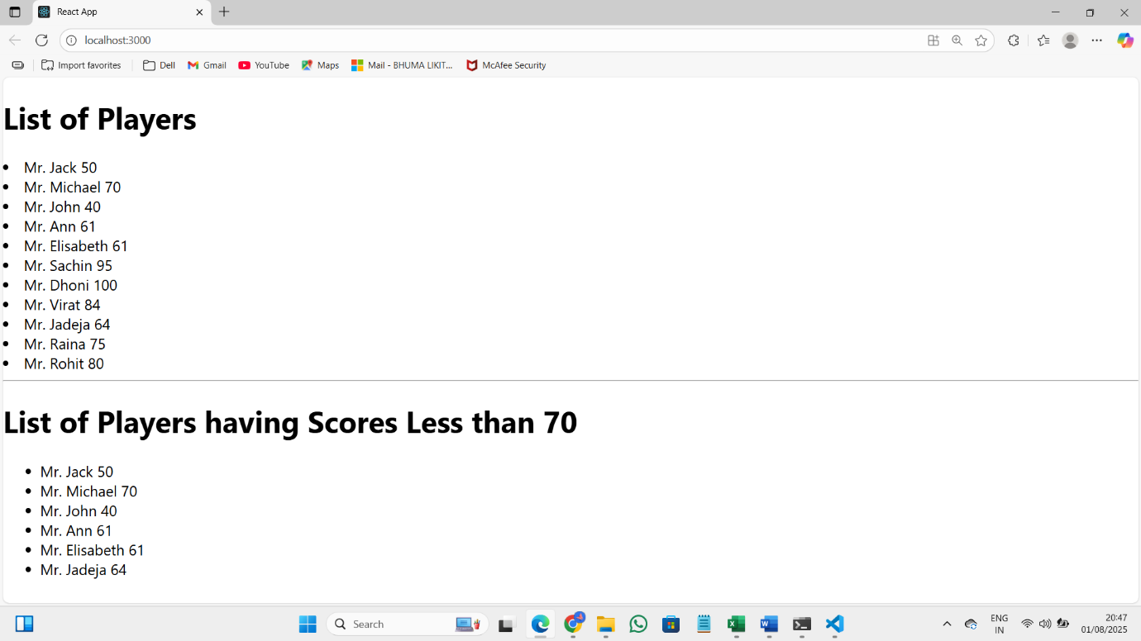Flag=false
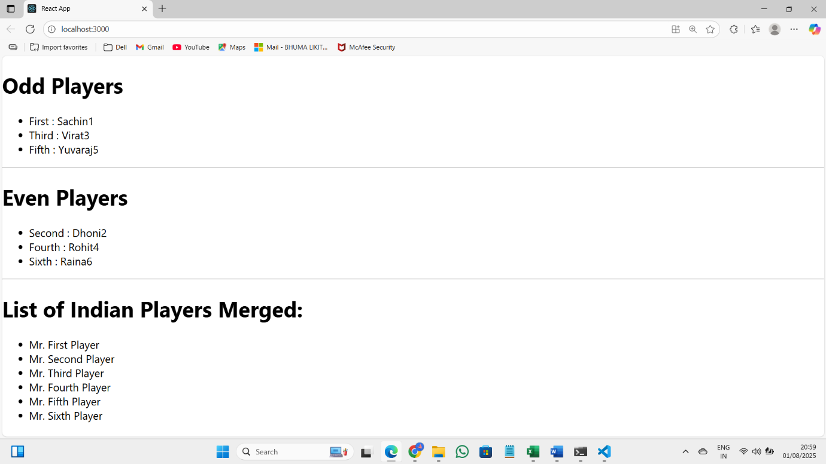

10.ReactJS-HOL:
CODE:
App.js:
import React from 'react';
import './App.css';

const offices = [
{
Name: 'DBS',
Rent: 50000,
Address: 'Chennai',
sr: 'https://www.sohopodomorocity.com/wp-content/uploads/2016/09/4.jpg',
},
{
Name: 'Tech Hub',
Rent: 75000,
Address: 'Bengaluru',
sr: 'https://officebanao.com/wp-content/uploads/2022/10/Modern-office-design-3.jpg',
},
{
Name: 'StartUp Space',
Rent: 60000,
Address: 'Hyderabad',
sr: 'https://www.textureplus.com/wp-content/uploads/2022/12/industrial-style-open-office.jpg',
},
];

const OfficeCard = ({ ItemName }) => {
// color logic exactly as in image
let colors = [];
if (ItemName.Rent <= 60000) {
colors.push('textRed');
} else {
colors.push('textGreen');
}

const element = 'Office Space';
const jsxatt = <img src={ItemName.sr} width="25%" height="25%" alt="Office Space" />;

return (
<div className="office-card">
<h1>{element} , at Affordable Range </h1>
{jsxatt}
<h1>Name: {ItemName.Name}</h1>
<h3 className={colors.join(' ')}>Rent: Rs. {ItemName.Rent}</h3>
<h3>Address: {ItemName.Address}</h3>
</div>
);
};

function App() {
return (
<div>
{offices.map((o) => (
<OfficeCard key={o.Name} ItemName={o} />
))}
</div>
);
}

export default App;
OUTPUT:
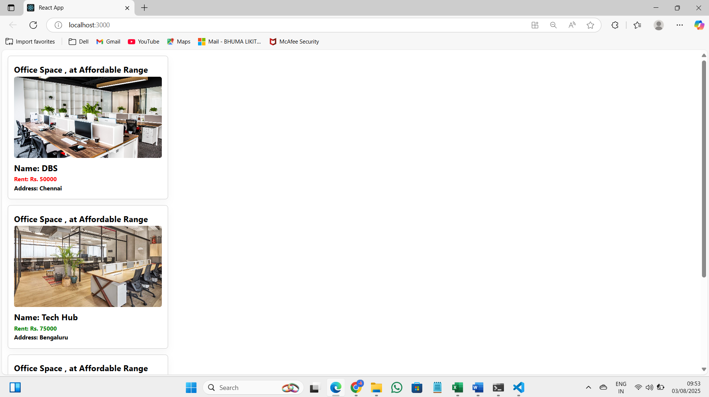
11.ReactJS-HOL:
CODE:
CurrencyConvertor.js:
import React, { useState } from "react";

const INR_TO_EUR_RATE = 0.011; // static for demo

export default function CurrencyConvertor() {
const [inr, setInr] = useState("");
const [result, setResult] = useState("");
const [error, setError] = useState("");

const handleSubmit = (e) => {
e.preventDefault();
setError("");
setResult("");

const amt = parseFloat(inr);
if (isNaN(amt) || amt < 0) {
const errMsg = "Please enter a valid INR amount.";
alert(errMsg);
setError(errMsg);
return;
}
const eur = (amt * INR_TO_EUR_RATE).toFixed(4);
const resText = `₹${amt} = €${eur}`;
alert(resText);
setResult(resText);
};

return (
<div style={{ marginTop: 30 }}>
<h2>Currency Convertor!!!</h2>
<form onSubmit={handleSubmit}>
<div style={{ marginBottom: 6 }}>
<label htmlFor="inr">Amount:</label>
<input
id="inr"
type="number"
placeholder="INR"
value={inr}
onChange={(e) => setInr(e.target.value)}
style={{ width: 180, marginLeft: 4 }}
/>
</div>

<div style={{ marginBottom: 6 }}>
<label htmlFor="currency">Currency:</label>
<textarea
id="currency"
readOnly
value="EUR"
rows={1}
style={{
width: 180,
marginLeft: 4,
padding: 4,
resize: "none",
overflow: "hidden",
}}
/>
</div>

<button type="submit">Submit</button>
</form>

{error && (
<div style={{ color: "red", marginTop: 8 }}>
<strong>{error}</strong>
</div>
)}
{result && (
<div style={{ color: "blue", marginTop: 8 }}>
<strong>{result}</strong>
</div>
)}

<div style={{ fontSize: 12, marginTop: 6 }}>
(Static rate: 1 INR = {INR_TO_EUR_RATE} EUR)
</div>
</div>
);
}

App.js:
import React, { useState } from "react";
import CurrencyConvertor from "./CurrencyConvertor";

function App() {
const [counter, setCounter] = useState(0);
const [message, setMessage] = useState("");

// increment logic
const incrementValue = () => setCounter((c) => c + 1);

// greeting logic with popup
const sayHello = (name = "Member1") => {
const popupText = `Hello! ${name}`;
alert(popupText); // popup as requested
setMessage(popupText);
};

// combined for Increment button
const handleIncrement = () => {
incrementValue();
sayHello("Member1");
alert(`Counter incremented to ${counter + 1}`);
};

const handleDecrement = () => {
setCounter((c) => c - 1);
const newVal = counter - 1;
alert(`Counter decremented to ${newVal}`);
setMessage("");
};

const handleSayWelcome = (text) => {
const popupText = `"${text}"`;
alert(popupText);
setMessage(popupText);
};

const handlePress = (e) => {
e.preventDefault();
const popupText = "I was clicked";
alert(popupText);
setMessage(popupText);
};

return (
<div>
<div className="counter">{counter}</div>

<div style={{ display: "flex", flexDirection: "column", maxWidth: 200 }}>
<button onClick={handleIncrement}>Increment</button>
<button onClick={handleDecrement}>Decrement</button>
<button onClick={() => handleSayWelcome("welcome")}>Say welcome</button>
<button onClick={handlePress}>Click on me</button>
</div>

{message && (
<div className="message-box">
<strong>Message:</strong> {message}
</div>
)}

<CurrencyConvertor />
</div>
);
}

export default App;

Output:
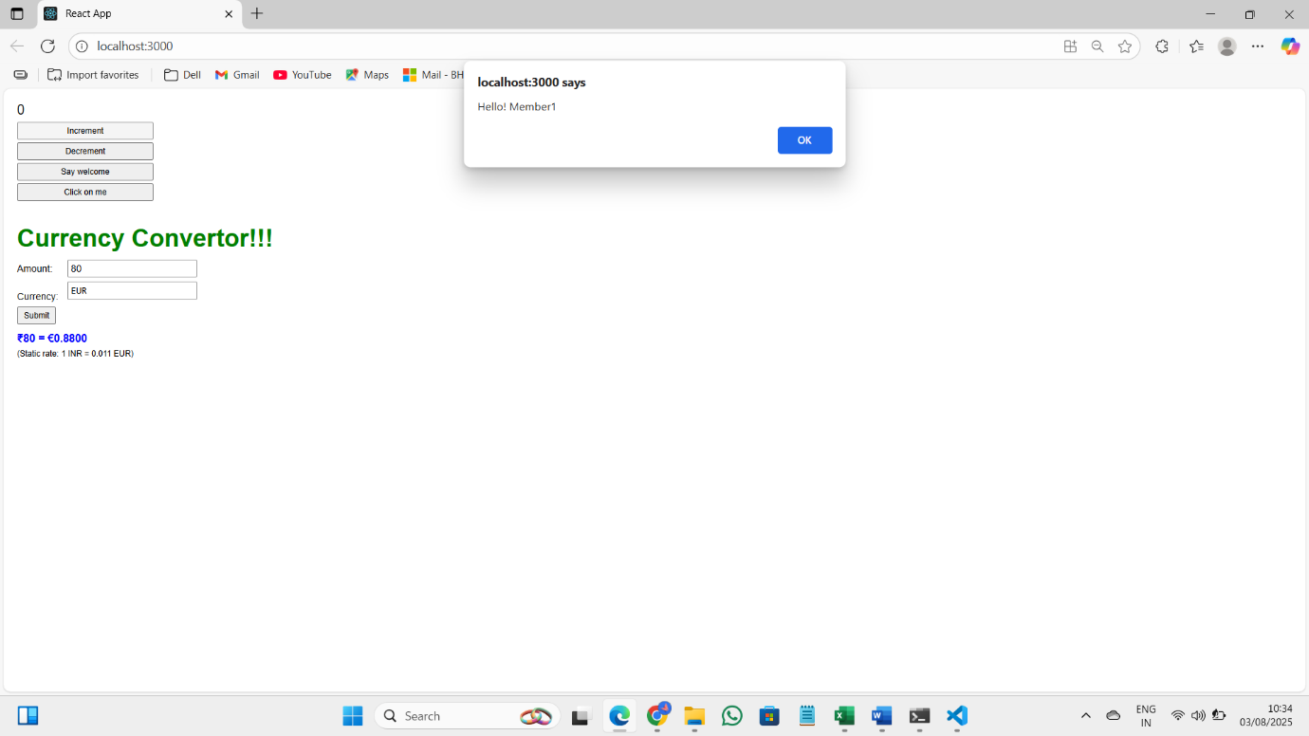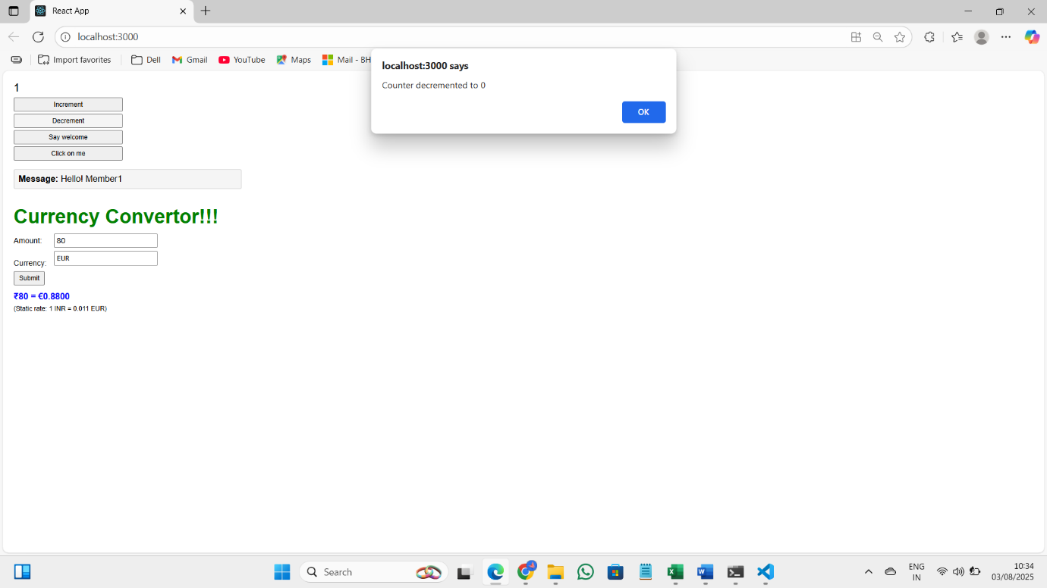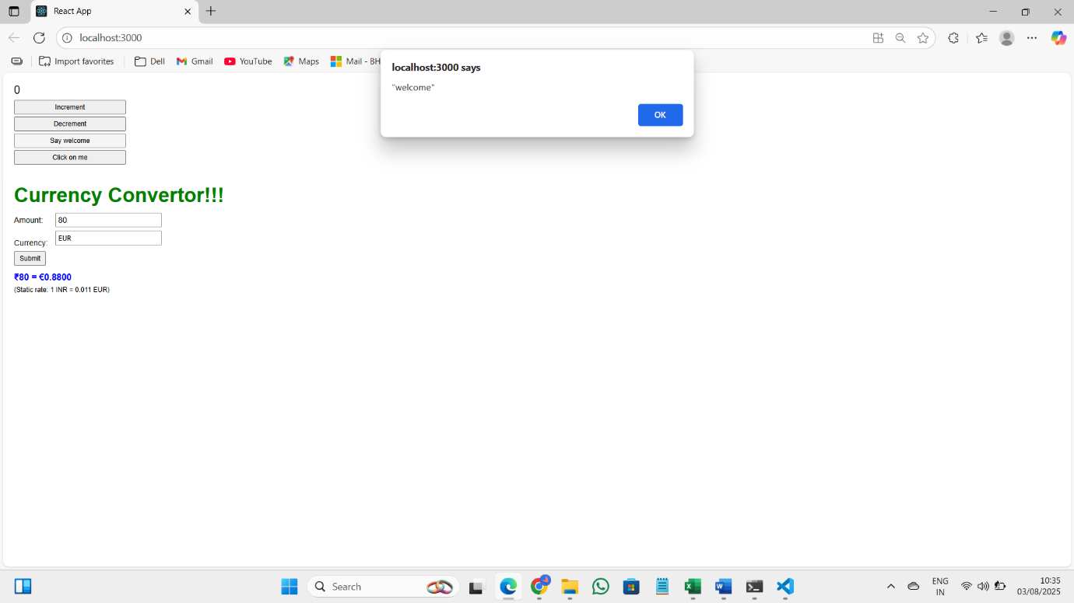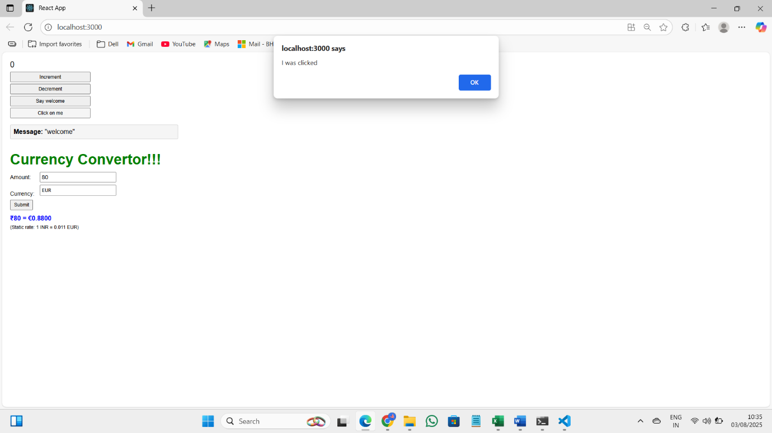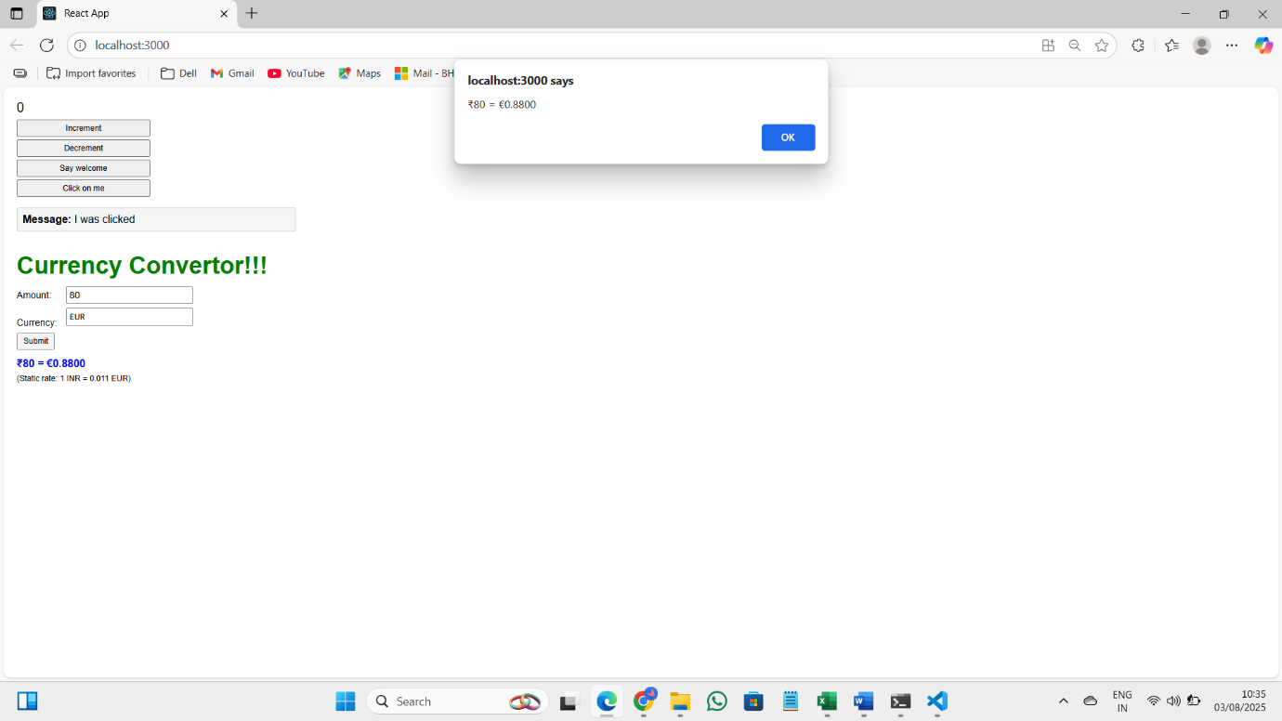
12.ReactJS-HOL:
CODE:
App.js:
import React, { useState } from 'react';
import './App.css';

/* --- Login / Logout button components (kept similar to snippet) --- */
function LoginButton({ onClick }) {
return (
<button aria-label="Login" onClick={onClick} className="action-button">
Login
</button>
);
}

function LogoutButton({ onClick }) {
return (
<button aria-label="Logout" onClick={onClick} className="action-button">
Logout
</button>
);
}

/* --- Greeting components --- */
function UserGreeting() {
return <h1 className="title">Welcome back</h1>;
}

function GuestGreeting() {
return <h1 className="title">Please sign up.</h1>;
}

function Greeting({ isLoggedIn }) {
return isLoggedIn ? <UserGreeting /> : <GuestGreeting />;
}

/* --- Flight display / booking --- */
const sampleFlights = [
{
id: 1,
from: 'New York (JFK)',
to: 'London (LHR)',
depart: '2025-08-15 10:00',
arrive: '2025-08-15 22:00',
price: '$750',
},
{
id: 2,
from: 'San Francisco (SFO)',
to: 'Tokyo (NRT)',
depart: '2025-08-16 07:30',
arrive: '2025-08-17 13:15',
price: '$980',
},
{
id: 3,
from: 'Dubai (DXB)',
to: 'Sydney (SYD)',
depart: '2025-08-20 02:00',
arrive: '2025-08-20 22:30',
price: '$1,200',
},
];

function FlightCard({ flight, isLoggedIn, onBook }) {
return (
<div className="flight-card">
<div><strong>From:</strong> {flight.from}</div>
<div><strong>To:</strong> {flight.to}</div>
<div><strong>Departure:</strong> {flight.depart}</div>
<div><strong>Arrival:</strong> {flight.arrive}</div>
<div><strong>Price:</strong> {flight.price}</div>
<div className="flight-action">
{isLoggedIn ? (
<button onClick={() => onBook(flight)} className="book-button">
Book
</button>
) : (
<button disabled className="book-button disabled">
Login to book
</button>
)}
</div>
</div>
);
}

function FlightList({ flights, isLoggedIn, onBook }) {
return (
<div className="flights-section">
<h2>Available Flights</h2>
{flights.map(f => (
<FlightCard
key={f.id}
flight={f}
isLoggedIn={isLoggedIn}
onBook={onBook}
/>
))}
</div>
);
}

/* --- Main application component --- */
function App() {
const [isLoggedIn, setIsLoggedIn] = useState(false);
const [bookedFlights, setBookedFlights] = useState([]);

const handleLogin = () => setIsLoggedIn(true);
const handleLogout = () => setIsLoggedIn(false);

const handleBookFlight = (flight) => {
setBookedFlights(prev => [...prev, flight]);
window.alert(`✅ Ticket booked: ${flight.from} → ${flight.to}`);
};

return (
<div className="app-container">
<header className="header">
<Greeting isLoggedIn={isLoggedIn} />
<div className="auth-control">
{isLoggedIn ? (
<LogoutButton onClick={handleLogout} />
) : (
<LoginButton onClick={handleLogin} />
)}
</div>
</header>

<main>
<FlightList
flights={sampleFlights}
isLoggedIn={isLoggedIn}
onBook={handleBookFlight}
/>

{isLoggedIn && bookedFlights.length > 0 && (
<section className="bookings">
<h2>Your Bookings</h2>
{bookedFlights.map((f, idx) => (
<div key={idx} className="booking-card">
<div>
<strong>{f.from}</strong> → <strong>{f.to}</strong> ({f.price})
</div>
<div>Departure: {f.depart}</div>
</div>
))}
</section>
)}
</main>
</div>
);
}
export default App;
OUTPUT:

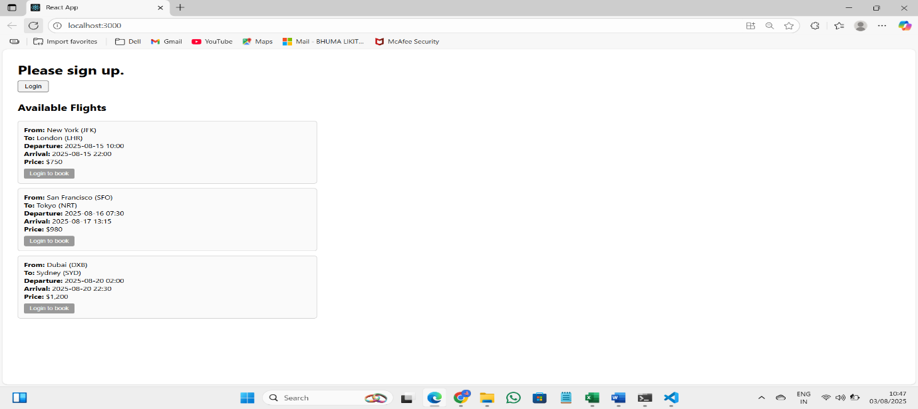
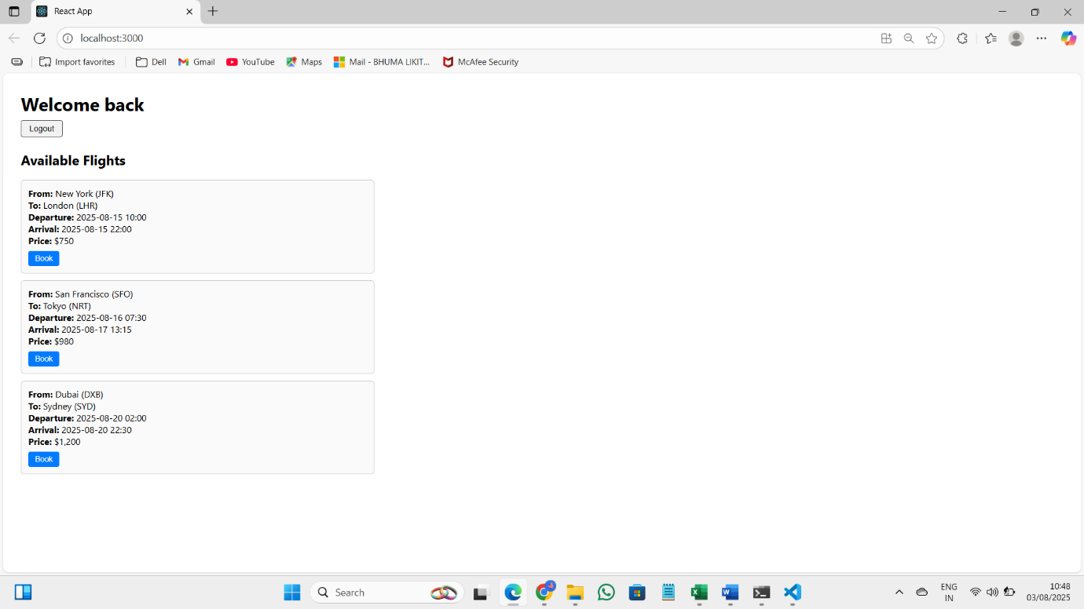
13.ReactJS-HOL:
CODE:
export const books = [
{ id: 101, bname: 'Master React', price: 670 },
{ id: 102, bname: 'Deep Dive into Angular 11', price: 800 },
{ id: 103, bname: 'Mongo Essentials', price: 450 }
];

export const blogs = [
{
id: 1,
title: 'React Learning',
author: 'Stephen Biz',
content: 'Welcome to learning React!'
},
{
id: 2,
title: 'Installation',
author: 'Schewzdenier',
content: 'You can install React from npm.'
}
];

export const courses = [
{ id: 1, cname: 'Angular', date: '4/5/2021' },
{ id: 2, cname: 'React', date: '6/3/20201' }
];

function BookDetails({ books }) {
if (!books || books.length === 0) {
return <p>No book data available.</p>;
}

return (
<div className="st2">
<h1>Book Details</h1>
<ul>
{books.map((book) => (
<div key={book.id}>
<h3>{book.bname}</h3>
<h4>{book.price}</h4>
</div>
))}
</ul>
</div>
);
}

export default BookDetails;

function BlogDetails({ blogs }) {
return (
<div className="v1">
<h1>Blog Details</h1>
{blogs.length > 0 ? (
blogs.map((blog) => (
<div key={blog.id}>
<h3>{blog.title}</h3>
<b>{blog.author}</b>
<p>{blog.content}</p>
</div>
))
) : (
<p>No blogs available.</p>
)}
</div>
);
}

export default BlogDetails;

function CourseDetails({ courses }) {
return (
<div className="mystyle1">
<h1>Course Details</h1>
{courses &&
courses.map((course) => (
<div key={course.id}>
<h3>{course.cname}</h3>
<p>{course.date}</p>
</div>
))}
</div>
);
}

export default CourseDetails;

App.js:
import './App.css';
import BookDetails from './Components/BookDetails';
import BlogDetails from './Components/BlogDetails';
import CourseDetails from './Components/CourseDetails';

import { books } from './data/books';
import { blogs } from './data/blogs';
import { courses } from './data/courses';

function App() {
return (
<div className="app-container">
<div className="column">
<CourseDetails courses={courses} />
</div>
<div className="column">
<BookDetails books={books} />
</div>
<div className="column">
<BlogDetails blogs={blogs} />
</div>
</div>
);
}

export default App;

OUTPUT:
