**TECH SAKSHAM**

Final Project Report On

FULL STACKK WEB DEVELOPMENT

**“ONLINE QUIZ”**

“RAJIV GANDHI UNIVERSITY OF KNOWLEDGE AND TECHNOLOGIES”

# 

|  |  |
| --- | --- |
| Roll No | NAME |
| R171200 | K. Likitha |
| R171193 | M. Swapna |
| R171195 | P.Mokshitha |

# INDEX

|  |  |  |
| --- | --- | --- |
| S.NO | INDEX | PAGE NUMBER |
| 1 | Abstract | 6 |
| 2 | Introduction   * 1. Purpose   2. Scope   3. Problem Definition   4. Proposed Solution | 7 |
| 3 | Product Perspective Product Function Benefits Disadvantage | 8 |
| 4 | Requirement Specification Hardware Configuration Software Requirement | 9 |
| 5 | Technologies Covered | 10 |
| 6 | Functional Requirements& Non-Functional Requirements | 11 |
| 7 | Use case diagram | 12 |
| 8 | Implementation-Code | 13-16 |
| 9 | Project Output | 17-24 |
| 10 | Conclusion | 25 |
| 11 | References | 25 |

### 5

**Abstract**

The project “ONLINE QUIZ” is a collection of different types of quizes like technical,apptitude,logical reasoning etc.,A user can play all of the quiz and can attempt any of the one.There will be limited number of questions and for each correct answer user will get a score.Users can see answers.To develop a user friendly quiz application which will contain:Numbers of quiz,Answers to every question,Uploading of user question and answer and to improve the knowledge level of users.To develop a application the user will come to know about his/her level and can learn additional knowledge.Also by this application a user can expand his/her knowledge among the world.

# 7

**Introduction**

# Purpose

This web application provides facility to Play online quiz and practice apptitude,technical,and logical.It provides a good platform,where a student not only judges there knowledge/skill but also they can improve knowledge/skill at the same time.

# Scope

The Scope of this project is very broad in terms of gaining knowledge and sharing knowledge with others.

-can be used anywhere any time as it is a web based application.

-This application will be used in educational instutions as well as in corporate world.

### Problem Definition

**“**Our aim is to develop a application for the users in which a user can attempt any number of quiz related to his/her choice.”

First we have to make interfaces for Home page,Questions attempting forum,Result page.Many By this application user can gain

,and knowledge,can solve his/her query and spread his/her knowledge with others.

### Proposed solution

The main requirement of application is to find questions and answers.In this application the user open the web app and choose any of the quiz of his/her choice.Before starting the quiz there is instruction window in which there are instruction related to attempt the quiz.After it user can start attaining the quiz.Here user can see answers are right or wrong and can also see the answer each.After completion of the quiz user will get credit score for each of its correct answers.Initially the questions are given by the admin but after sometime the user itself can submit questions and answers.

7

### Product Perspective:

It is a quiz application which is based on web application.It usually interacts with user and students.Mainly it is quiz application in which there are categories.Individual category will held 5 questions and each question carries mark.There is no negative markin.If we do not attempt any question then it will no go to next question.

In result screen,it will show total marks obtain in quiz,wrong answer will be shown while answering the quiz.

### Product Function:

Start quiz:User can play the quiz according to their choice. Result: User attempted the quiz and gets a result.

Replay:User can attempt the quiz again.

Add Questions: Admin can add the question by selecting the topic.

# Benefits:

* Online quiz are a popular form of entertainment for web surfers. Online Quiz are generally free to play & for entertainment purposes only though ONLINE QUIZ website offer prices.

Online quiz is setup to actually test knowledge or identity a person’s attribute. Some companies use online quiz as an efficient way of ttesting a potential hire’s knowledge without that candidate needing to travel.

# Disadvantage:

* You must take the time to conduct a proper screening to make sure the quizzes and links work properly.

8

# Requirement Specification

**Hardware Configuration:**

# Client side:

|  |  |
| --- | --- |
| RAM | 512 GB |
| Hard disk | 10 GB |
| Processor | 1.0 GHz |

**Server side:**

|  |  |
| --- | --- |
| RAM | 1 GB |
| Hard disk | 20 GB |
| Processor | 2.0 GHz |

# Software Requirement

|  |  |
| --- | --- |
| Front end | HTML,CSS,JavaScript,Jquery |
| Web Browser | Firefox , Google Chrome or any compatible browser |
| Operating System | Ubuntu,Windows or any equivalent OS |
| Software | Visual Studio |

9

### Technologies Covered:

HTML:

HTML stands for Hyper Text Markup Language.HTML provides the basic structure of sites,which is enhanced and modified by other technologies like css and javascript.

CSS:

CSS stands for cascading style sheet.CSS is used to presentation,formatting and layout.CSS

JavaScript:

JavaScript is a lightwieght interpreted programming language of an application used both on the client-side and server-side that allows you to make web pages interactive.

JavaScript is used to control the behaviour of different elements.

Jquery:

Jquery is an open-sourced javascript library designed to simplify HTML DOM traversal and manipulation,as well as event handling,css animation,and Ajax.The purpose of jQuery is to make it easier to use javascript on your website.

11

### Functional Requirements:

This section gives a functional requirement that applicable to the online quiz system.

There are two modules in this phase: 1.User module:

The user can choose any of the given quiz.Then the user will get result immediately after the completion of test.

2.Admin module

The admin can add the question by selecting the particular topic.

### Non-Functional Requirements:

* + The system can support multiple computer but it need to be install on every computer seperately.
  + User activities are secure.
  + Any modification for the data shall be synchronized and done by system admin.

### 12

**USE CASE DIAGRAM:**

Use case diagrams model behaviour within a system and helps the developers understand of what user require.The stick man represents whats called an actor.

The purpose is to show the interaction between the use case and

actor.

To represent the system requirements from users perspective. An actor could be the end-user of the system or an external

system.Use case digram can be useful for getting an overall view of the system and clarifying that can do and more importantly what they can’t do.

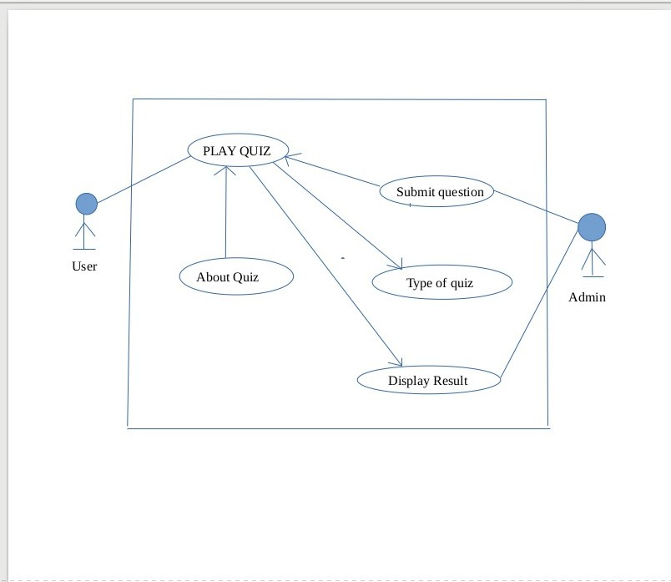

### 12

**IMPLEMENTATION (HTML,CSS,JAVASCRIPT)**

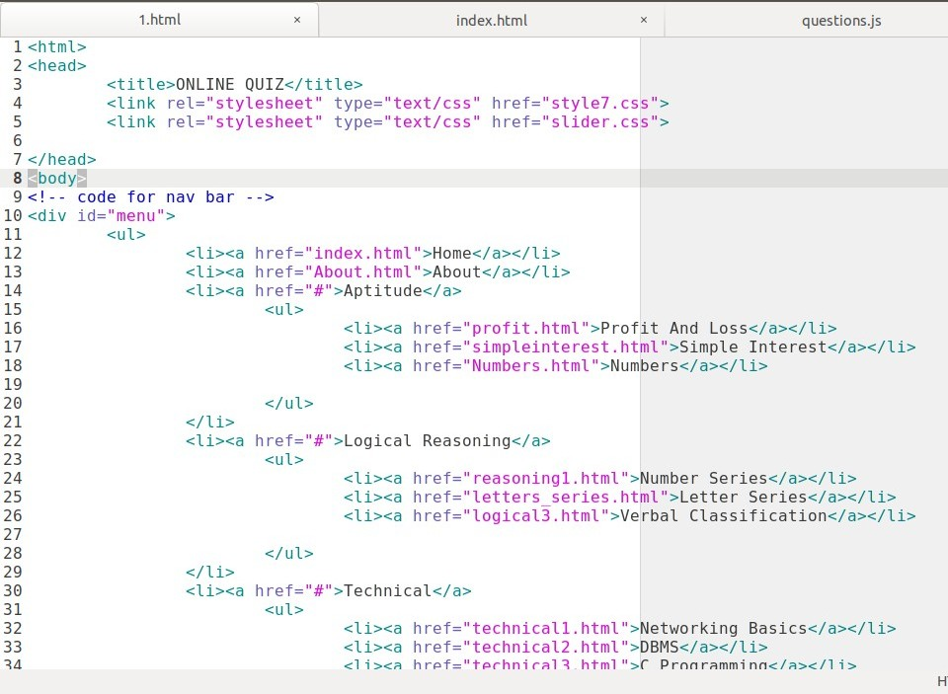

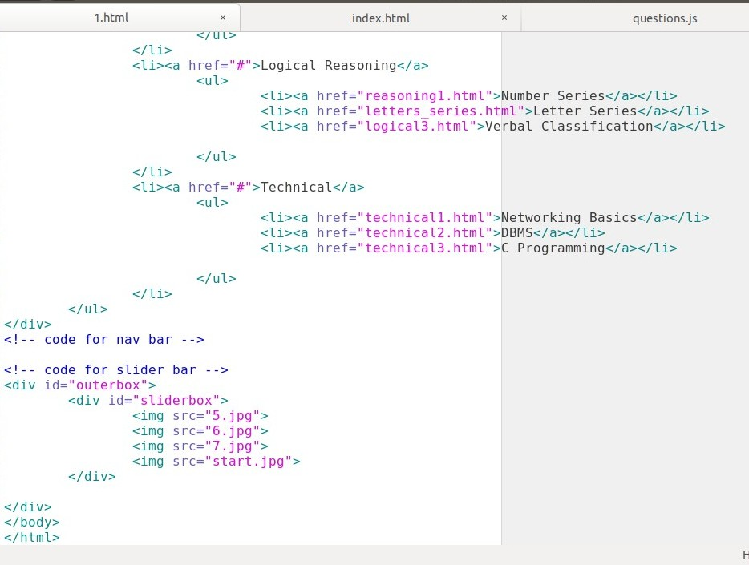

14

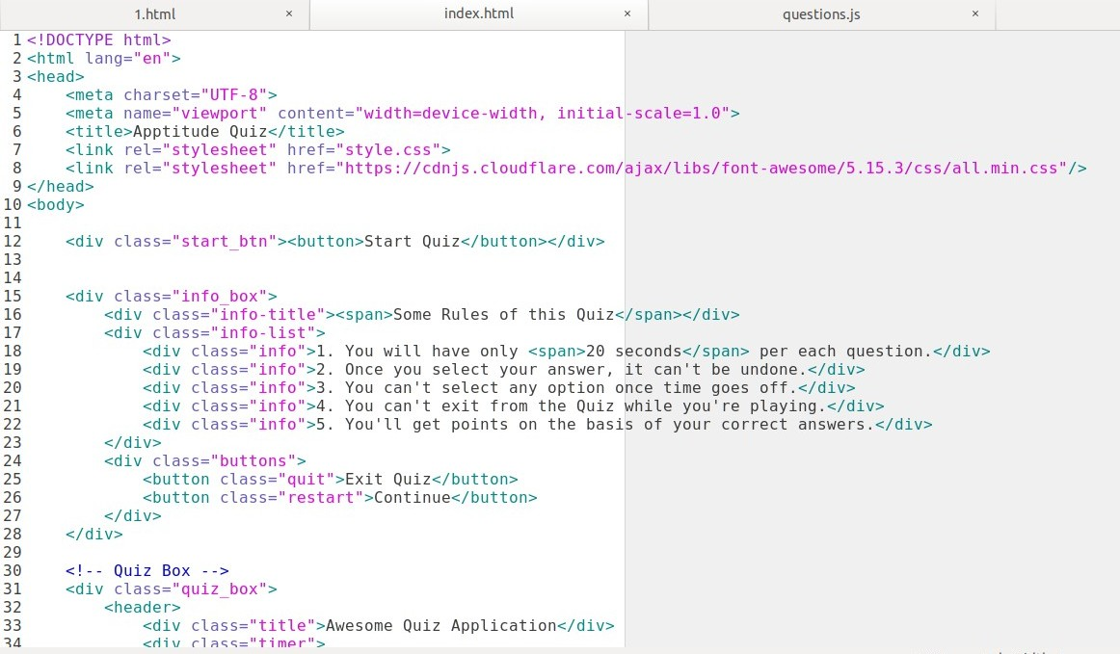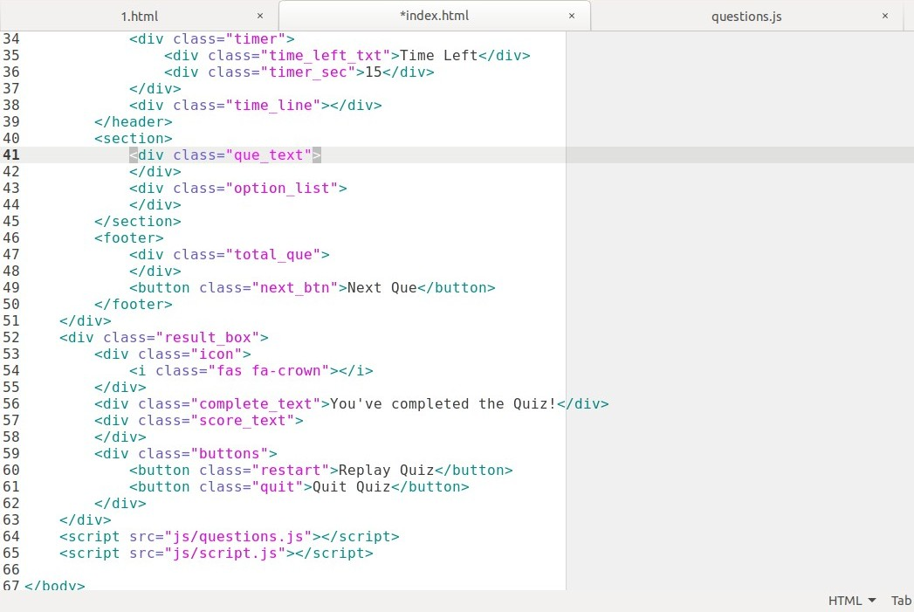

15

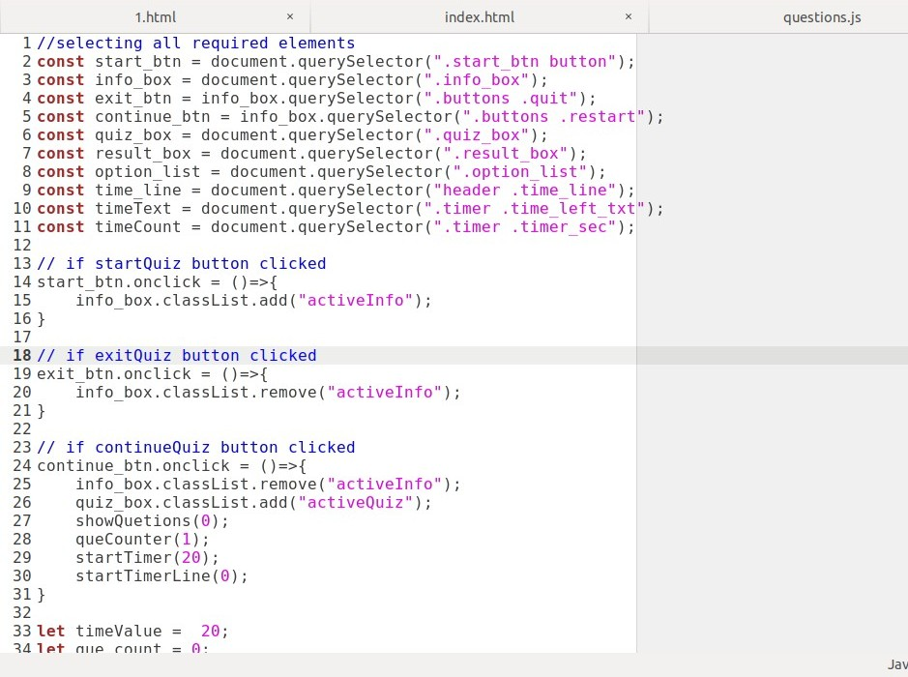

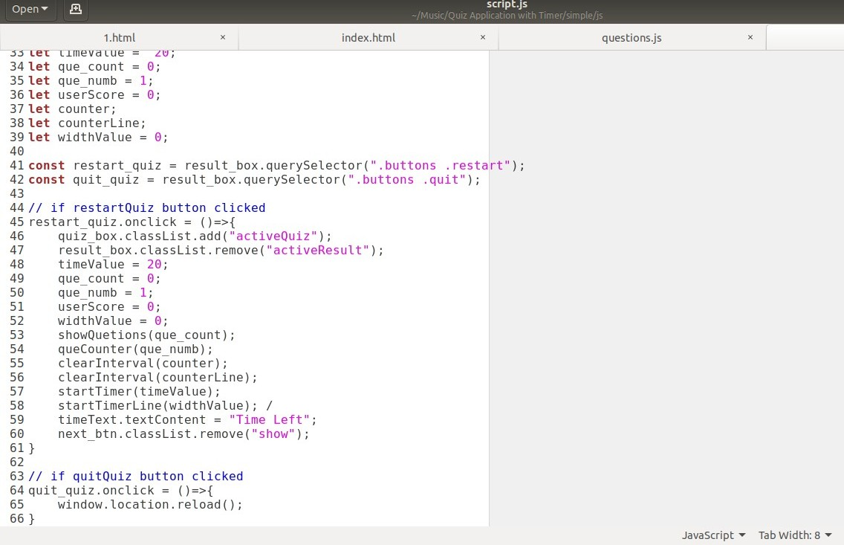

16

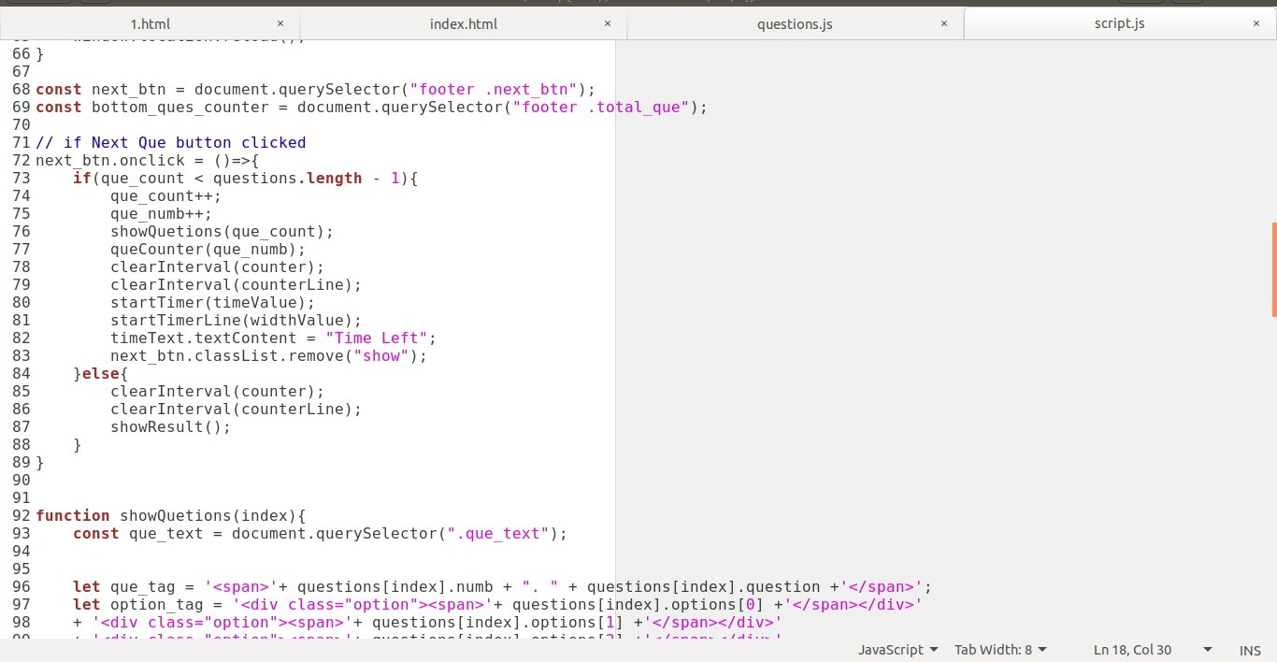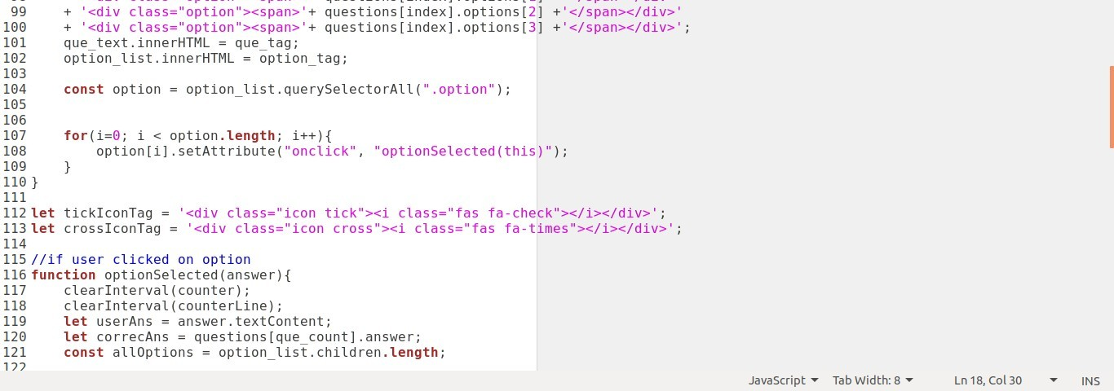

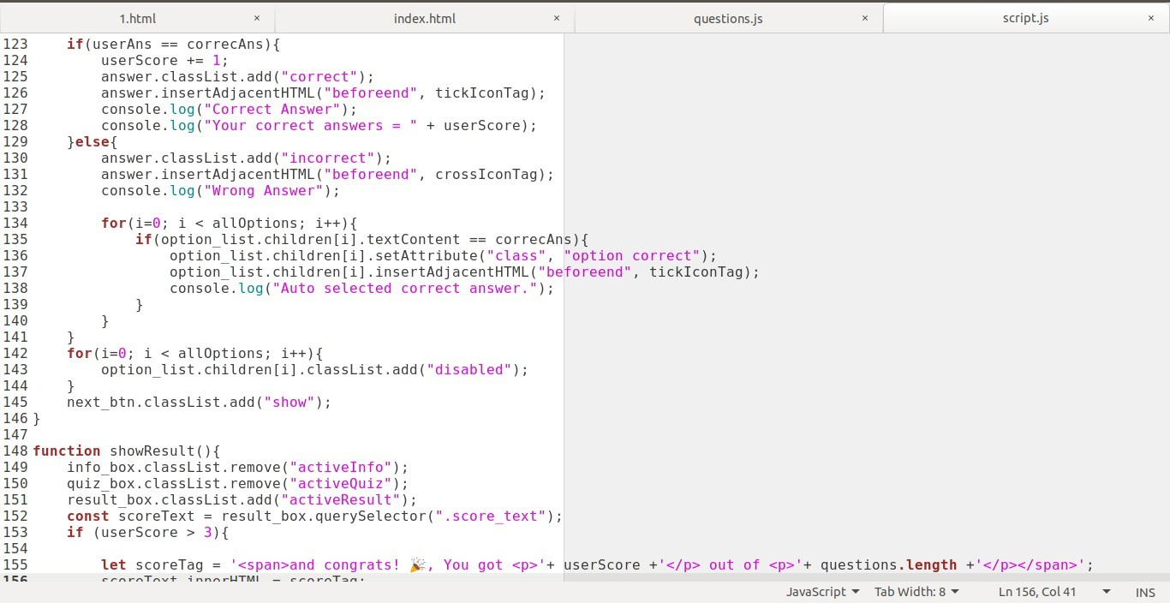

17

**Evaluation**

### HOME PAGE:



**18**

### SELECTION OF TOPIC BY USER:

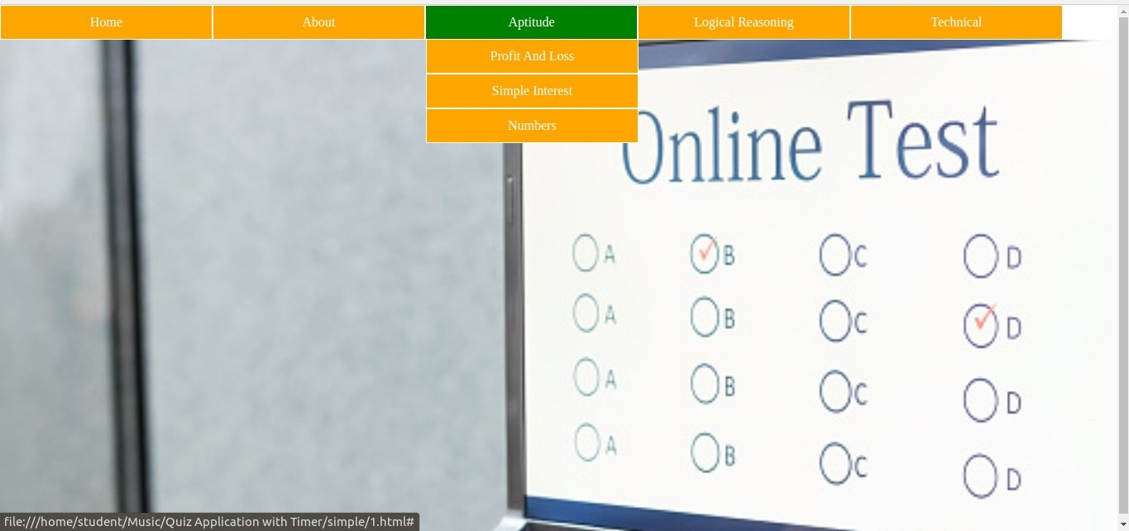

**19**

### START QUIZ PAGE:



**19**

### RULES OF THE SELECTED QUIZ:

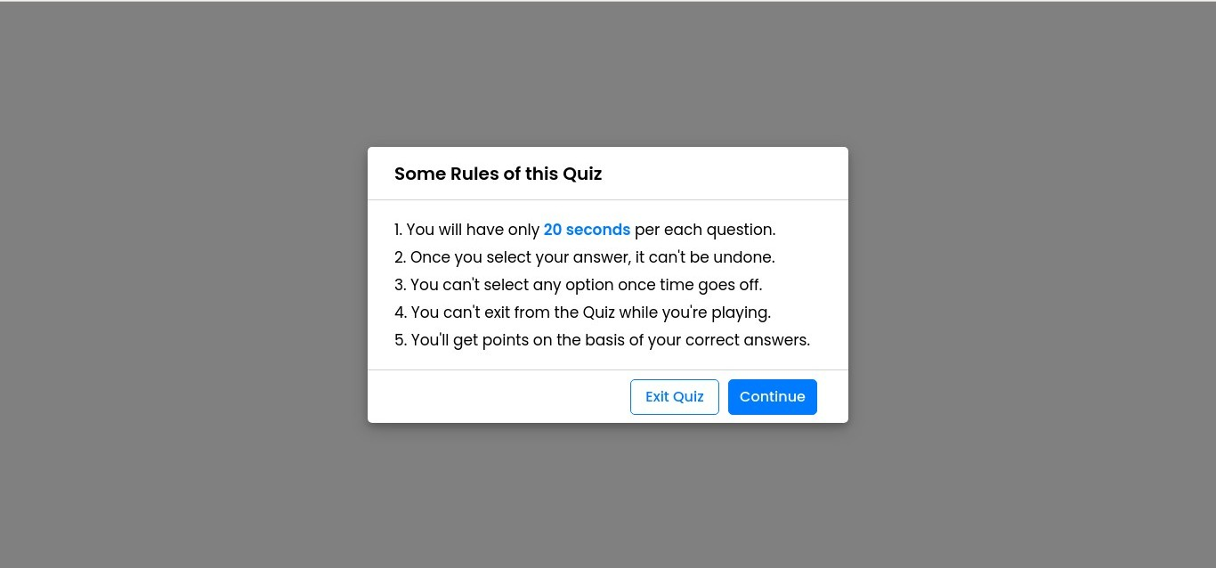

**20**

### QUESTION DISPLAY:

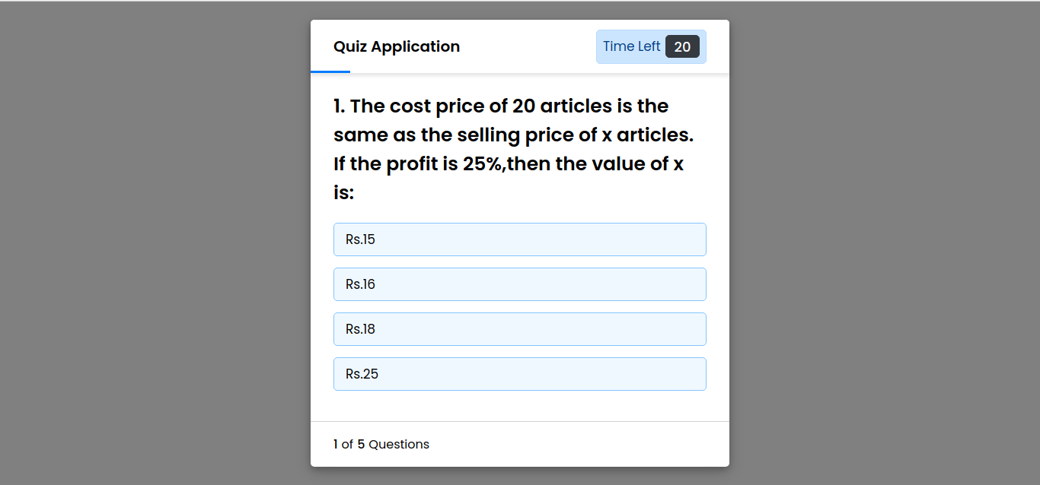

**21**

### QUIZ ANSWERING:

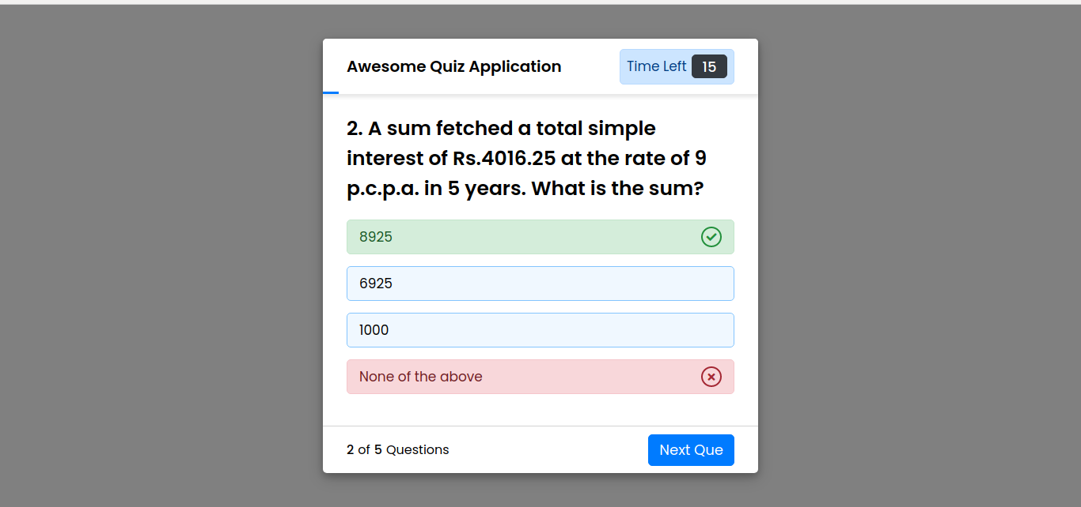

**22**

### RESULT PAGE:



**23**

### ABOUT PAGE:



**24**

### CONCLUSION:

This online quiz application provides facility to play quiz anywhere and anytime.It save time since user need to wait for result.A user User can practice the Topic related question and attempt the quiz again and again. All student/user get extra knowledge and skills.Admin has a privilege to put as much as question in any category given in application.

### REFERENCE:

* [https://www.w3schools.com](https://www.w3schools.com/)
* [https://www.indiabix.com](https://www.indiabix.com/)
* [https://www.javatpoint.com](https://www.javatpoint.com/)

25