Assignment 15.5
Name: M.LIKITHA
HT No: 2303A51958
Batch: 22

Task 1 – Student Attendance API
Task:
Create a RESTful API for student attendance tracking.
Instructions:
• Endpoints required:
o GET /attendance → View attendance records
o POST /attendance → Mark attendance
o PUT /attendance/{id} → Update attendance record
o DELETE /attendance/{id} → Remove attendance entry
• Ensure JSON-based request and response handling.

Prompt:
//create a restful api for student attendence tracking system
//Endpoints required:
//GET /attendance → View attendance records
//POST /attendance → Mark attendance
//PUT /attendance/{id} → Update attendance record
//DELETE /attendance/{id} → Remove attendance entry
//ensure json based response and request handling
//give some sample data for testing the api

Code:
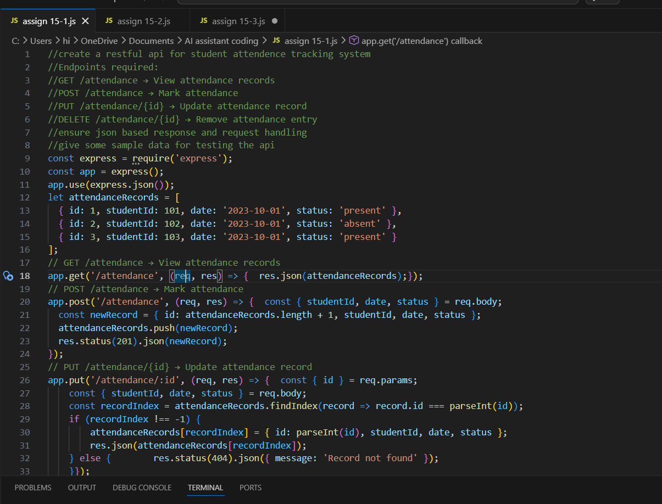
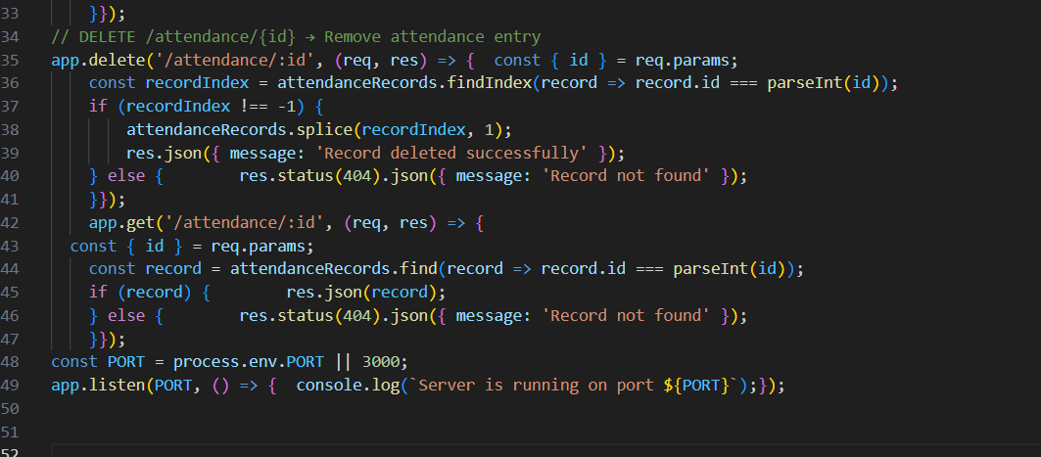

output:
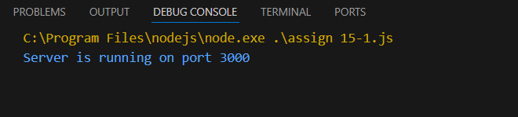

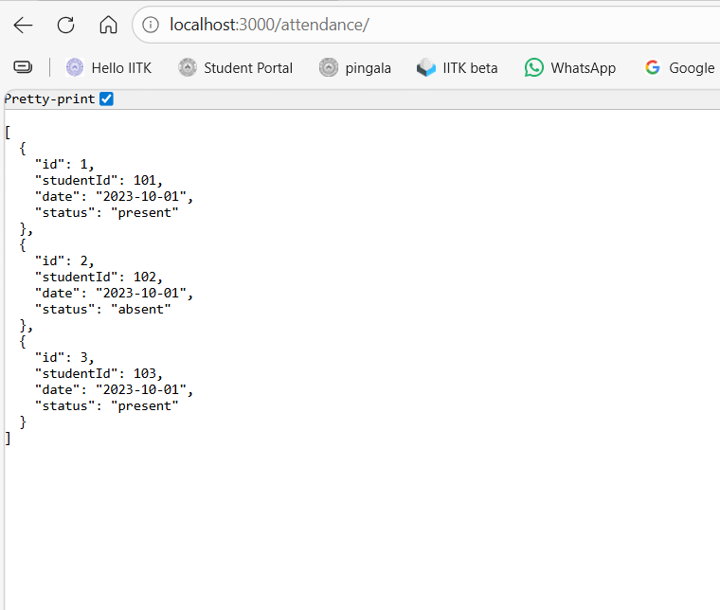
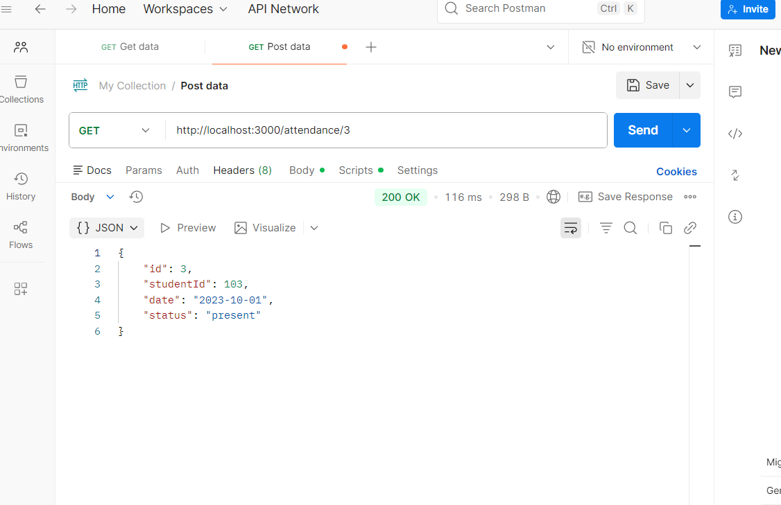

Explanation:
We import the express module and create an instance of it.
We use express.json() middleware to parse JSON request bodies.
We define an array attendanceRecords to store our sample attendance data.
We implement the GET /attendance endpoint to return all attendance records.
We implement the POST /attendance endpoint to add a new attendance record.
We implement the PUT /attendance/:id endpoint to update an existing attendance record based on its id. We implement the DELETE /attendance/:id endpoint to delete an attendance record based on its id.
We implement the GET /attendance/:id endpoint to retrieve a specific attendance record based on its id.
Finally, we start the server on a specified port and log a message to indicate that the server is running.

Task 2 – Inventory Management API
Task:
Develop a REST API for warehouse inventory management.
Instructions:
• Endpoints required:
o GET /inventory → List all items
o POST /inventory → Add new item
o PUT /inventory/{id} → Update stock quantity
o DELETE /inventory/{id} → Remove an item
• Implement validation for stock values.
Expected Output:
• API capable of managing inventory stock levels.

Prompt:
//Develop a REST API for warehouse inventory management.
//Implement the following endpoints:
//GET /inventory → View all inventory items
//POST /inventory → Add a new inventory item
//PUT /inventory/{id} → Update an existing inventory item
//DELETE /inventory/{id} → Remove
//add some sample data to the inventory for testing purposes
//Implement validation for stack values
Code:
- GET:
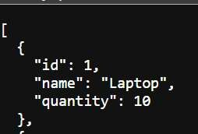
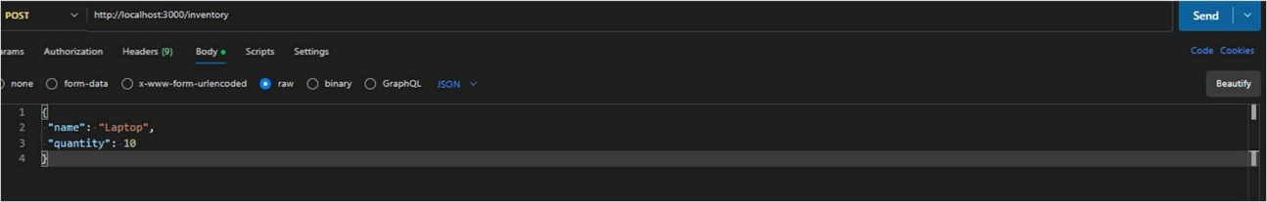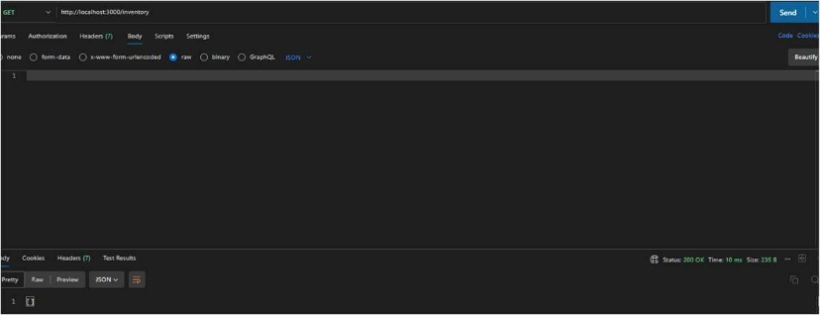

PUT:
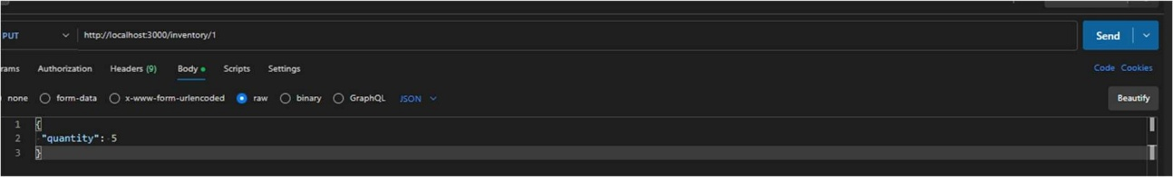
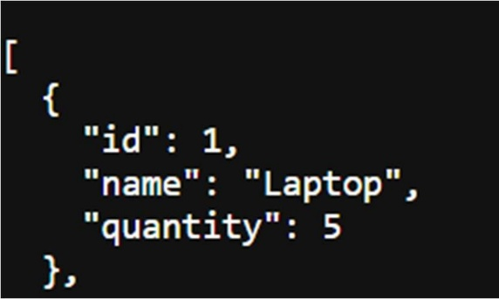
DELETE:
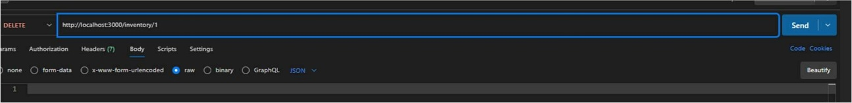
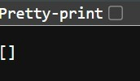
Output:
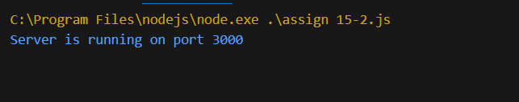
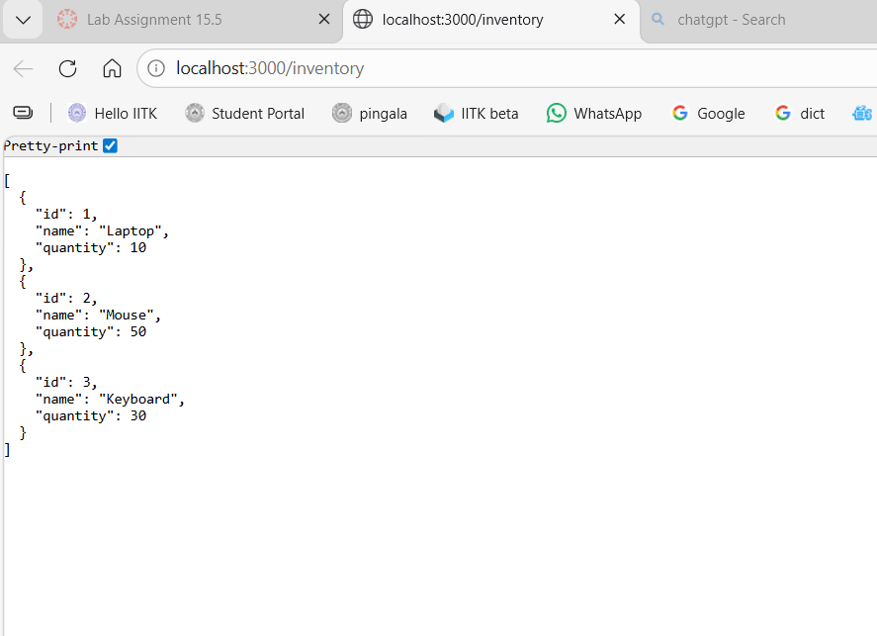
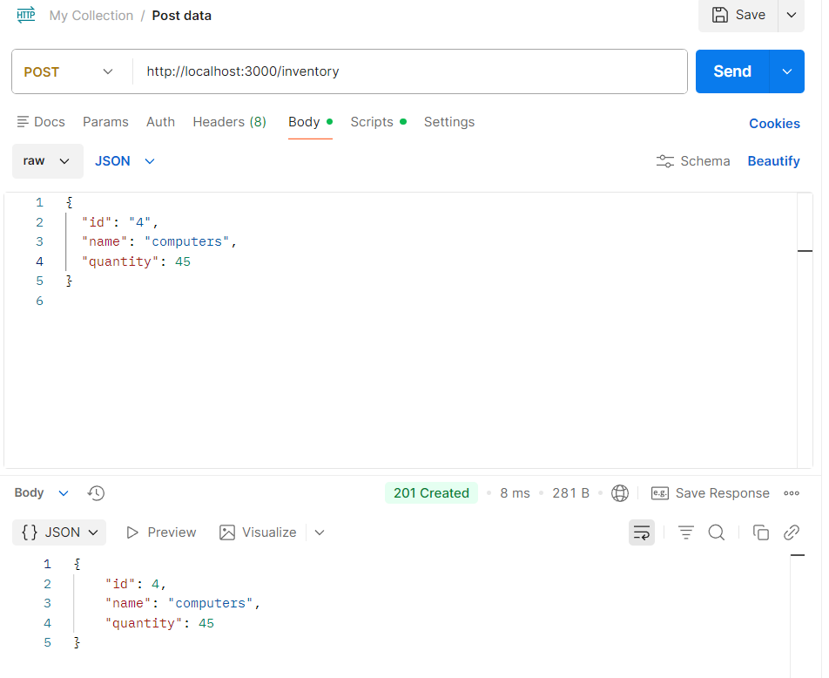
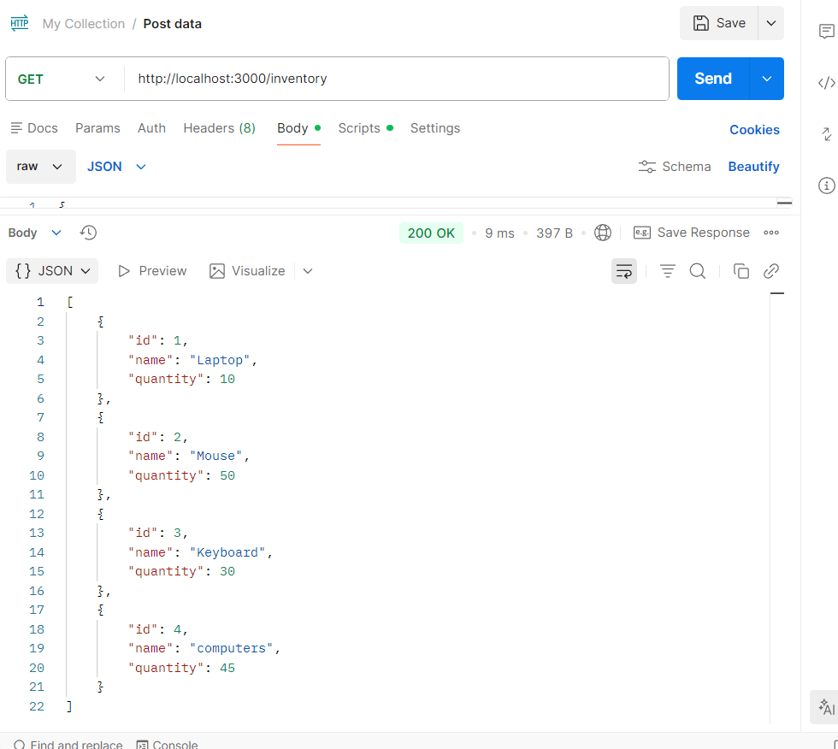
Explanation:
This code sets up a REST API for warehouse inventory management using Express.js. It includes endpoints to view all inventory items, add a new item, update an existing item, and delete an item. The API also includes validation for input data to ensure that the name is a string and the quantity is a non-negative number. Sample data is provided for testing purposes.
To test the API, you can use tools like Postman or curl to send HTTP requests to the endpoints. For example, you can send a GET request to http://localhost:3000/inventory to view all inventory items, or a POST request with a JSON body to add a new item. You can also update or delete items using the respective endpoints.

Task 3 – Hotel Room Booking API
Task:
Develop a RESTful API for hotel room booking.
Instructions:
• Endpoints required:
o GET /rooms → View available rooms
o POST /rooms/book → Book a room
o GET /rooms/{id} → View booking details
o DELETE /rooms/{id} → Cancel booking
• Implement error handling for unavailable rooms.

Prompt:
//Develop a RESTful API for hotel room booking.
//Endpoints required:
//GET /rooms → View available rooms
//POST /rooms/book → Book a room
//GET /rooms/{id} → View booking details
//DELETE /rooms/{id} → Cancel booking
//Implement error handling for unavailable rooms.

Code:
- GET:
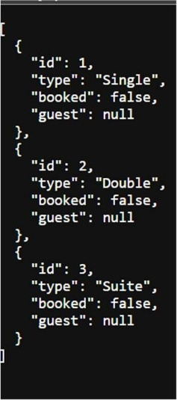
POST:
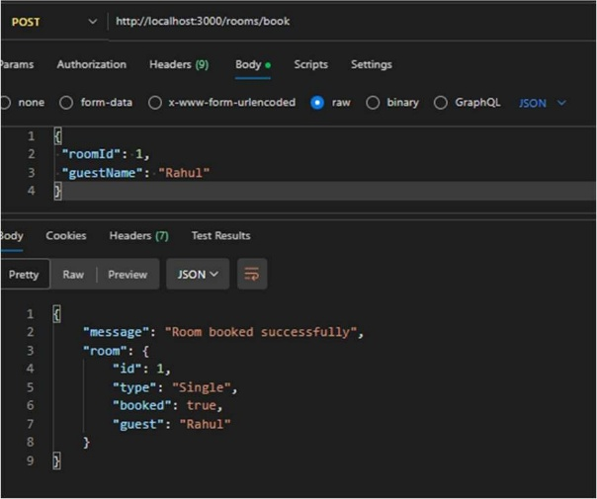
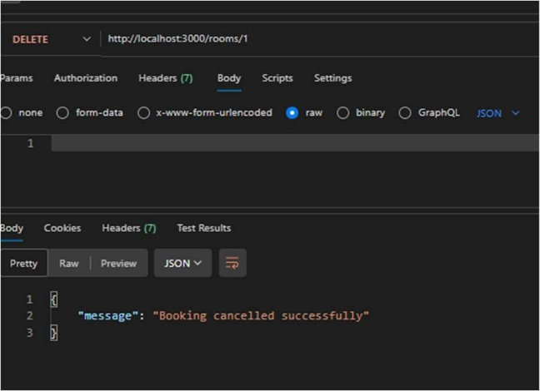
DELETE:

Output:
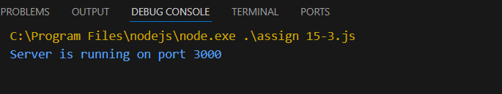

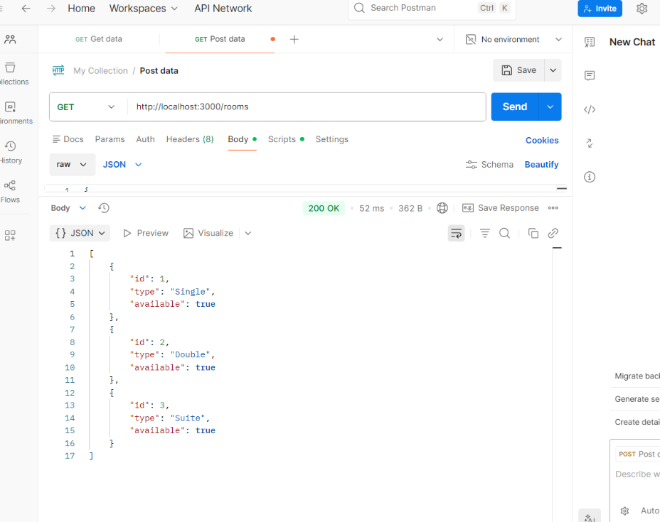
Explanation:
This code sets up a RESTful API for hotel room booking using Express.js. It includes endpoints to view available rooms, book a room, view booking details, and cancel a booking. The API also implements error handling for cases where a room is not found or is unavailable for booking. Sample data is provided for testing the API.
To test the API, you can use tools like Postman or curl to send HTTP requests to the endpoints. For example, you can send a GET request to http://localhost:3000/rooms to view available rooms, or a POST request with a JSON body to book a room. You can also view booking details or cancel a booking using the respective endpoints.

Task 4 – Online Voting API
Task:
Create a RESTful API for an online voting system.
Instructions:
• Endpoints required:
o GET /candidates → List candidates
o POST /vote → Cast a vote
o GET /results → View voting results
• Ensure one vote per user using in-memory validation.
Expected Output:
• API simulating a secure online voting process.

Prompt:
//Create a RESTful API for an online voting system
//Endpoints required:
//GET /candidates → List candidates
//POST /vote → Cast a vote
//GET /results → View voting results
//Ensure one vote per user using in-memory validation.
//Expected Output:
//API simulating a secure online voting process.
Code:
- GET:
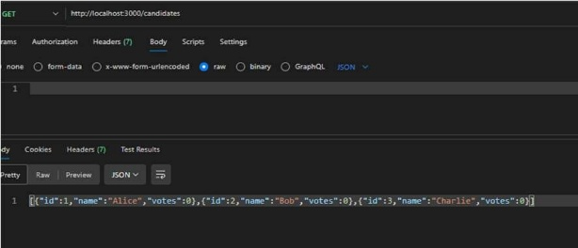

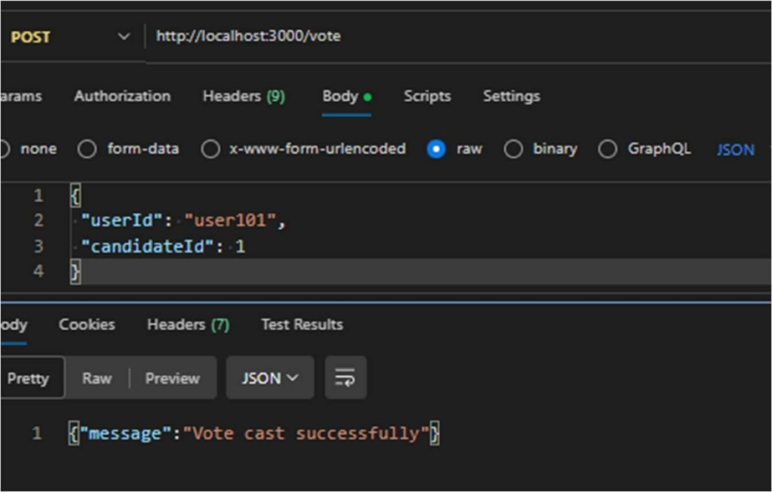
GET:
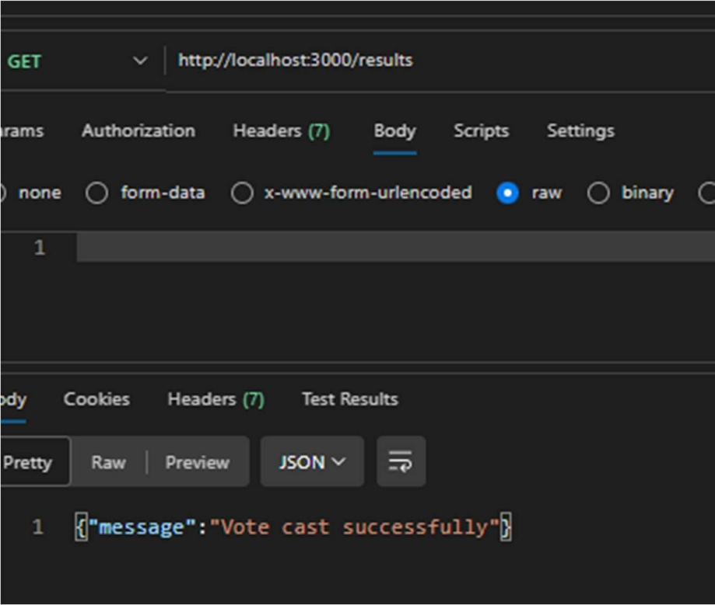
Output:
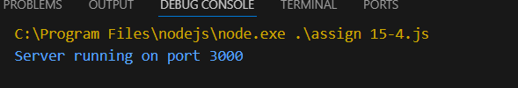
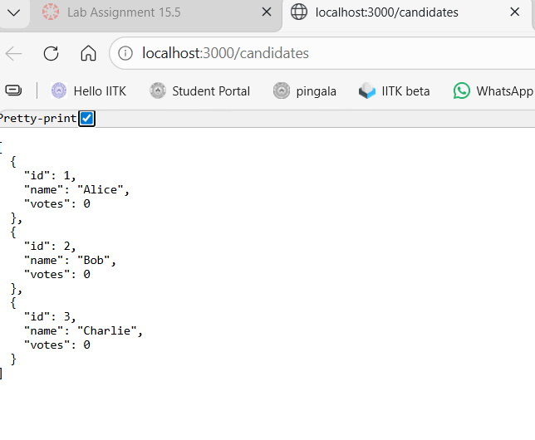
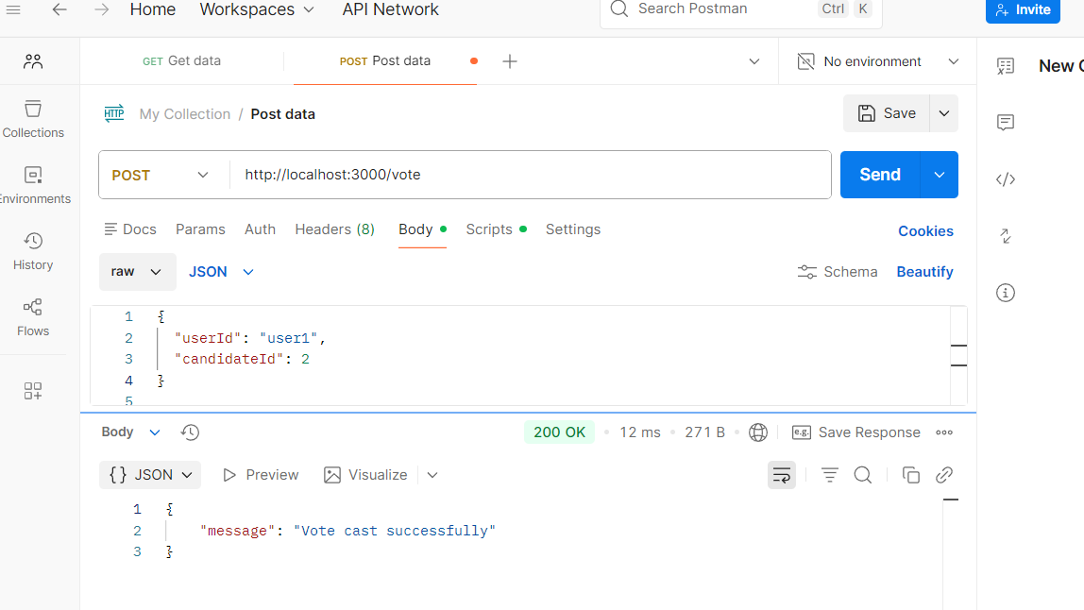
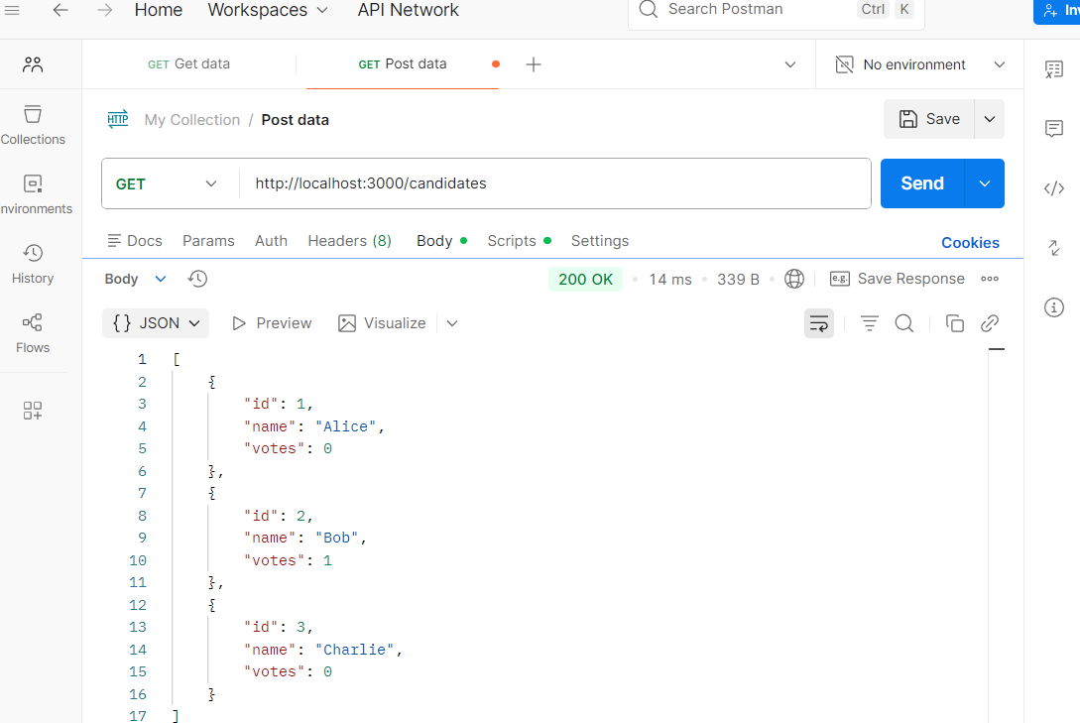

Explanation:
This API creates an online voting system where users can view candidates, cast votes, and check results. It uses Node.js with Express.js to build REST endpoints like GET /candidates, POST /vote, and GET /results. A Set is used for in-memory validation to ensure each user can vote only once, preventing duplicate voting.

Task 5 – Teacher Management API
Task:
Develop a RESTful API to manage teacher records.
Instructions:
• Endpoints required:
o GET /teachers → List all teachers
o POST /teachers → Add a new teacher
o PUT /teachers/{id} → Update teacher details
o DELETE /teachers/{id} → Remove a teacher
• Ensure proper error handling and JSON responses.
Expected Output:
• Functional API for managing teacher information.

Prompt:
//Develop a RESTful API to manage teacher records.
//Endpoints required:
//GET /teachers → List all teachers
//POST /teachers → Add a new teacher
//PUT /teachers/{id} → Update teacher details
//DELETE /teachers/{id} → Remove a teacher
//Ensure proper error handling and JSON responses.
//Expected Output:
//Functional API for managing teacher information.
Code:

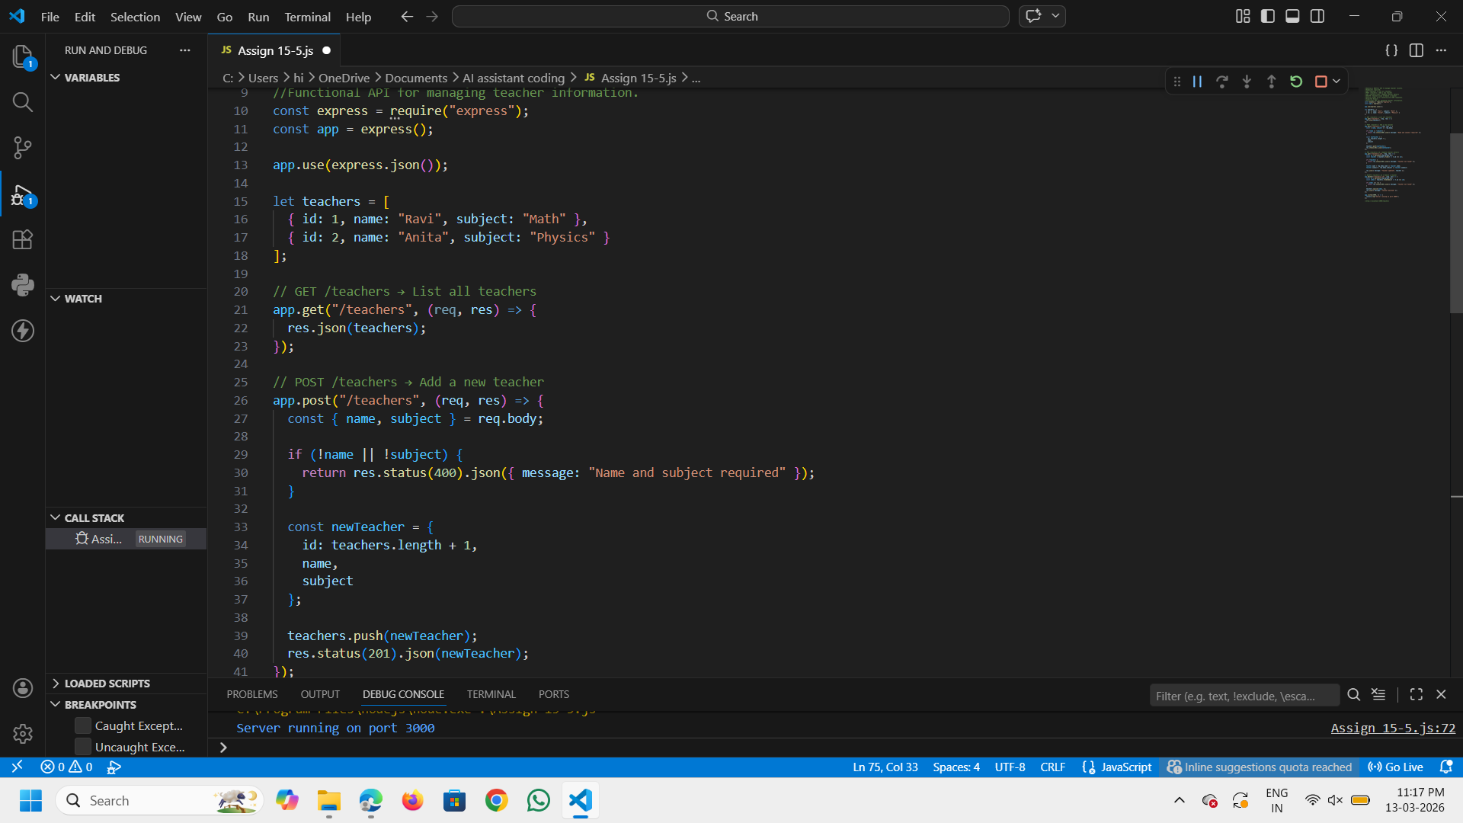
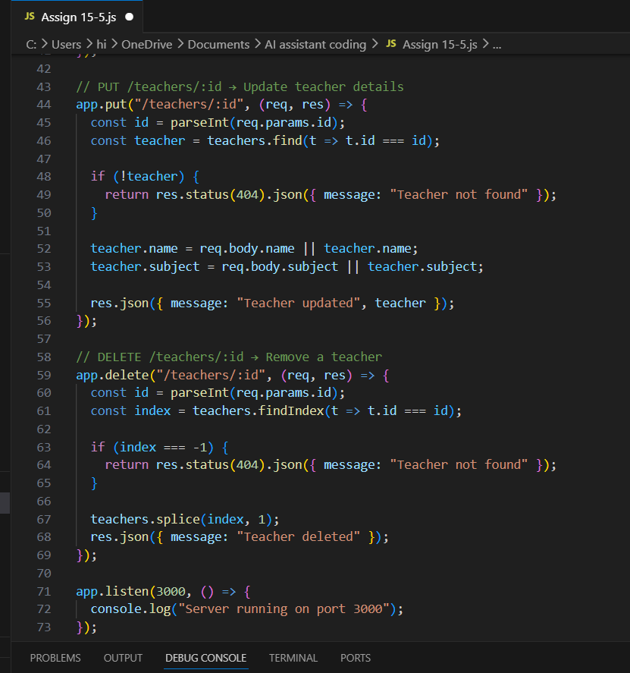
Output:
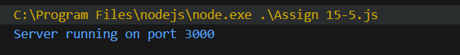

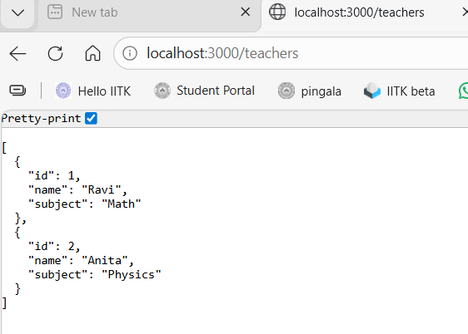

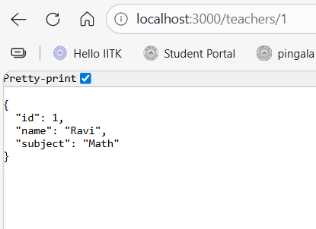

Explanation:
This RESTful API is built using Node.js and Express to manage teacher records.
The GET /teachers endpoint retrieves all teachers, while POST /teachers adds a new teacher to the list.
The PUT /teachers/:id endpoint updates a teacher’s details using the teacher ID, and DELETE /teachers/:id removes a teacher.
The API returns JSON responses and proper error messages if a teacher is not found or data is missing.

