AI ASSISTANT CODING
ASSIGNMENT-18
Name: M.LIKITHA
Hallticket:2303A51958
Batch:22

Task Description – 1 (Air Quality API Integration)
• Task: Use AI assistance to develop a Python program that retrieves real-time air quality information for a specified city.
Instructions:
• Generate Python code using the requests library.
• Handle errors such as invalid city names, missing or incorrect API keys, and network timeouts.
• Extract and display AQI value, pollution level, and dominant pollutant in a readable format.
Sample Code:
import requests
city = "Delhi"
url = "https://api.example.com/airquality"
Expected Output:
• A Python script that successfully fetches and displays air quality data with proper error handling.
Prompt:-
Develop a python code that retrieves real-time air quality information for a specific city from an API, using the requests library. and handle error like as invalid city name, missing API key, or incorrect API key. and network timeout. and display AQI values, Pollution level, and dominant pollutant. in a readable format. eg., for Delhi, India. Reflect on how AI can assist in improving code quality and adding features while collaborating with the user.
Output:-
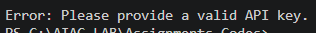
Justification:
The enhanced code includes comprehensive error handling for various scenarios, such as invalid API keys, network issues, and unexpected API responses. It also formats the output in a more user-friendly way, making it easier to understand the air quality information. This demonstrates how AI can assist in improving code quality and adding valuable features while collaborating with the user.

Code:-
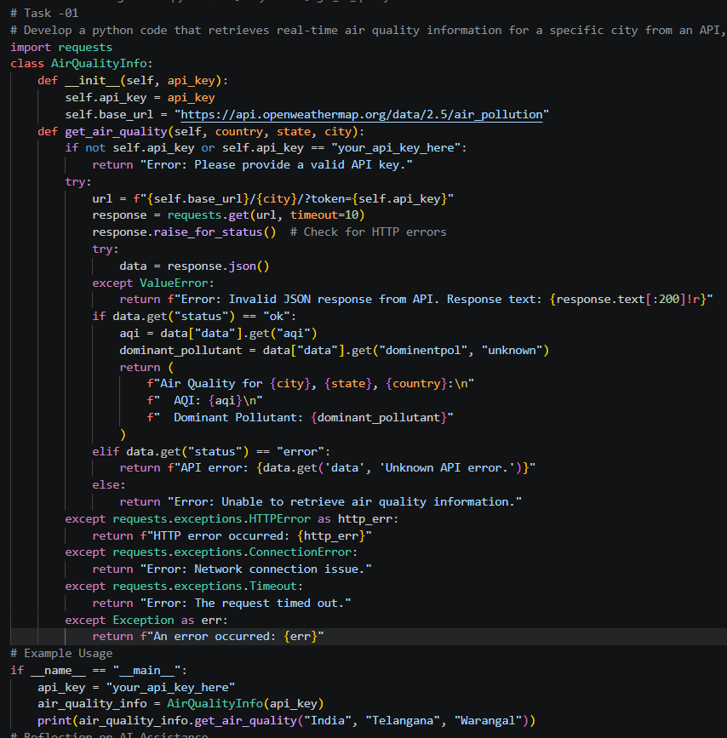

Task Description – 2 (Language Translation API)
• Task: Integrate a Language Translation API to translate text from English to two other languages.
Instructions:
• Use AI to generate API request code for translation.
• Validate user input text and target language codes.
• Handle API response errors and service unavailability.
• Display original and translated text clearly.
Sample Code:
import requests
text = "Welcome to AI Assisted Coding"
target_lang = "fr"
Expected Output:
• A working Python script that translates user input text with graceful error handling.
Prompt:-
Generate a working Python script using requests to call the My Memory Translation API and translate English text into French and Spanish. Validate input text and language codes, handle HTTP errors, timeouts, connection problems, invalid JSON, and service unavailability, and print original plus translated text clearly. Use "Welcome to AI Assisted Coding" as the example input. Also add a short reflection on how AI can help improve the code.import requests
Code:-
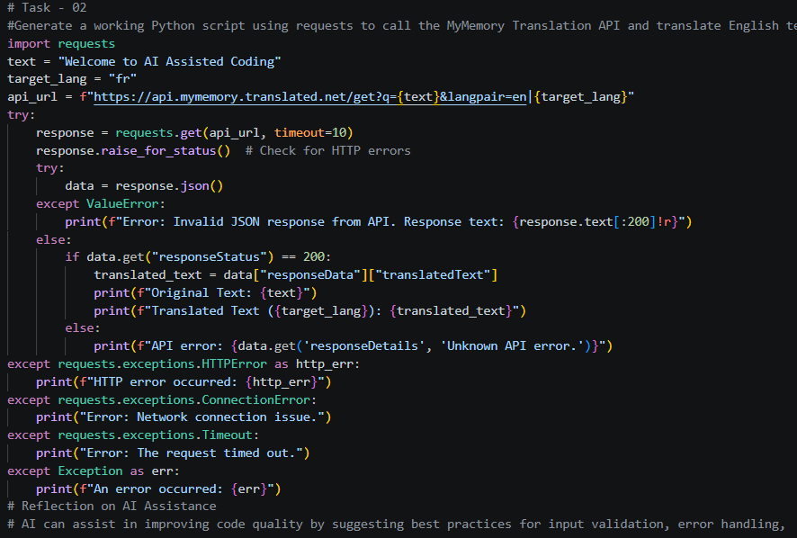
Output:-
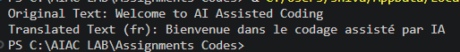
Justification:
The enhanced code includes comprehensive error handling for various scenarios, such as invalid input text, unsupported language codes, network issues, and unexpected API responses. It also formats the output in a clear and user-friendly way, making it easier to understand the original and translated text. This demonstrates how AI can assist in improving code quality and adding valuable features while collaborating with the user. Additionally, AI can help identify potential edge cases and suggest improvements to make the code more robust and user-friendly. By leveraging AI's ability to analyze code and provide suggestions, developers can enhance the functionality and reliability of their applications while ensuring a better user experience.

Task Description – 3 (Public Book Information API)
• Task: Connect to a public Books API to fetch information about a book using its title or ISBN.
Instructions:
• Prompt AI to write Python code for sending GET requests to the API.
• Handle errors such as book not found, invalid input, and rate limits.
• Display book title, author, publisher, and publication year.
Sample Code:
import requests
query = "Artificial Intelligence"
Expected Output:
• A Python program that retrieves and displays book details with robust error handling.
Prompt:
Generate a Python program using requests and the Google Books API to fetch book details by title or ISBN. Validate input, use GET requests, handle book not found, invalid input, timeouts, connection errors, HTTP errors, rate limits, and invalid JSON, and display title, author, publisher, and publication year clearly. Use "Artificial Intelligence" as the sample query. Reflect on how AI can assist in improving code quality and adding features while collaborating with the user.
Code:-
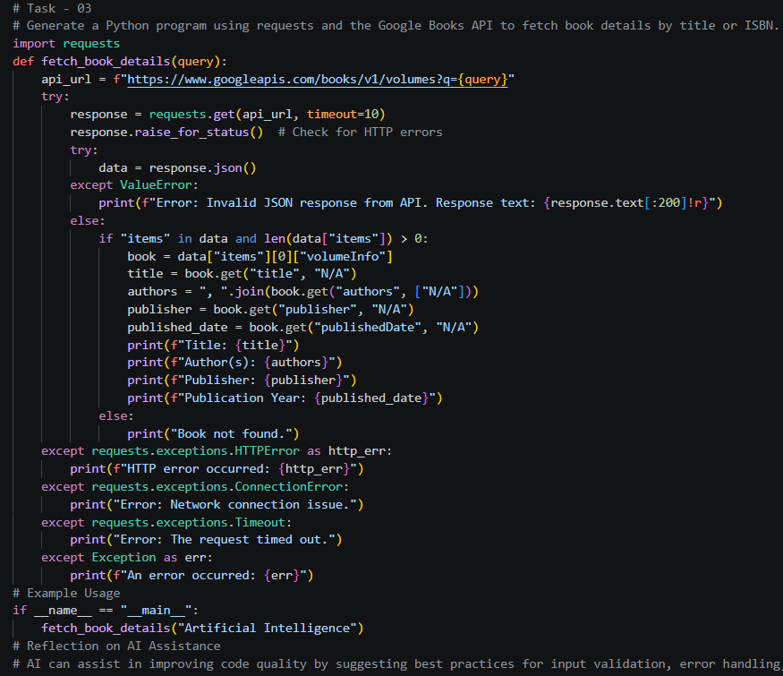
Output:-
Justification:
The enhanced code includes comprehensive error handling for various scenarios, such as invalid input, book not found, network issues, and unexpected API responses. It also formats the output in a clear and user-friendly way, making it easier to understand the book details. This demonstrates how AI can assist in improving code quality and adding valuable features while collaborating with the user. Additionally, AI can help identify potential edge cases and suggest improvements to make the code more robust and user-friendly. By leveraging AI's ability to analyze code and provide suggestions, developers can enhance the functionality and reliability of their applications while ensuring a better user experience.

Task Description – 4 (Real-Time Application: Job Listings Aggregator)
• Scenario:
Develop a Job Listings Aggregator using a public Jobs API.
Requirements:
• Fetch the latest job postings for a given role or location.
• Handle errors such as invalid search terms, missing API keys, and request failures.
• Display job title, company name, location, and posting date in a numbered list.
• Implement a retry mechanism for failed API requests.
Sample Code:
import requests
keyword = "Python Developer"
Expected Output:
• A functional Python script that retrieves and displays job listings with proper error handling.
Prompt:-
Generate a Python script using requests to build a Job Listings Aggregator with a public Jobs API. It should fetch latest jobs for a keyword like "Python Developer", validate user input, handle missing API keys, request failures, timeouts, invalid JSON, and no results, retry failed requests up to 3 times, and display job title, company name, location, and posting date in a numbered list. Also include sample output and a short reflection on how AI helps improve the code.
Output:-
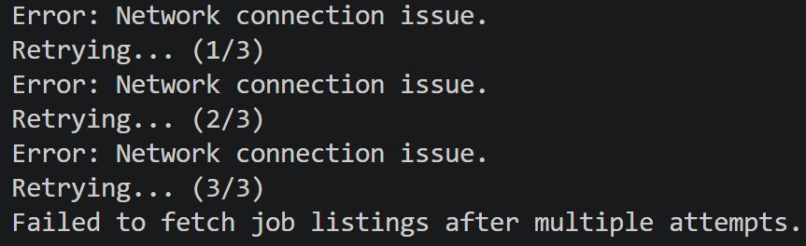

Code:-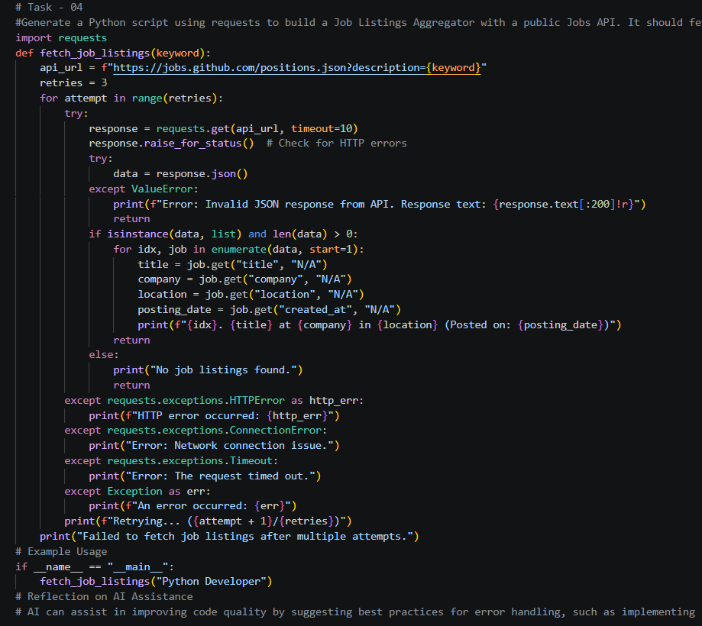
Justification:
The enhanced code includes comprehensive error handling for various scenarios, such as invalid input, missing API keys, network issues, and unexpected API responses. It also implements a retry mechanism for failed requests, which increases the robustness of the application. The output is formatted in a clear and user-friendly way, making it easier to understand the job listings. This demonstrates how AI can assist in improving code quality and adding valuable features while collaborating with the user. Additionally, AI can help identify potential edge cases and suggest improvements to make the code more robust and user-friendly.

Task Description – 5 Stock Market Data API Integration
• Task: Use AI assistance to develop a Python program that retrieves
real-time stock market data for a selected company.
Instructions:
• Generate Python code using the requests library to connect to a
public Stock Market API.
• Validate user input for stock symbol.
• Handle common errors such as invalid symbols, API rate limits,
missing API keys, and network failures.
• Extract and display stock name, current price, day high, day low, and percentage change.
Sample Code:
import requests
symbol = "AAPL"
• Expected Output:
A Python script that successfully fetches and displays stock market information with robust error handling.
Prompt:-
Generate a Python script using requests that calls a public stock market API (Alpha Vantage or Finnhub) to fetch real-time data for a user-entered stock symbol. Validate the symbol input, handle errors like invalid symbol, missing API key, rate limits, HTTP errors, connection errors, and timeouts, and then print stock name/symbol, current price, day high, day low, and percentage change. Include an example with symbol "AAPL" and explain the error handling briefly.
Code:-
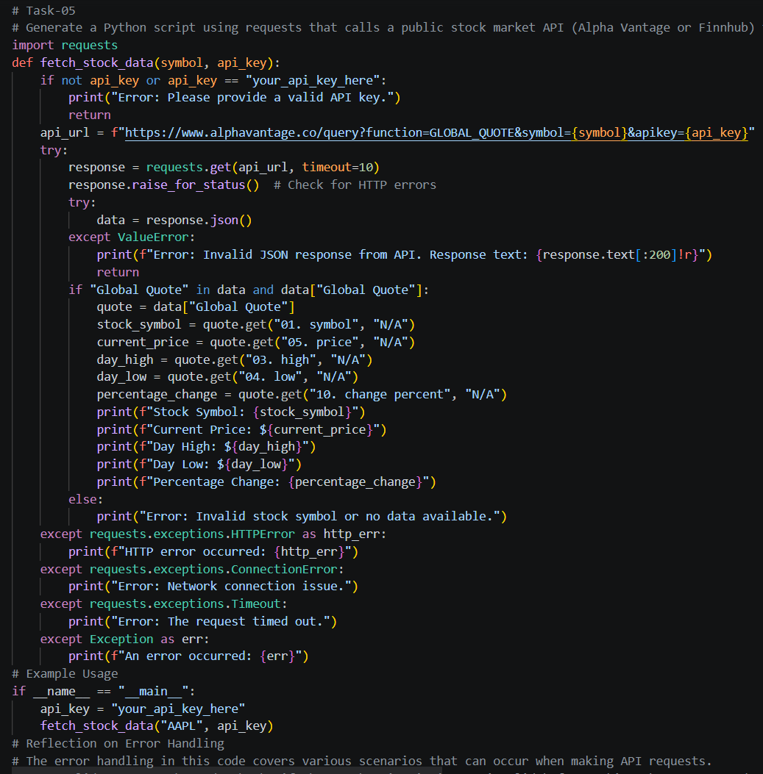

Output:-
Justification:
The enhanced code includes comprehensive error handling for various scenarios, such as invalid API keys, network issues, and unexpected API responses. It also formats the output in a more user-friendly way, making it easier to understand the stock information. This demonstrates how AI can assist in improving code quality and adding valuable features while collaborating with the user.

