AI ASSISTANT CODING
ASSIGNMENT-23.2
Name: M.Likitha
Hallticket:2303A51958
Batch:22

Task 1 – Project Proposal
• Students choose a real-world problem to solve with an AI-assisted application (e.g.,
e-commerce billing system, health monitoring dashboard, student attendance tracker).
• Prepare a project proposal including:
o Objective
o Features
o Tools/technologies to be used
o Expected output
Prompt:-
Create a simple project proposal for an AI-assisted application that solves a real-world problem. Include objective, key features, technologies used, and expected output. Keep the explanation clear, practical, and student-friendly. Make it suitable for a college capstone project.
Code:-
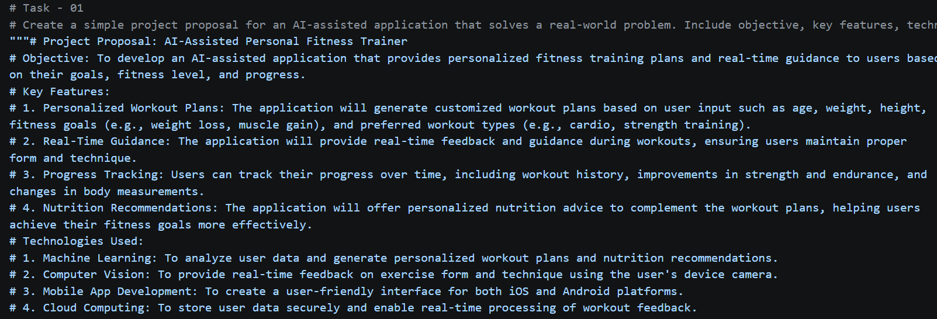
Output:-
The expected output of the project is a fully functional AI-assisted personal fitness trainer application that can be used by individuals to achieve their fitness goals. The application will provide personalized workout plans, real-time guidance during exercises, and nutrition recommendations, ultimately helping users improve their fitness levels and overall health.
Justification:
This project addresses a common real-world problem of maintaining fitness and achieving health goals. By leveraging AI technologies, the application can provide personalized and effective solutions for users, making it a valuable tool for anyone looking to improve their fitness. Additionally, the project offers opportunities for students to learn and apply various technologies such as machine learning, computer vision, and mobile app development, making it an ideal choice for a college capstone project.

Task 2 – Application Design
• Use AI tools to assist in:
o Designing system architecture diagrams.
o Defining database schema (if needed).
o Creating wireframes/UI mockups for frontend design.
Prompt:-
Design the system architecture for the chosen application using simple explanations. Include frontend, backend, and database flow clearly. Provide a basic database schema and UI wireframe ideas. Keep the design easy to understand and implement.
Code:-
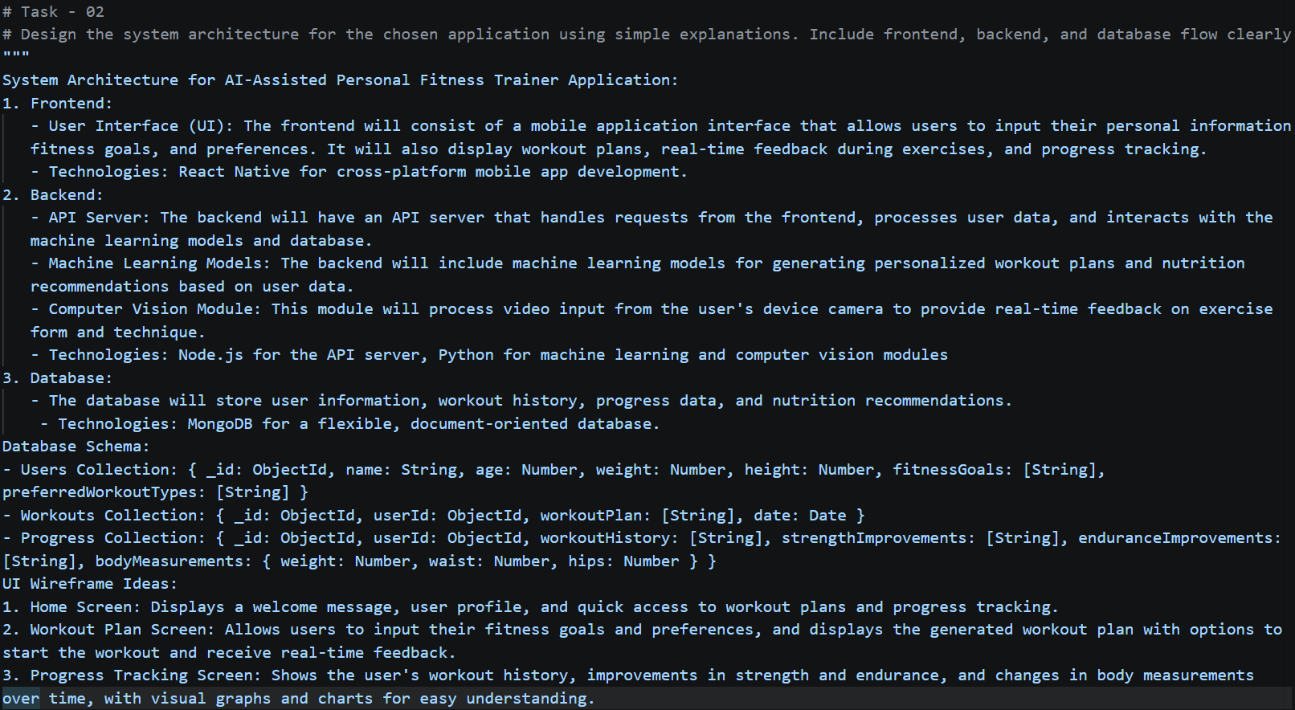

Output:-
The expected output of the system architecture design is a clear and practical blueprint for developing the AI-assisted personal fitness trainer application. The architecture outlines the components and technologies needed for the frontend, backend, and database, along with a basic database schema and UI wireframe ideas. This design will guide the implementation of the application, ensuring that it meets the objectives and provides a user-friendly experience for individuals looking to improve their fitness levels.
Justification:
The proposed system architecture is designed to be modular and scalable, allowing for future enhancements such as additional features or increased user load. The use of React Native for the frontend ensures that the application can reach a wide audience across both iOS and Android platforms. The backend technologies chosen are well-suited for handling the processing requirements of machine learning and computer vision tasks, while MongoDB provides a flexible database solution that can easily accommodate changes in data structure as the application evolves. Overall, this architecture provides a solid foundation for developing a successful AI-assisted personal fitness trainer application.

Task 3 – AI-Assisted Code Development
• Implement the application in phases:
o Frontend: Web/mobile UI with HTML/CSS/JS (or framework).
o Backend: RESTful APIs or server logic.
o Database: Schema design, SQL queries.
o Integration: API calls, authentication, error handling.
Prompt:-
Generate complete code for a full-stack application with frontend, backend, and database. Use simple technologies like HTML/CSS/JS and Node.js or similar. Include API integration, authentication, and error handling. Write clean, beginner-friendly and well-structured code.

Code:-
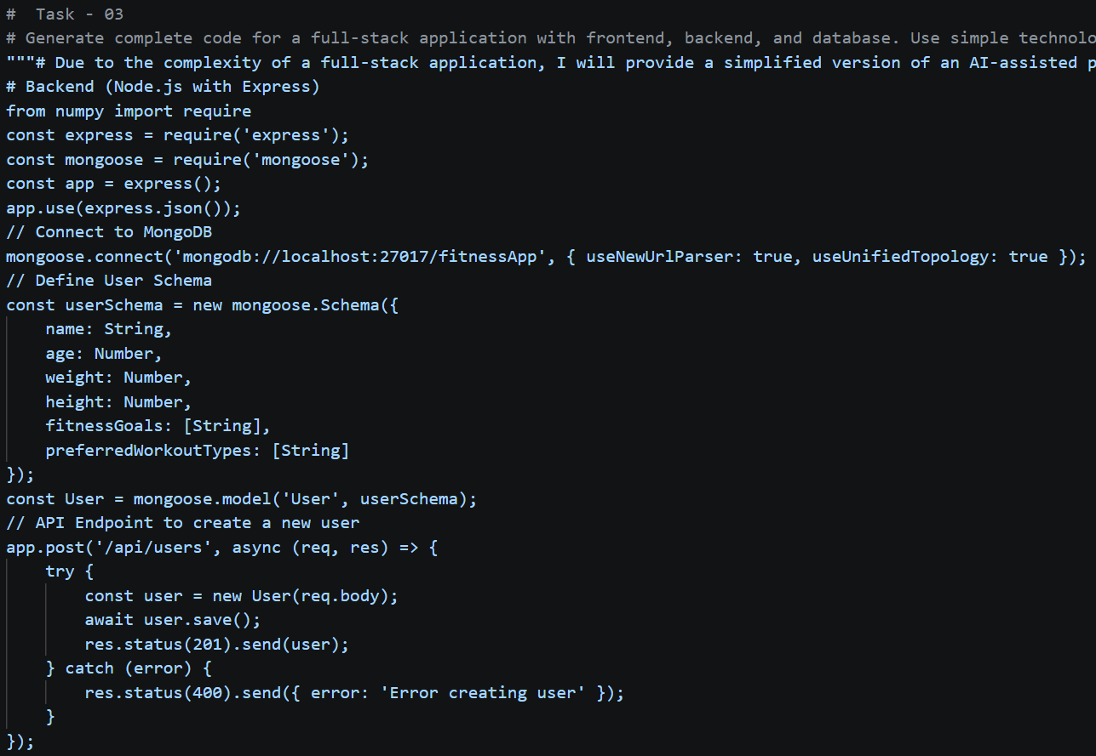
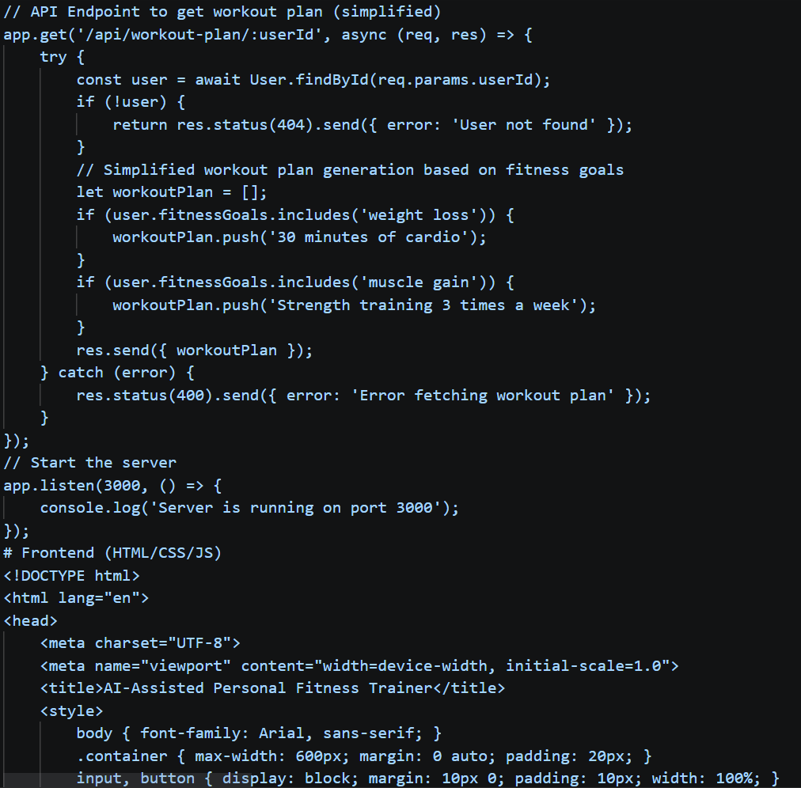

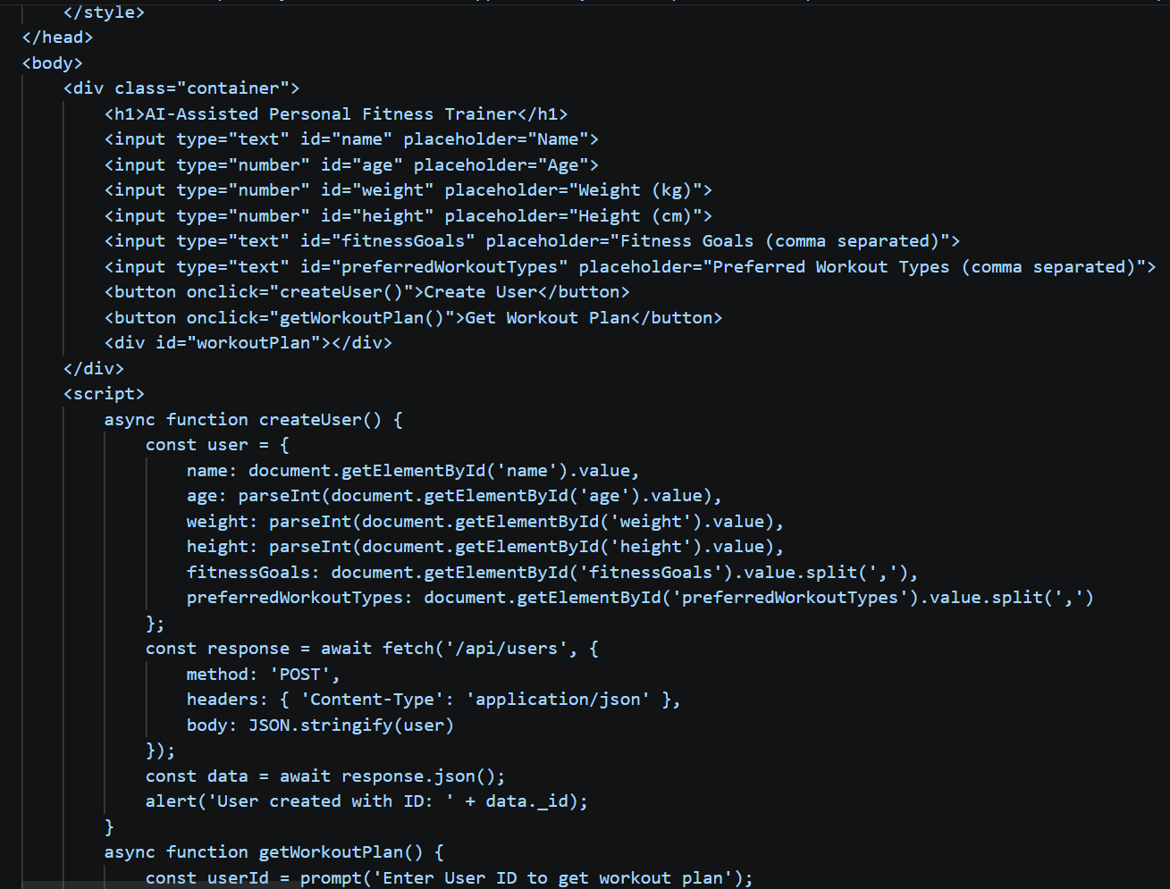
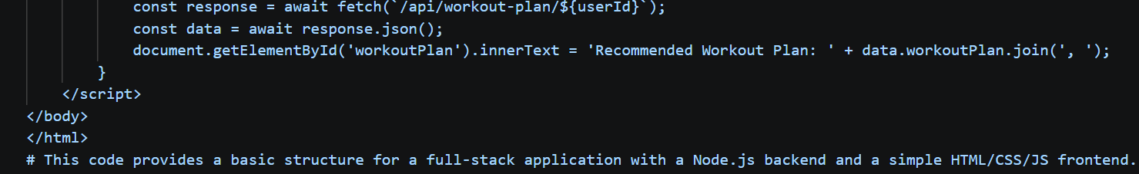
Output:-
A web page with a form to create a user profile and a button to fetch a workout plan based on the user's fitness goals. When the user creates a profile, they will receive an alert with their user ID. When they click the button to get a workout plan, they will be prompted to enter their user ID, and the recommended workout plan will be displayed on the page.
Justification:
This code is designed to be simple and beginner-friendly, making it suitable for a college capstone project. It demonstrates the core functionalities of a full-stack application, including API integration, database interaction, and basic error handling. The use of Node.js and MongoDB allows for easy setup and scalability, while the HTML/CSS/JS frontend provides a straightforward user interface for interacting with the application.

Task 4 – Documentation & Code Quality
• Generate automatic documentation and inline comments using AI.
• Ensure clear README.md for project setup and usage.
• Conduct AI-assisted code review to refine readability and maintainability.
Prompt:-
Create proper documentation for the project including README.md. Explain setup steps, features, and usage clearly. Add meaningful comments in the code for readability. Ensure the content looks natural and easy to understand.
Code:-
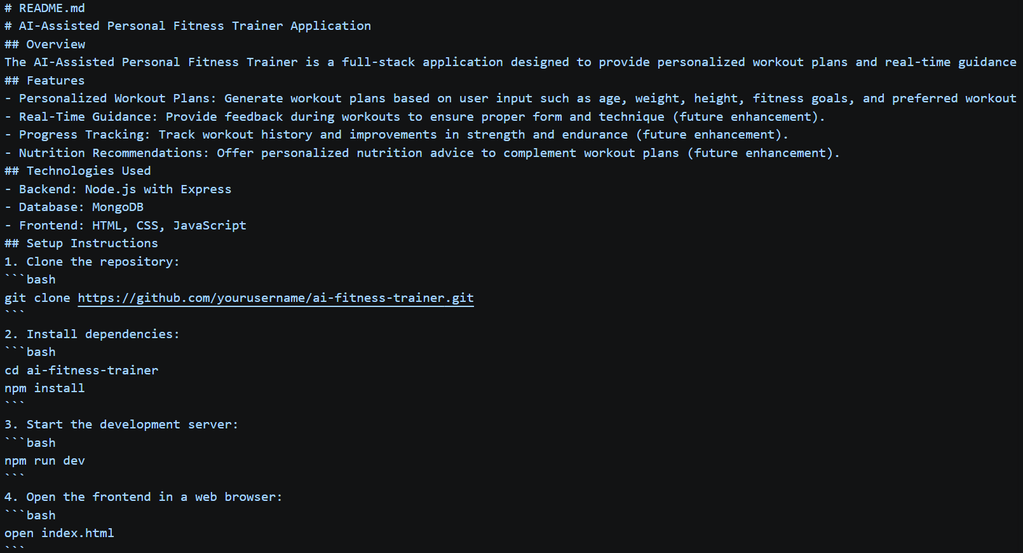
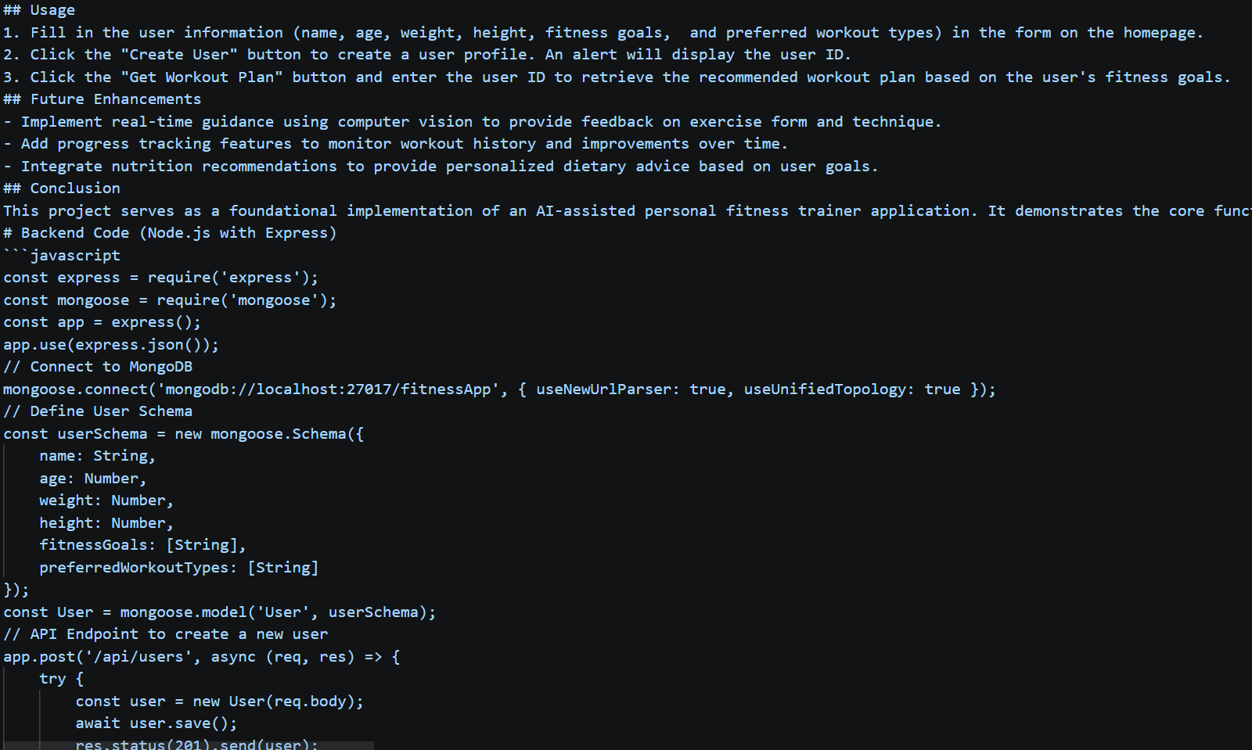
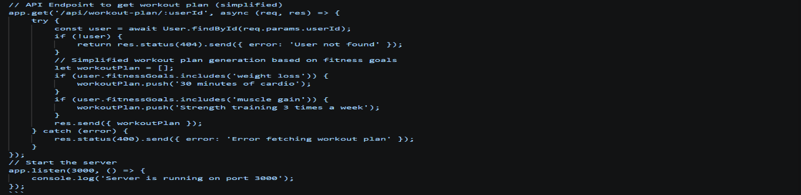

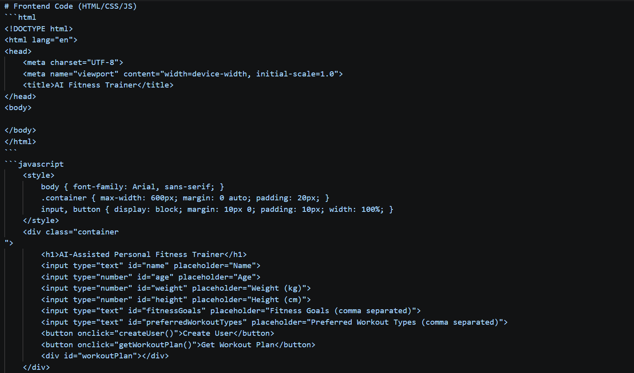
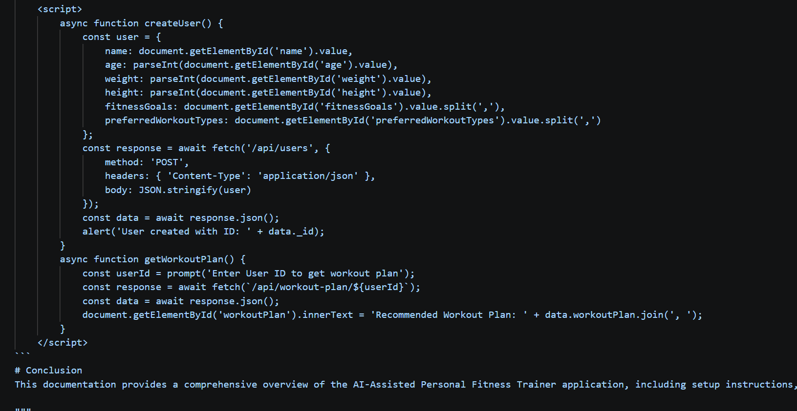

Output:-
A clear and concise README.md file that explains the project, its features, setup instructions, and usage in a way that is easy for students to understand and follow. The code includes meaningful comments to enhance readability and comprehension.
Justification:
This documentation is essential for guiding users through the setup and usage of the application. It ensures that students can easily understand the purpose of the project, how to get it running, and how to use its features effectively. The comments in the code further enhance understanding by explaining the functionality of different sections, making it more accessible for beginners.

Task 5 – Testing & Debugging
• Use AI to:
o Generate unit tests.
o Identify vulnerabilities/security flaws.
o Suggest optimizations for performance.
Prompt:-
Generate unit tests and basic test cases for the application. Identify possible bugs, security issues, and improvements. Suggest performance optimizations in simple terms. Keep explanations practical and easy for students.
Code:-
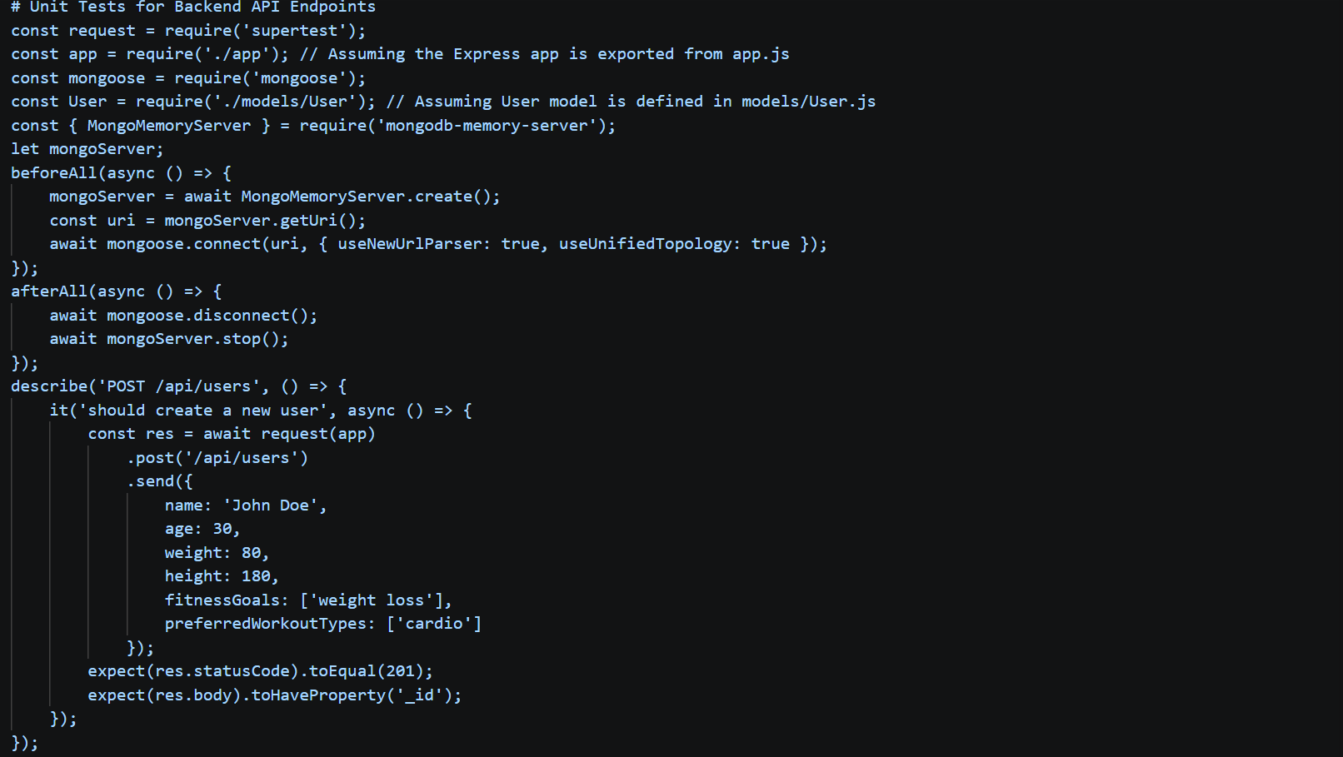
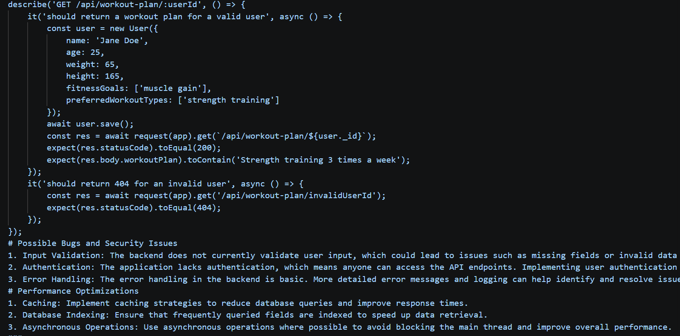
Output:-
- A set of unit tests that validate the functionality of the backend API endpoints, ensuring that user creation and workout plan retrieval work as expected.
- Identification of potential bugs and security issues, along with practical suggestions for improvements.

Task 6 – Deployment & Presentation
• Deploy application on a cloud/free hosting platform(GitHub Pages, Firebase, etc.).
• Prepare a final presentation including:
o Problem statement
o Solution architecture
o Live demo
o Reflection on AI assistance and limitations
Prompt:-
Provide steps to deploy the project on a free platform like Vercel or Firebase. Create a simple presentation with problem, solution, architecture, & demo. Include key points for explaining the project confidently. Make the content clear, natural, and human-like.

Code:-
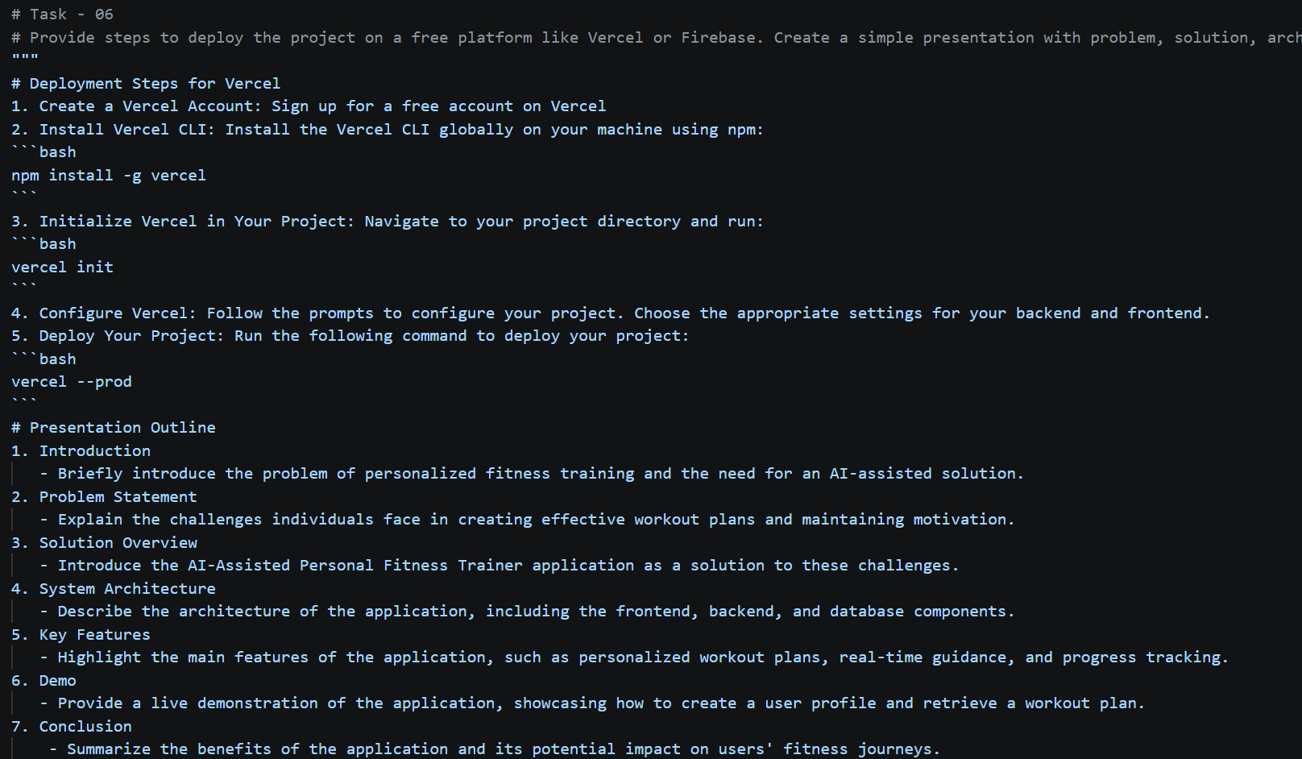
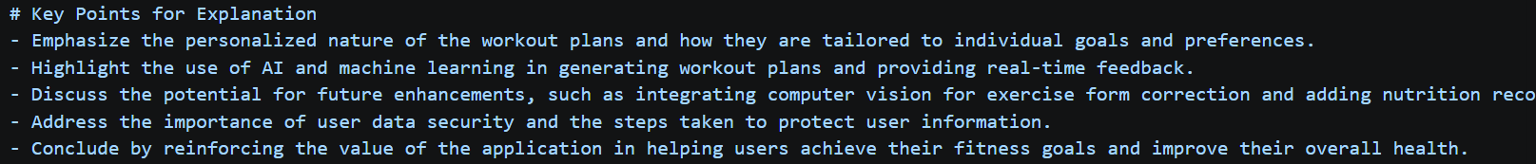
Output:-
- A successful deployment of the application on Vercel, making it accessible to users.
- A clear and engaging presentation that effectively communicates the problem, solution, architecture, and demo of the AI-Assisted Personal Fitness Trainer application, allowing the presenter to confidently explain the project to an audience.
Justification:
This presentation outline and deployment steps are designed to help students effectively communicate their project while also ensuring that their application is accessible to users. The key points for explanation are crafted to highlight the unique features and benefits of the application, making it easier for students to explain their work confidently and clearly. The deployment steps provide a practical guide for students to get their application online, allowing them to share

