AIAC ASSIGNMENT – 19.2

Name : M.Likitha
H.No : 2303A51958
Batch : 22

Task 1 – Python to Java Conversion
Task:
Convert a Python program that performs file handling operations into an
equivalent Java program using AI assistance.

Code:

Python:
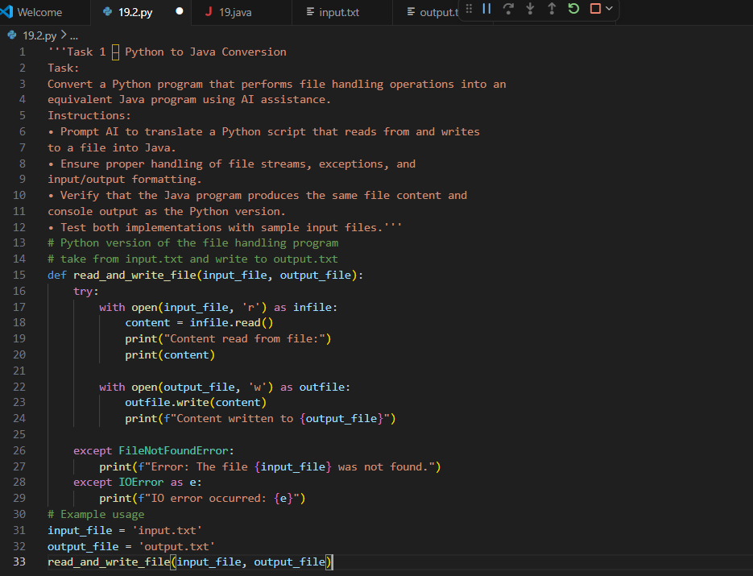

Java:
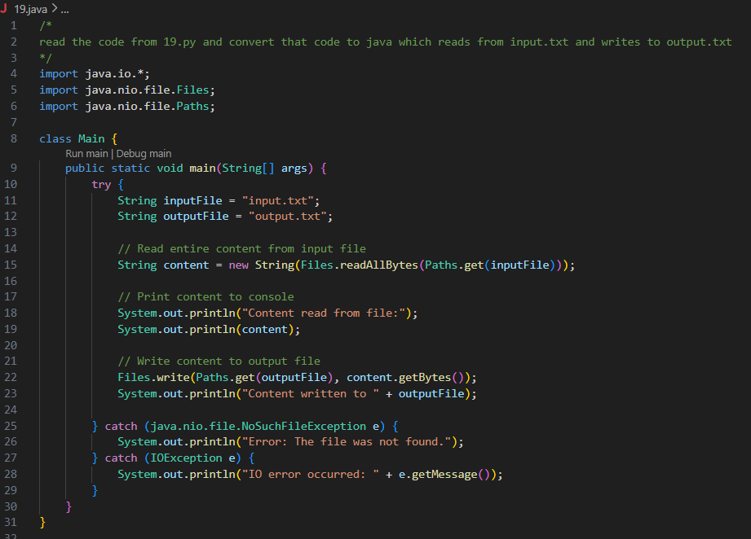

Output:
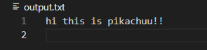
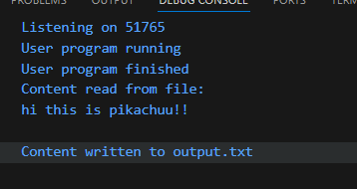

Observation:
The AI assistant makes converting code between languages much easier. Instead of manually rewriting the Python file-handling program into Java, the AI generates equivalent Java code with proper handling of file streams, exceptions, and input/output formatting. This saves time and effort, ensures accuracy. By testing with sample files, it becomes clear that the AI not only translates syntax but also preserves the logic, making cross-language coding tasks more straightforward and reliable.

Task 2 – C++ to Python Function Conversion
Task:
Translate a C++ program that implements a sorting algorithm into
Python using AI assistance.
Instructions:
• Provide AI with a C++ implementation of a sorting technique
(e.g., Bubble Sort or Selection Sort).
• Ask AI to generate an equivalent Python implementation.
• Ensure logical correctness and validate results using multiple
test cases.
• Confirm that the Python version maintains the same sorting
behavior.

Code :

Cpp:
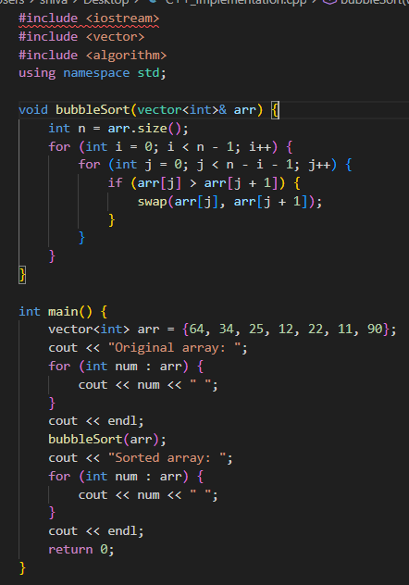
Output:- C++ Implementation
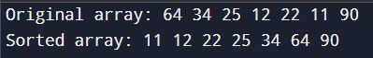

Python:
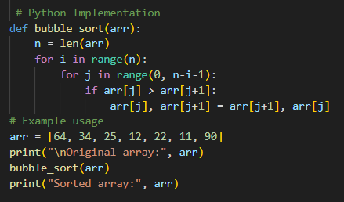

Output:- Python Implementation
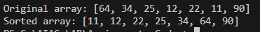

Observation :
The AI assistant makes converting algorithms between languages very convenient. By providing a C++ sorting program, the AI quickly generates an equivalent Python version that preserves the same logic and behavior. This saves time compared to rewriting code manually and ensures accuracy across different test cases. The AI not only translates syntax but also maintains the algorithm’s correctness, making it easier to validate results and understand how the same sorting technique works in both languages.

Task 3 – SQL to Pandas Query
Task:
Convert a SQL query involving GROUP BY and aggregate functions
into an equivalent Pandas Data Frame operation.

Code :
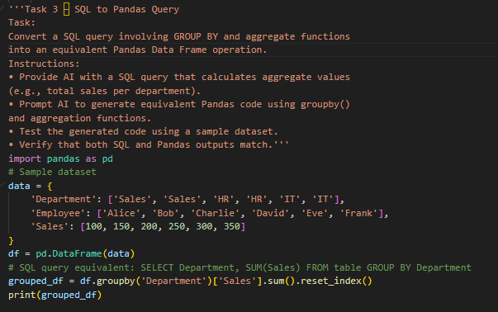

Output:
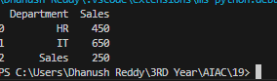

Observation :
The AI assistant makes it easy to move from SQL to Pandas by generating equivalent Python code using groupby() and aggregation functions. Instead of manually rewriting queries, the AI quickly translates SQL logic into Pandas operations that produce the same results. This saves time, ensures accuracy, and helps in understanding how database-style queries can be performed directly on data frames. Testing with sample datasets confirms that both SQL and Pandas outputs match, showing how AI simplifies cross-platform data analysis.

Task 4 – Real-Time Application: Multi-Language Snippet
Converter
Scenario:
Students will select a practical real-world application requiring the same
logic in two different programming languages.
Example:
• Converting a REST API implementation from Python (Flask) to
Java (Spring Boot).
• Translating a data processing script from Python to C++ for
performance optimization.

Code:
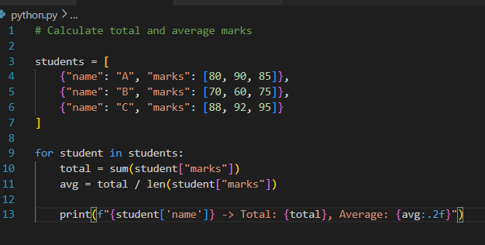

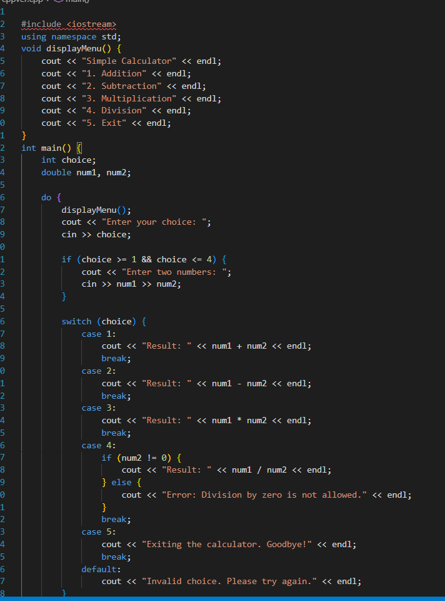

Observation :
The AI assistant makes real-world multi-language conversions much more practical. For example, when converting a REST API from Python (Flask) to Java (Spring Boot) or translating a data processing script from Python to C++ for performance, the AI generates equivalent code that preserves the same logic while adapting to each language’s syntax and framework. This saves a lot of effort compared to rewriting everything manually and ensures consistency across implementations. It shows how AI can bridge the gap between different programming environments, making cross-language development faster, easier, and more reliable.

Task -5: (Basic Function Translation (Python to C++)
Translate a simple Python function that checks whether a number is even
or odd into C++ using AI assistance.
Code:-
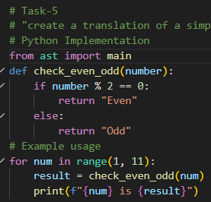

Output:-
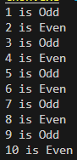

Code:-
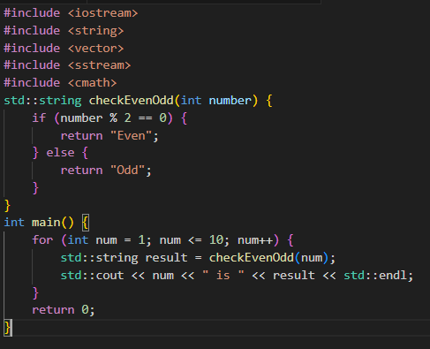

Output:-
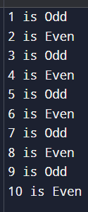

Observation:
The AI assistant makes translating simple functions between languages very easy. By providing a Python function that checks if a number is even or odd, the AI quickly generates an equivalent C++ version with correct syntax, input handling, and output formatting. This saves time compared to writing the code manually and ensures the logic remains consistent across both languages. Testing with different inputs confirms that the AI preserves the same behavior, showing how it simplifies cross-language programming tasks

