Human Development Index (HDI) Predictor
Project Documentation
Machine Learning Based HDI Prediction System

Abstract
The Human Development Index (HDI) Predictor is a Machine Learning-powered web application designed to estimate a country's Human Development Index using Life Expectancy, Expected Years of Schooling, Mean Years of Schooling, and Gross National Income (GNI) per capita. The application uses a Linear Regression model to predict HDI scores, classify countries into Low, Medium, High, and Very High development categories, and provide strategic recommendations. Developed using Python, Flask, Scikit-learn, Pandas, NumPy, Matplotlib, and Seaborn, the system offers a simple and interactive interface for students, researchers, and policymakers.

Problem Statement
Traditional HDI assessment requires manual interpretation of multiple socio-economic indicators. This process is time-consuming and may lead to inconsistencies. The proposed HDI Predictor automates the prediction process and provides instant insights and recommendations.

Features
• HDI Score Prediction
• Linear Regression Model
• Country Presets
• Interactive Flask Interface
• Development Category Classification
• Strategic Recommendations
• Responsive Dashboard
• Easy-to-use Interface

Tech Stack
Programming Language: Python
Frontend: HTML, CSS, JavaScript
Backend: Flask
Machine Learning: Scikit-learn (Linear Regression)
Data Processing: Pandas, NumPy
Visualization: Matplotlib, Seaborn
IDE: VS Code
Model Storage: Pickle

Installation Steps
1. Clone the repository.
2. Install dependencies using 'pip install -r requirements.txt'.
3. Run 'python app.py'.
4. Open http://127.0.0.1:5000 in your browser.

Usage Instructions
1. Launch the application.
2. Click Start Predicting.
3. Select a country or enter custom values.
4. Enter Life Expectancy, Expected Years of Schooling, Mean Years of Schooling, and GNI Per Capita.
5. Click Estimate HDI Score.
6. View HDI score, category, and recommendations.

Future Scope
• Deep Learning Models
• XGBoost / Random Forest
• Live UNDP Data
• Mobile Application
• Cloud Deployment
• Interactive Analytics Dashboard
Name | Role
Likitha Dande | Team Lead
Shaik Shuaib Ahmed | Member
Shaik Thotti Mahammad Rafi | Member
Nagapuri Sharath Chandra Bose | Member
Vijayabhaskar Keela | Member

Team Member Details

Application Screenshots

Home Page
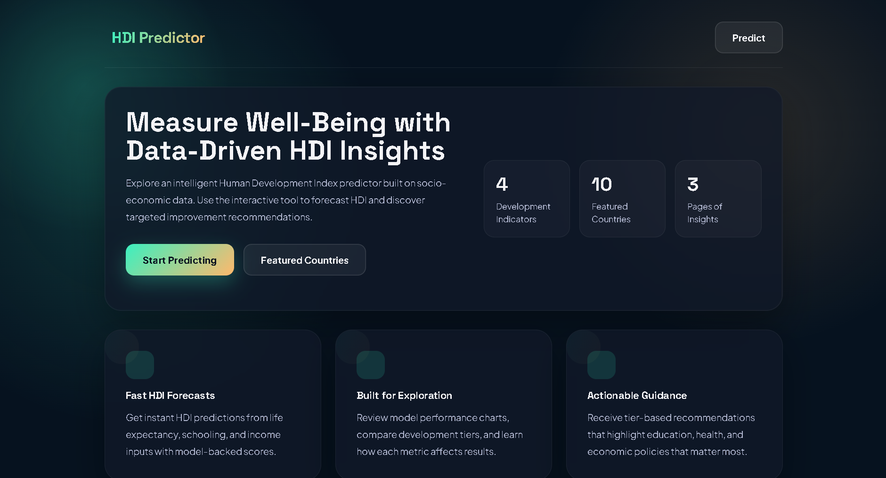
Figure: Home Page

Features Section
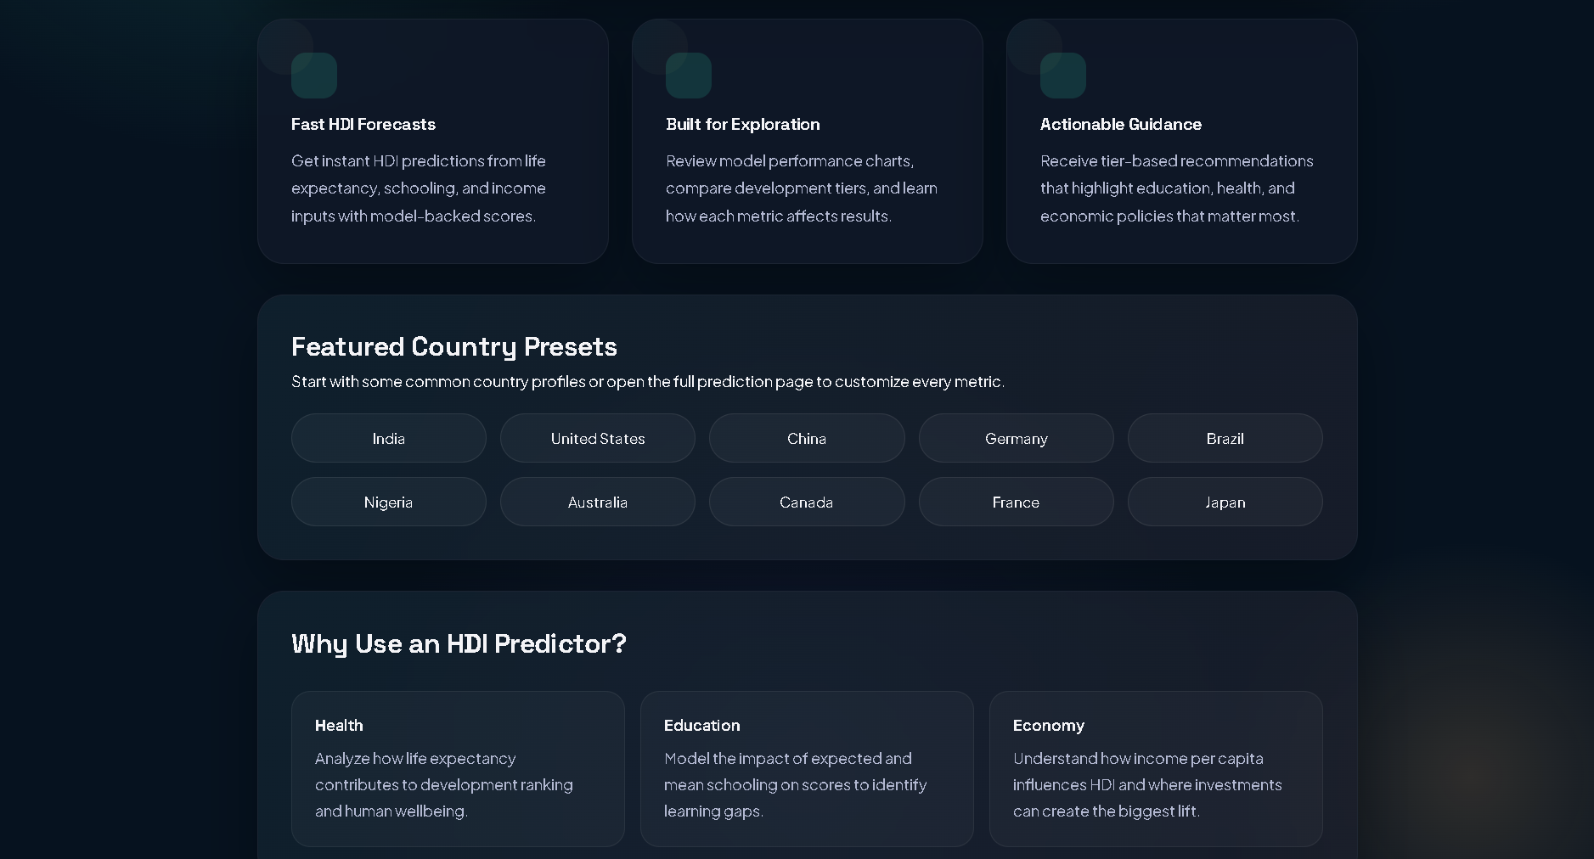
Figure: Features Section

Prediction Page
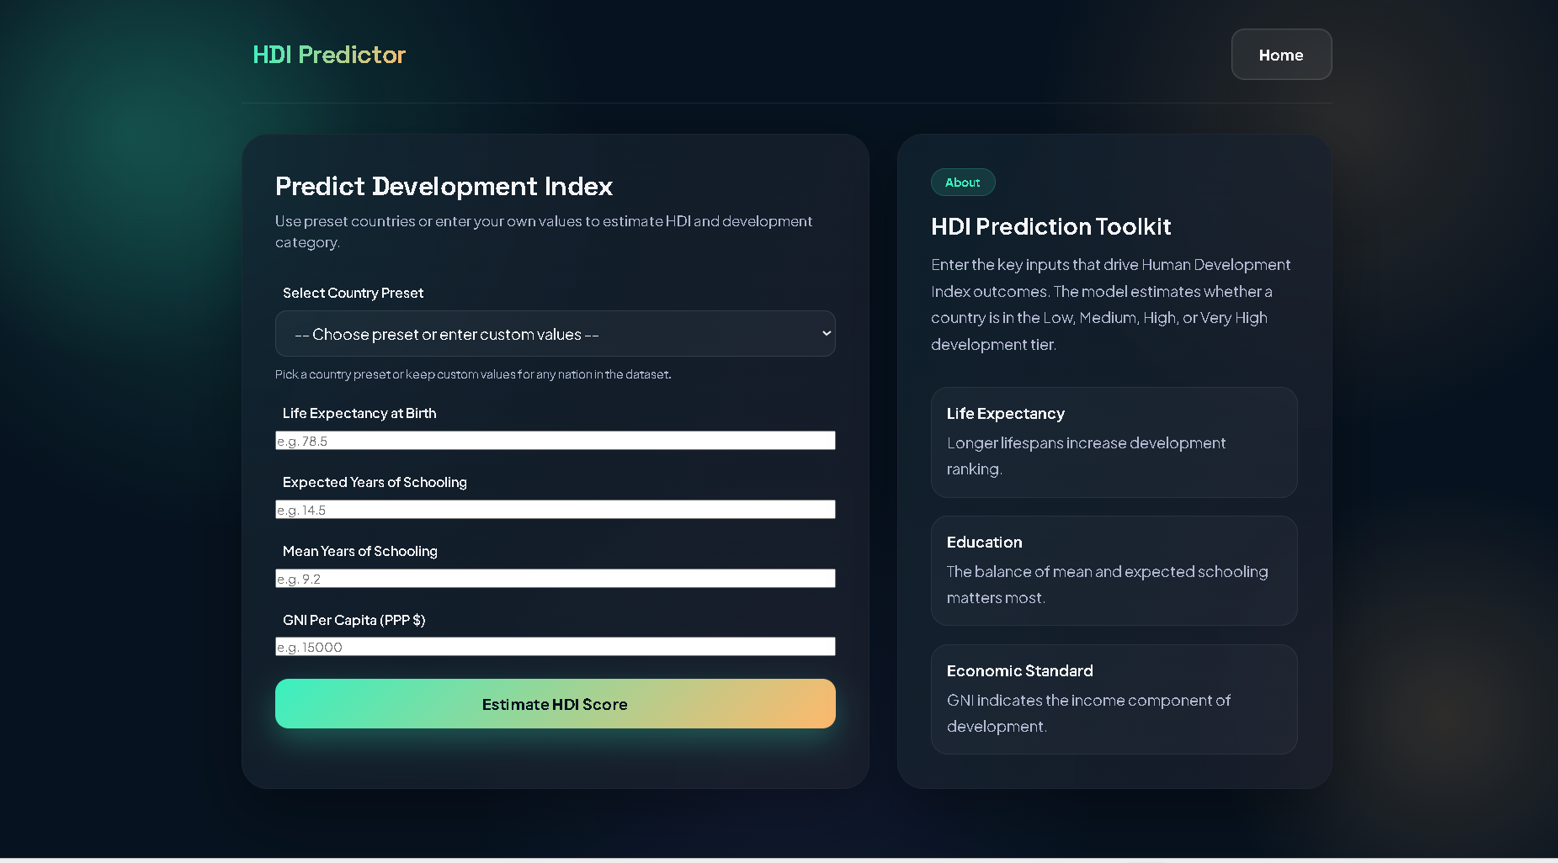
Figure: Prediction Page

Prediction Result
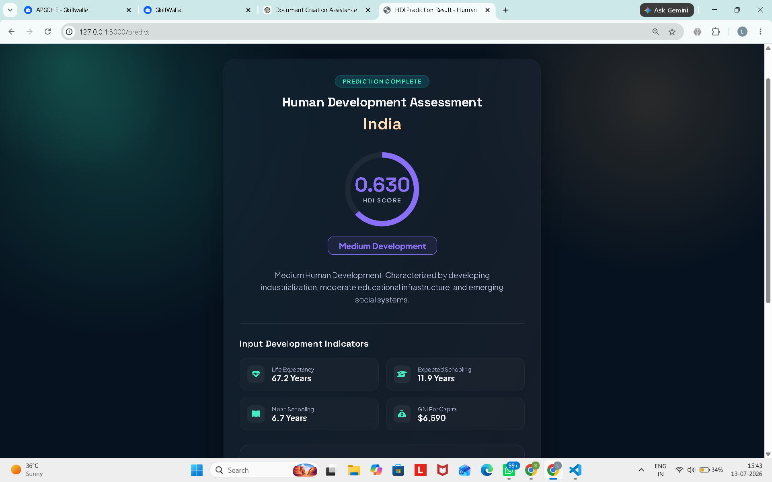
Figure: Prediction Result

Recommendations
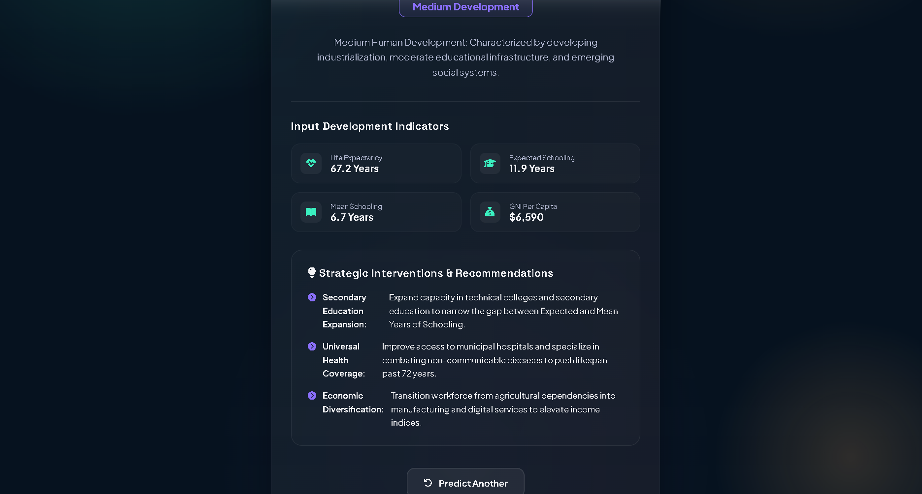
Figure: Recommendations

