Analysis On Behavioural Distinction Between Depression And Anxiety Using SVM

Dr. C. Padmaja
Dept. of ECE
G. Narayanamma Institute of
Technolgy and Science (for women)
Hyderabad, India
c.padmaja@gnits.ac.in

Likitha Reddy Venna
Dept. of ECE
G. Narayanamma Institute of
Technolgy and Science(for women)
Hyderabad, India
likithareddy2882@gmail.com

Abstract— Nowadays, depression has become a common mental disorder. Depression is different from everyday mood status. It is irrespective of age and gender. People who have gone through abusive behavior from others and stressful situations are more likely to have depression. Anxiety and depression cause many changes in day-to-day life. These changes may result in poor concentration, issues regarding sleep, hopelessness, suicidal thoughts etc. According to WHO, women are more depressed than men. Mental health also plays a major role in a person’s life. In order to have a peaceful and healthy mind and life, one should look after their psychological health. Diagnosis should be done properly in order to eradicate this from one’s life. Early prediction should be done such that everyone can lead a better life.
Keywords- Detecting stages of Depression, ML-Machine Learning ,SVM- Support Vector Machine , Quiz-based test, Text based test, web application

Introduction
Technically, machine learning has been concerned with developing applications that can access data from contemporary technology and draw lessons from them and it works accordingly. In today’s society, detecting depression at an early stage is an important part of psychology to heal. According to WHO (world health organization), depression is also the prime cause of disability and some sorporal diseases. In order to analyze data, it is necessary to observe it deeply. Every second, social media platforms collect lakhs of pieces of information and every message or content holds the user’s expression like feelings, sentiments and emotions. In this method, computerization is successfully used in analyzing the data which is uploaded from social media. With about 70% accuracy in differential classification, the results analyzed the patterns that varied between the two users. But in this method, results depend on the contents that are posted on social media but not on the behavior of the user and also invade privacy.
So, this paper mainly focuses on the detection of depression without invasion of privacy and also to increase accuracy. In this study, the main objective is to enable the computers to learn automatically without any interference of the user. In Which the junked data which is acquired from the different users by conducting survey is processes using machine learning algorithm.
By using Support vector machine, Natural language processing, word cloud, and Data processing are used to detect depression and it generates confusion matrix further to predict the depression. The term “supervised machine learning algorithm” refers to algorithms that uses a collection of annotated and set of datasets to teach themselves appropriately. Data from the past must be predicted by the annotated dataset. This learning algorithm can create a function that predicts the required output variables by observing the training dataset with known categories. In order to translate its model correctly, the machine learning algorithm can also be used for comparison of its result with the desired outcome. A mental disease called depression affects a person’s demeanour, feelings, and essentially all of their daily activities. When someone is depressed, their level of effort and concentration decreases day by day. They live a lonely existence alone and do nothing but be happy and enjoy life for no apparent cause.
Today, early detection of anxiety and melancholy is a common occurrence in disease. Computers can also define different functions encounter the concealed patterns in any unclassified dataset with the assistance of unsupervised learning data. Data from unsupervised learning is useful in describing functions that can also find the hidden pattern in any unsupervised dataset by computers. The reinforcement signal for a machine learning system is a basic system that is required for different algorithms to analyze and also to learn which output is optical. Machine learning algorithms allow for the study of massive amounts of data all over the globe with little to no human intervention.
Combining machine learning and AI can improve the effectiveness of a machine learning algorithm while processing huge amounts of different datasets. The two kinds of guided machine learning algorithms are classification algorithms and regression algorithms. When the output is limited to a defined collection of numbers, classification algorithms are used. For instance, a classification system is used to filter different spam emails categorizes useful and advertisements based on word quality

Literature review
The major contributions by various authors are studied and analysed.
Benton et al[1] recommendations for academics using social media data for the purpose of health research were presented as practical advice. These recommendations can be used as a guideline for future development.
Arkarprabha Sau et al [2] worked out using machine learning, to create a suitable predictive model to identify depression and anxiety in older persons based on the sociodemographic and health oriented characteristics.
Akkarpon Wongkobalp et al [3] the purpose of this study is to create a deep learning predictive model to identify people who are depreesed.by finding odd trends in over time is interesting because depression is a recurrent disorder.

Design and simulation
In the user interface, the user wants to know the stage of his depression. The user responds to ten questions, each of which has a different option and a weight attached to it. The proposed method is explained in figure 1.
USER INTERFACE
(Quiz based test & Text based test)
User

5 different stages of depression and anxiety

Q1
Q2
Q3
.

Qn
E1
E2
E3
.

En
Disorder Cases
Questioner
Evaluation Key
Extraction of the weights of the values of each Question
SVM
State of Person’s Behavior

Fig-1 Block diagram of use interface

These weights are then collected and given to the support vector machine model, which looks into the data and returns results based on the weights chosen. There is a question where the user expresses his feeling in a few sentences for this question. World cloud is applied in which it detects the mood of the person by the words which are used by the user to express his feelings explained in figure 2-4.

User Interface Platform


Fig-2 Homepage of the website

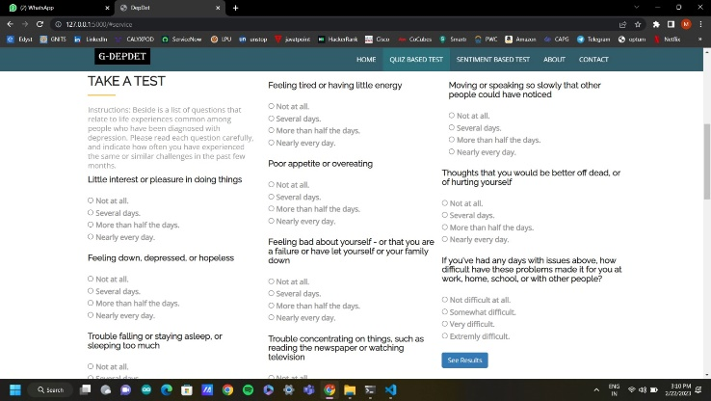

Fig-3 Text-based test

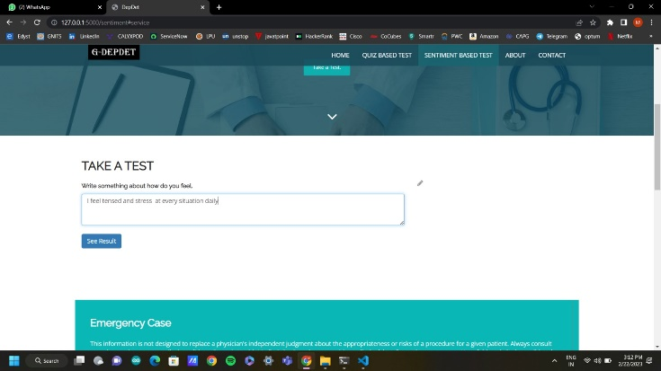
Fig-4 Quiz-based test

RESULTS
In this system, we explored the strategies that may be used for depression and anxiety analysis. We used linear discriminant analysis, K-Nearest Neighbour algorithm SVM, and SVM for depression detection and came to know that SVM is more accurate about 93% than other algorithms. So, we have created a user interface that is used to detect stages of depression using SVM.
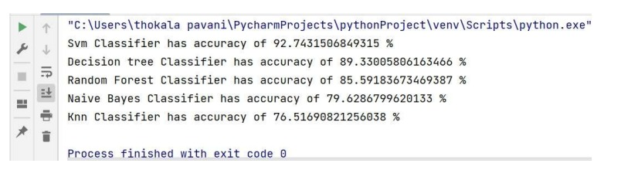
Fig-5 Accuracies of different algorithms

There are five stages in quiz-based test. They are:
- No Depression -weight (0-4)
- Mild Depression-weight (5-11)
- Moderate Depression-weight (12-16)
- Moderately Severe Depression-weight (16-21)
- Severe Depression-weight (22-30)
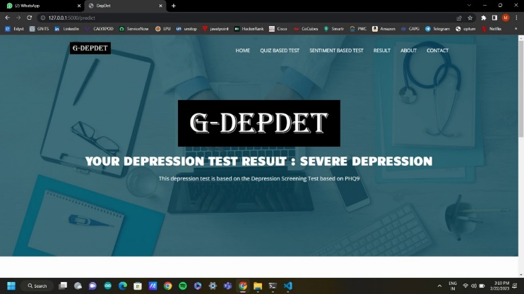
Fig-6 Results for text-based test

Fig-7 Results for quiz-based test

CONCLUSION
Mental or psychological disorders are a widespread yet underserved area in the health care system. Anxiety and depression are more or less universal experiences for everyone at some time in their lives. Young people are experiencing psychological issues, but they are attempting to manage them rather than taking help because intellectual analysis is still considered unacceptable in these days of globalization(development). A person suffering from these conditions is always in danger of hypertension, cardiac arrest, brain abnormality, and other complications.
The proposed method intends to lessen the need for humans to physically intervene when identifying early signs of sadness and anxiety in a particular person. Due to bigger dataset on which the model was trained, the offered diagnosis has a high accuracy level. The suggested system's future development will be concentrated on making the website more reachable for the public, which will enhance model accuracy and also precision This could be done by using multiple languages for diagnosis, especially the regional tongues spoken in India.
Further advancements will be achieved by moving away from the classification model of text and adapting to speech detection, and a body language model which can recognize sadness in number of languages and in variety of ways.

References
[1] A. Benton et al “Ethical research protocols for social media health research,” in Proceedings of the First ACL Workshop on Ethics in Natural Language Processing, EthNLP@EACL, Valencia, Spain, pp. 94–102,2017.
[2] Arkaprabha Sau et al “Predicting anxiety and depression in elderly patients using machine learning technology”, Healthcare Technology Letters, Vol.4 Issue.6, pp. 238 – 243, 2017
[3] Akkapon Wongkoblap et al “Classifying Depressed Users with Multiple Instance Learning from Social Network Data”, IEEE International Conference on Healthcare Informatics (ICHI), Vol.1 Issue.5, pg. 611-621, 2018.
[4] Wongkoblap, Akkapon & Vadillo, Miguel & Curcin, Vasa. (2018). Classifying Depressed Users with Multiple Instance Learning from Social Network Data. 436-436. 10.1109/ICHI.2018.00088.
[5]https://www.researchgate.net/publication/318136574_Extracting_Depression_Symptoms_from_Social_Networks_and_Web_Blogs_via_Text_Mining.
[6] https://vgpena.github.io/classifying-tweets-with-keras-and-tensorflow/
[7] https://github.com/AshwanthRamji/Depression-Sentiment-Analysis-with-Twitter-Data
[8] https://arxiv.org/pdf/1607.07384.pdf

