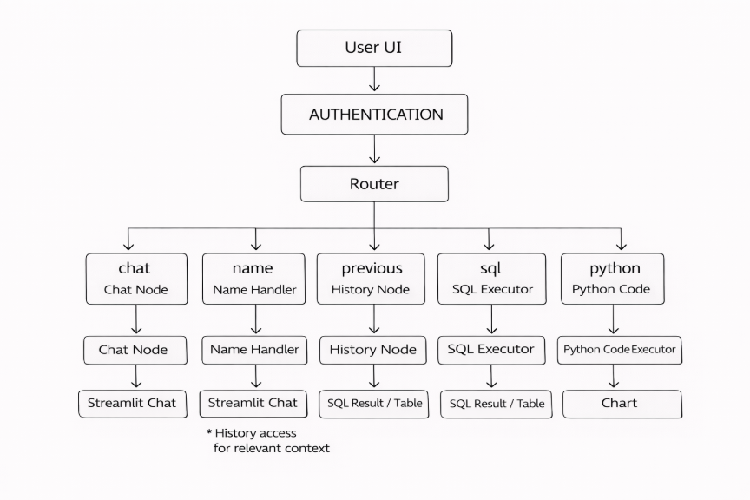

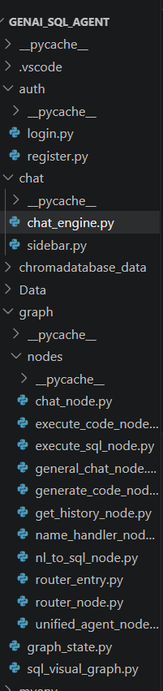 | 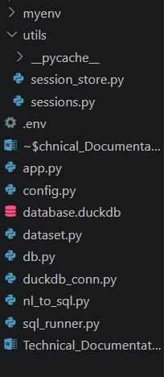
1. Auth
Handles User Authentication (Login + Registration).
login.py
- Implements login screen logic
- Verifies user credentials
- Starts user session
register.py
- Handles new user registration
- Saves user details to your session/user store
- Performs validation checks
2. Chat
Contains files related to LLM communication and sidebar UI.
chat_engine.py
- Central wrapper for your LLM
- Sends prompt → gets model response
- Used by ALL nodes (router, SQL, unified agent, visualization)
sidebar.py
- Builds Streamlit sidebar
- Renders chat sessions list
- Provides session selection + logout UI
3. chromadatababase_data
- Folder typically used for ChromaDB vector storage
- Stores embedding files, indexes
- Used if you enable semantic search or memory
- Stored user credentials
- Stored all session messages
4. Data/
entire database sync system lives here.
📄 employee.csv, sales_records.csv, etc.
- One CSV per table
- Always represents the latest snapshot of the DuckDB table
- Updated every time a write SQL operation happens
- Never duplicated — only ONE CSV per table

Data/backups/
Contains all historical CSV backups.
For every UPDATE, INSERT, DELETE, CREATE, or DROP:
A new backup is created
With timestamp naming:
employee_20260330_104422.csv
sales_records_20260330_113522.csv
Used for audit trails and recovery
5. graph/
This folder contains LangGraph architecture that powers the smart agent.
graph_state.py
Defines the state object passed between nodes:
Includes fields like:
- question
- sql
- table
- code
- visual
- analysis_text
- history
- router (multi-intent routing)
- session_id
- con for duckdb connection
sql_visual_graph.py
This is the brain of agent.
It:
- Builds and compiles the LangGraph
- Registers every node
- Creates routing rules
- Supports multi-intent execution, e.g.:
- SQL → execute_sql → visualization → execute_code → analysis
- Controls the complete conversational workflow

6. graph/nodes/
Each file in this folder is a separate LangGraph node (single step in the pipeline). router_node.py
- Uses LLM to detect user intent
- Supports multi-intent combinations
- Returns actions like:
- chat
- nl_to_sql
- generate_code
- unified_agent
- get_history
- name_handler
- general_chat
- nl_to_sql, generate_code
router_entry.py
- First node that runs
- Calls router_node
- Passes enhanced state to next nodes
- Stores router output in:
- state["router"]
nl_to_sql_node.py
- Converts natural language → SQL + TITLE + INSIGHT
- Reads list of tables dynamically
- Supports multi-table JOIN
- Ensures correct SQL format
- Here nl_to_sql.py is required
execute_sql_node.py
Executes SQL queries iside DuckDB.
- SELECT → returns DataFrame
- UPDATE/INSERT → modifies DB
- CREATE TABLE → creates new table
- DROP TABLE → removes table
- AUTO CSV SYNC
- AUTO BACKUPS
- WINDOWS-SAFE COPY commands
- Returns SQL results + table

generate_code_node.py
Generates Python visualization code using LLM.
- Reads all tables + columns
- Handles case-sensitive column names
- Generates SQL + chart code
- Supports INSIGHT text
- Used when user asks for:
- charts
- graphs
- visual trends
- comparisons
execute_code_node.py
Executes Python visualization code from LLM.
- Runs Matplotlib
- Saves plot into base64
- Returns "visual" to Streamlit UI
unified_agent_node.py
- Handles complex analytical responses, e.g.:
- “Why are sales employees leaving more?”
- “Explain correlation between X and Y”
- “Interpret this pattern using data”
- May generate SQL + insight
- Acts as a smart business analyst
general_chat_node.py
General non-SQL conversational questions:
- “What is attrition?”
- “Explain over time”
- “What does job role mean?”

get_history_node.py
Returns previous user messages (session-level chat history).

name_handler_node.py
Handles identity questions:
- “What is my name?”
- “Call me Likith”
chat_node.py
Handles greetings:
- hi
- hello
- hey
7. myenv
Your Python virtual environment.
Contains:
- Installed libraries
- Dependencies like:
- Streamlit
- DuckDB
- LangGraph
- OpenAI/Anthropic client
- Pandas
- System packages
Note:Not part of your code. Do not edit.
8.utils/
Contains helper utilities used across your application.
session_store.py
- Manages storing chat messages in the conversation
- Saves each message into the database/session
- Used by chat_engine.py and app.py
- Supports:
- save_message()
- fetch messages
- update sessions
- Handles multiple chat sessions
- Functions for:
- Creating new chat sessions
- Fetching session list
- Retrieving active session id
- Session metadata (title, timestamp, username)
Sessions.py
Initiate Sessions:
- Logged_in
- Username

9 .env
Environment variables file.
- Storing azure Credentials
10. app.py
This is the main Streamlit application.
Responsibilities:
- Renders full UI
- Handles login, sidebar, chat window
- Connects user input to LangGraph
- Displays:
- SQL Query
- SQL Table
- Python Code
- Visualization
- Insight
- History
- Saves conversation to session storage
- Prevents duplicate prompts
- Orchestrates everything end-to-end
11. config.py
Application configuration file.
Contains global configuration items such as:
LLM model name
System instructions
Default paths
Global constants
Imported inside several modules to maintain consistency
Single-source configuration management

12. database.duckdb
This file stores:
- All tables (employee, sales, HR, finance, etc.)
- Updated rows
- Newly created tables
- Dropped tables
- Persistent data across restarts
- Your entire database lives here
- CSVs in Data/ folder are only SYNC copies
13. dataset.py
Handles dataset loading and preprocessing.
Likely used for:
- Loading initial employee data
- Preprocessing before writing to DuckDB
- Utility for reading CSV/Excel files
Used during initial database setup and updates.
14. db.py
Creating persistentclient for storing:
- User_coll
- Session_coll
- Message_coll
15. duckdb_conn.py
Your dedicated DuckDB connection handler.
Responsibilities:
- Create a persistent connection to database.duckdb
- Ensure single connection is reused across app
- Prevent multiple conflicting DB sessions
- Loaded once in streamlit_session
Functions typically include:
- get_duckdb_connection()
- initialize tables (if missing)

16. nl_to_sql.py
Your NL2SQL core logic (outside LangGraph node system).
Includes:
- Base prompt used by NL2SQL node
- Utility functions to clean SQL
- Logic for multi-table awareness
- Safe-SQL formatting rules
- This script is called from:
nl_to_sql_node.py
- Converts natural language → correct SQL
- Prevents hallucination by verifying tables/columns

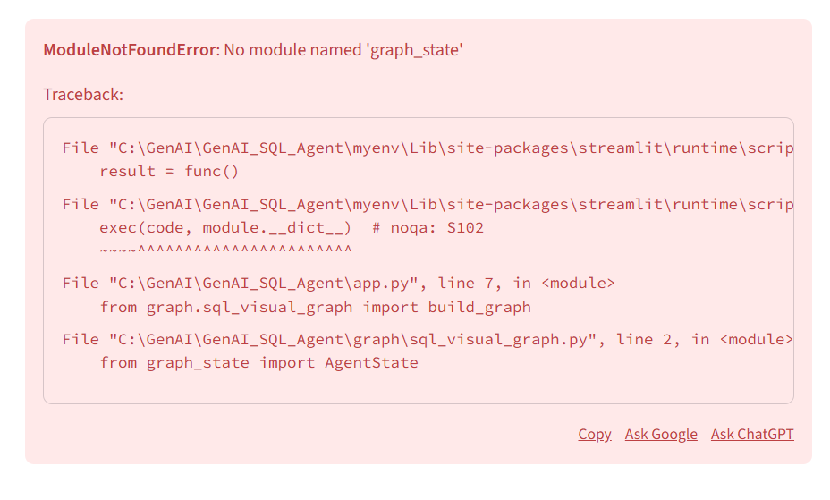
ERROR:
ModuleNotFoundError: No module named 'graph_state'
Cause:
graph/graph_state.py
Fix it:
from graph_state import AgentState
To:
from graph.graph_state import AgentState

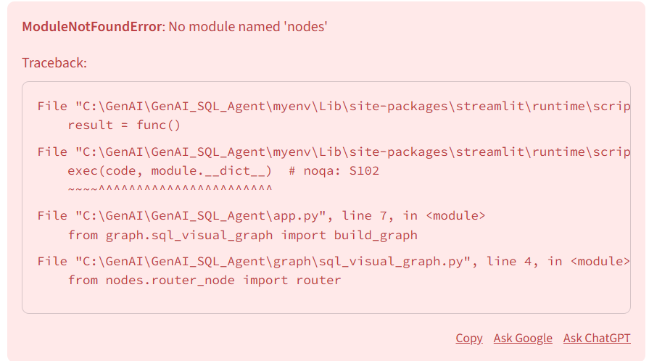
The ModuleNotFoundError: No module named 'nodes' means Python is trying to find a folder or file called nodes to pull code from, but it can't find it in its current search path.
Looking at your traceback, the error is triggered in sql_visual_graph.py at line 4. Here is the breakdown of why this is happening and how to fix it.

Why is this happening?
In Python, when you write from nodes.router_node import router, Python looks for a folder named nodes in:
- The directory of the script you ran (app.py).
- The directories listed in your PYTHONPATH environment variable.
- The standard library and installed site-packages.
Because your file sql_visual_graph.py is inside a subfolder (graph/), Python sometimes gets confused about whether nodes is sitting right next to it or back in the main project folder.

How to Fix It
1. Check for the __init__.py file
For Python to recognize a folder as a "package" it can import from, that folder must contain a file named __init__.py.
- Go into your nodes folder.
- If it's empty or only has router_node.py, create a new empty file and name it exactly __init__.py.
2. Fix the Import Path
Depending on where your nodes folder is located, you might need to change the code in sql_visual_graph.py:
- If nodes is inside the graph folder: Change the line to: from .nodes.router_node import router (The dot tells Python to look in the current folder).
- If nodes is in the main GenAI_SQL_Agent folder: Change the line to: from graph.nodes.router_node import router.
3. Set the PYTHONPATH (The "Magic Wand" Fix)
If your folder structure is correct but Python still can't see the modules, you need to tell your terminal that the GenAI_SQL_Agent folder is the "Root."

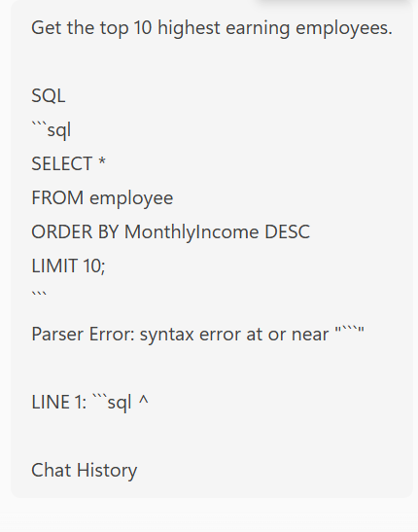
The error Parser Error: syntax error at or near "'''sql" is a "Markdown leakage" problem.
Basically, your AI model is being helpful and formatting the SQL code with backticks (like it would in a chat), but your Python code is taking those backticks and trying to run them as actual SQL. SQL databases have no idea what ` ` ` is, so they crash.
Why is this happening?
- The LLM's Output: The AI generates a response like:
SQL
SELECT * FROM employee...
- The Code's Mistake: Your Python script (likely in agent.py or wherever you execute the query) is grabbing that entire string—including the ```sql and ```—and sending it directly to the database.
- The Database's Reaction: The database sees the first character is a backtick (`), which isn't a valid SQL command, and throws a Parser Error.
How to solve it
You need to "clean" the string before sending it to the database. You can do this in two ways:
1. The Code Fix (Regex/String Strip)
In the part of your code where you get the response from the LLM, add a cleaning step.
Add this function to your code:
Python
def clean_sql_query(query_text):
# Remove markdown code blocks if they exist
query_text = query_text.replace("```sql", "").replace("```", "")
return query_text.strip()
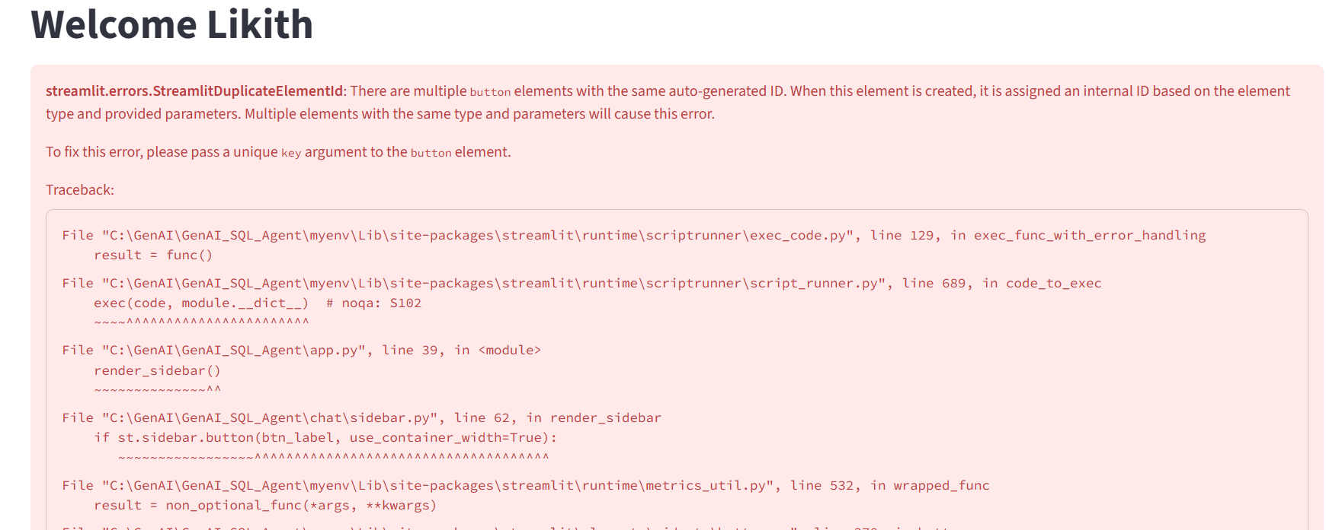
The error message in red says:
streamlit.errors.StreamlitDuplicateElementId:
There are multiple button elements with the same auto-generated ID.
💥 This happens when Streamlit generates two buttons with the EXACT same label and NO unique key, inside the same rerun cycle.
This is happening inside your sidebar.py, exactly here:
Replace:
st.sidebar.button(btn_label, use_container_width=True)
To:
if st.sidebar.button(" New Chat Session", key="new_chat", use_container_width=True):

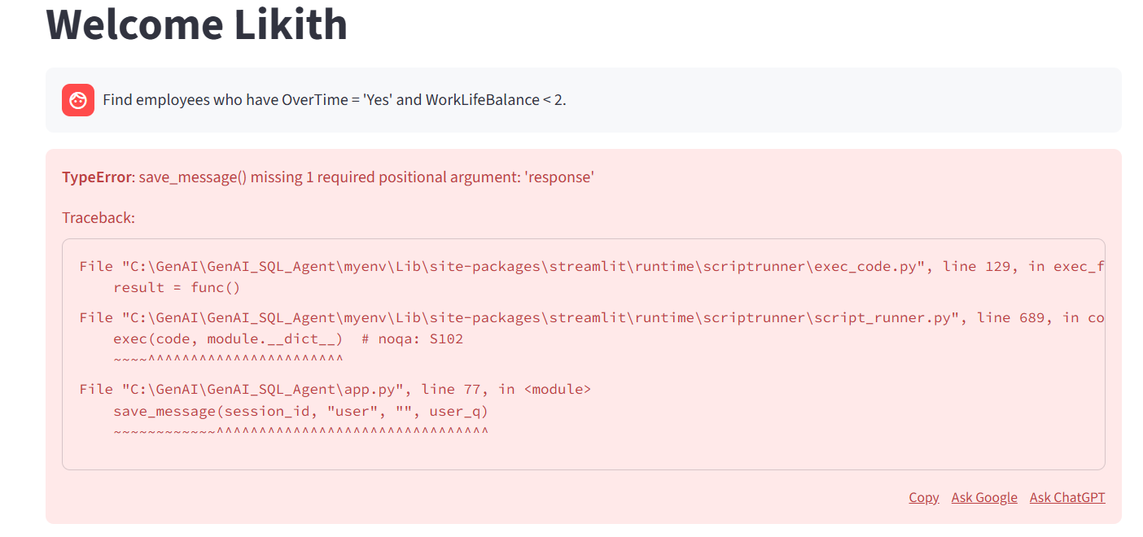
Error Shown:
TypeError: save_message() missing 1 required positional argument: 'response'
Why This Error Happens (Simple Explanation)
My function save_message() requires 4 mandatory parameters:
Python
save_message(session_id, username, user, sql, response)
But in my app.py, you called it like this:
save_message(session_id, "user", "", user_q)
Here I passed only 4 parameters instead of 5,and I skipped the required "response" argument.
So Python throws: missing 1 required positional argument: 'response'
This means:
You forgot to send the “response” parameter when calling save_message().

How to Fix It (Simple Fix)
Correct usage
Python
save_message(session_id, st.session_state.username, "user", "", user_q)

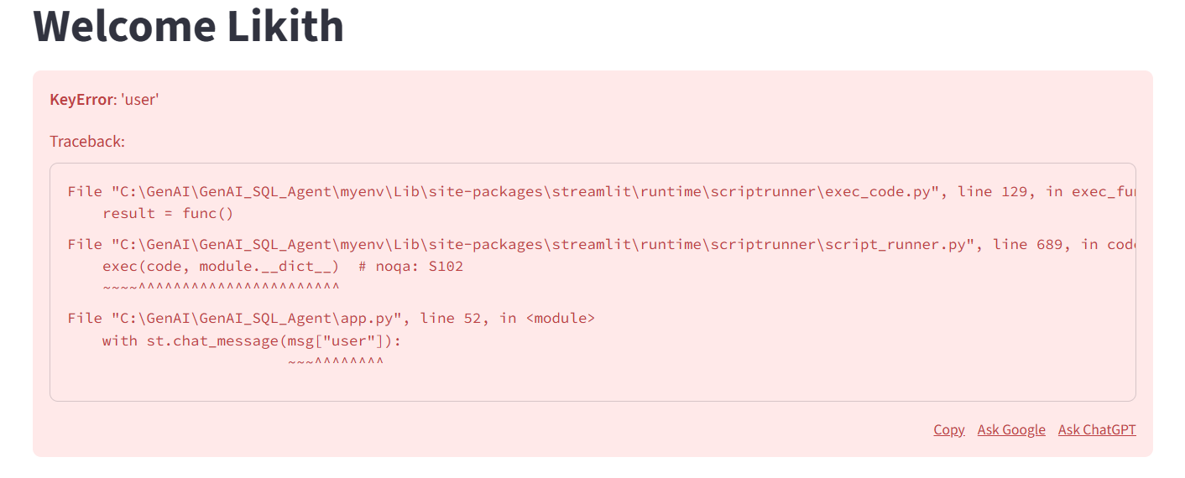
Meaning:
The error occurs because the application tries to read a "user" field from a message, but that key does not exist in some saved message records. As a result, Python raises a KeyError.
How to Fix It (Simple Fix for Code)
Instead of:
Python
with st.chat_message(msg["user"])
Show more lines
use safe access:
FIX:
Python
role = msg.get("user", "assistant")
with st.chat_message(role):
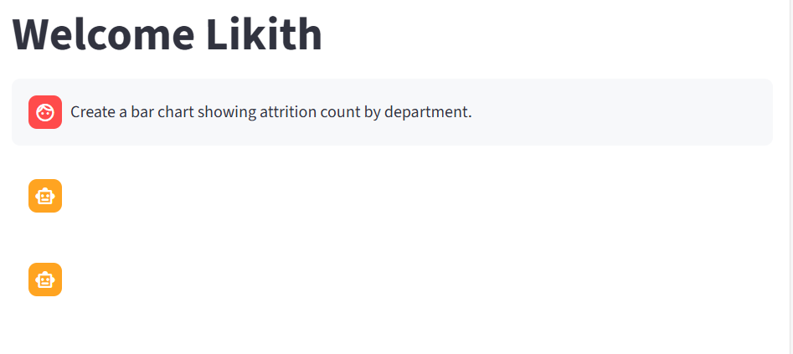
WHAT THIS ERROR MEANS (Simple Explanation)
My bot DID NOT show:
- Python code
- Chart image
- SQL
- Table
It only showed an empty assistant bubble.
- This happens when the visualization code failed to run inside execute_code_node,
and no img_base64 image was generated.
Because execute_code_node only displays a chart IF img_base64 exists,
an empty bubble is displayed.
WHY THIS ERROR HAPPENS (Simple Reason)
The LLM-generated Python code often contained this line:
Python
import duckdb
con = duckdb.connect()
This creates a NEW EMPTY DATABASE, not my app database.
So when visualization tries:
Python
_df = con.execute(sql).df()

it fails because the table employee does not exist in the new connection.
This makes the chart code crash silently -> mg_base64 = None ->
NO chart output →empty icons appear (your screenshot).

SIMPLE FIX (1-line solution)
In your generate_code_node.py, you MUST add this rule:
“DO NOT create a new DuckDB connection”
“ALWAYS use the provided con from state”
So your prompt must include this instruction:
Plain Text
DO NOT use: import duckdb or duckdb.connect()
ALWAYS use: df = con.execute("SELECT * FROM employee").df()
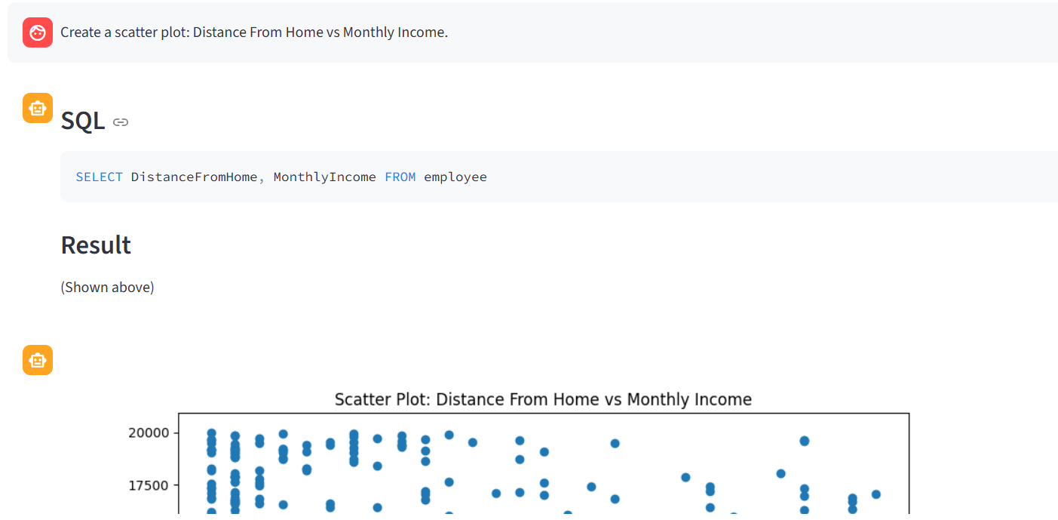

- User asked:
“Create a scatter plot: Distance From Home vs Monthly Income.”
- System displayed SQL + Table
- AND THEN displayed Visualization
I expected ONLY visualization, but I got SQL + visualization together.

PROBLEM (Simple Explanation)
router detected the visualization request,
BUT your generate_code_node also generated SQL inside Python code:
Python
sql = "SELECT DistanceFromHome, MonthlyIncome FROM employee"
result_df = con.execute(sql).df()
And then:
Your execute_code_node returned BOTH:
- visual → chart image
- sql → the SQL query
Your app.py shows SQL whenever answer["sql"] exists.
So your UI displays SQL first, then the chart.
This is why you get SQL + Visualization instead of ONLY Visualization.
It is not an error — it is expected behavior based on your current logic.
WHY IT HAPPENS (One line for documentation)
Because the AI-generated Python visualization code also contains SQL, the agent returns both the SQL query and the chart. Your Streamlit UI is built to show SQL whenever it exists, so SQL is displayed above the chart.
HOW TO FIX IT (Simple Fix)
If you want NO SQL shown for visualization requests,
you must change execute_code_node to NOT return sql.

FIX :
REMOVE SQL from visualization output
In your execute_code_node, find this:
Python
"sql": sql_value,
Show more lines
Replace with:
Python
"sql": None,


Error:
StreamlitDuplicateElementId: Multiple elements with the same auto-generated ID
Cause:
Streamlit creates a unique ID for each UI element. If two buttons or widgets use the same label inside a loop, Streamlit cannot distinguish them, which causes a duplicate ID error.
Solution:
Assign a unique key to each button or widget, for example:
Python
st.sidebar.button("My Button", key="my_button_1")

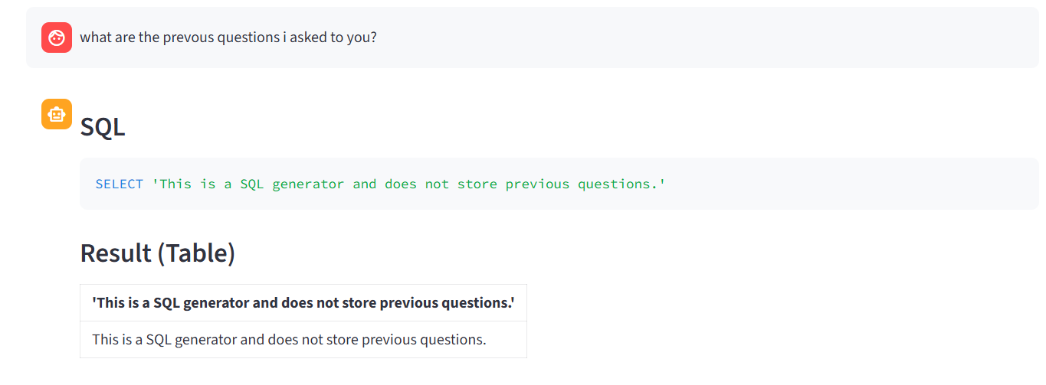
Error:
The system returned SQL instead of showing previous questions.
Cause:
The router failed to detect the question as a history request and routed it to the SQL generator by default.
Solution:
Add history-related keywords (like “previous questions”, “what did I ask”, “history”) to the router_node and ensure history detection comes before SQL routing.
Fix Code:
Python
HISTORY_KEYWORDS = [
"history",
"previous questions",
"past questions",
"previous",
"what did i ask",
"earlier questions",
"my last questions"
]

if any(h in q for h in HISTORY_KEYWORDS):
return "get_history"
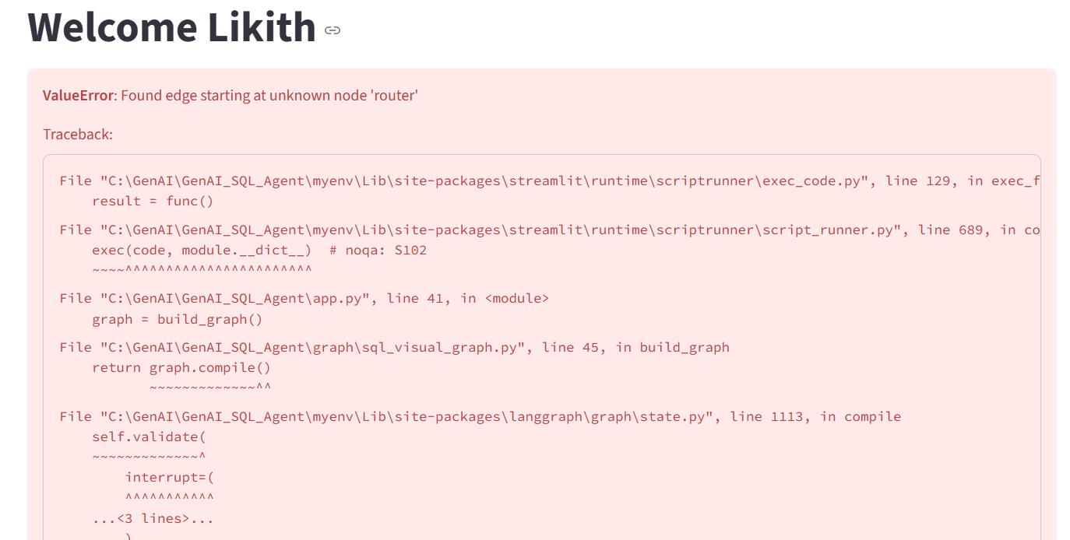
Error:
ValueError: Found edge starting at unknown node 'router'
Cause:
This happens when LangGraph is asked to create edges from a node named "router", but that node was never added to the graph, or its name is misspelled, or the previous compiled graph cache still contains an outdated structure.
Solution:
Add the router node properly and ensure naming is correct:
Python
“In sql_visual_graph”
graph.add_node("router", router_entry)

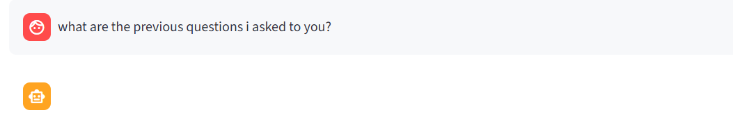
Issue:
When the user asked “what are the previous questions I asked to you?”, the system showed a blank assistant message instead of showing chat history.
Cause:
The router did not detect this message as a history request because the phrase was not included in the history keywords. As a result, the request was routed incorrectly, and the history node was never executed.
Solution:
Add more natural-language variations of “history” into the router’s keyword list. This ensures the router correctly sends such questions to the get_history node.
Fix Code:
Python
HISTORY_KEYWORDS = [
"history",
"previous questions",
"past questions",
"what did i ask",
"earlier questions",
"my old questions",
"show my history",
"what are the previous questions i asked to you"
]

if any(h in q for h in HISTORY_KEYWORDS):
return "get_history"

