

**Title: Pet Adoption Page**

**Course: UI/UX Design Fundamentals**

**Institution: e.g., Christ University**

**Date of Submission: 12/08/2025**

**Submitted By:**

**Krish D R : 2460480 :** [**krish.dr@btech.christuniversity.in**](mailto:krish.dr@btech.christuniversity.in)

**Likith N A : 2460825 : likith.na@btech.christuniversity.in**

**2. Abstract**

The *Pet Adoption Center* is a front-end website created using **HTML5** and **CSS3**. Its goal is to provide a visually appealing, easy-to-navigate platform for users to browse available pets, learn about the adoption process, read success stories, and volunteer. The design features a responsive grid layout for pets, modal popups for detailed profiles, and a downloadable application form. By focusing on accessibility, intuitive navigation, and clear information display, the project demonstrates a practical approach to real-world web design without relying on JavaScript. The final outcome is a static yet functional platform that can be easily extended for full adoption service integration.

**3. Objectives**

* Create a user-friendly platform to display adoptable pets.
* Implement a responsive grid-based layout for pet cards.
* Use modals to present detailed pet information without page reloads.
* Include sections for adoption process, success stories, and volunteering.
* Ensure design consistency with branding colors and visual hierarchy.
* Keep the design accessible and readable across all devices.

**4. Scope of the Project**

* Front-end design only (HTML & CSS).
* No JavaScript or backend integration.
* Works across desktop, tablet, and mobile screens.
* Uses only open-source images and tools.
* Intended for demonstration and educational purposes.

**5. Tools & Technologies Used**

| **Tool/Technology** | **Purpose** |
| --- | --- |
| HTML5 | Content structure |
| CSS3 | Styling and layout |
| VS Code | Code editing |
| Chrome DevTools | Testing & debugging |
| Placedog.net / Placekitten.com | Placeholder images |

**6. HTML Structure Overview**

* **Header**: Site title and navigation links.
* **Pets Section**: Responsive grid of cards for each pet with image, name, age, and tag.
* **Process Section**: Step-by-step adoption process in ordered list format.
* **Stories Section**: Real-life adoption success stories in styled boxes.
* **Volunteer Form**: Simple form for potential volunteers.
* **Modals**: Hidden sections revealed on click, showing detailed pet profiles.
* **Download Button**: Allows users to download the adoption application form.

**7. CSS Styling Strategy**

* **External Stylesheet** for maintainability.
* **Grid Layout & Flexbox** for responsive pet card arrangement.
* **Box Shadows & Rounded Corners** for card and modal aesthetics.
* **Hover Effects** on buttons and download link.
* **Modal Styling** using :target selector for pure CSS popups.
* **Color Theme**: Soft pastel shades (#ffe4e1, #ffb6c1, #fff8f0) to create a welcoming feel.

**8. Key Features**

| **Feature** | **Description** |
| --- | --- |
| Responsive Grid | Adjusts pet cards for different screen sizes. |
| CSS-Only Modals | Displays pet details without reloading the page. |
| Themed UI | Soft, friendly color palette. |
| Volunteer Form | Simple input & textarea form. |
| Downloadable PDF | Direct link to application form. |

**9. Challenges Faced & Solutions**

| **Challenge** | **Solution** |
| --- | --- |
| Maintaining image aspect ratios | Used fixed-width responsive image containers with border-radius. |
| Aligning cards evenly | Used Flexbox with gap property. |
| Pure CSS modals | Implemented :target selector with hidden divs and close buttons. |

**10. Outcome**

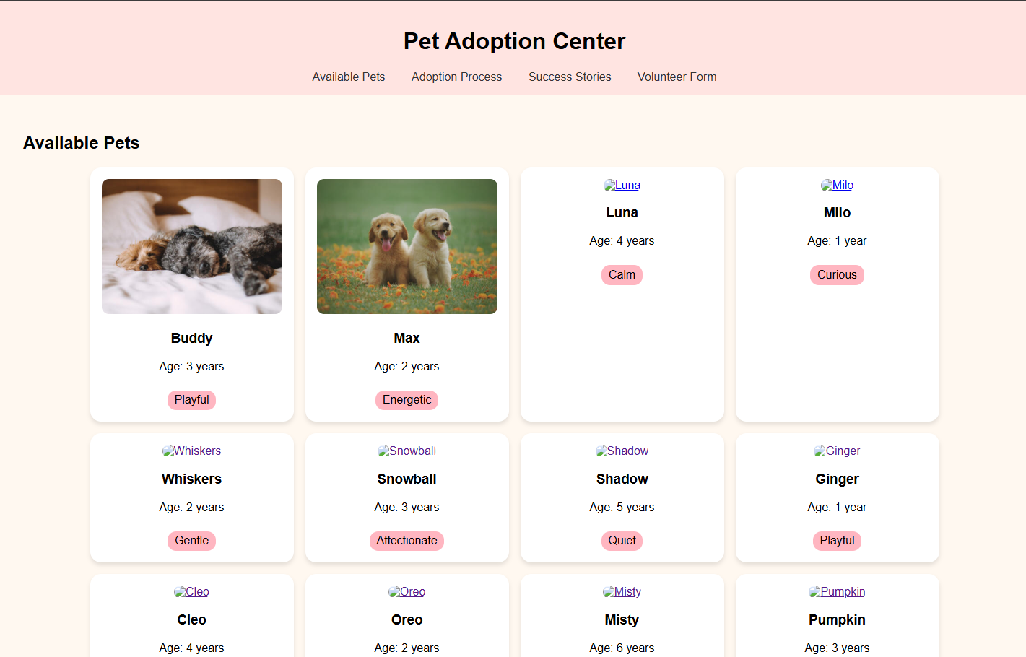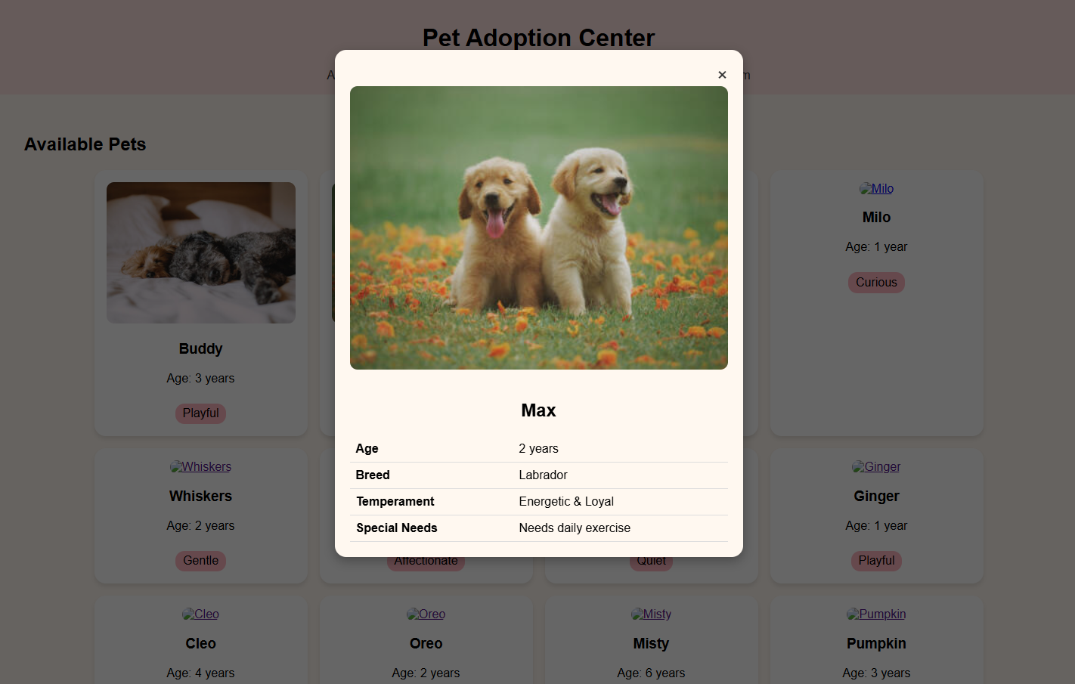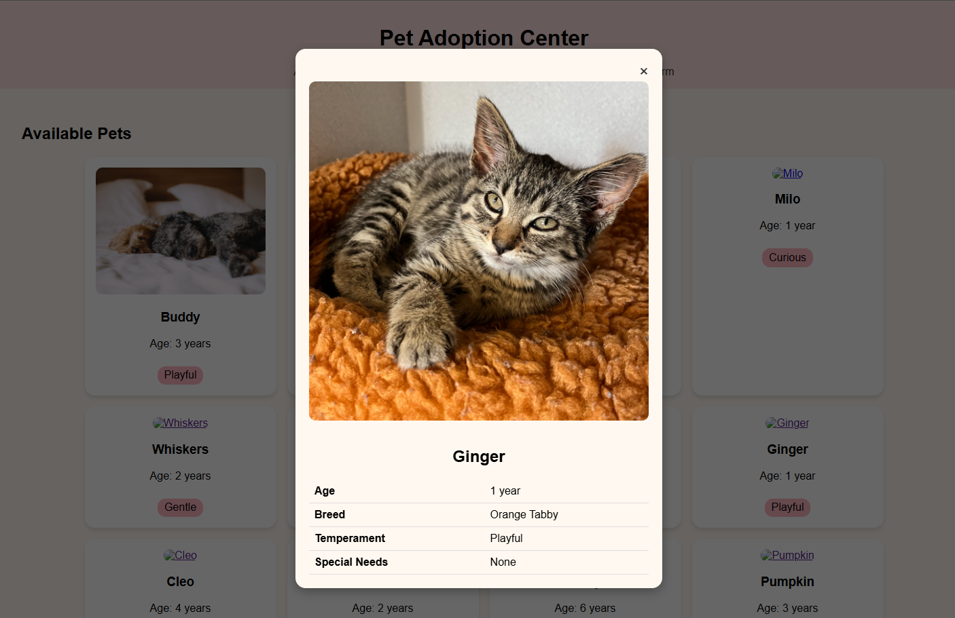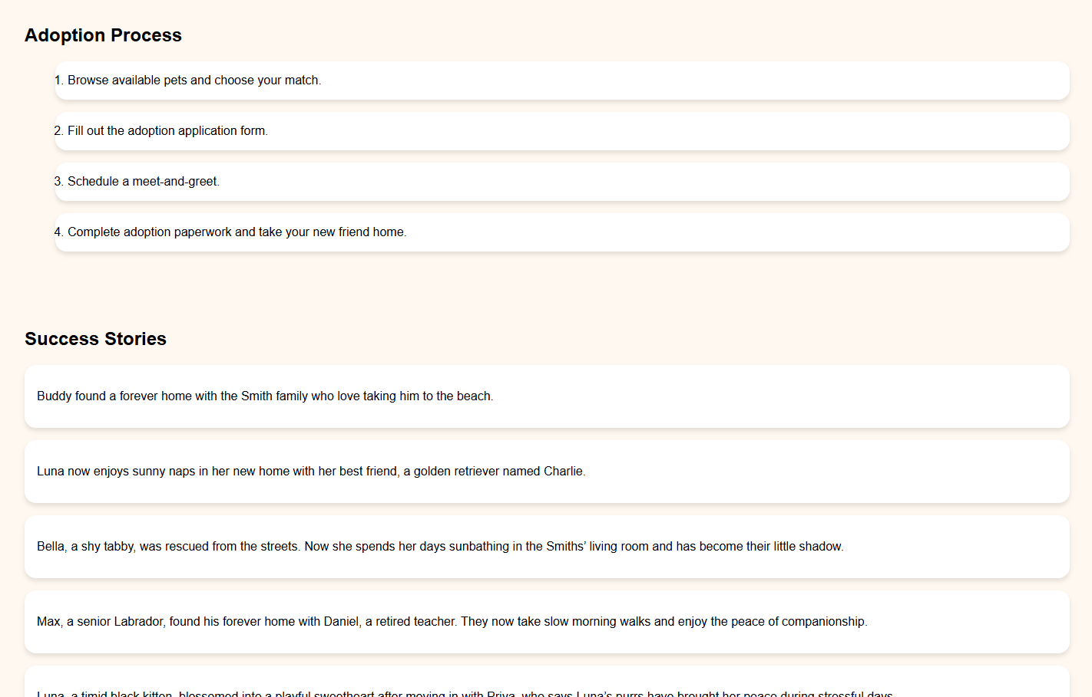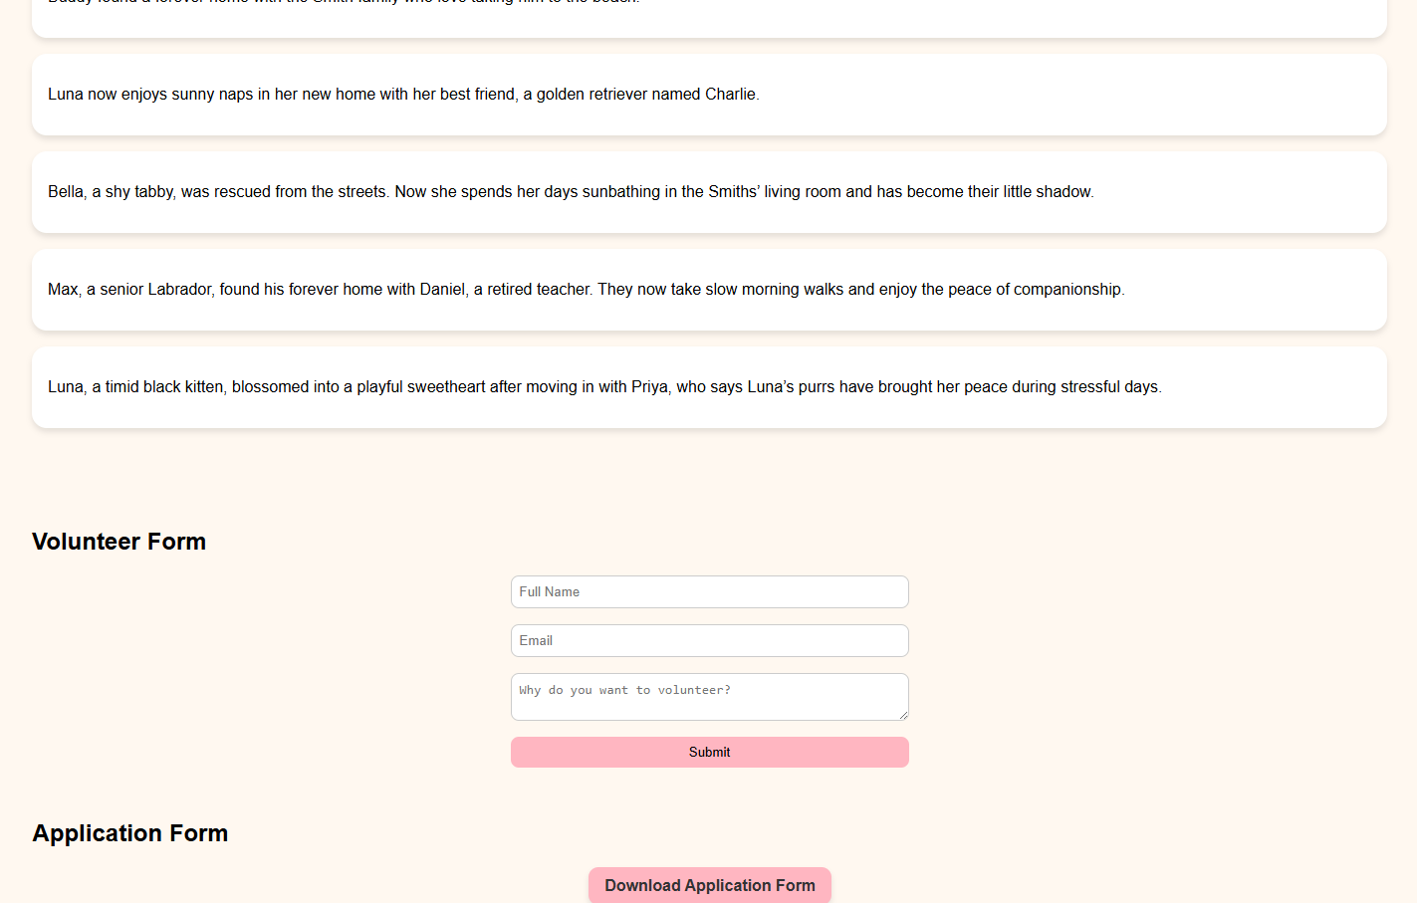

**11. Future Enhancements**

* Add **JavaScript** for interactive features (form validation, dynamic filtering).
* Integrate a **search function** for pets.
* Implement backend database for real adoption applications.
* Add **light/dark theme toggler**.
* Include animations for modal transitions.

### ****12. Sample Code****

**HTML Snippet (Pet Card)**

<!-- Dogs -->

<div class="card">

<a href="#buddyModal"><img src="https://placedog.net/400/300?id=1" alt="Buddy"></a>

<h3>Buddy</h3>

<p>Age: 3 years</p>

<span class="tag">Playful</span>

</div>

**CSS Snippet (Card Styling)**

body { font-family: Arial, sans-serif; background-color: #fff8f0; margin: 0; padding: 0; }

header { text-align: center; padding: 1rem; background-color: #ffe4e1; }

nav a { margin: 0 1rem; text-decoration: none; color: #333; }

section { padding: 2rem; }

.grid { display: flex; flex-wrap: wrap; gap: 1rem; justify-content: center; }

.card { background-color: #fff; border-radius: 15px; padding: 1rem; width: 250px; box-shadow: 0 4px 6px rgba(0,0,0,0.1); text-align: center; }

.card img { width: 100%; border-radius: 10px; cursor: pointer; }

.tag { display: inline-block; padding: 0.3rem 0.6rem; background-color: #ffb6c1; border-radius: 12px; margin-top: 0.5rem; }