PROJECT REPORT

PROJECT MEMBERS – BATCH 2
Vinnakota Poornima Bhargavi
Pentakota Jyotsna
Gaipuri Likhitha
Balireddy Harini
Shaik Nasareen

ACKNOWLEDGMENT
I would like to express my sincere gratitude to all those who supported and guided us throughout the completion of the project titled “Smart Voice Controlled Wheelchair using Embedded System and IoT.”
First and foremost, we express our heartfelt thanks to our respected Principal and the management of the institution for providing the necessary facilities and encouragement to successfully complete this project.
We would like to convey our sincere thanks to the Head of the Department and our project guide for their valuable guidance, continuous support, motivation, and technical suggestions during every stage of the project development.
We also extend our gratitude to all faculty members of the Electronics and Communication Engineering Department for sharing their knowledge and providing academic support throughout the project work.
We would like to thank our friends and classmates for their cooperation, encouragement, and helpful discussions during the implementation and testing of the project.
Finally, we express our deepest gratitude to our parents and family members for their continuous encouragement, support, and motivation, which helped us successfully complete this project.
This project helped us gain practical knowledge in Embedded Systems, IoT technologies, sensor interfacing, wireless communication, and real-time application development.

INDEX
- Abstract
- Introduction
- Basic Embedded System Concepts
- Components Used
- Power Supply System
- ESP32 Fundamentals
- Sensors and Actuator Modules
- Communication Protocols
- Circuit Connections
- Working Principle
- IoT Integration
- Applications
- Advantages
- Future Enhancements
- Result
- Conclusion
- References

ABSTRACT
The rapid advancement of Embedded Systems and Internet of Things (IoT) technologies has significantly transformed modern healthcare and assistive mobility systems. This project presents the design and development of a Smart Voice Controlled Wheelchair using Embedded System and IoT, aimed at assisting physically challenged and elderly individuals by providing an intelligent and user-friendly mobility solution. The system enables wheelchair movement through simple voice commands transmitted wirelessly from a smartphone to the ESP32 microcontroller via Bluetooth communication.
The proposed project integrates multiple embedded modules including a DC motor for wheelchair movement, a servo motor for steering control, an ultrasonic sensor for obstacle detection, and a GPS module for location tracking. The ESP32 acts as the central processing unit, receiving voice commands and controlling the movement of the wheelchair accordingly. The ultrasonic sensor continuously monitors nearby obstacles and helps prevent collisions by enhancing operational safety. Additionally, the GPS module provides real-time location tracking, which can be useful during emergencies and outdoor navigation.
The project demonstrates the practical implementation of embedded programming, wireless communication protocols, sensor interfacing, motor control, and IoT concepts in healthcare applications. The use of ESP32 provides advantages such as low power consumption, built-in Bluetooth and Wi-Fi connectivity, compact design, and efficient real-time processing capabilities. The system is designed using affordable and easily available components, making it cost-effective and suitable for educational and real-time development purposes.
This smart wheelchair system improves accessibility, reduces dependency on manual operation, and enhances the independence of users with mobility challenges. Furthermore, the project can be extended in the future with advanced technologies such as artificial intelligence, autonomous navigation, cloud-based monitoring, health tracking sensors, and mobile application integration. Overall, the project successfully demonstrates the integration Embedded Systems and IoT technologies in developing intelligent healthcare and assistive mobility solutions for real-world applications.

INTRODUCTION
The advancement of Embedded Systems and Internet of Things (IoT) technologies has created significant improvements in healthcare, automation, and assistive mobility systems. Smart healthcare devices are becoming increasingly important for improving the quality of life of physically challenged and elderly individuals. Among these technologies, intelligent wheelchair systems play a major role in providing mobility assistance and independent movement for users with physical disabilities.
Traditional wheelchairs generally require manual operation or joystick-based control, which may not be suitable for individuals with severe physical limitations. To overcome these challenges, voice-controlled mobility systems have emerged as an effective and user-friendly solution. Voice recognition technology combined with embedded systems enables users to control wheelchair movement using simple spoken commands, reducing physical effort and improving accessibility.
This project, titled “Smart Voice Controlled Wheelchair using Embedded System and IoT,” is designed to provide an intelligent, low-cost, and efficient mobility assistance system. The project uses the ESP32 microcontroller as the central processing unit due to its built-in Bluetooth and Wi-Fi capabilities, low power consumption, compact size, and efficient processing performance. The wheelchair movement is controlled using voice commands transmitted wirelessly from a smartphone through Bluetooth communication.
The system integrates several hardware components including a DC motor for movement control, a servo motor for steering, an ultrasonic sensor for obstacle detection, and a GPS module for location tracking. The ultrasonic sensor improves user safety by detecting nearby obstacles and helping prevent collisions during movement. The GPS module provides location monitoring, which can be useful for emergency situations and outdoor navigation.
The project demonstrates the practical implementation of Embedded Systems concepts such as sensor interfacing, motor control, wireless communication, real-time processing, and IoT integration. The use of affordable and easily available components makes the system cost-effective and suitable for educational, research, and prototype development purposes.
.
BASIC EMBEDDED SYSTEM CONCEPTS
An embedded system is a combination of hardware and software designed to perform a specific task or function within a larger system. Unlike general-purpose computers, embedded systems are dedicated systems optimized for specific applications such as automation, healthcare devices, robotics, and smart monitoring systems.
In this project, the Smart Voice Controlled Wheelchair using Embedded System and IoT is developed using embedded technologies to control wheelchair movement, process sensor data, and provide wireless communication. The embedded system continuously receives voice commands and sensor inputs, processes the information, and controls the motors and steering mechanism accordingly.
The major elements of an embedded system include:
1. Microcontroller
A microcontroller acts as the brain of the embedded system. It processes input data, executes programmed instructions, and controls the connected devices.
In this project, the ESP32 microcontroller is used because it provides:
- Built-in Bluetooth and Wi-Fi
- Fast processing speed
- Multiple GPIO pins
- Low power consumption
- Support for IoT applications
The ESP32 controls:
- DC motor movement
- Servo motor steering
- Ultrasonic obstacle detection
- GPS communication
- Bluetooth voice communication

2. Sensors
Sensors are input devices that detect physical changes in the environment and convert them into electrical signals.
The project uses:
- Ultrasonic Sensor for obstacle detection
- GPS Module for location tracking
The ultrasonic sensor measures the distance between the wheelchair and nearby obstacles using sound waves. The GPS module provides real-time geographical location information.
3. Actuators
Actuators are output devices that perform physical actions based on signals received from the controller.
The project uses:
- DC Motor for wheelchair movement
- Servo Motor for steering control
The DC motor enables forward and backward movement, while the servo motor controls left and right steering directions.
4. Motor Driver
A motor driver is an interface between the microcontroller and the motor. Since microcontrollers cannot provide sufficient current to drive motors directly, a motor driver is required.
In this project, the L298N motor driver is used to:
- Control motor direction
- Provide sufficient current to the motors
- Interface the motors with ESP32

5. Communication System
Communication protocols allow devices to exchange information wirelessly or through wired connections.
This project uses:
- Bluetooth communication for voice command transmission
- UART communication for GPS data transfer
The smartphone sends voice commands to the ESP32 through Bluetooth communication.
6. Power Supply
The embedded system requires a stable power supply for proper operation.
The project uses:
- Two 18650 rechargeable batteries
- L298N voltage regulation
The power supply provides energy to:
- ESP32
- Motors
- Sensors
- GPS module
7. Embedded Programming
Embedded programming is used to write instructions for the microcontroller.
The ESP32 is programmed using:
- Arduino IDE
- Embedded C/C++ programming language
The program performs:
- Voice command processing
- Motor control
- Obstacle detection
- GPS data handling
Importance of Embedded Systems in This Project
Embedded systems make the wheelchair intelligent by enabling:
- Real-time processing
- Automated movement control
- Wireless communication
- Safety monitoring
- Smart healthcare assistance
The integration of embedded systems and IoT technologies helps improve mobility assistance, accessibility, and user independence in modern healthcare applications.
The system also demonstrates the practical implementation of IoT concepts through wireless communication and real-time control. Bluetooth communication enables the smartphone to interact with the wheelchair system without physical connections. The use of embedded programming allows the system to process commands quickly and respond efficiently to user instructions. The project is developed using affordable and easily available components, making it cost-effective and suitable for educational and research purposes.
Overall, embedded systems provide the intelligence and automation required for developing smart healthcare devices and assistive technologies. The integration of embedded systems and IoT in this project helps improve accessibility, user independence, safety, and mobility assistance. This system can be further enhanced in the future with advanced technologies such as artificial intelligence, autonomous navigation, cloud monitoring, and health tracking systems for real-world healthcare applications.

COMPONENTS USED

S.no | Component | Quantity
1 | ESP32 Development Board | 1
2 | L298N Motor Driver | 1
3 | BO DC Motor | 1
4 | Servo Motor SG90 | 1
5 | HC-SR04 Ultrasonic Sensor | 1
6 | GPS Module NEO-6M | 1
7 | Breadboard | 1
8 | Jumper Wires | Several
9 | 18650 Batteries | 2
10 | Battery Holder | 1
11 | Robot Chassis / Base Platform | 1
12 | Smartphone for Voice Control | 1
13 | Wheels | 2
14 | USB Cable for ESP32 Programming | 1
15 | Power Switch | 1

POWER SUPPLY SYSTEM
The power supply system is one of the most important sections of the Smart Voice Controlled Wheelchair using Embedded System and IoT because all electronic components require a stable and reliable power source for proper operation. In this project, the complete system is powered using two rechargeable 18650 lithium-ion batteries connected to the L298N motor driver module.
The 18650 batteries provide sufficient voltage and current required for operating the ESP32 microcontroller, DC motor, servo motor, ultrasonic sensor, and GPS module. The batteries are connected through a battery holder to ensure proper and safe power connections. The L298N motor driver module acts as both a motor controller and a power distribution unit for the system.
The positive terminal of the battery pack is connected to the 12V input terminal of the L298N motor driver, while the negative terminal is connected to the ground (GND). The L298N module then distributes regulated power to the ESP32 and other connected components through the breadboard power rails. The 5V output pin of the L298N is connected to the VIN pin of the ESP32 to provide operating voltage to the controller.
A common grounding system is maintained throughout the circuit. The grounds of the battery, ESP32, motor driver, sensors, GPS module, and servo motor are connected together to ensure stable signal communication and proper circuit operation.
The power supply arrangement used in this project provides:
- Stable voltage supply
- Reliable motor operation
- Proper sensor functioning
- Efficient power distribution
- Portable battery-powered operation
The use of rechargeable batteries makes the system portable and suitable for real-time mobility applications. Proper power management improves system efficiency and ensures continuous operation of the wheelchair system without interruption.

ESP32 FUNDAMENTALS
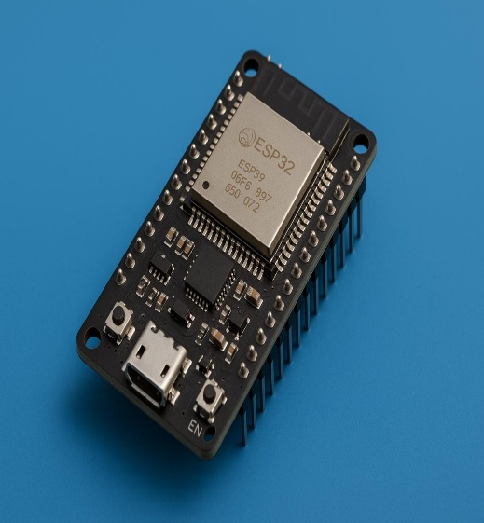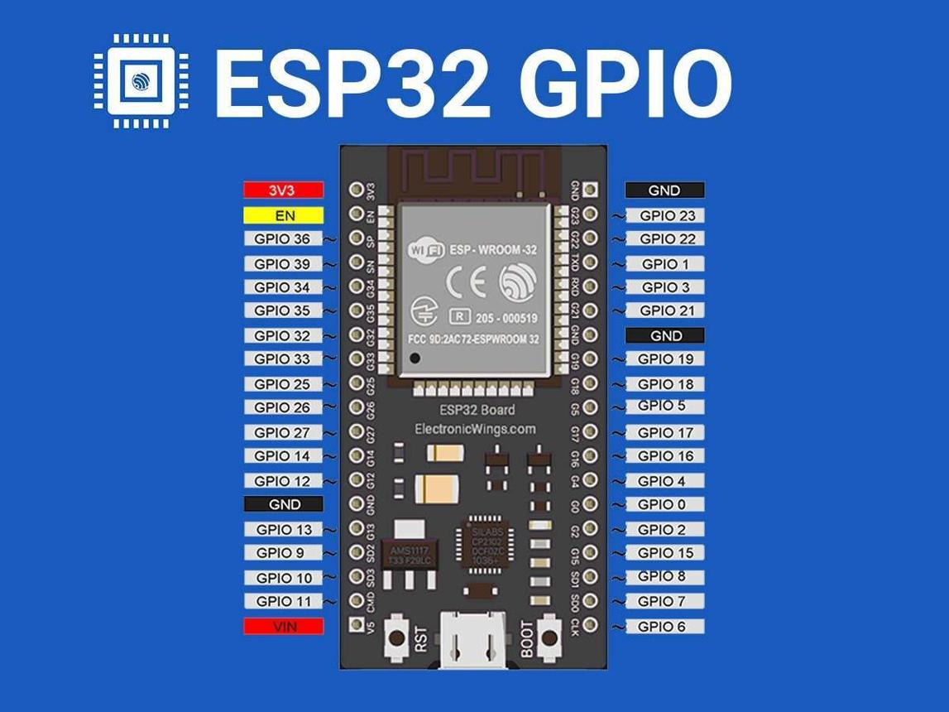
ESP32 is a powerful and low-cost microcontroller widely used in Embedded Systems and Internet of Things (IoT) applications. It is developed by Espressif Systems Espressif Systems and is designed for wireless communication, automation, and real-time embedded control applications. ESP32 is one of the most popular controllers used in smart devices because it provides built-in Bluetooth and Wi-Fi connectivity along with high processing performance.
In this project, “Smart Voice Controlled Wheelchair using Embedded System and IoT,” the ESP32 acts as the central processing unit of the entire system. It receives voice commands from the smartphone through Bluetooth communication, processes the commands, and controls the motors, sensors, and steering mechanisms accordingly.
The ESP32 microcontroller is selected for this project because of its advanced features, compact size, low power consumption, and wireless communication capabilities. It simplifies circuit design by eliminating the need for separate Bluetooth or Wi-Fi modules.
Features of ESP32
- Built-in Bluetooth and Wi-Fi
- Dual-core processor
- Low power consumption
- High-speed processing
- Multiple GPIO pins
- PWM support for motor control
- UART, SPI, and I2C communication support
- Compact and lightweight design
Pin Configuration
The ESP32 contains multiple General Purpose Input Output (GPIO) pins used for interfacing sensors, motors, and communication modules.
In this project, the following GPIO pins are used:
ESP32 Pin | Connected Components
GPIO26 | L298N IN1
GPIO27 | L298N IN2
GPIO13 | Servo Motor Signal
GPIO5 | Ultrasonic Sensor TRIG
GPIO18 | Ultrasonic Sensor ECHO
GPIO16 | GPS TX
GPIO17 | GPS RX

Working of ESP32 in the Project
The ESP32 continuously receives voice commands through Bluetooth communication from the smartphone application. Based on the received command, it controls the movement of the DC motor and steering servo motor. Simultaneously, the ESP32 reads data from the ultrasonic sensor to detect nearby obstacles and processes GPS data for location tracking.
The ESP32 also performs real-time decision-making and controls the entire embedded system efficiently. Its wireless communication capability makes the project more flexible, portable, and suitable for IoT applications.

Advantages of Using ESP32
- Reduces external hardware requirements
- Supports wireless communication
- Fast response and processing
- Suitable for IoT projects
- Energy efficient
- Easy programming using Arduino IDE
Overall, the ESP32 provides an efficient platform for developing smart embedded systems and IoT-based healthcare applications such as intelligent wheelchairs and assistive mobility systems.

SENSOR AND ACTUATOR MODULES
Sensors and actuators are important components of embedded systems and IoT applications. Sensors are input devices that detect physical changes in the environment and convert them into electrical signals, while actuators are output devices that perform physical actions based on commands from the controller. In this project, different sensors and actuators are integrated with the ESP32 microcontroller to provide intelligent movement control, obstacle detection, steering, and location tracking.
The Smart Voice Controlled Wheelchair using Embedded System and IoT uses multiple sensors and actuators to ensure efficient operation and user safety. These components work together under the control of the ESP32 microcontroller.
1. ULTRASONIC SENSOR (HC-SR04)
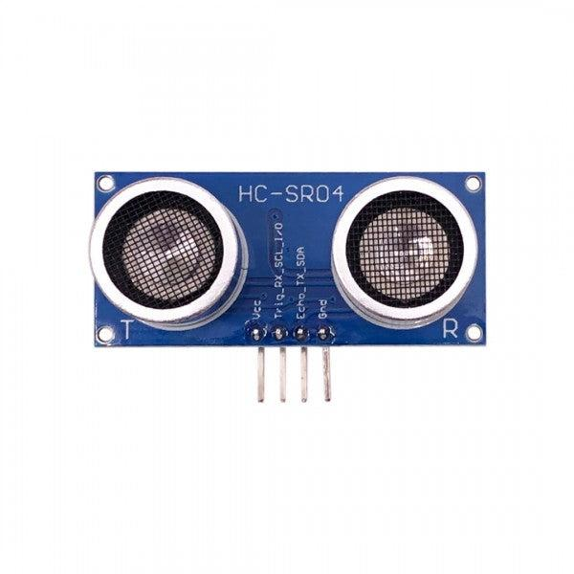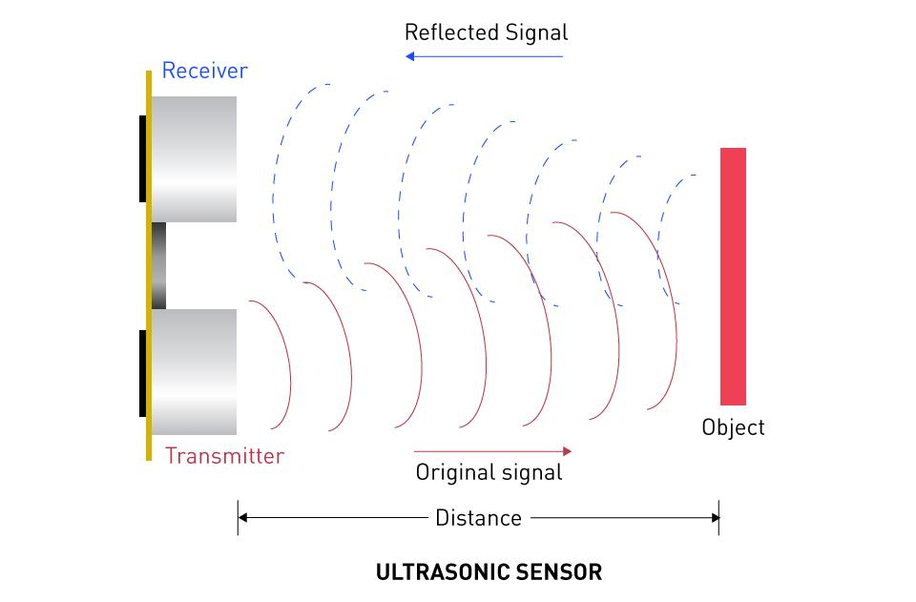

The HC-SR04 ultrasonic sensor is an electronic distance measuring sensor widely used in embedded systems, robotics, automation, and obstacle detection applications. It works using ultrasonic sound waves to detect objects and measure distance accurately. The sensor consists of two main parts: a transmitter and a receiver. The transmitter emits ultrasonic sound waves, and the receiver captures the reflected waves from nearby objects.
In this project, the ultrasonic sensor is used for obstacle detection to improve user safety and prevent collisions during wheelchair movement.
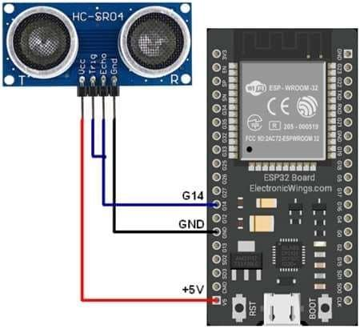
Working Principle
The ultrasonic sensor works on the principle of sound wave reflection. It transmits ultrasonic waves with frequencies above human hearing range (typically 40 kHz). When these waves strike an object, they reflect back toward the sensor receiver.
The sensor calculates the distance using:
- Time taken for the echo to return
- Speed of sound in air
How It Works
- The ESP32 sends a trigger signal to the ultrasonic sensor.
- The transmitter emits ultrasonic sound waves.
- The waves travel through air and strike an obstacle.
- Reflected waves return to the receiver.
- The sensor measures the echo return time.
- ESP32 calculates the distance.
- If an obstacle is detected nearby, movement can be stopped automatically.
Applications
- Obstacle detection
- Distance measurement
- Robotics
- Smart wheelchairs
- Parking systems
- Industrial automation
2. SERVO MOTOR (SG90)
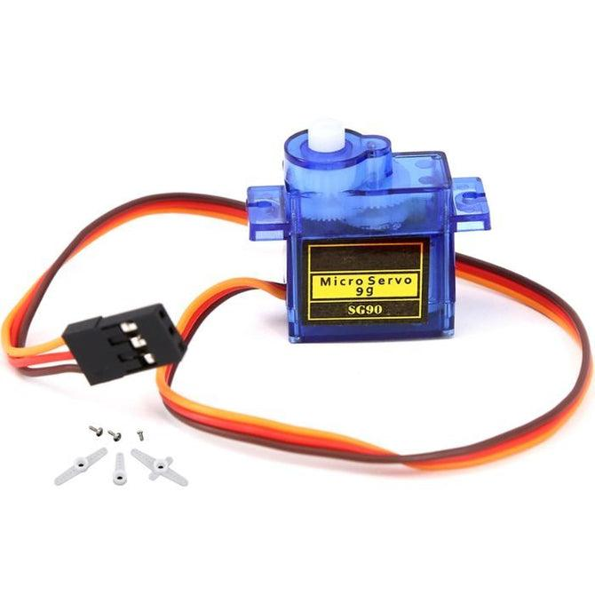

A servo motor is a rotary actuator used for precise angular movement and position control. Unlike normal DC motors, servo motors can rotate to specific angular positions based on control signals. Servo motors are widely used in robotics, automation systems, steering systems, and embedded applications.
In this project, the SG90 servo motor is used for steering control of the wheelchair system.

Working Principle
The servo motor works on the principle of Pulse Width Modulation (PWM). The motor rotates according to the PWM signal sent by the ESP32 controller.
Different pulse widths correspond to different angular positions.

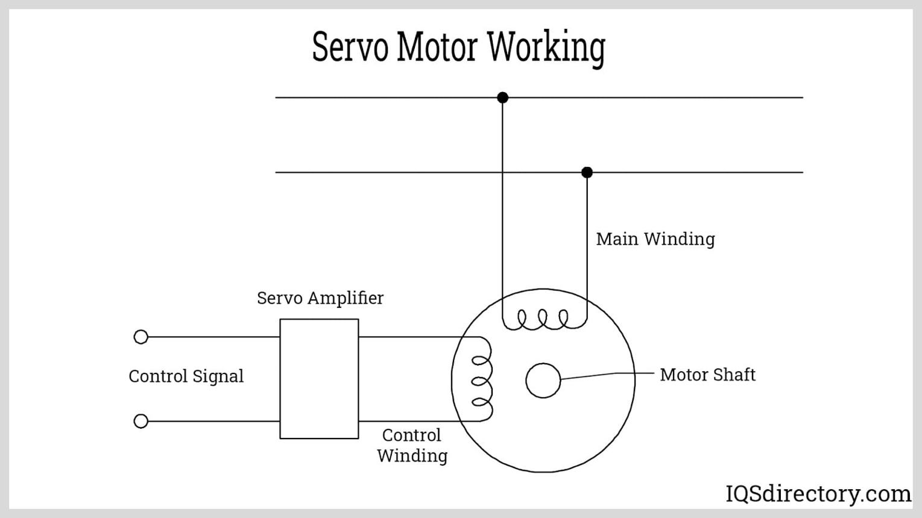
How It Works
- ESP32 sends PWM signals to the servo motor.
- The servo motor receives the control signal.
- Internal gears rotate the motor shaft.
- The motor moves to a specific angle.
- The front wheels turn left or right accordingly.
Typical angles:
- 45° → Left
- 90° → Straight
- 135° → Right

Applications
- Steering systems
- Robotics
- Automation systems
- Camera movement systems
- Industrial control systems

3. BO DC MOTOR
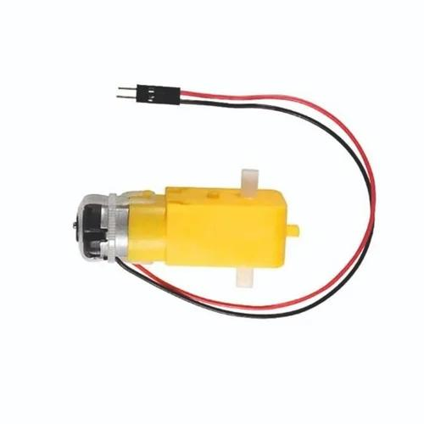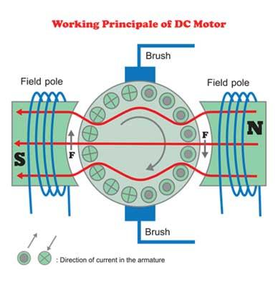

A DC motor is an electromechanical device that converts electrical energy into mechanical rotational energy. DC motors are widely used in robotics, electric vehicles, automation systems, and mobility applications.
In this project, the BO DC motor provides movement to the wheelchair system.
Working Principle
The DC motor works on the principle of electromagnetic force. When electric current passes through the motor coil inside a magnetic field, rotational motion is produced.

How It Works
- ESP32 sends movement commands.
- L298N motor driver receives signals.
- Motor driver supplies current to the DC motor.
- The motor shaft rotates.
- Wheels move forward or backward.
Changing motor polarity changes direction.
Applications
- Wheelchair movement
- Robotics
- Electric vehicles
- Conveyor systems
- Industrial machines
4. GPS MODULE (NEO-6M)
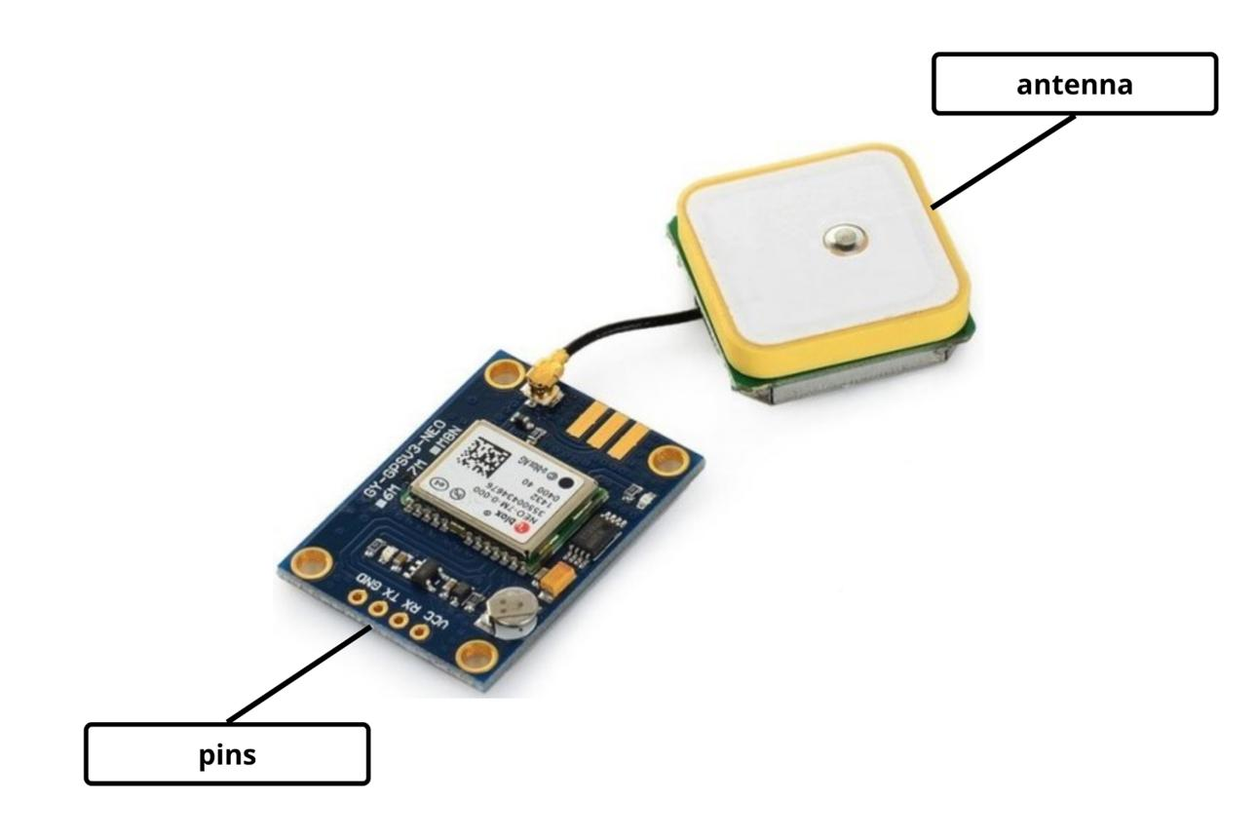

The GPS (Global Positioning System) module is used for location tracking and navigation applications. The NEO-6M GPS module receives signals from multiple satellites and calculates geographical coordinates such as latitude and longitude.
In this project, the GPS module is used for real-time wheelchair location tracking. 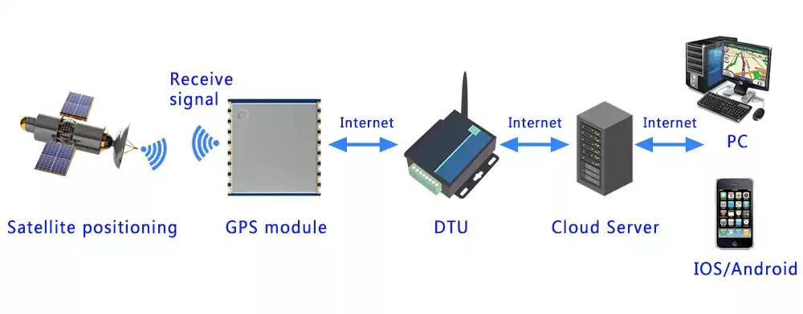
Working Principle
The GPS module works using satellite communication. Multiple GPS satellites continuously transmit signals toward Earth. The GPS receiver calculates position based on signal timing from satellites.
How It Works
- GPS satellites send location signals.
- GPS module receives satellite data.
- Module calculates coordinates.
- Coordinates are sent to ESP32 using UART communication.
- ESP32 processes location information.
Applications
- Navigation systems
- Vehicle tracking
- Smart healthcare systems
- Emergency location monitoring
- IoT tracking systems

5. L298N MOTOR DRIVER
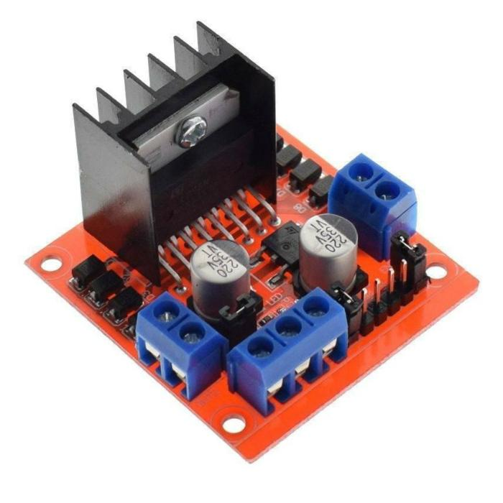

The L298N motor driver is a high-current motor control module used for driving DC motors. Microcontrollers like ESP32 cannot directly provide sufficient current to motors, so a motor driver is required.
In this project, the L298N module controls the DC motor movement.
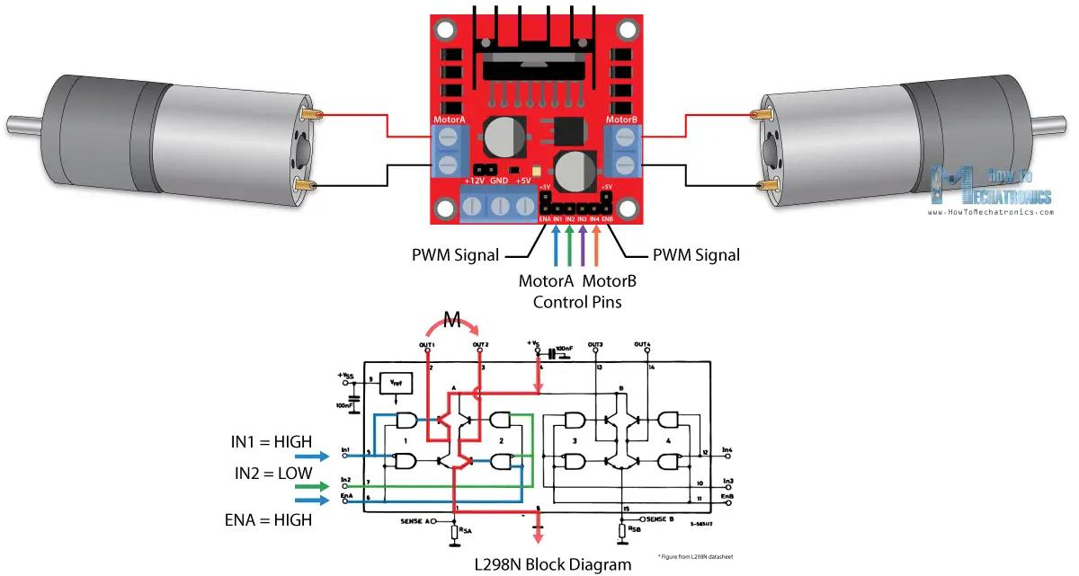
Working Principle
The motor driver works using H-Bridge circuitry. It controls:
- Motor direction
- Motor rotation
- Speed control
based on input signals from ESP32.
How It Works
- ESP32 sends digital signals to L298N.
- L298N amplifies the current.
- Current flows to the motor.
- Motor rotates according to the command.
- Direction changes based on signal polarity.
Applications
- Robotics
- Wheelchair systems
- Motor control systems
- Automation projects
- Electric vehicles

COMMUNICATION PROTOCOLS
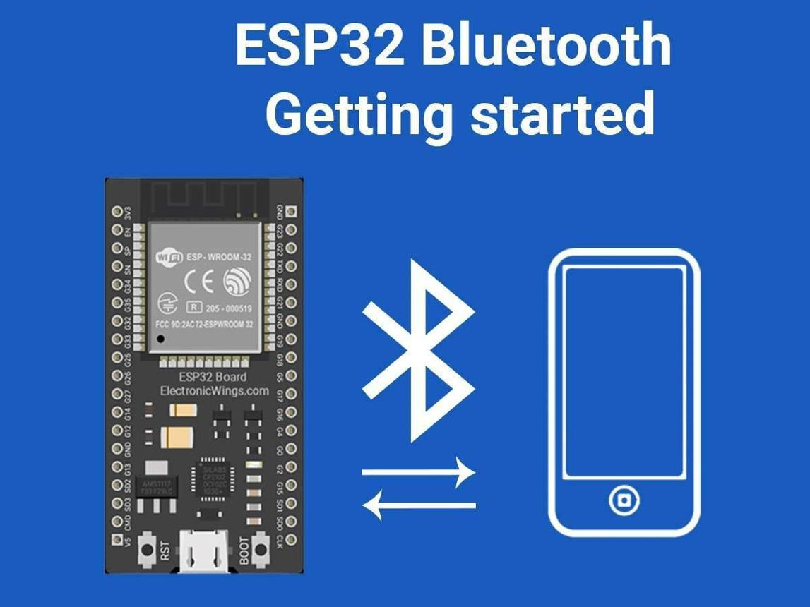

Communication protocols are sets of rules and methods used for exchanging data between electronic devices and embedded systems. These protocols enable communication between microcontrollers, sensors, modules, smartphones, and other hardware components. In embedded systems and IoT applications, communication protocols are essential for transmitting commands, sensor data, and control signals efficiently and reliably.
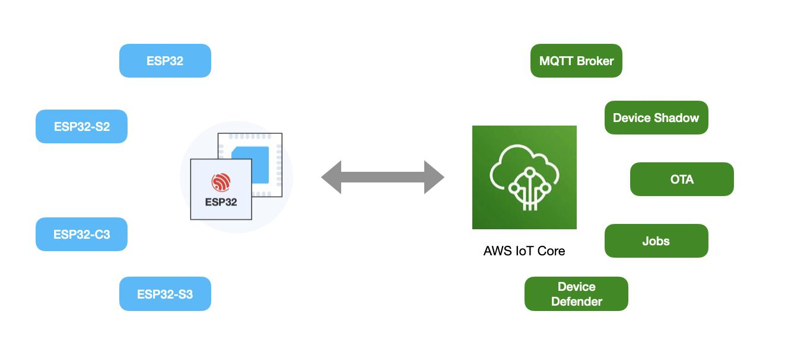
In the Smart Voice Controlled Wheelchair using Embedded System and IoT, different communication protocols are used to establish communication between the ESP32 microcontroller, smartphone, GPS module, and other connected devices. These protocols enable wireless voice command transmission, real-time sensor communication, and location tracking.
The project mainly uses:
- Bluetooth Communication
- UART Serial Communication
These communication methods help the system operate smoothly and efficiently in real-time applications.
1. BLUETOOTH COMMUNICATION
Bluetooth is a wireless communication technology used for short-range data transmission between electronic devices. It allows devices such as smartphones, laptops, and microcontrollers to communicate without physical cables.
In this project, Bluetooth communication is used to transmit voice commands from the smartphone to the ESP32 controller. The ESP32
contains built-in Bluetooth capability, which eliminates the need for an external Bluetooth module.
Working Principle
Bluetooth communication works using radio frequency signals in the 2.4 GHz ISM band. Devices pair with each other and exchange data wirelessly within a limited range.
The smartphone converts voice commands into text-based control signals and sends them to the ESP32 through Bluetooth communication.
How It Works
- User gives voice command through smartphone.
- Smartphone application converts speech into text command.
- Bluetooth connection sends the command wirelessly.
- ESP32 receives the command.
- ESP32 processes the command and controls movement.
Example:
- “Forward” → Move Forward
- “Left” → Turn Left
- “Stop” → Stop Movement
Applications
- Wireless communication systems
- Smart wheelchairs
- Home automation
- Robotics
- IoT devices
- Mobile-controlled systems

2. UART SERIAL COMMUNICATION
UART (Universal Asynchronous Receiver Transmitter) is a serial communication protocol used for transmitting and receiving data between electronic devices. It is widely used in embedded systems for communication between microcontrollers and external modules.
In this project, UART communication is used between the ESP32 and GPS module for location tracking.
Working Principle
UART communication works by transmitting data serially one bit at a time through:
- TX (Transmit) pin
- RX (Receive) pin
Both devices must operate at the same baud rate for proper communication.
How It Works
- GPS module receives satellite signals.
- GPS module converts satellite data into serial data.
- GPS TX pin sends data to ESP32 RX pin.
- ESP32 reads latitude and longitude values.
- Location information is processed and displayed.

Applications
- GPS communication
- Embedded systems
- Sensor interfacing
- Serial monitoring
- IoT communication systems

Importance of Communication Protocols in This Project
Communication protocols enable:
- Wireless voice control
- Real-time data transfer
- GPS location tracking
- Reliable communication between modules
- Efficient embedded system operation
The integration of Bluetooth and UART communication protocols makes the wheelchair system intelligent, responsive, and suitable for modern IoT-based healthcare applications.
CIRCUIT CONNECTIONS

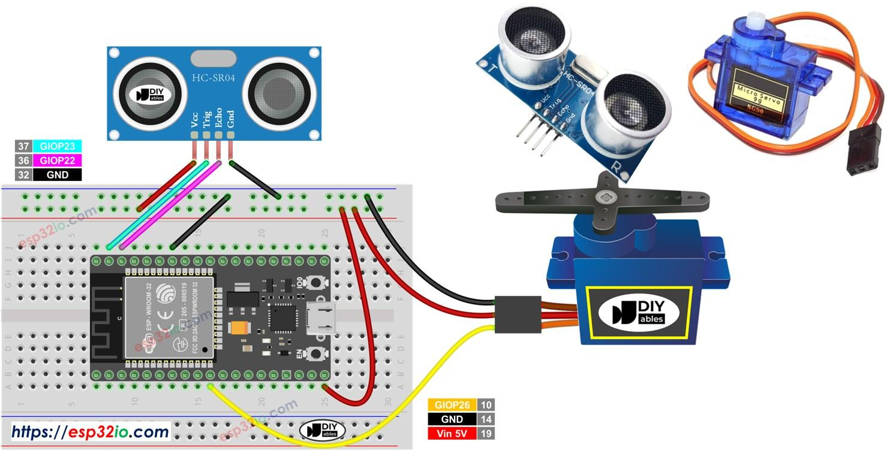

The circuit connections play an important role in the proper functioning of the Smart Voice Controlled Wheelchair using Embedded System and IoT. All components are connected carefully with the ESP32 microcontroller, which acts as the central controller of the system. The circuit includes power supply connections, motor driver interfacing, sensor connections, GPS communication, and steering control connections.
The complete system is powered using two 18650 rechargeable batteries connected to the L298N motor driver module. The motor driver distributes power to the ESP32, motors, sensors, and other connected modules. A common ground connection is maintained throughout the circuit to ensure stable communication and proper operation of all devices.
1. Battery Connections
The power supply for the entire system is provided using two 18650 lithium-ion batteries.
Battery to L298N Connections
Battery Terminal | L298N Pin
Positive (+) | 12V
Negative (-) | GND
The L298N motor driver receives battery power and distributes regulated voltage to the ESP32 and sensors.
2. L298N to Breadboard Connections
The L298N module supplies power to the breadboard rails.
L298N | Breadboard
5V | Positive Rail
GND | Ground Rail
The breadboard rails distribute power to:
- ESP32
- Servo motor
- Ultrasonic sensor
- GPS module

3. ESP32 Power Connections
ESP32 Pin | Breadboard
VIN | Positive Rail
GND | Ground Rail
The ESP32 receives regulated power through the VIN pin.
4. DC Motor Connections
The BO DC motor is connected to the L298N motor driver for movement control.
DC Motor | L298N
Motor Wire 1 | OUT1
Motor Wire 2 | OUT2
The L298N controls motor rotation direction and movement.
5. ESP32 to L298N Connections
The ESP32 sends movement control signals to the motor driver.
ESP32 Pin | L298N Pin
GPIO26 | IN1
GPIO27 | IN2
GND | GND
These pins control:
- Forward movement
- Backward movement
- Motor stop operation

6. Servo Motor Connections
The servo motor controls steering movement.
Servo Wire | Connection
Red | 5V
Brown/Black | GND
Orange/Yellow | GPIO13
The ESP32 sends PWM signals to rotate the servo motor left or right.
7. Ultrasonic Sensor Connections
The HC-SR04 ultrasonic sensor is used for obstacle detection.
HC-SR04 Pin | ESP32
VCC | 5V
GND | GND
TRIG | GPIO5
ECHO | GPIO18
The sensor continuously measures the distance between the wheelchair and nearby obstacles.
GPS Module Connections
The GPS module provides real-time location tracking.
GPS Module | ESP32
VCC | 5V
GND | GND
TX | GPIO16
RX | GPIO17
UART serial communication is used between the GPS module and ESP32.
Common Ground Connections
All components share a common ground connection for stable circuit operation.
The following grounds are connected together:
- Battery GND
- L298N GND
- ESP32 GND
- Servo GND
- Ultrasonic Sensor GND
- GPS Module GND
Proper grounding prevents signal errors and unstable system behavior.
Working of Circuit Connections
- The battery powers the L298N motor driver.
- The L298N supplies regulated voltage to the ESP32 and other components.
- ESP32 receives voice commands through Bluetooth communication.
- ESP32 processes commands and controls the DC motor and servo motor.
- Ultrasonic sensor continuously checks for nearby obstacles.
- GPS module provides location tracking information.
- The wheelchair moves according to the received voice commands.
The circuit integration successfully demonstrates the implementation of embedded systems and IoT technologies in smart healthcare and mobility assistance applications.

SOFTWARE USED :
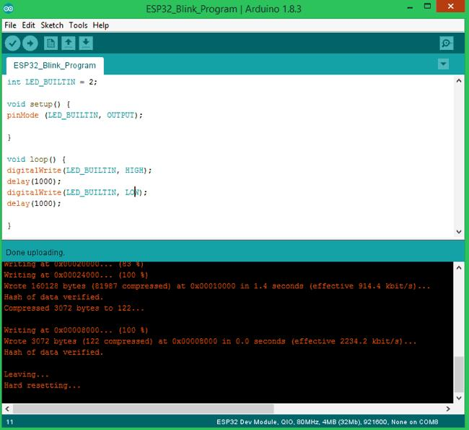
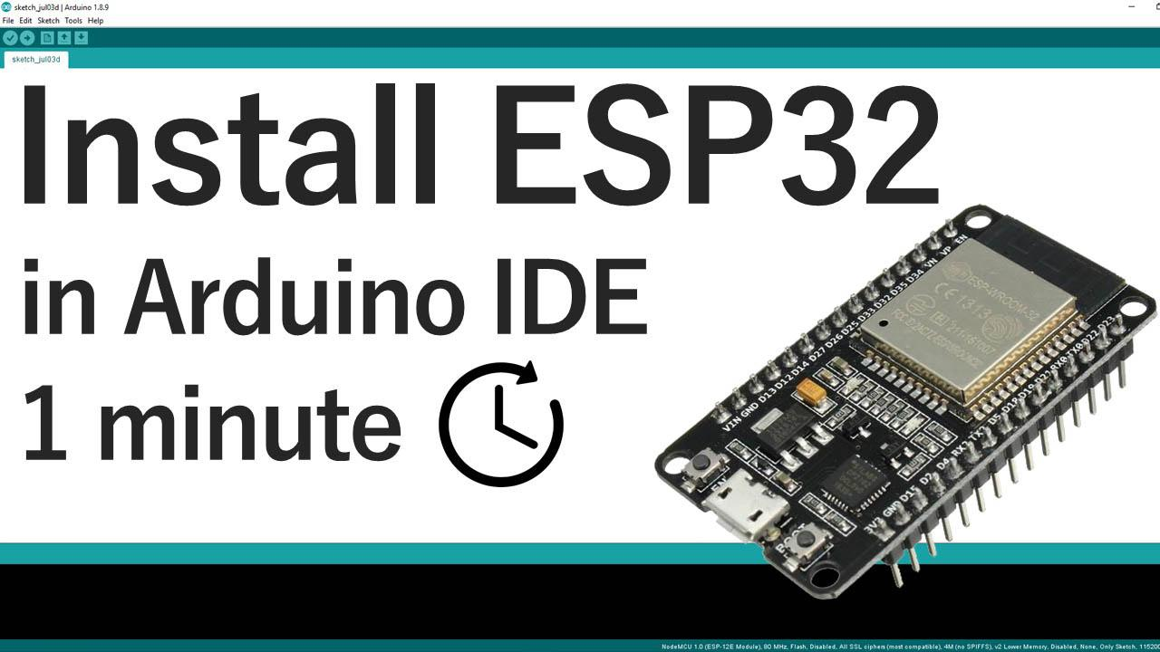
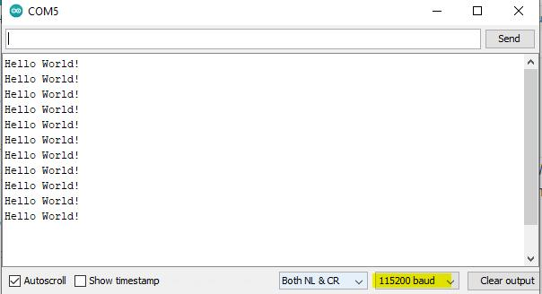

The Arduino program used in this project is written in Embedded C/C++ language using the Arduino IDE. The code is developed to control the movement of the wheelchair based on voice commands received through Bluetooth communication. The ESP32 microcontroller receives commands from the smartphone and controls the DC motor, servo motor, ultrasonic sensor, and GPS module accordingly.
The complete program is uploaded (dumped) into the ESP32 development board using the Arduino IDE through a USB cable connection. The Arduino IDE compiles the program and transfers the machine code into the flash memory of the ESP32 controller.
The program performs the following operations:
- Bluetooth communication
- Voice command processing
- Motor control
- Steering control
- Obstacle detection
- GPS communication

Main Functionalities of the Program
1. Bluetooth Communication
The ESP32 receives voice commands such as:
- Forward
- Backward
- Left
- Right
- Stop
through Bluetooth communication from the smartphone application.
2. Motor Control
The ESP32 controls the DC motor using the L298N motor driver module for:
- Forward movement
- Backward movement
- Stop operation
3. Servo Motor Control
The servo motor rotates to different angular positions for steering control:
- Left turn
- Right turn
- Straight direction
4. Ultrasonic Sensor Processing
The ultrasonic sensor continuously measures obstacle distance and helps prevent collisions.
5. GPS Communication
The GPS module sends latitude and longitude information to the ESP32 using UART communication.

IOT INTEGRATION
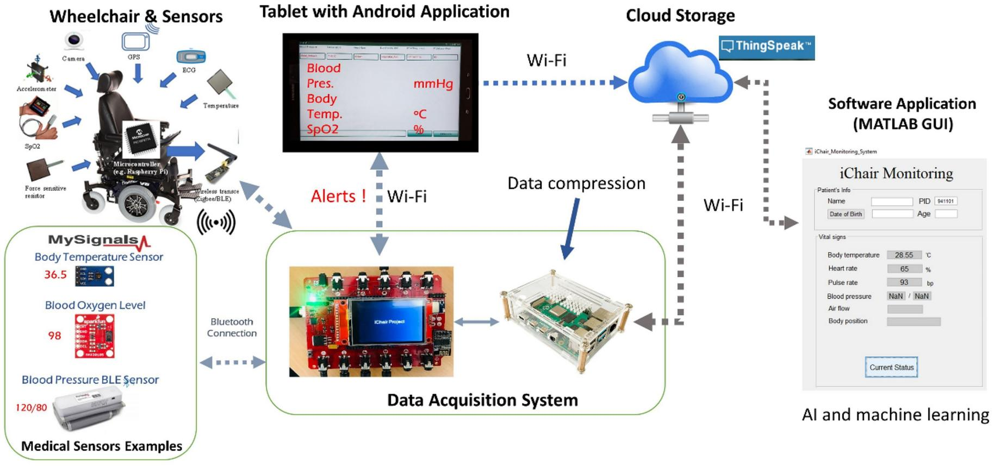
The Internet of Things (IoT) is a technology that enables electronic devices, sensors, controllers, and communication systems to connect and exchange data through the internet or wireless communication networks. IoT plays a major role in modern automation, healthcare systems, smart monitoring, robotics, and intelligent mobility applications.
In the Smart Voice Controlled Wheelchair using Embedded System and IoT, IoT technology is integrated to provide wireless communication, smart control, and real-time monitoring features. The project combines embedded systems, Bluetooth communication, sensors, GPS tracking, and intelligent automation to create a smart healthcare mobility solution.
The ESP32 microcontroller used in this project is an IoT-enabled controller with built-in Bluetooth and Wi-Fi capabilities. It acts as the central communication and processing unit of the entire system. The ESP32 receives voice commands wirelessly from the smartphone through Bluetooth communication and controls the movement of the wheelchair accordingly.
The IoT integration in this project enables:
- Wireless voice control
- Real-time communication
- Smart obstacle detection
- GPS-based location tracking
- Remote monitoring possibilities
Working of IoT in the Project
The project works using IoT communication and embedded system integration. The smartphone acts as the user interface, while the ESP32 functions as the intelligent controller.
Step-by-Step IoT Operation
- The user gives voice commands through a smartphone application.
- The smartphone converts speech into digital command signals.
- Bluetooth communication transmits the command wirelessly.
- ESP32 receives and processes the command.
- The DC motor and servo motor perform movement and steering actions.
- The ultrasonic sensor continuously monitors obstacles.
- The GPS module provides real-time location information.
- Data can later be integrated with cloud platforms or mobile applications.
IoT Components Used in the Project
Component | IoT Function
ESP32 | Main IoT controller
Smartphone | Voice command
Bluetooth Communication | Wireless data transfer
GPS Module | Location tracking
Ultrasonic Sensor | Obstacle monitoring

Advantages of IoT Integration
- Wireless communication
- Smart automation
- Real-time monitoring
- Improved user safety
- Intelligent healthcare support
- Remote tracking capability
- Expandable cloud connectivity
Future IoT Enhancements
The project can be upgraded further using advanced IoT technologies such as:
- Cloud-based wheelchair monitoring
- Mobile application dashboard
- AI-based voice recognition
- Emergency alert system
- Remote healthcare monitoring
- IoT data analytics
Applications of IoT in the Project
- Smart healthcare systems
- Intelligent wheelchairs
- Rehabilitation monitoring
- Elderly assistance systems
- Remote patient monitoring
- Smart mobility solutions
The integration of IoT technologies in this project improves automation, communication, safety, and mobility assistance, making the wheelchair system more intelligent, efficient, and suitable for modern healthcare applications.

ARDUINO IDE CODE
#include <BluetoothSerial.h>
BluetoothSerial SerialBT;
// ================= MOTOR PINS =================
// LEFT SIDE MOTORS
#define IN1 26
#define IN2 27
// RIGHT SIDE MOTORS
#define IN3 14
#define IN4 12
String command = "";
void setup()
{
Serial.begin(115200);
// Bluetooth Name
SerialBT.begin("ESP32_Voice_Controller");
// Motor Pins
pinMode(IN1, OUTPUT);
pinMode(IN2, OUTPUT);
pinMode(IN3, OUTPUT);
pinMode(IN4, OUTPUT);
stopMotors();
Serial.println("Robot Ready");
}
void loop()
{
// ================= BLUETOOTH =================
if (SerialBT.available())
{
command = SerialBT.readStringUntil('\n');
command.trim();
// Convert to lowercase
command.toLowerCase();
Serial.print("Command: ");
Serial.println(command);
// ================= FORWARD =================
if(command == "forward")
{
moveForward();
}
// ================= BACKWARD =================
else if(command == "backward")
{
moveBackward();
}
// ================= LEFT =================
else if(command == "left")
{
turnLeft();
}
// ================= RIGHT =================
else if(command == "right")
{
turnRight();
}
// ================= STOP =================
else if(command == "stop")
{
stopMotors();
}
}
}
// ================= FORWARD =================
void moveForward()
{
// Left Wheels Forward
digitalWrite(IN1, HIGH);
digitalWrite(IN2, LOW);
// Right Wheels Forward
digitalWrite(IN3, HIGH);
digitalWrite(IN4, LOW);
Serial.println("Moving Forward");
}
// ================= BACKWARD =================
void moveBackward()
{
// Left Wheels Backward
digitalWrite(IN1, LOW);
digitalWrite(IN2, HIGH);
// Right Wheels Backward
digitalWrite(IN3, LOW);
digitalWrite(IN4, HIGH);
Serial.println("Moving Backward");
}
// ================= LEFT =================
// LEFT SIDE STOP
// RIGHT SIDE MOVE
void turnLeft()
{
// Left Wheels Stop
digitalWrite(IN1, LOW);
digitalWrite(IN2, LOW);
// Right Wheels Forward
digitalWrite(IN3, HIGH);
digitalWrite(IN4, LOW);
Serial.println("Turning Left");
}
// ================= RIGHT =================
// RIGHT SIDE STOP
// LEFT SIDE MOVE
void turnRight()
{
// Left Wheels Forward
digitalWrite(IN1, HIGH);
digitalWrite(IN2, LOW);
// Right Wheels Stop
digitalWrite(IN3, LOW);
digitalWrite(IN4, LOW);
Serial.println("Turning Right");
}
// ================= STOP =================
void stopMotors()
{
// Left Wheels Stop
digitalWrite(IN1, LOW);
digitalWrite(IN2, LOW);

// Right Wheels Stop
digitalWrite(IN3, LOW);
digitalWrite(IN4, LOW);

Serial.println("Stopped");
}

Code Upload Procedure
Steps for Dumping the Code into ESP32
- Open Arduino IDE.
- Connect ESP32 board using USB cable.
- Select:
Tools → Board → ESP32 Dev Module
- Select the correct COM port.
- Paste the Arduino code.
- Click Verify button.
- Click Upload button.
- Wait for successful upload message.
The code is now dumped into the ESP32 and the system starts functioning automatically.
Output of the Program
The uploaded program enables:
- Voice-controlled wheelchair movement
- Steering control
- Obstacle detection
- GPS tracking
- Real-time embedded system operation
The Arduino program successfully demonstrates the practical implementation of embedded systems and IoT technologies in smart healthcare and mobility assistance applications.

PROJECT OUTPUT
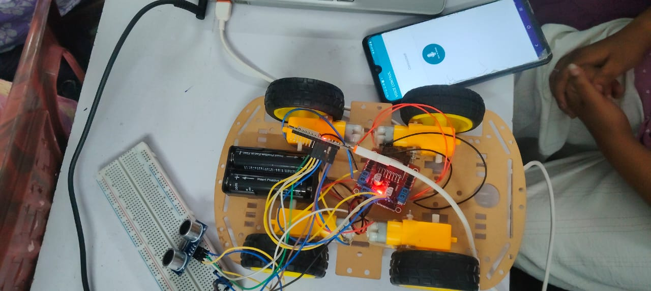

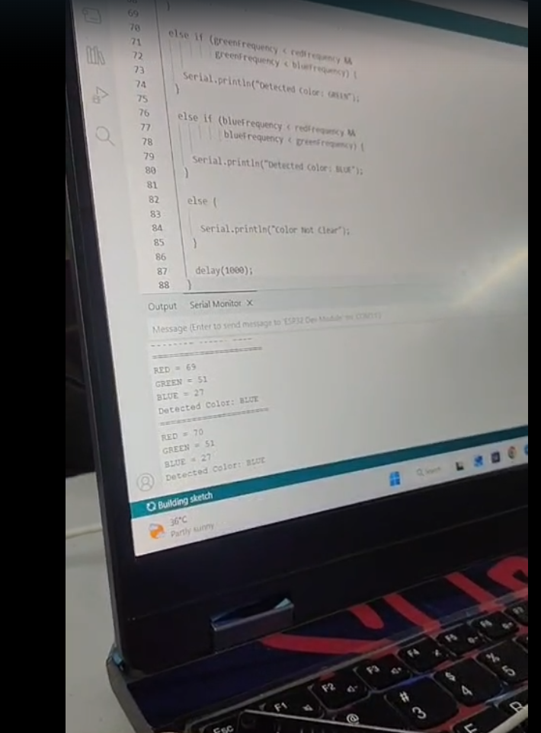

CONCLUSION
The Smart Voice Controlled Wheelchair using Embedded System and IoT successfully demonstrates the implementation of intelligent mobility assistance using embedded systems and IoT technologies. The project is designed to help physically challenged and elderly individuals by providing an easy and efficient voice-controlled movement system. The integration of ESP32, Bluetooth communication, sensors, GPS tracking, and motor control enables the development of a smart and user-friendly wheelchair system.
The ESP32 microcontroller acts as the central processing unit of the system and efficiently controls all connected devices. Voice commands received through Bluetooth communication allow the user to control wheelchair movement without physical effort. The DC motor provides movement control, while the servo motor enables steering operations. The ultrasonic sensor improves user safety by detecting nearby obstacles and preventing collisions during movement. The GPS module provides real-time location tracking, which can be useful in emergency situations and outdoor navigation.
The project demonstrates the practical application of embedded programming, wireless communication protocols, sensor interfacing, motor control, and IoT integration in healthcare systems. The use of affordable and easily available hardware components makes the system cost-effective and suitable for educational, research, and prototype development purposes.
Overall, the project improves accessibility, mobility assistance, safety, and user independence through intelligent automation. The system can be further enhanced in the future using advanced technologies such as artificial intelligence, autonomous navigation, cloud-based monitoring, health tracking sensors, and mobile application integration for real-time smart healthcare support. The project successfully proves the importance of Embedded Systems and IoT technologies in developing modern smart healthcare and assistive mobility solutions.

REFERENCES
ESP32 Official Documentation
https://www.espressif.com/en/products/socs/esp32
Arduino IDE Official Website
https://www.arduino.cc/en/software
Arduino Programming Reference
https://www.arduino.cc/reference/en/
HC-SR04 Ultrasonic Sensor Datasheet
https://components101.com/sensors/ultrasonic-sensor-working-pinout-datasheet
NEO-6M GPS Module Documentation
https://www.u-blox.com/en/product/neo-6-series
L298N Motor Driver Documentation
https://components101.com/modules/l293n-motor-driver-module
SG90 Servo Motor Documentation
https://components101.com/motors/servo-motor-basics-pinout-datasheet
Embedded Systems and IoT Concepts
https://www.ibm.com/topics/internet-of-things
Bluetooth Communication Concepts
https://www.bluetooth.com/learn-about-bluetooth/tech-overview/

