INTRODUCTION TO PROGRAM DESIGN

Systems analyst, a software engineer, or a programmer must have a design for the construction of a program.

The more complex the program is, the more extensive the design or plan process.

The following are the steps needed for the completion of a programming project:

Definition of the problem

Design of the program

Coding in a computer language

Debugging the program until it appears error free

Testing or validating the program to determine if it meets the functional specifications under all conditions

Documentation of the program

Maintenance and user support of the program

Analysis & Design

Step 1 – Define the program objectives

Step 2 – Design the program

Step 3 – Write the code

Step 4 – Compile

Step 5 – Run the program

Step 6 – Test and debug the program

Step 7 – Maintain and modify the program

Program Analysis

Program Analysis (Gather Requirements)

Problem definition must specify exactly what the program will do.

All inputs and desired outputs must be defined.

All desired features must be specified.

Any special handling of errors must be considered.

The problem definition is the blueprint from which the program will be constructed.

Program Design

Program Design

Design of the program is the process of translating the problem definition into a detailed plan for the solution.

Design should be detailed enough so that the the coding phase is simply a translation from human language to a computer language.

Algorithms & Pseudocode

An algorithm defines a procedure which is used to perform a specific task.

Algorithms are commonly expressed as a sequence of steps described in:

English (or any other human language)

Flowcharts

Pseudocode

Algebraic formulae

Pseudocode is a mix of human language, algebra, and computer-language-type instructions that facilitates the development of programs.

Pseudocode language or syntax is not strictly defined.

The style must be clear and used consistently throughout the pseudocode

It must also be easy for others to understand.

Flowcharts represent algorithms in a graphical format.

Top Down or Modular Design

Used to design a program from a general description through more detailed levels.

In the top or most general level, the pseudocode may contain human language statements that describe each task to be performed in rather nonspecific terminology.

The bottom level of pseudocode contains highly detailed and specific steps.

The translation from the bottom level of pseudocode to an actual computer program should a simple language translation.

A characteristic of top-down design is that a program is defined in terms of modules with each module performing a specific task or function.

In proceeding toward more refinement of a design, a module is broken down into a series of smaller modules.

Each module is a self-contained entity with well-defined inputs and outputs.

The advantage of top-down design is that we can focus on a particular module rather than on the whole program.

In C++, a module becomes a function.

Main methods to represent algorithms
Program Source Code: This method uses a particular programming language to express the algorithm. The rules of the programming in that particular language must be observed. An apparent disadvantage is that it may not understandable to people who are not very familiar to the semantics of that particular programming language. But the situation can be improved by including comments and meaningful variable names, e.g. a Pascal program to display the result of the division of two numbers is given below.

Flow Chart: This is a representation of the algorithm in the form of a diagram. There are separate symbols in the form of figures to represent various entities like Input Output box, Terminal Box etc. This method is limited in the sense that it is cumbersome to draw diagram for large algorithms.

Pseudocode: A pseudocode is a set of instructions for solving a problem in a human readable language. It is a very flexible method to express an algorithm as it does not require the knowledge of any particular programming language, and any person familiar with the general principles of programming languages can understand the algorithm, e.g., the following pseudocode is to input two numbers and divide the first by the second and display result.

Using Flowchart Symbols and Pseudocode Statements

When programmers plan the logic for a solution to a programming problem, they often use one of two tools, flowcharts or pseudocode. A flowchart is a pictorial representation of the logical steps it takes to solve a problem. Pseudocode is an English-like representation of the same thing. Pseudo is a prefix that means false, and to code a program means to put it in a programming language.

Using pseudocode involves writing down all the steps you will use in a program. The use of pseudocode is similar to writing the final statements in the programming language. When you are creating your flowchart, certain symbols represent certain things. You use parallelograms to represent an input operation. Arithmetic operation statements are examples of processing, which are represented with a rectangle. To represent an output statement, you use the same symbol as you do for input statements⎯the parallelogram. To show the correct sequence of these statements, you use arrows, or flowlines, to connect the steps. In order for a flowchart to be complete, it should include two or more elements: a terminal or start/stop symbol at each end. Figure 1-6 is an excellent illustration of a flowchart and pseudocode of program that doubles a number.

NOTE: Programmers seldom create both pseudocode and a flowchart for the same problem. They usually use one or the other. Figure 1-7 provides an example of inefficient pseudocode for program that doubles 10,000 numbers.

Pseudocode, Syntax and Structure

The English and algebraic components of a pseudocode are straightforward.

One exception is the clear distinction between the use of equality and assignment operators.

If the program will be coded in C, use the double equal sign (==) for equality and the single equal sign (=) for assignment.

The syntax used for input and output operations should be consistent in the pseudocode. For example

Use read for input and print for output.

Or input and output

Or read and write

Be consistent!

If C is going to be used, use the C convention in the pseudocode.

Example: Pseudocode for a register simulation

initialize number of customers to 0

initialize grand total sales to 0

while there is a customer in line

initialize the number of items to 0

initialize total amount due to 0

while there is an item to be processed

prompt for the number of units

read in the number of units

prompt for the unit price

read in the unit price

increment the number of items

add the total price of the item to total due

prompt for the next item

print out the banner

print out the total amount due

read in the amount tendered in

compute the amount of change

print out the amount tendered in

printout the amount due

printout the change

increment the number of customers

add the amount due to the grand total

prompt for another customer

display the summary transaction information

Summary

Good Programming skills

Terminology is important

History of C

Attributes of C

Program Analysis and Design

Top-down design

Pseudocode

Structured Design Using Flowcharts

Simple programming exercises can often be completed by writing code to implement the desired problem with little or no advance planning. Complex problems, however, can be difficult to implement and impossible to debug if not implemented using a structured design process. There are many structured design methodologies that can be used to implement programming (and other engineering) problems.

Structured design processes lead to the following benefits:
- Ø Early detection of design flaws.
- Ø Programs which can be easily modified
- Ø Clear and complete documentation
- Ø Modular design to improve testing
- Ø Modular design to break up problem into smaller sections

The application of a structure design methodology greatly increases the probability of completing a successful design with a minimum of time and expense. By using a structured design methodology, the likelihood of finding design flaws early improves considerably. Finding design flaws early in the design process greatly reduces the cost of fixing those flaws. A programming problem that might be fixable for a few dollars early in the design process might cost many thousands of dollars to repair when the flaw is not detected until the project is near completion. Structured design methods also improve the ability to modify and maintain programs since the techniques make the production of clear and complete documentation much easier. Structured designs can also be more easily broken up into modules to improve testing and to allow development by multiple design teams with a reasonable assurance that the resulting products will be compatible with each other.

There are many complex design methodologies for implementing large hardware/software projects such as a new corporate database or a new operating system. Projects implemented in embedded control, however, usually require much less code and thus need an appropriate design level. The technique that we will use in this class is one of top/down, structured flowcharts. Top/down design begins with an overall problem description. The main elements required to implement this design become the processes in the top-level flowchart. The processes at the top level are then broken down into greater detail in lower-level flowcharts. The flowcharting is complete when the process descriptions are sufficiently simple that no further breakdown can be done except to write the instruction(s) for the operation described.

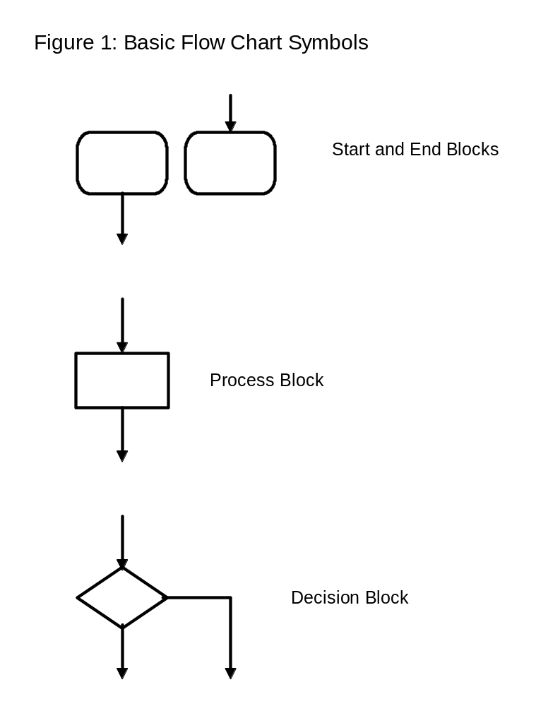
The following basic elements of a flowchart are shown in Figure 1:
- Ø The START block represents the beginning of a process. It always has exactly one output. The START block will be labeled with a brief description of the process carried out by the flowchart to follow. If this flowchart represents a process in a higher level flowchart, the start block contains the exact same text as the higher level block which this flowchart will describe in greater detail.
- Ø The END block represents the end of a process. It always has exactly one input and will generally contain either END (if a top-level flowchart) or RETURN (generally implemented as a subroutine in assembly language or a separate function in C).
- Ø A PROCESS block represents some operation carried out on an element of data. It will contain a brief descriptive label describing the process being carried out on the data. It may itself be further broken down into simpler steps by another complete flowchart representing that process. If it is further broken down, the flowchart that represents the process will have the same label in its start block as the process description at the higher level. A process always has exactly one input and one output.
- Ø A DECISION block always makes a binary choice. The label in a decision block should be a question that clearly has only two possible answers. The decision block will have exactly one input and two outputs. The two outputs will be labeled with the two answers to the question in order to show the direction of the logic flow depending upon the decision made.
- Ø On-page and off-page CONNECTORS may also appear in some flowcharts, but we will design flowcharts to ensure that no process requires more blocks than can be represented on a single page.

A structured flowchart is one in which all of the processes and decisions must fit into one of a few basic structured elements. The basic elements of a structured flowchart are shown in Figure 2. It should be possible to take any structured flowchart and enclose all of the blocks of the flowchart within one of the following process structures. Note that each of the structures shown below has exactly one input and one output and thus itself can be represented by a single process block.
- Ø The Sequence process is itself just a series of processes carried out one after the other. Most programs are represented at the highest level by a Sequence, possibly with a loop from the end back to the beginning.
- Ø The If-Then-Else process logically completes the binary decision block by providing two separate processes, one of which will be carried out in each path from the binary decision.
- Ø The Do-While process allows for the representation of a conditional loop structure within a program, where the decision to execute the process in the loop is made prior to the first execution of the process.

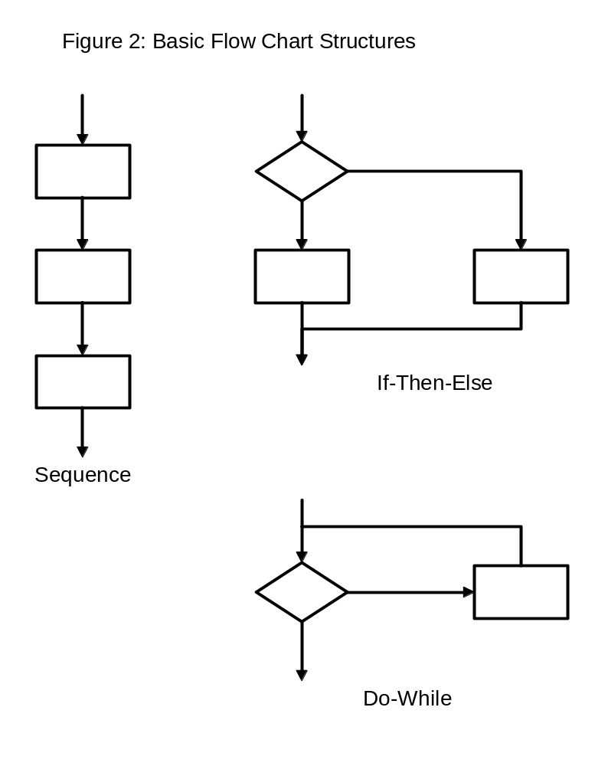
Although all flowcharts can be represented by the above basic structures, it is sometimes useful to employ some additional derived flowchart structures. These derived structures can be made from the basic structures, but are often more intuitive in designing the flow of a process.
The derived structures are shown in Figure 3:
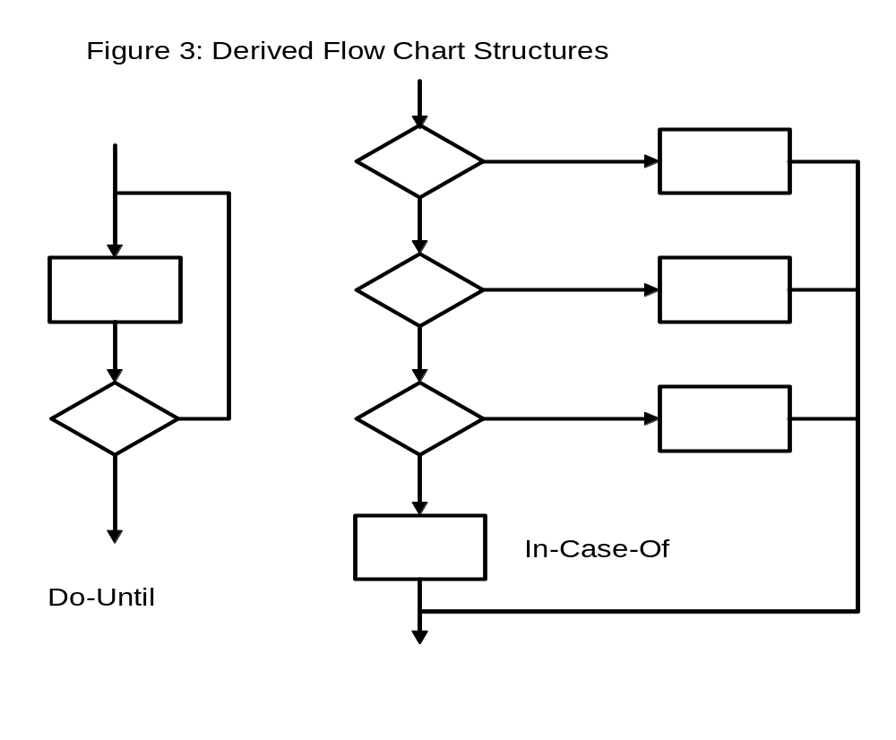
- Ø The Do-Until structure differs from the Do-While in that the process contained within the loop is always executed at least one time. This is equivalent to performing the process once before going into a Do-While loop. In the Do-While, the process may never be executed. Although the Do-While process is preferred, the Do-Until process is sometimes more intuitive.
- Ø The In-Case-Of structure is useful in representing a series of If-Then-Else statements where there are more than two related choices to be made. There will always be one fewer decision blocks than the number of choices in the In-Case-Of process.
Figure 4 shows an example of a properly structured flowchart. As an example of what happens if a program is written first and then a flowchart is created to represent the program, Figure 5 is provided as an example of a 'spaghetti' program. This program has elements of its structure impossibly intertwined around other elements of the structure. A program of this sort is very difficult to understand and maintain.

Structured design using flowcharts generally involves a top-down analysis of the problem to be solved. This begins with a carefully structured textual description of the problem to be solved. This phase often involves talking with the customer to determine exactly what will be needed in the design implementation. At this point external inputs and outputs are defined. (If we started from these inputs and outputs and worked up, we would be doing a bottom-up design.) From the text description, a top-level flowchart is created. This describes the processes to be carried at a high level with a minimum of detail. Often this top-level flowchart is a sequence of processes. In an embedded application where most programs never end, the END block may be replaced by a loop back to the beginning or some other point in the program (often certain initialization steps need to be executed only once).

Each process block in this high level flowchart is then broken down into greater detail through another flowchart which describes how the higher level process is to be implemented. In a complex design, many levels may be required before reaching a sufficiently detailed level of description to write the code. If carried out properly, each block in the lowest level flowchart will represent no more than one, or a few, assembly language or C instructions.

Properly executed, the analysis and flowcharting stages of the design process will probably consume 80% or more of the total program design time. The actual code generation should be very simple after the flowcharts have been completed. The labels in the blocks on the flowcharts will become an outline of the comments to be provided within the program itself. The comments within the program must describe the function of the instructions in the overall program and NOT be simply a description of the instruction itself.
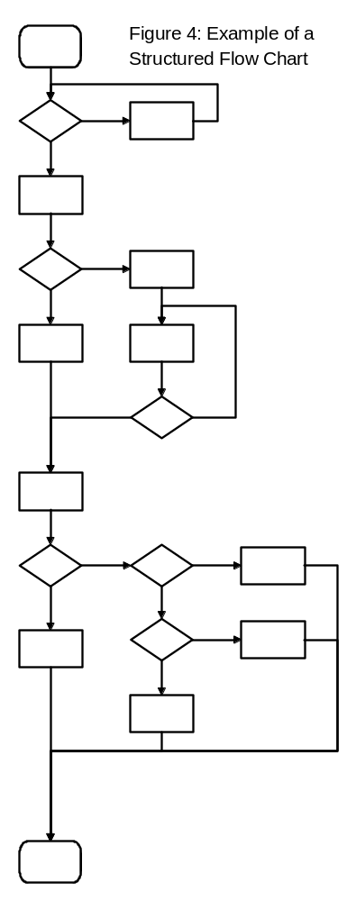
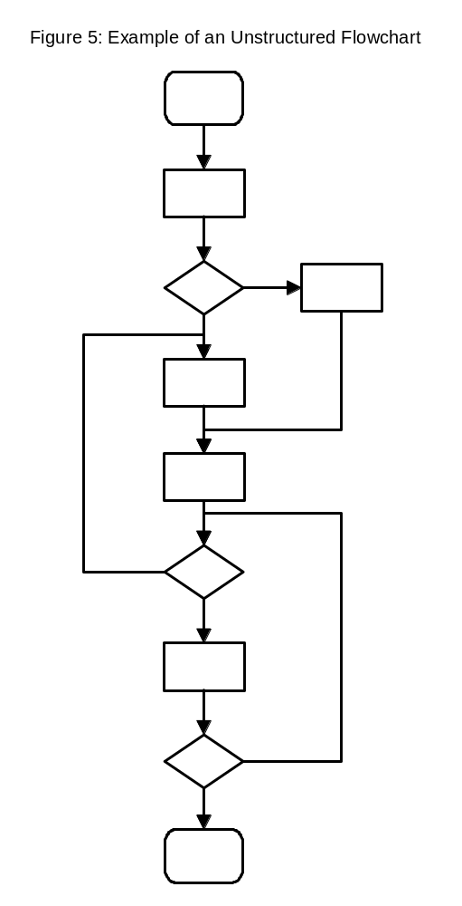

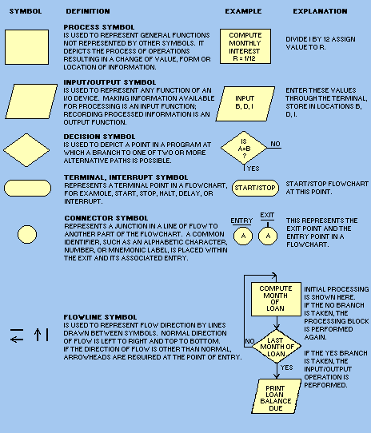
- Fundamental flowcharting symbols.
GRAPHIC SYMBOLS. - Within a flowchart, graphic symbols are used to specify arithmetic operations and relational conditions.
The following are commonly-used arithmetic and relational symbols.
+ plus, add
- minus, subtract
* multiply
/ divide
± plus or minus
= equal to
> greater than
< less than
 greater than or equal to
 less than or equal to
 not equal
YES or Yyes
NO or Nno
TRUE or Ttrue
FALSE or Ffalse
FLOWCHARTING TEMPLATE. - To aid in drawing the flowcharting symbols, you may use a flowcharting template. Figure 3-4 shows a template containing the standard symbol cutouts. A template is usually made of plastic with the symbols cut out to allow tracing the outline.
Constructing a Flowchart
There is no "best way" to construct a flowchart. There is no way to standardize problem solution. Flowcharting and programming techniques are often unique and conform to the individual's own methods or direction of problem solution.
This section will show an example of developing a programming flowchart. It is not the intent to say this is the best way; rather, it is one way to do it.
By following this text example you should grasp the idea of solving problems through flowchart construction. As you gain experience and familiarity with a computer system, these ideas will serve as a foundation.
To develop a flowchart, you must first know what problem you are to solve. It is then your job to study the problem definition and develop a flowchart to show the logic, steps, and sequence of steps the computer is to execute to solve the problem.
As an example, suppose you have taken a short-term second mortgage on a new home, and you want to determine what your real costs will be, the amount of interest, the amount to be applied to principal, and the final payment at the end of the 3-year loan period.
The first step is to be sure you understand the problem completely - What are the inputs and the outputs and what steps are needed to answer the questions? Even when you are specifying a problem of your own, you will find we don't usually think in small, detailed sequential steps. However, that is exactly how a computer operates, one step after another in a specified order. Therefore, it is necessary for you to think the problem solution through step by step. You might clarify the problem as shown by the Problem Definition
Problem definition and programming flowchart.
